**Lab Assignment for Week #8 (QACS - Oracle)**

**(Project Questions from Chapter 7 of the textbook)**

**(NOTE: Screen shot examples in these instructions may be different than your screen shot values)**

**Screen Shot #1A: Displaying the CUSTOMER table records**

Display the records contained in the CUSTOMER table. To accomplish this, left click on the table name in the object panel. From the query results panel on the right, select the “Data” tab.

**NOTE**: Make changes to the Inert_Data SQL file, as outlined below, before you populate the CUSTOMER table

**IMPORTANT – Ensure that the record which contains the name “Svane, Jack” has been changed to reflect your first and last name (DO NOT alter any other information regarding this record).**

**IMPORTANT –** Ensure that all tables and views are visible in the object panel of the Oracle SQL Developer screen

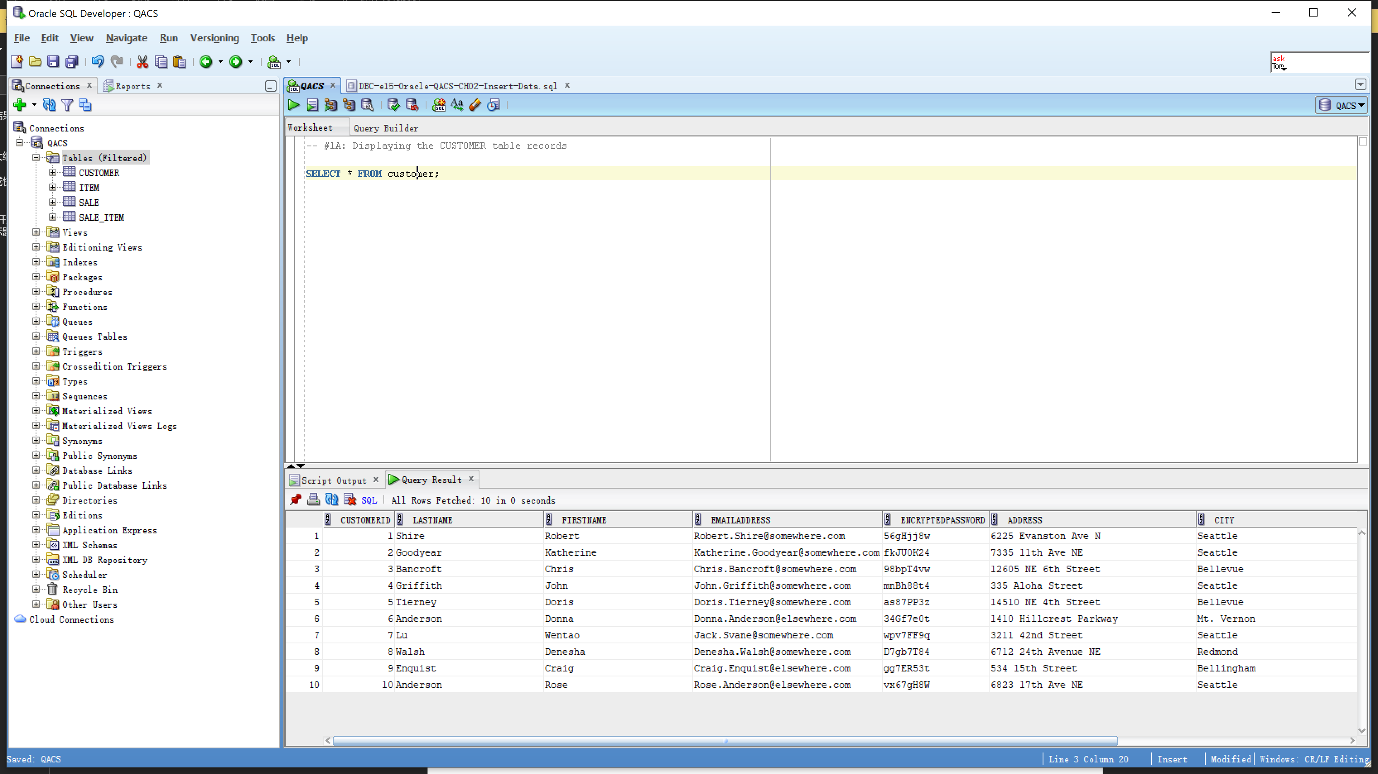

**Screen Shot #1B: Displaying the CUSTOMER table details**

Display the details of the CUSTOMER table**. To a**ccomplish this, left click on the view name in the object panel. From the query results panel on the right, select the “Details” tab.

**IMPORTANT –** Ensure that all tables and views, and function, are visible in the object panel of the Oracle SQL Developer screen

**IMPORTANT –** Ensure that the OWNER row is visible (you being the owner)

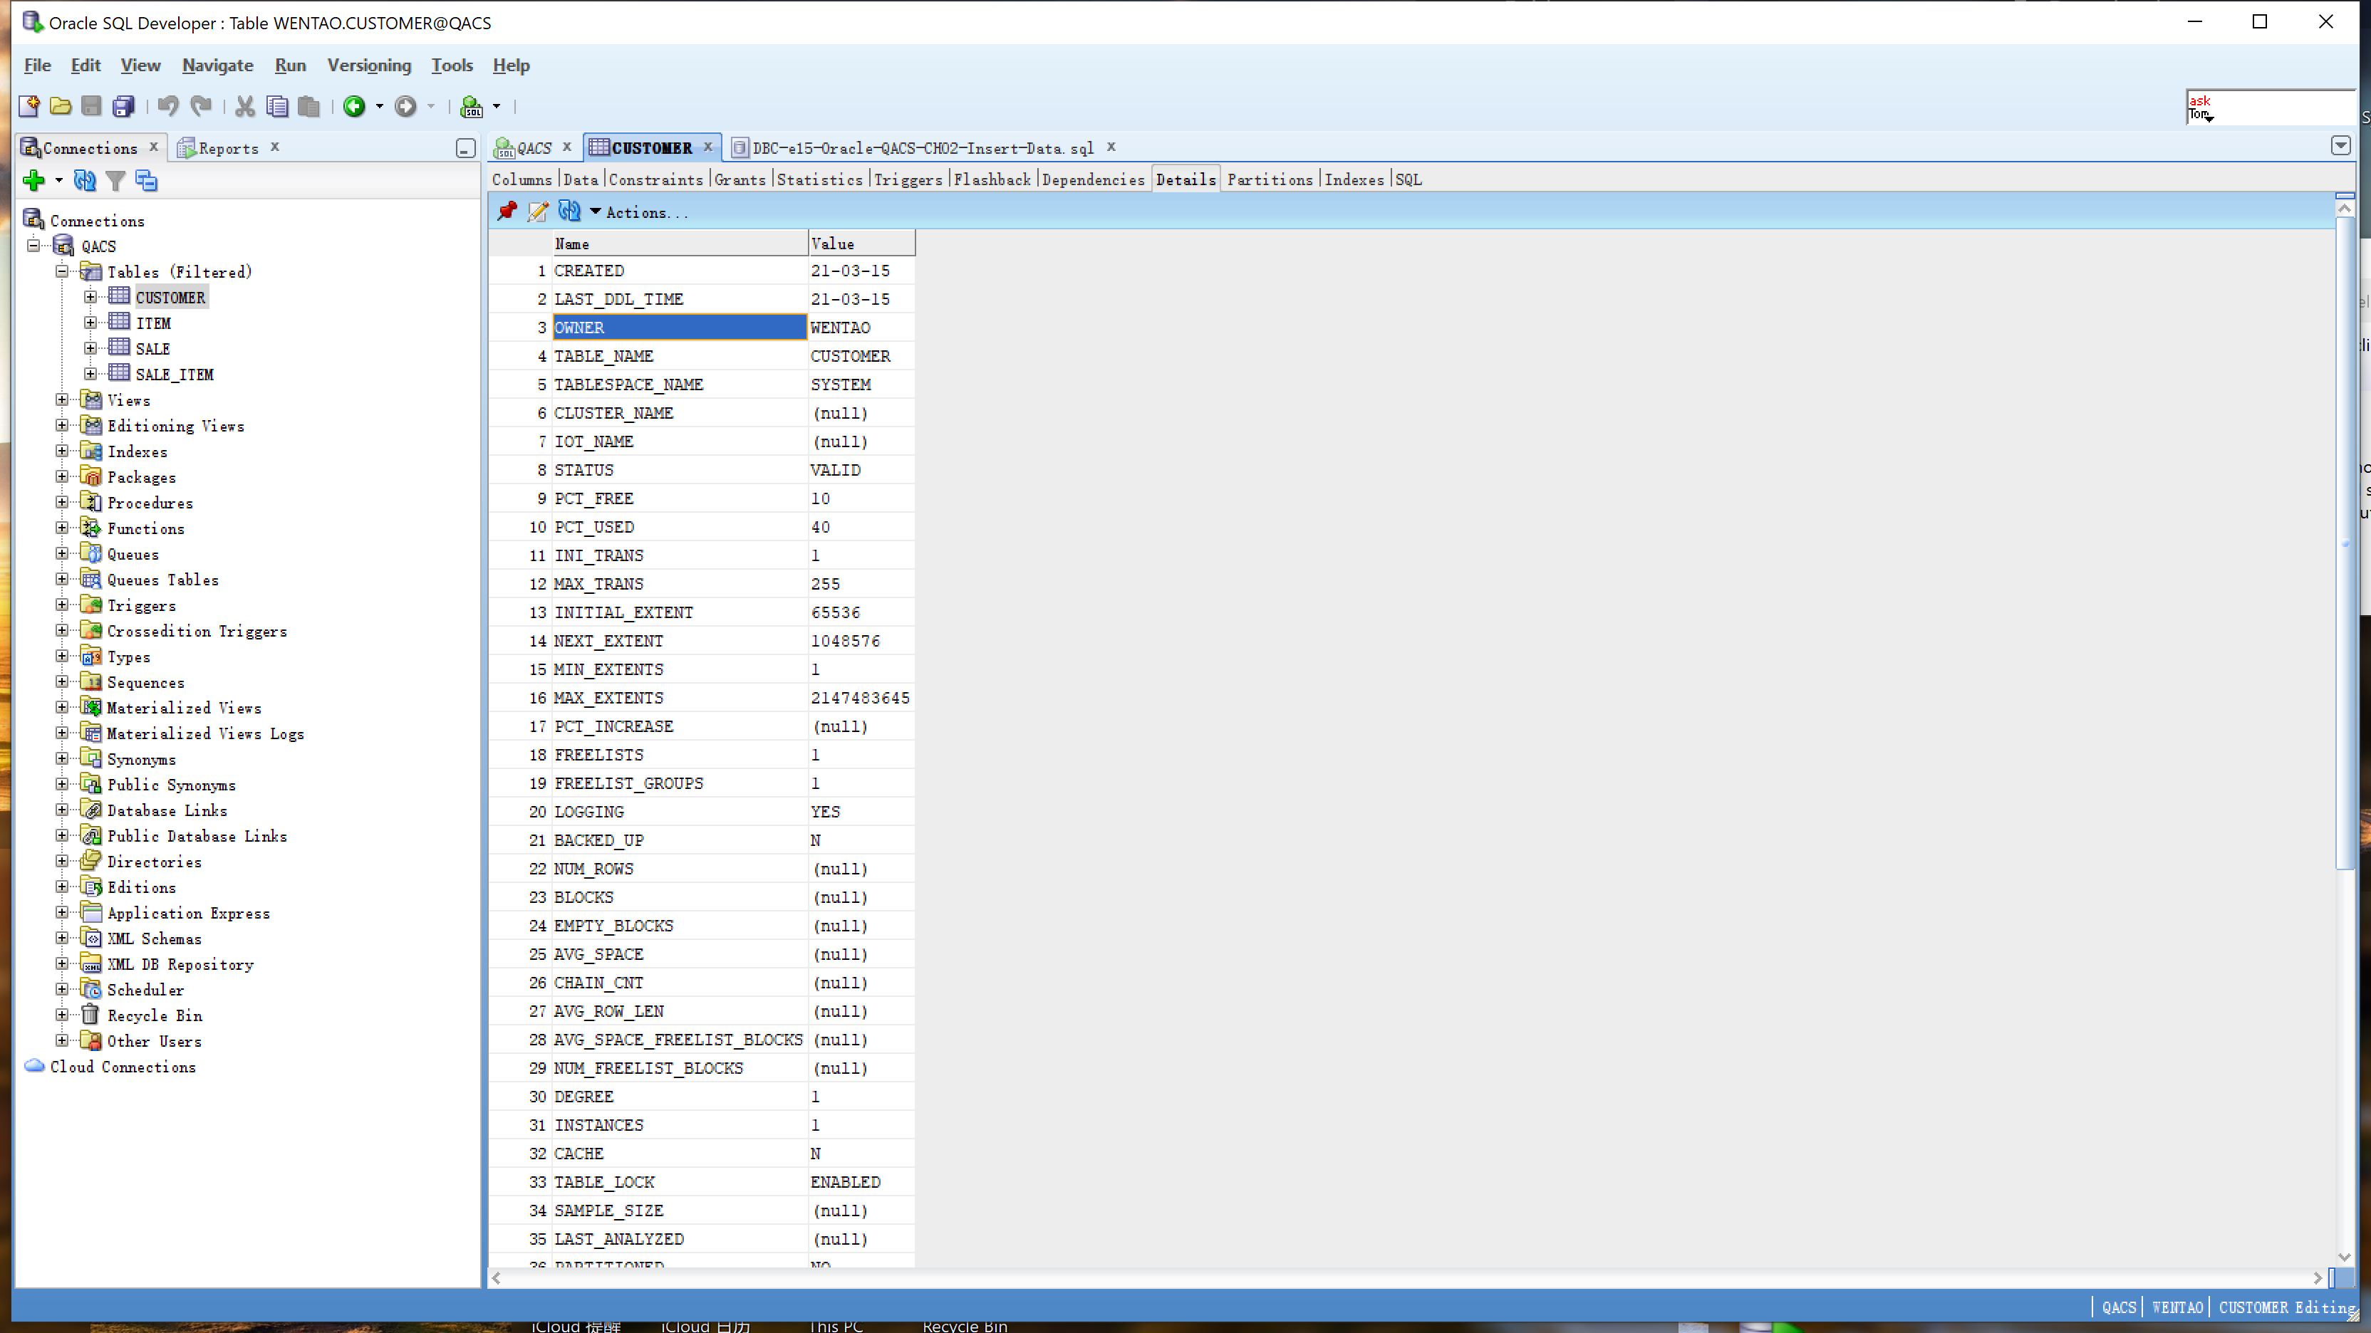

**Screen Shot #2A: Displaying view results**

**Question N on page 412 of Chapter 7 (from the textbook – 15th edition)**

Display the records produced by the view **SaleSummaryView**. To accomplish this, left click on the view name in the object panel. From the query results panel on the right, select the “Data” tab.

**IMPORTANT –** Ensure that all tables and views are visible in the object panel of the Oracle SQL Developer screen

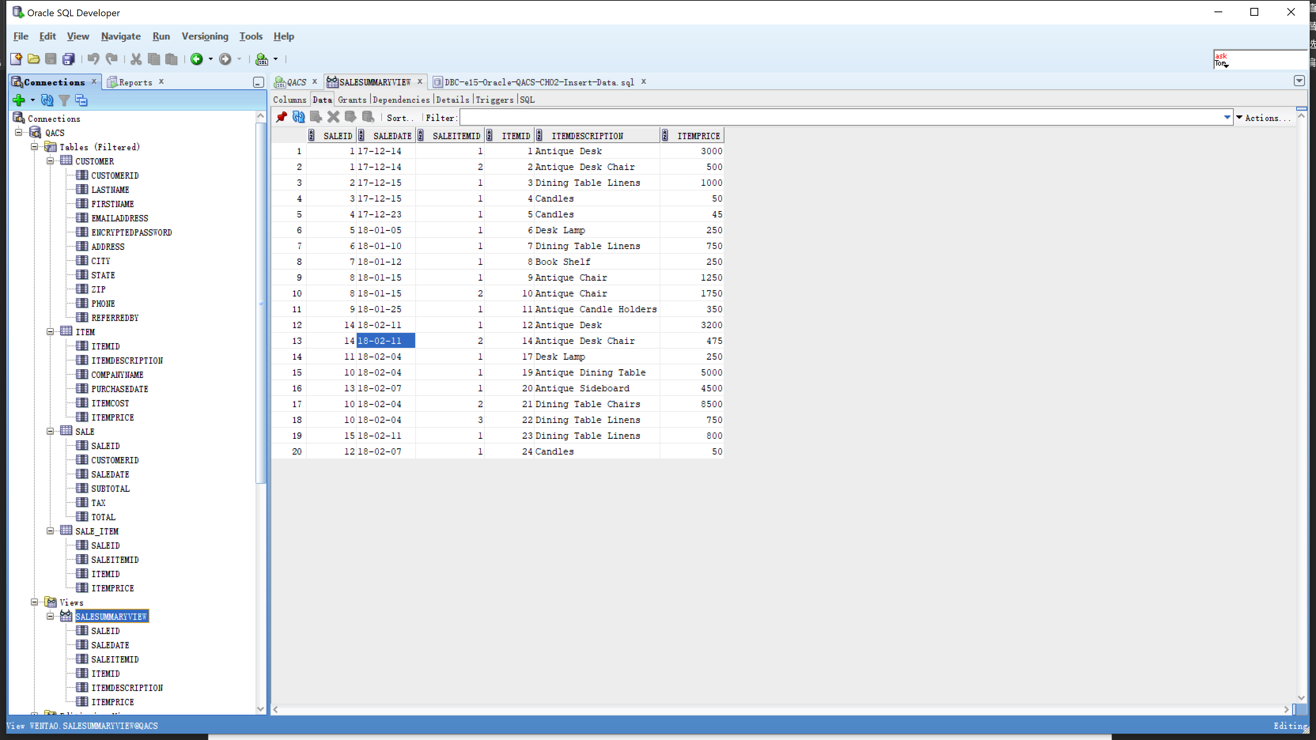

**Screen Shot #2B: Displaying the view SQL coding**

**Question N on page 412 of Chapter 7 (from the textbook – 15th edition)**

Display the SQL coding, through the View GUI dialog box. of the view **SaleSummaryView**. To accomplish this, right click on the view name in the object panel and from the pop-up menu, select the Edit option.

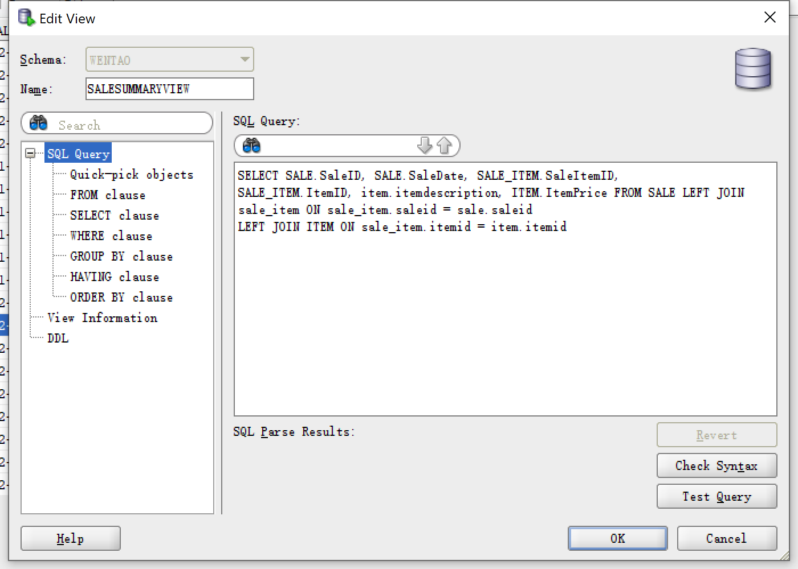

**Screen Shot #3A: Displaying view results**

**Question P on page 412 of Chapter 7 (from the textbook – 15th edition)**

Display the records produced by the view **CustomerSaleSummaryView**. To accomplish this, left click on the view name in the object panel. From the query results panel on the right, select the “Data” tab.

**IMPORTANT –** Ensure that all tables and views and function are visible in the object panel of the Oracle SQL Developer screen

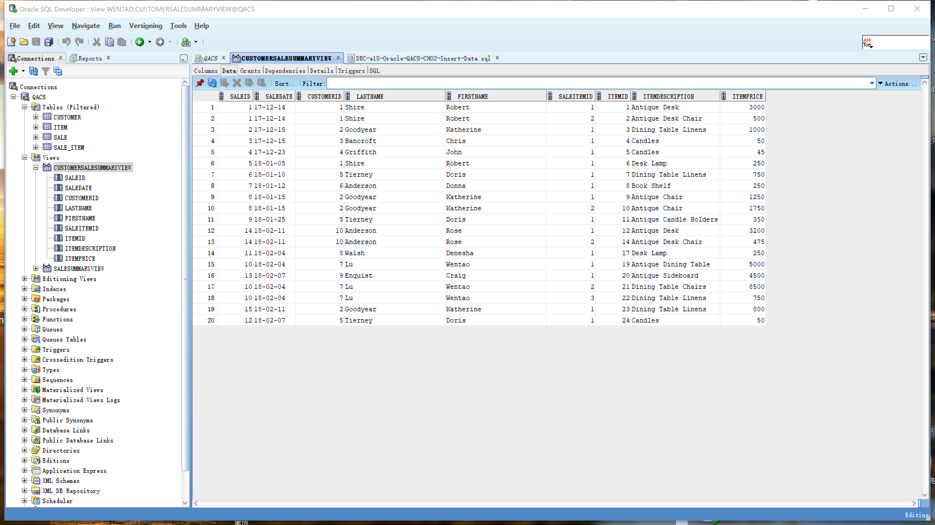

**Screen Shot #3B: Displaying the view SQL coding**

**Question P on page 412 of Chapter 7 (from the textbook – 15th edition)**

Display the SQL coding, through the View GUI dialog box. of the view **CustomerSaleSummaryView**. To accomplish this, right click on the view name in the object panel and from the pop-up menu, select the Edit option.

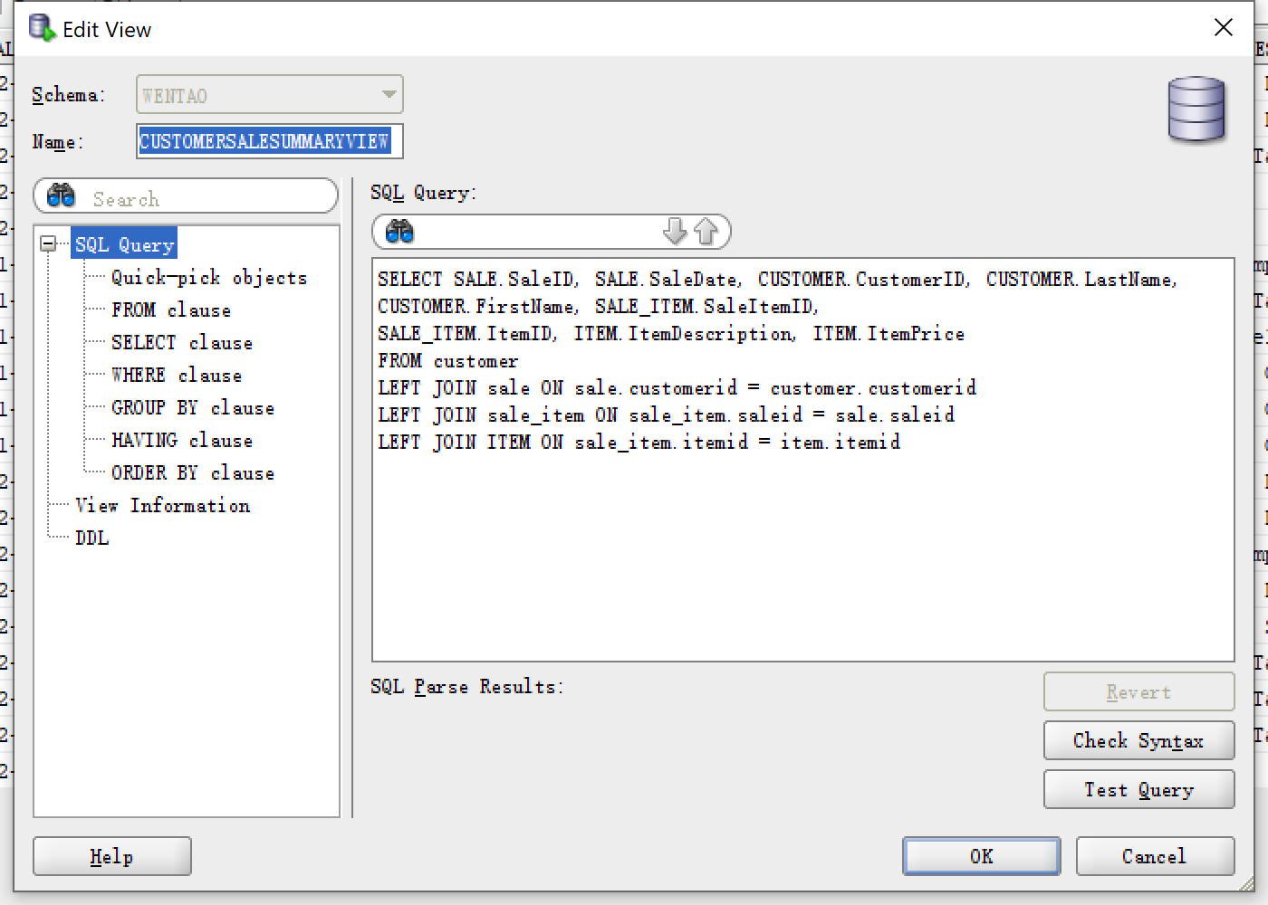

**Screen Shot #4A: Displaying view results**

**Question Q on page 412 of Chapter 7 (from the textbook – 15th edition)**

Display the records produced by the view **CustomerLastNameFirstSaleSummaryView**. To accomplish this, left click on the view name in the object panel. From the query results panel on the right, select the “Data” tab.

**IMPORTANT –** Ensure that all tables and views and function are visible in the object panel of the Oracle SQL Developer screen

**IMPORTANT –** Read additional instructions concerning this question in the lab assignment listed on the Brightspace site

**IMPORTANT –** Ensure that the concatenated customer name is listed as Last Name, followed by a comma and a space and then the first name (i.e. Shire, Robert)

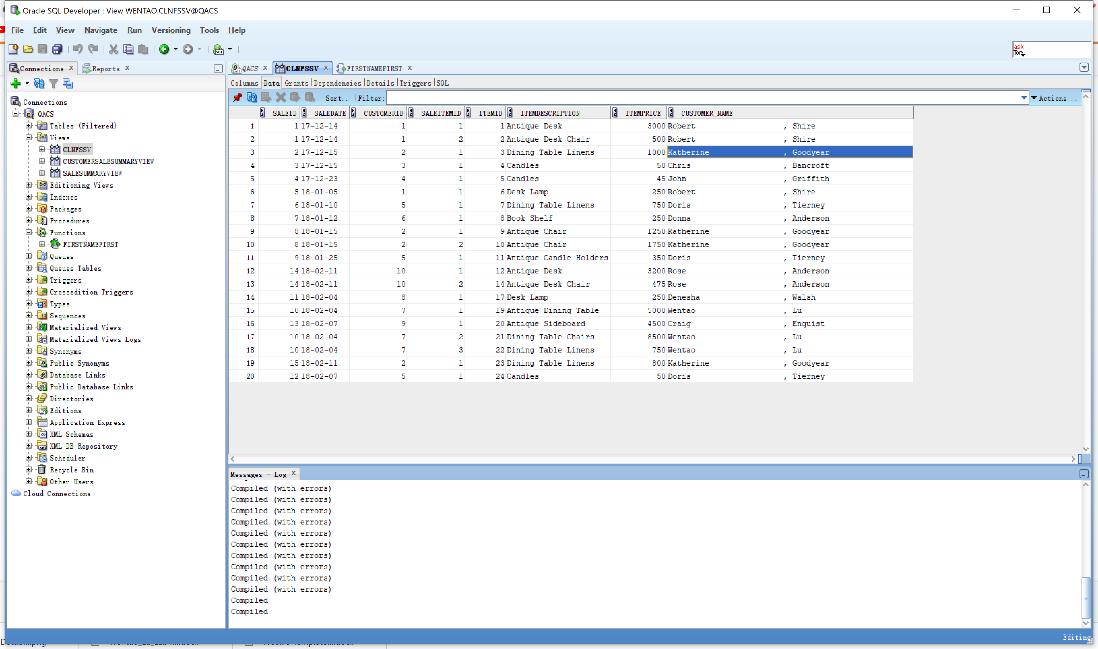

**Screen Shot #4B: Displaying the view SQL coding**

**Question Q on page 412 of Chapter 7 (from the textbook – 15th edition)**

Display the SQL coding, through the View GUI dialog box. of the view **CustomerLastNameFirstSaleSummaryView**. To accomplish this, right click on the view name in the object panel and from the pop-up menu, select the Edit option.

**IMPORTANT –** Ensure that all tables and views and function are visible in the object panel of the Oracle SQL Developer screen

**IMPORTANT –** Read additional instructions concerning this question in the lab assignment listed on the Brightspace site

**IMPORTANT –** Ensure that the concatenated customer name is listed as Last Name, followed by a comma and a space and then the first name (i.e. Shire, Robert)

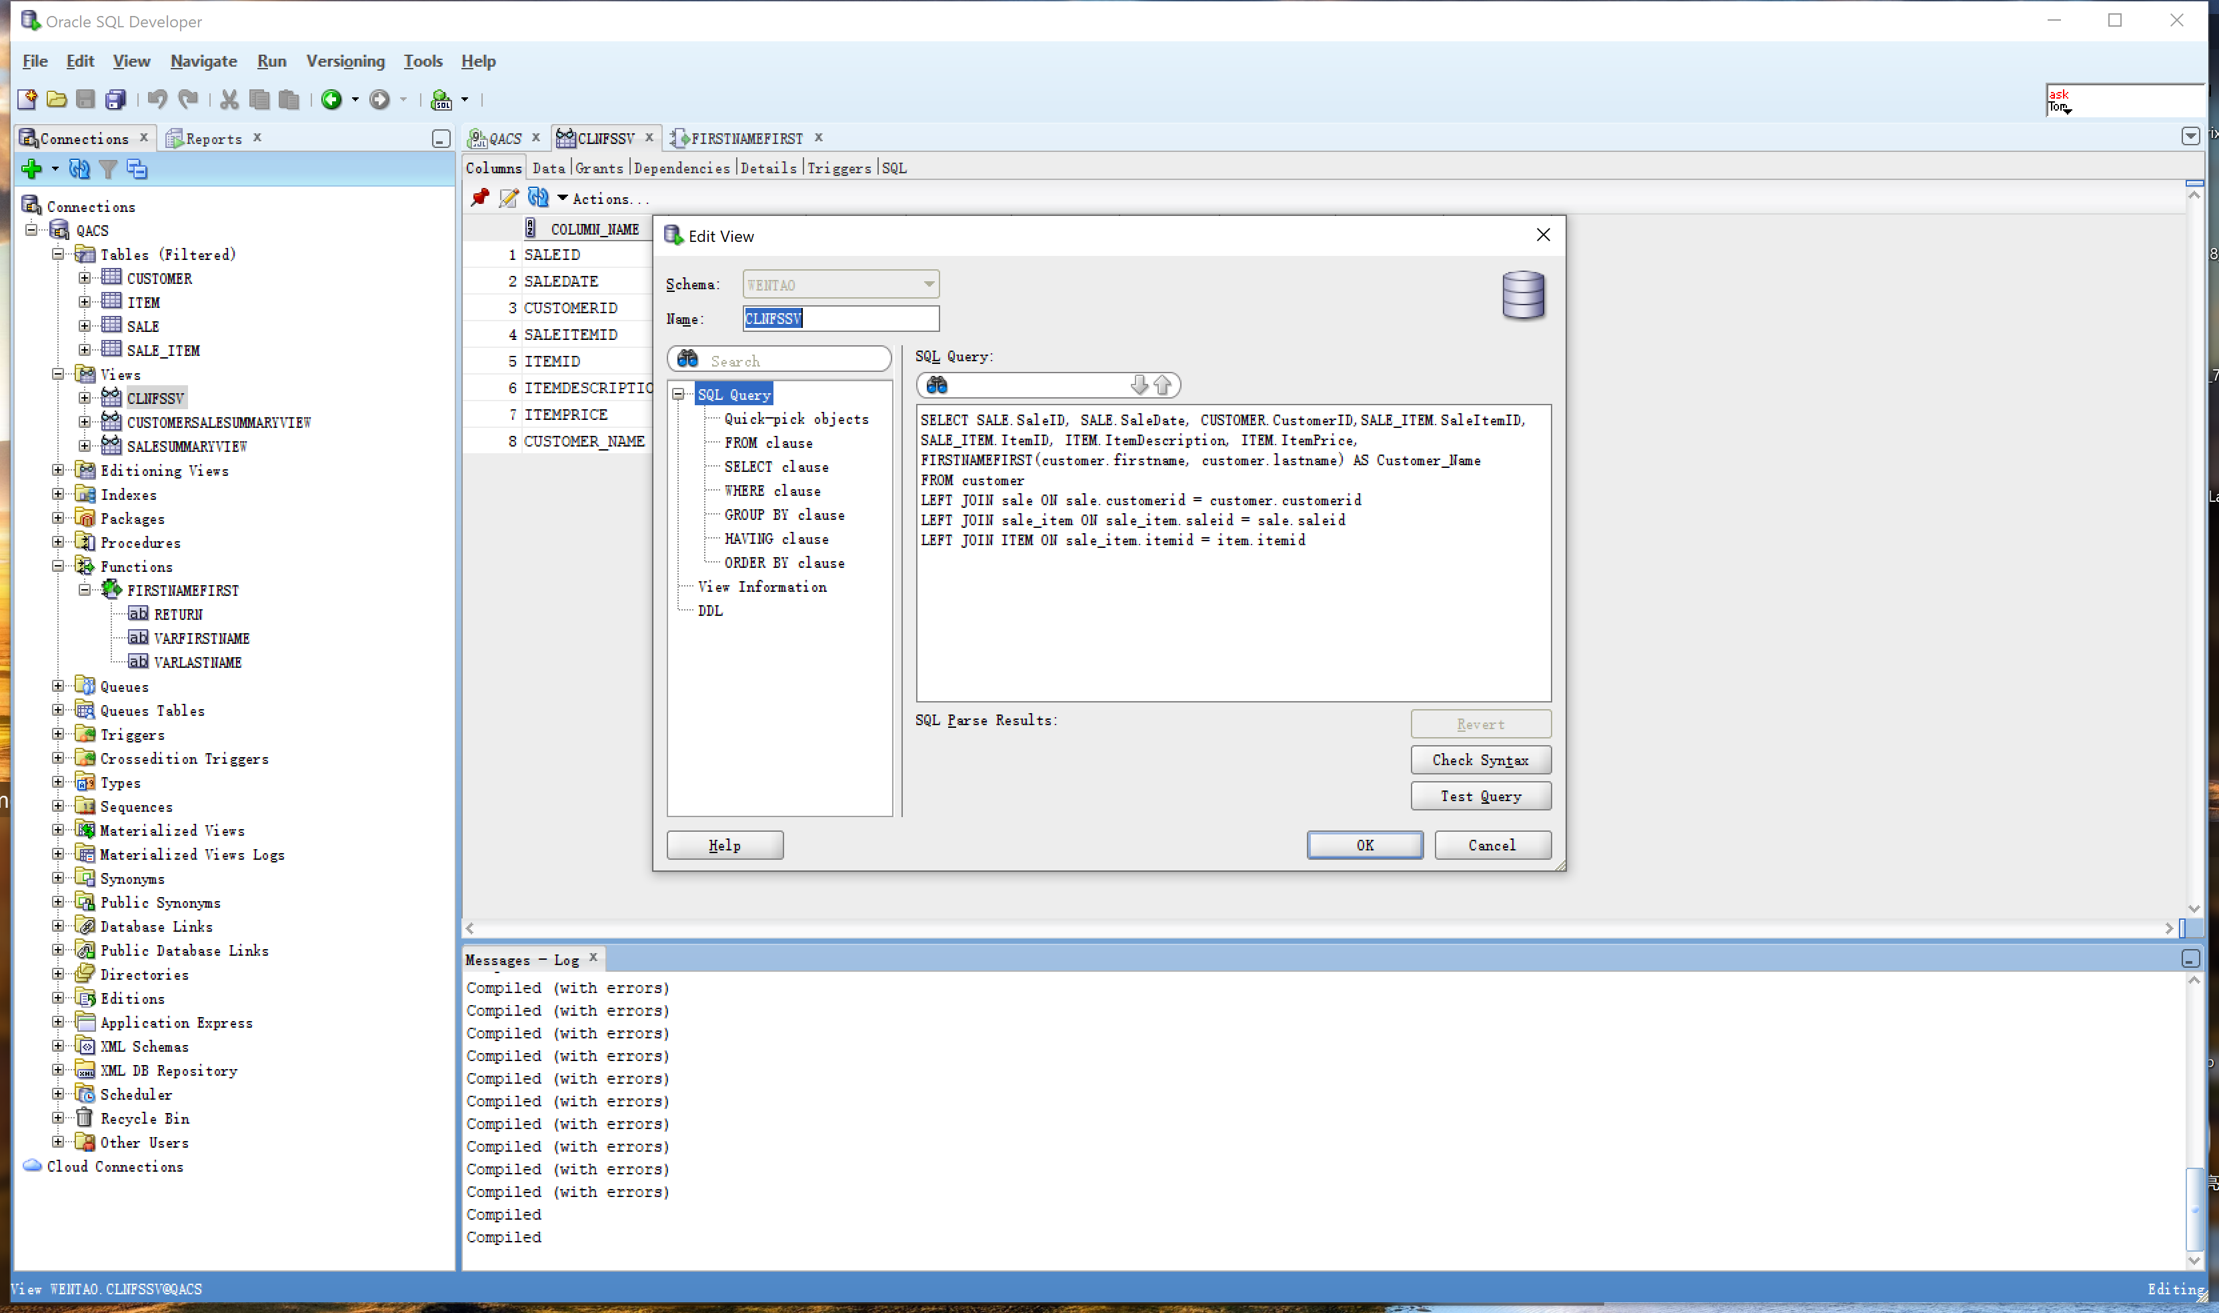

**Screen Shot #5A: Displaying view results**

**Question R on page 412 of Chapter 7 (from the textbook – 15th edition)**

Display the records produced by the view **CustomerSaleHistoryView**. To accomplish this, left click on the view name in the object panel. From the query results panel on the right, select the “Data” tab.

**NOTE**: This view retrieves records from a pre-existing view (i.e. CustomerSaleSummaryView)

**IMPORTANT –** Ensure that all tables and views and function are visible in the object panel of the Oracle SQL Developer screen

**IMPORTANT –** Read additional instructions concerning this question in the lab assignment listed on the Brightspace site

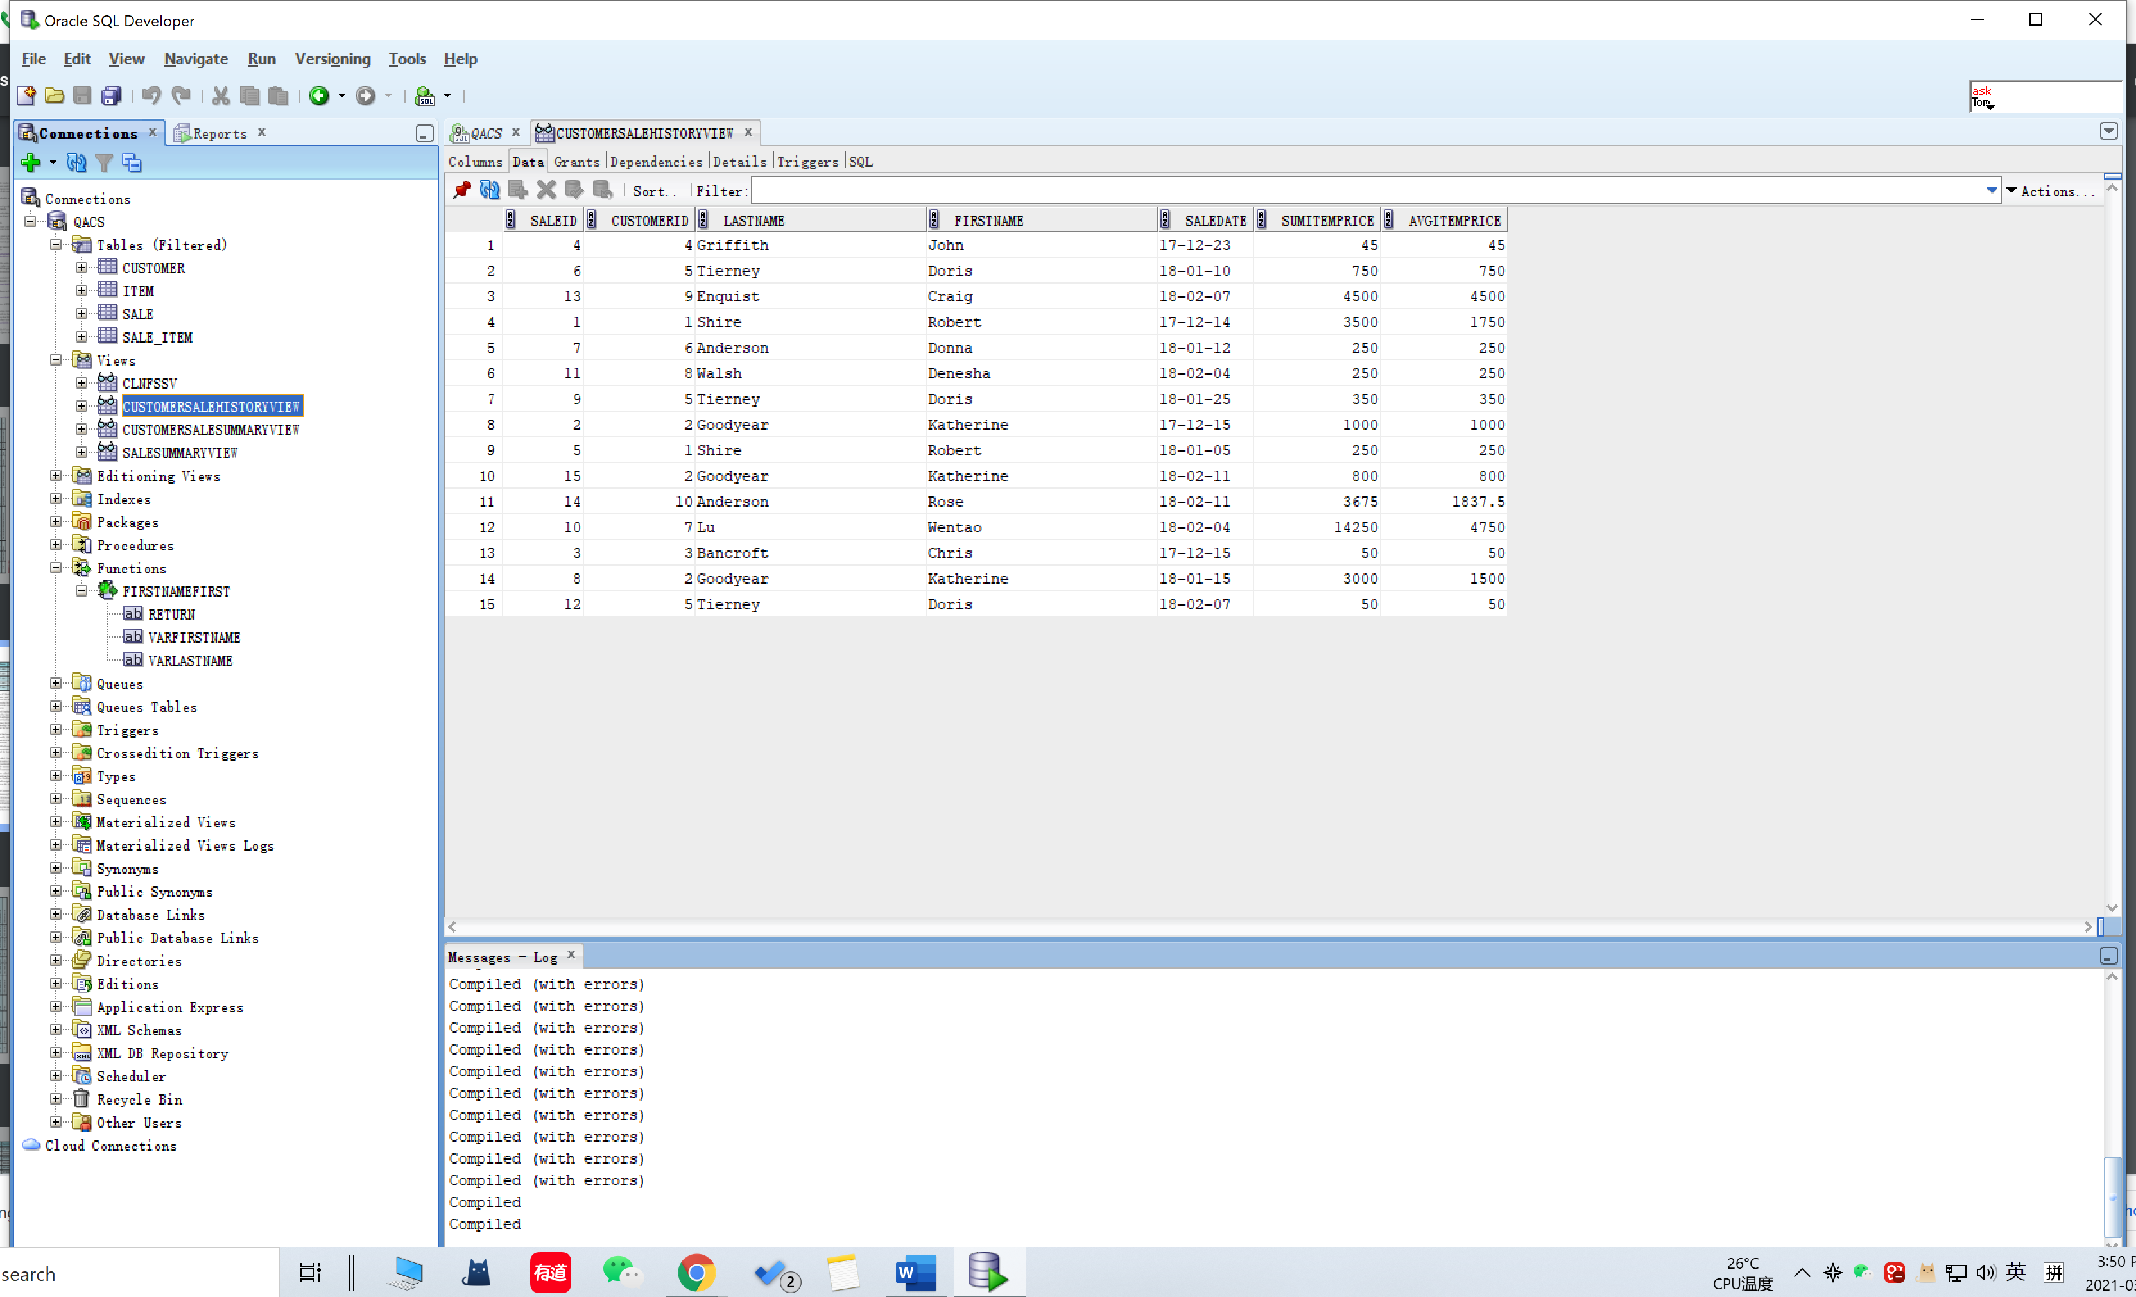

**Screen Shot #5B: Displaying the view SQL coding**

**Question R on page 412 of Chapter 7 (from the textbook – 15th edition)**

Display the SQL coding, through the View GUI dialog box. of the view **CustomerSaleHistoryView**. To accomplish this, right click on the view name in the object panel and from the pop-up menu, select the Edit option.

**NOTE**: This view retrieves records from a pre-existing view (i.e. CustomerSaleSummaryView)

**IMPORTANT –** Ensure that all tables and views and function are visible in the object panel of the Oracle SQL Developer screen

**IMPORTANT –** Read additional instructions concerning this question in the lab assignment listed on the Brightspace site

