**Lab Assignment for Week #9 (MI - Oracle)**

**(Project Questions from Chapter 7 of the textbook)**

**(NOTE: Screen shot examples in these instructions may be different than your screen shot values)**

**Screen Shot #1A: Displaying the STORE table records**

Display the records contained in the STORE table. To accomplish this, left click on the table name in the object panel. From the query results panel on the right, select the “Data” tab.

**NOTE: Make changes to the Inert_Data SQL file, as outlined below, before you populate the STORE table**

**IMPORTANT – Ensure that the record which contains the name “Jade Antiques” has been changed to reflect your first and last name (DO NOT alter any other information regarding this record). (Example, for student Sara Jones, the store would be renamed Sara Jones Antiques.)**

**IMPORTANT –** Ensure that all tables and views are visible in the object panel of the Oracle SQL Developer screen

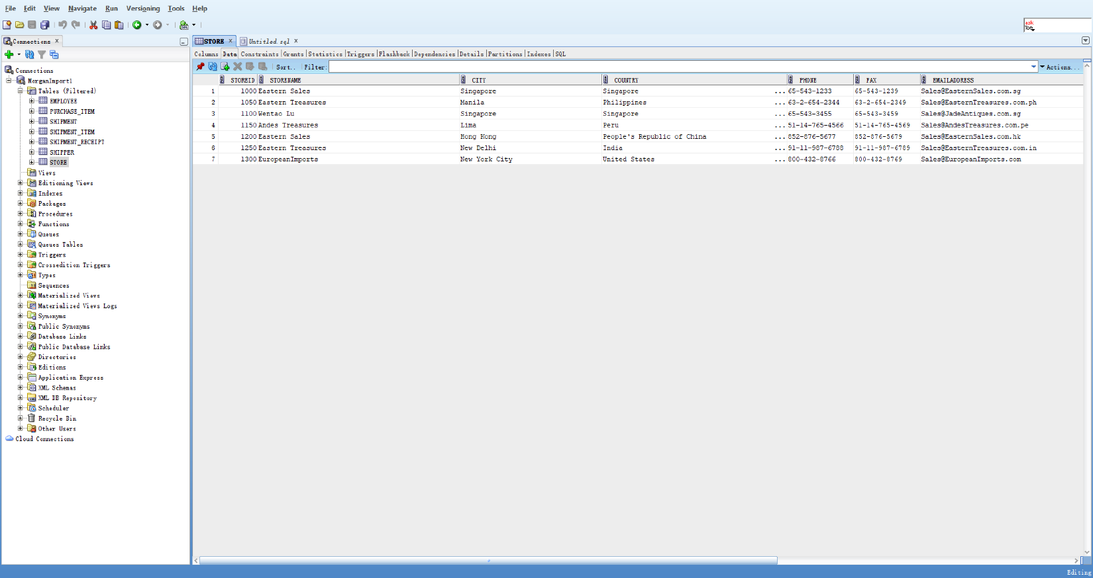

**Screen Shot #1B: Displaying the STORE table details**

Display the details of the STORE table**. To a**ccomplish this, left click on the view name in the object panel. From the query results panel on the right, select the “Details” tab.

**IMPORTANT –** Ensure that all tables and views are visible in the object panel of the Oracle SQL Developer screen

**IMPORTANT –** Ensure that the OWNER row is visible (you being the owner)

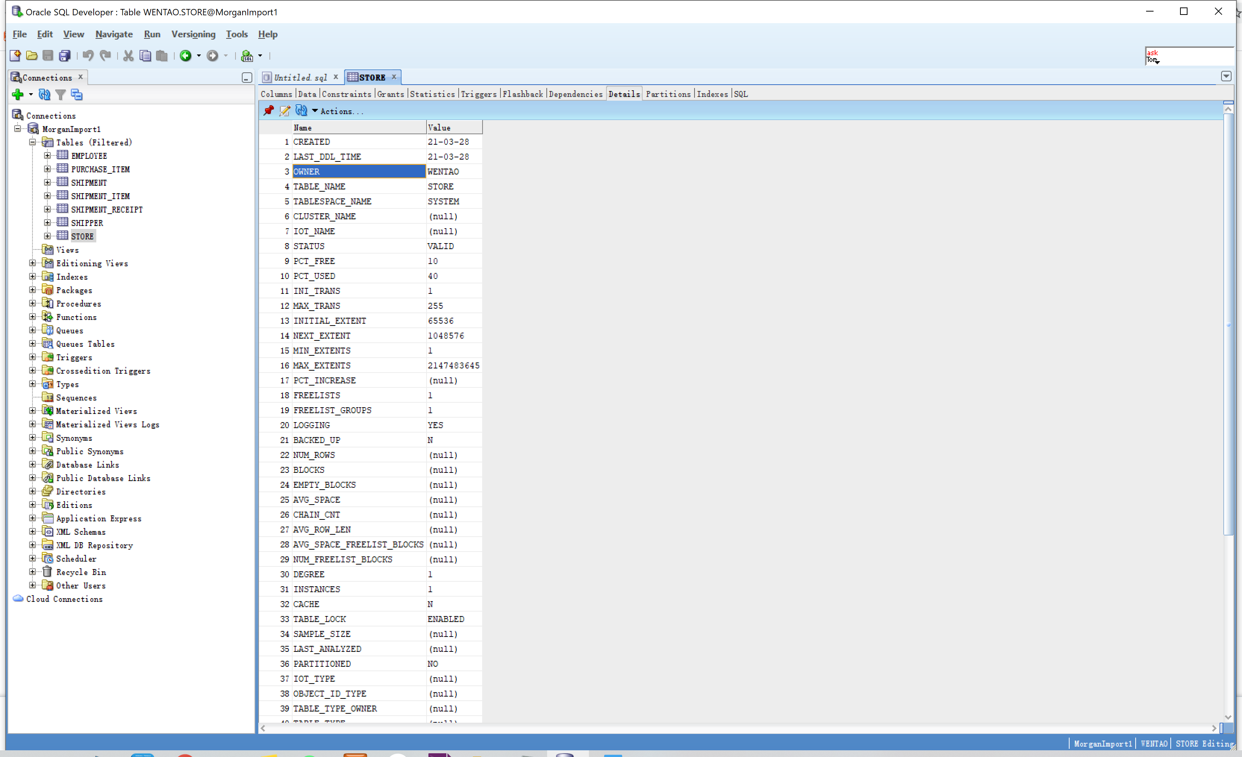

**Screen Shot #2A: Displaying view results**

**Question P on page 422 of Chapter 7 (from the textbook – 15th edition)**

Display the records produced by the view **StorePurchaseHistoryView**. To accomplish this, left click on the view name in the object panel. From the query results panel on the right, select the “Data” tab.

**IMPORTANT –** Ensure that all tables and views and function are visible in the object panel of the Oracle SQL Developer screen

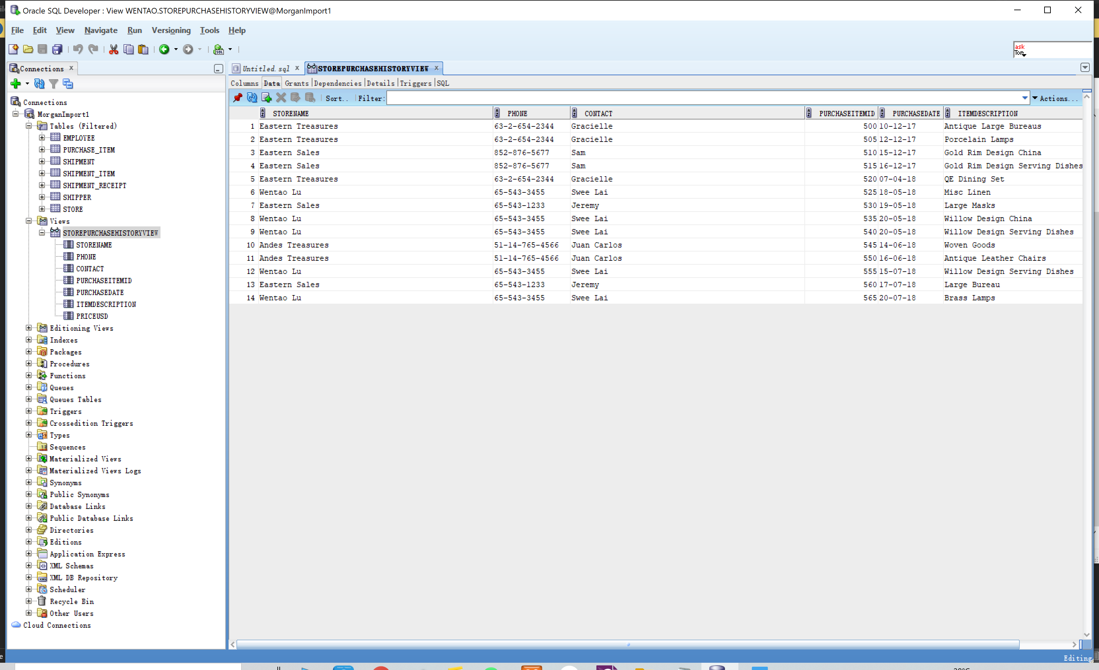

**Screen Shot #2B: Displaying the view SQL coding**

**Question P on page 422 of Chapter 7 (from the textbook – 15th edition)**

Display the SQL coding, through the View GUI dialog box. of the view **StorePurchaseHistoryView**. To accomplish this, right click on the view name in the object panel and from the pop-up menu, select the Edit option.

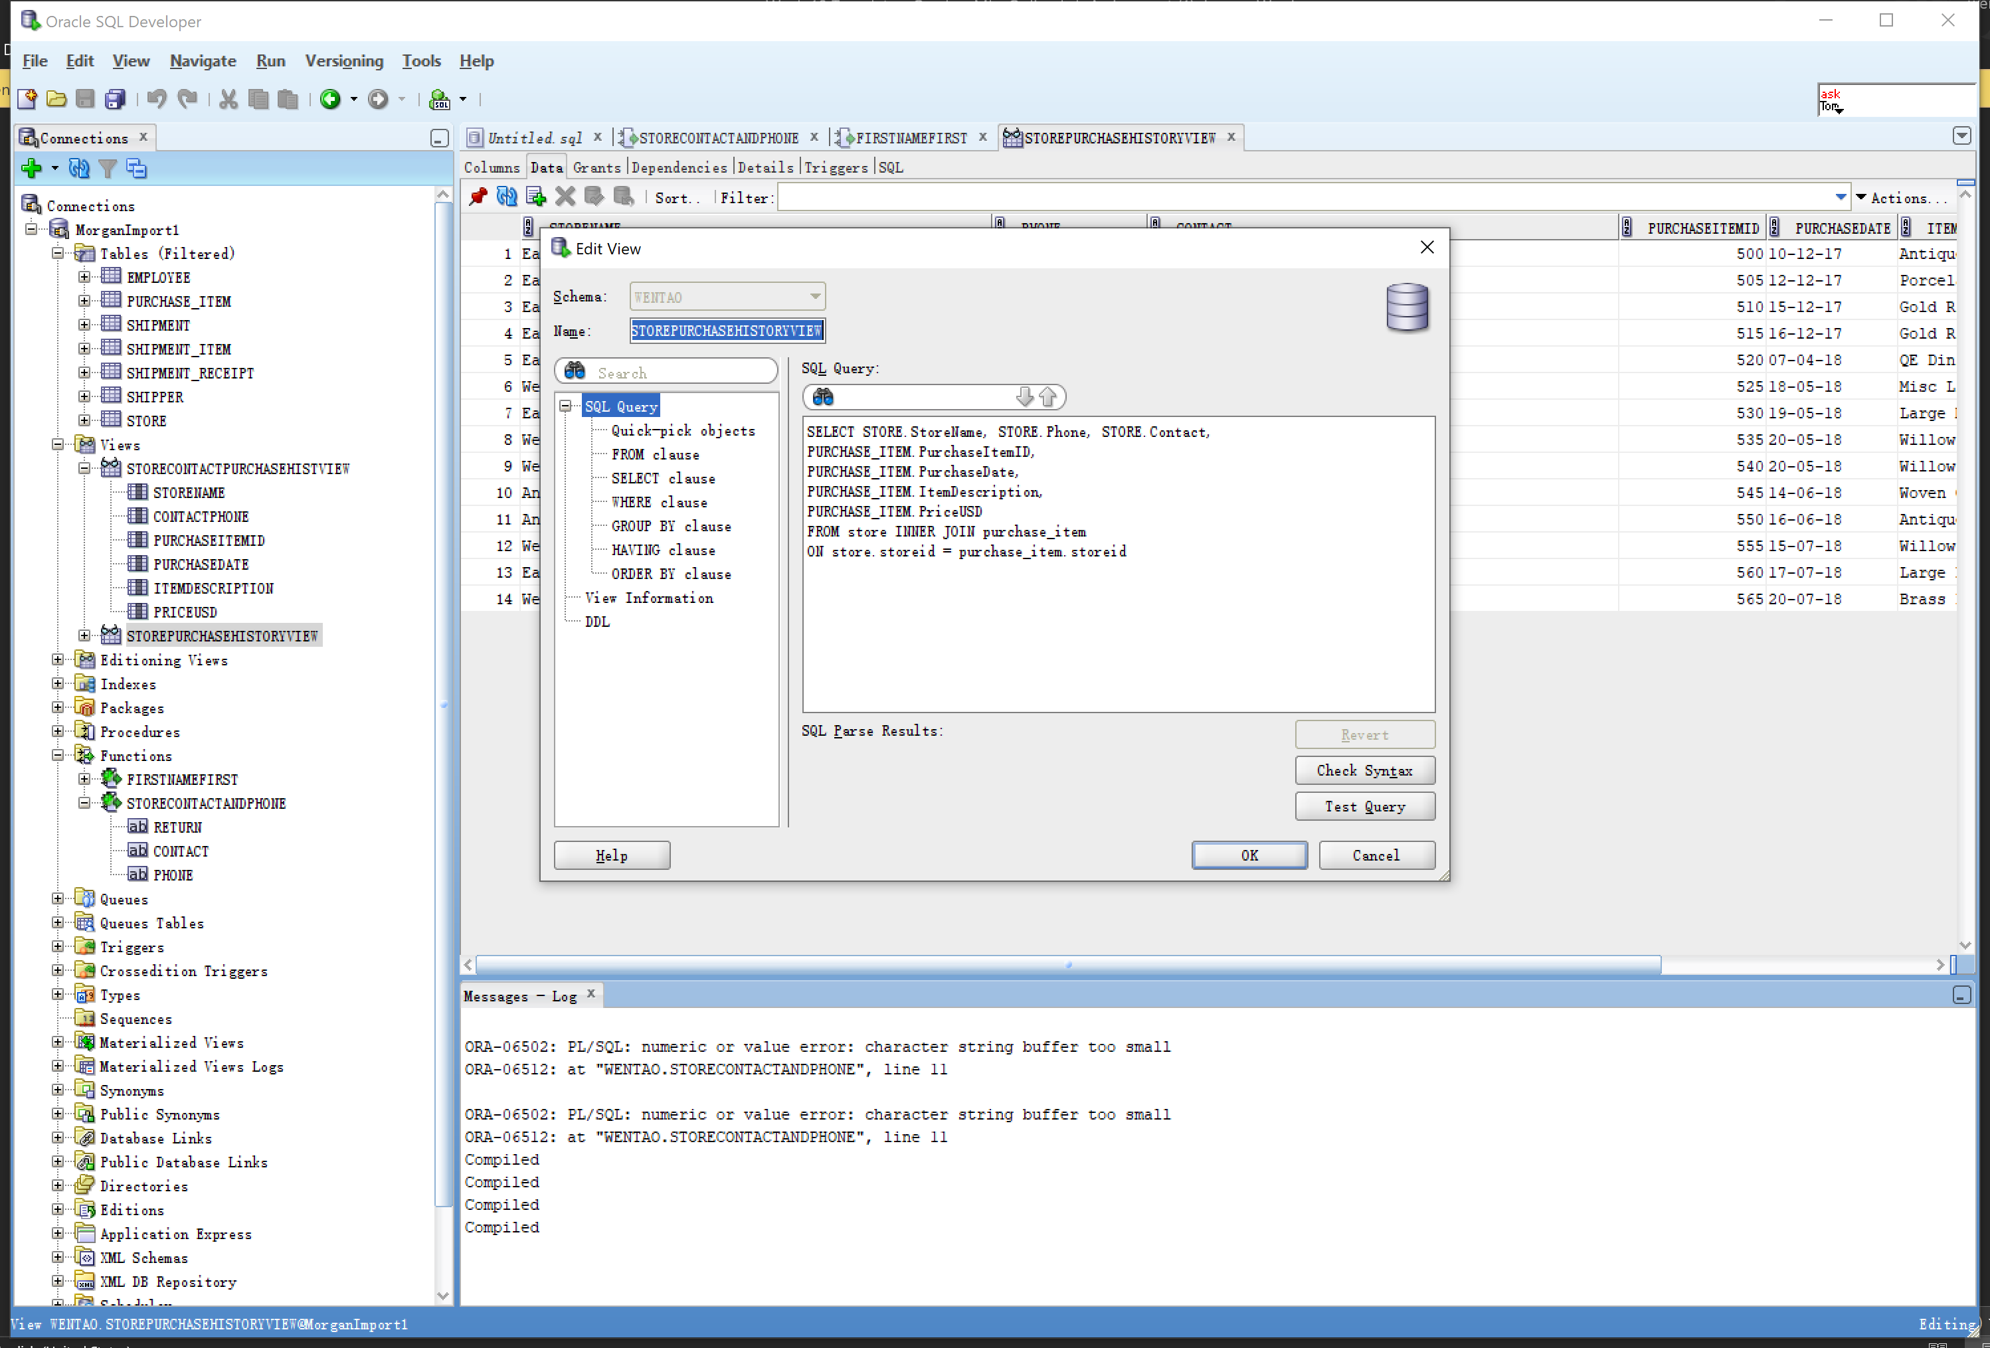

**Screen Shot #3A: Displaying view results**

**Question Q on page 422 of Chapter 7 (from the textbook – 15th edition)**

Display the records produced by the view **StoreContactPurchaseHistoryView**. To accomplish this, left click on the view name in the object panel. From the query results panel on the right, select the “Data” tab.

**IMPORTANT –** Ensure that all tables and views and function are visible in the object panel of the Oracle SQL Developer screen

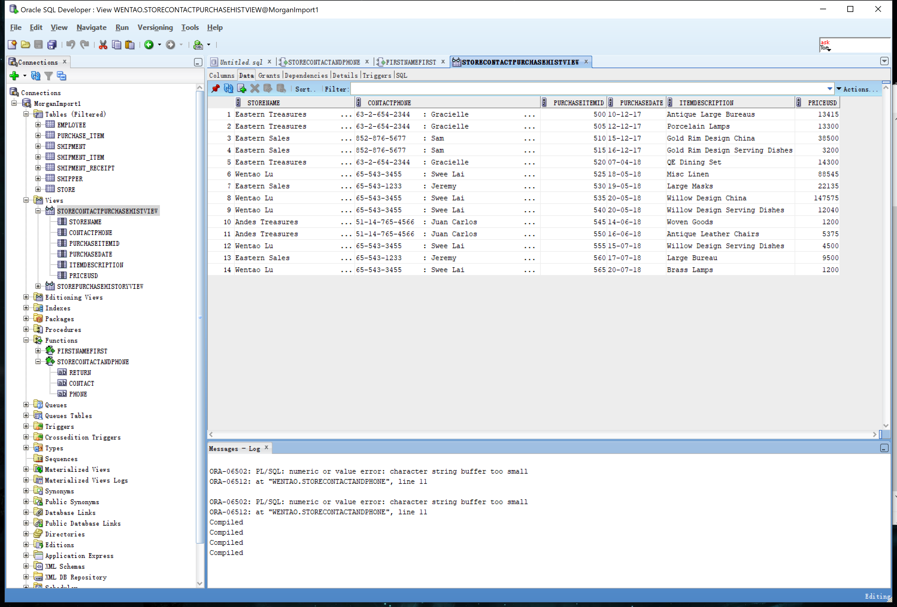

**Screen Shot #3B: Displaying the view SQL coding**

**Question Q on page 422 of Chapter 7 (from the textbook – 15th edition)**

Display the SQL coding, through the View GUI dialog box. of the view **StoreContactPurchaseHistoryView**. To accomplish this, right click on the view name in the object panel and from the pop-up menu, select the Edit option.

**IMPORTANT –** Ensure that all tables and views and function are visible in the object panel of the Oracle SQL Developer screen

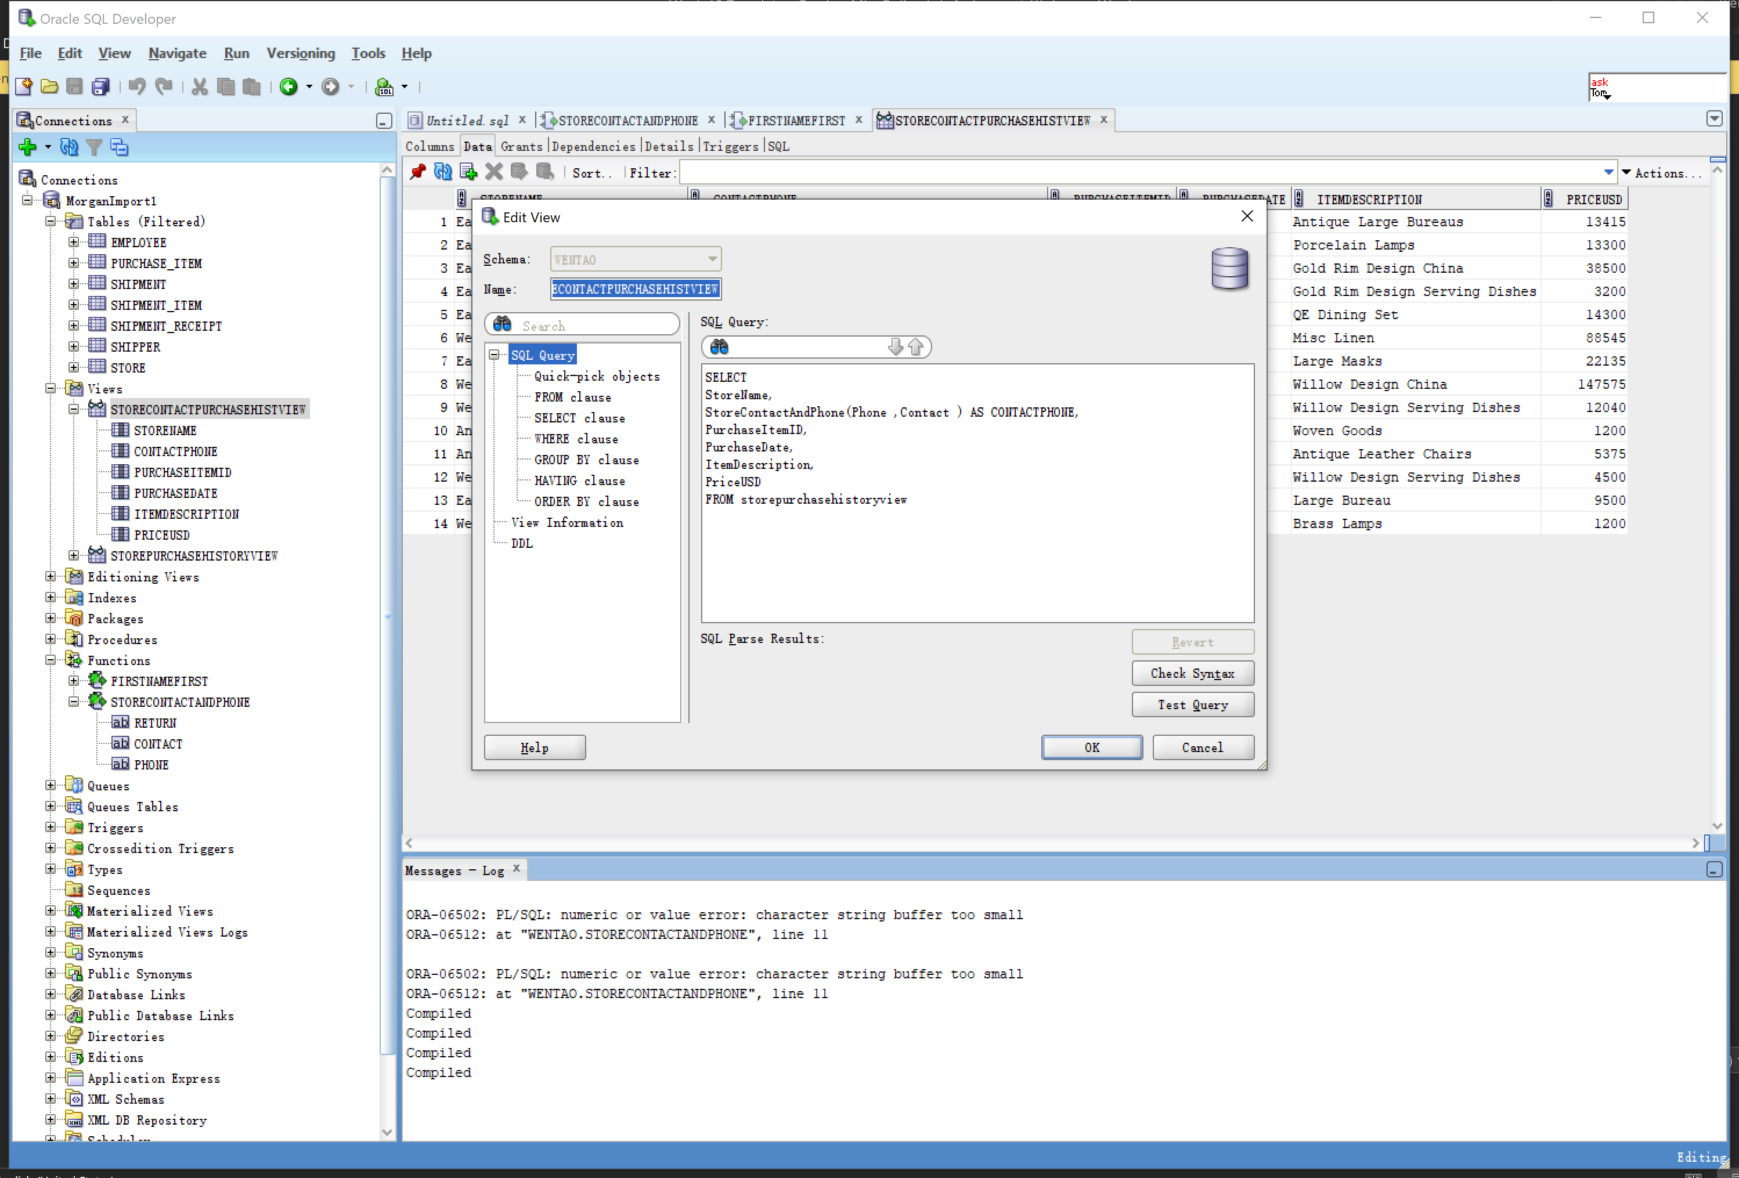

**Screen Shot #4A: Displaying view results**

**Question R on page 422 of Chapter 7 (from the textbook – 15th edition)**

Display the records produced by the view **StoreHistoryView**. To accomplish this, left click on the view name in the object panel. From the query results panel on the right, select the “Data” tab.

**NOTE**: This view uses records from a pre-existing view (i.e. StorePurchaseHistoryView)

**IMPORTANT –** Ensure that all tables and views and function are visible in the object panel of the Oracle SQL Developer screen

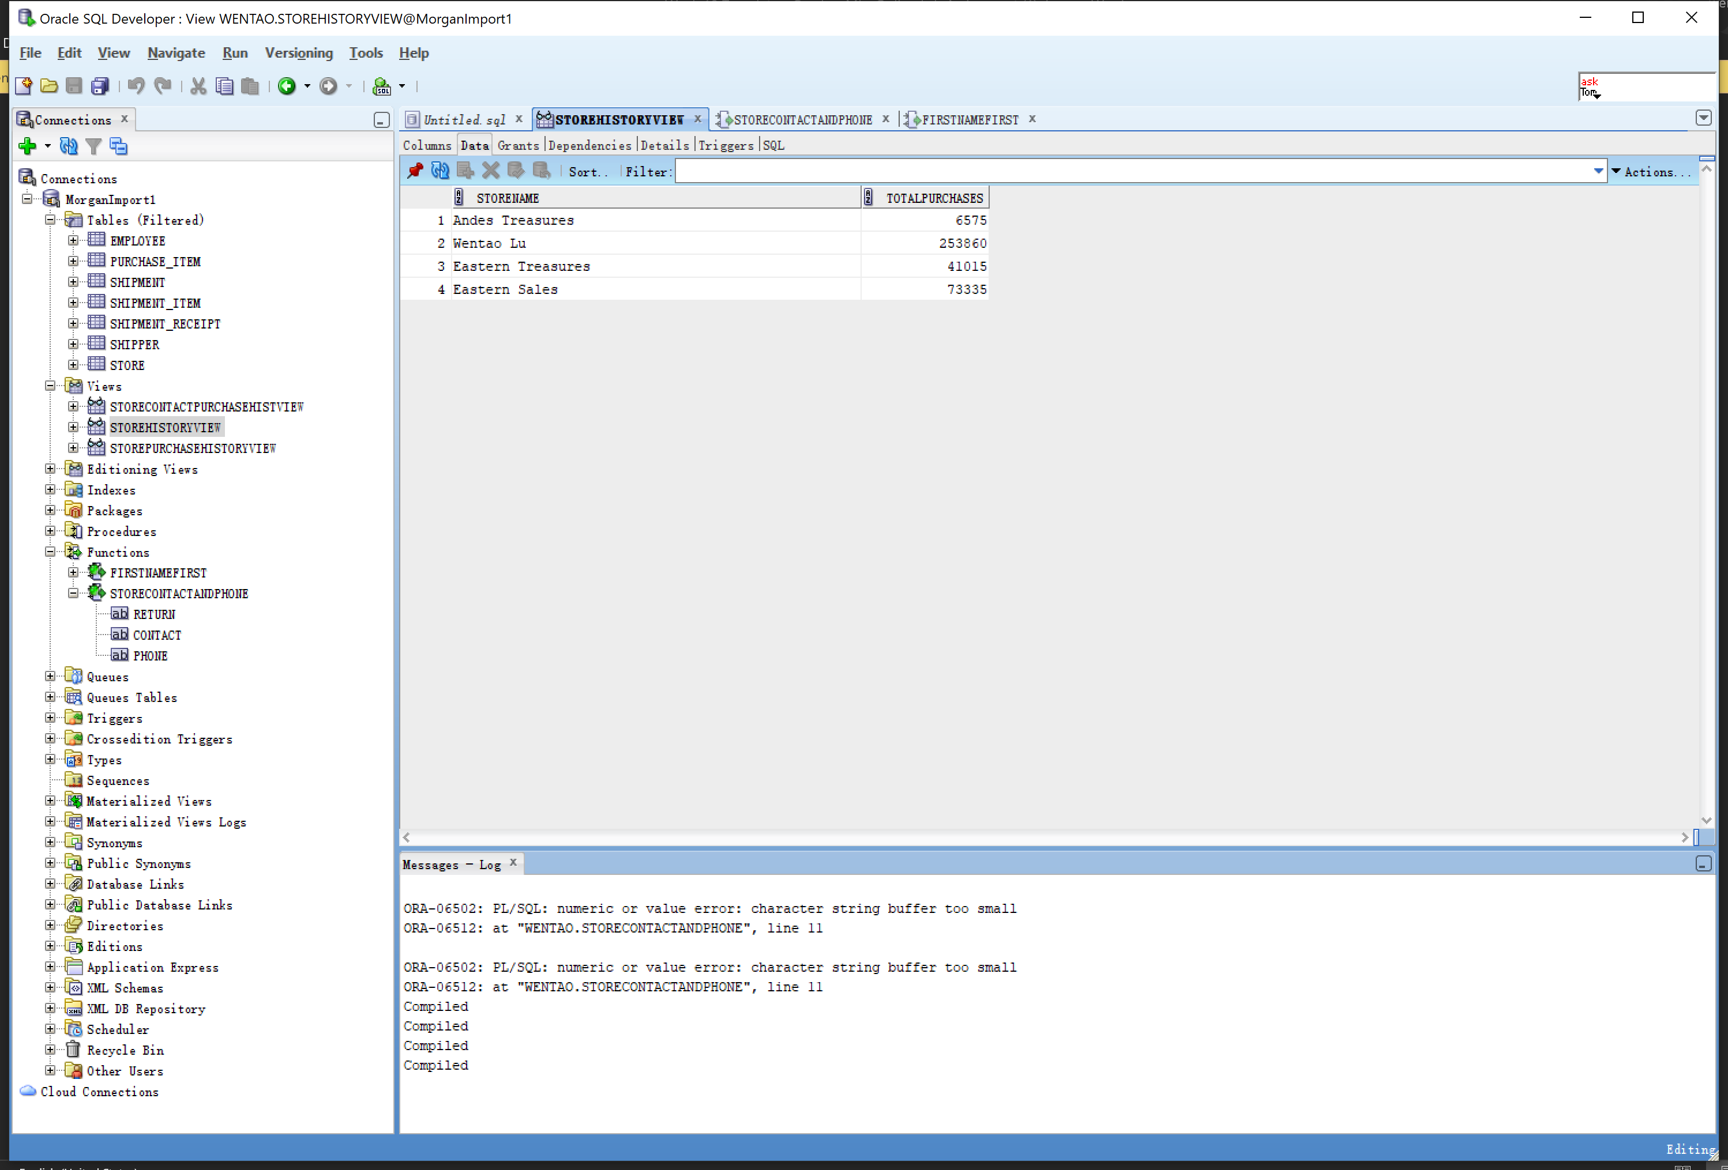

**Screen Shot #4B: Displaying the view SQL coding**

**Question R on page 422 of Chapter 7 (from the textbook – 15th edition)**

Display the SQL coding, through the View GUI dialog box. of the view **StoreHistoryView**. To accomplish this, right click on the view name in the object panel and from the pop-up menu, select the Edit option.

**NOTE**: This view uses records from a pre-existing view (i.e. StorePurchaseHistoryView)

**IMPORTANT –** Ensure that all tables and views and function are visible in the object panel of the Oracle SQL Developer screen

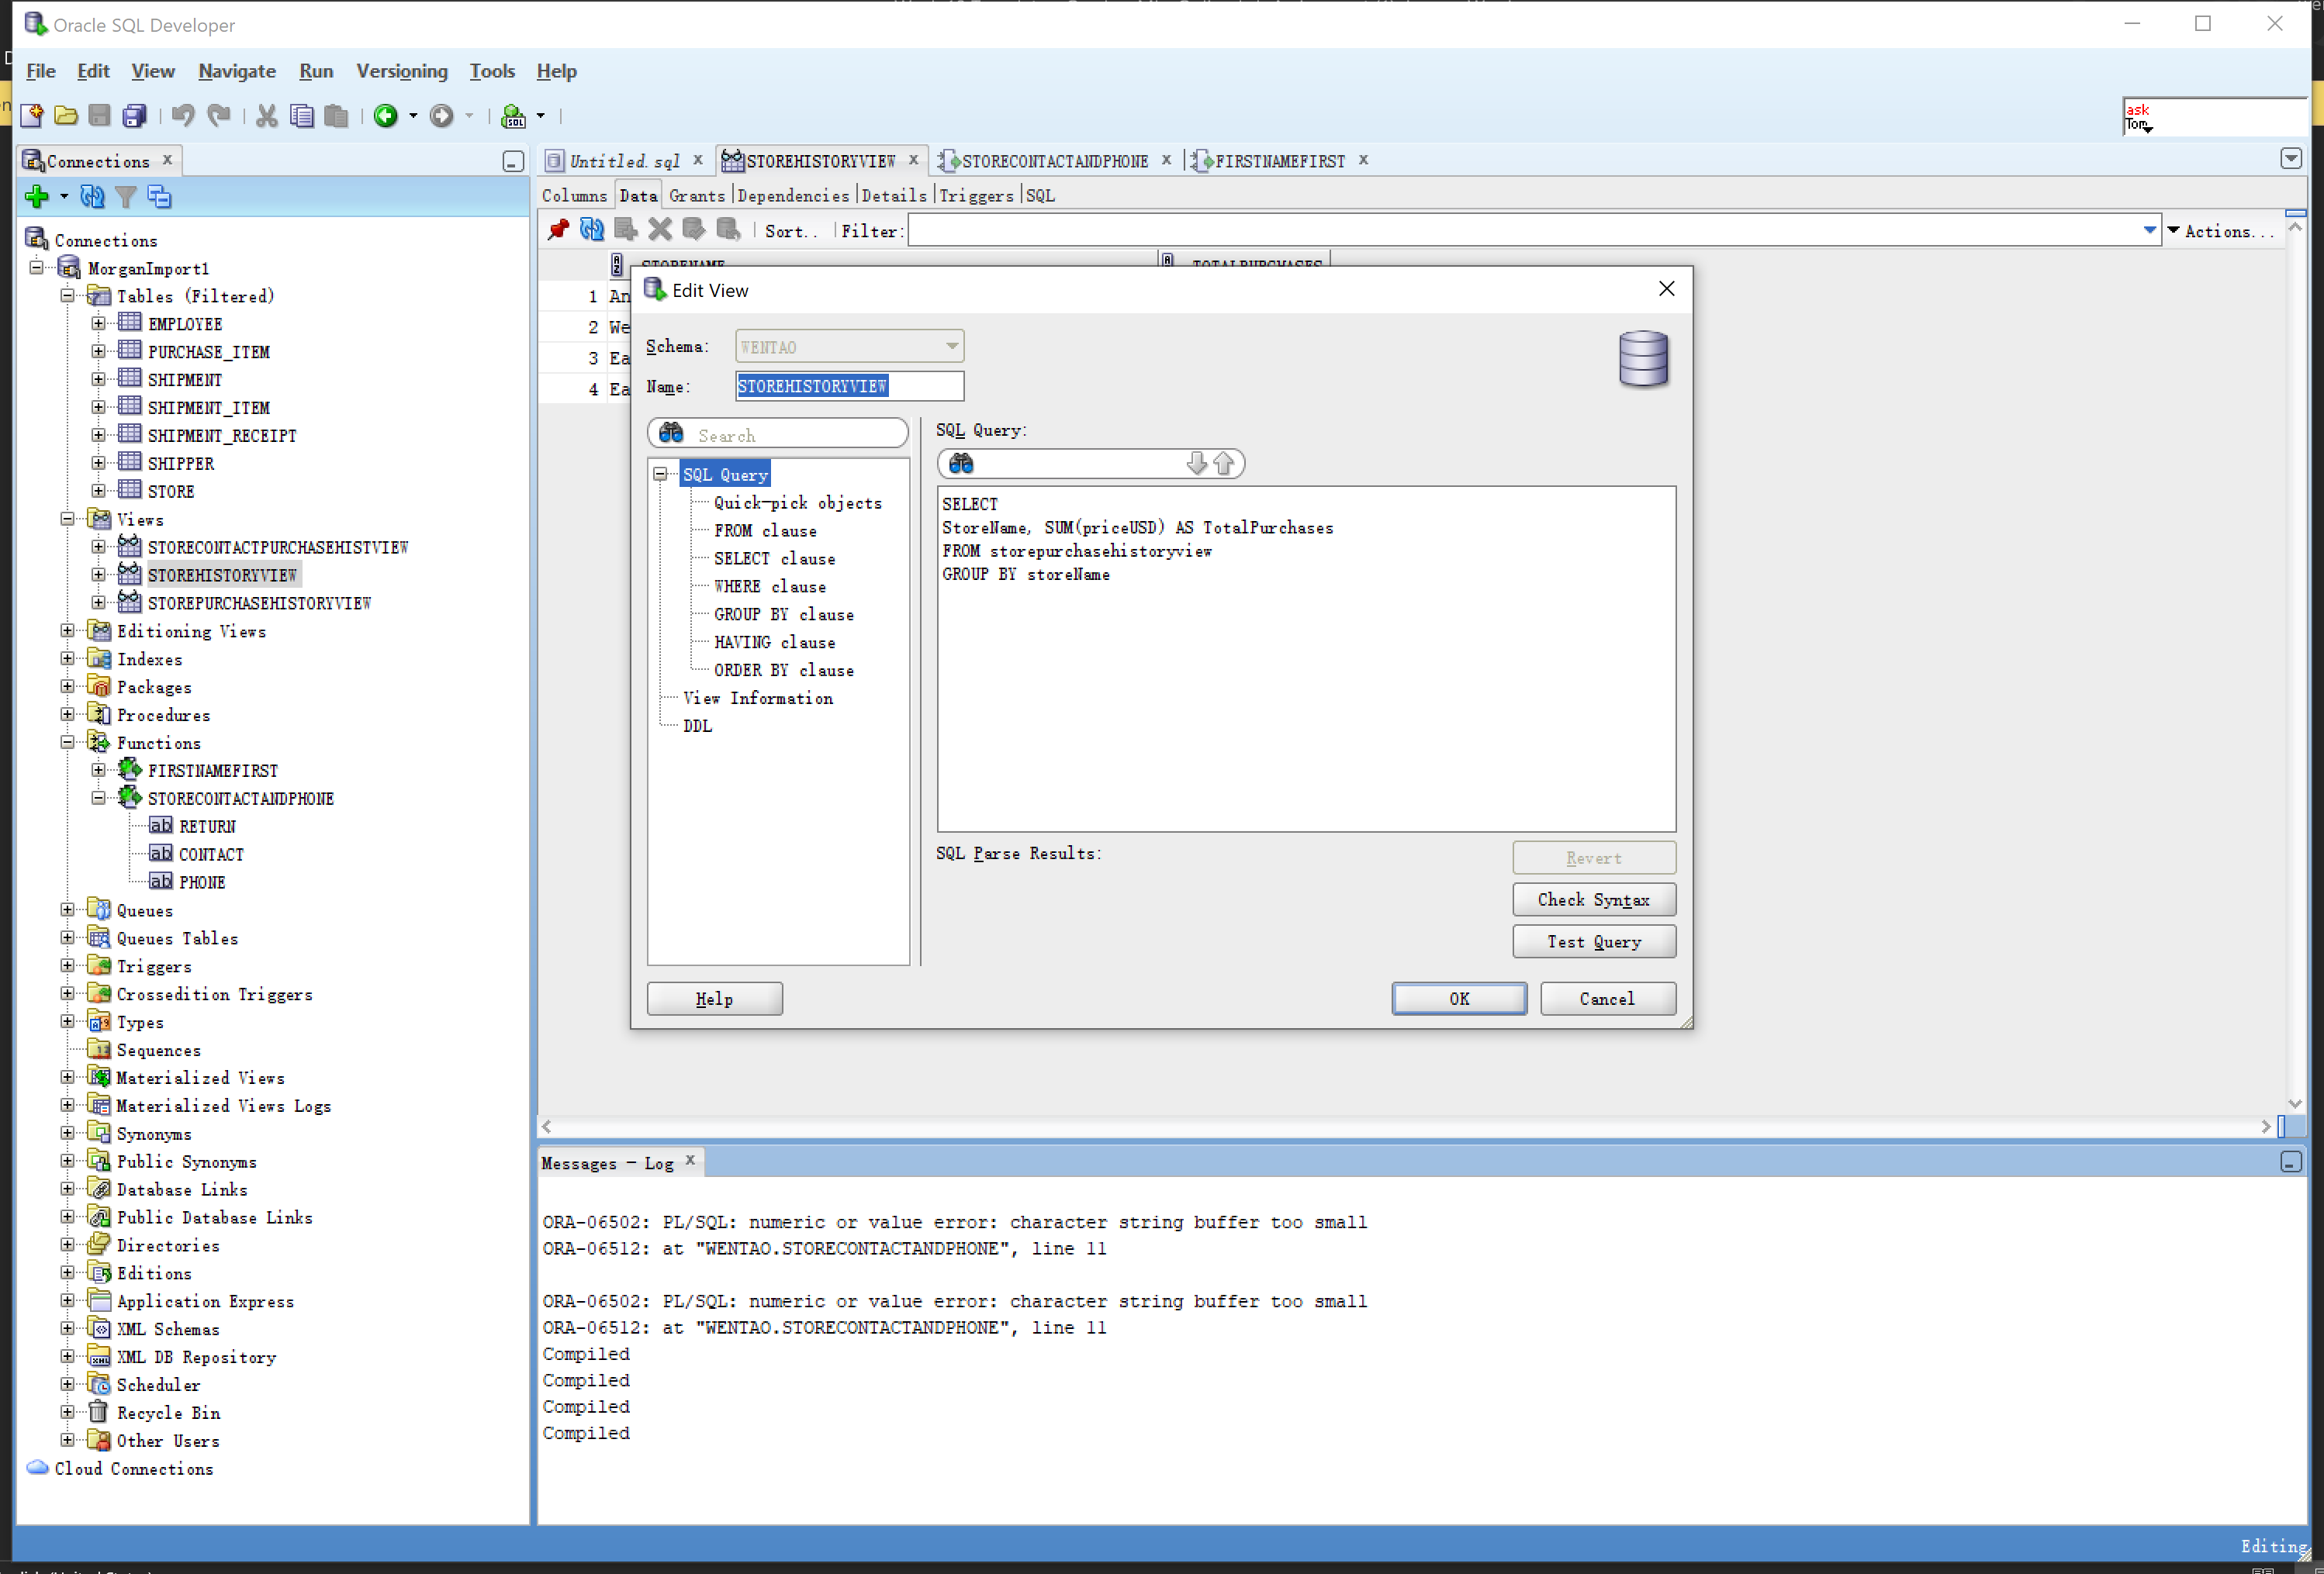

**Screen Shot #5A: Displaying view results**

**Question S on page 422 of Chapter 7 (from the textbook – 15th edition)**

Display the records produced by the view **MajorSources**. To accomplish this, left click on the view name in the object panel. From the query results panel on the right, select the “Data” tab.

**NOTE**: This view uses records from a pre-existing view (i.e. StoreHistoryView)

**IMPORTANT –** Ensure that all tables and views and function are visible in the object panel of the Oracle SQL Developer screen

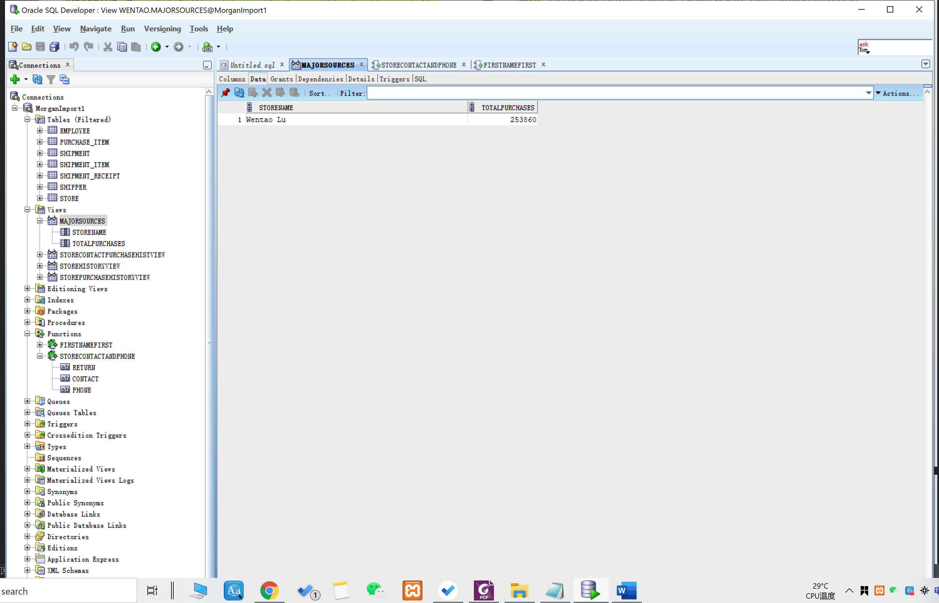

**Screen Shot #5B: Displaying the view SQL coding**

**Question S on page 422 of Chapter 7 (from the textbook – 15th edition)**

Display the SQL coding, through the View GUI dialog box. of the view **MajorSources**. To accomplish this, right click on the view name in the object panel and from the pop-up menu, select the Edit option.

**NOTE**: This view uses records from a pre-existing view (i.e. StoreHistoryView)

**IMPORTANT –** Ensure that all tables and views and function are visible in the object panel of the Oracle SQL Developer screen

