**Lab Assignment for Week #11 (VRG – MS SQL Server – Part 2)**

**(Project Questions from Chapter 7 and Online Chapter 10A of the textbook)**

**(NOTE: Screen shot examples in these instructions may be different than your screen shot values)**

**IMPORTANT IMPORTANT IMPORTANT**

**When executing the procedure InsertCustomerAndInterest (page 10A-108), ensure that the coding for the @NewLastName and @NewFirstName variables (which contain the name “Bench Michael”) has been changed to reflect your last and first name respectively**

**(DO NOT change any other data entries in the EXEC code).**

**IMPORTANT IMPORTANT IMPORTANT**

**Screen Shot #1: Displaying the TRANS table records. Read pages:**

**73 through 122 of online chapter 10A (from the textbook – 15th edition)**

**352 through 361 Chapter 7 (from the textbook – 15th edition)**

Display records (all columns) where the asking price equals $400 (in order to view the new transaction). Ensure that all tables, views and procedures are visible in the object panel on the left side of the screen display.

HINT: The new transaction (as a result of the procedures) will display as the last record with a Work ID value of “597”. NOTE: If the procedure was executed more than once, the WorkID value will be different.)

**IMPORTANT – Ensure that the records displayed are based on a query which sets the AskingPrice at $400.00.**

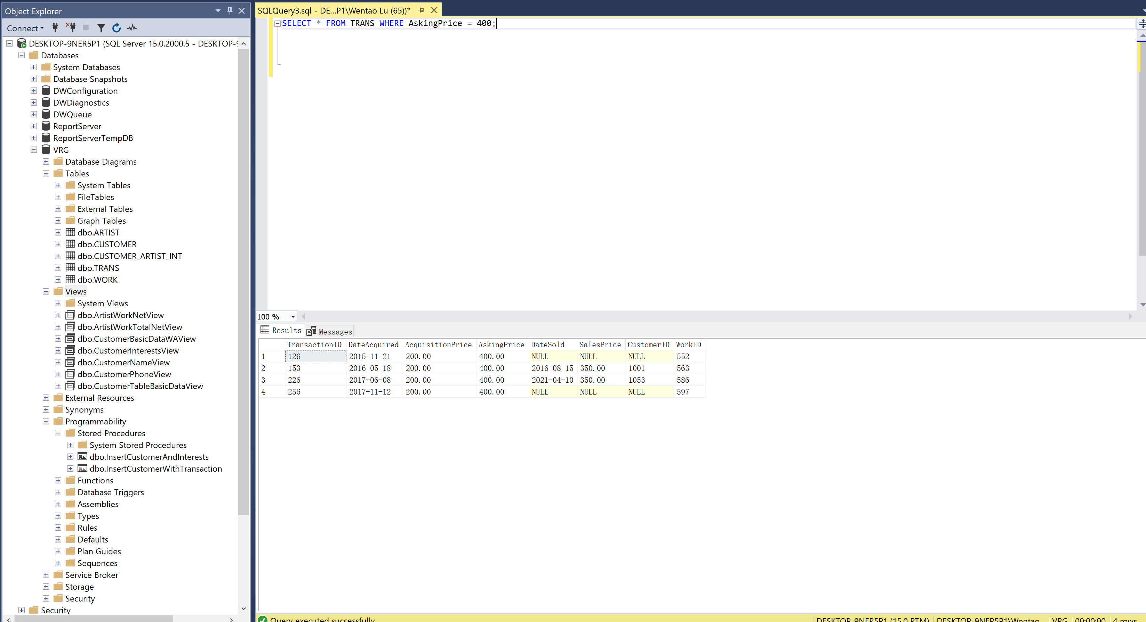

**Screen Shot #2: Displaying the WORK table records**

**Read pages:**

**73 through 122 of online chapter 10A (from the textbook – 15th edition)**

**352 through 361 Chapter 7 (from the textbook – 15th edition)**

**IMPORTANT IMPORTANT IMPORTANT**

**When executing the procedure InsertCustomerAndInterest (page 10A-108), ensure that the coding for the @NewLastName and @NewFirstName variables (which contain the name “Bench Michael”) has been changed to reflect your last and first name respectively**

**(DO NOT change any other data entries in the EXEC code).**

**IMPORTANT IMPORTANT IMPORTANT**

Display records (all columns) where the title of the work of art is “Spanish Dancer”. ). Ensure that all tables, views and procedures are visible in the object panel on the left side of the screen display.

HINT: The latest transaction (as a result of the procedures) will display as the last record with a Work ID value of “597”. (NOTE: If the procedure was executed more than once, the WorkID value will be different.)

**IMPORTANT – Ensure that the records displayed are based on a query which sets the Title as “Spanish Dancer”.**

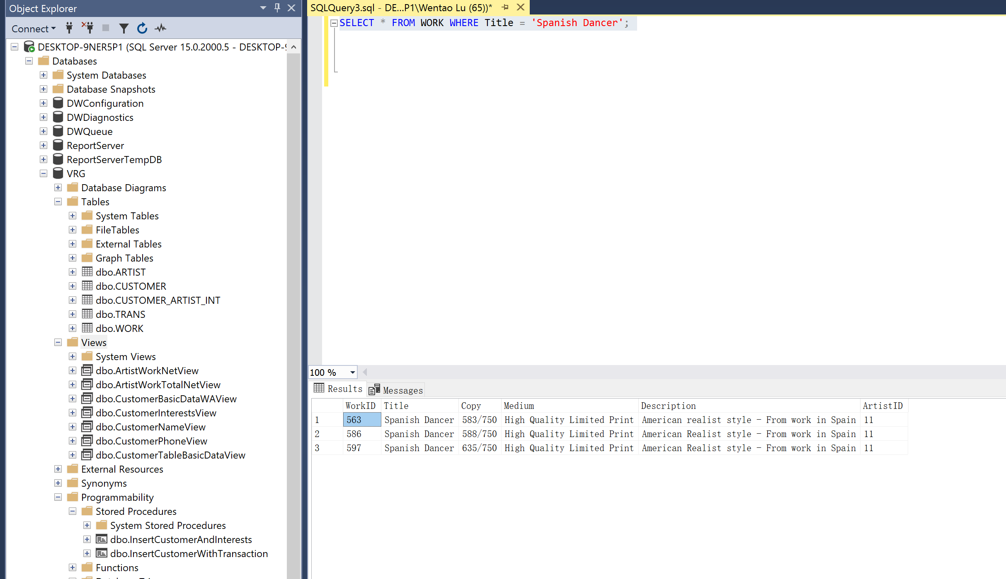

**Screen Shot #3: Displaying the CUSTOMERINTERESTSVIEW records**

**Read pages:**

**73 through 122 of online chapter 10A (from the textbook – 15th edition)**

**352 through 361 Chapter 7 (from the textbook – 15th edition)**

**IMPORTANT IMPORTANT IMPORTANT**

**When executing the procedure InsertCustomerAndInterest (page 10A-108), ensure that the coding for the @NewLastName and @NewFirstName variables (which contain the name “Bench Michael”) has been changed to reflect your last and first name respectively**

**(DO NOT change any other data entries in the EXEC code).**

**IMPORTANT IMPORTANT IMPORTANT**

Display **only three records**: two for Michael Bench (which has been changed to your name) and the record for Melinda Bench (whose last name has been changed from Gliddens to Bench as a result of executing the trigger CIV_ChangeCustomerLastName). ). Ensure that all tables, views and procedures are visible in the object panel on the left side of the screen display.

**NOTE**: display only the columns CustomerLastName, CustomerFirstName and ArtistName.

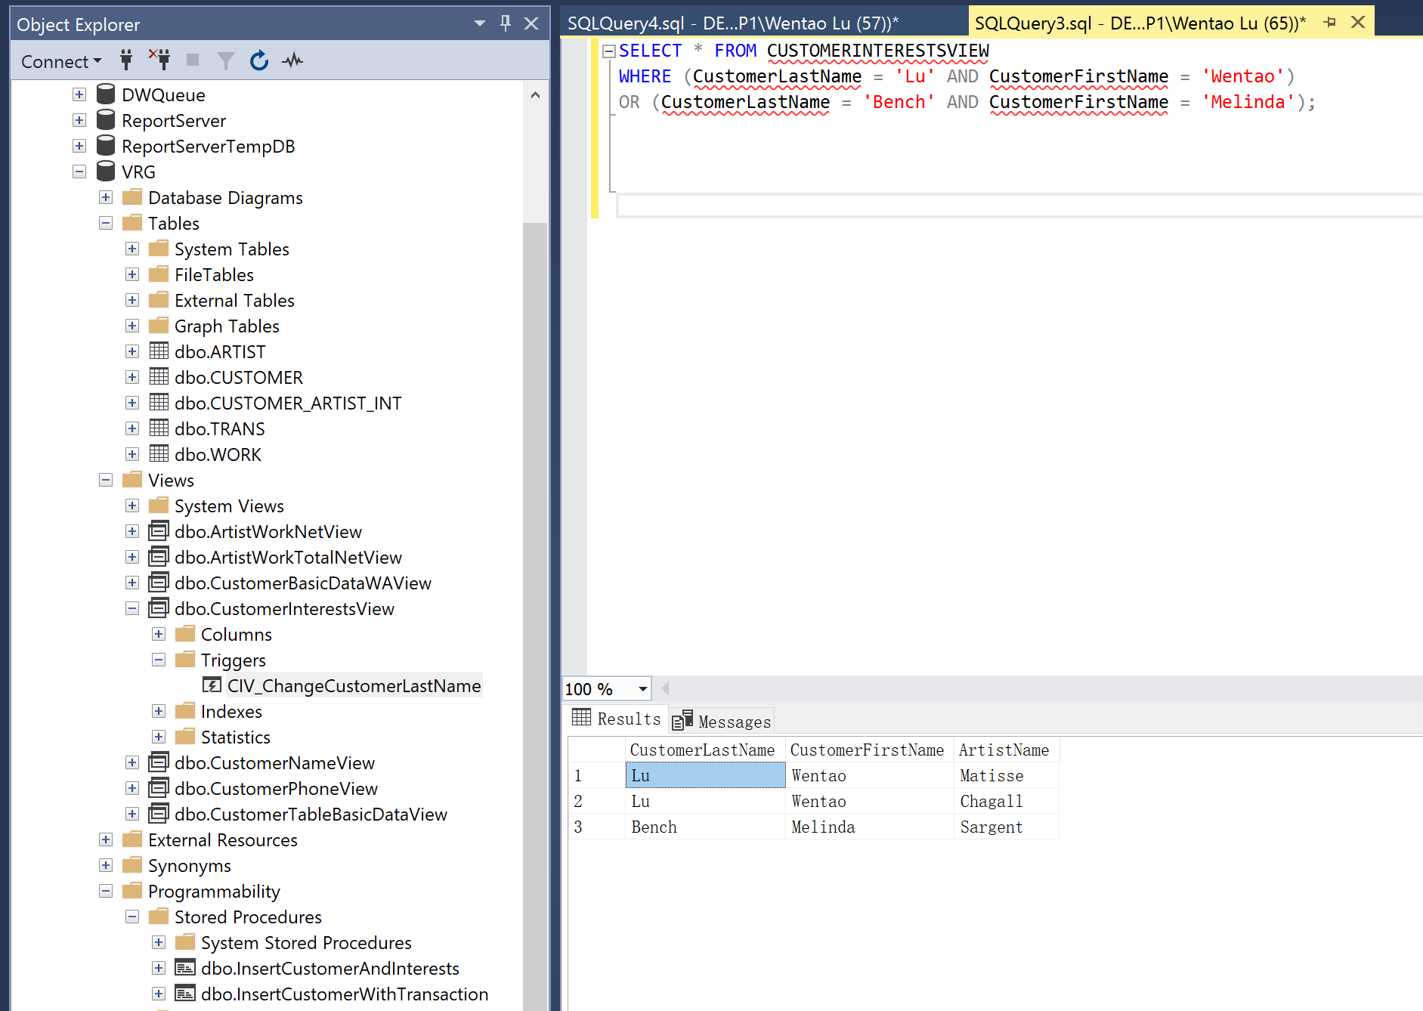

**Screen Shot #4: Displaying the CUSTOMERPHONEVIEW records**

**Read pages:**

**73 through 122 of online chapter 10A (from the textbook – 15th edition)**

**352 through 361 Chapter 7 (from the textbook – 15th edition)**

**IMPORTANT IMPORTANT IMPORTANT**

**When executing the procedure InsertCustomerAndInterest (page 10A-108), ensure that the coding for the @NewLastName and @NewFirstName variables (which contain the name “Bench Michael”) has been changed to reflect your last and first name respectively**

**(DO NOT change any other data entries in the EXEC code).**

**IMPORTANT IMPORTANT IMPORTANT**

Display **only two records**: one for Michael Bench (which has been changed to your name) and the other record for Melinda Bench (whose last name has been changed from Gliddens to Bench as a result of executing the trigger CIV_ChangeCustomerLastName). ). Ensure that all tables, views and procedures are visible in the object panel on the left side of the screen display.

**NOTE**: display only the columns CustomerLastName, CustomerFirstName and CustomerPhone

**IMPORTANT – Ensure that the CustomerPhone values include a space after the right bracket used for the area code – Example: (613) 123-4567.**

