**Lab Assignment for Week #12 (HSD – MS SQL Server)**

**(Project Questions from Chapter 12 of the textbook)**

**(NOTE: Screen shot examples in these instructions may be different than your screen shot values)**

**Screen Shot #1: Displaying the view contents**

**Read pages 588 through 617 of Chapter 12 (from the textbook – 15th edition)**

**IMPORTANT IMPORTANT IMPORTANT**

**When populating the CUSTOMER table in the HSD database, ensure that the customer “Able, Ralph” has been changed to reflect your last and first name respectively**

**(DO NOT change any other column values).**

**IMPORTANT IMPORTANT IMPORTANT**

**IMPORTANT: Ensure that the view HSDDWTOTALSALESVIEW is visible in the object panel on the left and that the records of the view are visible in the SQL query panel on the right. The records containing your name must be visible in the screen shot.**

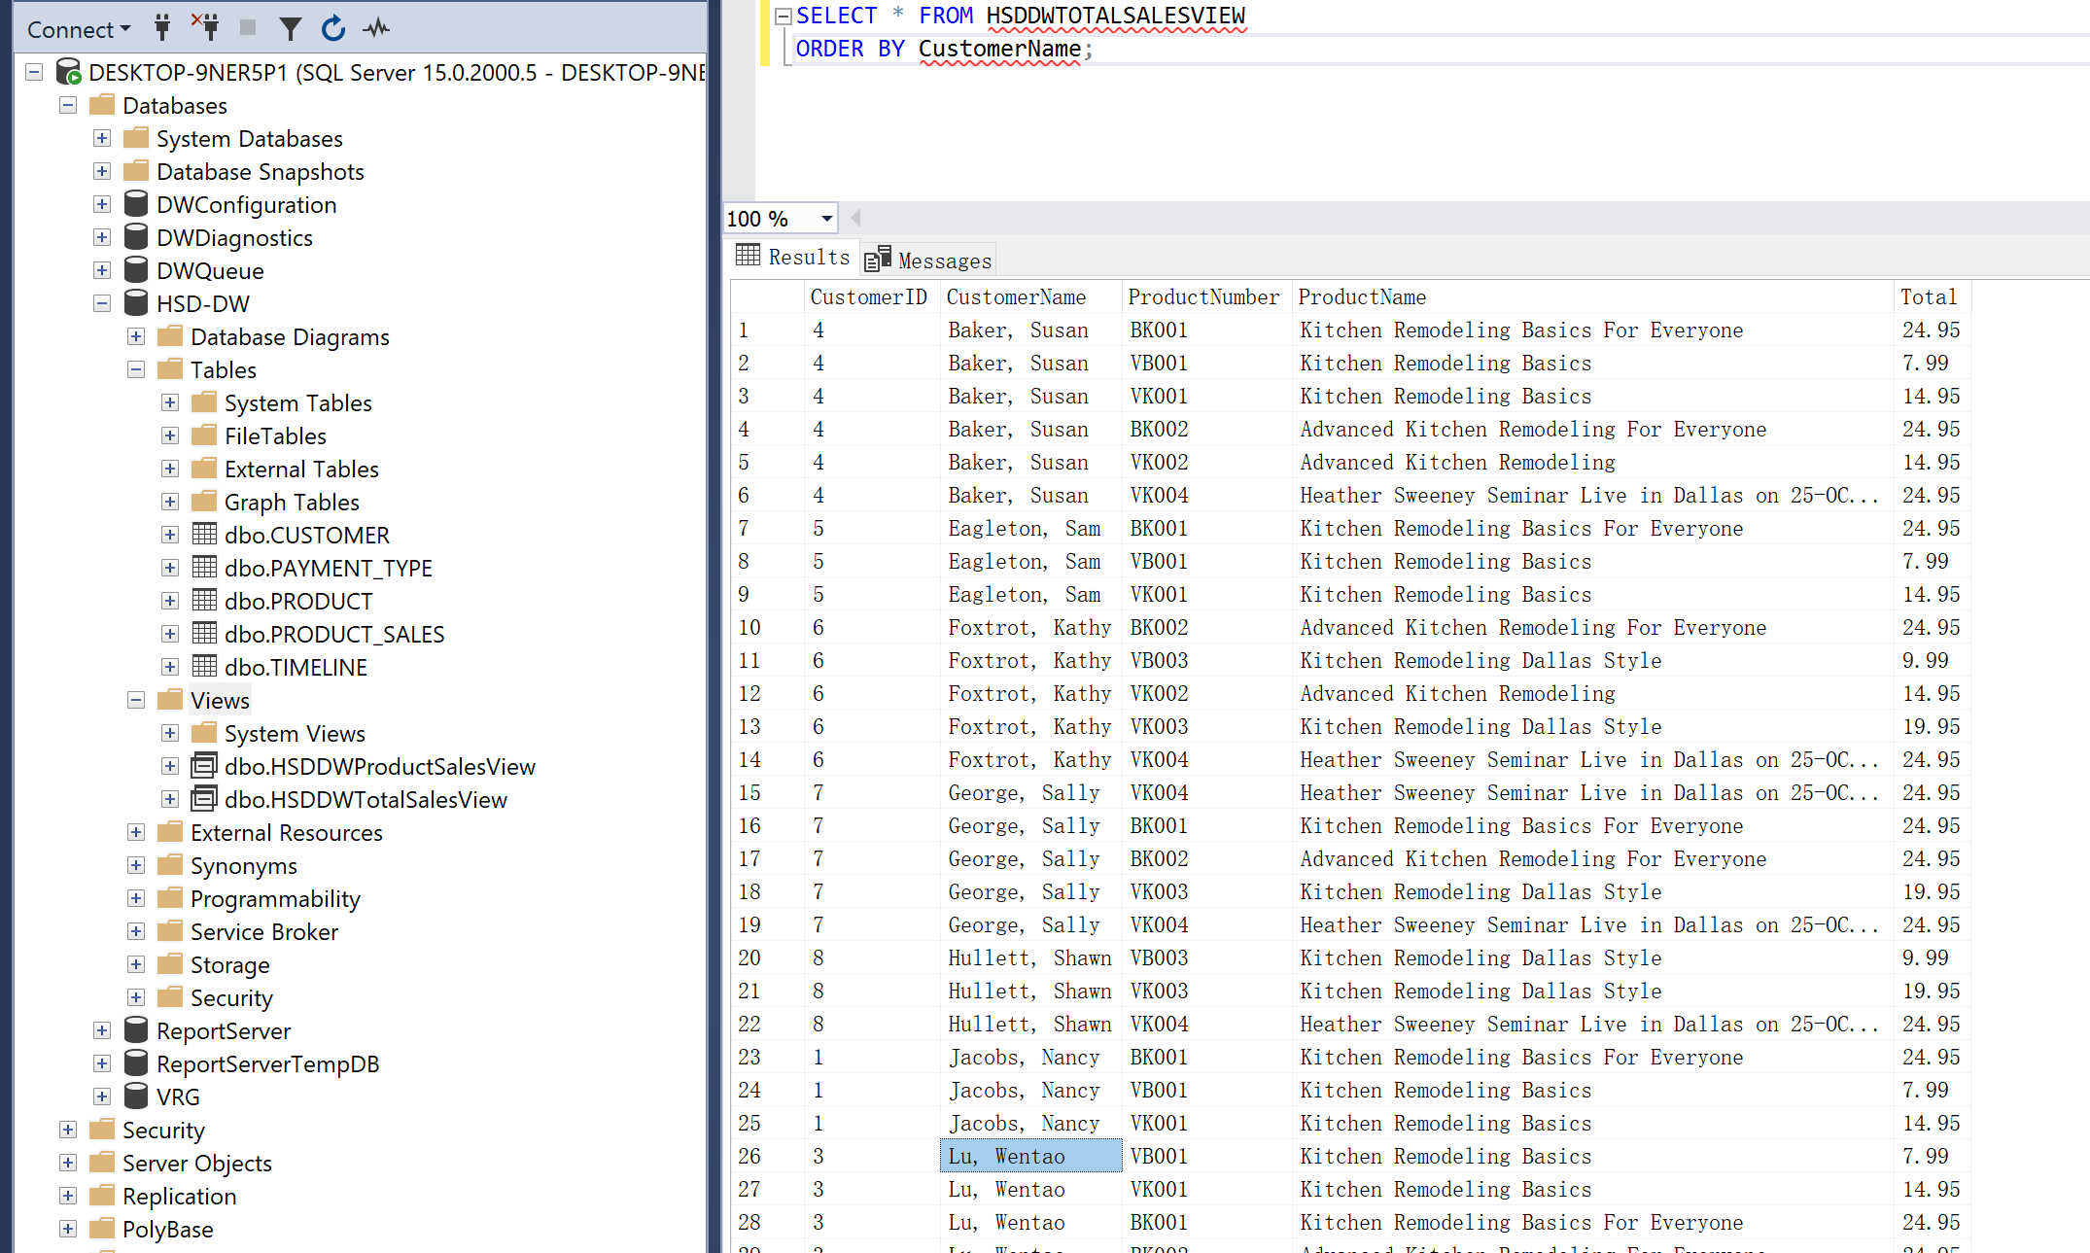

**Screen Shot #2: Displaying the pivot table**

**Read pages 588 through 617 of Chapter 12 (from the textbook – 15th edition)**

Display the Excel pivot table (similar to the screen shot below).

**IMPORTANT – Ensure that the pivot table addresses the following six points (please view the example for the lab assignment):**

1. **Pivot table has appropriate colour scheme (your choice)**
2. **All header cells labelled appropriately (for the Customer and Product columns)**
3. **Product and Customer filter buttons are functional**
4. **All cells with numerical values are in Currency format (Hint: you DO NOT type in the dollar sign nor decimal point)**
5. **All values and titles are centered horizontally and vertically**
6. **All columns (except the Customer column) are of equal width**

**IMPORTANT: Ensure that the complete pivot table is visible in the screen shot. The row containing your name must be visible in the screen shot.**

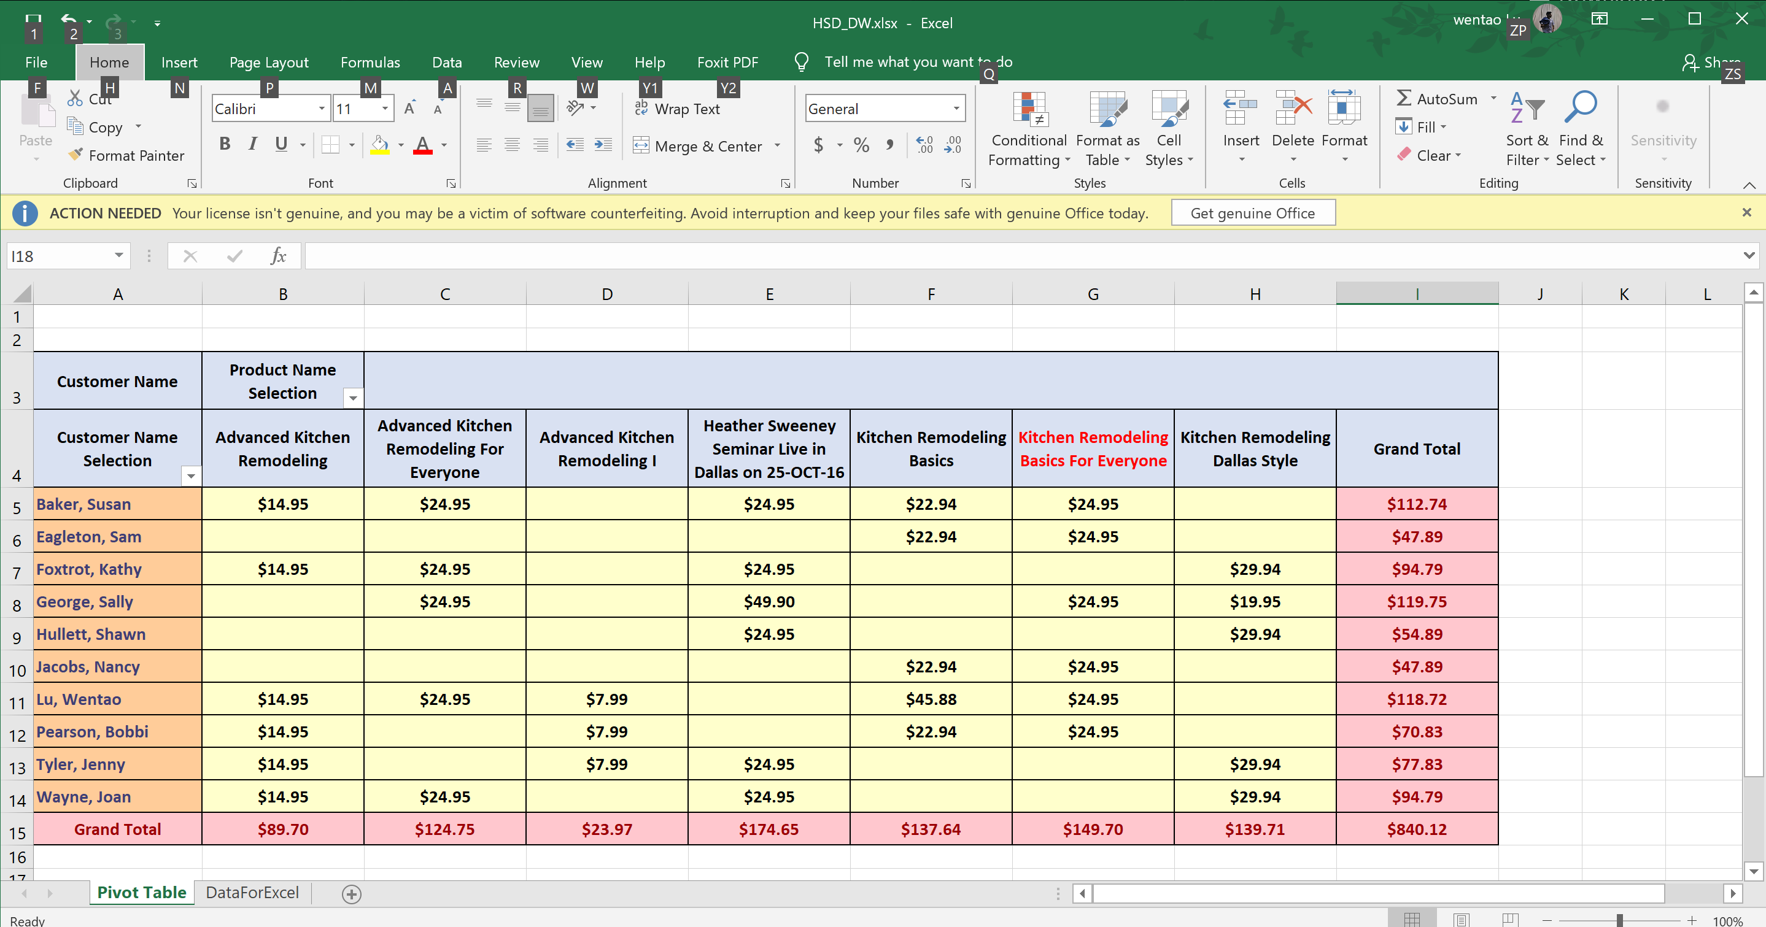

**Screen Shot #3: Displaying the pivot table with the Product and Customer filters activated**

**Read pages 588 through 617 of Chapter 12 (from the textbook – 15th edition)**

Display the Excel pivot table, with the Customer and Product filters being used, such that:

* The following customers are displayed:
  + Your name (originally Able, Ralph)
  + Foxtrot, Kathy
  + Tyler, Jenny
* The following products are displayed:
  + All product titles beginning with the word “Advanced” (3 product titles).

**IMPORTANT – Ensure that the filtered pivot table addresses the following six points (please view the example provided for the lab assignment - referred to in screen shot #1):**

1. **Pivot table has appropriate colour scheme (your choice)**
2. **All header cells labelled appropriately**
3. **Product and Customer filter buttons are functional**
4. **All cells with numerical values are in Currency format (Hint: you DO NOT type in the dollar sign nor decimal point)**
5. **All values and titles are centered horizontally and vertically**
6. **All columns (except the Customer column) are of equal width**

