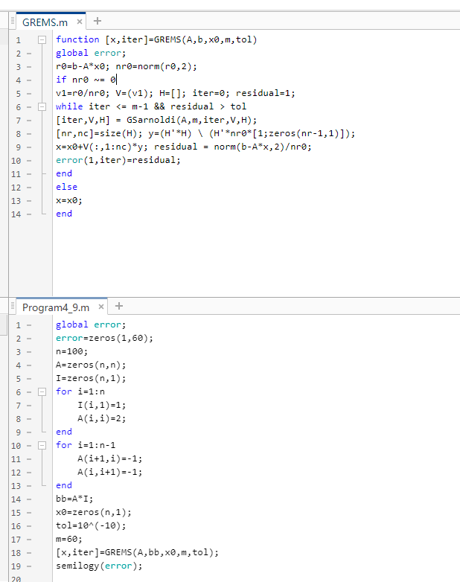

There is a drop in iteration 48, which mean the Krylov space in that iteration can contain the optimal solution.