1. Introduction
Here, we present a new public dynamic code by Python, which will be a post-processing toolbox of LitMod2D_2.0 to calculate the dynamic topographic effect of the lithosphere and upper mantle. The code uses mixed grid and staggered finite differences methods and the marker-in-cell technique (SFD-MIC) to solve the 2D incompressible stokes equations. It could calculate the velocity, stress, and strain rate distributions along our profile. The stress transmitted to the surface can be related to the dynamic topography that together with the upper mantle composition will allow us to infer the dynamic processes of the region.

2. Governing equations
Momentum equation:
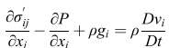
Newtonian fluid:
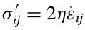
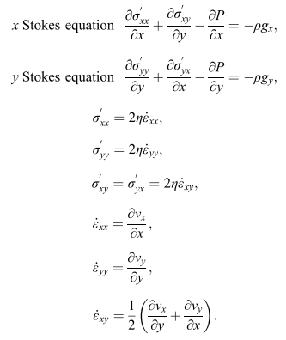

Thus, the Stokes equations simplify to:
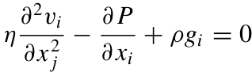

Incompressible continuity equation :

3. Initial model and Boundary condition
The initial model structure, including geophysical and petrological structure, is got from LitMod2D_2.0.
Free slip is adopted for the all velocity condition.

gx, gy, pfrist

marker(xm, ym):
rock_m, density_m, viscosity_m, mkk, mTT,

node() for stokes equtions
rock, density, viscosity, kk, TT,

centre of mesh(xx, yy)

