Bryce Montano

Project 4

## Introduction

**Output from myURLS.pages**

|  |  |  |  |
| --- | --- | --- | --- |
| **Page RTT(ms)** | **PLT: no TFO (s)** | **PLT: TFO (s)** | **Improvement** |
| http://www.omscs.gatech.edu/cs-6460-educational-technology | | | |
| 200 | 10551.557 | 7778.537 | 26.2806711844 |
| 100 | 6934.997 | 5318.198 | 23.3136221977 |
| 20 | 4757.641 | 4510.191 | 5.20110701921 |
| http://www.brycemontano.com | | | |
| 200 | 11748.727 | 897.829 | 92.3580741982 |
| 100 | 1121.89 | 486.444 | 56.6406688713 |
| 20 | 307.606 | 175.899 | 42.8167851082 |
| http://www.talrealty.com | | | |
| 200 | 2771.725 | 1472.181 | 46.885748045 |
| 100 | 1579.22 | 896.11 | 43.2561644356 |
| 20 | 627.198 | 465.357 | 25.8038131499 |

As indicated in the output above, the improvement from TCP Fast Open (TFO) is rather dramatic especially on BryceMontano.com & TalRealty.com where improvement ranged between 42-92% and 24-46% respectively.

## http://www.omscs.gatech.educs-6460-educational-technology

1. **What effect does TFO have on the timing?**
   1. TFO on the 6460 course site provided significant improvement when implementing a 200 and 100 ms delay but on a 20 ms delay, the improvements were less substantial with just a 5% improvement over non-TFO connections.
2. **How does the RTT value affect these results?**
   1. The higher the RTT the greater the improvement in page load time (PLT) TFO connections.
3. **Does the particular content available at this URL lend itself to performance enhancements provided by TFO?** 
   1. For the most part, yes. The reason I say this is while TFO definitely provides a performance enhancement for this particular website, because some of it’s content is distributed across different domains such as it’s style sheets which are being pulled in from bootstrapcdn.com as well as a Google Analytics script which requires a connection to be established with the client and then data is sent to the Google Analytics API.
4. **Were these results surprising in any way?**
   1. They were around what I expected to be given that the paper stated that page load times would increase anywhere from 10-40%. The results I observed were within these ranges. I was also surprised by the small 5% performance increase with the 20 ms RTT. I am wondering if this is due to the fact of javascript assets that needed to be loaded. This could also be due to a few anomalies within the test. See the figure below which shows a few tests towards the top which show longer than normal request times for TFO enabled.

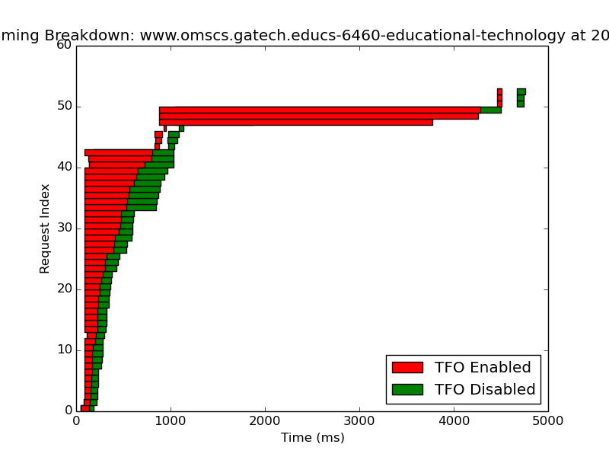

## http://www.BryceMontano.com

1. **What effect does TFO have on the timing?**
   1. TFO on BryceMontano.com provided a remarkable improvement when utilizing a 200 ms RTT delay which provided a 92.3% improvement. Even with smaller RTT’s of 100 & 20, their performance improvements were both outside of the normal range of improvements observed in the *TCP Fast Open* paper.
2. **How does the RTT value affect these results?**
   1. Again, the higher the RTT the greater the improvement in page load time (PLT) TCP TFO connections. However, it is worth nothing that the difference between 20ms RTT and 100 ms RTT is much smaller than the difference between 200 ms to 100 ms.
3. **Does the particular content available at this URL lend itself to performance enhancements provided by TFO?** 
   1. Similar to the OMSCS site, BryceMontano.com includes a javascript file, and a CSS file from a different domain, which is not great for TCP TFO but I don’t think it hurting the overall PLT for BryceMontano.com especially because there were little no assets to load on the page other than some fonts.
4. **Were these results surprising in any way?**
   1. Not necessarily especially since there were few assets to load and the overall size of the site is extremely small.

## http://www.talrealty.com

1. **What effect does TFO have on the timing?**
   1. TFO again provided significant performance increases on TalRealty.com especially with the 200 and 100 ms RTT.
2. **How does the RTT value affect these results?**
   1. The 200 ms and 100 ms RTT provided significant performance increases with 46% and 43% improvements respectively.
3. **Does the particular content available at this URL lend itself to performance enhancements provided by TFO?** 
   1. I believe so especially because so much of the content resides on TalRealty.com with the exception of some font and jquery libraries which are being hosted on different domains.
4. **Were these results surprising in any way?**
   1. Yes especially because though the OMSCS site had to resolve much more assets such as images, .js files, all of those assets reside within the same domain. I still would have thought that the results on [www.talrealty.com](http://www.talrealty.com) would have been similar to those on OMSCS.

## Summary of findings

TFO helped improve page load times dramatically, especially when RTT is high. Whereas with smaller RTT’s (which indicate smaller network latency times), the performance improvements were much smaller. Furthermore I believe that due to running this software within a VM, over a wireless connection accounted for some irregularity and non-ideal conditions. I also noticed that many times the software would hang and even after restarts would not run again. I would have to restart my computer, do a completely new git clone and start over. This could indicate the software is not 100% rid of bugs.