Bryce Montano

Project 5 Analysis

## Figures

### Figure A – Average throughput in all 3 tests

(Note: All three experiments include a 512 KB buffer size)

### Figure B - MPTCP WIFI + 3G results

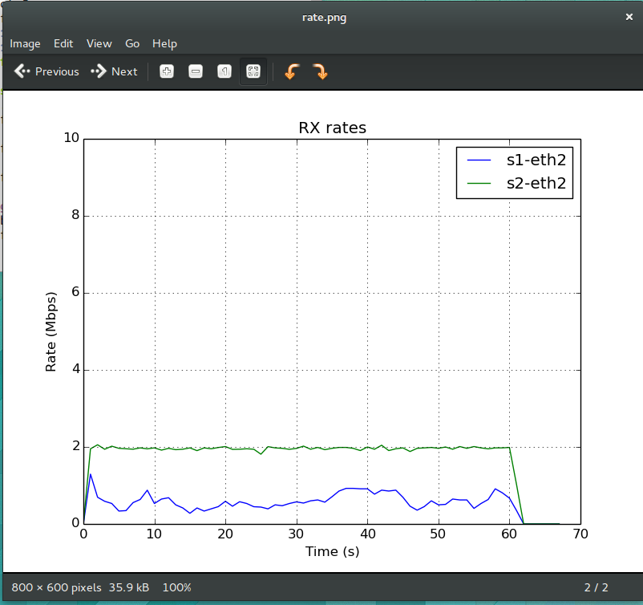

Figure C - TCP Wifi Results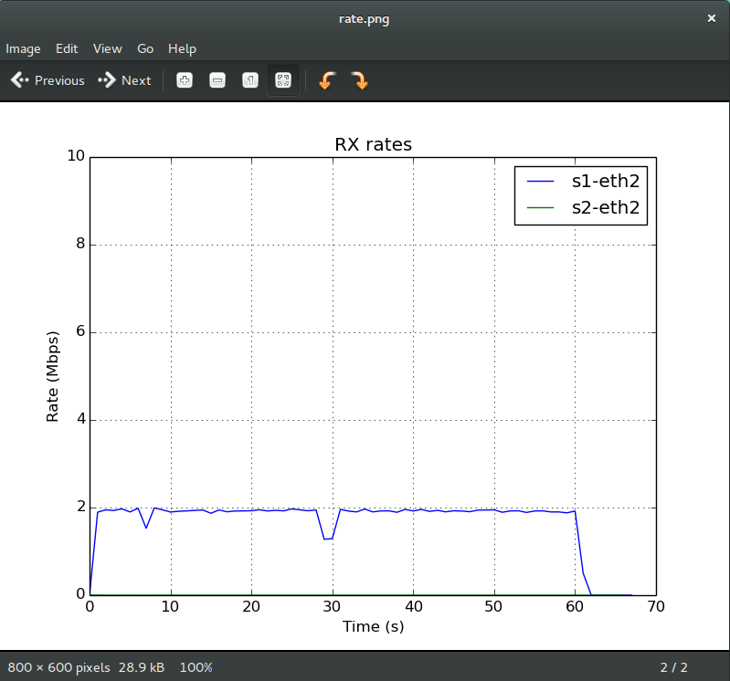

### Figure D - 3G Results

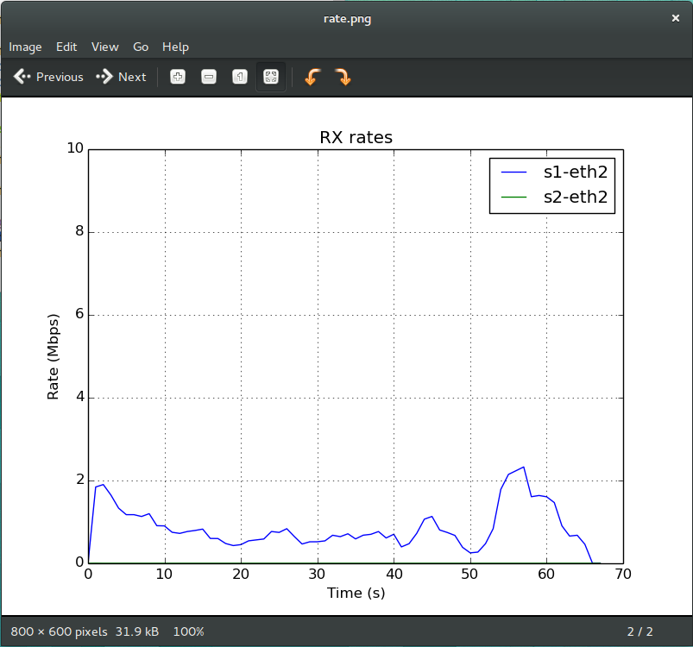

## Analysis

Each of the 3 topologies performed about as well as expected with the exception of the TCP 3G topology which consistently hovered under the 2 MB /S throughput that was allocated for it. This could be due to running the experiment on a VM rather than on actual hardware though the results I observed seem in the ballpark of those observed in the paper. Furthermore the paper does reference being directly connected to server via a gigabit link which could account for the discrepancy.

Obviously, MPTCP WIFI +3G had the best performance as it was able to utilize both the TCP 3G and TCP Wifi connections in concurrence. This of course brought significant performance increases (40% increase with the addition of the 3G connection to the TCP Wifi connection). Similarly there is an almost 400% performance increase from TCP 3G to MPTCP Wifi +3G due to the addition of the TCP Wifi connection.

Similar to the results found in the paper, the MPTCP Wifi +3G experiment never underperformed when compared to the results of the TCP Wifi (standalone) or TCP 3G (standalone). The overall average speed increases were roughly the same as those found in the paper as well with MPTCP Wifi +3G achieving almost 3MB /S throughput rates.

Considering the deployment requirements raised in the paper and based on the results found in my experiments, I do think MPTCP would be worth the hurdles needed to overcome during the implementation of this technology. When you look at performance increases ranging from 40-200% (depending upon the type of TCP connection added), there is indeed considerable benefit from the additional connection(s). However, as mentioned in the paper - memory issues due to the network sending and resending packets out of-order, complexity of dealing with added latency due to generating server keys, relying on middleboxes to accurately forward TCP headers, and relying on smartphone buffer sizes to continue increasing in order for performance increases to continue to grow - are all real issues that could take considerable time, resources and effort to overcome. Never mind the fact that multi-homing (as used in MPTCP) is of course a violation of the end-to-end principal and was not considered in the original design of the internet. Still given these constraints, MPTCP benefits seem to outweigh its risks / costs especially when you consider the benefits it can provide to Smartphones all of which now days incorporate at least 2 different communication interfaces.