Project plan document

- General
This document lists items of project we will complete in 1-2 weeks

- Project plan

2.1 update during 20170911-20170915

Figure 1 shows the workflow of gpsCalibration in iMorpheusAI.

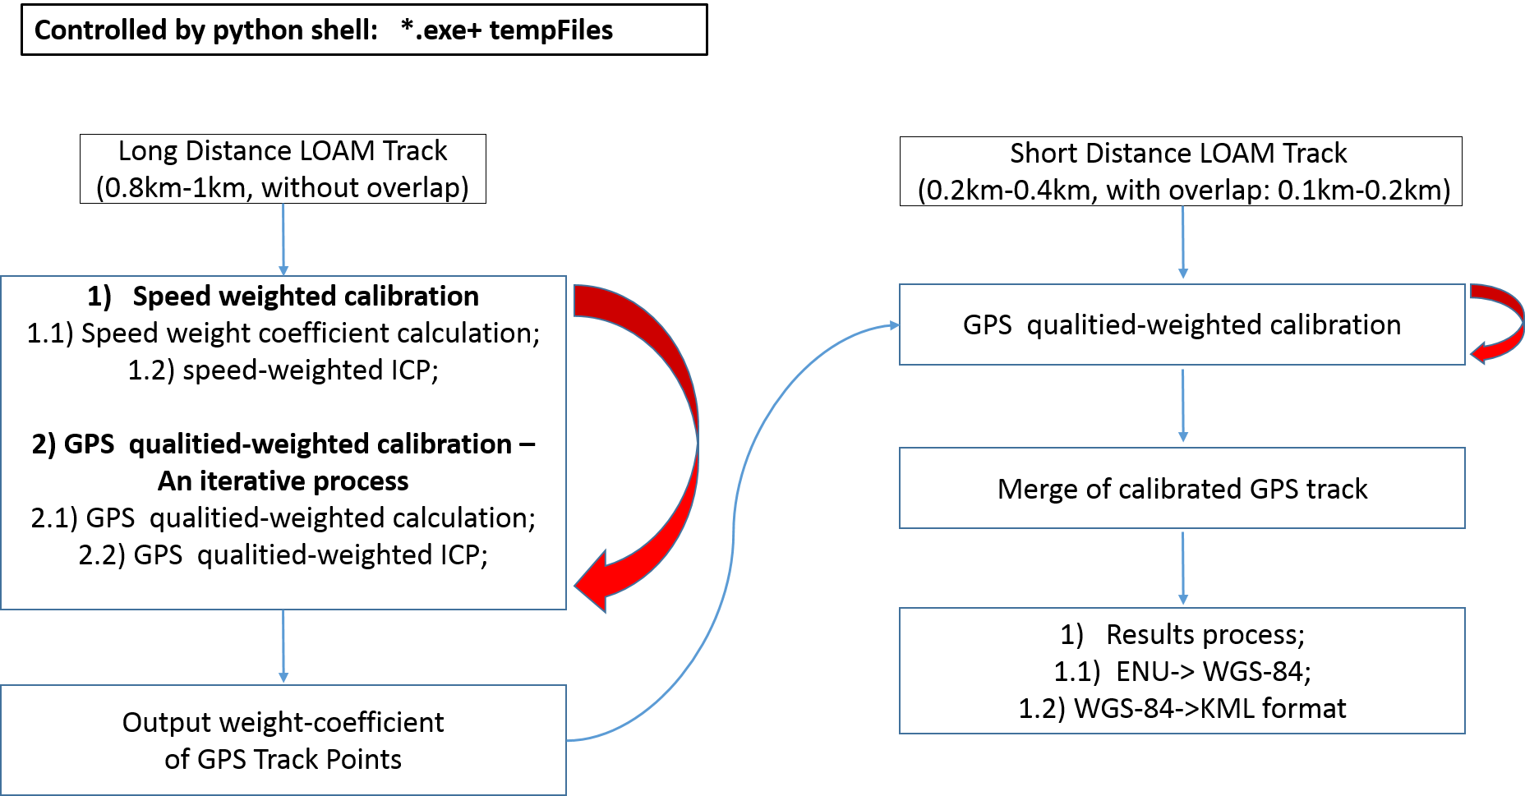

Figure 2 shows workflow we are focusing on. We think these will be done in 2 weeks.

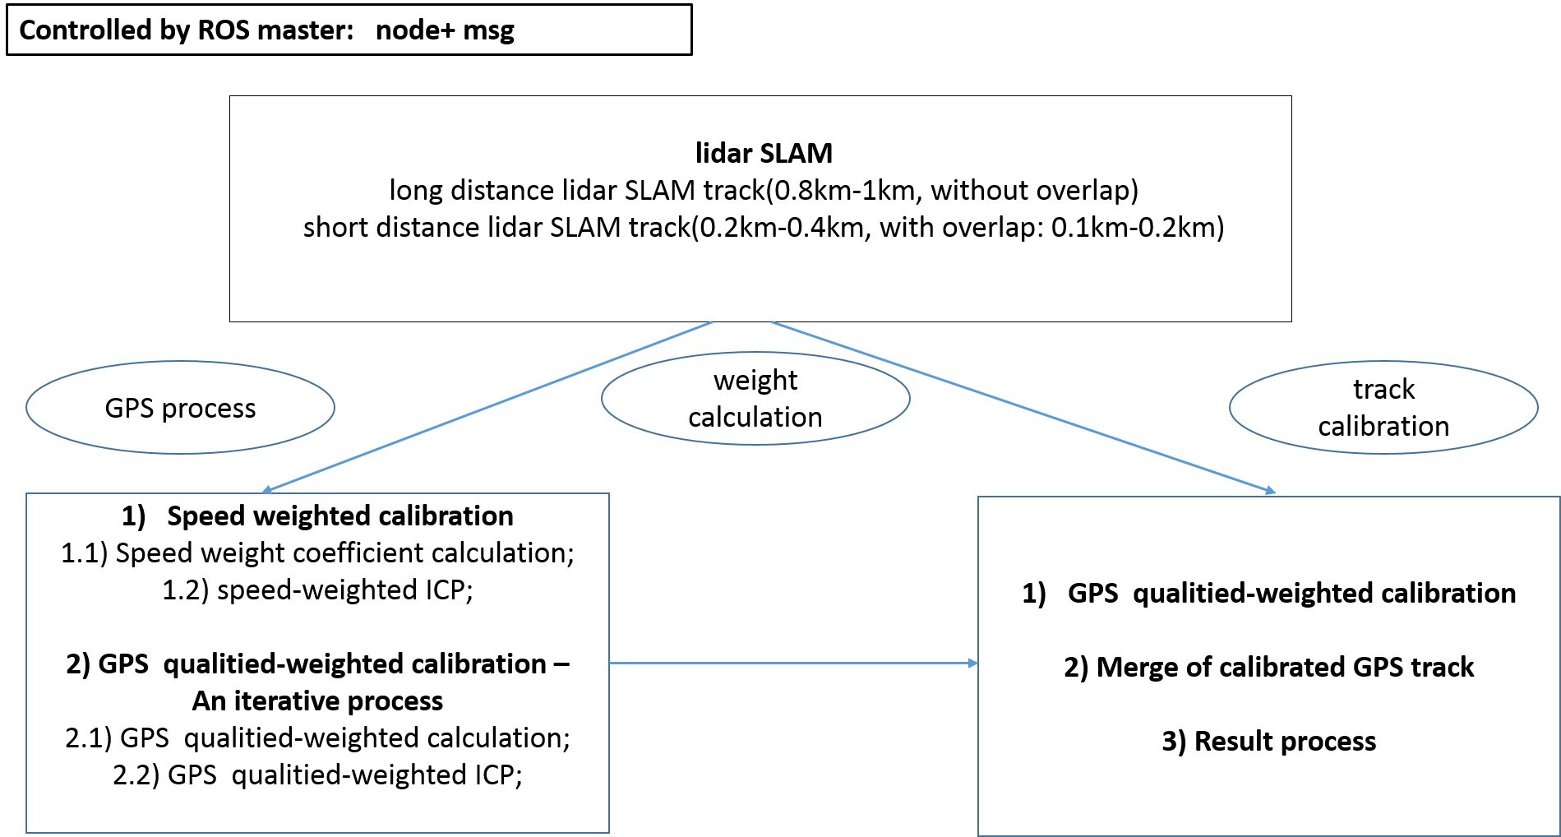

Table 1 shows schedule of this project

Coder | Content | Plan | Remarks
Yangjiale | - Packaging of GPS process module.  - Short distance LOAM track process, improving in a ROS node.  - GPS qualitied-weighted calibration  - Results process  - Data test of all nodes. | 20170904-  20170915 | By 20170910, packaging and test has been fished.  Improve of code process may need 2-3 days work.  Data test takes 2-3 days, which should be enough.  20170918, we have improved gpsCalibration code into a ROS package. This code frame is good for maintaining and development.  In next two weeks, jobs are focusing on SLAM(lidar, camera).  20170925, we have tested the ROS package-gpsCalibration. Some functions need to be taken into this package: exception handling, GPS module, stress testing etal.  In next week, jobs are still focusing on SLAM(lidar, camera).
Yangjiale | - gpsCalibration-> ROS package, data test | 20170918-  20170919
Yangjiale | - LOAM, code deep learning. | 20170920-  20170922
Yangjiale | - In charge of code improve, ORB_SLAM test | 20170925-  20170930
Wangshunli | - Test of long distance LOAM track process, assistance in data test.  - Data test of packages. | 20170904-  20170915
Wangshunli | - gpsCalibration-> ROS package, data test | 20170918-  20170919
Wangshunli | - ORB_SLAM Test | 20170920-  20170930
Liutaichen | - Packaging of Weight calculation and track calibration modules.  - Assistance in data test.  - Merge of calibrated GPS track.  - Installation shell of Ubuntu | 20170904-  20170915
Liutaichen | - Communication with JiangYun, PPT | 20170918-  20170919
Liutaichen | - Improvement of SLAM in gpsCalibration module. | 20170920-  20170922
Liutaichen | - Training, management  - Loop closure: combine camera and lidar algorithm | 20170925-  20170930
Cuitaixiang | - Installation+Test  - Familiar with project management  - ORB_SLAM Test | 20170925-  20170930
Nanxing | - Installation+Test  - Familiar with project management  - GPS module | 20170925-  20170930

