**Casino Simulation**

**Tutorial / User Manual**

**Applied Programming Concepts (ELEC-3225-01)**

**July 24th, 2022**

**Tutorial**

**Installation:**

1. Go to <https://github.com/Wentworth-applied-programming-concept/casino>
2. Make sure you’re on the main branch – and click on the green “Code” button

1. Download zipped folder of the program

1. Unzip the folder. You can use Microsoft file explorer.

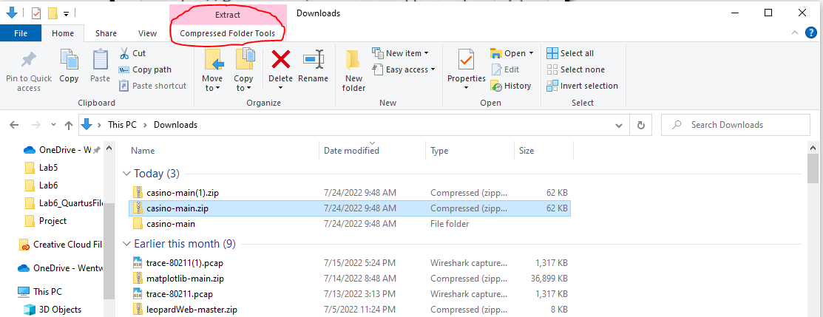

1. You will need to know the directory of the folder which contains all the files to run the program, so take note of it.

1. Now, you have all of the program files. Our program uses a couple of Python packages such as peewee and matplotlib. You can use pip to install these packages. Starting with Python 3.4, pip is included by default with the python binary installers.
   1. To check your version of python, open the windows command line by typing “cmd” into the windows search bar.
   2. Type “python --version” into the command line to check which version of python you have

1. If you have an older version than Python 3.4, I’d recommend just installing the latest version of Python. (<https://www.python.org/downloads/>)
   1. Otherwise, use the command “pip install peewee”

* 1. Use the command “pip install matplotlib”



Note: I already have the packages so it just prints “requirement already satisfied”, but you should see outputs displaying the packages being installed.

**Running The Program**

1. Now, you should have everything installed to run the program. To run the program, we have to first navigate to the directory where the casino sim is installed. This is where you use the directory from installation step 5.
   1. Use the command cd <directory_name> to navigate here

1. First, you must run the database module to create tables where the casino can store entries. The database module can be run with two arguments: “d” and “c”.
   1. Run the command “python -m src.core.database d” to delete the database

* 1. Run the command “python -m src.core.database c” to create the database



* + 1. Note: if you receive an error like the one below, you are in the wrong directory. I found that my casino-main folder in downloads had another “casino-main” folder. Simply cd into that.





1. Now that you have the database created, you can run the program. Run the command “python -m src.ui.ui” to start the program



1. You should see a login screen. If you have a fresh database like from previous steps, it will contain a couple of entries. A player (username: *bobby123*, password: *admin*) and an admin (username: *admin*, password: *admin*).

**User Manual**

1. If you login as a player, you will be presented with the player view of the system. The main menu displays your username, account balance, and locations to change attributes about your account. There is a dropdown menu which allows you to play games, check your account’s game history, generate graphs of game history, and logout.
2. We eventually need to simulate the casino running which will involve creating a bunch of users and game entries – however for now you will have no previous game entries – and you’ll have to play games for them to appear. The graphs also won’t generate unless game entries are created on different dates.

1. Note: to actually play the games, you must first log in as an admin and add money to one of the accounts.
2. If you login as an admin, you will be presented with the management view of the system. The main view displays the casino’s all-time profit – as well as all-time profits from each individual game. The main menu has locations where the admin can change the difficulty of the games. This is a scalar value which will either impact odds (such as in slots) or impact payout (such as in blackjack).

* 1. There is a dropdown menu which has several other views of the system. However, we haven’t ran actual simulations on the system so majority of the entries will be quite bare.
  2. Inside *player view* and *admin view*, admins can add/remove users, as well as update their attributes. To update attributes – select the user you wish to change from the table, enter attributes into the boxes below and select update user.
  3. Inside of *game view*, admins can search by parameters by selecting a parameter from the dropdown menu below and typing something into the search box.

**Launching the Games**

1. Once in the *player view*, select *Menu -> Launch Games* from the drop down, then select the game to launch by clicking the corresponding ‘Play’ buttons. The games will launch in the command window.

