**计算机图形学实验**

**姓 名：文尉鹏**

**学 号：20201120571**

**专 业：计算机科学与技术**

**教 师：钱文华**

实验一 直线段生成算法

时间：2022年3月16日

地点：信息学院2204机房

1. 实验内容：

熟悉OPENGL，通过实例程序生成直线段。

1. 实验目的：

安装OPENGL，能编写代码运行，参考课本代码。

1. 实验代码：

|  |
| --- |
| #include <GL/glut.h>  void init(void) {  glClearColor(1.0, 1.0, 1.0, 0.0);  glMatrixMode(GL_PROJECTION);  gluOrtho2D(0.0, 200.0, 0.0, 150.0);  }  void lineSegment(void) {  glClear(GL_COLOR_BUFFER_BIT);  glColor3f(0.0, 0.4, 0.2);  glBegin(GL_LINES);  glVertex2i(180, 15);  glVertex2i(10, 145);  glEnd();  glFlush();  }  void main(int argc, char** argv) {  glutInit(&argc, argv);  glutInitDisplayMode(GLUT_SINGLE | GLUT_RGB);  glutInitWindowPosition(50, 100);  glutInitWindowSize(400, 300);  glutCreateWindow("An Example OpenGL Program");  init();  glutDisplayFunc(lineSegment);  glutMainLoop();  } |

4、实验结果：

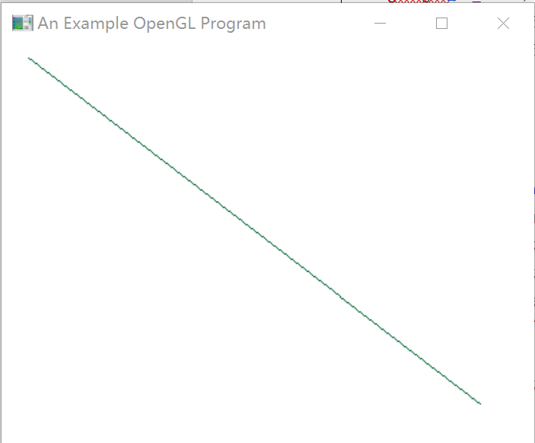

实验二 DDA直线生成算法

时间：2022年3月23日

地点：信息学院2204机房

1、实验内容：

熟悉OPENGL，通过DDA、中点算法生成直线段

2、实验目的：

安装OPENGL，能编写代码运行，参考课本代码

3、实验代码：

|  |
| --- |
| #include <stdlib.h>  #include <math.h>  #include <GL/glut.h>  #include <stdio.h>  void init(void) {  glClearColor(0.0f, 0.0f, 0.0f, 0.0f);  glMatrixMode(GL_PROJECTION);  gluOrtho2D(0, 800, 0, 600);  }  inline int round(const float a) {  return int(a + 0.5);  }  void setPixel(GLint x, GLint y) {  glBegin(GL_POINTS);  glVertex2i(x, y);  glEnd();  }  void lineDDA(int x0, int y0, int xEnd, int yEnd) {  int dx = xEnd - x0, dy = yEnd - y0, steps, k;  float xIncrement, yIncrement, x = x0, y = y0;  if (fabs(dx) > fabs(dy)) {  steps = fabs(dx);  }  else {  steps = fabs(dy);  }  xIncrement = float(dx) / float(steps);  yIncrement = float(dy) / float(steps);  setPixel(round(x), round(y));  for (k = 0; k < steps; k++) {  x += xIncrement;  y += yIncrement;  setPixel(round(x), round(y));  }  }  void lineSegment(void) {  glClear(GL_COLOR_BUFFER_BIT);  int x0, y0, xEnd, yEnd;  printf("请输入第一个点的坐标:\n");  scanf("%d%d", &x0, &xEnd);  printf("请输入第二个点的坐标:\n");  scanf("%d%d", &y0, &yEnd);  lineDDA(x0, y0, xEnd, yEnd);  glFlush();  }  void main(int argc, char** argv) {  glutInit(&argc, argv);  glutInitDisplayMode(GLUT_SINGLE | GLUT_RGB);  glutInitWindowPosition(0, 0);  glutInitWindowSize(800, 600);  glutCreateWindow("DDA直线生成算法");  glutDisplayFunc(&lineSegment);  init();  glutMainLoop();  } |

4、实验结果：

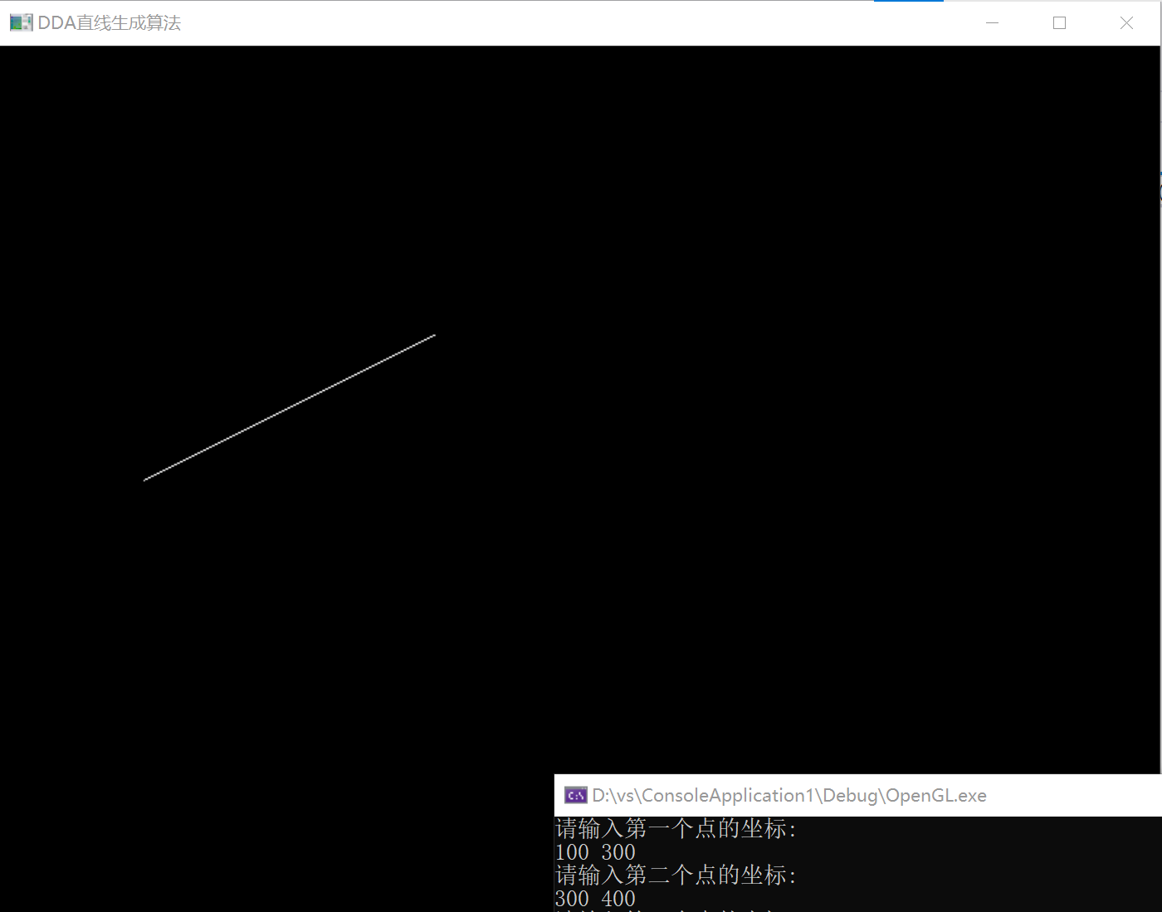

实验三 Bresenham、 改进Bresenham算法生成直线段实验

时间：2022年3月30日

地点：信息学院2204机房

1、实验内容：

熟悉OPENGL，通过Bresenham中点、改进Bresenham算法生成直线段。

2、实验目的：

安装OPENGL，能编写代码运行，参考课本代码。

3、实验代码：

（1）Bresenham算法：

|  |
| --- |
| #include<stdlib.h>  #include<math.h>  #include<GL/glut.h>  #include<stdio.h>  void init(void) {  glClearColor(1.0, 1.0, 1.0, 0.0);  glMatrixMode(GL_PROJECTION);  gluOrtho2D(0.0, 800.0, 0.0, 600.0);  }  void setPixel(GLint x, GLint y) {  glBegin(GL_POINTS);  glVertex2i(x, y);  glEnd();  }  void lineBres(int x0, int y0, int xEnd, int yEnd) {  int dx = fabs(xEnd - x0), dy = fabs(yEnd - y0);  int p = 2 * dy - dx;  int twoDy = 2 * dy, twoDyMinusDx = 2 * (dy - dx);  int x, y;  if (x0 > xEnd) {  x = xEnd;  y = yEnd;  xEnd = x0;  }  else {  x = x0;  y = y0;  }  setPixel(x, y);  while (x < xEnd) {  x++;  if (p < 0) {  p += twoDy;  }  else {  y++;  p += twoDyMinusDx;  }  setPixel(x, y);  }  }  void lineSegment(void) {  glClear(GL_COLOR_BUFFER_BIT);  glColor3f(0.0, 0.4, 0.2);  int x0, y0, xEnd, yEnd;  printf("请输入第一个点的坐标:\n");  scanf("%d%d", &x0, &xEnd);  printf("请输入第二个点的坐标:\n");  scanf("%d%d", &y0, &yEnd);  lineBres(x0, y0, xEnd, yEnd);  glFlush();  }  void main(int argc, char** argv) {  glutInit(&argc, argv);  glutInitDisplayMode(GLUT_SINGLE | GLUT_RGB);  glutInitWindowPosition(0, 0);  glutInitWindowSize(800, 600);  glutCreateWindow("Bresenham算法生成直线段");  glutDisplayFunc(&lineSegment);  init();  glutMainLoop();  } |

（2）改进Bresenham算法：

|  |
| --- |
| #include<stdlib.h>  #include<math.h>  #include<GL/glut.h>  #include<stdio.h>  void init(void) {  glClearColor(1.0, 1.0, 1.0, 0.0);  glMatrixMode(GL_PROJECTION);  gluOrtho2D(0.0, 800.0, 0.0, 600.0);  }  void ProBresenham(int x0, int y0, int xEnd, int yEnd){ //改进的Bresenham算法画线  int x, y, dx, dy, e;  dx = xEnd - x0;  dy = yEnd - y0;  e = -dx;  x = x0;  y = y0;  while (x <= xEnd) {  glBegin(GL_POINTS);  glVertex2i(x, y);  glEnd();  x++;  e = e + 2 * dy;  if (e > 0) {  y++;  e = e - 2 * dx;  }  }  }  void lineSegment(void) {  glClear(GL_COLOR_BUFFER_BIT);  glColor3f(0.0, 0.4, 0.2);  int x0, y0, xEnd, yEnd;  printf("请输入第一个点的坐标:\n");  scanf("%d%d", &x0, &xEnd);  printf("请输入第二个点的坐标:\n");  scanf("%d%d", &y0, &yEnd);  ProBresenham(x0, y0, xEnd, yEnd);  glFlush();  }  void main(int argc, char** argv) {  glutInit(&argc, argv);  glutInitDisplayMode(GLUT_SINGLE | GLUT_RGB);  glutInitWindowPosition(0, 0);  glutInitWindowSize(800, 600);  glutCreateWindow("改进Bresenham算法生成直线段");  glutDisplayFunc(&lineSegment);  init();  glutMainLoop();  } |

4、实验结果：

（1）Bresenham算法：

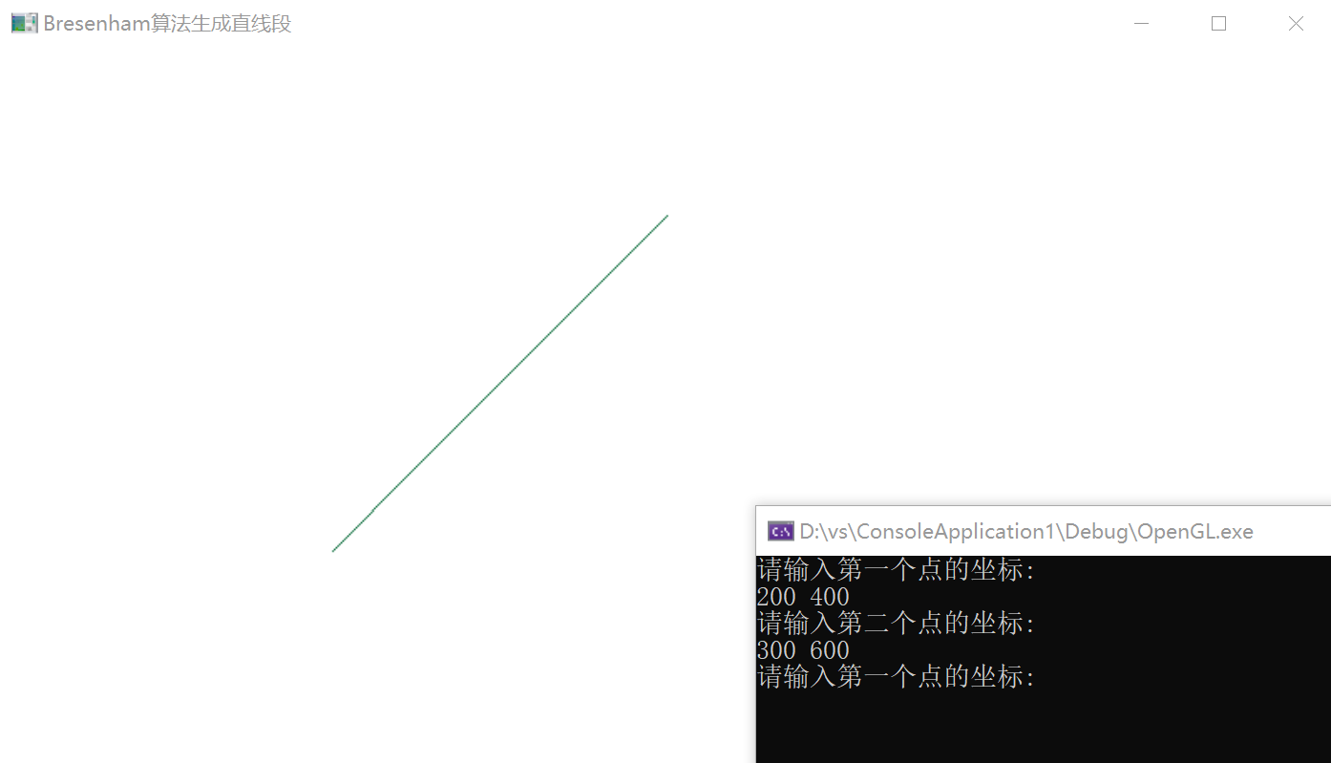

（2）改进Bresenham算法：

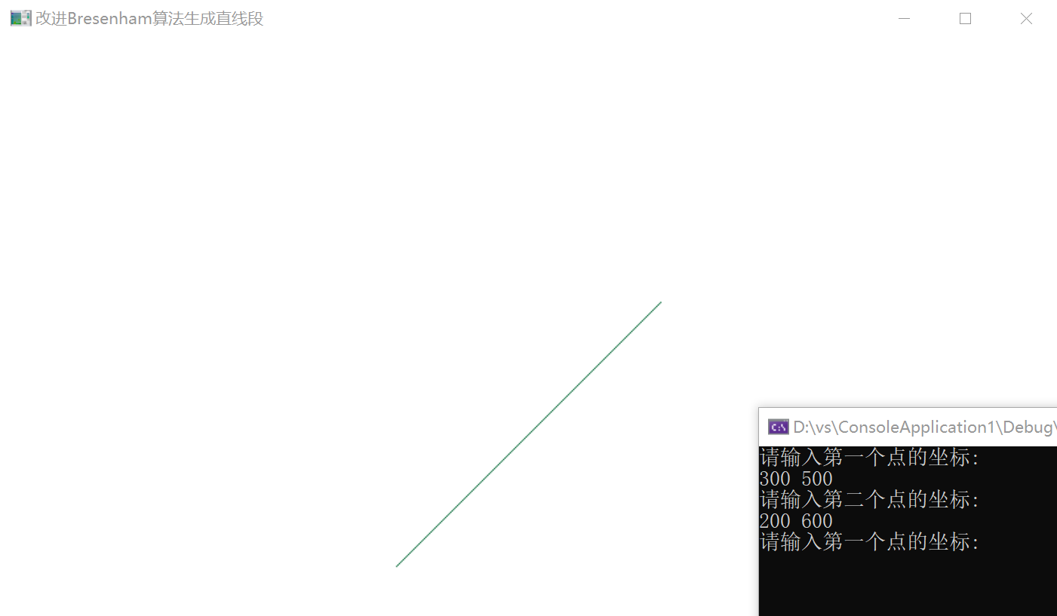

实验四 填充算法实验

时间：2022年4月6日

地点：信息学院2204机房

1、实验内容：

熟悉OPENGL，用扫描线填充算法填充多边形。

2、实验目的：

验证扫描线填充算法，指定任意的多边形边数，填充多边形。

3、实验代码：

|  |
| --- |
| #include <iostream>  #include <vector>  #include "GL/glut.h"  using namespace std;  //定义用于边表ET和活动边表AET的通用类Edge  class Edge  {  public:  int ymax;  float x;  float dx;  Edge* next;  };  //定义用于表示像素点坐标的类Point  class Point  {  public:  int x;  int y;  Point(int x, int y)  {  this->x = x;  this->y = y;  }  };  /////////////////////请使用对应Demo/////////////////////  //窗体宽高  //Demo1  //const int windowWidth = 18;  //const int windowHeight = 12;  //Demo2  //const int windowWidth = 180;  //const int windowHeight = 120;  //Demo3、Demo4、Demo5  const int windowWidth = 1200;  const int windowHeight = 900;  //多边形顶点  //Demo1  //vector<Point> vertices = { Point(2, 5), Point(2, 10), Point(9, 6), Point(16, 11), Point(16, 4), Point(12, 2), Point(7, 2) };  //Demo2  //vector<Point> vertices = { Point(200, 500), Point(200, 800), Point(900, 600), Point(960, 610), Point(860, 340), Point(720, 420), Point(700, 200),Point(400,300) };  vector<Point> vertices = { Point(200, 500), Point(200, 800), Point(900, 600) };  //vector<Point> vertices = { Point(200, 500), Point(200, 800), Point(900, 600), Point(960, 610) };  //Demo3 多边形  //vector<Point> vertices = { Point(200, 500), Point(200, 1000), Point(900, 600), Point(1600, 1100), Point(1600, 400), Point(1200, 200), Point(700, 200) };  //Demo4 箭头  //vector<Point> vertices = { Point(395, 887), Point(479, 998), Point(1199, 433), Point(1101, 867), Point(1294, 715), Point(1417, 171), Point(857, 163), Point(668, 314), Point(1111, 321) };  //Demo5 闪电  //vector<Point> vertices = { Point(566, 970), Point(685, 1020), Point(754, 683), Point(985, 768), Point(1037, 481), Point(1208, 546), Point(1233, 179), Point(1140, 440), Point(951, 386), Point(899, 662), Point(668, 562) };  //边表  Edge* ET[windowHeight];  //活动边表  Edge* AET;  void init(void)  {  glClearColor(1.0, 1.0, 1.0, 0.0);  glMatrixMode(GL_PROJECTION);  gluOrtho2D(0.0, windowWidth, 0.0, windowHeight);  }  void polygonScan()  {  //计算最高点的y坐标  int maxY = 0;  for (int i = 0; i < vertices.size(); i++)  {  if (vertices[i].y > maxY)  {  maxY = vertices[i].y;  }  }  //初始化ET和AET  Edge* pET[windowHeight];  for (int i = 0; i < maxY; i++)  {  pET[i] = new Edge();  pET[i]->next = nullptr;  }  AET = new Edge();  AET->next = nullptr;  //清空显示窗口并设置画点颜色为红色  glClear(GL_COLOR_BUFFER_BIT);  glColor3f(1.0, 0.0, 0.0);  glBegin(GL_POINTS);  //建立边表ET  for (int i = 0; i < vertices.size(); i++)  {  //取出当前点1前后相邻的共4个点，点1与点2的连线作为本次循环处理的边，另外两个点点0和点3用于计算奇点  int x0 = vertices[(i - 1 + vertices.size()) % vertices.size()].x;  int x1 = vertices[i].x;  int x2 = vertices[(i + 1) % vertices.size()].x;  int x3 = vertices[(i + 2) % vertices.size()].x;  int y0 = vertices[(i - 1 + vertices.size()) % vertices.size()].y;  int y1 = vertices[i].y;  int y2 = vertices[(i + 1) % vertices.size()].y;  int y3 = vertices[(i + 2) % vertices.size()].y;  //水平线直接舍弃  if (y1 == y2)  continue;  //分别计算下端点y坐标、上端点y坐标、下端点x坐标和斜率倒数  int ymin = y1 > y2 ? y2 : y1;  int ymax = y1 > y2 ? y1 : y2;  float x = y1 > y2 ? x2 : x1;  float dx = (x1 - x2) * 1.0f / (y1 - y2);  //奇点特殊处理，若点2->1->0的y坐标单调递减则y1为奇点，若点1->2->3的y坐标单调递减则y2为奇点  if (((y1 < y2) && (y1 > y0)) || ((y2 < y1) && (y2 > y3)))  {  ymin++;  x += dx;  }  //创建新边，插入边表ET  Edge* p = new Edge();  p->ymax = ymax;  p->x = x;  p->dx = dx;  p->next = pET[ymin]->next;  pET[ymin]->next = p;  }  //扫描线从下往上扫描，y坐标每次加1  for (int i = 0; i < maxY; i++)  {  //取出ET中当前扫描行的所有边并按x的递增顺序（若x相等则按dx的递增顺序）插入AET  while (pET[i]->next)  {  //取出ET中当前扫描行表头位置的边  Edge* pInsert = pET[i]->next;  Edge* p = AET;  //在AET中搜索合适的插入位置  while (p->next)  {  if (pInsert->x > p->next->x)  {  p = p->next;  continue;  }  if (pInsert->x == p->next->x && pInsert->dx > p->next->dx)  {  p = p->next;  continue;  }  //找到位置  break;  }  //将pInsert从ET中删除，并插入AET的当前位置  pET[i]->next = pInsert->next;  pInsert->next = p->next;  p->next = pInsert;  }  //AET中的边两两配对并填色  Edge* p = AET;  while (p->next && p->next->next)  {  for (int x = p->next->x; x < p->next->next->x; x++)  {  glVertex2i(x, i);  }  p = p->next->next;  }  //删除AET中满足y=ymax的边  p = AET;  while (p->next)  {  if (p->next->ymax == i)  {  Edge* pDelete = p->next;  p->next = pDelete->next;  pDelete->next = nullptr;  delete pDelete;  }  else  {  p = p->next;  }  }  //更新AET中边的x值，进入下一循环  p = AET;  while (p->next)  {  p->next->x += p->next->dx;  p = p->next;  }  }  glEnd();  glFlush();  }  int main(int argc, char** argv) {  glutInit(&argc, argv);  glutInitDisplayMode(GLUT_SINGLE | GLUT_RGB);  glutInitWindowPosition(50, 100);  glutInitWindowSize(windowWidth, windowHeight);  glutCreateWindow("填充算法");  init();  glutDisplayFunc(polygonScan);  glutMainLoop();  return 0;  } |

4、实验结果：

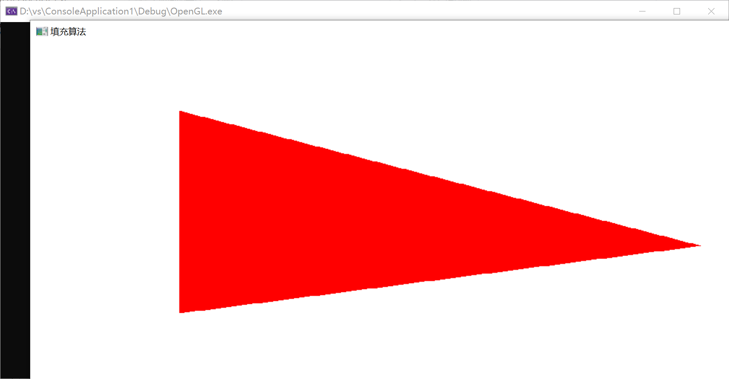

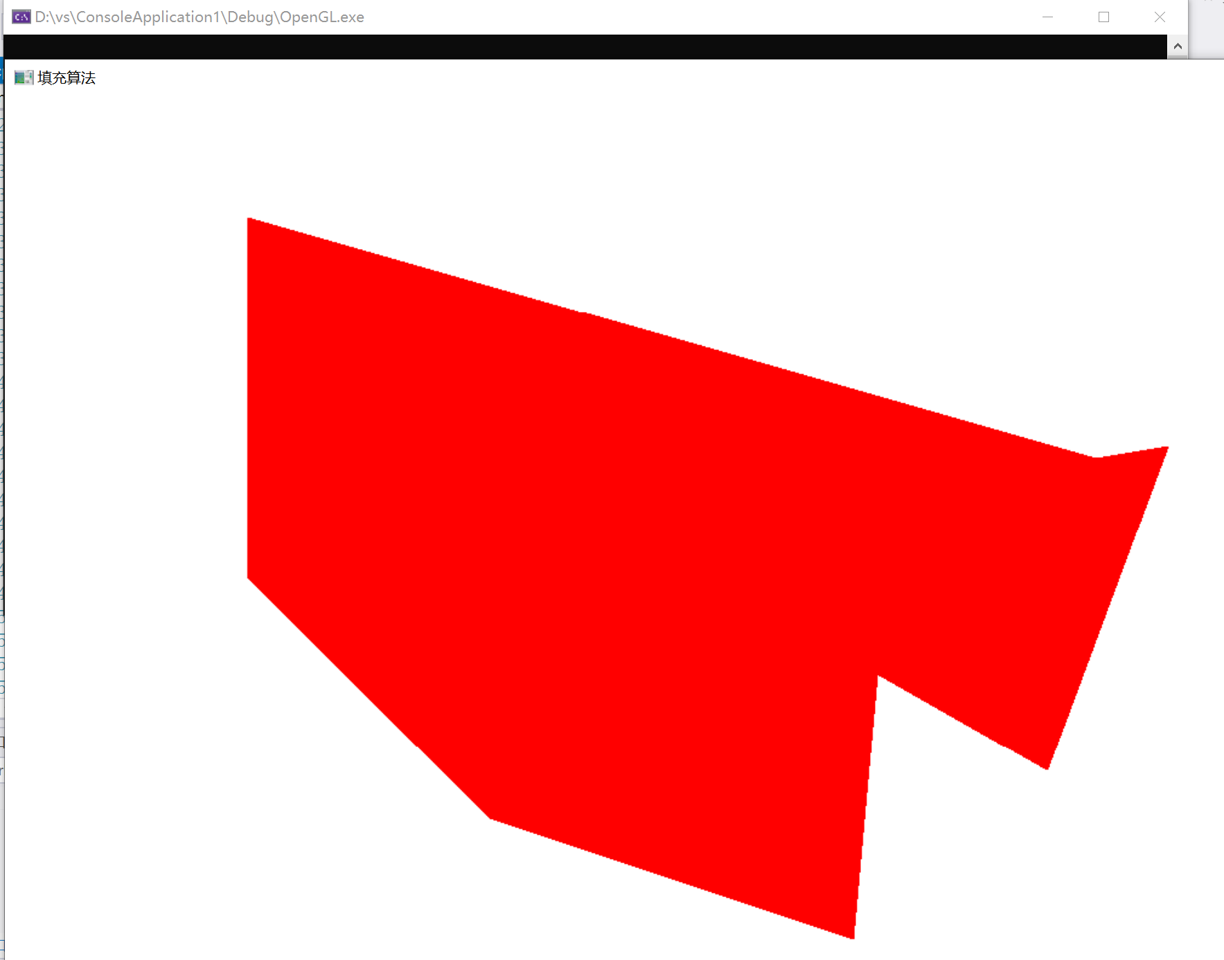

实验五 填充算法实验

时间：2022年4月13日

地点：信息学院2202机房

1、实验内容：

（1）圆扫描转换。

（2）种子点填充算法。

2、实验目的：

（1）输入圆的半径，画出圆。

（2）输入多边形，种子点位置，填充多边形。

3、实验代码：

（1）输入圆的半径，画出圆

|  |
| --- |
| #include<windows.h>  #include<GL/glut.h>  #include<stdio.h>  void init(int argc, char** argv)  {  glutInit(&argc, argv);  glutInitDisplayMode(GLUT_SINGLE | GLUT_RGB);  glutInitWindowPosition(50, 100);  glutInitWindowSize(400, 400);  glutCreateWindow("Bresenham");  glClearColor(1.0, 1.0, 1.0, 0);  glMatrixMode(GL_PROJECTION);  gluOrtho2D(0, 400, 0, 400);  }  void Bresenham_Circle(int xc, int yc, int r)  {  int x, y, d;  x = 0;  y = r;  d = 3 - 2 * r;  glVertex2i(x + xc, y + yc);  while (x < y)  {  if (d < 0)  {  d = d + 4 * x + 6;  }  else  {  d = d + 4 * (x - y) + 10;  y--;  }  x++;  glVertex2i(x + xc, y + yc);  glVertex2i(y + xc, x + yc);  glVertex2i(y + xc, -x + yc);  glVertex2i(x + xc, -y + yc);  glVertex2i(-x + xc, -y + yc);  glVertex2i(-y + xc, -x + yc);  glVertex2i(-x + xc, y + yc);  glVertex2i(-y + xc, x + yc);  }  }  void myDisplay(void)  {  glClear(GL_COLOR_BUFFER_BIT);  glColor3f(0.0, 0.4, 0.2);  glPointSize(2);  glBegin(GL_POINTS);  int r;  printf("请输入圆的半径：");  scanf("%d", &r);  Bresenham_Circle(200, 200, r);  glEnd();  glFlush();  }  int main(int argc, char** argv)  {  init(argc, argv);  glutDisplayFunc(myDisplay);  glutMainLoop();  return 0;  } |

（2）输入多边形，种子点位置，填充多边形

|  |
| --- |
| //系统递归栈太慢了，用stack或者queue会好一点，本质一样，都是bfs  #include<iostream>  #include<vector>  #include<queue>  #include<stack>  #include<GL/glut.h>  using namespace std;  int window_width = 800, window_height = 600;  struct point  {  int x, y;  point() {}  point(int xx, int yy) :  x(xx), y(yy) {}  };  vector<point> vertice; //顶点  float newcolor[3] = { 0, 1, 1 }; //填充颜色  float boundarycolor[3] = { 0, 0, 0 }; //边界颜色  void draw_a_point(int x, int y);  bool is_equal(float* a, float* b);  void BoundaryFill4(int x, int y);  void BoundaryFill4_Stack(int x, int y);  void mymouse(int button, int state, int x, int y);  void KeyBoards(unsigned char key, int x, int y);  //画点函数  void draw_a_point(int x, int y)  {  glBegin(GL_POINTS);  glColor3fv(newcolor);  glVertex2f(x, y);  glEnd();  glFlush();  }  //判断函数  bool is_equal(float* a, float* b)  {  return a[0] == b[0] && a[1] == b[1] && a[2] == b[2];  }  //4连通区域的递归填充算法  //void BoundaryFill4(int x, int y)  //{  // float color[3];  // glReadPixels(x, y, 1, 1, GL_RGB, GL_FLOAT, color);  // //cout << x << "," << y << ":" << color[0] << color[1] << color[2] << endl;  // if (!is_equal(color, newcolor) && !is_equal(color, boundarycolor))  // {  // draw_a_point(x, y);  // BoundaryFill4(x, y + 1);  // BoundaryFill4(x, y - 1);  // BoundaryFill4(x + 1, y);  // BoundaryFill4(x - 1, y);  // }  //}  //用队列queue实现的 4连通区域的填充算法  void BoundaryFill4(int x, int y)  {  queue<point> q;  q.push(point(x, y));  while (!q.empty())  {  point now = q.front();  q.pop();  int nowx = now.x, nowy = now.y;  float color[3];  glReadPixels(nowx, nowy, 1, 1, GL_RGB, GL_FLOAT, color); //读取像素颜色  if (!is_equal(color, newcolor) && !is_equal(color, boundarycolor))  {  draw_a_point(nowx, nowy);  q.push(point(nowx, nowy + 1)); //下方  q.push(point(nowx, nowy - 1));  q.push(point(nowx + 1, nowy));  q.push(point(nowx - 1, nowy)); //左方  }  }  }  //用栈实现的 扫描线形式的填充算法  void BoundaryFill4_Stack(int x, int y)  {  stack <point> q;  q.push(point(x, y));  while (!q.empty())  {  point now = q.top();  q.pop();  int nowx = now.x, nowy = now.y;  float color[3];  glReadPixels(nowx, nowy, 1, 1, GL_RGB, GL_FLOAT, color);  if (!is_equal(color, newcolor) && !is_equal(color, boundarycolor))  {  draw_a_point(nowx, nowy);  q.push(point(nowx, nowy + 1));  q.push(point(nowx, nowy - 1));  q.push(point(nowx + 1, nowy));  q.push(point(nowx - 1, nowy));  }  }  }  void mymouse(int button, int state, int x, int y)  {  if (button == GLUT_LEFT_BUTTON && state == GLUT_DOWN)  {  draw_a_point(x, window_height - y);  point p(x, window_height - y);  vertice.push_back(p);  cout << "顶点" << vertice.size() << ": (" << x << ", " << y << ")" << endl;  }  if (button == GLUT_RIGHT_BUTTON && state == GLUT_DOWN)  {  glClearColor(1, 1, 1, 1);//设置绘制窗口颜色为白色  glColor3fv(boundarycolor);  glBegin(GL_LINES);  for (int i = 0; i < vertice.size(); i++)  {  if (i == vertice.size() - 1)//画完最后一个点，使其闭合  {  glVertex2f(vertice[0].x, vertice[0].y);  glVertex2f(vertice[i].x, vertice[i].y);  }  else  {  glVertex2f(vertice[i].x, vertice[i].y);  glVertex2f(vertice[i + 1].x, vertice[i + 1].y);  }  }  glEnd();  glFlush();  vertice.clear();  }  if (button == GLUT_MIDDLE_BUTTON && state == GLUT_DOWN)  {  cout << "center: (" << x << ", " << y << ")" << endl;  BoundaryFill4(x, window_height - y);  //BoundaryFill4_Stack(x, window_height - y);  }  }  void KeyBoards(unsigned char key, int x, int y)  {  if (key == 32)  {  BoundaryFill4(x, window_height - y);  glFlush();  }  }  void display()  {  glClear(GL_COLOR_BUFFER_BIT);  glColor3f(0.0, 0.4, 0.2);  glPointSize(1);  glBegin(GL_POINTS);  //BoundaryFill4(m, window_height - n);  glEnd();  glFlush();  }  int main(int argc, char* argv[])  {  cout << "点击鼠标左键画点；" << endl << "点击鼠标右键结束画点，形成多边形；" << endl << "点击鼠标中键确定区域填充种子点位置。" << endl;  glutInit(&argc, argv);  glutInitDisplayMode(GLUT_SINGLE | GLUT_RGB);  glutInitWindowPosition(400, 150);  glutInitWindowSize(window_width, window_height);  glutCreateWindow("区域种子填充");  glMatrixMode(GL_PROJECTION);/*设置为投影类型模式和其他观察参数*/  //glMatrixMode(GL_MODELVIEW);  glLoadIdentity();/*设置为投影类型模式和其他观察参数*/  //gluOrtho2D(0, window_width, window_height, 0);/*设置为投影类型模式和其他观察参数，观察窗口的大小要与画布大小一致，所以直接设置全局变量即可*/  gluOrtho2D(0, window_width, 0, window_height); //上面的不可以！！！  glClearColor(1, 1, 1, 1);//设置绘制窗口颜色为白色  glClear(GL_COLOR_BUFFER_BIT);  glutDisplayFunc(&display);//自己加的，回调函数  glutMouseFunc(&mymouse);  //glutKeyboardFunc(&KeyBoards);  glutMainLoop();  return 0;  } |

4、实验结果：

（1）输入圆的半径，画出圆

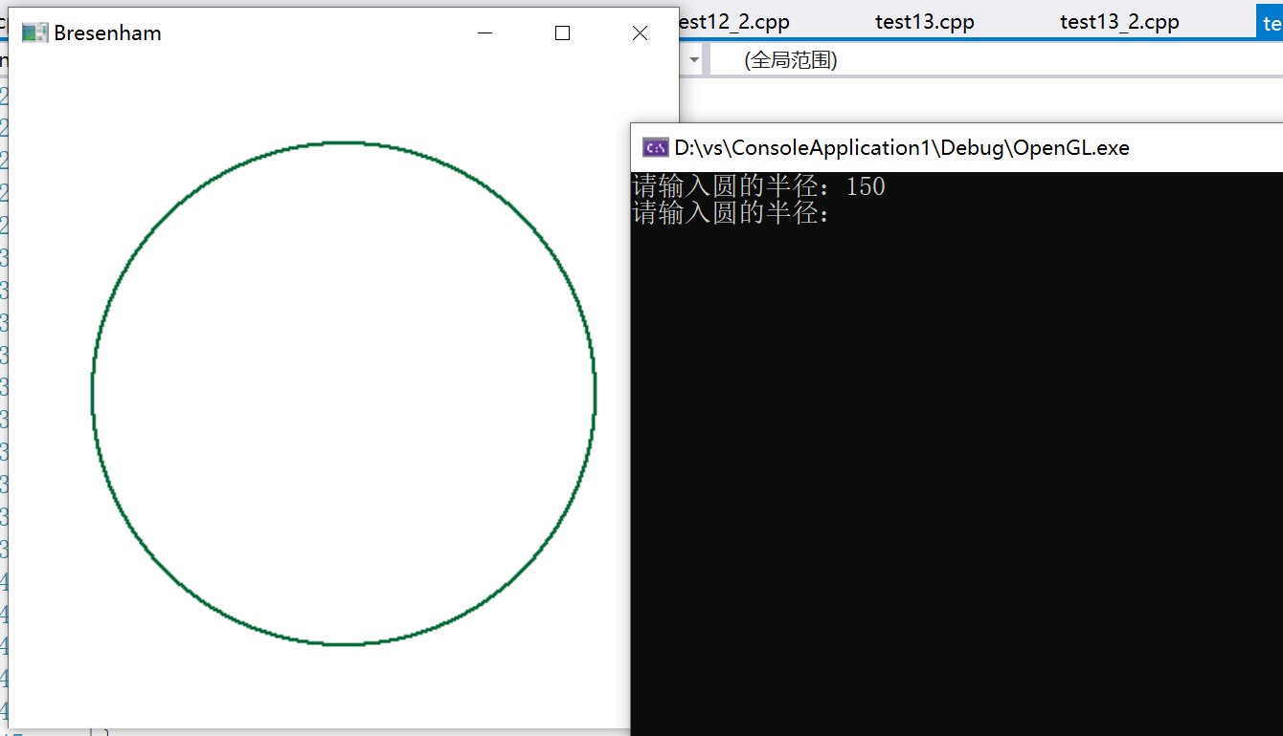

（2）输入多边形，种子点位置，填充多边形

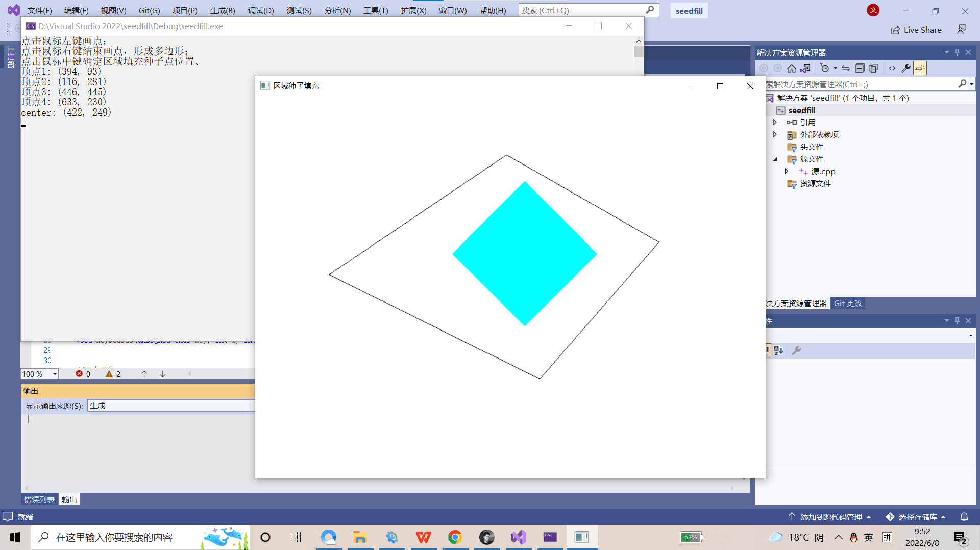

实验六 填充算法实验

时间：2022年4月20日

地点：信息学院2202机房

1、实验内容：

二维几何变换算法（平移、比例、旋转、对称）。

2、实验目的：

验证二维几何变换，熟悉变换矩阵。

3、实验代码：

|  |
| --- |
| #include<GL/glut.h>  #include<stdlib.h>  #include<math.h>  GLsizei winWidth = 600, winHeight = 600;  GLfloat xwcMin = 0.0, xwcMax = 225.0;  GLfloat ywcMin = 0.0, ywcMax = 225.0;  class wcPt2D {  public :  GLfloat x, y;  };  typedef GLfloat Matrix3x3[3][3];  Matrix3x3 matComposite;  const GLdouble pi = 3.12159;  void init(void) {  glClearColor(1.0, 1.0, 1.0, 0.0);  }  void matrix3x3SetIdentity(Matrix3x3 matIdent3x3) {  GLint row, col;  for (row = 0; row < 3; row++) {  for (col = 0; col < 3; col++) {  matIdent3x3[row][col] = (row == col);  }  }  }  void matrix3x3PreMultiply(Matrix3x3 m1, Matrix3x3 m2) {  GLint row, col;  Matrix3x3 matTemp;  for (row = 0; row < 3; row++) {  for (col = 0; col < 3; col++) {  matTemp[row][col] = m1[row][0] * m2[0][col] + m1[row][1] * m2[1][col] + m1[row][2] * m2[2][col];  }  }  for (row = 0; row < 3; row++) {  for (col = 0; col < 3; col++) {  m2[row][col] = matTemp[row][col];  }  }  }  void translate2D(GLfloat tx, GLfloat ty) {  Matrix3x3 matTransl;  matrix3x3SetIdentity(matTransl);  matTransl[0][2] = tx;  matTransl[1][2] = ty;  matrix3x3PreMultiply(matTransl, matComposite);  }  void rotate2D(wcPt2D pivotPt, GLfloat theta) {  Matrix3x3 matRot;  matrix3x3SetIdentity(matRot);  matRot[0][0] = cos(theta);  matRot[0][1] = -sin(theta);  matRot[0][2] = pivotPt.x * (1 - cos(theta)) + pivotPt.y * sin(theta);  matRot[1][0] = sin(theta);  matRot[1][1] = cos(theta);  matRot[1][2] = pivotPt.y * (1 - cos(theta)) - pivotPt.x * sin(theta);  matrix3x3PreMultiply(matRot, matComposite);  }  void scale2D(GLfloat sx, GLfloat sy, wcPt2D fixedPt) {  Matrix3x3 matScale;  matrix3x3SetIdentity(matScale);  matScale[0][0] = sx;  matScale[0][2] = (1 - sx) * fixedPt.x;  matScale[1][1] = sy;  matScale[1][2] = (1 - sy) * fixedPt.y;  }  void transformVerts2D(GLint nVerts, wcPt2D* verts) {  GLint k;  GLfloat temp;  for (k = 0; k < nVerts; k++) {  temp = matComposite[0][0] * verts[k].x + matComposite[0][1] * verts[k].y + matComposite[0][2];  verts[k].y = matComposite[1][0] * verts[k].x + matComposite[1][1] * verts[k].y + matComposite[1][2];  verts[k].x = temp;  }  }  void triangle(wcPt2D* verts) {  GLint k;  glBegin(GL_TRIANGLES);  for (k = 0; k < 3; k++) {  glVertex2f(verts[k].x, verts[k].y);  }  glEnd();  }  void displayFcn(void) {  GLint nVerts = 3;  wcPt2D verts[3] = { {50.0,25.0},{150.0,25.0},{100.0,100.0} };  wcPt2D centroidPt;  GLint k, xsun = 0, ysum = 0;  for (k = 0; k < nVerts; k++) {  xsun += verts[k].x;  ysum += verts[k].y;  }  centroidPt.x = GLfloat(xsun) / GLfloat(nVerts);  centroidPt.y = GLfloat(ysum) / GLfloat(nVerts);  wcPt2D pivPt, fixedPt;  pivPt = centroidPt;  fixedPt = centroidPt;  GLfloat tx = 0.0, ty = 100.0;  GLfloat sx = 0.5, sy = 0.5;  GLdouble theta = pi / 2.0;  glClear(GL_COLOR_BUFFER_BIT);  glColor3f(0.0, 0.0, 1.0);  triangle(verts);  matrix3x3SetIdentity(matComposite);  scale2D(sx, sy, fixedPt);  rotate2D(pivPt, theta);  translate2D(tx, ty);  transformVerts2D(nVerts, verts);  glColor3f(1.0, 0.0, 0.0);  triangle(verts);  glFlush();  }  void winReshapeFcn(GLint newWidth, GLint newHeight) {  glMatrixMode(GL_PROJECTION);  glLoadIdentity();  gluOrtho2D(xwcMin, xwcMax, ywcMin, ywcMax);  glClear(GL_COLOR_BUFFER_BIT);  }  void main(int argc, char** argv) {  glutInit(&argc, argv);  glutInitDisplayMode(GLUT_SINGLE | GLUT_RGB);  glutInitWindowPosition(50, 50);  glutInitWindowSize(winWidth, winHeight);  glutCreateWindow("xxxxxxx");  init();  glutDisplayFunc(displayFcn);  glutReshapeFunc(winReshapeFcn);  glutMainLoop();  } |

4、实验结果：

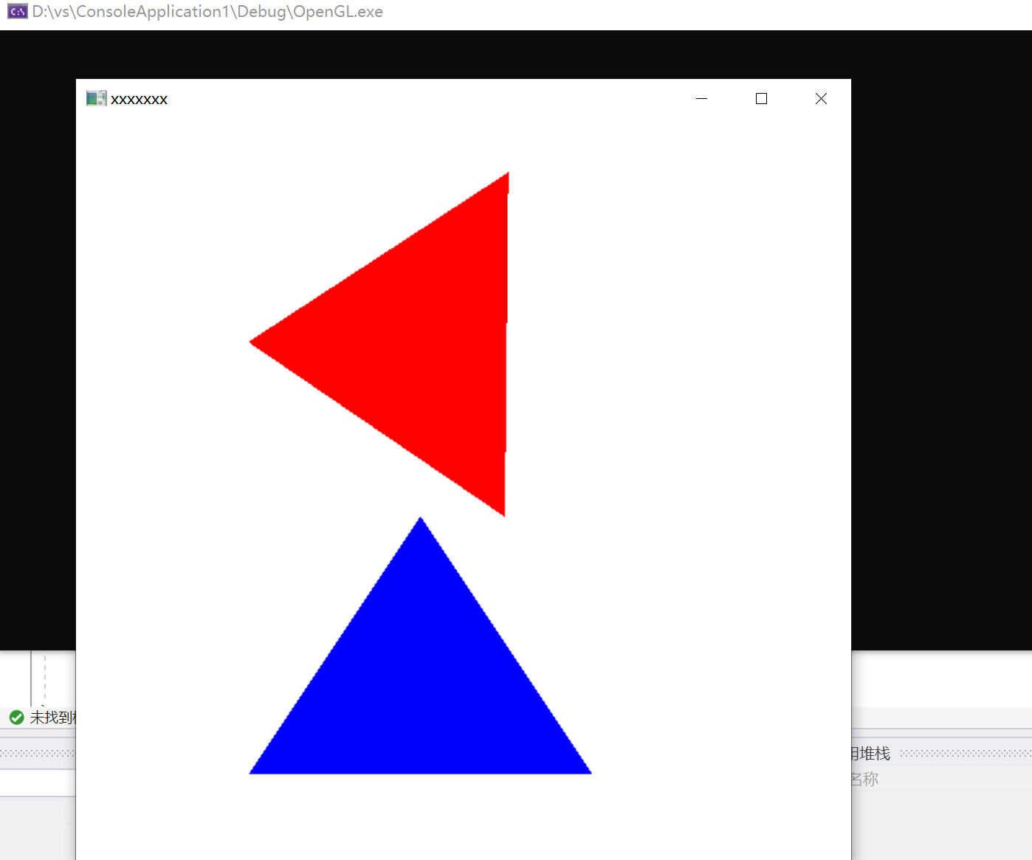

实验七 GLUT鼠标函数实验

时间：2022年4月26日

地点：信息学院2204机房

1、实验内容：

（1）教材P458，GLUT鼠标函数

（2）使用opengl，实现任一反走样技术

2、实验目的：

调用鼠标函数完成相应功能，2-3个程序

3、实验代码：

（1）教材P458，GLUT鼠标函数

|  |
| --- |
| #include<GL/glut.h>  GLsizei winWidth = 400, winHeight = 300;  void init(void) {  glClearColor(0.0, 0.0, 1.0, 1.0);  glMatrixMode(GL_PROJECTION);  gluOrtho2D(0.0, 200.0, 0.0, 150.0);  }  void displayFcn(void) {  glClear(GL_COLOR_BUFFER_BIT);  glColor3f(1.0, 0.0, 0.0);  glPointSize(3.0);  }  void winReshapeFcn(GLint newWidth, GLint newHeight) {  glViewport(0, 0, newWidth, newHeight);  glMatrixMode(GL_PROJECTION);  glLoadIdentity();  gluOrtho2D(0.0, GLdouble(newWidth), 0.0, GLdouble(newHeight));  winWidth = newWidth;  winHeight = newHeight;  }  void plotPoint(GLint x, GLint y) {  glBegin(GL_POINTS);  glVertex2i(x, y);  glEnd();  }  void mousePtPlot(GLint button, GLint action, GLint xMouse, GLint yMouse) {  if (button == GLUT_LEFT_BUTTON && action == GLUT_DOWN) {  plotPoint(xMouse, winHeight - yMouse);  }  glFlush();  }  void main(int argc, char** argv) {  glutInit(&argc, argv);  glutInitDisplayMode(GLUT_SINGLE | GLUT_RGB);  glutInitWindowPosition(100, 100);  glutInitWindowSize(winWidth, winHeight);  glutCreateWindow("xxx");  init();  glutDisplayFunc(displayFcn);  glutReshapeFunc(winReshapeFcn);  glutMouseFunc(mousePtPlot);  glutMainLoop();  } |

（2）使用opengl，实现任一反走样技术

|  |
| --- |
| #include<windows.h>  #include<gl/glut.h>  #include<math.h>  #include<iostream>  using namespace std;  #define x_Screen 800  #define y_Screen 600  #define little 50  #define middle 20  #define large 8  void myBackground()  {  glClearColor(0.0, 0.0, 0.0, 1.0);  glColor3f(1.0, 1.0, 1.0);  }  void myDisplay()  {  glEnable(GL_DEPTH_TEST);  //如果没有抗锯齿，则点为方形的。如果我们启动抗锯齿设置，则点是一个圆点。  glEnable(GL_POINT_SMOOTH);  glEnable(GL_LINE_SMOOTH);  glHint(GL_POINT_SMOOTH_HINT, GL_NICEST); // Make round points, not square points  glHint(GL_LINE_SMOOTH_HINT, GL_NICEST); // Antialias the lines  glEnable(GL_BLEND);  glBlendFunc(GL_SRC_ALPHA, GL_ONE_MINUS_SRC_ALPHA);  glClear(GL_COLOR_BUFFER_BIT | GL_DEPTH_BUFFER_BIT);  int i;  glBegin(GL_POINTS);  for (i = 0; i < little; i++)  glVertex2f(50.0 + rand() % x_Screen, 50.0 + rand() % y_Screen);  glEnd();  glPointSize(2);  glBegin(GL_POINTS);  for (i = 0; i < middle; i++)  glVertex2f(50.0 + rand() % x_Screen, 50.0 + rand() % y_Screen);  glEnd();  glPointSize(8);  glBegin(GL_POINTS);  for (i = 0; i < large; i++)  glVertex2f(50.0 + rand() % x_Screen, 50.0 + rand() % y_Screen);  glEnd();  glBegin(GL_POLYGON);  for (i = 0; i < 64; i++)  glVertex2f(600 + 50.0 * cos((float)i / 10), 500 + 50.0 * sin((float)i / 10));  glEnd();  glLineWidth(3);  glBlendFunc(GL_SRC_ALPHA, GL_ONE_MINUS_SRC_ALPHA);  glEnable(GL_BLEND);  glEnable(GL_LINE_SMOOTH);  glBegin(GL_LINE_STRIP);  for (i = 0; i < 19; i++) {  glVertex2f(rand() % 10 + i * 70, rand() % 50 + 50.0 + (i % 2) * 80);  }  glEnd();  glutSwapBuffers();  }  void myChange(int w, int h)  {  glViewport(0, 0, w, h);  glMatrixMode(GL_PROJECTION);  glLoadIdentity();  gluOrtho2D(0.0, x_Screen, 0.0, y_Screen);  glMatrixMode(GL_MODELVIEW);  glLoadIdentity();  }  void main(int argc, char** argv)  {  glutInit(&argc, argv);  glutInitDisplayMode(GLUT_DOUBLE | GLUT_RGB | GLUT_DEPTH);  glutInitWindowSize(x_Screen, y_Screen);  glutCreateWindow("Star");  glutDisplayFunc(myDisplay);  glutReshapeFunc(myChange);  myBackground();  glutMainLoop();  } |

4、实验结果：

（1）教材P458，GLUT鼠标函数

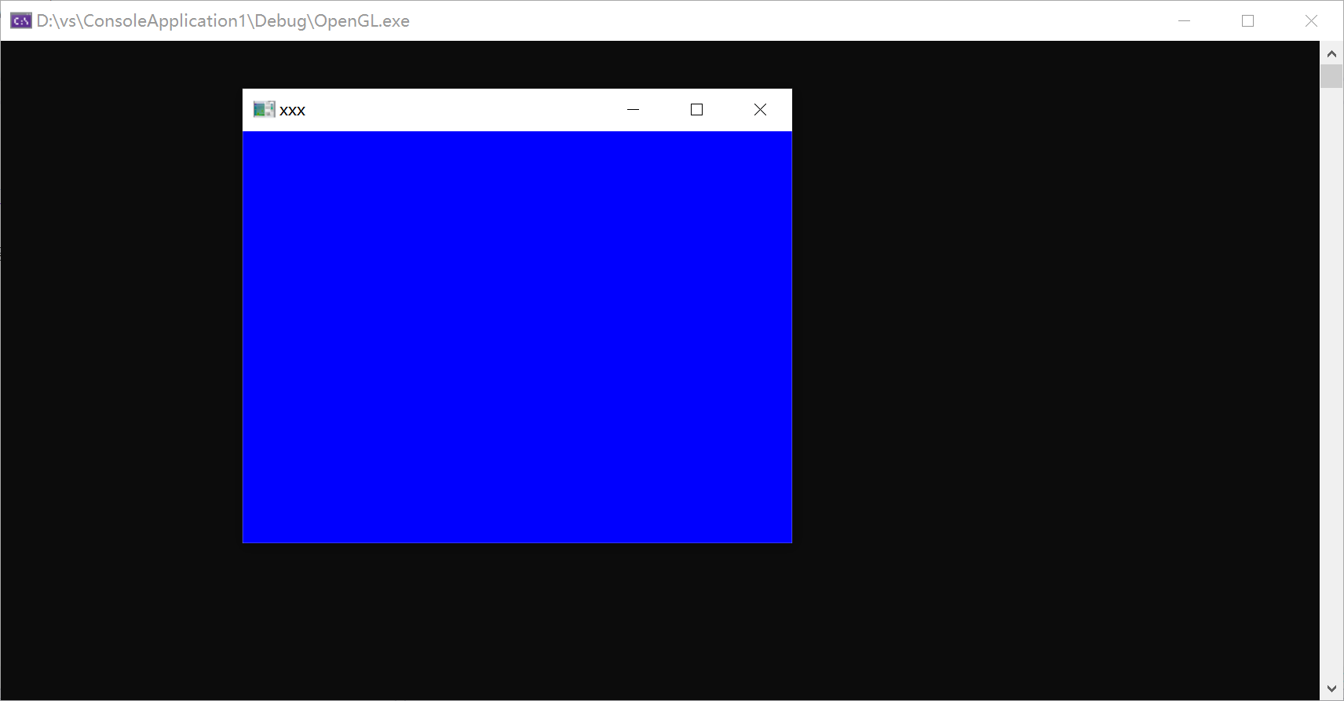

（2）使用opengl，实现任一反走样技术

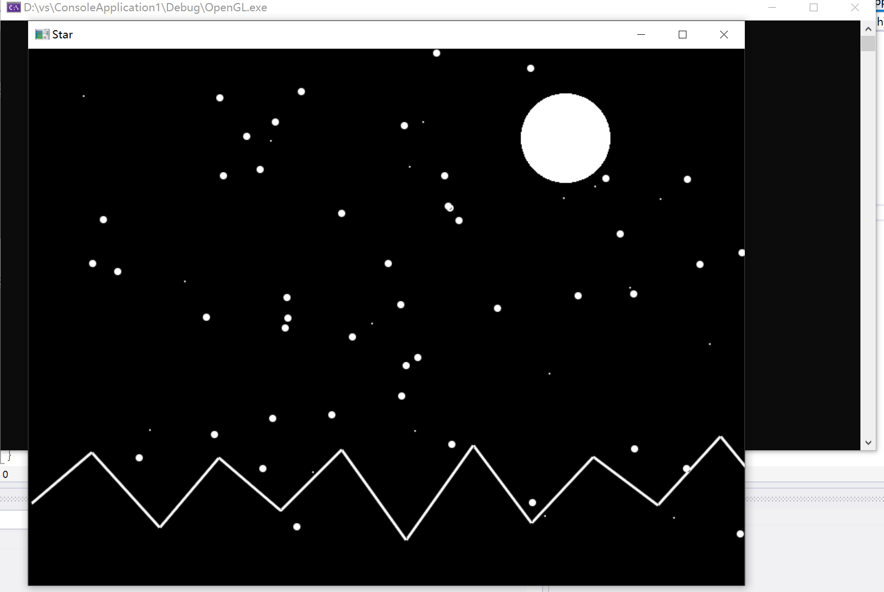

实验八 二维图像裁剪实验

时间：2022年5月3日

地点：信息学院2204机房

1、实验内容：

使用opengl，用Cohen-Sutherland线段裁剪算法对直线段进行裁剪

2、实验目的：

验证Cohen-Sutherland裁剪算法，从键盘输入任意的直线段，用指定的裁剪窗口裁剪直线段

3、实验代码：

|  |
| --- |
| #include <GL/glut.h>  #include <cstdio>  #define LEFT 1//0001  #define RIGHT 2//0010  #define BOTTOM 4//0100  #define TOP 8//1000  int x1 = 150, y1 = 50, x2 = 50, y2 = 250, XL = 100, XR = 300, YB = 100, YT = 200; //(x1,y1)、(x2,y2)为直线段的端点，XL为左边界，XR为右边界，YB为下边界，YT为上边界  int x1_init = 150, y1_init = 50, x2_init = 50, y2_init = 250; //将直线段端点备份，以便画出裁剪前的直线段  void encode(int x, int y, int& c)  {//|或运算两者有一个为1结果就为1  c = 0;  if (x < XL) c |= LEFT;//按照数字进行或运算，左边界  else if (x > XR) c |= RIGHT;//右边界  if (y < YB) c |= BOTTOM;//下边界  else if (y > YT) c |= TOP;//上边界  }  //上左:1001; 中左:0001; 下左:0101;  //上中:1000; 中中:0000 下中:0100  //上右:1010 中右:0010 下右:0110  void CS_LineClip() //Cohen-Sutherland裁剪算法  {  int x, y;  int code1, code2, code;  encode(x1, y1, code1);//先求出端点所在的区号  encode(x2, y2, code2);//先求出端点所在的区号  //循环处理  while (code1 != 0 || code2 != 0)//只有两个端点同时都在矩形区域里才不使用函数  {  if (code1 & code2)//两个都为1才成立，这两个都在同一个区域中 直接不进行处理  return;  if (code1 != 0)//如果  code = code1;  else  code = code2;  if (LEFT & code)//线段与左边界相交(如果  {  x = XL;//求出的左边界的交点的x值  y = y1 + (y2 - y1) * (XL - x1) / (x2 - x1);//求出左边交点的y值  }  else if (RIGHT & code)//线段与右边界相交  {  x = XR;//求出右边界的交点的x值  y = y1 + (y2 - y1) * (XR - x1) / (x2 - x1);//根据斜率计算出右边界的交点的y值  }  else if (BOTTOM & code)//线段与下边界相交  {  y = YB;//求出下边界的交点的y值  x = x1 + (x2 - x1) * (YB - y1) / (y2 - y1);//求出下边界的交点的x值根据斜率  }  else if (TOP & code)//线段与上边界相交  {  y = YT;  x = x1 + (x2 - x1) * (YT - y1) / (y2 - y1);  }  if (code == code1)  {  x1 = x; y1 = y; encode(x1, y1, code1);//将区域 外的端点覆盖掉  }  else  {  x2 = x; y2 = y; encode(x2, y2, code2);//将区域 外的端点覆盖掉  }  }  }  void mydisplay() //显示函数  {  //绘制方形边界  glClear(GL_COLOR_BUFFER_BIT);  glColor3f(1.0, 0.0, 0.0);//设置背景颜色  glPointSize(2);//设置点的大小  glBegin(GL_LINE_LOOP);//绘制区域的操作  glVertex2i(XL, YT);//绘制矩形  glVertex2i(XL, YB);  glVertex2i(XR, YB);  glVertex2i(XR, YT);  glEnd();  glFlush();  //绘制未裁剪前的线段  glBegin(GL_LINES);//绘制直线的操作  glVertex2i(x1_init, y1_init);  glVertex2i(x2_init, y2_init);  glEnd();  glFlush();  //绘制裁剪后的线段  glColor3f(0.0, 0.0, 0.0);  glBegin(GL_LINES);  glVertex2i(x1, y1);  glVertex2i(x2, y2);  glEnd();  glFlush();  //绘制剪裁区域外的直线段  x1_init = 400, y1_init = 50, x2_init = 300, y2_init = 250;  glColor3f(0.0, 0.0, 0.0);  glBegin(GL_LINES);  glVertex2i(x1_init, y1_init);  glVertex2i(x2_init, y2_init);  glEnd();  glFlush();  }  int main(int argc, char* argv[])  {  glutInit(&argc, argv);  glutInitDisplayMode(GLUT_RGB | GLUT_SINGLE);  glutInitWindowPosition(500, 100);//窗口位置  glutInitWindowSize(500, 400);  glutCreateWindow("Cohen-Sutherland裁剪算法");  glClearColor(1.0, 1.0, 1.0, 0.0); //设置背景颜色  glMatrixMode(GL_PROJECTION); // 设置投影参数  gluOrtho2D(0.0, 600.0, 0.0, 400.0); // 设置场景的大小  CS_LineClip(); //执行一次裁剪算法  glutDisplayFunc(&mydisplay);//调用绘制函数  glutMainLoop();  return 0;  } |

4、实验结果：

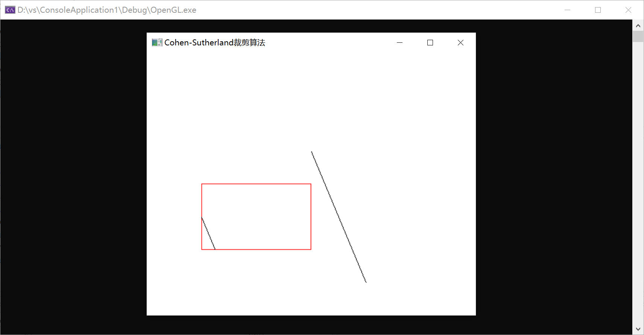

实验九 三维图形几何变换实验

时间：2022年5月11日

地点：信息学院2204机房

1、实验内容：

教材P222，三维图形旋转、缩放变换、平移变换、错切变换、对称变换等任意变换。

2、实验目的：

调用函数完成三维图形几何变换。

3、实验代码：

|  |
| --- |
| #include <GL/glut.h>  #include<stdlib.h>  #include<math.h>  GLsizei winWidth = 600, winHeight = 600;  GLint nVerts = 12;//点的个数  GLfloat tx = 0, ty = 1, tz = 3;//存储要平移的距离  GLfloat angle = 60;//旋转角度  GLfloat scale = 2.0;//缩放比例  typedef GLfloat M4[4][4];  M4 matComposite;  class pt3D {  public:  GLfloat x, y, z;  };  pt3D verts[] = {  { 0.0, 1.0, 0.0 }, { -1.0, -1.0, 1.0 }, { 1.0, -1.0, 1.0 },  { 0.0, 1.0, 0.0 }, { 1.0, -1.0, 1.0 }, { 1.0, -1.0, -1.0 },  { 0.0, 1.0, 0.0 }, { 1.0, -1.0, -1.0 }, { -1.0, -1.0, -1.0 },  { 0.0, 1.0, 0.0 }, { -1.0, -1.0, -1.0 }, { -1.0, -1.0, 1.0 }  };//存放三维物体的各个点坐标，由于有4个三角形面，所以有12个点，设置顶点一致就好，拼接三角形，底面不做绘制  pt3D resultVerts[12];//存放变换后的矩阵，即最新的点坐标  class color {  public:  GLfloat r, g, b;  };  color colors[] = {  { 1.0, 0.0, 0.0 }, { 0.0, 1.0, 0.0 }, { 0.0, 0.0, 1.0 }, { 1.0, 1.0, 0.0 }  };//存放每个面的颜色  void init()  {  glClearColor(1.0, 1.0, 1.0, 0.0);  glOrtho(-5.0, 5.0, -5.0, 5.0, -5.0, 5.0);  glMatrixMode(GL_PROJECTION);  }  void m4SetIdentity(M4 matIdentity4x4)  {  GLint col, row;  for (row = 0; row < 4; row++) {  for (col = 0; col < 4; col++) {  matIdentity4x4[row][col] = (row == col);  }  }  }  void m4PreMultiply(M4 m1, M4 m2)  {  GLint row, col;  M4 matTemp;  for (row = 0; row < 4; row++) {  for (col = 0; col < 4; col++) {  matTemp[row][col] = m1[row][0] * m2[0][col] + m1[row][1] * m2[1][col] + m1[row][2] * m2[2][col] + m1[row][3] * m2[3][col];  }  }  for (row = 0; row < 4; row++) {  for (col = 0; col < 4; col++) {  m2[row][col] = matTemp[row][col];  }  }  }  void translate3D(GLfloat tx, GLfloat ty, GLfloat tz)  {  M4 matTranslate3D;  m4SetIdentity(matTranslate3D);  matTranslate3D[0][3] = tx;  matTranslate3D[1][3] = ty;  matTranslate3D[2][3] = tz;  m4PreMultiply(matTranslate3D, matComposite);  }  void transformVerts3D()  {  GLint k;  for (k = 0; k < nVerts; k++) {  resultVerts[k].x = matComposite[0][0] * verts[k].x + matComposite[0][1] * verts[k].y + matComposite[0][2] * verts[k].z + matComposite[0][3];  resultVerts[k].y = matComposite[1][0] * verts[k].x + matComposite[1][1] * verts[k].y + matComposite[1][2] * verts[k].z + matComposite[1][3];  resultVerts[k].z = matComposite[2][0] * verts[k].x + matComposite[2][0] * verts[k].y + matComposite[2][2] * verts[k].z + matComposite[2][3];  }  }  //画一个三棱锥，每个面设不同的颜色  void draw(pt3D* mat)  {  int j;  for (int i = 0; i < 4; i++) {  glColor3f(colors[i].r, colors[i].g, colors[i].b);  for (j = i * 3; j < i * 3 + 3; j++) {  glVertex3f(mat[j].x, mat[j].y, mat[j].z);  }  }  }  void displayFunc()  {  glClear(GL_COLOR_BUFFER_BIT | GL_DEPTH_BUFFER_BIT);  glRotatef(30, 0.0f, 1.0f, 0.0f);  glBegin(GL_LINES);//画坐标轴，可以省略，主要是为了看旋转变化  glColor3f(1.0, 0.0, 0.0);//y轴红色  glVertex3f(0, 0, 0);  glVertex3f(0, 4, 0);  glColor3f(0.0, 1.0, 0.0);  glVertex3f(0, 0, 0);  glVertex3f(4, 0, 0);//x轴绿色  glColor3f(0.0, 0.0, 1.0);  glVertex3f(0, 0, 0);  glVertex3f(0, 0, 3);//z轴蓝色  glEnd();  glBegin(GL_TRIANGLES); // 绘制三角形  draw(verts);  glEnd();  glLoadIdentity();//不可以省略，否则后面对其它三维物体的变换也会发生在上面已经绘制的物体中  GLfloat scaleBack = 1 / scale;  glRotatef(angle, 0.0, 1.0, 0.0);  glScalef(1.0, scale, 1.0);  //GLfloat tx = 0, ty = 1.0, tz = 3;  m4SetIdentity(matComposite);  translate3D(tx, ty, tz);  transformVerts3D();  glBegin(GL_TRIANGLES);  draw(resultVerts);  glEnd();  glScalef(1.0, scaleBack, 1.0);  glLoadIdentity();  glFlush();  }  /*  键盘设置，下面的还可以改善：当旋转或平移到一定数值时，回到原始状态  */  void processSpecialKeys(int key, int x, int y)  {  switch (key) {  case GLUT_KEY_UP:ty += 0.1; break;  case GLUT_KEY_DOWN:ty -= 0.1; break;  case GLUT_KEY_LEFT:tz += 0.1; break;  case GLUT_KEY_RIGHT:tz -= 0.1; break;  case GLUT_KEY_PAGE_UP:scale += 0.1; break;  case GLUT_KEY_PAGE_DOWN:scale -= 0.1; break;  case GLUT_KEY_INSERT:angle += 10; break;  case GLUT_KEY_END:tx = 0; ty = 1; tz = 3; angle = 60; scale = 2; break;//回到原始状态  default:break;  }  displayFunc();  }  void main(int argc, char** argv)  {  glutInit(&argc, argv);  glutInitDisplayMode(GLUT_SINGLE | GLUT_RGB);  glutInitWindowPosition(50, 50);  glutInitWindowSize(winWidth, winHeight);  glutCreateWindow("3D");  init();  glutDisplayFunc(displayFunc);  glutSpecialFunc(processSpecialKeys);  glutMainLoop();  } |

4、实验结果：

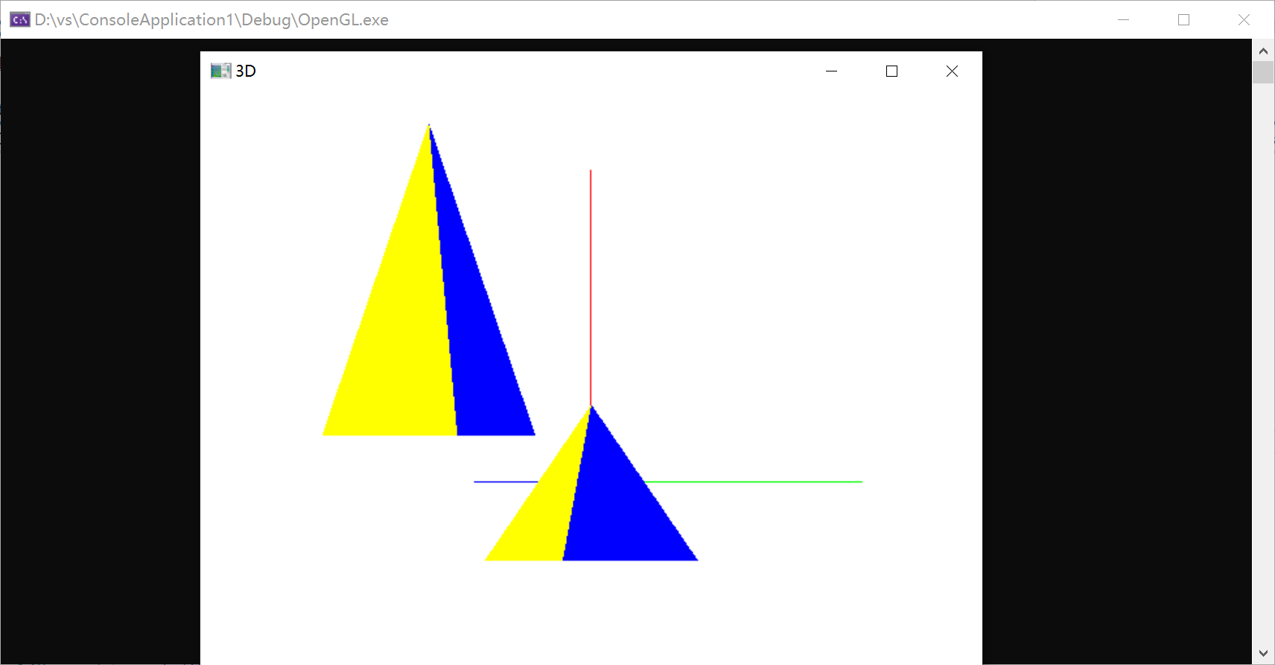

实验十 可编程着色实验

时间：2022年5月17日

地点：信息学院2204机房

1、实验内容：

使用opengl，教材P541，颜色编码建模显示。

2、实验目的：

（1）验证片元着色器算法，获得着色结果；

（2）调用函数完成颜色编码建模实验。

3、实验代码：

|  |
| --- |
| #include<GL/glut.h>  //设置一个窗口的大小  GLsizei winWidth = 500, winHeight = 500;  GLfloat xComplexMin = -2.00, xComplexMax = 0.50;  GLfloat yComplexMin = -1.25, yComplexMax = 1.25;  GLfloat complexWidth = xComplexMax - xComplexMin;  GLfloat complexHeight = yComplexMax - yComplexMin;  class complexNum {  public:  GLfloat x, y;  };  struct color { GLfloat r, g, b; };  void init(void)  {  glClearColor(1.0, 1.0, 1.0, 0.0);  }  void plotpoint(complexNum z)  {  glBegin(GL_POINTS);  glVertex2f(z.x, z.y);  glEnd();  }  complexNum complexSquare(complexNum z)  {  complexNum zSquare;  zSquare.x = z.x * z.x - z.y * z.y;  zSquare.y = 2 * z.x * z.y;  return zSquare;  }  GLint mandelSqTransf(complexNum z0, GLint maxIter)  {  complexNum z = z0;  GLint count = 0;  while ((z.x * z.x + z.y * z.y <= 4.0) && (count < maxIter)) {  z = complexSquare(z);  z.x += z0.x;  z.y += z0.y;  count++;  }  return count;  }  void mandelbrot(GLint nx, GLint ny, GLint maxIter)  {  complexNum z, zIncr;  color ptColor;  GLint iterCount;  zIncr.x = complexWidth / GLfloat(nx);  zIncr.y = complexHeight / GLfloat(ny);  for (z.x = xComplexMin; z.x < xComplexMax; z.x += zIncr.x)  for (z.y = yComplexMin; z.y < yComplexMax; z.y += zIncr.y) {  iterCount = mandelSqTransf(z, maxIter);  if (iterCount >= maxIter)  ptColor.r = ptColor.g = ptColor.b = 0.0;  else if (iterCount > (maxIter / 10)) {  ptColor.r = 1.0;  ptColor.g = 0.5;  ptColor.b = 0.0;  }  else if (iterCount > (maxIter / 10)) {  ptColor.r = 1.0;  ptColor.g = ptColor.b = 0.0;  }  else if (iterCount > (maxIter / 20)) {  ptColor.b = 0.5;  ptColor.r = ptColor.g = 0.0;  }  else if (iterCount > (maxIter / 100)) {  ptColor.r = ptColor.b = 0.0;  ptColor.g = 0.3;  }  else {  ptColor.r = 0.0;  ptColor.g = ptColor.b = 1.0;  }  glColor3f(ptColor.r, ptColor.g, ptColor.b);  plotpoint(z);  }  }  void displayFcn(void)  {  GLint nx = 1000, ny = 1000, maxIter = 1000;  glClear(GL_COLOR_BUFFER_BIT);  mandelbrot(nx, ny, maxIter);  glFlush();  }  void winReshapeFcn(GLint newWidth, GLint newHeight) {  glViewport(0, 0, newHeight, newHeight);  glMatrixMode(GL_PROJECTION);  glLoadIdentity();  gluOrtho2D(xComplexMin, xComplexMax, yComplexMin, yComplexMax);  glClear(GL_COLOR_BUFFER_BIT);  }  void main(int argc, char** argv)  {  glutInit(&argc, argv);  glutInitDisplayMode(GLUT_SINGLE | GLUT_RGB);  glutInitWindowPosition(50, 50);  glutInitWindowSize(winWidth, winHeight);  glutCreateWindow("Mandelbrot 集");  init();  glutDisplayFunc(displayFcn);  glutReshapeFunc(winReshapeFcn);  glutMainLoop();  } |

4、实验结果：

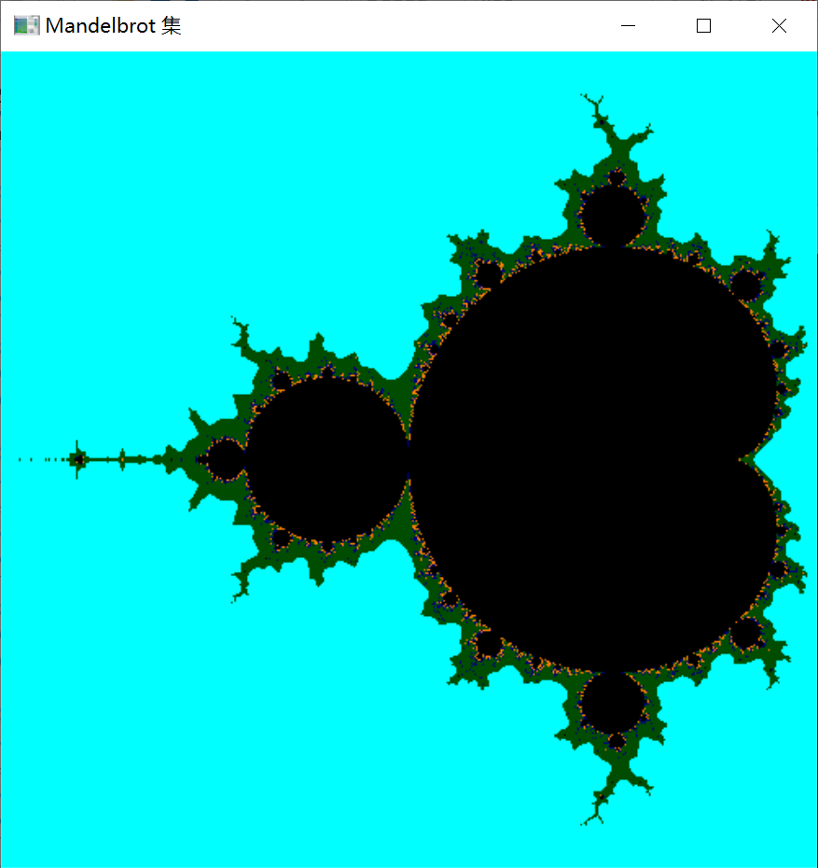

实验十一 交互控制实验

时间：2022年5月17日

地点：信息学院2204机房

1、实验内容：

使用opengl，完成鼠标、键盘交互操作。

2、实验目的：

熟悉鼠标、键盘交互。

3、实验代码：

|  |
| --- |
| #include<GL/glut.h>  #include<stdio.h>  GLsizei winWidth = 500, winHeight = 500;  char sixel;  float thera = 0;  float x = 0, y = 0, z = 0;  void init(void) {  glClearColor(1.0, 1.0, 1.0, 0.0);  }  void displayWirePolyhedra(float x, float y, float z, float thera) {  glClear(GL_COLOR_BUFFER_BIT);  glColor3f(0.0, 0.0, 1.0);  gluLookAt(5.0, 5.0, 5.0, 0.0, 0.0, 0.0, 0.0, 1.0, 0.0);  glScalef(1.0, 1.0, 1.0);  glTranslatef(1.0, 2.0, 0.0);//下一个图形坐标  glutSolidTeapot(1.5);  //glutWireTeapot(1.5);//放大倍数  glScalef(1.0, 1.0, 1.0);//缩放比  glTranslatef(-1.0, -5.0, 0.0);//下一个图形坐标  glRotatef(thera, x, y, z);  glutWireTeapot(1.5);  //glutSolidTeapot(2.0);  glFlush();  }  void display() {  displayWirePolyhedra(x, y, z, thera);  }  void winReshapeFcn(GLint newWidth, GLint newHeight) {  glViewport(0, 0, newWidth, newHeight);  glMatrixMode(GL_PROJECTION);  glFrustum(-1.0, 1.0, -1.0, 1.0, 2.0, 20.0);  glMatrixMode(GL_MODELVIEW);  glClear(GL_COLOR_BUFFER_BIT);  }  void main(int argc, char** argv) {  glutInit(&argc, argv);  glutInitDisplayMode(GLUT_SINGLE | GLUT_RGB);  glutInitWindowPosition(100, 100);  glutInitWindowSize(winWidth, winHeight);  glutCreateWindow(" ");  init();  printf_s("请选择绕拿一个轴旋转x,y,z \n");  scanf_s("%c", &sixel);  getchar();  if (sixel == 'x') {  x = 1.0;  y = 0.0;  z = 0.0;  printf_s("请输入旋转的角度\n");  scanf_s("%f", &thera);  }  else if (sixel == 'y') {  x = 0.0;  y = 1.0;  z = 0.0;  printf_s("请输入旋转的角度\n");  scanf_s("%f", &thera);  }  else if (sixel == 'z') {  x = 0.0;  y = 0.0;  z = 1.0;  printf_s("请输入旋转的角度\n");  scanf_s("%f", &thera);  }  else {  printf_s("输入有误\n");  }  glutDisplayFunc(display);  glutReshapeFunc(winReshapeFcn);  glutMainLoop();  } |

4、实验结果：

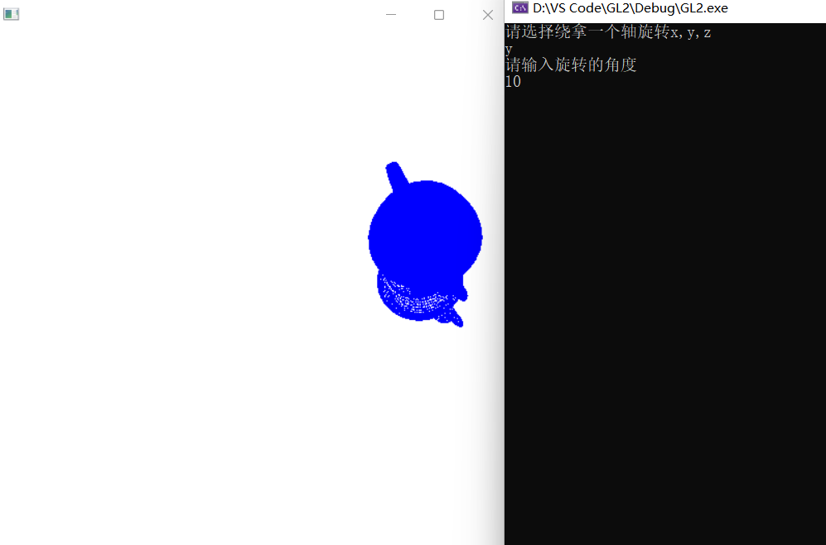

实验十二 三维观察实验

时间：2022年5月25日

地点：信息学院2204机房

1、实验内容：

（1）使用opengl，完成投影变换等实验；

（2）P 264 。

2、实验目的：

熟悉三维观察相关内容。

3、实验代码：

（1）使用opengl，完成投影变换等实验：

|  |
| --- |
| #include <stdlib.h>  #include <GL/glut.h>  float theta = 0.0;  void drawPyramid() //该金字塔在以原点为中心，边长为2的立方体范围内  {  glBegin(GL_TRIANGLES);  glColor3f(1.0f, 0.0f, 0.0f); //前面为红色  glVertex3f(0.0f, 1.0f, 0.0f); //前面三角形上顶点  glVertex3f(-1.0f, -1.0f, 1.0f); //前面三角形左顶点  glVertex3f(1.0f, -1.0f, 1.0f); //前面三角形右顶点  glColor3f(0.0f, 1.0f, 0.0f); //右面为绿色  glVertex3f(0.0f, 1.0f, 0.0f); //右面三角形上顶点  glVertex3f(1.0f, -1.0f, 1.0f); //右面三角形左顶点  glVertex3f(1.0f, -1.0f, -1.0f); //右面三角形右顶点  glColor3f(0.0f, 0.0f, 1.0f); //背面为蓝色  glVertex3f(0.0f, 1.0f, 0.0f); //背面三角形上顶点  glVertex3f(1.0f, -1.0f, -1.0f); //背面三角形左顶点  glVertex3f(-1.0f, -1.0f, -1.0f); //背面三角形右顶点  glColor3f(1.0f, 1.0f, 0.0f); //左面为黄色  glVertex3f(0.0f, 1.0f, 0.0f); //左面三角形上顶点  glVertex3f(-1.0f, -1.0f, -1.0f); //左面三角形左顶点  glVertex3f(-1.0f, -1.0f, 1.0f); //左面三角形右顶点  glEnd();  glBegin(GL_POLYGON); //金字塔底面正方形  glColor3f(0.5f, 0.5f, 0.5f); //底面为灰色  glVertex3f(-1.0f, -1.0f, 1.0f);  glVertex3f(1.0f, -1.0f, 1.0f);  glVertex3f(1.0f, -1.0f, -1.0f);  glVertex3f(-1.0f, -1.0f, -1.0f);  glEnd();  }  void display()  {  glClear(GL_COLOR_BUFFER_BIT | GL_DEPTH_BUFFER_BIT); //清空颜色和深度缓存  glMatrixMode(GL_MODELVIEW);  glLoadIdentity();  //gluLookAt(2.0, 2.0, 2.0, 0.0, 0.0, 0.0, 0.0, 1.0, 0.0);  glTranslatef(0.0f, 0.0f, -5.0f);  glRotatef(theta, 0.0f, 1.0f, 0.0f);  drawPyramid();  glutSwapBuffers();  }  void reshape(int w, int h) //重绘回调函数，在窗口首次创建或用户改变窗口尺寸时被调用  {  glViewport(0, 0, w, h);  glMatrixMode(GL_PROJECTION);  glLoadIdentity();  //glFrustum(-1.0, 1.0, -1.0, 1.0, 3.1, 10.0);  //gluPerspective(45,1,0.1,10.0);  glOrtho(-2.0, 2.0, -2.0, 2.0, 2.0, 10.0);  }  void init()  {  glClearColor(1.0, 1.0, 1.0, 1.0);  glEnable(GL_DEPTH_TEST); //启动深度测试模式  }  void myKeyboard(unsigned char key, int x, int y)  {  if (key == 'a' || key == 'A')  theta += 5.0;  if (key == 's' || key == 'S')  theta -= 5.0;  if (key == 'c' || key == 'C')  exit(0);  if (theta > 360) theta -= 360;  if (theta < 0) theta += 360;  glutPostRedisplay(); //重新调用绘制函数  }  int main(int argc, char** argv)  {  glutInit(&argc, argv);  glutInitDisplayMode(GLUT_DEPTH | GLUT_DOUBLE | GLUT_RGB);  glutInitWindowSize(500, 500);  glutInitWindowPosition(0, 0);  glutCreateWindow("金字塔---A键:顺时针旋转,S键:逆时针旋转,C键:退出");  glutReshapeFunc(reshape); //指定重绘回调函数  glutDisplayFunc(display);  glutKeyboardFunc(myKeyboard); //指定键盘回调函数  init();  glutMainLoop();  } |

（2）P 264 ：

|  |
| --- |
| #include<GL/glut.h>  GLint winWidth = 600, winHeight = 600; // Initialdisplay - window size  GLfloat x0 = 100.0, y0 = 50.0, z0 = 50.0;  GLfloat xref = 50.0, yref = 50.0, zref = 0.0;// Viewing - coordinate origin  GLfloat Vx = 0.0, Vy = 1.0, Vz = 0.0;  GLfloat xwMin = -40.0, ywMin = -60.0, xwMax = 40.0, ywMax = 60.0;  GLfloat dnear = 25.0, dfar = 125.0;  void init(void) {  glClearColor(1.0, 1.0, 1.0, 0.0);  glMatrixMode(GL_MODELVIEW);  gluLookAt(x0, y0, z0, xref, yref, zref, Vx, Vy, Vz);  glMatrixMode(GL_PROJECTION);  glFrustum(xwMin, xwMax, ywMin, ywMax, dnear, dfar);  }  void displayFcn(void) {  glClear(GL_COLOR_BUFFER_BIT);  /*Set parameters for a square fi11 area. */  glColor3f(0.0, 1.0, 0.0);  glPolygonMode(GL_FRONT, GL_FILL);  glPolygonMode(GL_BACK, GL_LINE);  glBegin(GL_QUADS);  glVertex3f(0.0, 0.0, 0.0);  glVertex3f(100.0, 0.0, 0.0);  glVertex3f(100.0, 100.0, 0.0);  glVertex3f(0.0, 100.0, 0.0);  glEnd();  glFlush();  }  void reshapeFcn(GLint newWidth, GLint newHeight) {  glViewport(0, 0, newWidth, newHeight);  winWidth = newWidth;  winHeight = newHeight;  }  void main(int argc, char** argv) {  glutInit(&argc, argv);  glutInitDisplayMode(GLUT_SINGLE | GLUT_RGB);  glutInitWindowPosition(50, 50);  glutInitWindowSize(winWidth, winHeight);  glutCreateWindow("Perspective View of A Square");  init();  glutDisplayFunc(displayFcn);  glutReshapeFunc(reshapeFcn);  glutMainLoop();  } |

4、实验结果：

（1）使用opengl，完成投影变换等实验：

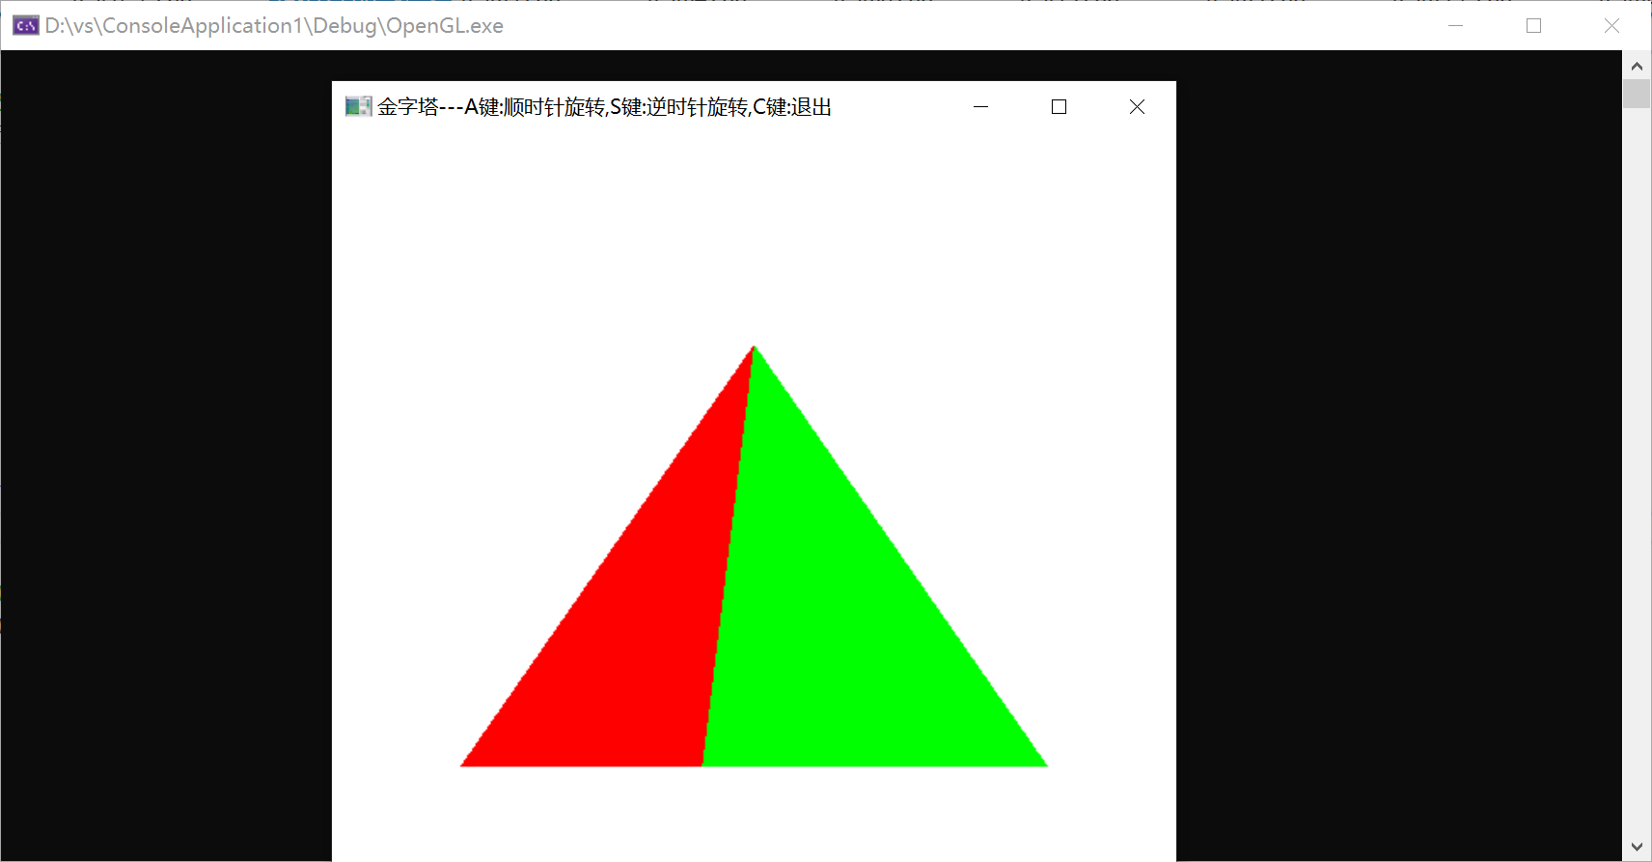

（2）P 264：

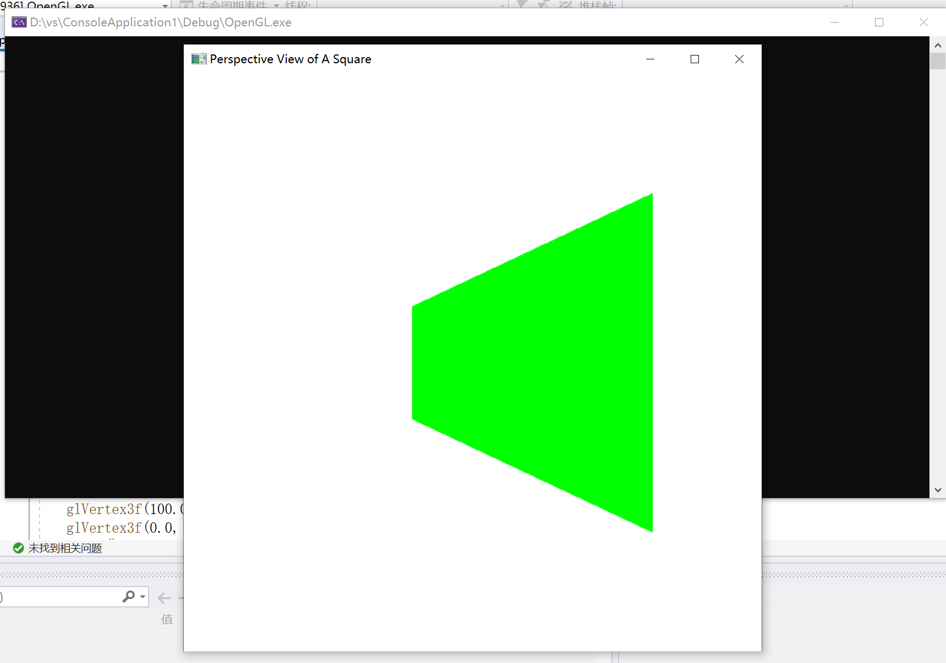

实验十三 多面体实验

时间：2022年6月1日

地点：信息学院2204机房

1、实验内容：

生成多面体线框图，P300、P307。

2、实验目的：

熟悉三维线框图相关内容。

3、实验代码：

（1）P300：

|  |
| --- |
| #include <windows.h>  #include <GL/glut.h>  GLsizei winWidth = 500, winHeight = 500;  void init(void) {  glClearColor(1.0, 1.0, 1.0, 0.0);  }  void displayWirePolyhedra(void) {  glClear(GL_COLOR_BUFFER_BIT);  glColor3f(0.0, 0.0, 1.0);  gluLookAt(5.0, 5.0, 5.0, 0.0, 0.0, 0.0, 0.0, 1.0, 0.0);  glScalef(1.5, 2.0, 1.0);  glutWireCube(1.0);  glScalef(0.8, 0.5, 0.8);  glTranslatef(-6.0, -5.0, 0.0);  glutWireDodecahedron();  glTranslatef(8.6, 8.6, 2.0);  glutWireTetrahedron();  glTranslatef(-3.0, -1.0, 0.0);  glutWireOctahedron();  glScalef(0.8, 0.8, 1.0);  glTranslatef(4.3, -2.0, 0.5);  glutWireIcosahedron();  glFlush();  }  void winReshapeFcn(GLint newWidth, GLint newHeight) {  glViewport(0, 0, newWidth, newHeight);  glMatrixMode(GL_PROJECTION);  glFrustum(-1.0, 1.0, -1.0, 1.0, 2.0, 20.0);  glMatrixMode(GL_MODELVIEW);  glClear(GL_COLOR_BUFFER_BIT);  }  int main(int argc, char** argv) {  glutInit(&argc, argv);  glutInitDisplayMode(GLUT_SINGLE | GLUT_RGB);  //glutInitWindowPosition(100, 100);  //glutInitWindowSize(winWidth, winHeight);  int cx = glutGet(GLUT_SCREEN_WIDTH);  int cy = glutGet(GLUT_SCREEN_HEIGHT);  glutInitWindowPosition((cx - winWidth) / 2, (cy - winHeight) / 2);  glutInitWindowSize(winWidth, winHeight);  glutCreateWindow("Wire-Frame Po1yhedra");  init();  glutDisplayFunc(displayWirePolyhedra);  glutReshapeFunc(winReshapeFcn);  glutMainLoop();  } |

（2）P307：

|  |
| --- |
| #include<GL/glut.h>  GLint winWidth = 600, winHeight = 600; // Initialdisplay - window size  GLfloat x0 = 100.0, y0 = 50.0, z0 = 50.0;  GLfloat xref = 50.0, yref = 50.0, zref = 0.0;// Viewing - coordinate origin  GLfloat Vx = 0.0, Vy = 1.0, Vz = 0.0;  GLfloat xwMin = -40.0, ywMin = -60.0, xwMax = 40.0, ywMax = 60.0;  GLfloat dnear = 25.0, dfar = 125.0;  void init(void) {  glClearColor(1.0, 1.0, 1.0, 0.0);  glMatrixMode(GL_MODELVIEW);  gluLookAt(x0, y0, z0, xref, yref, zref, Vx, Vy, Vz);  glMatrixMode(GL_PROJECTION);  glFrustum(xwMin, xwMax, ywMin, ywMax, dnear, dfar);  }  void displayFcn(void) {  glClear(GL_COLOR_BUFFER_BIT);  /*Set parameters for a square fi11 area. */  glColor3f(0.0, 1.0, 0.0);  glPolygonMode(GL_FRONT, GL_FILL);  glPolygonMode(GL_BACK, GL_LINE);  glBegin(GL_QUADS);  glVertex3f(0.0, 0.0, 0.0);  glVertex3f(100.0, 0.0, 0.0);  glVertex3f(100.0, 100.0, 0.0);  glVertex3f(0.0, 100.0, 0.0);  glEnd();  glFlush();  }  void reshapeFcn(GLint newWidth, GLint newHeight) {  glViewport(0, 0, newWidth, newHeight);  winWidth = newWidth;  winHeight = newHeight;  }  void main(int argc, char** argv) {  glutInit(&argc, argv);  glutInitDisplayMode(GLUT_SINGLE | GLUT_RGB);  glutInitWindowPosition(50, 50);  glutInitWindowSize(winWidth, winHeight);  glutCreateWindow("Perspective View of A Square");  init();  glutDisplayFunc(displayFcn);  glutReshapeFunc(reshapeFcn);  glutMainLoop();  } |

4、实验结果：

（1）P300:

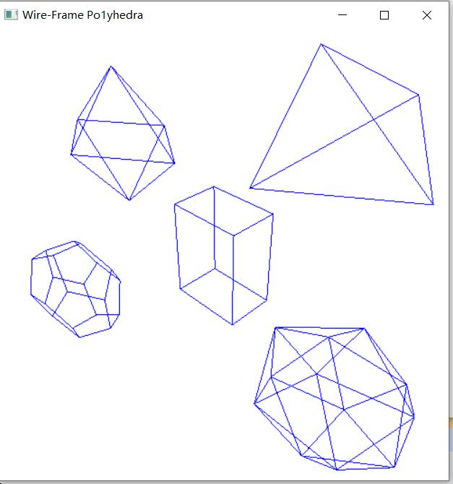

（2）P307：

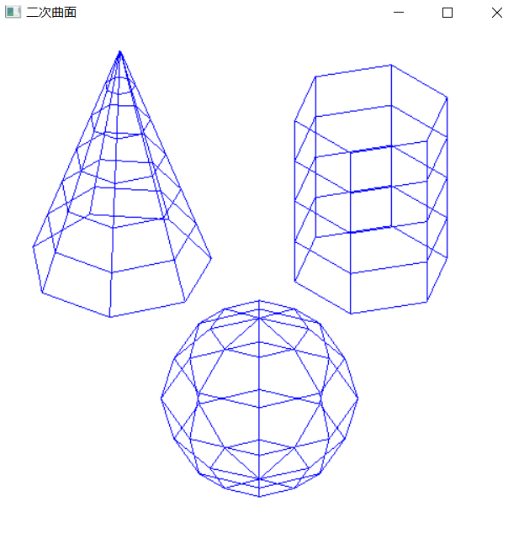

实验十四 曲线曲面生成实验

时间：2022年6月7日

地点：信息学院2204机房

1、实验内容：

生成曲线或者曲面，P323

2、实验目的：

熟悉Bezier、样条等相关内容

3、实验代码：

|  |
| --- |
| #include <GL/glut.h>  #include <stdio.h>  #include <math.h>  GLsizei winWIdth = 600, winHeight = 600;  GLfloat xwcMin = -50.0, xwcMax = 50.0, ywcMin = -50.0, ywcMax = 50.0;  class wcPt3D  {  public: GLfloat x, y, z;  };  void init(void)  {  glClearColor(1.0, 1.0, 1.0, 0.0);  }  void plotPoint(wcPt3D p)  {  glBegin(GL_POINTS);  glVertex2f(p.x, p.y);  glEnd();  }  void binomialCoeffs(GLint n, GLint* C)  {  GLint i, j;  for (i = 0; i <= n; i++)  {  C[i] = 1;  for (j = n; j >= i + 1; j--)  {  C[i] *= j;  }  for (j = n - i; j >= 2; j--)  {  C[i] /= j;  }  }  }  void computeBezPt(GLfloat u, wcPt3D* bezPt, GLint nCtrlPts, wcPt3D* ctrlPts, GLint* C)  {  GLint i, j = nCtrlPts - 1;  GLfloat bezBlendFcn;  bezPt->x = bezPt->y = bezPt->z = 0.0;  for (i = 0; i < nCtrlPts; i++)  {  bezBlendFcn = C[i] * pow(u, j) * pow(1 - u, j - i);  bezPt->x += ctrlPts[i].x * bezBlendFcn;  bezPt->y += ctrlPts[i].y * bezBlendFcn;  bezPt->z += ctrlPts[i].z * bezBlendFcn;  }  }  void bezier(wcPt3D* ctrlPts, GLint nCtrlPts, GLint nBezPts)  {  GLint* C, k;  GLfloat u;  wcPt3D bezPt;  C = new GLint[nCtrlPts];  binomialCoeffs(nCtrlPts - 1, C);  for (k = 0; k <= nBezPts; k++)  {  u = GLfloat(k) / GLfloat(nBezPts);  computeBezPt(u, &bezPt, nCtrlPts, ctrlPts, C);  plotPoint(bezPt);  }  delete[] C;  }  void displayFcn(void)  {  GLint nCtrlPts = 4, nBezCurvePts = 1000;  wcPt3D ctrlPts[4] = {  {-40.0, -40.0, 0.0},  {-10.0, 200.0, 0.0},  {10.0, -200.0, 0.0},  {40.0, 40.0, 0.0} };  glClear(GL_COLOR_BUFFER_BIT);  glPointSize(4);  glColor3f(1.0, 0.0, 0.0);  bezier(ctrlPts, nCtrlPts, nBezCurvePts);  glFlush();  }  void winReshapeFcn(GLint newWidth, GLint newHeight)  {  glViewport(0, 0, newWidth, newHeight);  glMatrixMode(GL_PROJECTION);  glLoadIdentity();  gluOrtho2D(xwcMin, xwcMax, ywcMin, ywcMax);  glClear(GL_COLOR_BUFFER_BIT);  }  void main(int argc, char** argv)  {  glutInit(&argc, argv);  glutInitDisplayMode(GLUT_SINGLE | GLUT_RGB);  glutInitWindowPosition(50, 50);  glutInitWindowSize(winWIdth, winHeight);  glutCreateWindow("Bezier Curve");  init();  glutDisplayFunc(displayFcn);  glutReshapeFunc(winReshapeFcn);  glutMainLoop();  } |

4、实验结果：

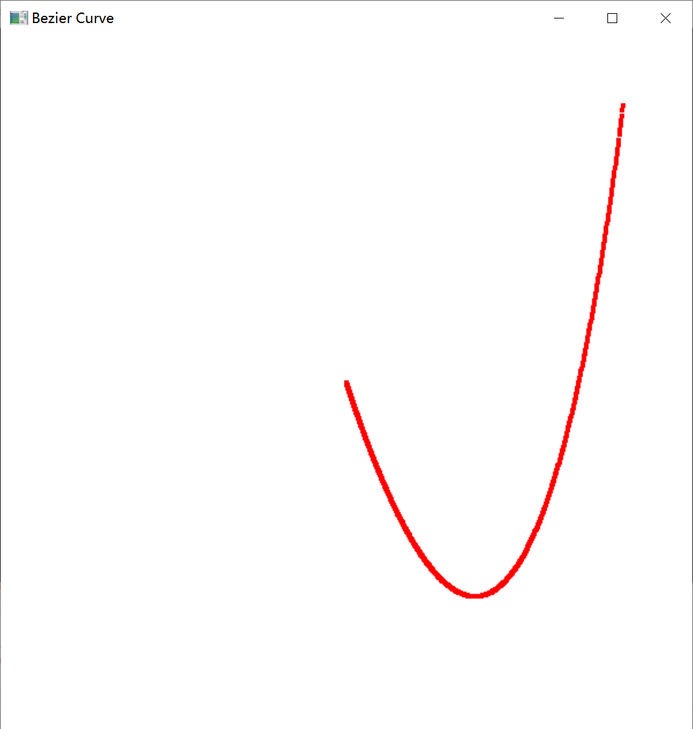

实验十五 曲线曲面生成实验

时间：2022年6月15日

地点：信息学院2204机房

1、实验内容：

完成消隐实验，采用Z-buffer算法完成消隐。

2、实验目的：

熟悉Z-buffer 、画家算法等相关内容。

3、实验代码：

|  |
| --- |
| import cv2  import numpy as np  import time  XLine=1000  YLine=700  img  =  np.zeros((YLine, XLine, 3), np.uint8)#生成背景  pts=[]  z_buffer=np.zeros((XLine,YLine),np.uint32)  z_buffer+=100000  #无穷大  #为了满足需求而设置的值  count=0  def zfunc(x,y):      return x+y  def draw_func(event, x, y, flags, param):      global pts      if event == cv2.EVENT_LBUTTONDOWN:          print('(x:',x,',y:',y,')')          str1 = '(x:'+ str(x) + ',y:'+ str(y) + ')'          #cv2.putText(img,str1 , (x, y), cv2.FONT_HERSHEY_PLAIN,1.0, (0, 0, 255), thickness=1)          cv2.circle(img,(x,y),1,(0,255,0),thickness=1)          pts.append([x,y])  #活性边表与新边表中的节点  class Node:      def __init__(self,xmin,ymax,k1,next=None):          self.x=xmin#也就是x的初始值          self.ymax=ymax          self.k1=k1#也就是δx          self.next=next      def print(self):          t=self          while t!=None:              print(t.x,t.ymax,t.k1,end="-->")              t=t.next          print()  def FillPoly(fpts,color):      global z_buffer,count      count+=1      #cv2.fillPoly(img,fpts,color)      Ymin,Ymax=1000000,0      for pt in fpts:          if Ymin>pt[1]:              Ymin=pt[1]          if Ymax<pt[1]:              Ymax=pt[1]        #构造新边表      NET=[x for x in range(Ymax+1)]      for i in range(len(fpts)):          #后面一个点的序号          j=i+1 if i<len(fpts)-1 else 0          if fpts[i][1]>fpts[j][1]:              ymax,ymin=fpts[i][1],fpts[j][1]              xmin=fpts[j][0]          else:              ymin,ymax=fpts[i][1],fpts[j][1]              xmin=fpts[i][0]          #与x轴平行,跳过该边          if fpts[i][1]==fpts[j][1]:              continue          if fpts[i][0]==fpts[j][0]:              k1=0          else:              k1=(fpts[i][0]-fpts[j][0])/(fpts[i][1]-fpts[j][1])          if type(NET[ymin])!=type(66):              t=NET[ymin]              while t.next!=None:                  t=t.next              t.next=Node(xmin,ymax,k1)          else:              NET[ymin]=Node(xmin,ymax,k1)      for i,x in enumerate(NET):          if type(x)!=type(66):              print(i)              x.print()      AET=Node(0,0,0)      print("YY")      for y in range(Ymin,Ymax+1):          #print(y)          #慢慢画          cv2.waitKey(3)          cv2.imshow('src',img)          #加入新边          if type(NET[y])!=type(66):              t=AET              while t.next:                  t=t.next              t.next=NET[y]          #填充颜色          #按x排序          xs=[]          t=AET          while t.next:              t=t.next              xs.append(t.x)          xs=sorted(xs)          for i in range(1,len(xs),2):              for x in range(int(xs[i-1]),int(xs[i])):                  #z=zfunc(x,y)  这里是zbuffer消隐操作                  z=count                  if z==3 and z_buffer[x,y]==1:#这里是为了交作业 ヽ(ﾟ▽ﾟ)ノ                      z_buffer[x,y]=z                      cv2.circle(img,(x,y),1,color,thickness=1)                  elif z<z_buffer[x,y]:                      z_buffer[x,y]=z                      cv2.circle(img,(x,y),1,color,thickness=1)          #删除并更新边          t=AET          while t.next:              ct=t.next              ct.x+=ct.k1              if ct.ymax==y:                  t.next=ct.next              t=t.next              if t==None:                  break    cv2.namedWindow('src')  cv2.setMouseCallback('src',draw_func)  while(1):      cv2.imshow('src',img)      code=cv2.waitKey(100)      if code == ord('q'):#按下q退出          break      elif code == ord('e'):#按下该键表示画完一个多边形          tmp=np.array(pts,np.int32)          tmp=[tmp.reshape((-1,1,2))]          fpts=pts          pts=[]          #cv2.polylines(img,tmp,True,(255,255,255))      #按下 r,g,b 填充多边形为相应的颜色      elif code == ord('r'):          FillPoly(fpts,(0,0,255))      elif code == ord('y'):          FillPoly(fpts,(0,255,255))      elif code == ord('b'):          FillPoly(fpts,(255,0,0))  cv2.destroyAllWindows() |

4、实验结果：

