
From Survey Data to Actionable Risk Lists: Next-Year Prediction in MEPS
Machine-learning risk ranking for high cost, emergency department use, and inpatient events with age- and sex-based subgroup evaluation

Wenxi gu
universidad complutense de madrid
Máster Data Science, Big Data & Business Analytics 2025-2026
FEBRUARY 17, 2026

1. Executive Summary

Healthcare systems and insurers need to identify individuals at risk of high future costs and acute events (emergency department (ED) visits and inpatient stays) to allocate limited care management resources efficiently. This thesis develops and evaluates person-level prediction models using the MEPS Household Component, Panel 27 (2022–2023; HC-252).

Using Year-1 information to predict Year-2 outcomes, we study four targets: (i)Year-2 total expenditures(log‑transformed), (ii) Year-2 high-cost status, (iii) any ED visit in Year-2, and (iv) any inpatient stay in Year-2. We compare baseline regression models with machine-learning approaches and evaluate performance using ranking-focused metrics suitable for imbalanced outcomes, complemented by subgroup robustness checks.

Overall, results support using the models better suited for ranking/selection than predicting exact outcomes for each individual. The predictive signal is strongest for high-cost status, moderate for ED risk, and weakest for inpatient events, likely because inpatient events are often driven by acute shocks not captured in Year‑1 survey data. Across the four targets (log‑cost, high‑cost, ED, IP), prior-year spending and utilization are the most informative predictors, with additional contributions from age, insurance and baseline health indicators. Finally, we present a lightweight MVP (“Health Outcome Predictor”) illustrating how top-k selection and clear outputs can translate model results into an actionable decision workflow.

2. Problem Statement & Hypotheses

2.1 Problem Statement
Healthcare spending in the United States is highly concentrated: a very small share of individuals accounts for a disproportionately large fraction of total expenditures. Recent analyses using the Medical Expenditure Panel Survey (MEPS) Household Component show that in 2022 the top 5% of spenders accounted for roughly half of all healthcare expenditures, while the bottom 50% accounted for less than 3%. (Hernandez-Viver & Mitchell, 2025) Identifying such high-cost individuals prospectively and understanding the drivers of their spending is a central challenge for healthcare systems and insurers.
The Medical Expenditure Panel Survey – Household Component (MEPS-HC) is a nationally representative longitudinal survey of the U.S. civilian non-institutionalized population, following each panel for five interviews over two calendar years and collecting detailed information on health status, medical conditions, utilization, expenditures and insurance coverage. (Cohen, 1997) Panel 27 (2022–2023), released as the longitudinal file HC-252, links person-level information across two full years and is therefore well suited to studying how Year-1 characteristics predict Year-2 outcomes.
Prior research using MEPS has demonstrated that information on chronic conditions, self-reported health and functional limitations substantially improves prediction of future high expenditures compared with models using only age and gender. (Fleishman & Cohen, 2010) Beyond clinical factors, social determinants of health and socio-economic status have been shown to be strongly associated with health care expenditures and to vary in their impact across insurance types. (Mohan & Gaskin, 2024) A large literature also documents that ED visits and hospitalizations are concentrated among patients with specific demographic, socio-economic and clinical profiles, suggesting that these events may be predictable from prior information. (Sun et al., 2003)
At the same time, there is growing evidence that prediction algorithms in healthcare can systematically under-serve certain groups. For example, a widely used commercial risk-stratification algorithm that relied on past costs as a proxy for health needs was shown to substantially underestimate the needs of black patients compared with white patients at the same risk score. (Obermeyer et al., 2019) More recent work has explicitly evaluated fairness metrics for machine-learning models predicting hospitalization and ED visits, finding sizeable performance gaps across demographic and socio-economic subgroups. (Davoudi et al., 2024)
Against this background, the central problems addressed in this thesis are:
- Prospective prediction of total expenditures.
How accurately can Year-2 total health care expenditures be predicted from information available at the end of Year-1, including socio‑economic status (SES), insurance coverage, baseline health and prior utilization?
- Identification of high-cost individuals.
Can we reliably classify individuals into high-cost versus non-high-cost groups for Year-2, and which predictors are most important for this classification?
- Prediction of acute events.
To what extent can Year-2 emergency room visits, and inpatient stays be predicted using Year-1 characteristics and prior utilization patterns?
- Equity and subgroup performance.
Do model performance and prediction errors differ systematically across subgroups defined by age, sex, income and insurance type, and what are the implications for equity and potential bias?
- Practical use and productization.
How could a prediction model based on MEPS variables be translated into a simple, explainable tool that could support decision-making in practice, for example in an insurer or care-management context?

2.2 Research Questions and Hypotheses
Building on prior work on high-cost patients, predictors of future expenditures and acute utilization, and emerging evidence on fairness in health-care prediction models, this thesis formulates the following research questions (RQ) and Hypotheses (H):
RQ1. Which individual-level factors are most strongly associated with Year-2 total health care expenditures?
- H1. Higher baseline expenditures, a greater burden of chronic conditions and poorer self-reported health are associated with higher Year-2 total expenditures, even after adjusting for socio-economic and insurance covariates. (Fleishman & Cohen, 2010; Mohan & Gaskin, 2024)
RQ2. How well can we distinguish high-cost individuals in Year-2 using Year-1 information?
- H2. Models that combine socio-demographic variables, poverty status, insurance type, chronic conditions and prior utilization will achieve substantially better discrimination of high-cost individuals than simple baselines based only on age and prior spending. (Fleishman & Cohen, 2010)
RQ3. Which factors predict Year-2 emergency room visits and inpatient stays?
- H3. Lack of insurance or gaps in coverage, lower socio-economic status and higher baseline use of emergency and inpatient services are associated with increased risk of Year-2 ED visits and hospitalizations. (Sun et al., 2003; Mohan & Gaskin, 2024)
RQ4. Is model performance consistent across socio-demographic and/or insurance subgroups?
- H4. Prediction errors and discrimination metrics differ across subgroups defined by income, race/ethnicity and insurance type, reflecting underlying structural differences in access to care and utilization patterns. These differences may raise fairness concerns that need to be explicitly assessed and discussed. (Obermeyer et al., 2019; Davoudi et al., 2024)
These research questions and Hypotheses guide the design of the empirical analysis, the choice of variables and outcomes, and the evaluation strategy for the prediction models developed in subsequent chapters.

3. Data & Sampling Design

3.1 The Medical Expenditure Panel Survey
The empirical analysis is based on the Medical Expenditure Panel Survey – Household Component (MEPS-HC), conducted by the U.S. Agency for Healthcare Research and Quality (AHRQ) and the National Center for Health Statistics.
MEPS uses an overlapping panel design: each household panel is followed for five interview rounds over approximately 2 years, covering two full calendar years of data. In any given year, information is collected from two panels: one in its first year of data collection and one in its second. Annual full-year consolidated files summaries person-level information for each calendar year, while separate longitudinal files link the two years for each panel.
Detailed information on the design and data-collection procedures of the MEPS Household Component, including the construction of person-level weights and the variance-estimation strata and primary sampling units—is provided in Cohen’s (1997) methodology report Design and Methods of the Medical Expenditure Panel Survey Household Component.

3.2 Panel 27 and the HC-252 Longitudinal File
This thesis uses the Panel 27 Longitudinal Data File, HC-252, which links the 2022 and 2023 full-year consolidated files HC-243 and HC-251 at the individual level. HC-252 contains one record per sampled individual and provides:
- survey administration and panel participation variables.
- demographic and socio-economic characteristics.
- health insurance coverage and employment variables.
- self-reported health status and priority health conditions.
- annual utilization and expenditure summaries for 2022 (Year-1) and 2023 (Year-2).
- person-level longitudinal weights (LONGWT) and variance estimation variables (VARSTR, VARPSU). VARSTR and VARPSU are survey design variables used for variance estimation under complex sampling.
The public-use HC-252 file includes 8,292 individuals and 2,648 variables. For the present analysis, the official Excel version of HC-252 (h252.xlsx) was imported into Python and used as the raw dataset.

3.3 Initial Sample and Panel Participation
At the current stage of the work, no sample restriction has yet been applied in the data file: all 8,292 records in HC-252 are retained in the raw DataFrame (df_raw). Several variables, however, are specifically designed to support the construction of appropriate analytic samples for longitudinal analysis:
- DUPERSID: a unique person identifier that can be used to link across MEPS files.
- PANEL: the panel number (27 for all observations in HC-252).
- YEARIND: indicator of whether an individual is in scope for both years or only one calendar year.
- ALL5RDS: indicator that the person is in scope and has data in all five interview rounds.
- DIED, INST, MILITARY, ENTRSRVY, LEFTUS, OTHER: variables describing death during the panel, institutionalization, active-duty military status, late entry into the survey, leaving the U.S., and other special situations.
In later stages of the thesis, these variables will be used to define a main analytic sample that represents individuals in scope for both calendar years and with complete longitudinal information (for example, restricting to YEARIND=1 and ALL5RDS=1).
For survey-weighted analysis, HC-252 provides a longitudinal person weight LONGWT, which allows estimates to be generalized to the U.S. civilian non-institutionalized population for the 2022–2023 period, and design variables VARSTR and VARPSU for variance estimation under the complex sample design.

3.4 Selection of Core Variables
Given the very high dimensionality of the raw HC-252 file (2,648 variables), we concluded a key early design decision was to define a manageable and conceptually coherent set of core variables to be used for exploratory data analysis and modelling. Using the official codebooks and documentation for HC-252, HC-243 and HC-251, we systematically reviewed variable labels and the variable-source crosswalks to identify variables in the following domains:
- identification and survey design.
- demographics (age, sex, race/ethnicity, region).
- socio-economic status and family structure (family income, poverty status, household size).
- health insurance coverage and employment.
- self-reported general and mental health.
- priority chronic conditions (e.g. hypertension, diabetes, coronary heart disease, stroke, asthma, high cholesterol).
- year-specific utilization and expenditures, including total health care expenditures, emergency room visits, inpatient discharges, and expenditure by payer type.
These variables were assembled manually into a white-list selected based on literature relevance, Year‑1 availability, missingness, and interpretability, and implemented in a Python function select_core_columns() within the project’s preprocessing module. Applying this function to the raw dataset produces a reduced DataFrame (df_core) that retains all 8,292 individuals but only 103 variables, corresponding to the chosen core set.

4. Phase I – Exploratory Data Analysis

4.1 Light preprocessing
Before descriptive analysis, a minimal cleaning step was applied to the consolidated dataset: (i) MEPS special missing codes were recoded to standard missing values (NaN); (ii) any remaining logically invalid negative values in expenditure/payment variables were set to missing; and (iii) the sample was restricted to individuals observed in both calendar years with all five rounds (YEARIND=1, ALL5RDS=1). After these steps, the analytic sample includes 7,812 individuals. No outlier removal or imputation was performed at this stage; these are addressed in Phase II for model-ready feature construction.

4.2 Overview of predictors (high-level)
The dataset covers the full life course with a near-balanced sex distribution, and includes substantial socio-economic heterogeneity (income is strongly right-skewed and poverty categories are used for subgroup stratification in descriptive analysis). Insurance coverage is relatively stable across years, with private and public coverage representing the majority of individuals. Health status measures show that most respondents report good-to-excellent health, while chronic conditions (e.g., hypertension, diabetes, asthma) are prevalent enough to provide meaningful clinical signals. Detailed distributions for demographics/SES, insurance/employment, and health variables are provided in Appendix A (Figures A.1–A.7).

4.3 Missing data patterns
At the group level, average missingness is lowest for demographics, SES, insurance coverage and utilization/cost variables; higher missingness is mainly driven by inapplicability/skip patterns, especially for employment-related variables and narrow coverage-history flags; moderate for chronic conditions. Variables that are missing for the vast majority of the sample (e.g., PREVCOVR, MORECOVR) are excluded from the modelling feature set. This pattern suggests that a complete-case approach is acceptable for core demographic and SES variables, while more careful treatment is needed for employment and clinical indicators.

4.4 Outcomes and utilization (modelling-relevant findings)
Year-2 total expenditure (TOTEXPY2) exhibits a highly right-skewed, heavy-tailed distribution, with a small minority accounting for extremely high costs. This motivates modelling expenditures on the log scale using log1p(TOTEXPY2). Figures 4.4-1–4.4-2 illustrate the heavy-tail pattern. Acute care outcomes are also strongly imbalanced: approximately 14% of individuals have any ED visit in Year-2 (ANY_ED_Y2=1) and about 7% have any inpatient stay (ANY_IP_Y2=1). Count variables for ED and inpatient use are highly concentrated at zero, motivating binary event modelling as the primary approach. Payer-specific expenditure distributions are presented in Appendix A (Figure A.8).
Overall, the EDA confirms the expected MEPS patterns—skewed expenditures, concentrated acute utilization, and broad socio-economic/clinical heterogeneity. And this directly informs the modelling strategy in Phase II–III (log-transform for costs; binary outcomes and ranking metrics for acute events).
Figure 4.4-1 Distribution of TOTEXPY1 / Figure 4.4-2: Distribution of TOTEXPY2
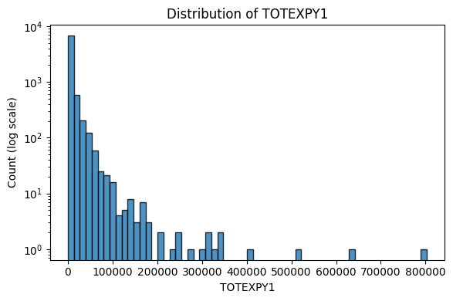
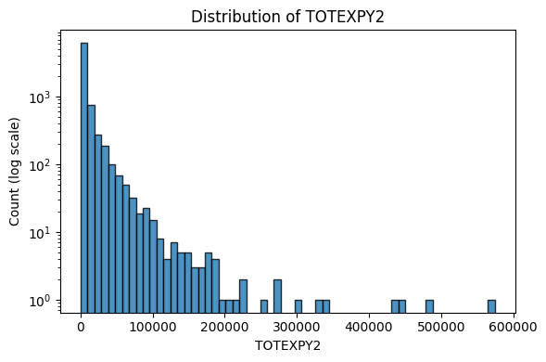

5. Phase II: Data Preparation & Feature Engineering

5.1 Preprocessing and analytic dataset
Phase I described the main distributional properties of the MEPS Panel 27 core dataset (e.g., strongly right-skewed expenditures and relatively low prevalence of ED visits and inpatient stays). In Phase II, the goal is to create a modelling-ready table by applying a reproducible preprocessing pipeline and constructing targets and predictors.
We start from the curated core-variable dataset and restrict the analytic sample to individuals in scope for both years with complete panel participation (YEARIND=1, ALL5RDS=1), yielding N=7,812 observations. Special MEPS missing codes (e.g., inapplicable/refused/don’t know) are recoded to standard missing values (NaN). Negative values in MEPS are typically special codes for missing/inapplicable responses; any remaining negative expenditure amounts are treated as invalid artifacts (e.g., from data adjustments) and recoded to missing. Variables with extremely high missingness and limited modelling value (e.g., coverage-history flags) are excluded from feature construction.
The resulting cleaned dataset (df_pre) is then passed into the feature engineering pipeline to produce df_feat.

5.2 Target construction
Targets are created from Year-2 outcomes:
- Regression target
$$LOG_TOTEXPY2=log⁡(1+TOTEXPY2)$$
which reduces the heavy-tailed skewness of annual expenditures.
- High-cost classification target
$$HIGHCOST_Y2=1(TOTEXPY2≥q_{0.90})$$
where $q_{0.90}$is the 90th percentile of TOTEXPY2 in the analytic sample. This yields 782 positives (≈10%) and 7,030 negatives.
- Acute utilization targets
  - ANY_ED_Y2 (any emergency department visit in Year-2) = 1 if ERTOTY2 > 0, else 0 (1,115 positives; ≈14.3%)

  - ANY_IP_Y2 (any inpatient stay in Year-2) = 1 if IPDISY2 > 0, else 0 (567 positives; ≈7.3%)
These class balances match the Phase I EDA results and confirm that ED and inpatient outcomes are moderately imbalanced classification tasks.

5.3 Feature engineering and feature set definition
Feature engineering is designed to use Year-1 predictors only (baseline information) to avoid leakage when predicting Year-2 outcomes. The feature pipeline generates both (i) interpretable categorical labels for low-cardinality variables and (ii) numeric engineered features (log transforms, binary indicators, multimorbidity).

5.3.1 Candidate features
After excluding identifiers, weights, and targets, the engineered table contains 127 candidate predictors, based on the 103 core variables selected in section 3.4. Data types are used to split features into:
- Categorical columns (7):
AGE_GROUP, RACE_ETH, REGIONY1_CAT, EDU_GROUP, POVCATY1_CAT, FAMSIZE_Y1_GRP, INS_TYPE_Y1
- Numeric columns (120):
These include both raw MEPS columns and engineered numeric features.

5.3.2 Parsimonious modelling features (engineered over raw)
To keep models stable and interpretable, we do not feed all raw numeric codes into the baseline models. Instead, we build a parsimonious numeric set that prioritizes engineered, Year-1 predictors such as:
- demographics/SES: AGE, SEX_BIN, LOG_FAMINCY1, FAMSIZE_Y1
- baseline utilization/cost: LOG_TOTEXPY1, ANY_ED_Y1, ANY_IP_Y1
- health status: RTHLTH1_FAIRPOOR, MNHLTH1_FAIRPOOR
- chronic conditions: condition flags (*_BIN) + multimorbidity score
- employment: WORKED_Y1, unemployment compensation indicators, and an “information available” flag to distinguish NIU/unknown from true zeros
Categorical variables are mapped to labels before one‑hot encoding. (e.g., INS_TYPE_Y1, POVCATY1_CAT) so they can be encoded consistently in the modelling pipeline.

5.4 Model-ready encoding and imputation
For modelling, we use a scikit-learn preprocessing pipeline based on a ColumnTransformer:
- Numeric preprocessing: median imputation (SimpleImputer(strategy="median"))
- Categorical preprocessing: most-frequent imputation (SimpleImputer(strategy="most_frequent")) followed by one-hot encoding (OneHotEncoder(handle_unknown="ignore"))
This produces a numeric design matrix $X$ suitable for linear models and classifiers while ensuring that unseen categories in the validation/test splits do not cause runtime errors. In Phase III, preprocessing steps are fit on the training split and applied to validation/test splits as part of the end-to-end pipeline.

5.5 Output of Phase II
Phase II outputs a single modelling table (df_feat) that contains:
- cleaned Year-1 features (engineered numeric features + labeled categoricals),
- Year-2 targets for regression and classification
This dataset is used as the input for all baseline and comparative models in Phase III.

6. Phase III: Modelling
This phase evaluates predictive models that use Year-1 information to forecast Year-2 outcomes. All models are trained and evaluated using a consistent train/validation/test protocol with a shared preprocessing pipeline (imputation + one-hot encoding for categoricals). Hyperparameters and decision thresholds (for classification) are selected using the validation set only.

6.1 Targets & Evaluation Metrics
Targets
The modelling tasks follow the targets defined in Section 5.2. In brief, we consider:
- Regression: Year-2 total expenditures on the log scale (LOG_TOTEXPY2).
- Classification: three binary outcomes in Year-2: high-cost status (HIGHCOST_Y2), any ED visit (ANY_ED_Y2), and any inpatient stay (ANY_IP_Y2).
Evaluation metrics
- Regression (LOG_TOTEXPY2): MAE on log scale, RMSE on log sale, and R² on the validation/test sets.
- Classification: ROC AUC and PR AUC (Average Precision). Because the outcomes are imbalanced (especially inpatient stays), PR AUC is reported alongside ROC AUC. In addition, a decision threshold is selected on the validation set to maximize F1; that threshold is then applied unchanged to the test set.

6.2 Baselines
Baseline setup
All baselines use the same pipeline structure:
- Predictors: a parsimonious feature set drawn from demographics, SES, insurance, employment, baseline health, chronic conditions, and Year-1 utilization/cost. Two feature configurations are evaluated: a key predictor set (AGE, LOG_TOTEXPY1, ANY_ED_Y1, ANY_IP_Y1, INS_TYPE_Y1) and the full candidate feature set; both use the same pipeline for a fair comparison.
- Preprocessing: numeric imputation (median); categorical imputation (most frequent) + one-hot encoding (handle_unknown="ignore").
- Splitting: train/validation/test split with validation used for model selection. Classification splits use stratification to preserve class proportions.
Baseline models
- Regression baseline: ElasticNet predicting LOG_TOTEXPY2.
- Classification baselines: Logistic regression with class balancing for HIGHCOST_Y2, ANY_ED_Y2, and ANY_IP_Y2. For each classification model, the decision threshold is chosen on the validation set to maximize F1.
Baseline performance
Table 6.2-1. Baseline model performance

Task | Feature set | Baseline model | Test metric(s) | Notes
Expenditure regression | Key predictors | ElasticNet | R² = 0.490; RMSE_log = 2.239 | log target
Expenditure regression | Full features | ElasticNet | R² = 0.523; RMSE_log = 2.165 | log target
High-cost prediction | Key predictors | Logistic (class_weight=balanced) | AUC = 0.863; PR-AUC = 0.466; F1 = 0.530 | Strongest classification baseline
High-cost prediction | Full features | Logistic (class_weight=balanced) | AUC = 0.850; PR-AUC = 0.424; F1 = 0.450
Any ED visit | Key predictors | Logistic (class_weight=balanced) | AUC = 0.698; PR-AUC = 0.314; F1 = 0.319 | Moderate discrimination
Any ED visit | Full features | Logistic (class_weight=balanced) | AUC = 0.707; PR-AUC = 0.331; F1 = 0.373
Any inpatient stay | Key predictors | Logistic (class_weight=balanced) | AUC = 0.752; PR-AUC = 0.203; F1 = 0.269 | Most challenging
Any inpatient stay | Full features | Logistic (class_weight=balanced) | AUC = 0.751; PR-AUC = 0.220; F1 = 0.277
PR-AUC summarizes the precision–recall trade-off (precision = TP/(TP+FP), recall = TP/(TP+FN)) and is more informative than ROC-AUC when the positive class is rare.

A small set of key predictors set (age, baseline cost, baseline utilization, insurance type) already provides strong baseline performance. For regression, expanding to the full candidate feature set yields a modest but consistent improvement (lower RMSE_log and higher R²), while for classification, expanding to the full candidate feature set yields only modest gains for ED and inpatient prediction and does not improve HIGHCOST discrimination, indicating that the main signal is captured by core utilization and cost variables.

Classification achieves higher AUC/PR‑AUC, while regression is evaluated separately by R²/MAE, which is expected given the heavy-tailed and highly heterogeneous nature of annual costs. We therefore emphasize ranking-based evaluation for imbalanced events (PR-AUC in addition to ROC-AUC). PR‑AUC reflects ranking quality under class imbalance. We also apply a top-k framing for capacity-constrained settings (limited care‑management slots / limited intervention capacity).

6.3 Class Imbalance Handling
All three classification targets are imbalanced (especially ANY_IP_Y2). To address this, we used a combination of metric choice, sampling strategy, weighting, and thresholding:

6.3.1 Imbalance-aware evaluation
Accuracy is not informative under imbalance. Therefore, model selection emphasized:
- PR-AUC (Average Precision) as the primary selection metric for classification, since it is sensitive to minority-class performance.
- ROC-AUC as a secondary metric for ranking quality.
- F1 at a tuned threshold to summarize a balanced precision–recall operating point.

6.3.2 Stratified splitting
Train/validation/test splits for classification were performed with stratification, maintaining the class proportion across splits (stratified split preserving the 60:20:20 ratio.) and reducing instability in validation metrics.

6.3.3 Cost-sensitive training (weights)
Because different algorithms support class imbalance in different ways, we applied cost-sensitive weighting using each model’s standard mechanism:
- Random Forest: class_weight="balanced_subsample" to reduce majority-class dominance during tree construction.
- XGBoost: for rare outcomes, imbalance can be handled with
$$scale_pos_weight=\frac{n_{neg}}{n_{pos}}$$
to up-weight positive class errors during training.
- MLP: balanced sample_weight was used to reduce bias toward predicting the majority class.

6.3.4 Threshold tuning and risk stratification
Even with weighting, the choice of the decision threshold $t$strongly determines precision vs recall.
We therefore reported:
- F1-optimal threshold (chosen on validation) for a balanced operating point, and
- Risk stratification (“Top-k”) views when appropriate, where the top 5/10/20% highest predicted risks are flagged. This approach matches realistic resource constraints (e.g., outreach programs can only target a fixed proportion of the population).
This combination provides a clearer and more actionable view of model utility under class imbalance than a single default threshold of 0.5.

6.4 Model Predictions
After defining the imbalance-aware evaluation framework, we compared Random Forest, XGBoost, and MLP because they represent three common paradigms for tabular prediction: Random Forest as a robust nonlinear baseline, boosted trees (XGBoost) as a strong method for structured data, and a neural network (MLP) to test whether a flexible deep model adds value beyond tree-based approaches.

6.4.1 Experimental setup
All prediction models were trained using Year-1 features to predict Year-2 outcomes, following the same pipeline to ensure fair comparison:
- Train/validation/test split (classification stratified by the target).
- Preprocessing: median imputation for numeric features and most-frequent imputation for categorical features; categorical variables were one-hot encoded. For MLP, numeric features were additionally standardized.
- Model selection: hyperparameters were selected on the validation set.
- Evaluation: final performance was reported on the held-out test set (single evaluation after model selection).
For classification tasks, models output a predicted probability $p_{i}=P(Y=1∣X_{i})$. A probability threshold $t$is then used to convert probabilities into class labels. In the main results below, the classification threshold was selected on the validation set to maximize F1 and then applied to the test set.

6.4.2 Regression: Year-2 log total expenditure (LOG_TOTEXPY2)
We compared Random Forest (RF), XGBoost (XGB) and a Multilayer Perceptron (MLP) to predict LOG_TOTEXPY2. Overall, all three models achieved very similar test performance (R² around 0.53), suggesting diminishing returns from increasing model complexity once expenditures are log-transformed.
- XGB with early stopping + stronger regularization produced the best (or near-best) RMSE/R², while
- RF tended to have slightly better MAE (more robust average error),
- MLP was comparable, with slightly worse MAE than tree-based models.

Table 6.4-1. LOG_TOTEXPY2

Model | RMSE_log | MAE_log | R²
Random Forest (tuned) | 2.153 | 1.533 | 0.529
XGBoost (early stopping) | 2.150 | 1.542 | 0.530
MLP | 2.149 | 1.547 | 0.530

In practice, these differences are small. Therefore, the regression results support the conclusion that multiple non-linear models can reach a similar level of predictive accuracy for log-expenditures under the current feature set. For the thesis, XGB is the primary model for LOG_TOTEXPY2.

6.4.3 Classification: HIGHCOST_Y2, ANY_ED_Y2, ANY_IP_Y2

Table 6.4-2. HIGHCOST_Y2 (prevalence ≈ 10.0%)

Model | AUC | PR-AUC | F1@t* | t* | Precision@t* | Recall@t* | TN | FP | FN | TP
Random Forest | 0.868 | 0.459 | 0.536 | 0.55 | 0.487 | 0.596 | 1309 | 98 | 63 | 93
XGBoost | 0.856 | 0.443 | 0.525 | 0.65 | 0.444 | 0.641 | 1282 | 125 | 56 | 100
MLP | 0.853 | 0.420 | 0.459 | 0.75 | 0.397 | 0.545 | 1278 | 129 | 71 | 85

Random Forest provides the best overall performance on this target, with the highest PR-AUC (0.459) and F1 (0.536). XGBoost increases recall (0.641 vs 0.596) but at the cost of more false positives and lower precision, resulting in slightly lower F1. MLP is clearly behind tree-based models. For the thesis, RF is the primary model for HIGHCOST_Y2.

Table 6.4-3. ANY_ED_Y2 (prevalence ≈ 14.3%)

Model | AUC | PR-AUC | F1@t* | t* | Precision@t* | Recall@t* | TN | FP | FN | TP
XGBoost | 0.728 | 0.350 | 0.366 | 0.20 | 0.313 | 0.439 | 1125 | 215 | 125 | 98
Random Forest (tuned) | 0.707 | 0.320 | 0.362 | 0.40 | 0.312 | 0.430 | 1128 | 212 | 127 | 96
MLP | 0.710 | 0.328 | 0.344 | 0.60 | 0.290 | 0.422 | 1110 | 230 | 129 | 94

Although thresholded classification outcomes are similar, XGB’s higher PR-AUC suggests it provides a better risk ordering, which is useful for risk stratification.
Risk stratification (Top-k policy) using RF probabilities
To reflect resource-constrained settings, we also evaluated “Top-k” selection for ED risk. Under RF:

- Top 10% highest risk: precision 0.410, recall 0.287
- Top 20% highest risk: precision 0.313, recall 0.439
Notably, the “Top 20%” policy closely matches the F1-optimal threshold operating point (similar flagged counts and recall), providing an intuitive implementation framework for intervention targeting.
Given higher PR-AUC and AUC, XGB is selected as the primary model for ANY_ED_Y2.

Table 6.4-4. ANY_IP_Y2 (prevalence ≈ 7.26%)

Model | AUC | PR-AUC | F1@t* | t* | Precision@t* | Recall@t* | TN | FP | FN | TP
Random Forest (tuned) | 0.755 | 0.225 | 0.285 | 0.40 | 0.234 | 0.363 | 1316 | 134 | 72 | 41
XGBoost | 0.752 | 0.202 | 0.261 | 0.15 | 0.204 | 0.363 | 1290 | 160 | 72 | 41
MLP | 0.758 | 0.202 | 0.275 | 0.65 | 0.215 | 0.381 | 1293 | 157 | 70 | 43

Both tree models capture the same number of true admissions (TP=41) and have identical recall at their chosen thresholds, but XGB produces more false positives (FP=160 vs 134), lowering precision and reducing F1. MLP achieves a slightly higher recall (TP=43, recall 0.381 vs 0.363) but also flags more individuals (FP=157), resulting in precision 0.215 and F1=0.275, which remains below the tuned RF baseline (F1=0.285). Overall, RF offers the best trade-off for this rare outcome, consistent with its higher PR-AUC (0.225 vs 0.202 for XGB/MLP).
Risk stratification (Top-k policy) using RF probabilities
Because inpatient admission is rare and interventions are typically capacity-limited, Top-k evaluation provides a practical lens. Under RF:
- Top 5% highest risk: precision 0.333, recall 0.230
- Top 10% highest risk: precision 0.237, recall 0.327
- Top 20% highest risk: precision 0.182, recall 0.504
This shows that selecting the top 20% highest-risk individuals captures roughly half of inpatient admissions, although precision decreases as the flagged population grows.
Based on PR-AUC/F1 and a more favorable false-positive burden at comparable recall, RF is selected as the primary model ANY_IP_Y2.

7. Phase IV: Results & Error Analysis
Phase IV summarizes predictive performance across targets and provides a brief error analysis to clarify how models should be used.
Results:
Table 7-1. Final model performance by target (test set)
Target | Prevalence  （proportion of positives in the sample) | Primary model | AUC | PR-AUC | F1@t* | t* | Notes
HIGHCOST_Y2 | ~10.0% | Random Forest | 0.868 | 0.459 | 0.536 | 0.55 | Strongest discrimination
ANY_ED_Y2 | ~14.3% | XGBoost | 0.728 | 0.350 | 0.366 | 0.20 | Moderate, best ranking quality
ANY_IP_Y2 | ~7.3% | Tuned Random Forest | 0.755 | 0.225 | 0.285 | 0.40 | Hardest (rare outcome)
LOG_TOTEXPY2 | — | XGBoost (early stopping) | — | — | — | — | RMSE_log=2.15, R²=0.53

Table 7-1 summarizes test performance across targets. HIGHCOST_Y2 achieves the strongest discrimination, ED is moderately predictable, and inpatient admission remains the most challenging due to lower prevalence. For regression, the early-stopped XGBoost model achieves consistent but imperfect accuracy (R²≈0.53), indicating Year-1 features explain a meaningful yet incomplete share of Year-2 expenditure variation.
Error Analysis:
We focus error analysis on ANY_IP_Y2 (Year-2 inpatient admission) because it is the hardest target (low prevalence and admissions are often driven by short-term shocks not captured in Year-1 survey variables). Using the final inpatient model at the operating point (validation‑selected threshold t=0.40), errors show a clear pattern: predicted risk is high for TP and FP (mean proba ≈ 0.565 and 0.514), but much lower for FN (mean ≈ 0.210), and no FN exceeds the threshold (FN max ≈ 0.392) — threshold = 0.40; all FN have predicted probability < 0.40. This suggests missed admissions are not borderline threshold cases; they appear low-risk given available Year-1 predictors.
Comparing false positives vs false negatives indicates that false positives tend to have a higher baseline risk burden: they are older (AGE ≈ 68.3 vs 49.5) and have higher prior spending (LOG_TOTEXPY1 ≈ 9.75 vs 7.60), as well as higher rates of prior ED use (ANY_ED_Y1 ≈ 0.403 vs 0.194) and hypertension (HIBPDXY1_BIN ≈ 0.754 vs 0.417). Overall, the inpatient model is best interpreted as a risk stratification tool rather than a deterministic predictor of admissions.
Table 7-2. ANY_IP_Y2 error summary (t = 0.40)
Item | Value
Confusion matrix | TN=1316, FP=134, FN=72, TP=41
Mean predicted probability | TP=0.565, FP=0.514, FN=0.210, TN=0.141
FN highest probability | 0.392 (< 0.40)
FP vs FN (AGE) | 68.3 vs 49.5
FP vs FN (LOG_TOTEXPY1) | 9.75 vs 7.60
FP vs FN (ANY_ED_Y1) | 0.403 vs 0.194
FP vs FN (HIBPDXY1_BIN) | 0.754 vs 0.417

8. Phase V: Explainability & Fairness

8.1 Drivers of Predictions: Feature Contribution Analysis
To explain what drives model predictions, we combine permutation importance (global contribution ranking) with a limited set of directional subgroup summaries (observed rates/means and mean model-assigned risk/mean predictions). For classification targets, feature contribution is quantified as the mean decrease in PR-AUC (average precision) when a feature is randomly permuted (shuffled). For the expenditure regression, contribution is quantified as the mean increase in RMSE_log after permutation. Because detailed subgroup breakdowns can be lengthy, the main text reports only the most salient contrasts, while full tables are provided in Appendix B.

8.1.1 Global feature contribution (permutation importance)
Table 8.1-1 summarizes the strongest drivers for each target under the selected primary model. Across all targets, baseline spending and prior utilization repeatedly appear among the top contributors, consistent with persistence in health care need and utilization patterns. For HIGHCOST_Y2 and LOG_TOTEXPY2, prior-year spending dominates; for ED and inpatient outcomes, prior utilization and broad baseline risk markers remain central.
Table 8.1-1. Top drivers by target (permutation importance).
Classification: mean decrease in PR-AUC; Regression: mean increase in RMSE_log.
Target (Primary model) | Importance metric | Top drivers (value)
HIGHCOST_Y2 (RF) | ΔPR-AUC | LOG_TOTEXPY1 (0.116), AGE (0.045), ANY_ED_Y1 (0.031), HIBPDXY1_BIN (0.030), FAMSIZE_Y1_GRP (0.023)
ANY_ED_Y2 (XGB) | ΔPR-AUC | LOG_TOTEXPY1 (0.084), ANY_ED_Y1 (0.053), LOG_FAMINCY1 (0.039), AGE (0.037), LOG_UNEMP_COMP_Y1 (0.018)
ANY_IP_Y2 (RF) | ΔPR-AUC | LOG_TOTEXPY1 (0.046), ANY_ED_Y1 (0.028), HIBPDXY1_BIN (0.015), AGE (0.014), SEX_BIN (0.007)
LOG_TOTEXPY2 (XGB-ES) | ΔRMSE_log | LOG_TOTEXPY1 (0.996), AGE (0.056), RACE_ETH (0.050), INS_TYPE_Y1 (0.033), FAMSIZE_Y1 (0.021)

Full variable names and definitions are provided in Appendix D (Variable Glossary).

8.1.2 Directional interpretation (selected contrasts)
Permutation importance identifies which features matter most but does not directly indicate direction. To provide directional context, we additionally examined subgroup contrasts for a small set of clinically meaningful variables. Specifically, for each target we report (i) the observed subgroup outcome rate/mean and (ii) the model’s mean predicted risk (classification) or mean predicted outcome (regression) within the same subgroup. Observed subgroup rates are computed on the full analytic sample, whereas model-assigned risk is summarized on the held-out test split only. Table 8.1-2 reports the most informative contrasts for each target. Full feature rankings and complete subgroup tables are reported in Appendix B (Tables B1–B4).
Table 8.1-2. Key directional patterns (selected subgroup contrasts).
Observed = observed outcome prevalence rate/mean; Model = mean predicted risk/mean prediction.

Target | Key contrast | Observed (high vs low risk group) | Model (high vs low risk group)
HIGHCOST_Y2 | LOG_TOTEXPY1 Q4 vs Q1  (top vs bottom quartile of LOG_TOTEXPY1, Q4=top 25%) | 29.4% vs 1.6% | 53.9% vs 7.4%
 | ANY_ED_Y1=1 vs 0 | 22.0% vs 8.1% | 44.9% vs 21.9%
 | AGE 65+ vs 0–17 | 20.9% vs 2.0% | 44.2% vs 7%
ANY_ED_Y2 | ANY_ED_Y1=1 vs 0 | 33.6% vs 11.1% | 32.4% vs 11.1%
 | LOG_TOTEXPY1 Q4 vs Q1 | 25.6% vs 6.4% | 24.7% vs 5.8%
 | AGE 65+ vs 18–29 | 21.6% vs 9.8% | 21.9% vs 10.5%
ANY_IP_Y2 | LOG_TOTEXPY1 Q4 vs Q1 | 16.0% vs 2.3% | 36.2% vs 8.1%
 | AGE 65+ vs 0–17 | 15.7% vs 1.8% | 36.7% vs 7.9%
 | HIBPDXY1=1 vs 0 | 14.3% vs 4.2% | 32.0% vs 13.6%
LOG_TOTEXPY2 | LOG_TOTEXPY1 Q4 vs Q1 | mean 9.02 vs 3.57 | mean 9.03 vs 3.60
 | AGE 65+ vs 18–29 | mean 8.48 vs 5.00 | mean 8.47 vs 4.89

8.1.3 Target-specific interpretation
HIGHCOST_Y2. High-cost risk is most strongly driven by prior-year spending, with additional stratification from age, baseline utilization (ED/IP), and chronic burden/health status. Subgroup patterns show clear concentration among older adults and high baseline spenders, supporting the interpretation of persistence in high-cost status.
ANY_ED_Y2. ED use exhibits a strong utilization persistence effect: individuals with higher baseline spending have substantially higher Year-2 ED prevalence and predicted risk. Having an ED visit in Year-1 (ANY_ED_Y1=1) and older age further separate higher-risk from lower-risk groups.
ANY_IP_Y2. Inpatient admission is primarily driven by baseline risk proxies (prior spending and age) and chronic burden (e.g., hypertension). The prominence of ANY_ED_Y1 suggests prior ED use is a marker of health instability that also increases subsequent hospitalization risk. As with ED, the inpatient model is best interpreted as a risk stratification tool for a rare outcome.
LOG_TOTEXPY2 regression. Expenditure predictions are dominated by LOG_TOTEXPY1, confirming strong temporal persistence in spending; age provides smaller but consistent additional stratification. The model reproduces clear gradients across prior-year spending quartiles and age groups in both observed and predicted mean log expenditures.
Finally, these results should be interpreted as associations learned from Year-1 survey variables rather than causal effects. Differences across subgroups may be driven by underlying variation in health needs, access to care, and typical patterns of healthcare use.

8.2 Fairness audit executive summary
We conducted a lightweight fairness audit across sex and age bands using group-wise PR-AUC and recall under top-k targeting (top 10% / 20% highest-risk). Results suggest limited sex-based differences for HIGHCOST_Y2 and ANY_IP_Y2 under capacity-limited targeting (e.g., HIGHCOST recall@top10% ≈ 0.54 for both males and females; ANY_IP recall@top10% ≈ 0.34 vs 0.32), while ANY_ED_Y2 shows larger sex differences in ranking and capture (higher PR-AUC and top-k recall among females). In contrast, age-related heterogeneity is substantial across outcomes, with consistently stronger capture in older adults and near-zero recall for very low-prevalence pediatric groups.
Table 8.2-1a Fairness audit by sex (PR-AUC and recall@top10%)
Target | Sex | n | Prevalence | PR-AUC | Recall@Top10%
HIGHCOST_Y2 (RF) | Male | 751 | 7.9% | 0.497 | 54.2%
HIGHCOST_Y2 (RF) | Female | 812 | 11.9% | 0.444 | 53.6%
ANY_ED_Y2 (XGB) | Male | 722 | 12.2% | 0.330 | 19.3%
ANY_ED_Y2 (XGB) | Female | 841 | 16.1% | 0.365 | 36.3%
ANY_IP_Y2 (RF) | Male | 740 | 4.7% | 0.190 | 34.3%
ANY_IP_Y2 (RF) | Female | 823 | 9.5% | 0.250 | 32.1%

Table 8.2-1b Fairness audit by age group (PR-AUC and recall@top10%)
Target | Age group | n | Prevalence | PR-AUC | Recall@Top10%
HIGHCOST_Y2 (RF) | 0–17 | 281 | 1.1% | 0.394 | 0.0%
HIGHCOST_Y2 (RF) | 18–44 | 486 | 5.1% | 0.211 | 8.0%
HIGHCOST_Y2 (RF) | 45–64 | 433 | 12.5% | 0.485 | 48.1%
HIGHCOST_Y2 (RF) | 65+ | 363 | 20.4% | 0.523 | 75.7%
ANY_ED_Y2 (XGB) | 0–17 | 315 | 10.5% | 0.345 | 18.2%
ANY_ED_Y2 (XGB) | 18–44 | 485 | 9.9% | 0.316 | 18.8%
ANY_ED_Y2 (XGB) | 45–64 | 409 | 17.6% | 0.394 | 27.8%
ANY_ED_Y2 (XGB) | 65+ | 354 | 19.8% | 0.365 | 44.3%
ANY_IP_Y2 (RF) | 0–17 | 287 | 1.0% | 0.018 | 0.0%
ANY_IP_Y2 (RF) | 18–44 | 528 | 5.3% | 0.091 | 3.6%
ANY_IP_Y2 (RF) | 45–64 | 410 | 7.6% | 0.277 | 32.3%
ANY_IP_Y2 (RF) | 65+ | 338 | 15.1% | 0.286 | 51.0%
Figure 8.2-1 Prevalence vs. Recall@Top10% (Sex + Age Groups)
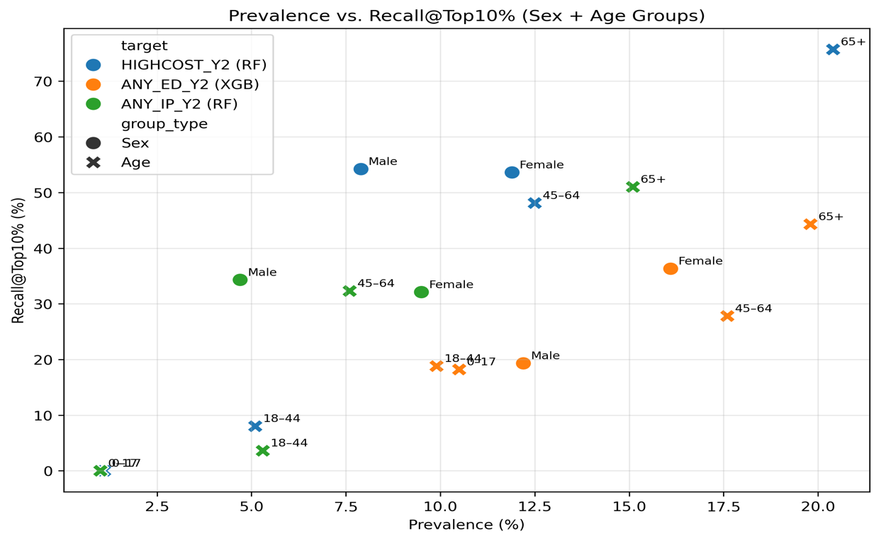

9.Phase VI: Productization Concept: Health Outcome Predictor (MVP)

9.1 What the MVP does
To demonstrate how the thesis models could be used in a capacity-constrained setting, we built a lightweight Streamlit application, Health Outcome Predictor (MVP). The MVP performs inference only (no retraining) and supports two operational tasks:
- Classification (risk ranking): score individuals with a predicted probability for Year-2 binary outcomes (e.g., high-cost, ED use, inpatient use).
- Regression (cost ranking): predict Year-2 total expenditure on the original scale in USD, using the inverse transform of the thesis target:
$$\hat{TOTEXPY2}=exp⁡(\hat{log⁡(1+TOTEXPY2)})-1$$

The core usage is top-k selection: the user chooses a fraction (e.g., top 10%), and the app returns the ranked list and a selection flag for the top-k individuals.

9.2 Inputs and outputs
Input. The demo mode uses df_feat.parquet, a feature-engineered dataset derived from Year-1 variables only. Uploaded data is expected to follow the same feature schema (feature-level input).
Output. The app displays:
- number of rows scored and selected (k),
- overall vs selected mean score/cost,
- lift = (selected mean)/(overall mean),
- a top-k threshold (minimum score/cost among the selected group),
- a ranked table with downloadable CSV (including prediction and selected_topk).
To improve readability of the ranked list, the MVP also shows rule-based reason tags (e.g., prior ED use, high prior-year spending). These tags are simple, rule-based summaries of selected baseline variables to improve readability of the ranked list.
Figure 9.2-1. Health Outcome Predictor (MVP) — Classification (risk ranking)
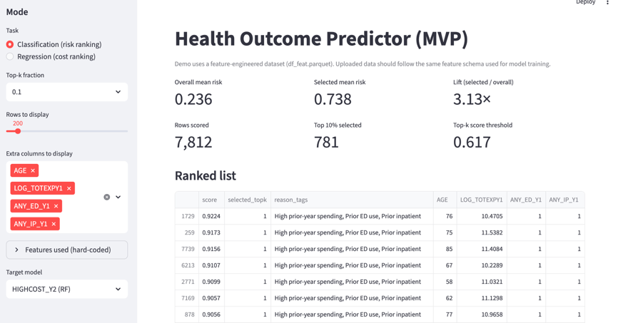
The interface scores individuals using the trained classification model, supports capacity-constrained top-k selection, and reports overall vs selected mean risk, lift, and the top-k score threshold.
Figure 9.2-2. Health Outcome Predictor (MVP) — Regression (cost ranking) 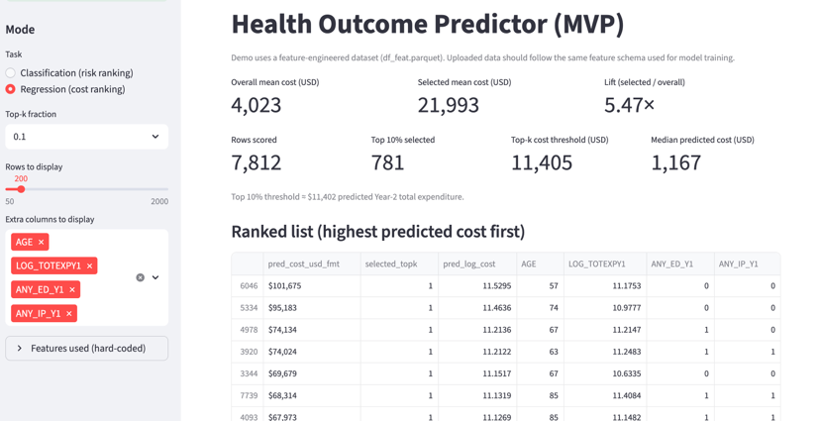

The interface ranks individuals by predicted Year-2 total expenditure on the USD scale (inverse transform from log1p(TOTEXPY2)), supports top-k selection, and reports overall vs selected mean cost, lift, and the top-k cost threshold. Results are exportable as a CSV.

9.3 Reproducibility
The implementation is provided in the GitHub repository: < https://github.com/WenxiGu/Thesis-project-MEPS > (see README for setup and execution instructions).

10. Phase VII: Conclusions & Business Implications
This thesis evaluated whether Year-1 (baseline) MEPS Panel 27 features can predict Year-2 expenditures and acute events, and whether model performance is consistent across key subgroups. Overall, results support using the models primarily for risk stratification (ranking / top-k selection) rather than deterministic prediction of individual outcomes, reflecting the inherent difficulty of predicting rare events.
RQ1. Which factors are most strongly associated with Year-2 expenditures?
Year-2 expenditure on the log scale (LOG_TOTEXPY2) is driven most strongly by prior-year spending (LOG_TOTEXPY1), indicating strong temporal persistence in costs. Permutation importance for the selected regression model (XGBoost with early stopping) shows LOG_TOTEXPY1 dominating the contribution, with smaller but consistent additional stratification from age and selected socio-demographic variables (e.g., race/ethnicity, insurance type, family size). Subgroup patterns confirm clear gradients: predicted and observed mean log costs increase sharply across LOG_TOTEXPY1 quartiles and are higher among older adults.
Conclusion (RQ1): future spending is predictable mainly because spending is persistent; socio-economic and insurance variables contribute secondary stratification rather than replacing the explanatory role of prior spending.
RQ2. How well can we distinguish high-cost individuals in Year-2?
HIGHCOST_Y2 (top 10% of TOTEXPY2) is the most predictable classification target. The primary Random Forest model achieves AUC=0.868 and PR-AUC=0.459 on the test set, with F1=0.536 at the validation-selected threshold. These results indicate strong ranking quality and practical separability of the high-cost tail using Year-1 predictors.
A survey-weighted robustness check (LONGWT) yields slightly lower AUC/PR-AUC (AUC 0.850, PR-AUC 0.391) but does not change the core conclusion that high-cost stratification remains feasible in a population-representative lens.
Conclusion (RQ2): high-cost risk stratification is operationally viable, especially when implemented as ranking/top-k selection rather than relying on a single probability threshold.
RQ3. Which factors predict Year-2 ED visits and inpatient stays?
ED risk is moderately predictable and shows a strong utilization persistence effect. The selected XGBoost model achieves AUC=0.728 and PR-AUC=0.350 for ANY_ED_Y2, and subgroup contrasts confirm higher observed and predicted ED rates among those with prior ED use, higher baseline spending, and older age.
Inpatient admission is the most challenging target due to lower prevalence (≈7.3%). The tuned Random Forest achieves AUC=0.755 and PR-AUC=0.225 for ANY_IP_Y2. Error analysis indicates false negatives are not borderline threshold cases: FN predicted probabilities are much lower than TP/FP, and no FN exceeds the chosen threshold (FN max ≈ 0.392 < 0.40), consistent with admissions being driven by short-term shocks not captured in baseline survey variables.
Conclusion (RQ3): ED and inpatient outcomes are partly predictable from baseline utilization/spending and health burden, but inpatient prediction should be framed as prioritization rather than event forecasting.
RQ4. Is performance consistent across socio-demographic and/or insurance subgroups?
A lightweight fairness audit suggests limited sex-based differences for HIGHCOST and inpatient targeting under top-k policies, while ED shows more noticeable sex differences (higher PR-AUC and recall@top10% among females). Age-related heterogeneity is substantial: capture is consistently stronger in older groups and near-zero in very low-prevalence pediatric group under small top-k policies, reflecting large prevalence gradients.
Conclusion (RQ4): subgroup performance varies, particularly by age. This thesis evaluates fairness only across age and sex, reinforcing the need to report subgroup metrics and to use risk scores as decision aids with oversight. For subgroups with poorer results (e.g., 0–17), additional targeted data of positive cases in these groups might be needed to train higher recall models. Audits across additional attributes (e.g., race/ethnicity, income, insurance) are reserved for future work.

Business implications
- Capacity-based deployment (how to operationalize ranking):
In practice, these models are most actionable as ranking tools that support capacity-constrained outreach. A realistic deployment is to generate a monthly prioritized list (top-k) sized to the available care-management capacity (e.g., nurse navigators can contact N members per month). This approach mirrors real-world workflow better than relying on a single fixed probability threshold for rare outcomes.
- Implementation detail: fix the outreach budget first (k or %) → rank members → assign to teams → document reasons and outcomes → review performance quarterly. Target-specific actionability:
- HIGHCOST_Y2 (proactive budgeting & care management): Use the ranking to prioritize members for proactive case management (e.g., medication review, chronic care follow-up, care-plan adherence support).
KPIs: top-k cost capture; utilization trends, etc.
- ANY_ED_Y2 (navigation and access-focused outreach): Use the ranking to prioritize members for navigation (e.g., scheduling primary care, after-hours alternatives, transportation support where applicable).
KPIs: Primary Care Provider (PCP) follow-up completion; repeat ED visits among contacted members, etc.
- ANY_IP_Y2: use as a watch-list for clinical review/escalation, not as a claim of preventable admissions.
KPIs: inpatient capture in top-k; timeliness of follow-up, etc.
- Governance and compliance: Any practical use must incorporate privacy safeguards and comply with MEPS public-use restrictions (no re-identification and no linkage to individually identifiable external datasets).

Limitations and next steps
Model performance is meaningful but not perfect (test R² ≈ 0.53 for costs, and weaker discrimination for ED/IP), which reflects both data limits and the inherent unpredictability of short-term shocks. The analysis uses only MEPS Panel 27 (2022–2023), so results may not fully generalize to other years or settings. MEPS variables are survey-based and self-reported, which introduces measurement error, and the models do not use richer clinical or external data that could improve accuracy. As a result, the models are best suited for ranking and top-k selection, not deterministic individual prediction.
Next steps are to check model performance across more groups (e.g., race/ethnicity, income, insurance), verify that predicted probabilities match real-world rates (calibration), monitor whether performance changes over time (drift), and set clear rules for who can access the system and how usage is logged. For very low-prevalence groups (e.g., pediatric inpatient), performance is unstable; improving recall there likely requires more positive cases or targeted data collection.

Appendix A: EDA Supplementary Figures (Phase I)

This appendix provides detailed descriptive figures referenced in Phase I. Figures summarize the analytic sample (YEARIND=1, ALL5RDS=1; n=7,812), baseline predictors, missingness patterns, and outcome distributions. These plots support the modelling choices in Phase II–III (log-transform for costs; binary modelling and ranking metrics for acute events).
Figure A.1. Age distribution (Year-1).
Interpretation: The sample spans the full life course. Modelling implication: age is expected to be a strong predictor and is included in all models.
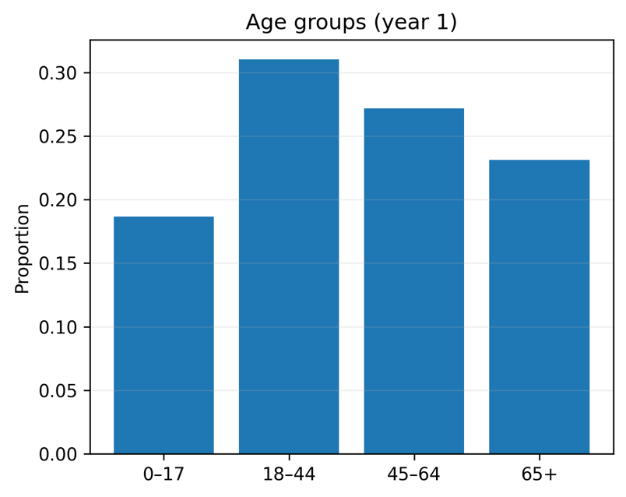

Figure A.2. Sex, race/ethnicity, and region.
Interpretation: The sample is broadly balanced by sex and region, with expected race/ethnicity composition. Modelling implication: these variables support subgroup analysis and fairness reporting.
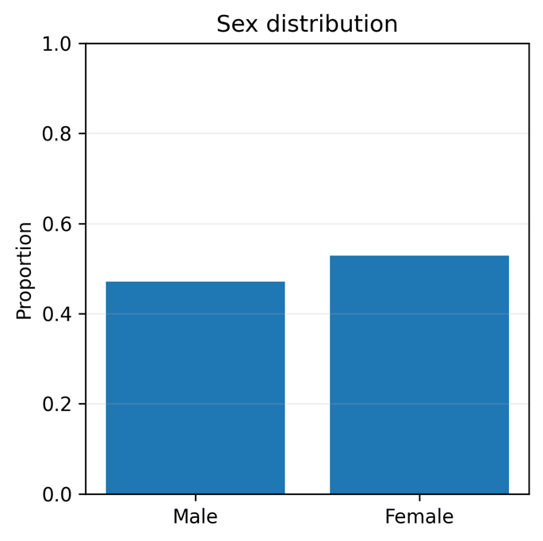

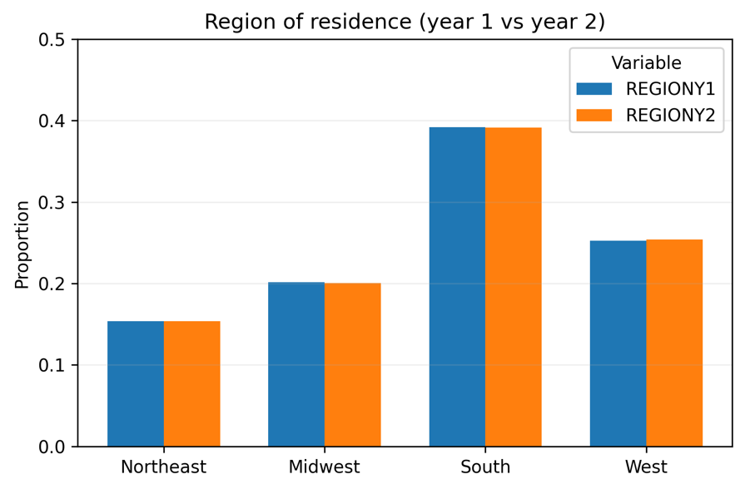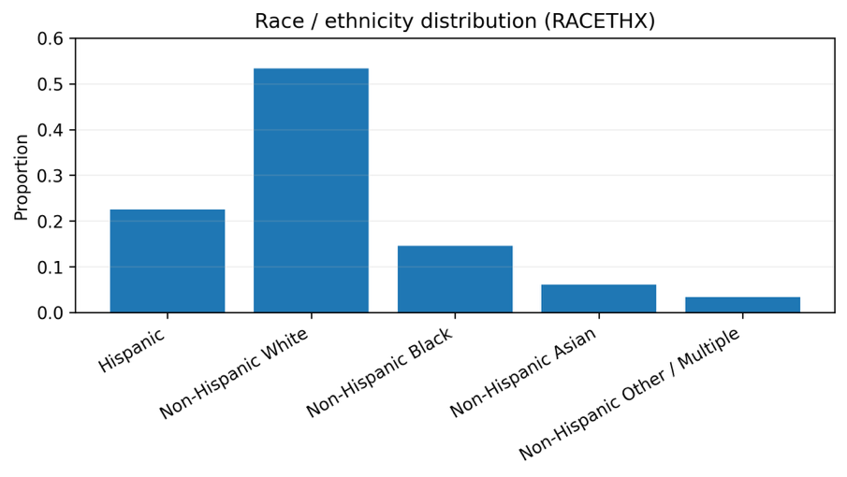

Figure A.3. Education, income and poverty categories.
Interpretation: Income is strongly right-skewed, and education level groups and poverty categories provide a stable SES stratification. Modelling implication: SES features are retained as potential drivers of utilization and cost.
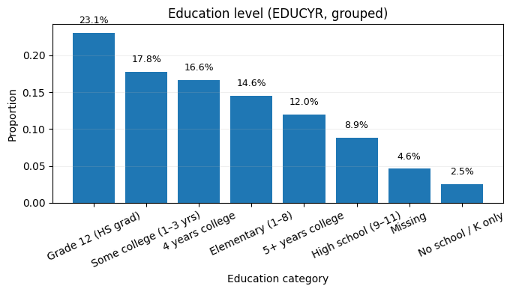
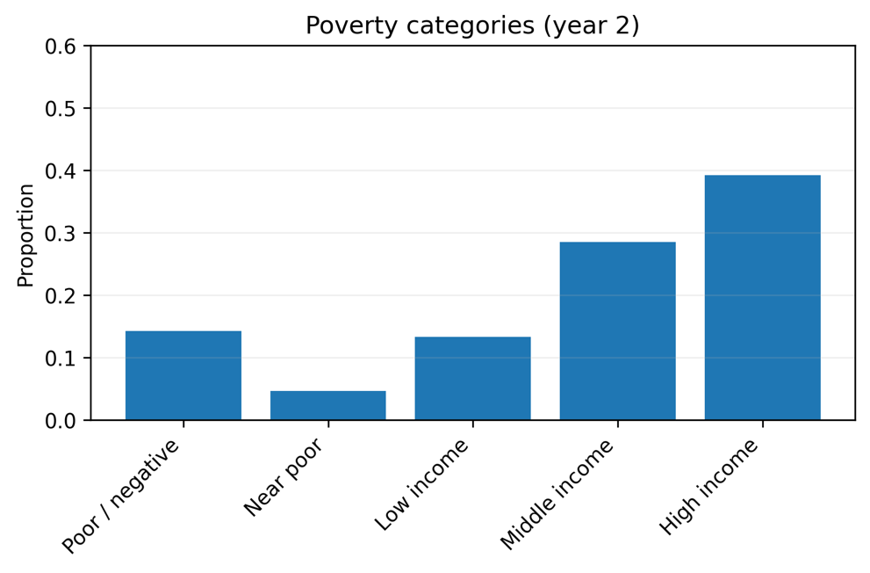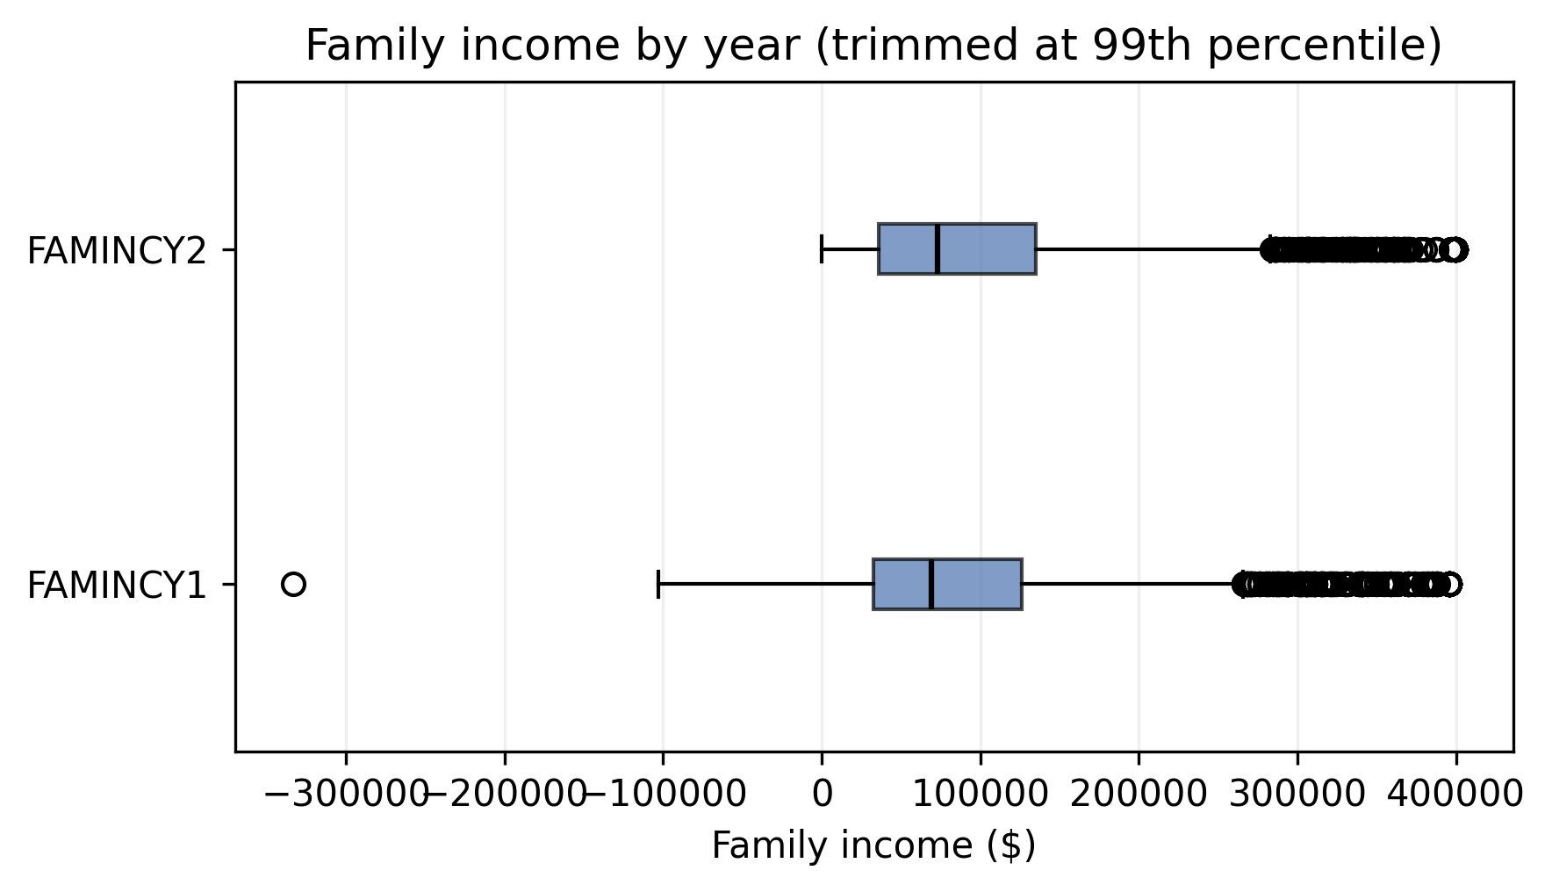

Figure A.4. Insurance coverage and insurance type.
Interpretation: Coverage is relatively stable across years with meaningful variation across private/public/uninsured groups. Modelling implication: insurance is included as a key policy-relevant predictor.
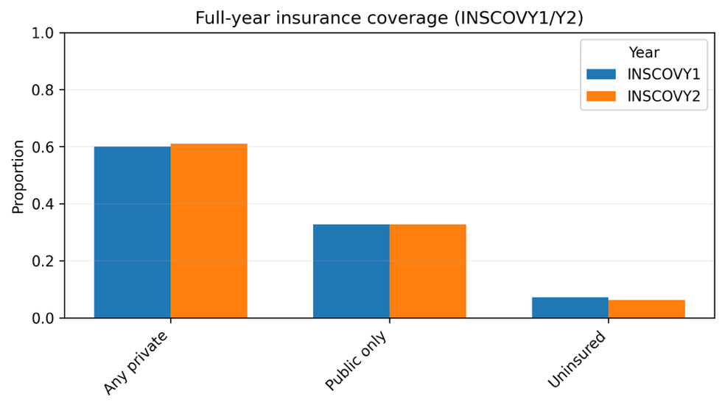
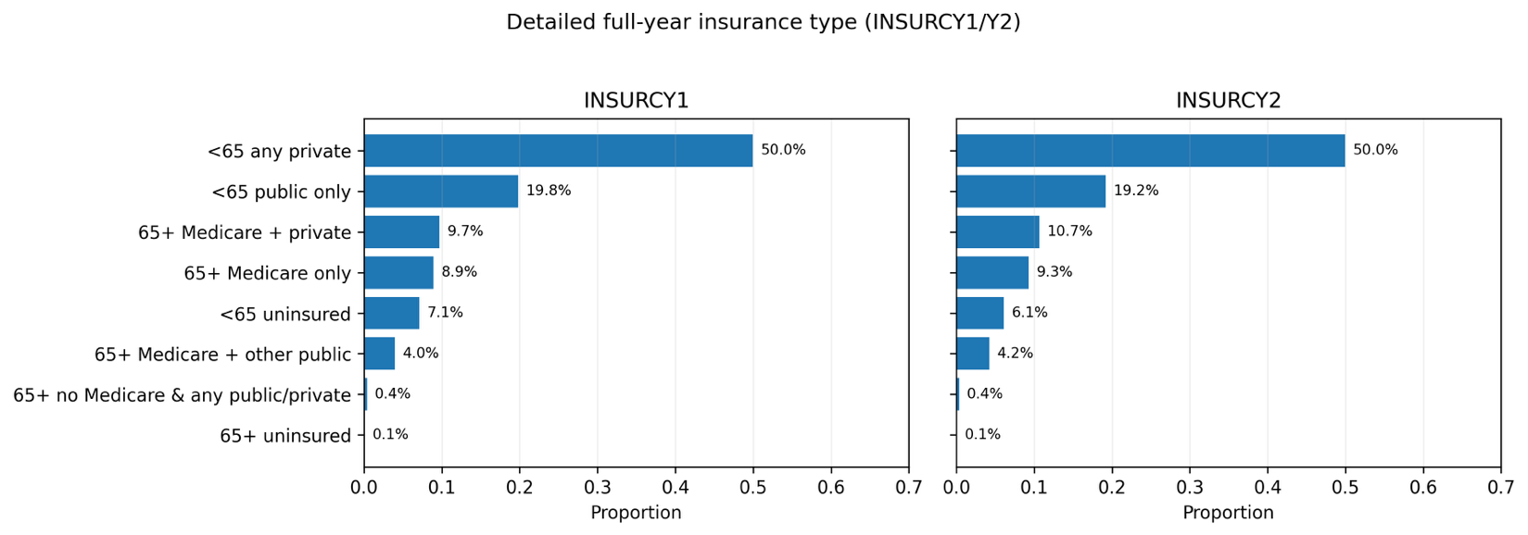

Figure A.5. Employment variables and unemployment compensation.
Interpretation: Many employment fields are inapplicable (children/older adults) and show structural missingness; compensation is highly zero-inflated. Modelling implication: employment variables require careful missingness handling and/or engineered indicators
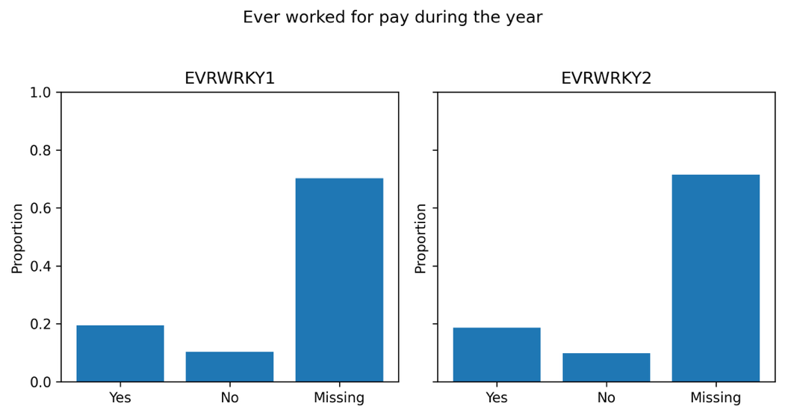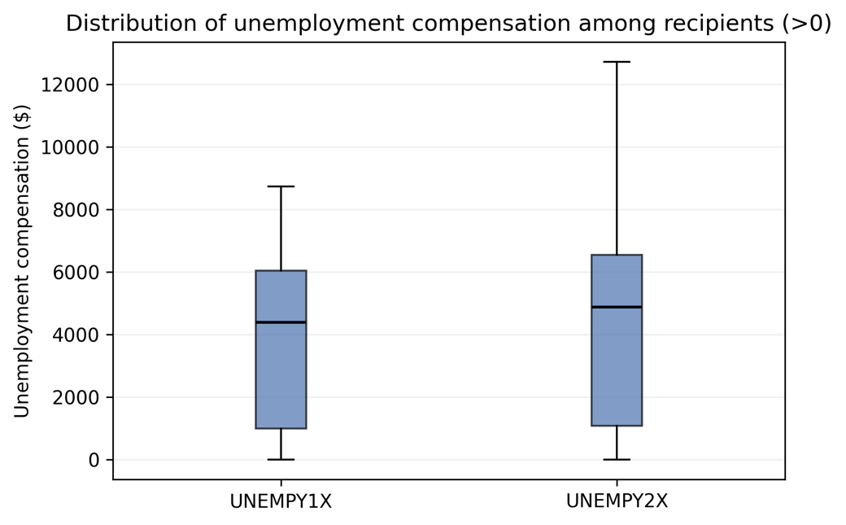
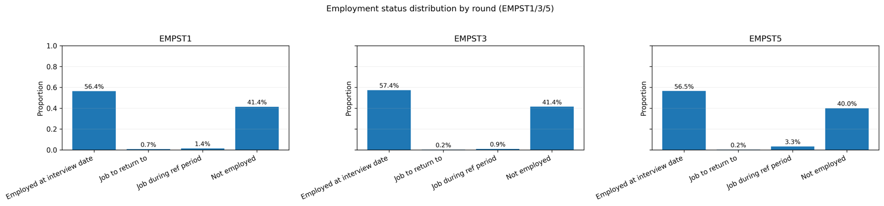

Figure A.6. Self-rated health and mental health.
Interpretation: Most respondents report good-to-excellent health, with a minority reporting fair/poor.
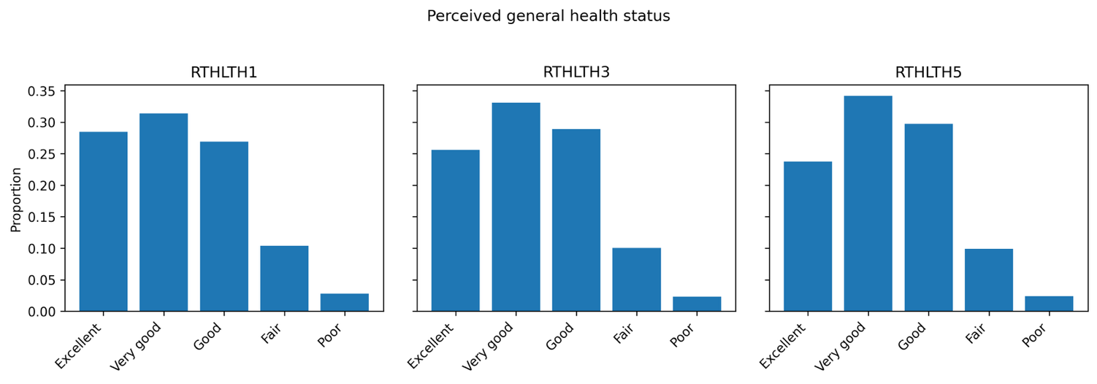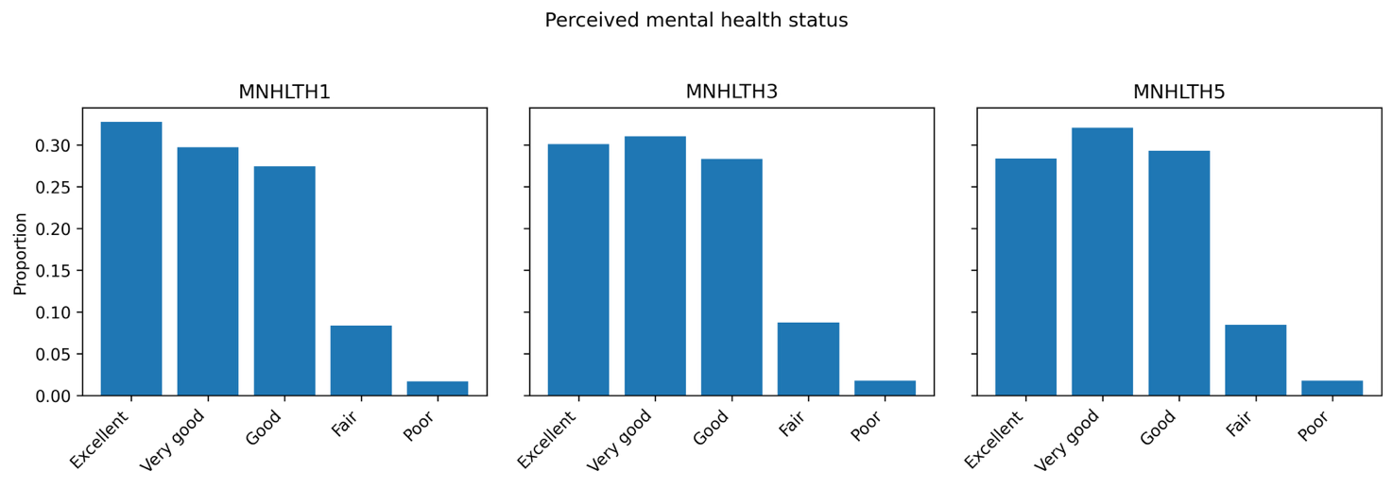

Figure A.7. Chronic condition prevalence and multimorbidity index.
Interpretation: Chronic conditions are common and multimorbidity exists in a non-trivial subgroup.
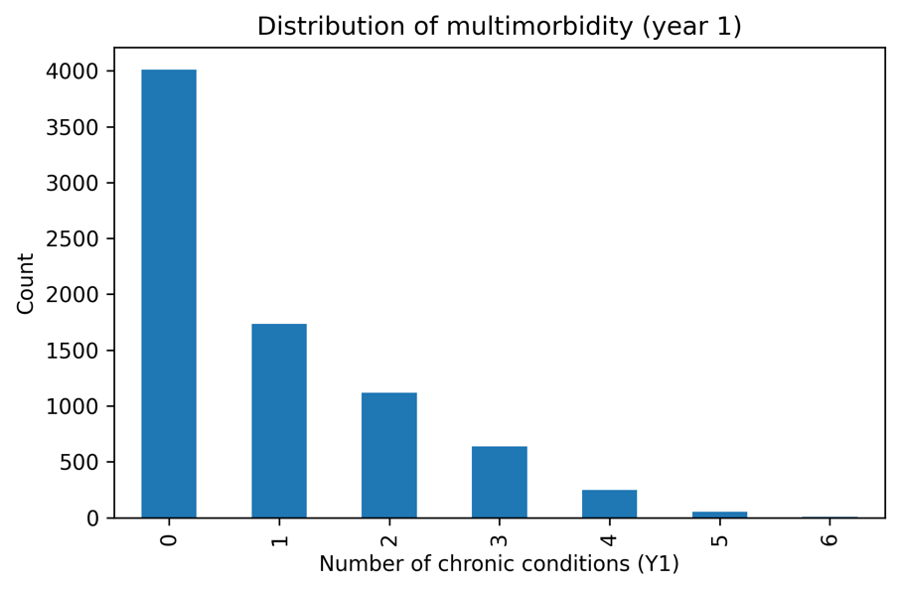

Figure A.8. Payer-specific spending breakdown (Year-2).
Interpretation: Total expenditures are financed primarily through private insurance and Medicare, with smaller contributions from out-of-pocket and Medicaid. From a “who pays more” perspective, Medicare has the highest per-person amounts among those with any Medicare payments, followed by private insurance. Medicaid and out-of-pocket spending tend to have lower per-person amounts, but they have broad coverage across individuals.
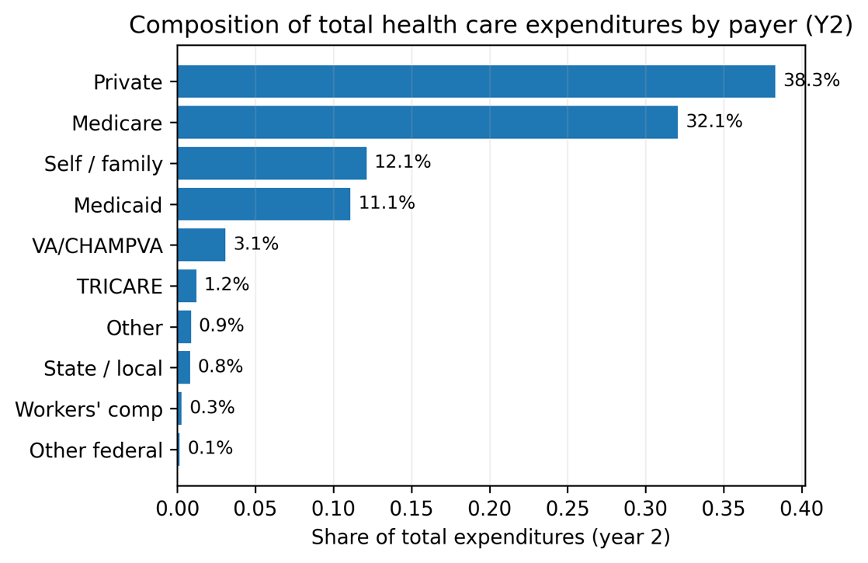
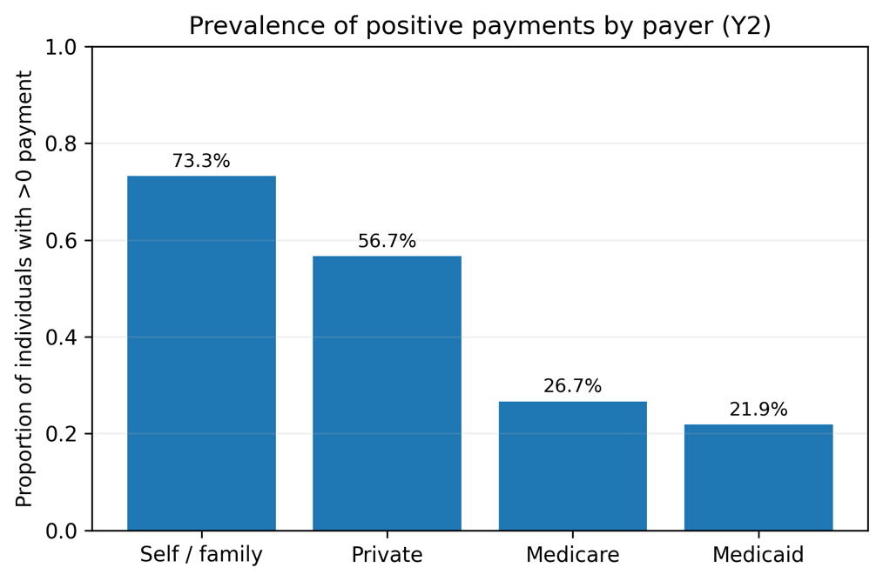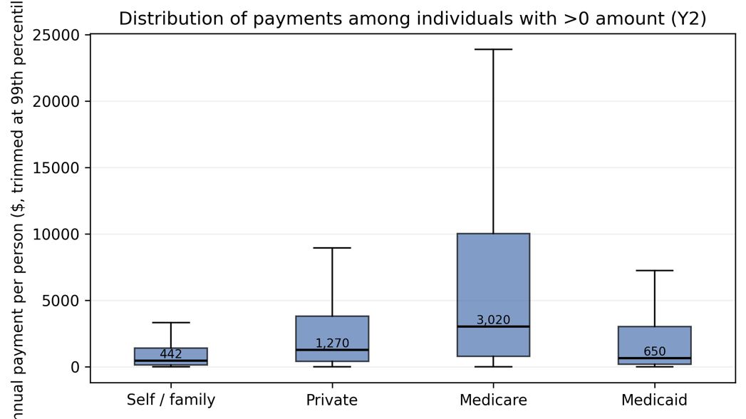

Appendix B: Detailed Feature Contribution and Subgroup Tables

Table B1. HIGHCOST_Y2 subgroup tables (observed rate %, mean predicted risk %)

B1.1 LOG_TOTEXPY1 quartiles
Group | Observed % | Predicted %
Q4(high) | 29.4 | 53.9
Q3 | 5.9 | 23.2
Q2 | 3.1 | 13.2
Q1(low) | 1.6 | 7.4

B1.2 AGE_GROUP
Group | Observed % | Predicted %
65+ | 20.9 | 44.2
45–64 | 12.2 | 29.8
30–44 | 5.9 | 16.3
18–29 | 3.0 | 11.4
0–17 | 2.0 | 7.0
B1.3 ANY_ED_Y1
Group | Observed % | Predicted %
1 | 22.0 | 44.9
0 | 8.1 | 21.9

B1.4 ANY_IP_Y1
Group | Observed % | Predicted %
1 | 31.5 | 61.5
0 | 8.7 | 22.7

B1.5 RTHLTH1_FAIRPOOR
Group | Observed % | Predicted %
1 | 24.1 | 44.7
0 | 7.9 | 21.6

B1.6 HIBPDXY1_BIN / CHOLDXY1_BIN
Variable | Group | Observed % | Predicted %
HIBPDXY1_BIN | 1 | 19.8 | 42.3
HIBPDXY1_BIN | 0 | 5.8 | 16.4
CHOLDXY1_BIN | 1 | 19.0 | 40.3
CHOLDXY1_BIN | 0 | 6.4 | 18.4

B1.7 INS_TYPE_Y1
Group | Observed % | Predicted %
65+ Medicare + other public | 28.4 | 52.4
65+ other coverage | 24.1 | 45.8
65+ Medicare + private | 20.3 | 44.8
65+ Medicare only | 18.5 | 39.9
<65 public only | 7.5 | 18.4
<65 any private | 7.1 | 20.0
<65 uninsured | 2.2 | 7.5
65+ uninsured | 0.0 | 13.6

B1.8 POVCATY1_CAT
Group | Observed % | Predicted %
Near poor | 14.0 | 25.9
Poor/negative | 11.6 | 25.3
Low income | 9.4 | 24.0
Middle income | 9.0 | 22.5
High income | 9.8 | 26.9

B1.9 REGIONY1_CAT / RACE_ETH
Variable | Group | Observed % | Predicted %
REGIONY1_CAT | Northeast | 13.5 | 29.8
REGIONY1_CAT | Midwest | 9.5 | 27.3
REGIONY1_CAT | West | 9.0 | 23.4
REGIONY1_CAT | South | 9.5 | 23.0
RACE_ETH | NH White | 12.7 | 31.0
RACE_ETH | NH Black | 9.3 | 21.3
RACE_ETH | NH Other/multiple | 6.7 | 22.3
RACE_ETH | NH Asian | 6.3 | 16.8
RACE_ETH | Hispanic | 5.6 | 15.4

Table B2. ANY_ED_Y2 subgroup tables (observed % / predicted %)

B2.1 ANY_ED_Y1
Group | Observed % | Predicted %
1 | 33.6 | 32.4
0 | 11.1 | 11.1

B2.2 AGE_GROUP
Group | Observed % | Predicted %
65+ | 21.6 | 21.9
45–64 | 15.1 | 14.8
30–44 | 10.1 | 9.6
18–29 | 9.8 | 10.5
0–17 | 11.0 | 9.9

B2.3 LOG_TOTEXPY1 quartiles
Group | Observed % | Predicted %
Q4(high) | 25.6 | 24.7
Q3 | 14.0 | 15.0
Q2 | 11.1 | 10.5
Q1(low) | 6.4 | 5.8

B2.4 LOG_FAMINCY1 quartiles
Group | Observed % | Predicted %
Q1(low) | 20.7 | 20.1
Q2 | 14.1 | 13.5
Q3 | 11.9 | 12.1
Q4(high) | 10.3 | 10.7

B2.5 POVCATY1_CAT
Group | Observed % | Predicted %
Near poor | 20.2 | 17.8
Poor/negative | 19.1 | 17.8
Low income | 16.0 | 16.6
Middle income | 13.5 | 13.3
High income | 11.5 | 12.0

B2.6 ANY_UNEMP_COMP_Y1
Group | Observed % | Predicted %
1 | 24.5 | 33.0
0 | 14.1 | 13.9

B2.7 REGIONY1_CAT
Group | Observed % | Predicted %
Midwest | 15.3 | 15.4
South | 15.0 | 15.1
Northeast | 13.5 | 13.2
West | 12.7 | 12.4

Table B3. ANY_IP_Y2 subgroup tables (observed % / predicted %)

B3.1 LOG_TOTEXPY1 quartiles
Group | Observed % | Predicted %
Q4(high) | 16.0 | 36.2
Q3 | 5.9 | 18.5
Q2 | 4.8 | 12.8
Q1(low) | 2.3 | 8.1

B3.2 AGE_GROUP
Group | Observed % | Predicted %
65+ | 15.7 | 36.7
45–64 | 7.2 | 19.4
30–44 | 4.5 | 12.5
18–29 | 4.1 | 10.9
0–17 | 1.8 | 7.9

B3.3 HIBPDXY1_BIN
Group | Observed % | Predicted %
1 | 14.3 | 32.0
0 | 4.2 | 13.6

Table B4. LOG_TOTEXPY2 regression subgroup tables (mean log cost)

B4.1 LOG_TOTEXPY1 quartiles
Group | Mean actual | Mean predicted
Q4(high) | 9.025 | 9.026
Q3 | 7.652 | 7.607
Q2 | 6.432 | 6.421
Q1(low) | 3.567 | 3.598

B4.2 AGE_GROUP
Group | Mean actual | Mean predicted
65+ | 8.477 | 8.474
45–64 | 7.185 | 7.273
30–44 | 5.792 | 5.947
0–17 | 5.640 | 5.669
18–29 | 4.999 | 4.890

Appendix C. Robustness Check: Survey-weighted Performance (LONGWT)

Table C1. Unweighted vs weighted (LONGWT) classification performance
TARGET (PRIMARY MODEL) | t | metric | unweighted | weighted (LONGWT)
HIGHCOST_Y2 (RF) | 0.55 | AUC | 0.868 | 0.850
 |  | PR-AUC | 0.459 | 0.391
 |  | Precision | 0.487 | 0.496
 |  | Recall | 0.596 | 0.388
ANY_ED_Y2 (XGB) | 0.20 | AUC | 0.728 | 0.700
 |  | PR-AUC | 0.350 | 0.287
 |  | Precision | 0.313 | 0.268
 |  | Recall | 0.439 | 0.459
ANY_IP_Y2 (RF) | 0.40 | AUC | 0.755 | 0.748
 |  | PR-AUC | 0.225 | 0.192
 |  | Precision | 0.234 | 0.240
 |  | Recall | 0.363 | 0.283

Survey-weighted evaluation was conducted for the classification outcomes to assess population-level robustness under the MEPS longitudinal weights (LONGWT). For the expenditure regression, we report unweighted test performance as the primary evaluation, since the regression model is intended for relative risk/cost ranking rather than population mean estimation, and a full design-based regression evaluation is beyond the scope of this thesis.
We used the same fixed thresholds (T) as in the unweighted evaluation to enable a like-to-like comparison of precision and recall. Because weighting changes the effective population composition, precision–recall trade-offs can shift at a fixed threshold; recalibrating T under weights is possible but was not the goal of this robustness check. As shown in Table C1, survey-weighted evaluation (LONGWT) yields slightly lower AUC/PR-AUC across targets compared with unweighted test metrics, indicating that population weighting changes the effective operating point without altering the main conclusions.

Appendix D. Acronyms and Variable Glossary
A. Acronyms
Acronym | Meaning
MEPS-HC | Medical Expenditure Panel Survey – Household Component
AHRQ | Agency for Healthcare Research and Quality
HC-252 | MEPS Panel 27 longitudinal file (2022–2023)
HC-243 | MEPS full-year consolidated file (2022)
HC-251 | MEPS full-year consolidated file (2023)
ED | Emergency Department visit
IP | Inpatient stay / hospital admission
SES | Socio-economic status
LONGWT | Longitudinal person weight
VARSTR | Variance estimation stratum (survey design)
VARPSU | Primary sampling unit (survey design)
AUC | Area Under the ROC Curve
PR-AUC | Precision–Recall AUC (Average Precision)
TP/TN/FP/FN | True Positive/True Negative/False Positive/False Negative
RMSE | Root Mean Squared Error
MAE | Mean Absolute Error
R² | Coefficient of determination
RF | Random Forest
XGB | XGBoost
MLP | Multilayer Perceptron

B. Variable Glossary
Variable | Meaning / Definition | Notes / Derivation
TOTEXPY1 | Total health care expenditures, Year-1 | MEPS total expenditure
TOTEXPY2 | Total health care expenditures, Year-2 | MEPS total expenditure
LOG_TOTEXPY1 | log(1 + TOTEXPY1) | Engineered predictor
LOG_TOTEXPY2 | log(1 + TOTEXPY2) | Regression target
HIGHCOST_Y2 | High-cost indicator in Year-2 | Top-cost percentile (as defined in thesis)
ERTOTY2 | Total ED visits, Year-2 | MEPS count variable
IPDISY2 | Total inpatient discharges, Year-2 | MEPS count variable
ANY_ED_Y1 | Any ED visit in Year-1 | Indicator: ERTOTY1 > 0
ANY_ED_Y2 | Any ED visit in Year-2 | Indicator: ERTOTY2 > 0
ANY_IP_Y1 | Any inpatient stay in Year-1 | Indicator: IPDISY1 > 0
ANY_IP_Y2 | Any inpatient stay in Year-2 | Indicator: IPDISY2 > 0
ANY_IP | Any inpatient stay (generic label) | Used in text; see ANY_IP_Y1/ANY_IP_Y2
AGE_GROUP | Age group (0–17, 18–44, 45–64, 65+) | Engineered from AGEY1X/AGEY2X
SEX_BIN | Female indicator | 1 if SEX = 2
RACE_ETH | Race/ethnicity label | Engineered from RACETHX
REGIONY1_CAT | Region label (Year-1) | Engineered from REGIONY1
EDU_GROUP | Education group | Engineered from EDUCYR
POVCATY1_CAT | Poverty category label | Engineered from POVCATY1
FAMSIZE_Y1 | Family size (Year-1) | From FAMSZEY1
FAMSIZE_Y1_GRP | Family size group (1–6, 7+) | Engineered from FAMSZEY1
INS_TYPE_Y1 | Insurance type (Year-1) | Engineered from INSURCY1
WORKED_Y1 | Ever worked in Year-1 | Engineered from EVRWRKY1
LOG_FAMINCY1 | log(1 + family income, Y1) | Engineered from FAMINCY1
LOG_UNEMP_COMP_Y1 | log(1 + unemployment compensation, Y1) | Engineered from UNEMPY1X
ANY_UNEMP_COMP_Y1 | Any unemployment compensation, Y1 | Indicator: UNEMPY1X > 0
RTHLTH1_FAIRPOOR | Fair/poor self-rated health, R1 | Engineered from RTHLTH1
MNHLTH1_FAIRPOOR | Fair/poor mental health, R1 | Engineered from MNHLTH1
HIBPDXY1 | High blood pressure, Year-1 | MEPS condition indicator
HIBPDXY1_BIN | Hypertension indicator | Engineered from HIBPDXY1
CHOLDXY1_BIN | High cholesterol indicator | Engineered from CHOLDXY1

Appendix E: Ethical Considerations
- Intended use: The models are intended for risk stratification / top-k prioritization under capacity constraints. Outputs support human review rather than automated decisions.
- Non-use: Not for diagnosis, not for causal claims, and not as the sole basis for denying services/coverage.
- Potential harms:
  - False positives: unnecessary outreach or stigma.
  - False negatives: missed high-risk individuals (especially low-prevalence outcomes such as inpatient).
  - Mitigation: use ranking/top-k with human oversight; avoid hard thresholds as the only decision rule; communicate uncertainty.
- Fairness: Model performance may differ across subgroups (e.g., age/sex). This thesis reports subgroup metrics (e.g., recall@top-k, PR-AUC) and recommends continuous monitoring and transparent reporting if used operationally.
- Interpretability: “Reason tags” in the MVP are rule-based summaries of baseline inputs to improve readability and plausibility checks. They are not model-derived and should not be interpreted as feature importance or causal drivers.

Appendix F. Data Use Compliance
This thesis uses the public-use MEPS-HC Panel 27 longitudinal file (HC-252). In this repository, we include derived, feature-engineered datasets (e.g., df_feat.parquet) and trained model artifacts for reproducibility. These derived outputs are created from public-use MEPS data and are therefore subject to the same public-use restrictions. In particular, no attempt is made to re-identify individuals, and the data are not linked to any individually identifiable external datasets. Results are reported only in aggregate form, and shared artifacts are intended for research and demonstration purposes only. Users of this repository are responsible for ensuring continued compliance with MEPS public-use requirements.

Appendix G. Reproducibility
All code used in this thesis is provided in the accompanying GitHub repository: < https://github.com/WenxiGu/Thesis-project-MEPS >. The analysis is organized into notebooks for EDA and modelling, and a src/ package for reusable preprocessing, feature engineering, and modelling utilities. A Streamlit MVP and trained model artifacts are included for demonstration.
Code structure
- notebooks/: end-to-end workflow (EDA → feature engineering → modelling → evaluation).
- src/: reusable data I/O, preprocessing, feature engineering, and modelling utilities.
- app/: Streamlit MVP for inference and top-k selection.
- results/: figures, tables, and exported model artifacts.
Random seeds
All models use a fixed random seed to ensure reproducibility:
- RANDOM_SEED = 42 (defined in config.py and reused across scripts).
- Model training scripts and notebooks pass random_state=42 where applicable.
Environment
- Python 3.12.
- Dependencies pinned in requirements.txt (app + modelling).
- Conda environment for thesis notebooks in environment_thesis.yml.
Re-running the analysis
- Install dependencies (pip install -r requirements.txt or environment_thesis.yml).
- Run notebooks in order:
01_EDA.ipynb → 02_Data Preparation & Feature Engineering.ipynb →
03_Modelling_baseline.ipynb → 04_Model Predictions.ipynb → 05_weighted evaluation.ipynb.
- (Optional) Retrain and export preferred models:
train_and_save_preferred_models.py

References

Hernandez-Viver, A. and Mitchell, E.M. Concentration of Healthcare Expenditures and Selected Characteristics of Persons with High Expenses, U.S. Civilian Noninstitutionalized Population, 2018-2022. Statistical Brief #560. AHRQ Publication No. 25-0017-3-EF. March 2025. Agency for Healthcare Research and Quality, Rockville, MD. https://meps.ahrq.gov/data_files/publications/st560/stat560.shtml

Cohen, J. Design and Methods of the Medical Expenditure Panel Survey Household Component. MEPS Methodology Report No. 1. AHCPR Pub. No. 97-0026. Rockville, MD. Agency for Healthcare Policy and Research, 1997. http://meps.ahrq.gov/mepsweb/data_files/publications/mr1/mr1.pdf

Fleishman, J. A., & Cohen, J. W. (2010). Using information on clinical conditions to predict high-cost patients. Health Services Research, 45(2), 532–552.
https://doi.org/10.1111/j.1475-6773.2009.01080.x

Mohan, G., & Gaskin, D. J. (2024). Social determinants of health and US health care expenditures by insurer. JAMA Network Open, 7(10), e2440467. https://doi.org/10.1001/jamanetworkopen.2024.40467

Sun, B. C., Burstin, H. R., & Brennan, T. A. (2003). Predictors and outcomes of frequent emergency department users. Academic Emergency Medicine, 10(4), 320–328. https://doi.org/10.1111/j.1553-2712.2003.tb01344.x
https://pubmed.ncbi.nlm.nih.gov/12670845/

Obermeyer, Z., Powers, B., Vogeli, C., & Mullainathan, S. (2019). Dissecting racial bias in an algorithm used to manage the health of populations. Science, 366(6464), 447–453. https://doi.org/10.1126/science.aax2342

Davoudi, A., Chae, S., Evans, L., Sridharan, S., Song, J., Bowles, K. H., McDonald, M. V., & Topaz, M. (2024). Fairness gaps in machine learning models for hospitalization and emergency department visit risk prediction in home healthcare patients with heart failure. International Journal of Medical Informatics, 191, 105534. https://doi.org/10.1016/j.ijmedinf.2024.105534

Definitions of variables and acronyms are provided in Appendix D.

