1. Which tables and fields would you access to determine which book titles have been purchased by a customer and when the order shipped?
   1. BOOKS: ISBN, TITLE;
   2. ORDERITEMS: ORDER#, ISBN;
   3. ORDERS: SHIPDATE, ORDER#, CUSTOMER#
2. How would you determine which orders have not yet been shipped to the customer?
   1. ORDERS: ORDER#, without a shipdate
3. If management needed to determine which book category generated the most sales in April 2009, which tables and fields would they consult to derive this information?
   1. ORDERITEMS: ORDER#, ISBN, ITEM#, QUANTITY
   2. BOOKS: ISBN, COST, RETAIL, DISCOUNT, CATEGORY
   3. ORDERS: ORDER#, ORDERDATE
4. Explain how you would determine how much profit was generated from orders placed in April 2009.
   1. ORDER: ORDER#, ORDERDATE
   2. ORDERITEMS: PAIDEACH, QUANTITY, ISBN
   3. BOOKS: ISBN, COST, RETAIL, DISCOUNT
5. If a customer inquired about a book written in 2003 by an author named Thompson, which access path (tables and fields) would you need to follow to find the list of books meeting the customer’s request?
   1. BOOKS: PUBDATE, ISBN,
   2. BOOKAUTHOR: ISBN, AUTHORID
   3. AUTHOR: AUTHORID, FNAME
6. A college needs to track placement test scores for incoming students. Each student can take a variety of tests, including English and math. Some students are required to take placement tests because of previous coursework.



1. Every employee in a company is assigned to one department. Every department can contain many employees.



1. A movie megaplex needs to collect movie attendance data. The company maintains 16 theaters in a single location. Each movie offered can be shown in one or more of the available theaters and is typically scheduled for three to six showings in a day. The movies are rotated through the theaters to ensure that each is shown in one of the stadium-seating theaters at least once.

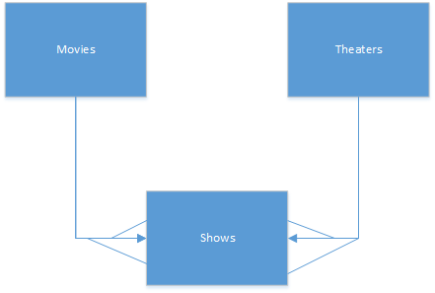

1. An online retailer of coffee beans maintains a long list of unique coffee flavors. The company purchases beans from a number of suppliers; however, each specific flavor of coffee is purchased from only a single supplier. Many of the customers are repeat purchasers and typically order at least five flavors of beans in each order.



1. Data for an information technology conference needs to be collected. The conference has a variety of sessions scheduled over a two-day period. All attendees must register for the sessions they plan to attend. Some speakers are presenting only one session, whereas others are handling multiple sessions. Each session has only one speaker.

