JustLee Books has become the exclusive distributor for a number of books. The company now

needs to assign sales representatives to retail bookstores to handle the new distribution duties.

For these assignments, create new tables to support the following:

1. Modify the following SQL command so that the Rep_ID column is the PRIMARY KEY for the table and the default value of Y is assigned to the Comm column. (The Comm column indicates whether the sales representative earns commission.)
   1. Original code

CREATE TABLE store_reps

(rep_ID NUMBER(5),

last VARCHAR2(15),

first VARCHAR2(10),

comm CHAR(1));

* 1. Modification
     1. Script

CREATE TABLE store_reps

(rep_ID NUMBER(5),

last VARCHAR2(15),

first VARCHAR2(10),

comm CHAR(1) DEFAULT 'Y',

CONSTRAINT store_reps_rep_ID_pk PRIMARY KEY (rep_ID));

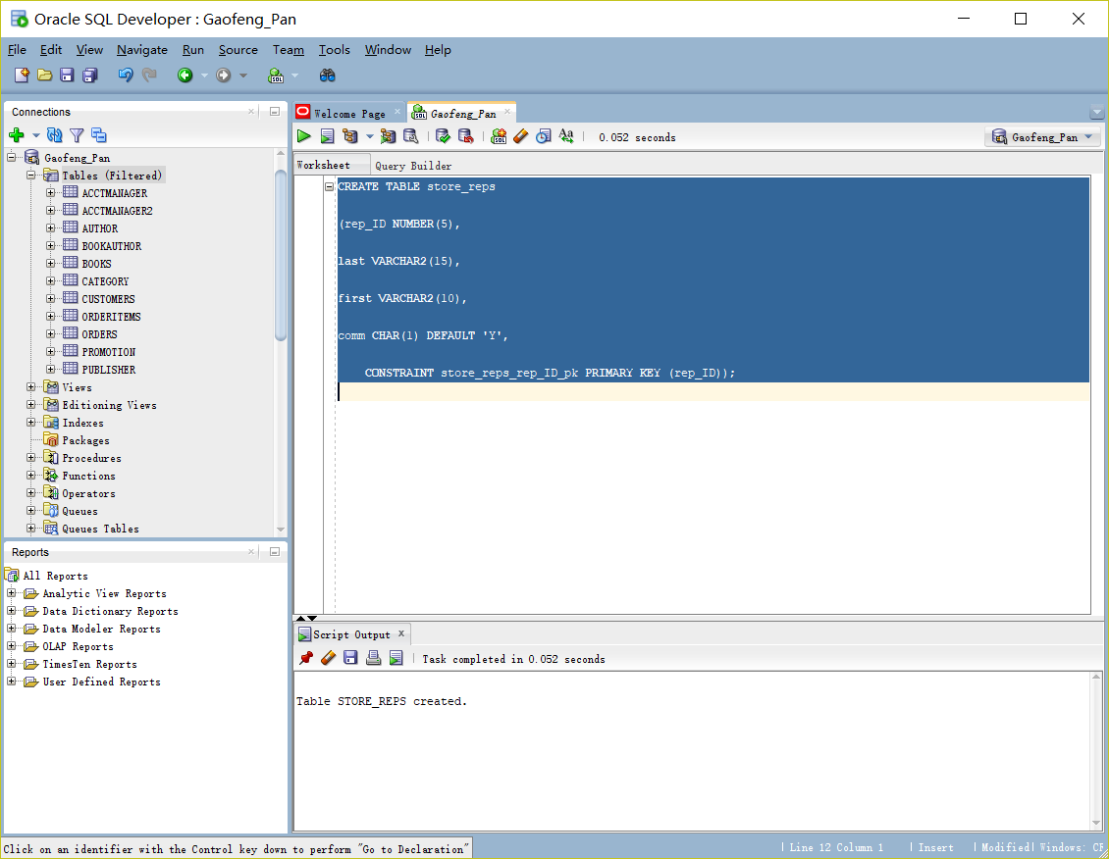

1. Change the STORE_REPS table so that NULL values can’t be entered in the name columns (First and Last).

ALTER TABLE store_reps

MODIFY (last CONSTRAINT store_reps_last_nn

NOT NULL);

ALTER TABLE store_reps

MODIFY (first CONSTRAINT store_reps_first_nn

NOT NULL);

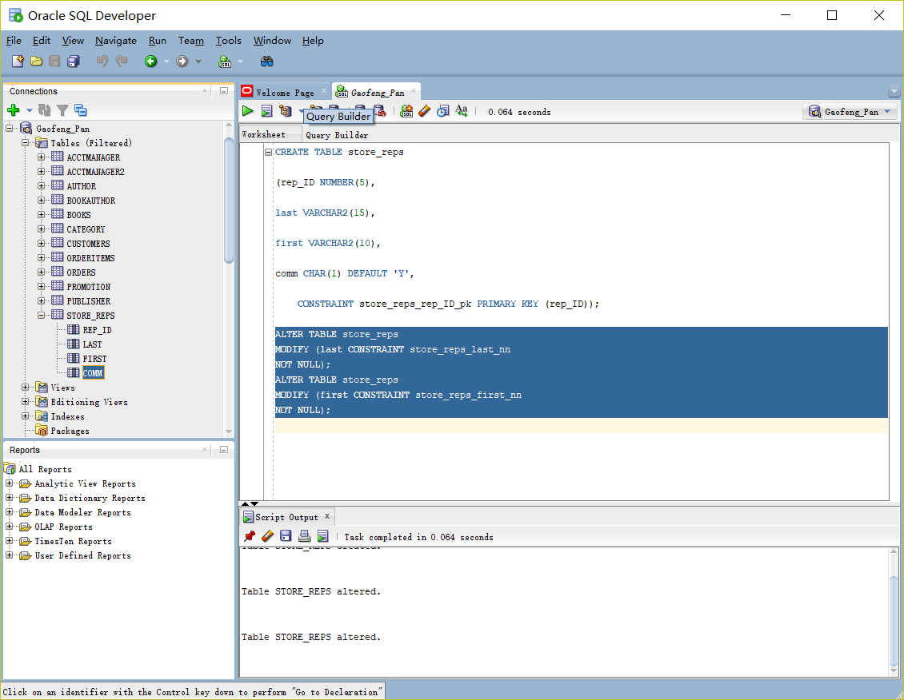

1. Change the STORE_REPS table so that only a Y or N can be entered in the Comm column.
   1. Script

ALTER TABLE store_reps

add constraint store_reps_comm_ck CHECK(Comm IN ('Y','N'));

* 1. Screenshot
     1. 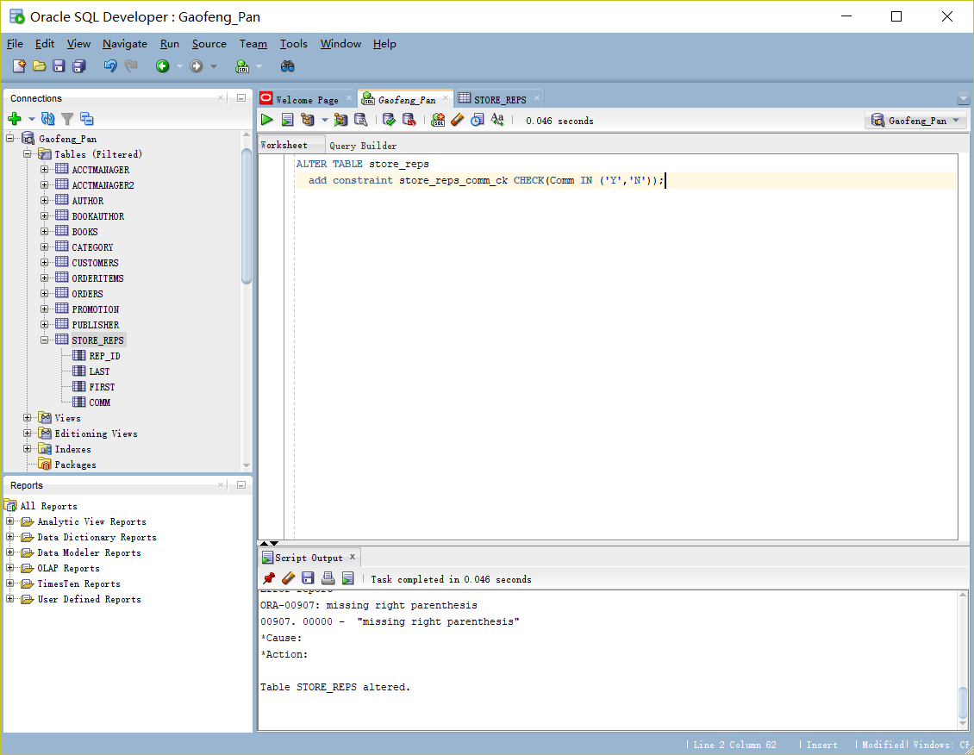

1. Add a column named Base_salary with a datatype of NUMBER(7,2) to the STORE_REPS table. Ensure that the amount entered is above zero.
   1. Script

ALTER TABLE store_reps

ADD Base_salary Number(7,2);

ALTER TABLE store_reps

ADD CONSTRAINT store_reps_Base_salary_ck CHECK(Base_salary >0);

* 1. Screenshot
     1. 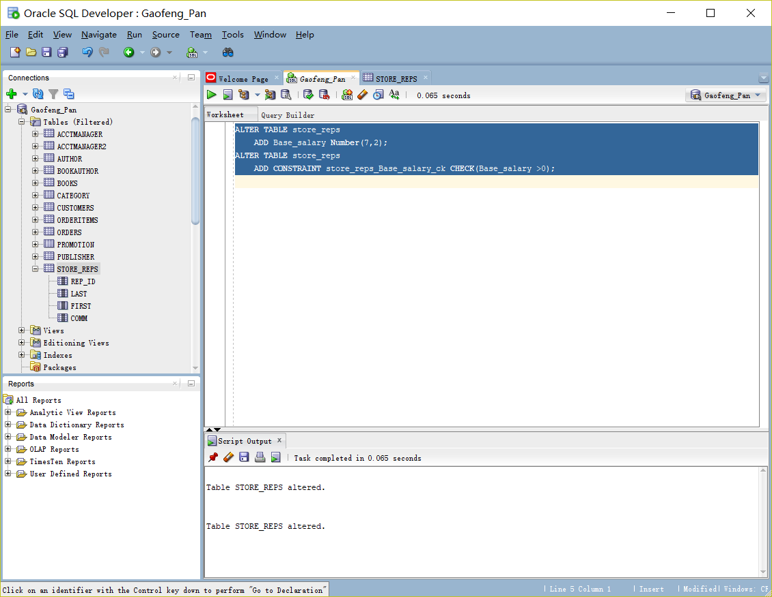

1. Create a table named BOOK_STORES to include the columns listed in the following chart.
   1. SCRIPT

CREATE TABLE BOOK_STORES

(Store_ID NUMBER(8),

Name VARCHAR2(30)NOT NULL,

Contact VARCHAR2(30),

Rep_ID VARCHAR2(5),

CONSTRAINT BOOK_STORES_Store_ID_pk PRIMARY KEY (Store_ID),

CONSTRAINT BOOK_STORES_Name_uk Unique(Name));

* 1. SCREEN SHOT
     1. 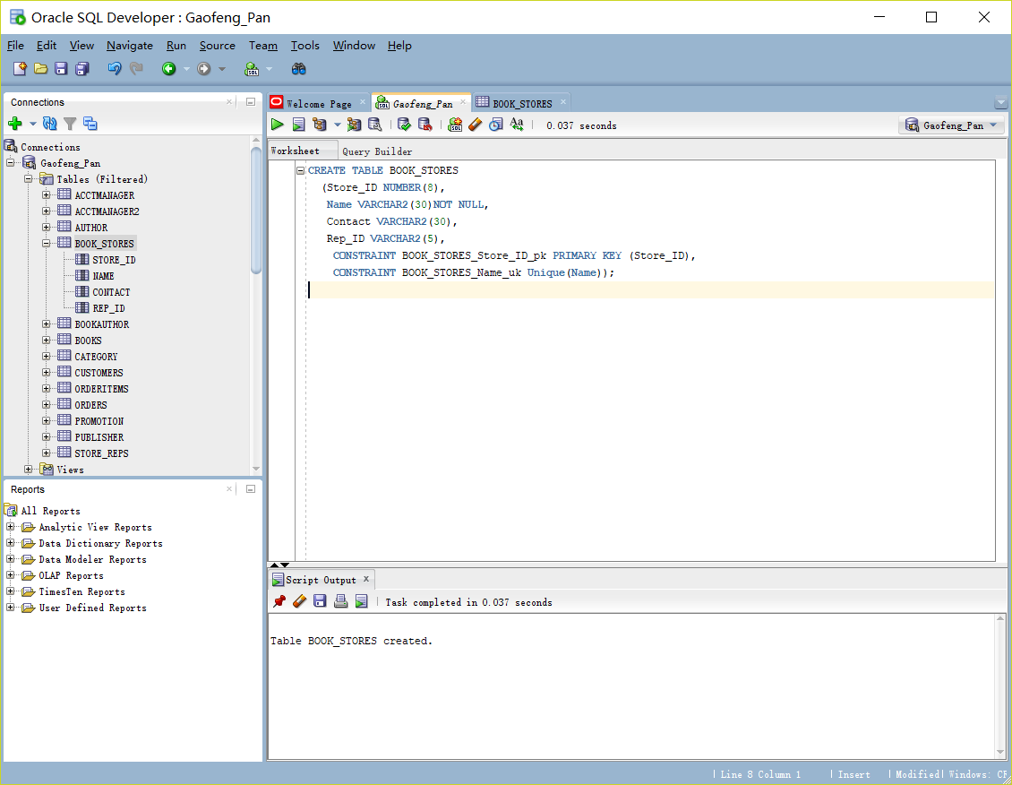

1. Add a constraint to make sure the Rep_ID value entered in the BOOK_STORES table is a valid value contained in the STORE_REPS table. The Rep_ID columns of both tables were initially created as different datatypes. Does this cause an error when adding the constraint?

Yes

Make table modifications as needed so that you can add the required constraint.

Column Name Datatype Constraint Comments

Store_ID NUMBER(8) PRIMARY KEY column

Name VARCHAR2(30) Should be UNIQUE and NOT NULL

Contact VARCHAR2(30)

Rep_ID VARCHAR2(5)

* 1. SCRIPT
     1. ALTER TABLE BOOK_STORES
     2. modify(Rep_ID number(5))
     3. add constraint book_stores_rep_ID_fk Foreign Key (Rep_Id)
     4. references Store_Reps(Rep_ID);
  2. SCREENSHOT
     1. 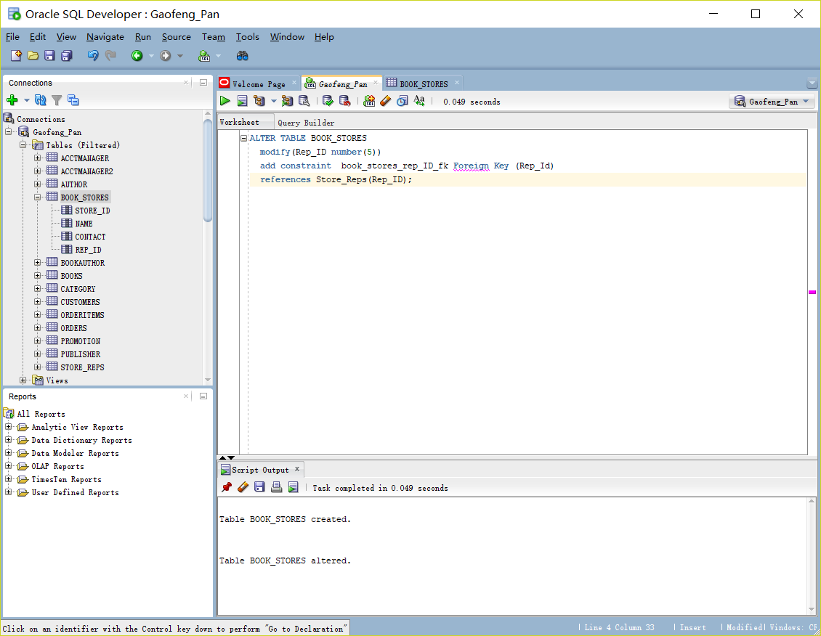

1. Change the constraint created in Assignment #6 so that associated rows of the BOOK_STORES table are deleted automatically if a row in the STORE_REPS table is deleted.
   1. ALTER TABLE BOOK_STORES
   2. ADD CONSTRAINT BOOK_STORES_Rep_Id_FK FOREIGN KEY (Rep_Id)
   3. REFERENCES STORE_REPS(Rep_Id) ON DELETE CASCADE;

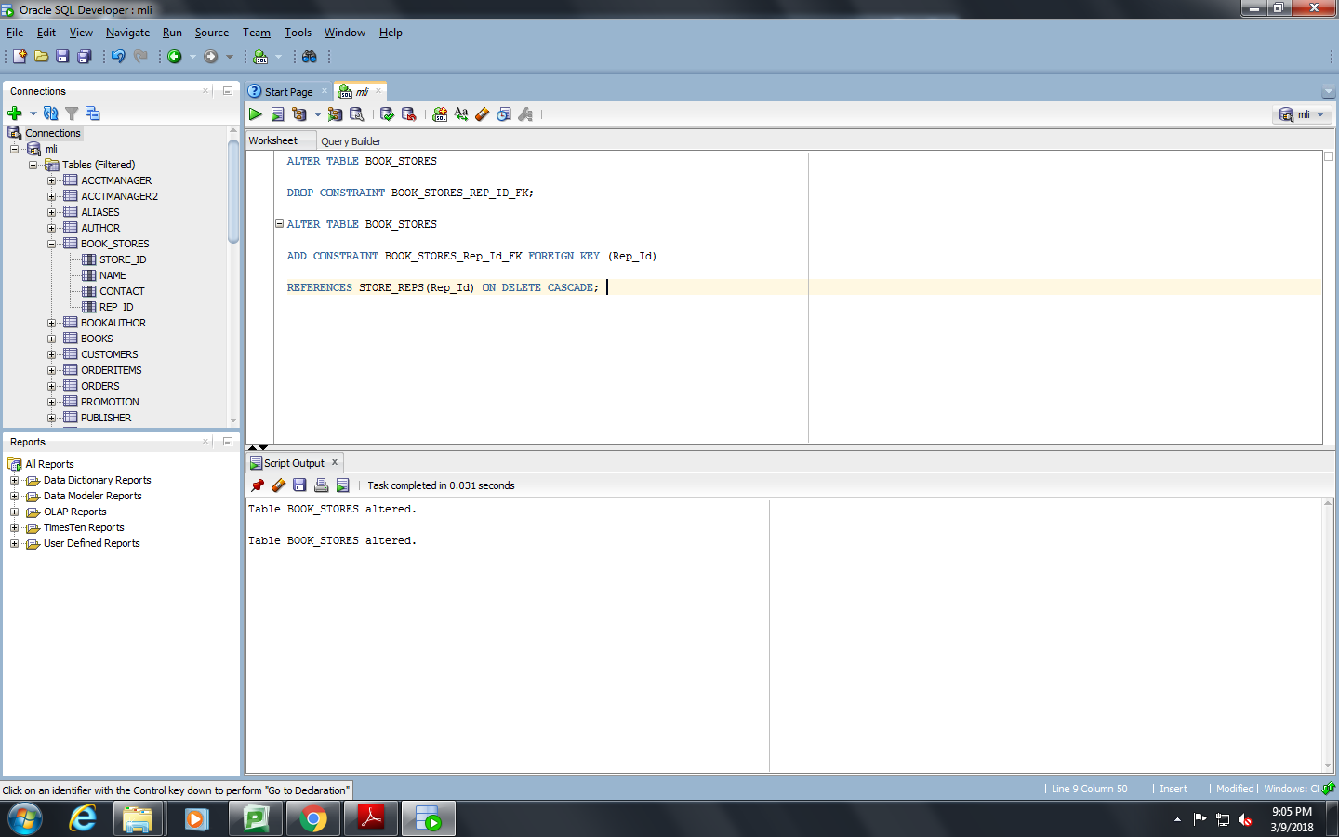

1. Create a table named REP_CONTRACTS containing the columns listed in the following chart. A composite PRIMARY KEY constraint including the Rep_ID, Store_ID, and Quarter columns should be assigned. In addition, FOREIGN KEY constraints should be assigned to both the Rep_ID and Store_ID columns.
   1. Column Name Datatype
   2. Store_ID NUMBER(8)
   3. Name NUMBER(5)
   4. Quarter CHAR(3)
   5. Rep_ID NUMBER(5)
      1. SCRIPT
         1. CREATE TABLE REP_CONTRACTS
         2. (STORE_ID NUMBER(8),
         3. NAME NUMBER(5),
         4. QUARTER CHAR(3),
         5. REP_ID NUMBER(5),
         6. CONSTRAINT REP_CONTRACTS_PK PRIMARY KEY (REP_ID, STORE_ID, QUARTER),
         7. CONSTRAINT REP_CONTRACTS_REP_ID_FK FOREIGN KEY(REP_ID)
         8. REFERENCES STORE_REPS (REP_ID),
         9. CONSTRAINT REP_CONTRACTS_STORE_ID_FK FOREIGN KEY(STORE_ID)
         10. REFERENCES BOOK_STORES (STORE_ID));
      2. SCREENSHOT

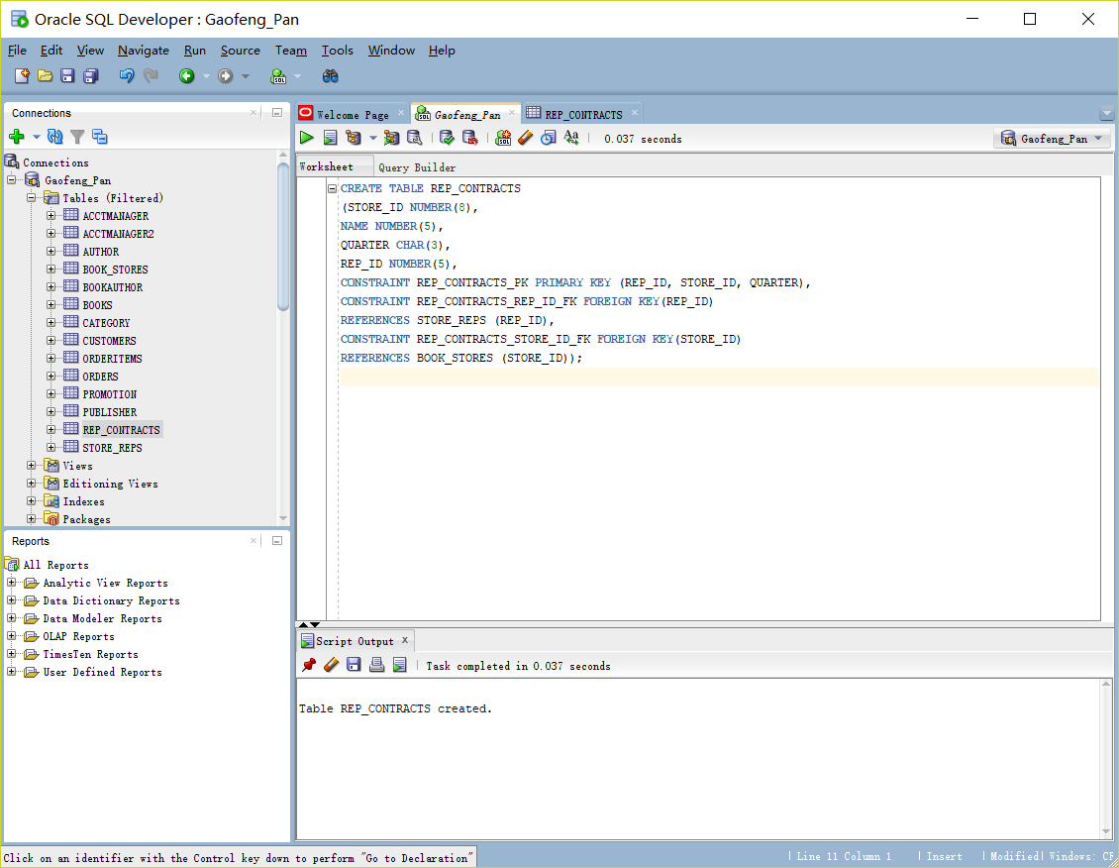

1. Produce a list of information about all existing constraints on the STORE_REPS table.
   1. SELECT CONSTRAINT_NAME, CONSTRAINT_TYPE,SEARCH_CONDITION,R_CONSTRAINT_NAME
   2. FROM USER_CONSTRAINTS
   3. WHERE TABLE_NAME = 'STORE_REPS';
   4. 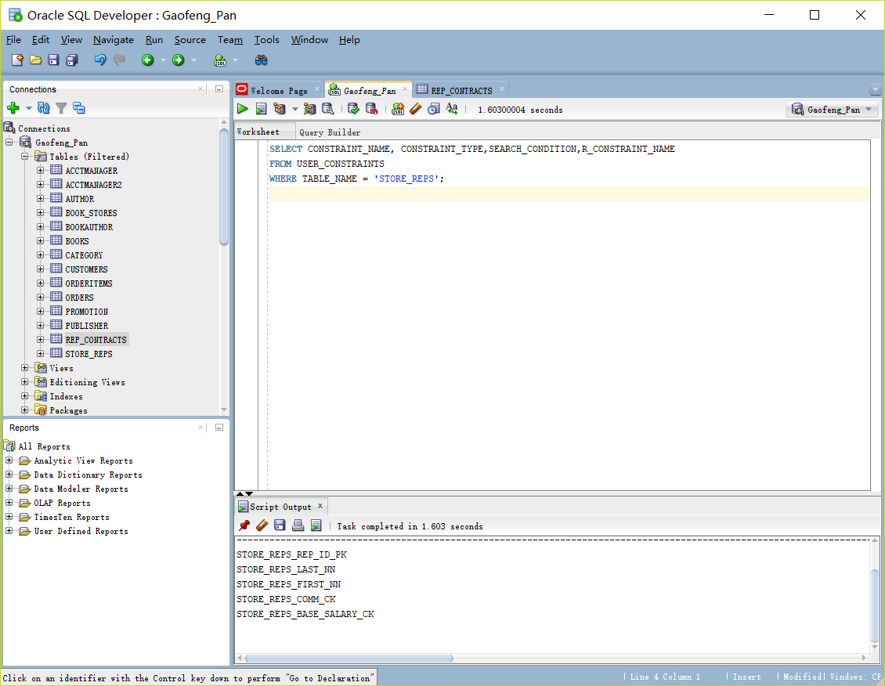
2. Issue the commands to disable and then enable the CHECK constraint on the Base_salary column.
   1. ALTER TABLE STORE_REPS
   2. DISABLE CONSTRAINT STORE_REPS_BASE_SALARY_CK;
   4. ALTER TABLE STORE_REPS
   5. ENABLE CONSTRAINT STORE_REPS_BASE_SALARY_CK;
   6. 