To perform the following assignments, refer to the tables created in the JLDB_Build_5.sql script

at the beginning of the chapter.

1. Add a new row in the ORDERS table with the following data: Order# = 1021, Customer# =

1009, and Order date = July 20, 2009.

SCRIPT:

INSERT INTO ORDERS(ORDER#, CUSTOMER#,ORDERDATE)

VALUES('1021','1009','20-JULY-09');

SCREENSHOT:

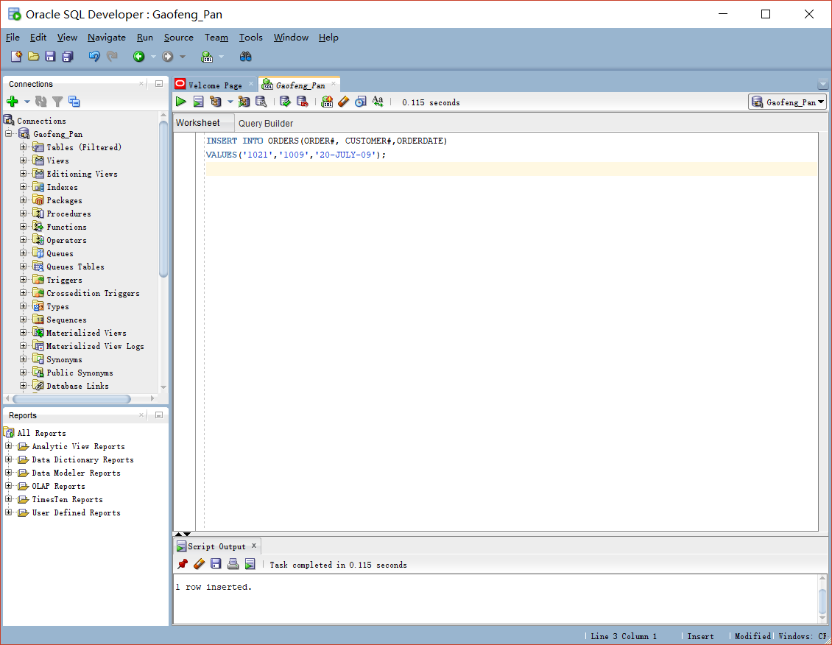

2. Modify the zip code on order 1017 to 33222.

SCRIPT:

UPDATE ORDERS

SET SHIPZIP='33222'

WHERE ORDER# = '1017';

SCREENSHOT:

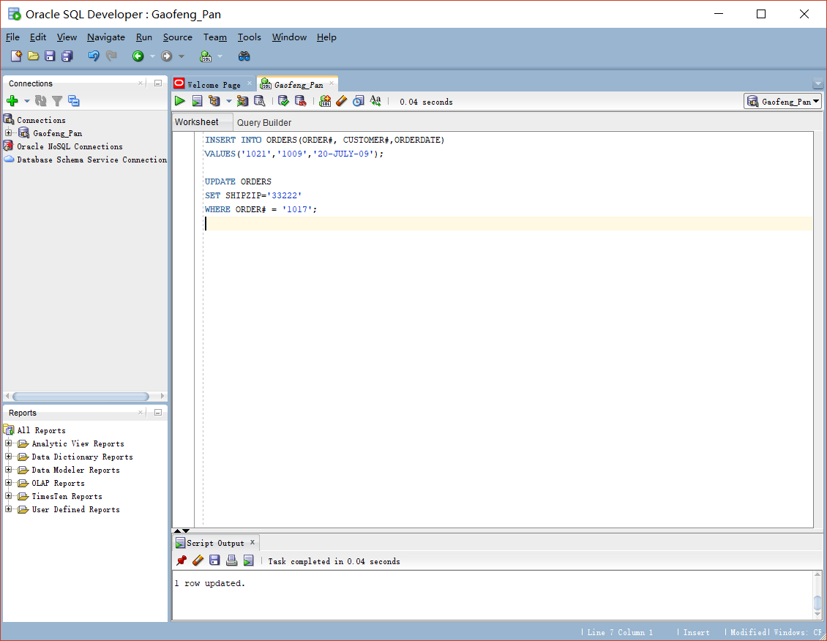

3. Save the changes permanently to the database.

SCRIPT:

COMMIT;

SCREEN SHOT:

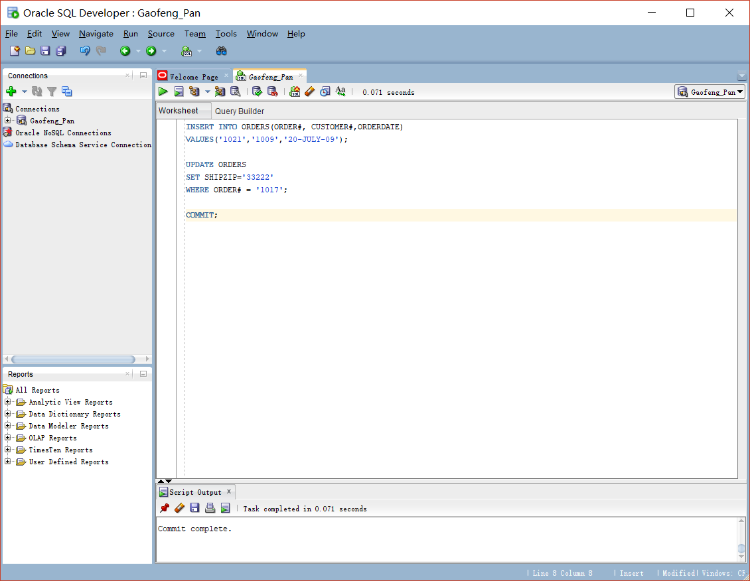

4. Add a new row in the ORDERS table with the following data: Order# = 1022, Customer# =

2000, and Order date = August 6, 2009. Describe the error raised and what caused the error.

SCRIPT:

INSERT INTO ORDERS(ORDER#,CUSTOMER#,ORDERDATE)

VALUES ('1022','2000','06-AUG-2009');

SCREENSHOT:

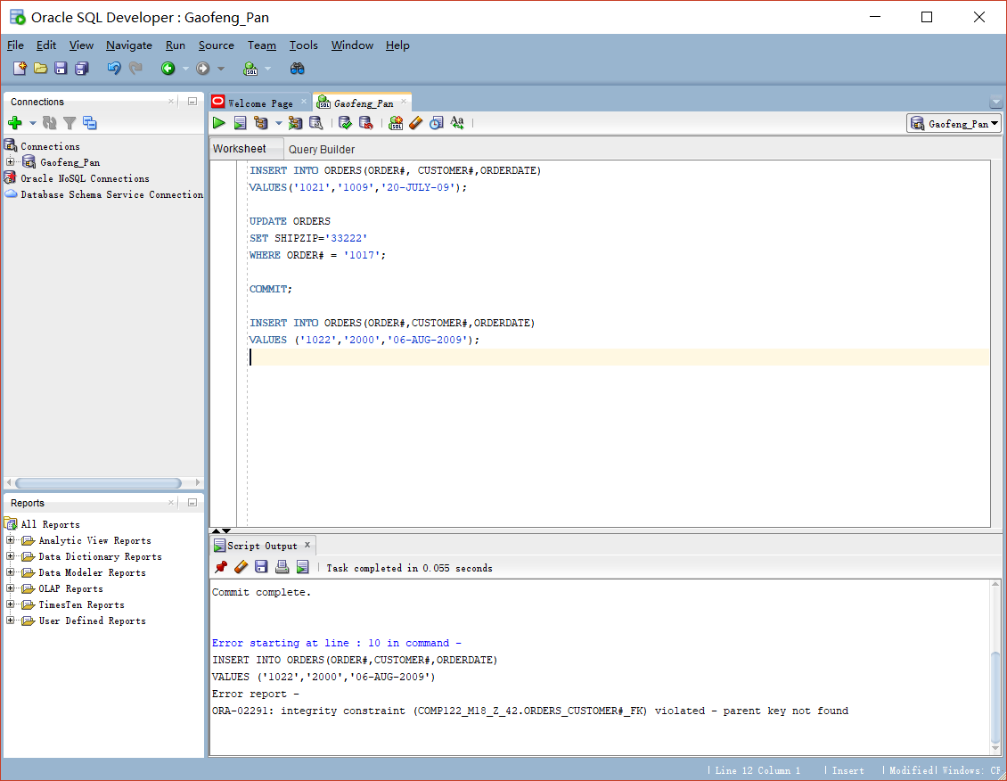

5. Add a new row in the ORDERS table with the following data: Order# = 1023 and

Customer# = 1009. Describe the error raised and what caused the error.

ANSWER: ERROR IS ORA-02291 , INTEGRITY CONSTRAINT

CAUSE: a foreign key value has no matching primary key value., the way to reduce the error is to delete the foreign key that already exist or add a matching primary to the table.

6. Create a script using substitution variables that allows a user to set a new cost amount for

a book based on the ISBN.

SCRIPT

UPDATE BOOKS

SET COST = '&COST'

WHERE ISBN ='&ISBN';

SCREEN SHOT

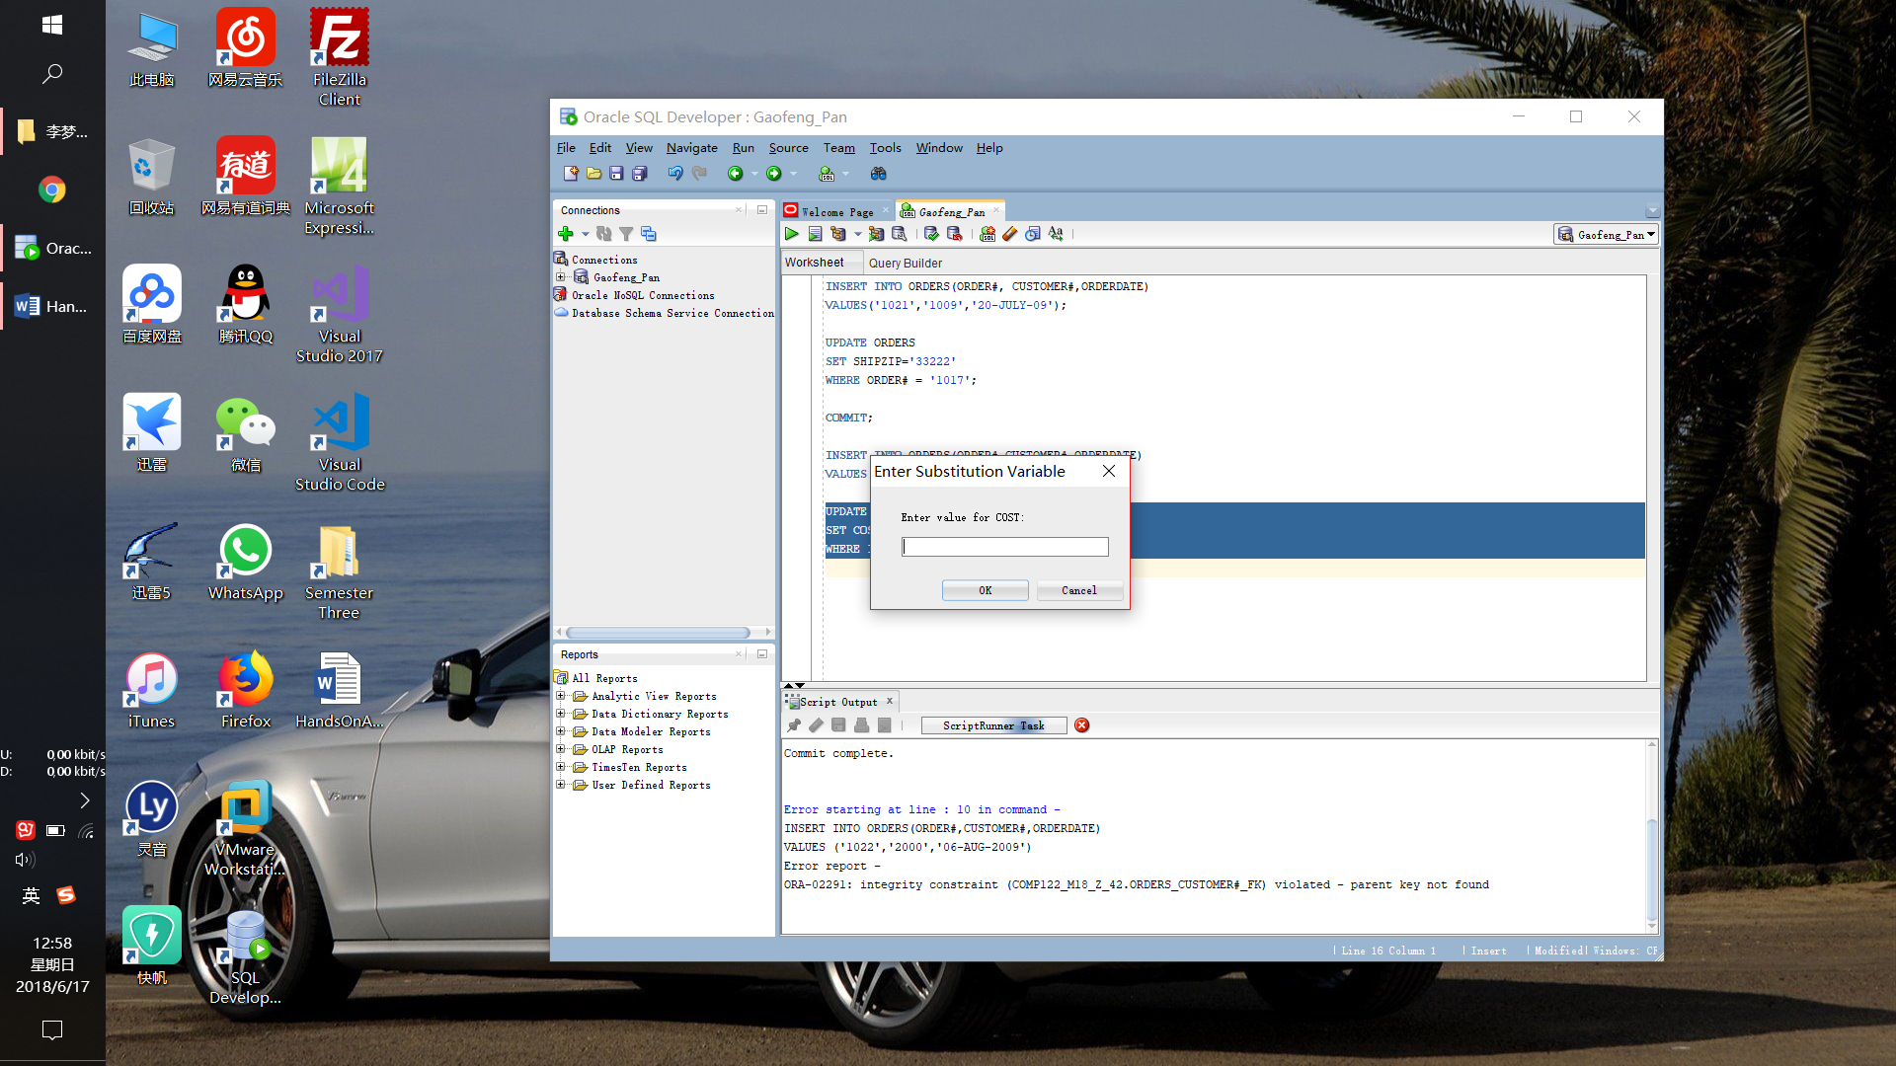

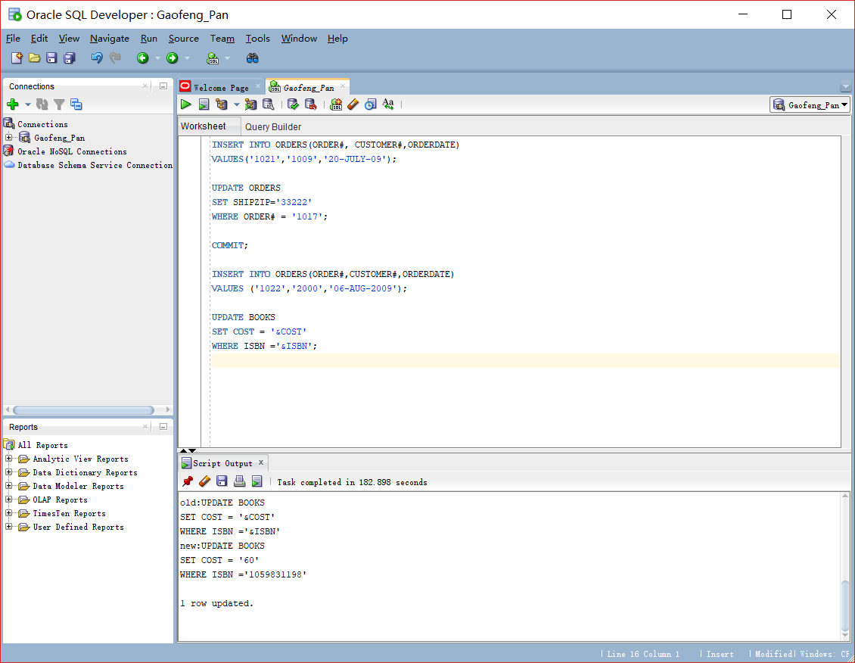

7. Execute the script and set the following values: isbn = 1059831198 and cost = $20.00.

SCRIPT

UPDATE BOOKS

SET COST = '&COST'

WHERE ISBN ='&ISBN';

SCREENSHOT:

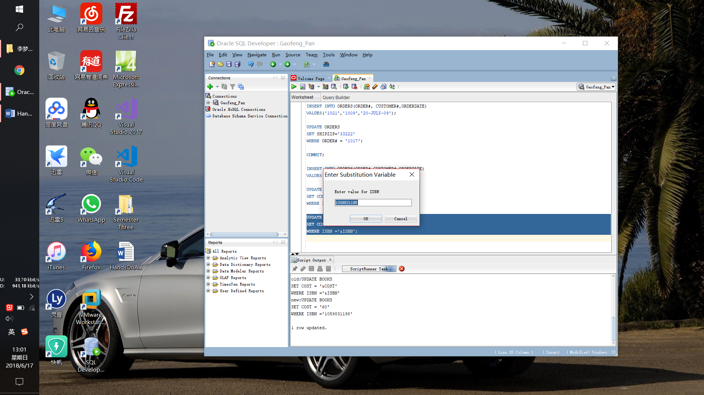

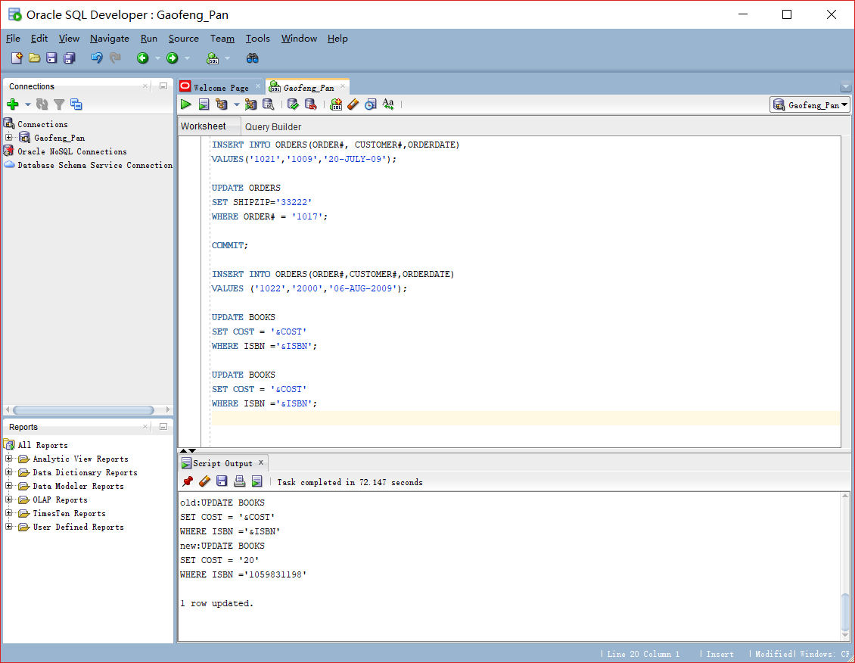

8. Execute a command that undoes the change in Step 7.

SCRIPT:

ROLLBACK;

SCREENSHOT:

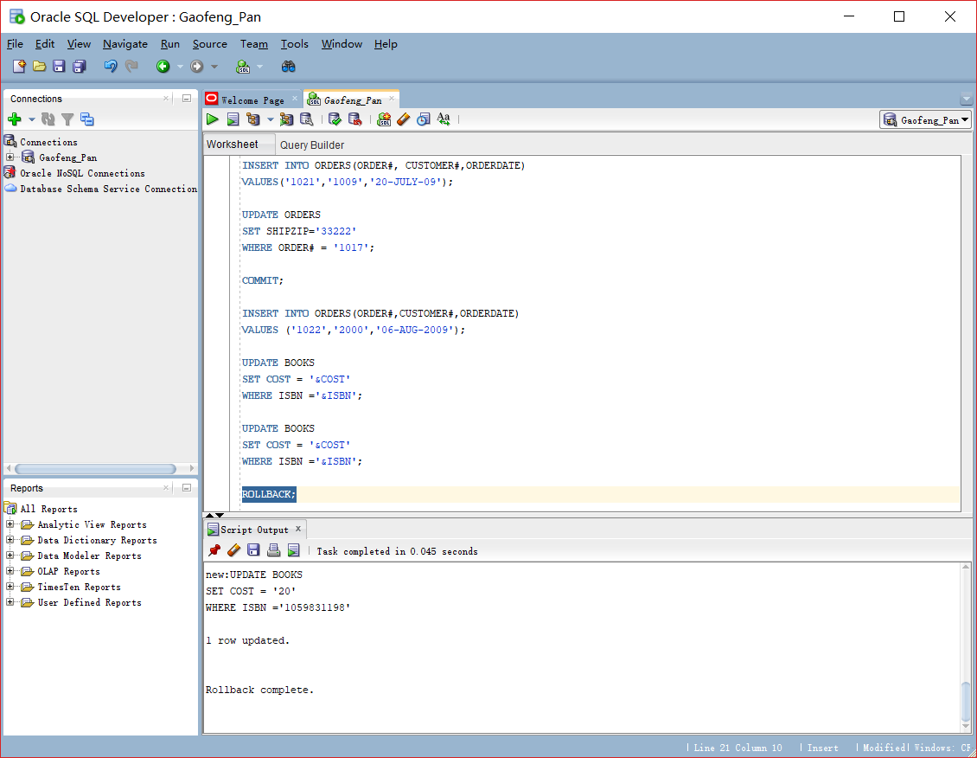

9. Delete Order# 1005. You need to address both the master order record and the related

detail records.

SCRIPT:

delete from orderitems

where order# = '1005';

delete from orders

where order#='1005';

SCREENSHOT:

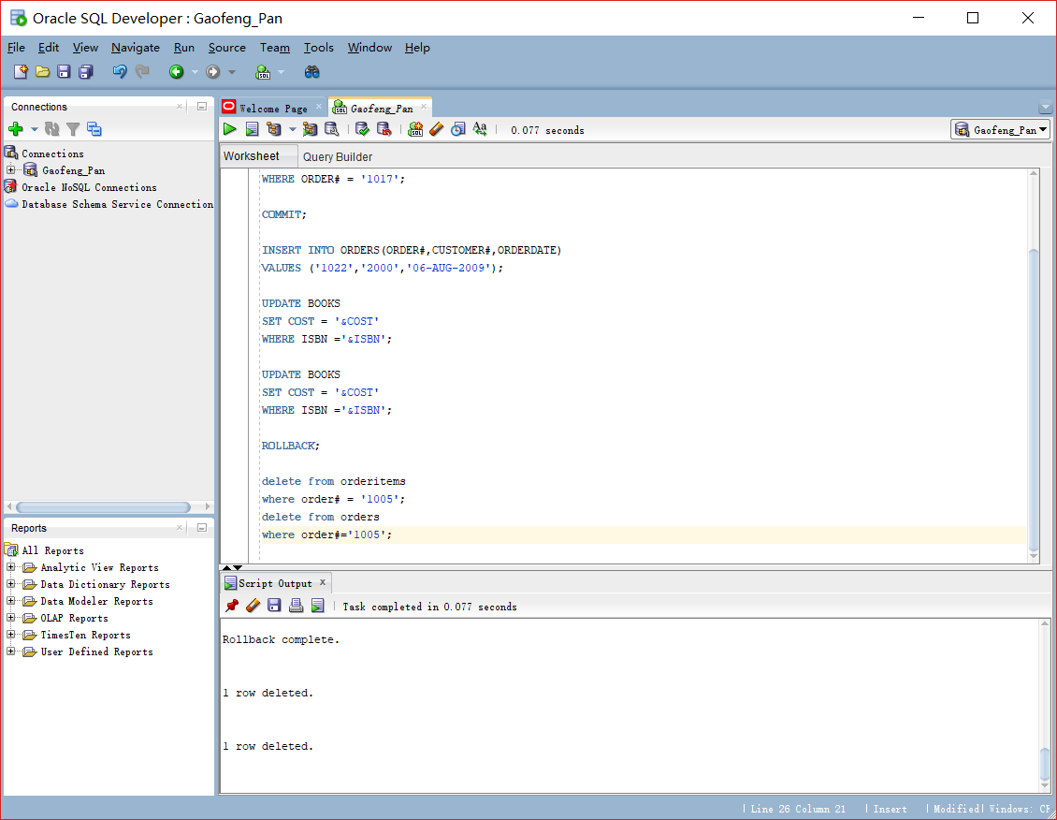

10. Execute a command that undoes the previous deletion.

Script:

Rollback;

Screenshot:

