1. Which customers live in New Jersey? List each customer’s last name, first name, and state.
   * 1. select lastname,firstname,state
     2. from customers
     3. where state='NJ';
     4. 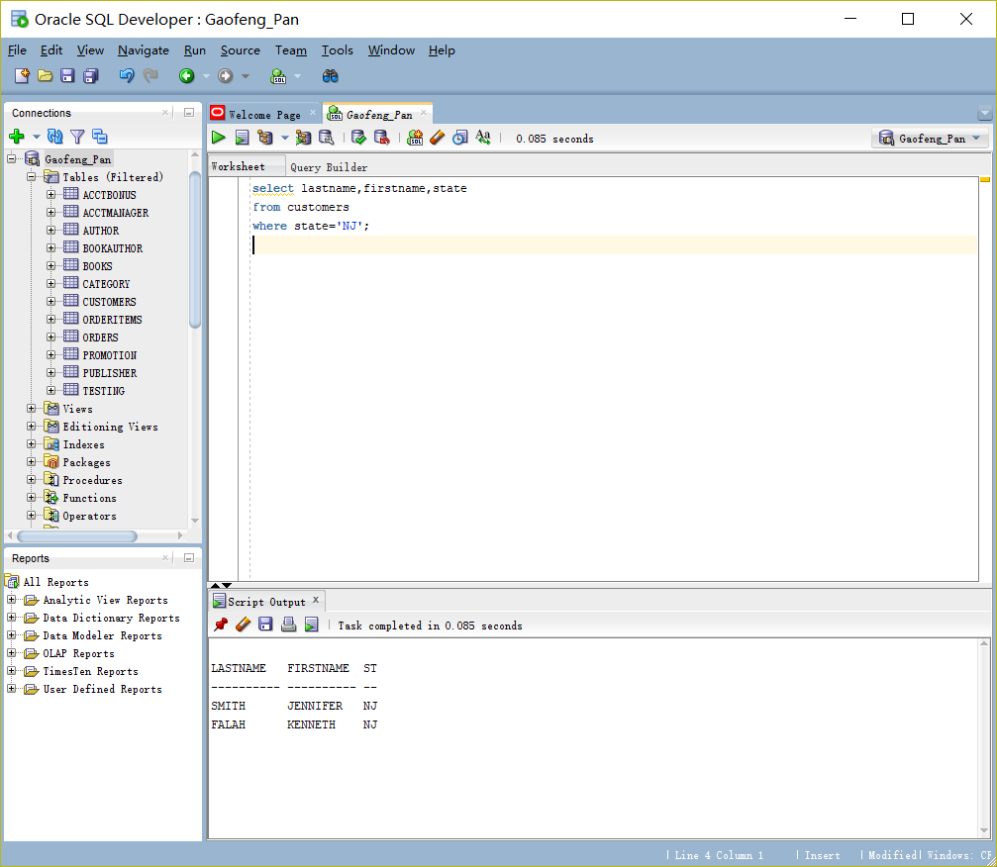
2. Which orders shipped after April 1, 2009? List each order number and the date it shipped.
   * 1. select order#, shipdate
     2. from orders
     3. where shipdate>'01-APR-09';
     4. 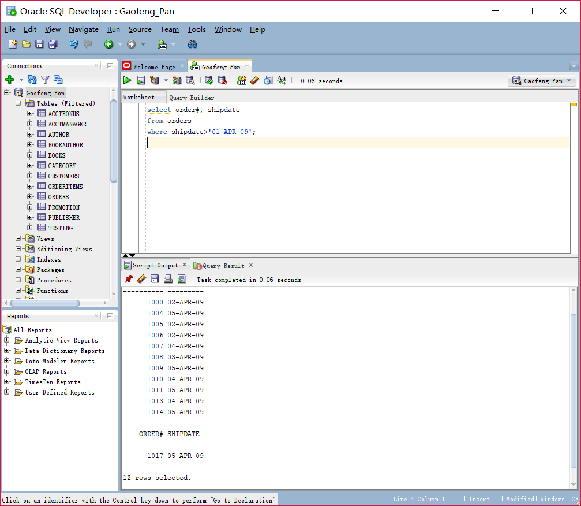
3. Which books aren’t in the Fitness category? List each book title and category.
   * 1. select title, category
     2. from books
     3. where CATEGORY !='FITNESS';
     4. 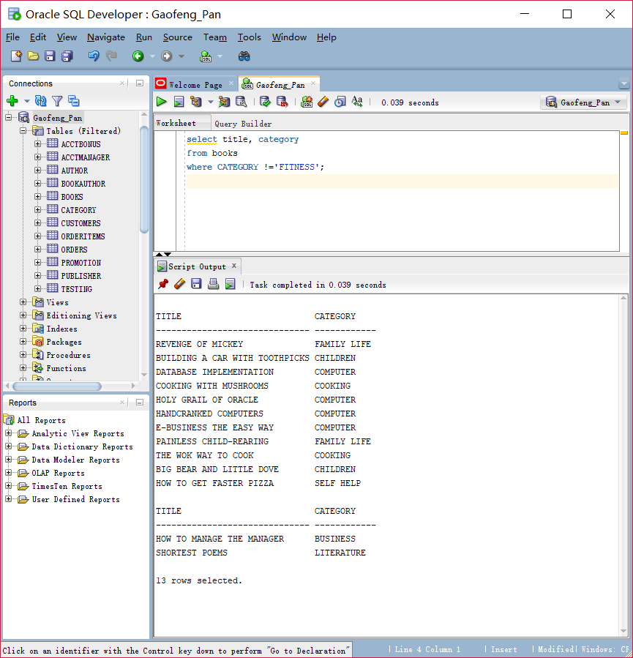
4. Which customers live in Georgia or New Jersey? Put the results in ascending order by last name. List each customer’s customer number, last name, and state. Write this query in two different ways.
   * 1. select customer#, lastname, state
     2. from customers
     3. where state in ('GA', 'NJ')
     4. order by lastname;
     5. 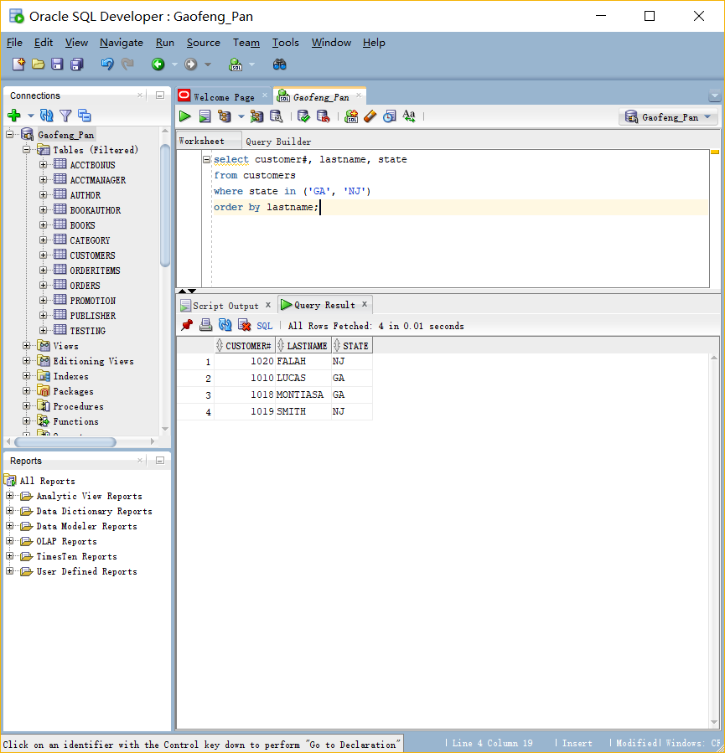
5. Which orders were placed on or before April 1, 2009? List each order number and order date. Write this query in two different ways.
   * 1. select order#, orderdate
     2. from orders
     3. where orderdate <'01-APR-09';
     4. 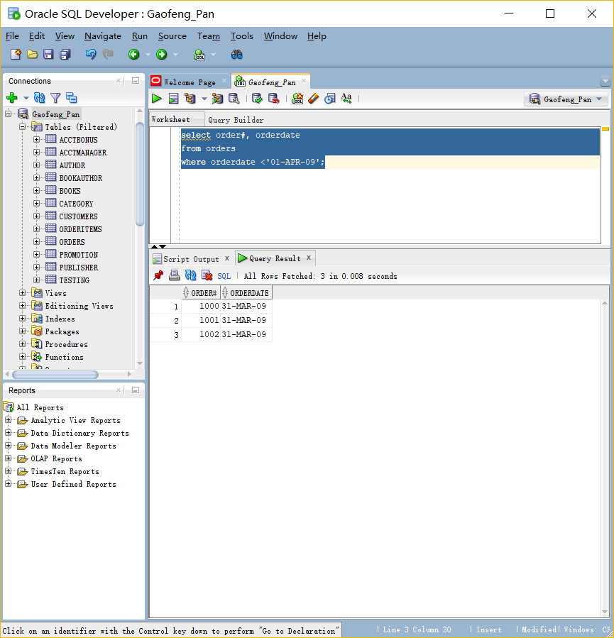
     5. select order#, orderdate
     6. from orders
     7. where orderdate <'01-04-09';
   1. It can’t work. 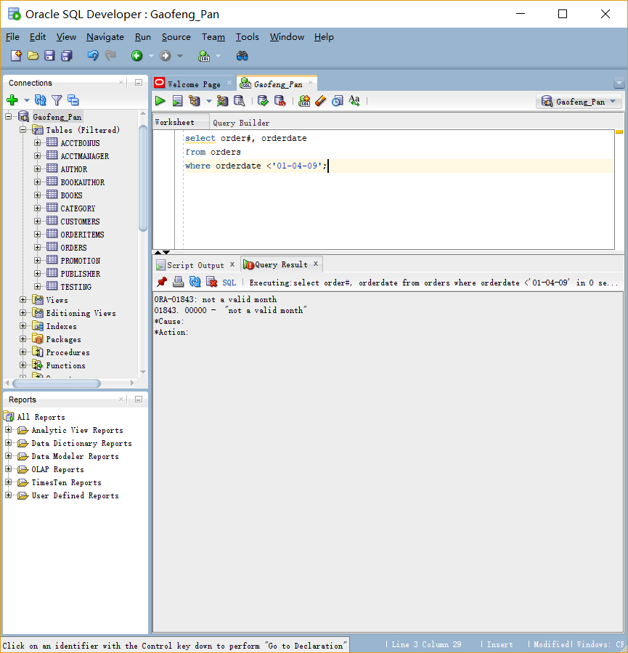
6. List all authors whose last name contains the letter pattern “IN.” Put the results in order of last name, then first name. List each author’s last name and first name.
   * 1. select lname, fname
     2. from author
     3. where lname like '%IN%'
     4. order by lname,fname;
   1. 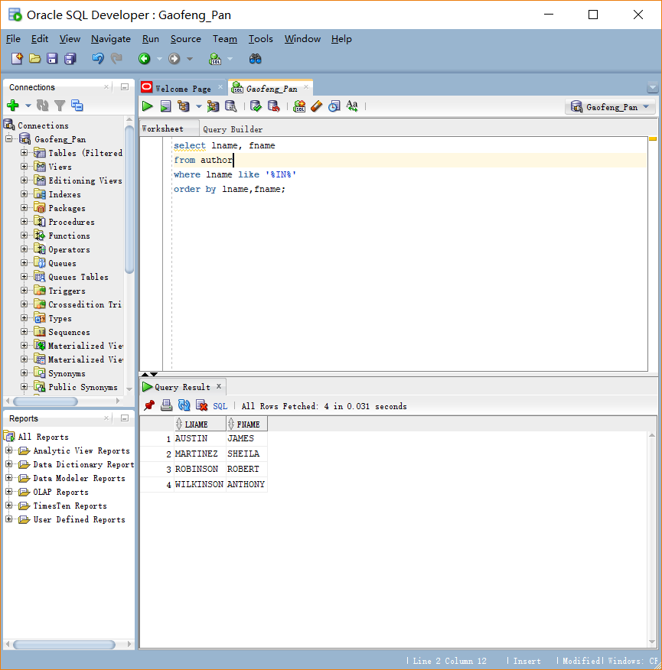
7. List all customers who were referred to the bookstore by another customer. List each customer’s last name and the number of the customer who made the referral.
   * 1. select lastname, referred
     2. from customers
     3. where referred is not null;
     4. 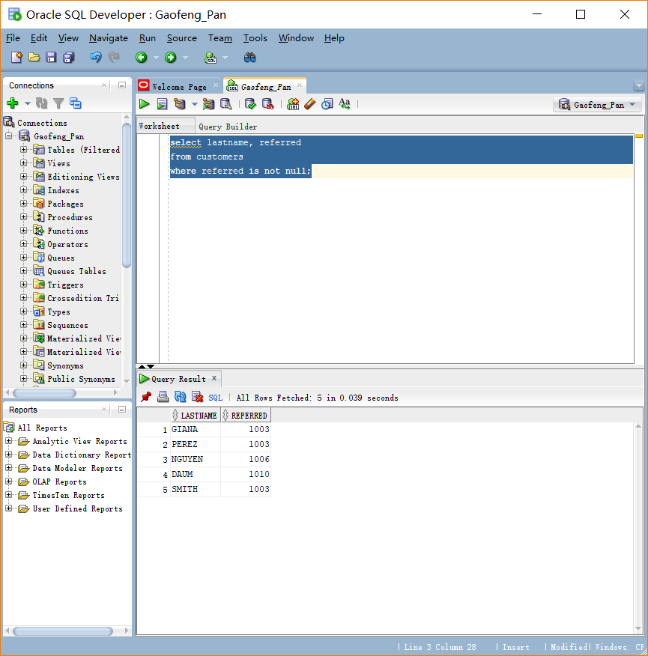
8. Display the book title and category for all books in the Children and Cooking categories. Create three different queries to accomplish this task: a) a search pattern operation, b) a logical operator, and c) another operator not used in a or b.
   * 1. select title, category
     2. from books
     3. where CATEGORY in('CHILDREN', 'COOKING');
     4. 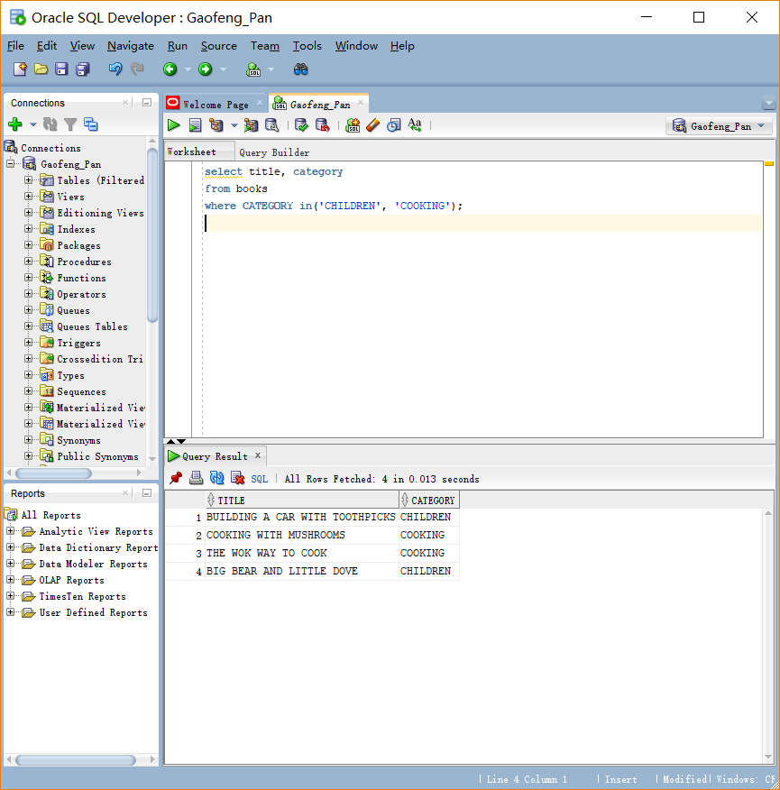
     5. select title, category
     6. from books
     7. where CATEGORY ='CHILDREN' or category= 'COOKING';
     8. 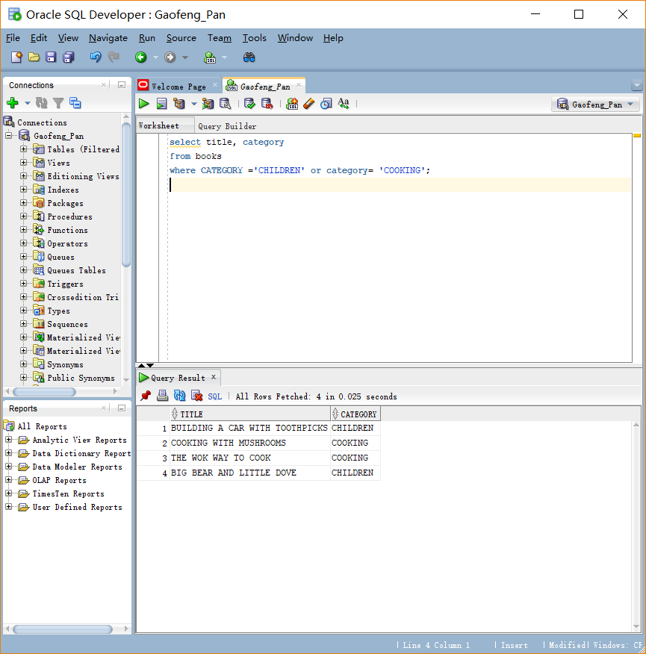
     9. select title, category
     10. from books
     11. where CATEGORY like 'C%N' or category like 'C%G';
     12. 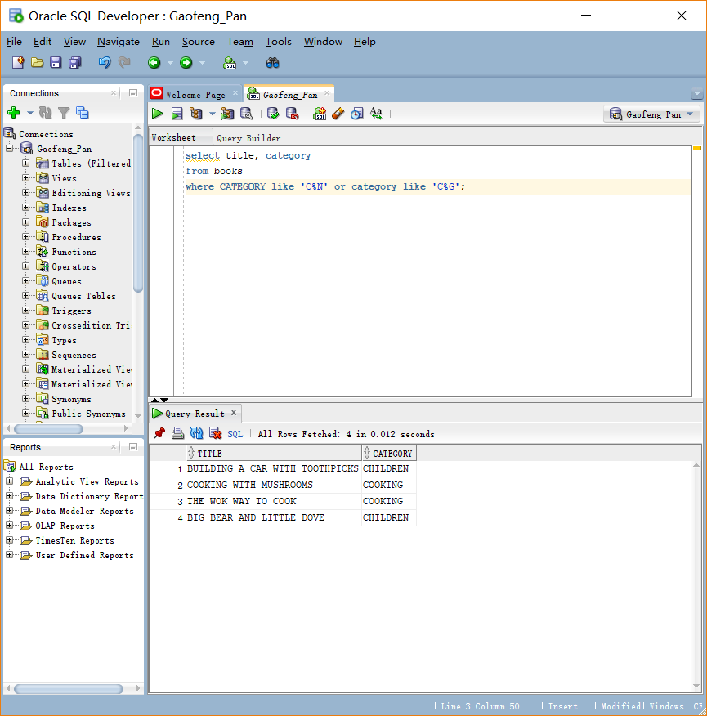
9. Use a search pattern to find any book title with “A” for the second letter and “N” for the fourth letter. List each book’s ISBN and title. Sort the list by title in descending order.
   * 1. select isbn, title
     2. from books
     3. where title like '_A%' and title like '___N%'
     4. order by title desc;
     5. 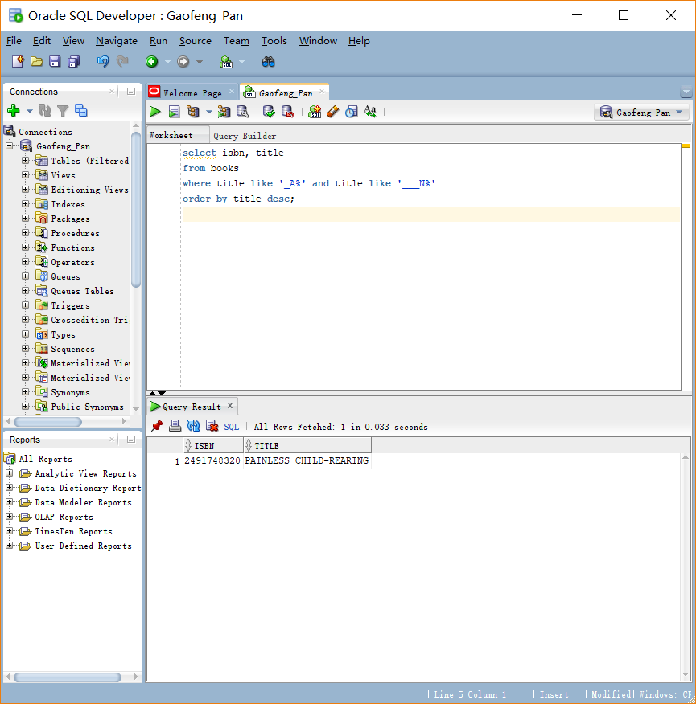
10. List the title and publish date of any computer book published in 2005. Perform the task of searching for the publish date by using three different methods: a) a range operator, b) a logical operator, and c) a search pattern operation.
    * 1. select title, pubdate
      2. from books
      3. where category='COMPUTER' and pubdate > '31-DEC-04' and pubdate < 01-JAN-06';
      4. 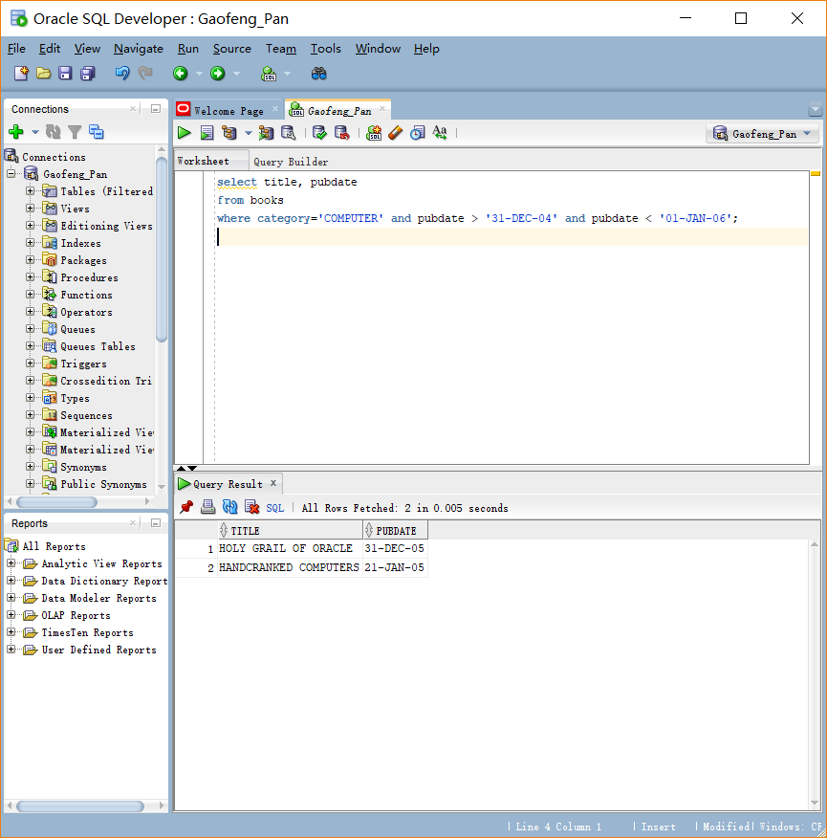
      5. select title, pubdate
      6. from books
      7. where category like 'C%R' and pubdate > '31-DEC-04' and pubdate < '01-JAN-06';
      8. 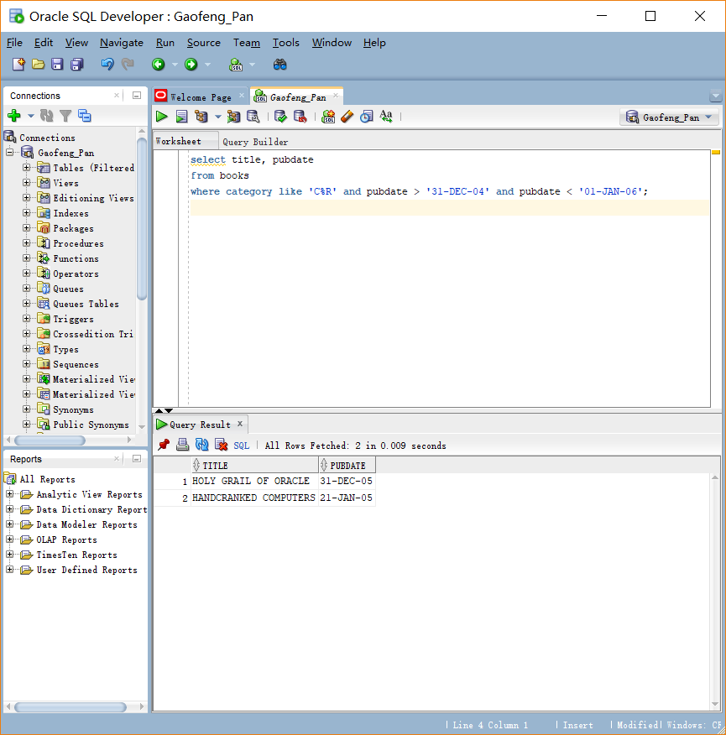
      9. select title, pubdate
      10. from books
      11. where category like 'C%R' and pubdate like '__-___-05';
      12. 