1. Create a list that displays the title of each book and the name and phone number of the contact at the publisher’s office for reordering each book.
   1. Script：
      1. select books.title, name, publisher.phone "Phone number"
      2. from books,publisher
      3. where books.pubid = publisher.pubid(+);
   2. Screenshot
      1. 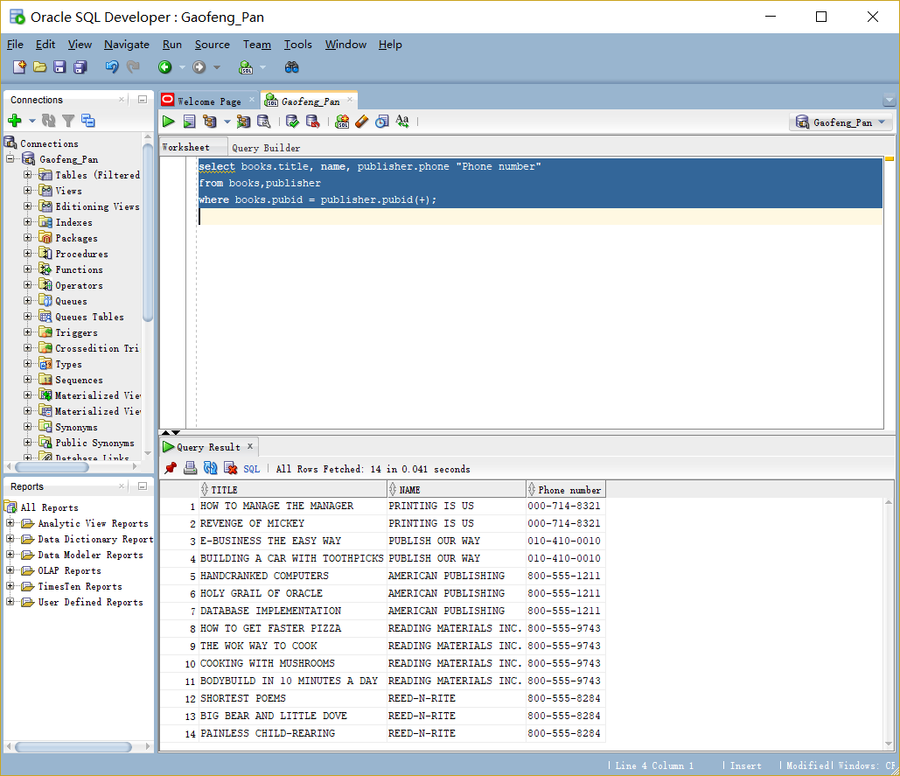
2. Determine which orders haven’t yet shipped and the name of the customer who placed the order. Sort the results by the date on which the order was placed.
   1. Script：
   2. select order#, customers.firstname ||','||customers.lastname "Customer Name", orderdate
   3. from orders, customers
   4. where shipdate is null and orders.customer# = customers.customer# (+)
   5. order by 3 desc;
   6. Screenshot：
      1. 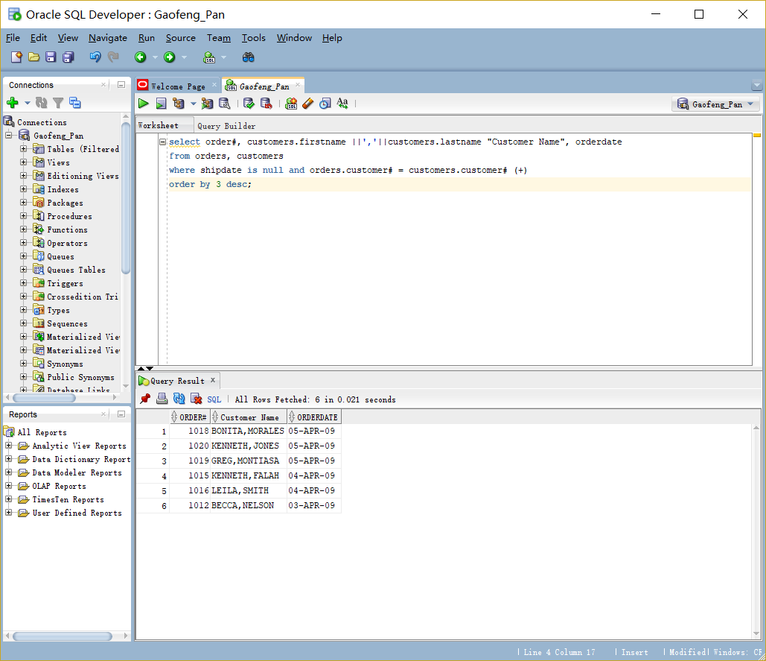
3. Produce a list of all customers who live in the state of Florida and have ordered books about computers.
   1. Script：
      1. select customers.customer#, customers.firstname ||','||customers.lastname "Customer Name", orders.order#, orderitems.ISBN, books.category
      2. from customers, orders, orderitems, books
      3. where state = 'FL' and customers.customer# = orders.customer#(+) and orderitems.order# = orders.order# and books.isbn=orderitems.isbn
      4. and books.category = 'COMPUTER'
      5. order by 1;
   2. Screenshot：
      1. 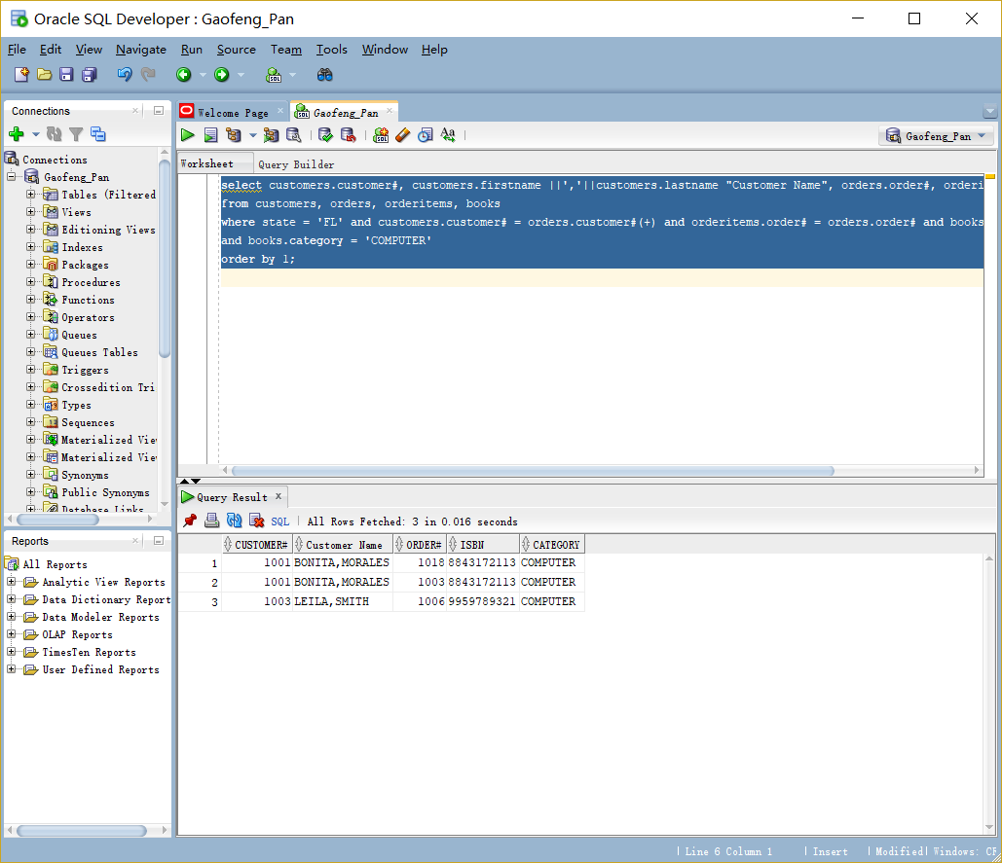
4. Determine which books customer Jake Lucas has purchased. Perform the search using the customer name, not the customer number. If he has purchased multiple copies of the same book, unduplicate the results.
   1. Script：
      1. select distinct Title
      2. from customers
      3. natural join orders
      4. natural join orderitems
      5. natural join books
      6. where firstname='JAKE' and lastname='LUCAS';
   2. Screenshot：
      1. 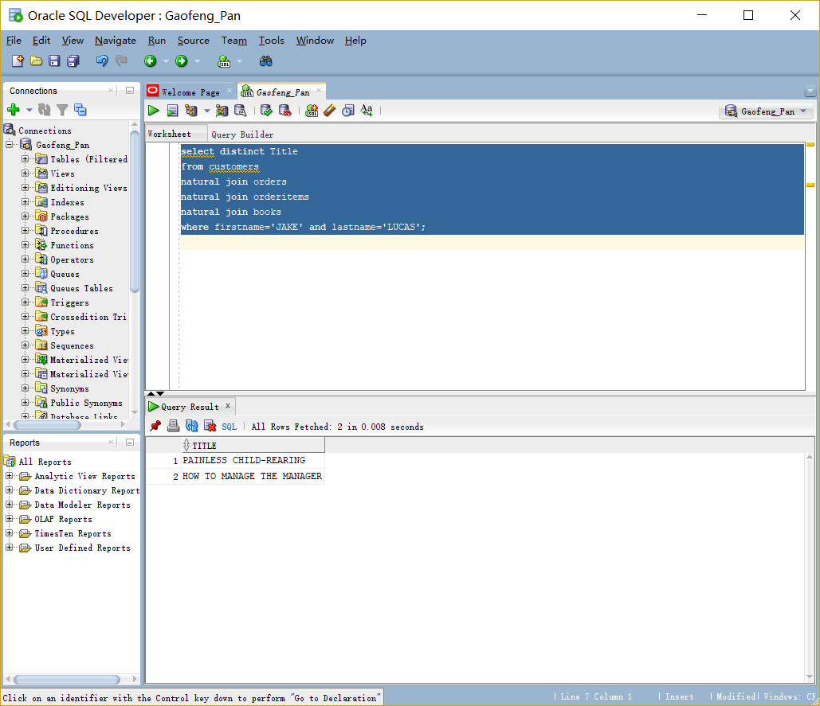
5. Determine the profit of each book sold to Jake Lucas, using the actual price the customer paid (not the book’s regular retail price). Sort the results by order date. If more than one book was ordered, sort the results by profit amount in descending order. Perform the search using the customer name, not the customer number.
   1. Script：
      1. SELECT TITLE, PAIDEACH-COST AS PROFIT
      2. FROM CUSTOMERS
      3. natural join orders
      4. natural JOIN ORDERITEMS
      5. natural JOIN BOOKS
      6. where firstname='JAKE' AND LASTNAME='LUCAS'
      7. ORDER BY ORDERDATE, PROFIT;
   2. Screenshot：
      1. 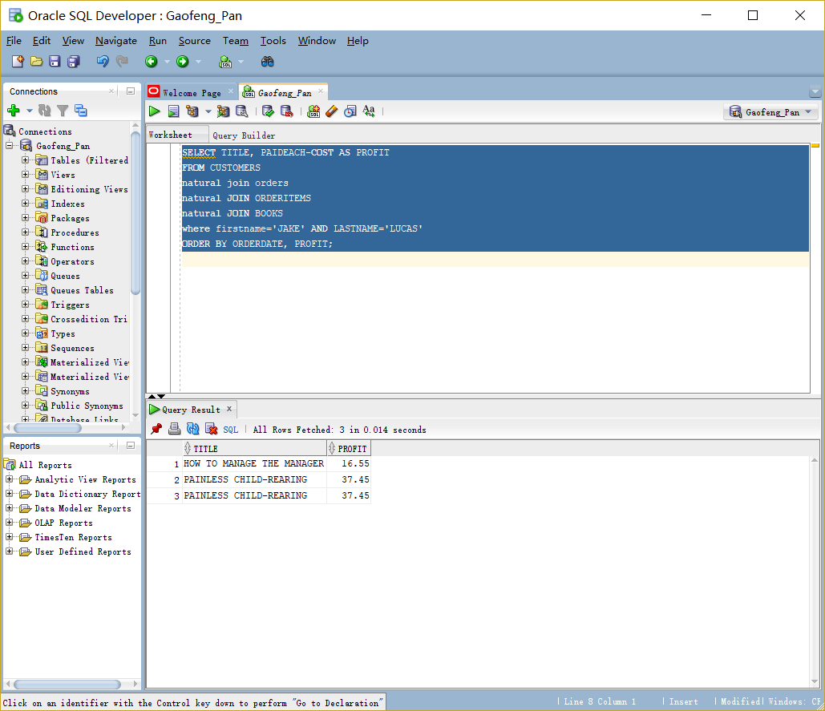
6. Which books were written by an author with the last name Adams? Perform the search using the author name.
   1. Script：
      1. select title from books, bookauthor, author
      2. where books.isbn = bookauthor.isbn and bookauthor.authorid = author.authorid and lname = 'ADAMS';
   2. Screenshot：
      1. 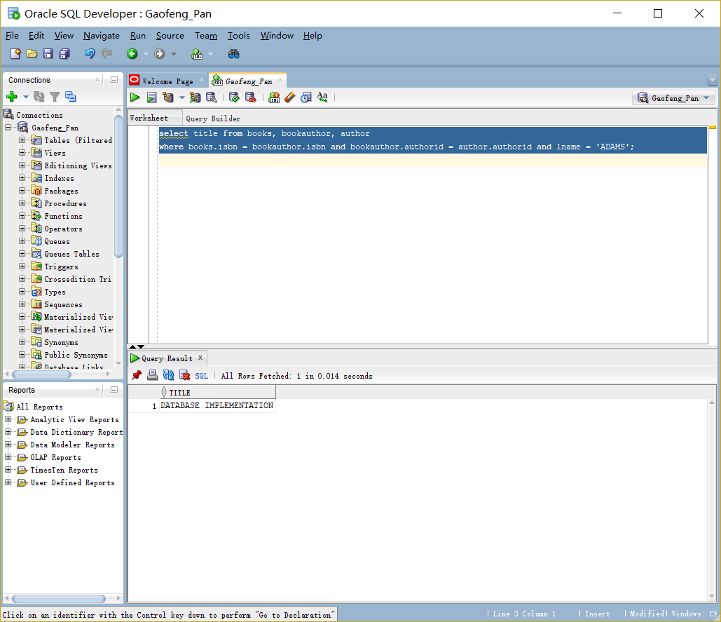
7. What gift will a customer who orders the book Shortest Poems receive? Use the actual book retail value to determine the gift.
   1. Script：
      1. select books.title, books.retail "Retail Cost", orders.shipcost, orderitems.paideach, (books.retail+orders.shipcost-orderitems.paideach)
      2. as "Customer Gift"
      3. from books, orderitems, orders
      4. where title = 'SHORTEST POEMS'
      5. and books.isbn = orderitems.isbn
      6. and orderitems.order#=orders.order#;
   2. Screenshot：
      1. 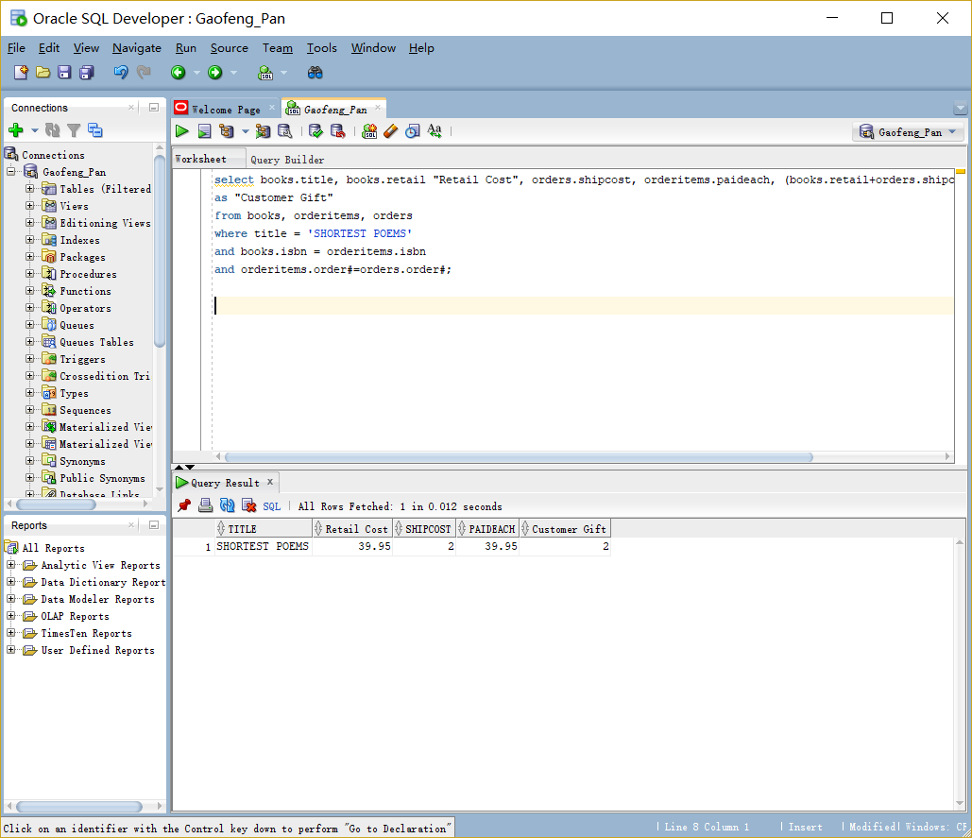
8. Identify the authors of the books Becca Nelson ordered. Perform the search using the customer name.
   1. Script：
      1. select author.fname||' '||author.lname "Author Name" from customers,orders,orderitems, bookauthor, author
      2. where upper (customers.firstname||' '||customers.lastname) = 'BECCA NELSON'
      3. and customers.customer#=orders.customer#
      4. and orderitems.order#=orders.order#
      5. and orderitems.isbn = bookauthor.isbn
      6. and bookauthor.authorid=author.authorid;
   2. Screenshot：
      1. 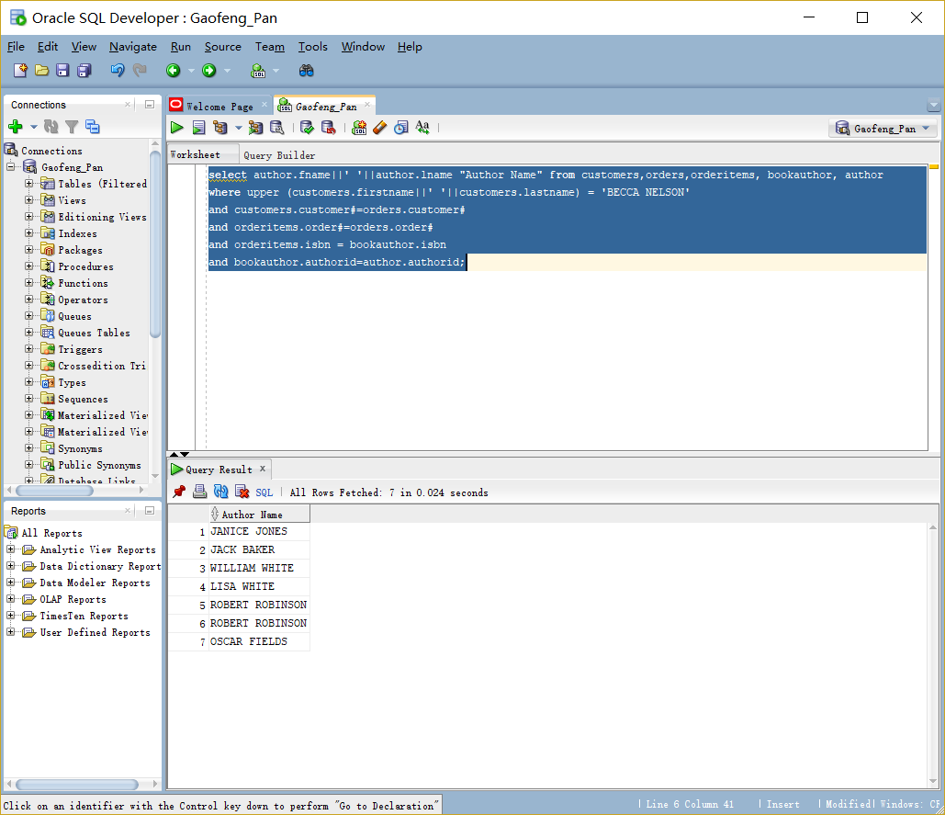
9. Display a list of all books in the BOOKS table. If a book has been ordered by a customer, also list the corresponding order number and the state in which the customer resides.
   1. Script：
      1. select title, o.order#, state
      2. from customers, orders o, books, orderitems
      3. where customers.customer# = o.order#
      4. and o.order# = orderitems.order#
      5. and orderitems.isbn = books.isbn;
   2. Screenshot：
      1. 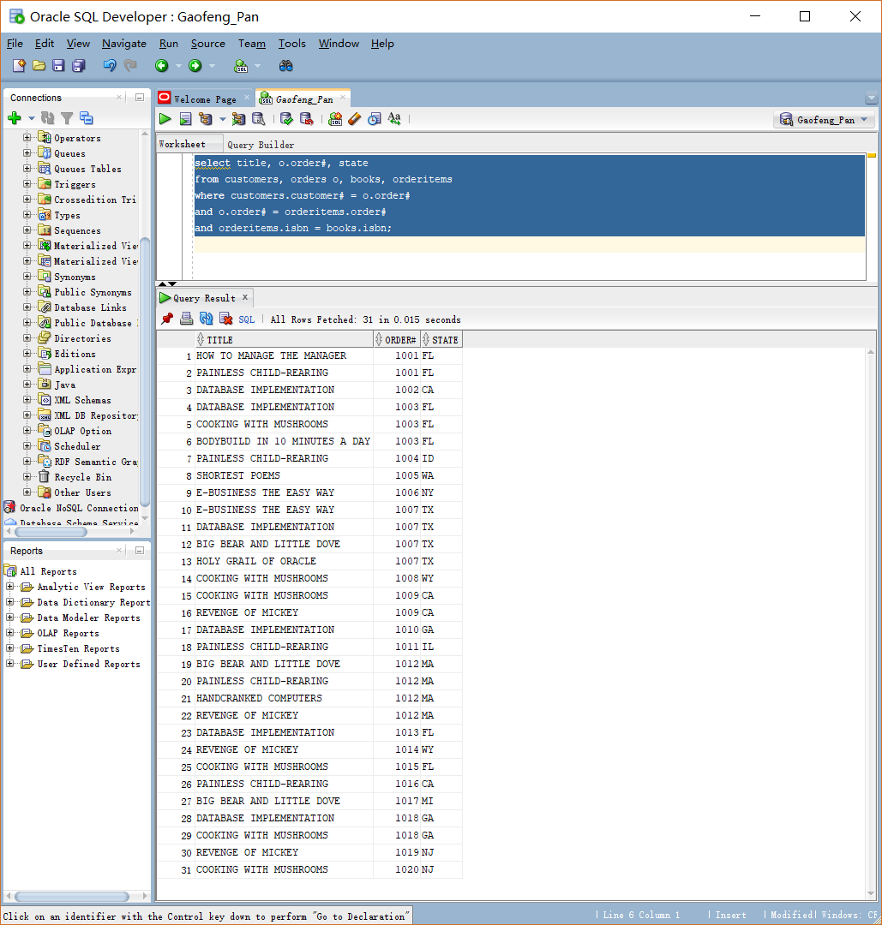
10. An EMPLOYEES table was added to the JustLee Books database to track employee information. Display a list of each employee’s name, job title, and manager’s name. Use column aliases to clearly identify employee and manager name values. Include all employees in the list and sort by manager name.
    1. Script：
11. select a.empno,
12. a.Fname ||' '|| a.Lname "employees name",
13. b.Fname ||' '|| b.Lname "employees name"
14. from EMPLOYEES a,employees b
15. where a.MGR = b.EMPNO;
    1. Screenshot：
16. 