

CENTENNIAL COLLEGE PROGRESS CAMPUS

COURSE COMP125 Summer 2018

ASSIGNMENT #1

Basal Metabolic Rate (BMR) Calculator

Create an HTMLdocument called **assignment1.html** that implements a calorie intake calculator based on the Harris-Benedict equation used by nutritionists and health professionals to determine the daily energy needs based on age, sex, height, weight and level of physical activity.

Follow these guidelines to implement your assignment:

1. Research the formula on wiki:

<https://en.wikipedia.org/wiki/Harris%E2%80%93Benedict_equation>

1. Build a form to accept all the required input from the visitors.
2. Create a JavaScript file called assignment1.js and write the code for a function that calculates the calorie intake based on the user input.
3. Invoke the function every time the visitor presses a Calculate button on the form.
4. Display the results (BMR and daily calories intake) on the page.
5. (**10% of the grade**) Use HTML5 controls that limit/validate the user input.
6. (**10% of the grade**) Use good web design practices to enhance visually your html page.
7. (**10% of the grade**) Extend the calculator to accept metric measurements.

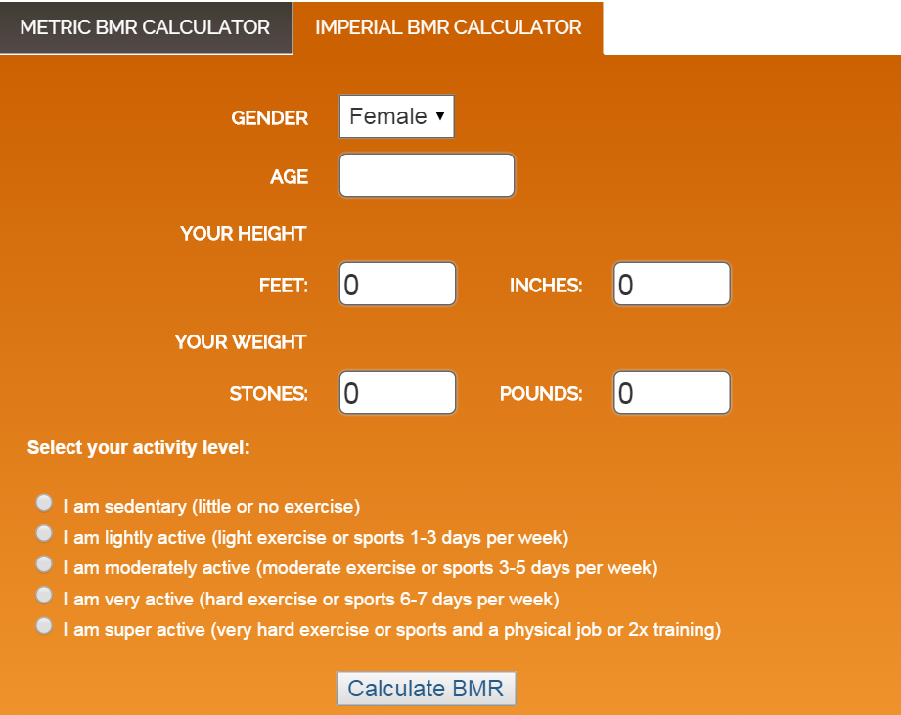

(The screenshot above is provided only as guidance to familiarize you with the functionality of a BMR calculator).

**Late assignments are accepted two more days after the due date and they are marked out of 80%**.

**Submissions past 2 days after the due date are marked out as zero (0).**