

**CENTENNIAL COLLEGE PROGRESS CAMPUS**

**COURSE COMP125 Summer 201**8

**ASSIGNMENT #4**

**Form Validation**

Create an HTML document called assignment4.html that collects the following information from the user:  
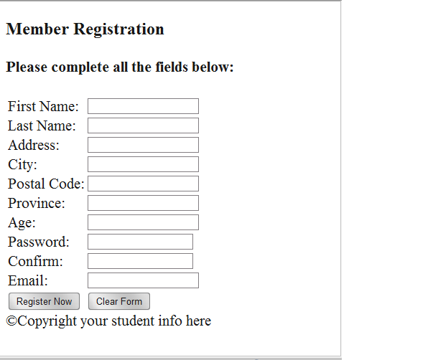

Next modify assignment4.html to include the JavaScript code required for field validation.

Following are the guidelines for validating the user input:

→ All the fields are mandatory (cannot be left blank)

→ The postal code has to be in the a0a0a0 format – (research it on the internet)

→ Province is one of QC, ON, MN, SK, AB, BC.

→ Age has to be at least 18 yrs. old.

→ The Email field must contain the @ and . characters

(**5% of the mark** for using a regular expression – research it on the internet)

→ The Confirm Password and Password fields should have identical input.

→ Passwords must have at least 6 characters and must contain at least one digit and one upper-case character.

(**5% of the mark** for using a regular expression – research it on the internet)

When the form fields pass validation, an alert message is displayed to show a confirmation message (e.g. “Thanks for registering with our website, your customer record was created successfully.”).

**(10% of the mark)** Customize/design your page using a CSS style sheet and graphics of your choice. Include a banner area with graphics and a title of your choice, add additional visual enhancements to the page as you consider suitable.

Upload the html document and supporting picture files to the studentweb server and create a hyperlink called Assignment 4 from your home page to point to the assignment4.html file.

**Late assignments are only accepted for two additional days and are marked out of 80%.**

**Submissions past 2 days after the due date are marked out as zero (0).**