Phase 1 Report: Owner/Renter Data Extraction
& Distribution Fitting
Date: 2026-02-26 | ABM Restructuring: MG/NMG → Homeowner/Renter

1. Overview
This report documents the restructuring of the ABM's primary grouping axis from MG (mitigation grant) vs NMG (non-mitigation grant) to homeowner vs renter (housing tenure). The classification rule is: Q3 = 2 → renter; all other values → owner.

1.1 Data Sources
• Raw survey data: data_ori.xlsx (NMG sheet: 789 rows; MG sheet: 148 rows; total: 937)
• TP decay calibration data: cal_data.xlsx (NMG_FE: 173 rows; MG_FE: 40 rows; total: 213)
• Q3 encoding: 1 = homeowner, 2 = renter

1.2 Variable Formulas (verified from Excel)
Variable | Formula | Scale
TP_mean | mean(Q22_1 : Q22_11) — 11 items | 1–5 Likert
CP_mean | mean(Q24_1, Q24_2, Q25_1, Q25_2, Q25_4, Q25_5, Q25_7, Q25_8) — 8 items | 1–5 Likert
SP_mean | mean(Q25_3, Q25_6, Q25_9) — 3 items | 1–5 Likert
SC_mean | mean(Q21_1 : Q21_6) — 6 items | 1–5 Likert
PA_mean | mean(Q21_7 : Q21_15) — 9 items | 1–5 Likert
FI | Q27 | 1–5 Likert
EH | Q29 | 1–5 Likert
BP | Q31 | 1–5 Likert
RL | Q33 | 1–5 Likert

1.3 Important Bug Discovery
MG_variable sheet has broken Excel formulas: The TP_mean, CP_mean, and SP_mean columns in MG_variable reference NMG sheet cells (e.g., =AVERAGE(NMG!BH2:BR2)) instead of MG sheet cells. This means all 148 MG respondents' psychological variable data was actually NMG data at the same row index. MG_syn_variable (1,989 rows used by Bayesian engine) inherits this error. The new owner/renter extraction recomputes all variables from raw data, bypassing this bug.

2. Sample Sizes After Split
Dataset | Group | n | Source MG | Source NMG
Full Survey | Owner | 694 | 77 | 617
Full Survey | Renter | 243 | 71 | 172
TP Decay Calibration | Owner | 170 | 28 | 142
TP Decay Calibration | Renter | 43 | 12 | 31

Note: Renter calibration sample (n=43) is small. This may require discussion on whether synthetic augmentation or pooled estimation is needed.

3. Beta Distribution Parameters
Each psychological variable was normalized to [0, 1] by dividing by 5 (Likert 1–5 → 0.2–1.0), then fitted with a Beta(α, β) distribution using MLE (scipy.stats.beta.fit with floc=0, fscale=1). The KS test checks goodness-of-fit (p > 0.05 = good fit).
Group | Variable | n | alpha | beta | mean | std | KS_stat | KS_p
owner | TP | 694 | 6.12264 | 4.480251 | 0.5775 | 0.145 | 0.0534 | 0.0366
owner | CP | 694 | 5.430291 | 3.333322 | 0.6196 | 0.1554 | 0.1494 | 0.0
owner | SP | 694 | 2.666478 | 2.014197 | 0.5697 | 0.2077 | 0.1488 | 0.0
owner | SC | 694 | 3.367934 | 1.154551 | 0.7447 | 0.1855 | 0.2861 | 0.0
owner | PA | 694 | 3.574675 | 1.850491 | 0.6589 | 0.187 | 0.1361 | 0.0
renter | TP | 243 | 4.765219 | 3.36416 | 0.5862 | 0.163 | 0.0459 | 0.6673
renter | CP | 243 | 5.236203 | 3.154798 | 0.624 | 0.1581 | 0.1113 | 0.0044
renter | SP | 243 | 2.142183 | 1.474363 | 0.5923 | 0.2287 | 0.1748 | 0.0
renter | SC | 243 | 3.996214 | 1.576349 | 0.7171 | 0.1757 | 0.2133 | 0.0
renter | PA | 243 | 2.761719 | 1.42806 | 0.6592 | 0.2081 | 0.1649 | 0.0

3.1 Key Observations
• TP (Threat Perception): Owner has slightly tighter distribution (α=6.12 vs 4.77). Renter TP shows excellent KS fit (p=0.667); owner TP marginal (p=0.037).
• CP (Coping Perception): Very similar between groups (mean ~0.62).
• SP (Social Perception): Renter has slightly higher mean (0.592 vs 0.570) and wider spread.
• SC (Social Capital): Owner has higher mean (0.745 vs 0.717). Both distributions are strongly right-skewed (β < 2).
• PA (Place Attachment): Nearly identical means (~0.659). Owner has tighter distribution.
• KS test: Only TP passes for both groups. Other variables show significant deviation — likely due to discrete Likert data creating non-smooth distributions. The Beta approximation is standard practice for ABM initialization despite this.

3.2 Comparison with Old MG/NMG Parameters
Variable | MG α | MG β | MG mean | NMG α | NMG β | NMG mean | Owner α | Owner β | Owner mean | Renter α | Renter β | Renter mean
TP | 4.441 | 2.887 | 0.606 | 5.346 | 3.615 | 0.597 | 6.123 | 4.48 | 0.578 | 4.765 | 3.364 | 0.586
CP | 4.078 | 3.33 | 0.55 | 5.263 | 4.178 | 0.557 | 5.43 | 3.333 | 0.62 | 5.236 | 3.155 | 0.624
SP | 1.367 | 1.694 | 0.447 | 1.725 | 1.933 | 0.472 | 2.667 | 2.014 | 0.57 | 2.142 | 1.474 | 0.592
SC | 5.369 | 3.105 | 0.634 | 4.563 | 2.389 | 0.656 | 3.368 | 1.155 | 0.745 | 3.996 | 1.576 | 0.717
PA | 2.555 | 2.165 | 0.541 | 4.007 | 2.791 | 0.589 | 3.575 | 1.85 | 0.659 | 2.762 | 1.428 | 0.659

Key differences: Owner/Renter CP and SP means are notably higher than old MG/NMG means (~0.62 vs ~0.55 for CP; ~0.58 vs ~0.46 for SP). This is partly because the old MG values were computed from incorrect data (NMG formulas). SC shows much higher values in the new split (0.72–0.74 vs 0.63–0.66), likely reflecting the correct computation from raw data.

4. Action Adoption Rates
Group | Action | n_total | n_respond | response_rate | mean_likert | std_likert
owner | FI | 694 | 694 | 1.0 | 2.916 | 1.131
owner | EH | 694 | 432 | 0.6225 | 2.586 | 1.179
owner | BP | 694 | 432 | 0.6225 | 2.604 | 1.098
owner | RL | 694 | 242 | 0.3487 | 3.12 | 1.13
renter | FI | 243 | 243 | 1.0 | 3.012 | 1.176
renter | EH | 243 | 125 | 0.5144 | 2.752 | 1.196
renter | BP | 243 | 125 | 0.5144 | 2.784 | 1.182
renter | RL | 243 | 112 | 0.4609 | 3.134 | 1.135

4.1 Key Observations
• FI (Flood Insurance): 100% response rate for both groups. Renters have slightly higher mean intention (3.01 vs 2.92).
• EH (Elevation/Hardening): Owners respond more (62.2% vs 51.4%), but renters who do respond show slightly higher intensity (2.75 vs 2.59). This makes sense — owners have more agency over structural modifications.
• BP (Building Protection): Same pattern as EH — owners respond more but renters show slightly higher intensity.
• RL (Relocation): Renters respond significantly more (46.1% vs 34.9%) with similar mean intensity (~3.13). This aligns with theory — renters have lower relocation barriers.
Discussion point: In the original model, EH and BP were owner-only actions, and RL was available to all but emphasized for MG. In the new owner/renter framework, we should discuss whether EH/BP should still be available to renters (who may influence landlord decisions) or restricted to owners only.

5. Distribution Plots

5.1 Overlay Comparison (Owner vs Renter)
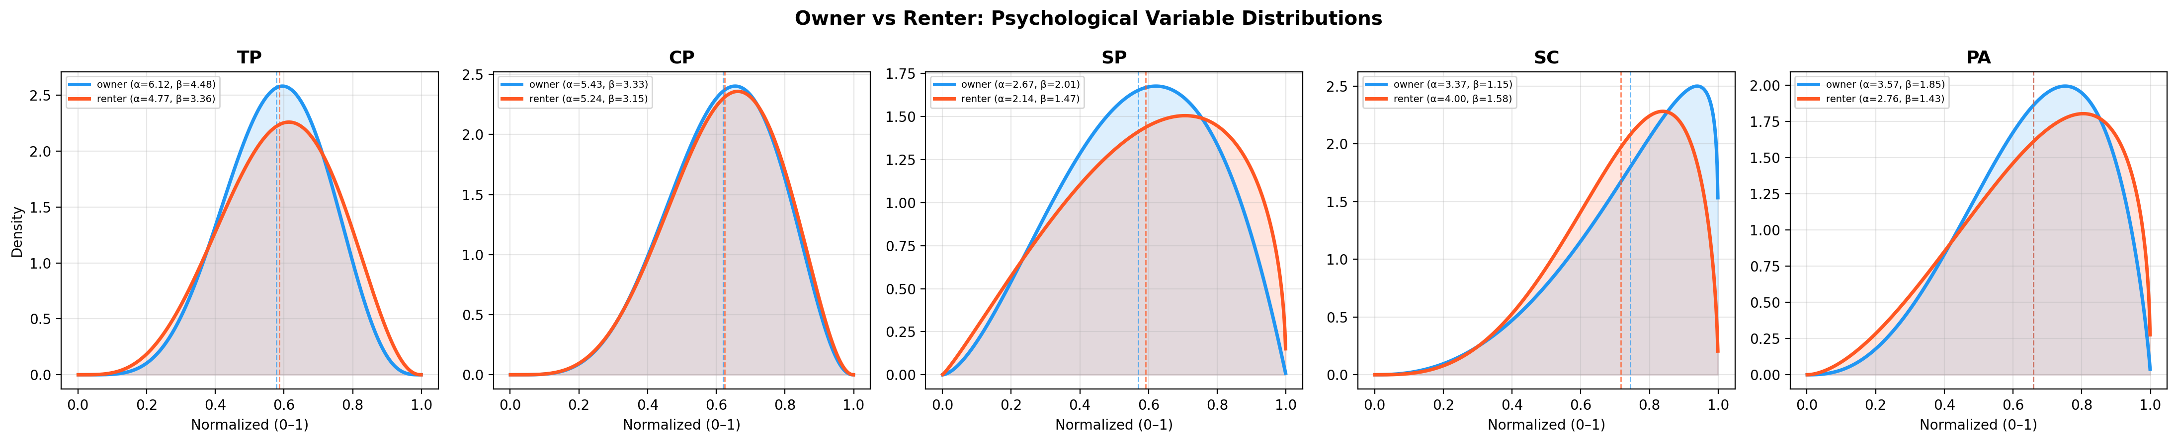

5.2 Beta Fits with Histograms
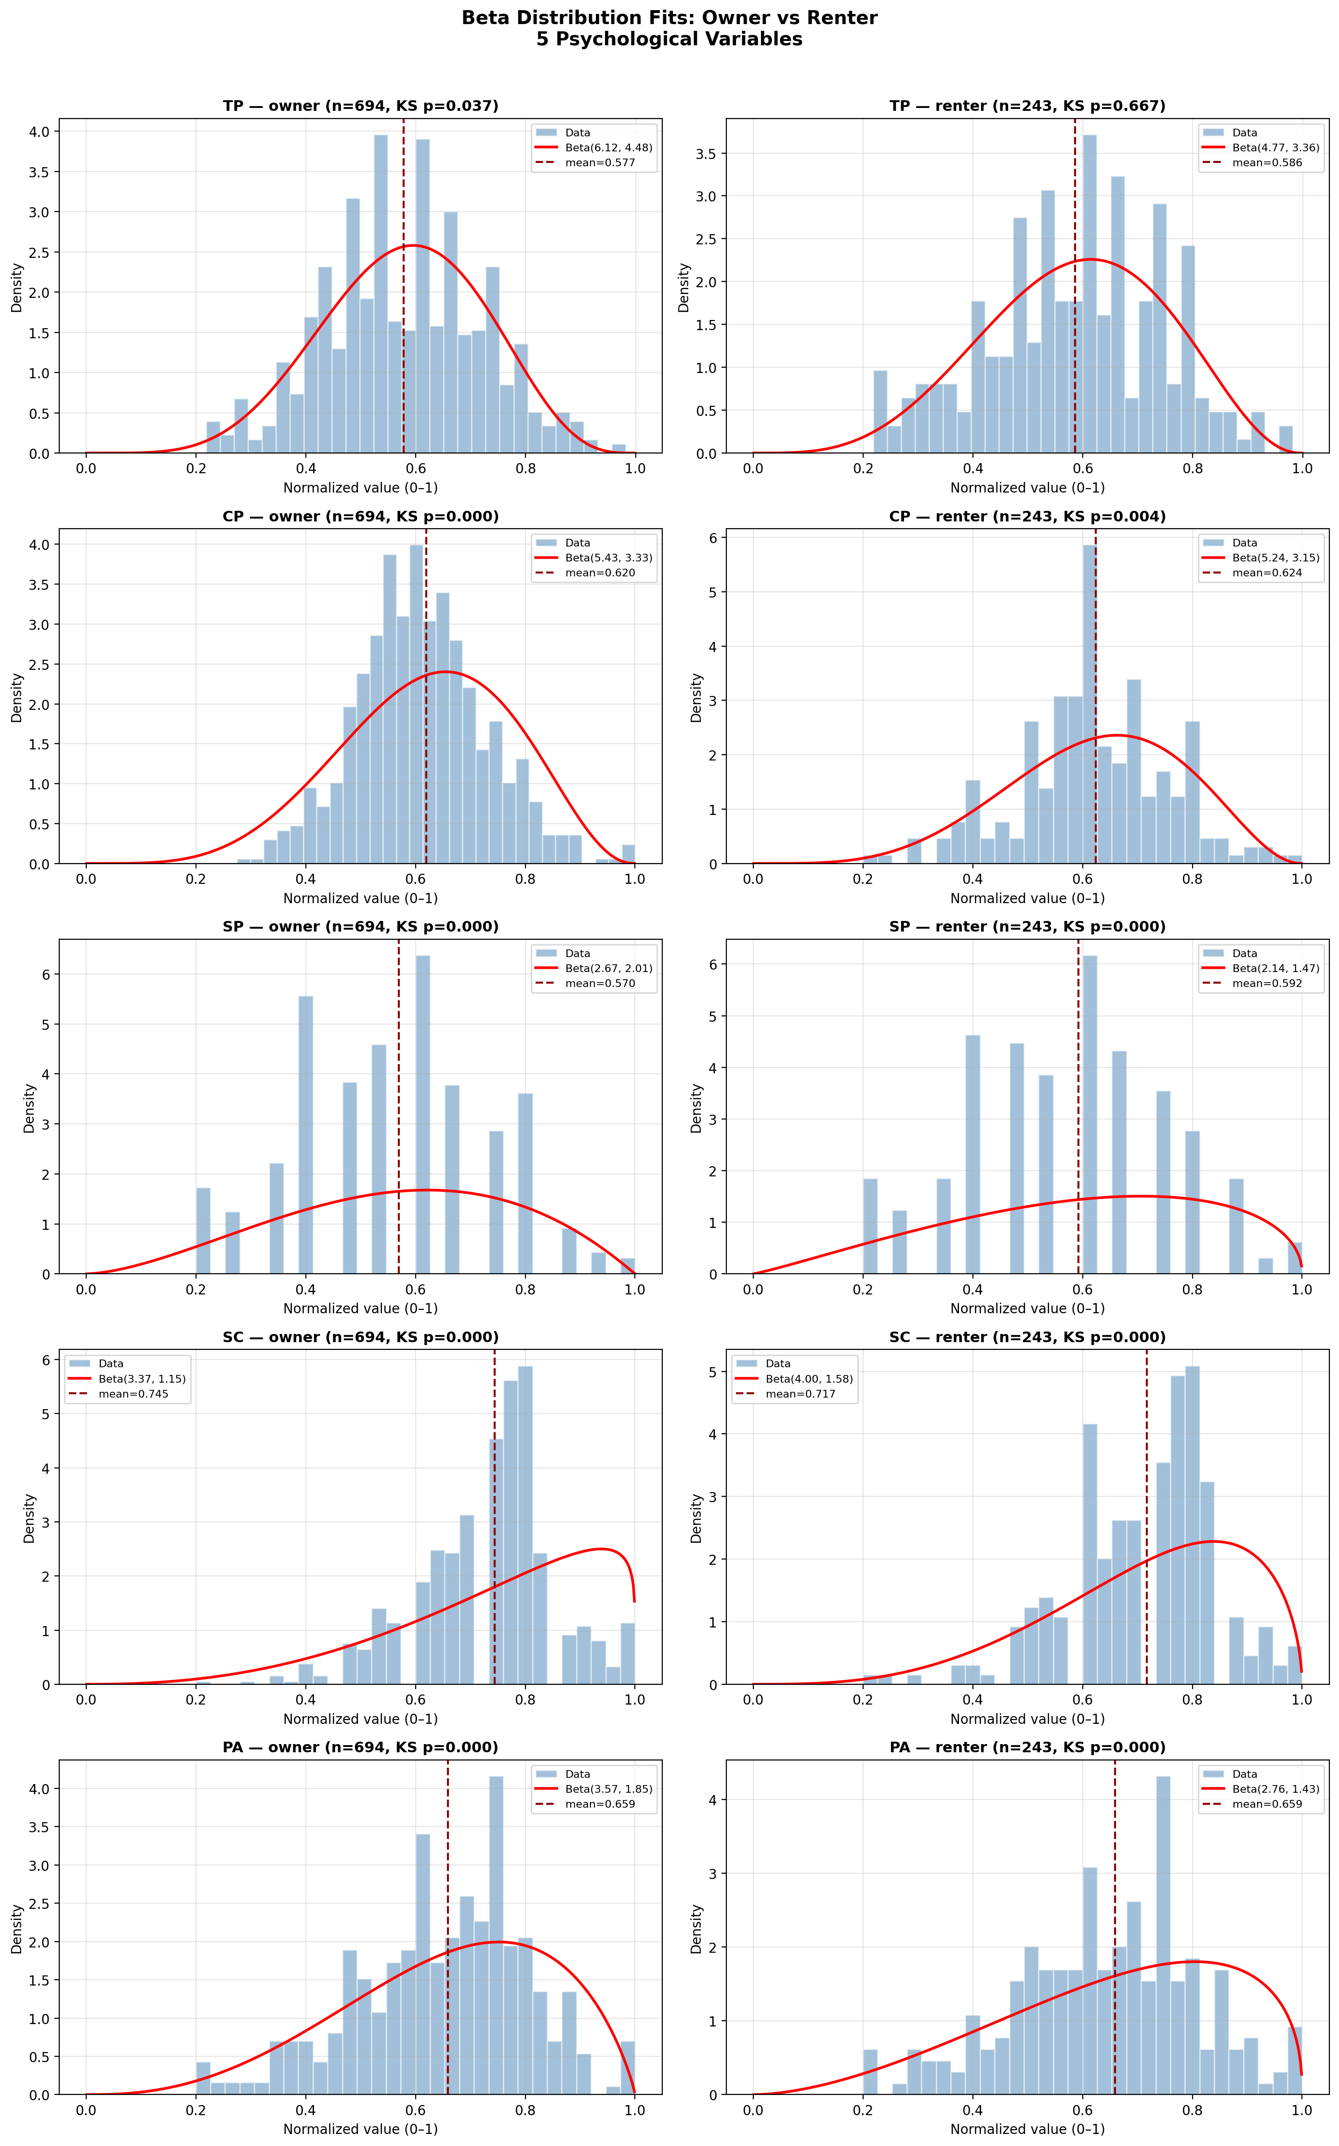

5.3 Action Response Rates
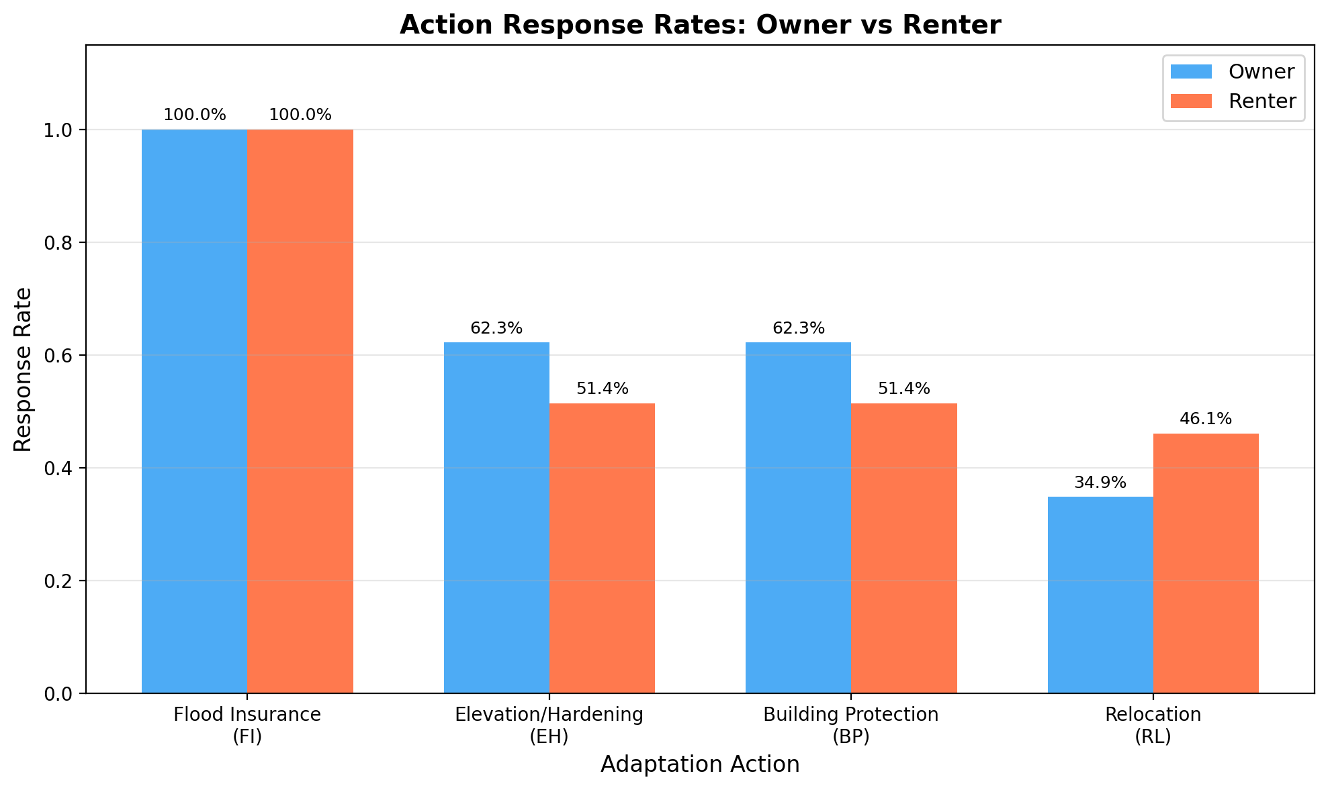

5.4 Action Mean Likert Scores
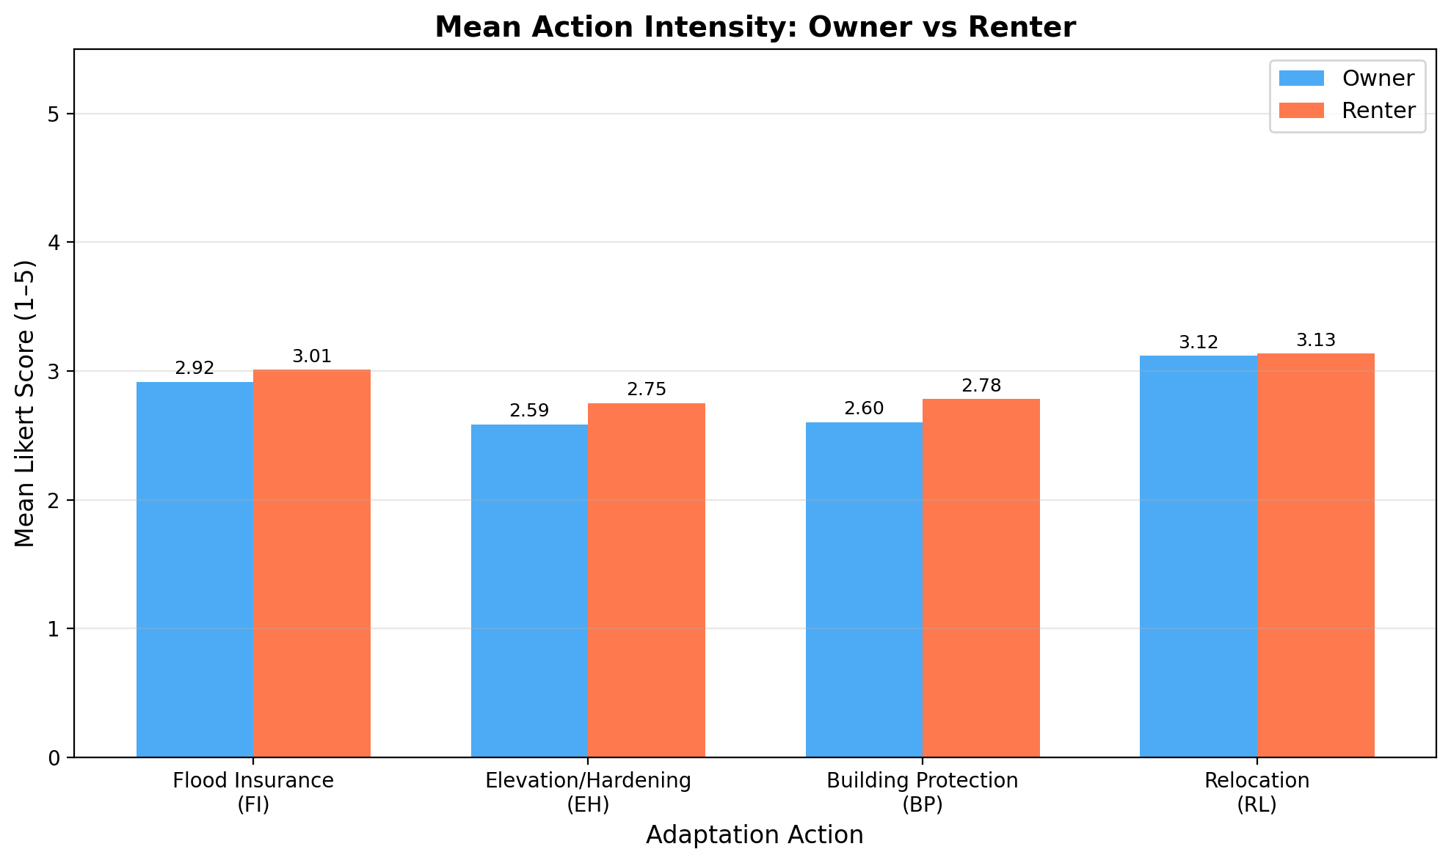

6. TP Decay Calibration Data
The calibration dataset contains only respondents with flood experience (Q15 not NaN). Variables include Q15 (flood recency ordinal), Q15_year (converted to approximate years), and the 5 psychological means.
Statistic | Owner | Renter
Count | 170 | 43
Q15 mean | 2.27 | 2.63
Q15_year mean | 5.05 | 7.19
SC mean | 3.67 | 3.36
PA mean | 3.35 | 3.25
TP mean | 3.34 | 3.60
CP mean | 3.19 | 3.38
SP mean | 2.83 | 3.02

Renters have slightly longer average time since last flood (7.2 vs 5.1 years) and higher TP mean (3.60 vs 3.34). The renter sample (n=43) is small but usable for grid-search calibration. Bootstrap confidence intervals will be wider.

7. Ready-to-Use PerceptionSampler Parameters
These Beta parameters can directly replace the hardcoded values in PerceptionSampler.py (line 20–35):
params = {
'owner': {
'TP': {'alpha': 6.122639800, 'beta': 4.480251499},
'CP': {'alpha': 5.430291126, 'beta': 3.333321897},
'SP': {'alpha': 2.666477827, 'beta': 2.014197185},
'SC': {'alpha': 3.367934467, 'beta': 1.154550838},
'PA': {'alpha': 3.574674584, 'beta': 1.850491186},
},
'renter': {
'TP': {'alpha': 4.765219193, 'beta': 3.364159852},
'CP': {'alpha': 5.236202560, 'beta': 3.154797843},
'SP': {'alpha': 2.142182744, 'beta': 1.474363312},
'SC': {'alpha': 3.996213540, 'beta': 1.576348572},
'PA': {'alpha': 2.761719297, 'beta': 1.428060094},
}
}

8. Next Steps
1. Professor reviews this report and approves distributions.
2. Phase 2: Update Bayesian regression config → run with owner/renter data → produce new .pkl model files.
3. Phase 3: Update TP decay calibration → run grid search → new α, β, τ₀, d, k parameters.
4. Phase 4: Propagate owner/renter labels through simulation code (bayes_fast_predictors.py, mgmix_tp.py, mgmix_decision.py, mgmix_pipeline.py).

8.1 Discussion Points for Professor
• Renter calibration sample (n=43): sufficient or needs augmentation?
• EH/BP availability: restrict to owners only, or allow renters?
• Original plan: RL = renter-only. Current data shows owners also respond to RL (34.9%). Keep RL for both groups or restrict?
• MG_variable bug: does this affect any previously published results?
• KS test failures: acceptable for ABM initialization? (standard practice)

