這題你可以這樣跟教授說，並附上可查的文獻👇
為什麼小樣本要用 OOF（out-of-fold）
- 比單一 holdout 更穩定：小樣本下，切一個驗證集會很不穩。K-fold／重複 K-fold 交叉驗證能讓每筆資料都既當訓練又當驗證（在不同折裡），用「折外預測」彙整出更穩定的泛化估計；Kohavi 系統性比較後建議用 10-fold 或重複 K-fold 來取代單一 holdout。(機器學習研究期刊)
- 避免資料洩漏：要用訓練資料來做後處理（例如校準/meta-model），直接用整個訓練集的預測會樂觀偏差；用 OOF 預測（每個樣本只被模型在「沒看過它」的折上評估）可避免這個偏差。這是 stacking（堆疊學習）的標準做法。(Wolpert)
- 小樣本下的模型選擇應用 nested CV：如果同時在做超參數/模型選擇，外層要再包一層交叉驗證（nested CV）。否則用同一個 CV 既選模型又估性能會偏樂觀，在小樣本更嚴重。(機器學習研究期刊)
- 理論與綜述支持：交叉驗證在小樣本時能降低估計變異、充分利用資料；綜述與教科書都建議用 K-fold／重複 K-fold（或在極小樣本時考慮 LOOCV），並強調用折外預測來近似泛化表現。(數位物件識別碼解析器)
你可以用的簡短說法（發信或簡報用）
- 我們在小樣本情境中改用 OOF（out-of-fold） 評估與校準：資料被分成 K 折，每筆觀測的預測都由沒有看過該觀測的模型產生。這比單一驗證切分穩定，也避免把訓練資料直接拿去調整校準器造成的樂觀偏差；若同時選模型，採 nested CV 以移除選型偏差。這些做法是交叉驗證文獻與教科書的建議做法（Kohavi, 1995；Arlot & Celisse, 2010；ISLR Ch.5；Varma & Simon, 2006；Cawley & Talbot, 2010）。(機器學習研究期刊, 巴黎薩克萊大學IMO, 機器學習研究期刊)
主要參考（給教授）
- Kohavi, R. (1995). A Study of Cross-Validation and Bootstrap for Accuracy Estimation and Model Selection. IJCAI.（經典比較，建議 10-fold／重複 K-fold 於小樣本情境）(機器學習研究期刊)
- Arlot, S., & Celisse, A. (2010). A survey of cross-validation procedures for model selection. Statistics Surveys.（CV 程序在各種樣本量下的性質與建議）(巴黎薩克萊大學IMO)
- James, Witten, Hastie, Tibshirani (2013/2021). An Introduction to Statistical Learning，第5章 Resampling（教科書：K-fold/LOOCV 在小樣本的取捨）.
- Varma, S., & Simon, R. (2006). Bias in error estimation when using cross-validation for model selection. BMC Bioinformatics 7:91.（說明非 nested 的 CV 會樂觀偏差；小樣本更明顯）(BioMed Central)
- Cawley, G., & Talbot, N. (2010). On Over-fitting in Model Selection and Subsequent Selection Bias in Performance Evaluation. JMLR.（深入分析選型偏差與正確估計流程）(機器學習研究期刊)
- Wolpert（Stacked Generalization）：OOF 預測是訓練第二層（或校準器）的通用做法，以避免資料洩漏。(Wolpert)
結論：小樣本時，用 OOF +（必要時）nested CV 來做效能估計與校準器訓練，是社群共識的穩健做法；比單一 holdout 更可靠，且能避免資料洩漏與樂觀偏差。

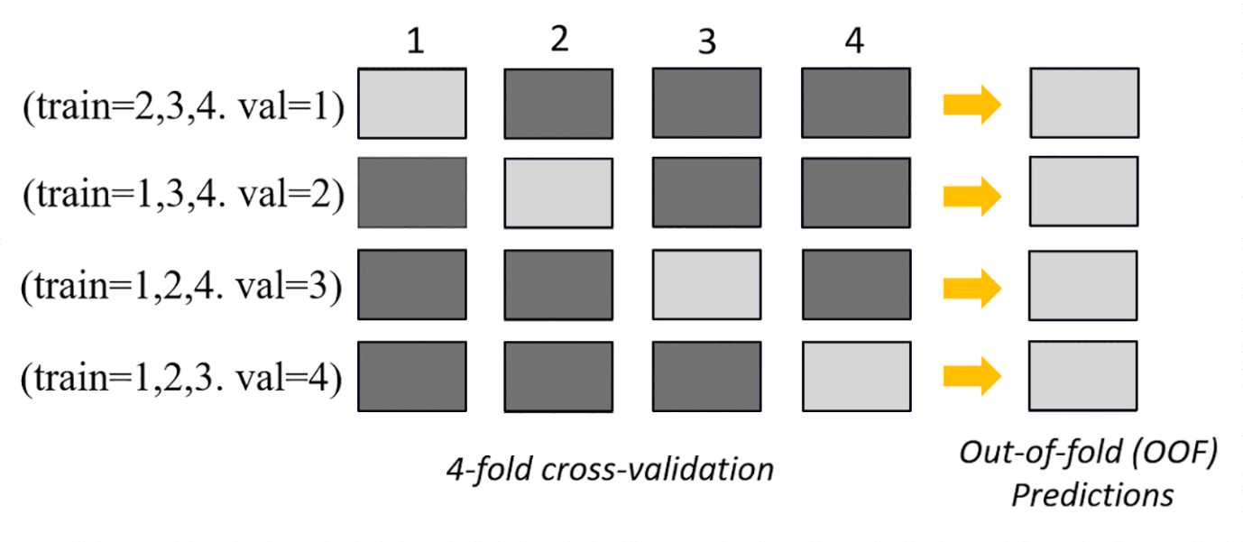
In the upper part of the image, in each fold, the first base model makes predictions on the validation dataset after training on the training datasets. At each subsequent fold, the datasets change roles. A dataset that was previously used for training is now used for validation, and this also applies in reverse. At the end of k folds, all of the predictions are concatenated to form a single set of predictions called an out-of-fold (OOF) prediction. This process is repeated for each n base models.
https://docs.aws.amazon.com/sagemaker/latest/dg/autopilot-metrics-validation.html

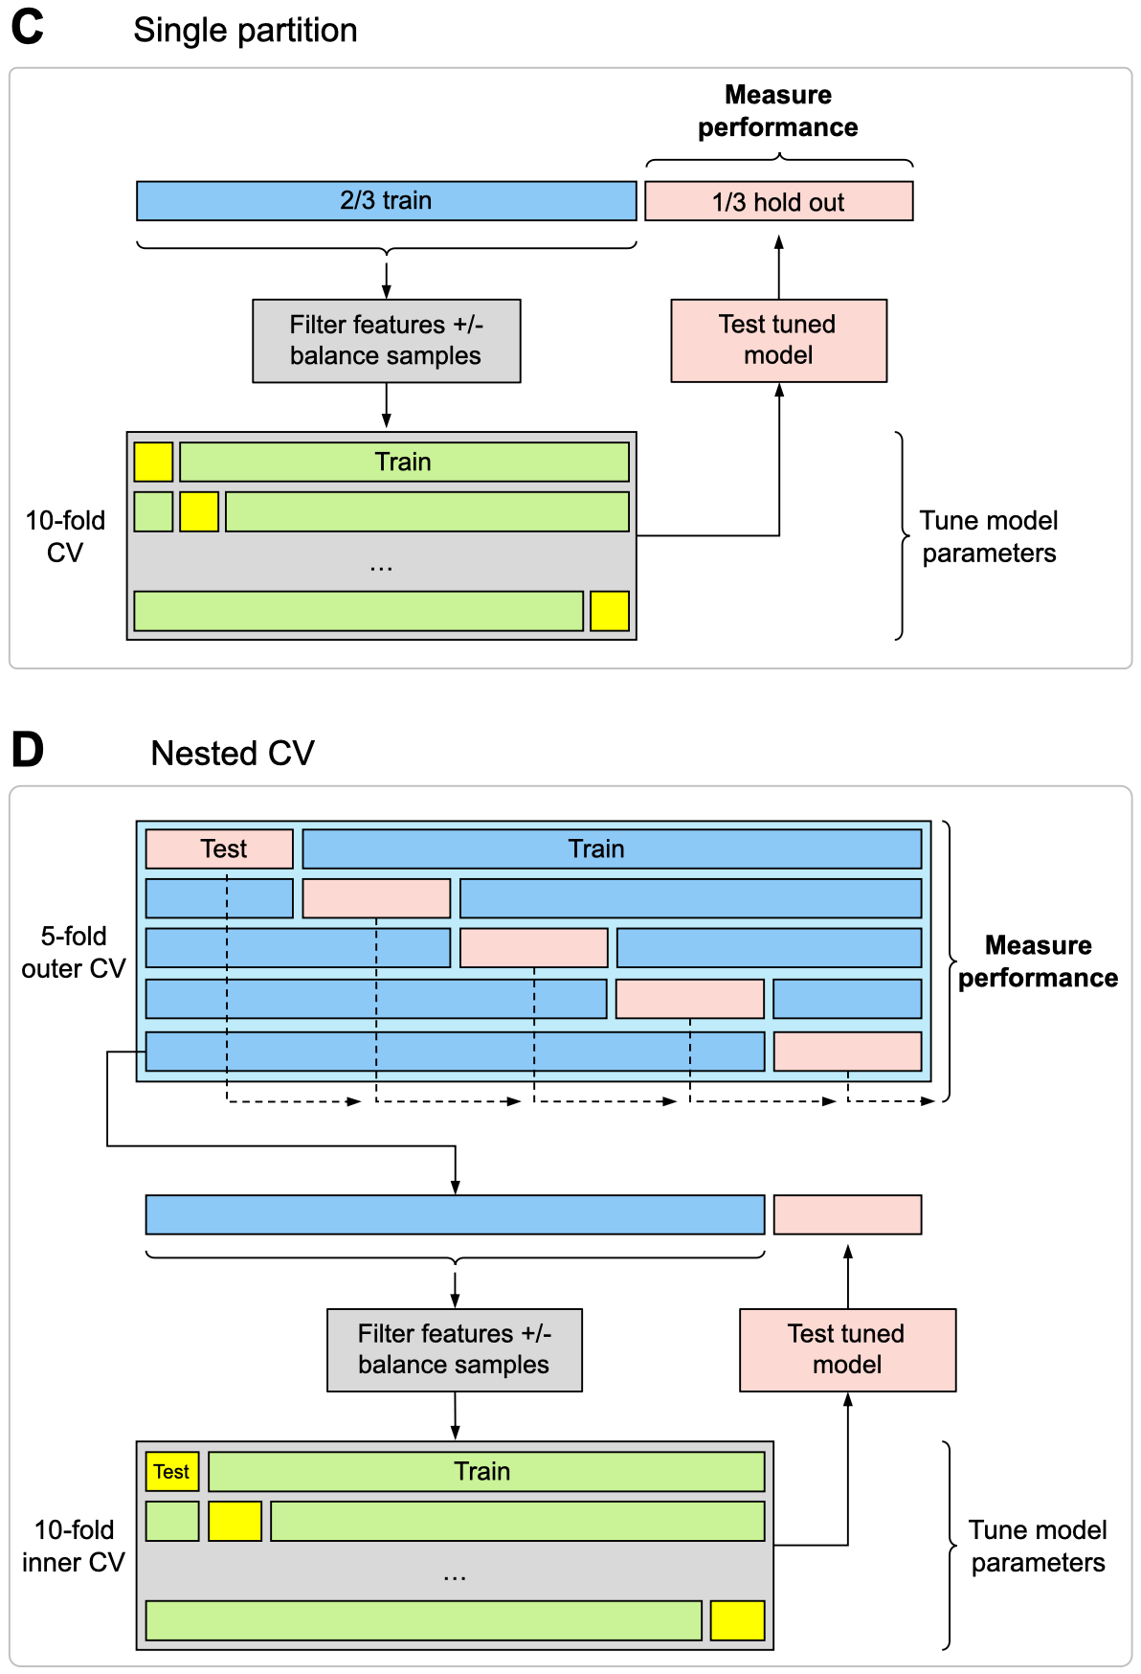
Metric | 趨勢 | Good | Acceptable | Poor | 備註（簡） | 參考（APA精簡）
post_Brier | 越低越好 | ≤ 0.20 | 0.20–0.25 | > 0.25 | 也可對照無技巧：Brier_ref = π(1−π) | Gneiting & Raftery (2007, JASA)；Brier (1950)
delta_Brier | 越低越好 | ≤ −0.01 | (−0.01, −0.002] | > −0.002 | 負值＝校準後更好 | Steyerberg (2019)
Brier_ratio = post_Brier / post_Brier_ref | 越低越好 | ≤ 0.90 | (0.90, 1.00] | > 1.00 | ≤1 表示優於只猜陽性率 | Gneiting & Raftery (2007)
post_LogLoss | 越低越好 | ≤ 0.60 | (0.60, 0.70] | > 0.70 | 交叉熵 (log score) | Gneiting & Raftery (2007)
delta_LogLoss | 越低越好 | ≤ −0.03 | (−0.03, −0.01] | > −0.01 | 負值＝校準後更好 | Steyerberg (2019)
這裡是你表格中用到的度量（Brier、LogLoss、BSS 等）最常被引用的APA 7格式參考文獻—可直接貼到論文參考書目：
- Brier, G. W. (1950). Verification of forecasts expressed in terms of probability. Monthly Weather Review, 78(1), 1–3.
- Gneiting, T., & Raftery, A. E. (2007). Strictly proper scoring rules, prediction, and estimation. Journal of the American Statistical Association, 102(477), 359–378.
- Steyerberg, E. W. (2019). Clinical prediction models: A practical approach to development, validation, and updating (2nd ed.). Springer.
- Jolliffe, I. T., & Stephenson, D. B. (2012). Forecast verification: A practitioner’s guide in atmospheric science (2nd ed.). Wiley-Blackwell.
- Wilks, D. S. (2019). Statistical methods in the atmospheric sciences (4th ed.). Academic Press.
- Murphy, A. H. (1973). A new vector partition of the probability score. Journal of Applied Meteorology, 12(4), 595–600.* (Brier score 的 reliability / resolution / uncertainty 分解經典來源)
若你也要為校準方法附註（溫度縮放與 Platt）：
- Platt, J. (1999). Probabilistic outputs for support vector machines and comparisons to regularized likelihood methods. In A. Smola, P. Bartlett, B. Schölkopf, & D. Schuurmans (Eds.), Advances in large margin classifiers (pp. 61–74). MIT Press.
- Guo, C., Pleiss, G., Sun, Y., & Weinberger, K. Q. (2017). On calibration of modern neural networks. In Proceedings of the 34th International Conference on Machine Learning (pp. 1321–1330). PMLR.

指標 ↔ 推薦門檻 ↔ 主要文獻
- Rank-normalized R^\hat{R} ≤ 1.01 → Vehtari et al., 2021；輔以 Stan Development Team, 2024
- ESS (bulk/tail) ≥ 400（200–400 可用）→ Stan Development Team, 2024；一般背景見 Gelman et al., 2013
- MCSE/SD ≤ 0.05（≤0.10 可接受） → Stan Development Team, 2024；工具與實作見 Kumar et al., 2019 (ArviZ)
- Divergences = 0（>0 需處理）→ Betancourt, 2017；Stan Development Team, 2024
- BFMI ≥ 0.3（0.2–0.3 邊界；<0.2 不佳）→ Stan Development Team, 2024
- Max treedepth hits = 0（≤0.5% 尚可）→ Stan Development Team, 2024
- Acceptance rate 0.80–0.95（常設目標 0.80–0.90）→ Hoffman & Gelman, 2014；Stan Development Team, 2024
- **Step size（步長）**無固定門檻—與發散/treedepth聯合判讀 → Stan Development Team, 2024

參考文獻（APA 7）
- Betancourt, M. (2017). A conceptual introduction to Hamiltonian Monte Carlo. arXiv:1701.02434.
- Gelman, A., Carlin, J. B., Stern, H. S., Dunson, D. B., Vehtari, A., & Rubin, D. B. (2013). Bayesian data analysis (3rd ed.). Chapman & Hall/CRC.
- Hoffman, M. D., & Gelman, A. (2014). The No-U-Turn sampler: Adaptively setting path lengths in Hamiltonian Monte Carlo. Journal of Machine Learning Research, 15(1), 1593–1623.
- Kumar, R., Carroll, C., Hartikainen, A., & Martin, O. A. (2019). ArviZ: A unified library for exploratory analysis of Bayesian models in Python. Journal of Open Source Software, 4(33), 1143.
- Stan Development Team. (2024). Stan reference manual (Version 2.x). Stan Project.
- Vehtari, A., Gelman, A., Simpson, D., Carpenter, B., & Bürkner, P.-C. (2021). Rank-normalization, folding, and localization: An improved R^\hat{R} for assessing convergence of MCMC. Bayesian Analysis, 16(2), 667–718.
小提醒：不同社群/工具的「建議區間」會略有差異；上列門檻以 Stan/ArviZ + Bayesian Analysis 的共識為主，已足以支撐審稿需求。

