Institutional Constraints Widen Adaptive Behavioural Diversity
in Language-Based Water Agents
Wen-Yu Lin¹*, Cal Buelo¹
¹ Department of Civil and Environmental Engineering, Lehigh University, Bethlehem, PA, USA
* Corresponding author: wel224@lehigh.edu
Abstract
In a 42-year Colorado River simulation, governed language agents extracted more water while maintaining scarcity-appropriate behaviour (demand ratio 0.394 vs 0.288; irrational behaviour rate 42% vs 91%). This adaptive exploitation — higher extraction during abundance, proportionate curtailment during drought — is a water-system dynamic whose reasoning is compressed by parameterized decision functions. Institutional rules created feasibility boundaries within which agents developed differentiated strategies autonomously, producing higher behavioural diversity than both ungoverned agents and a hand-coded baseline. Removing a single rule — the demand ceiling linking individual proposals to basin-wide demand — increased diversity but raised irrational behaviour, nearly doubling shortage frequency and distinguishing adaptive from arbitrary diversity. The governance effect generalized from chronic drought to acute flood hazard and was directionally positive for five of six models tested, reducing irrational behaviour rates from 0.8–11.6% to 0.1–1.7%. Institutional boundaries widen adaptive capacity in ways that fixed decision rules cannot represent.
Introduction
For six decades, computational models of water resource systems have represented human decisions in a single paradigm: as computable mappings from system states to actions. Whether the mapping is a linear program, a coupled differential equation, or an agent's decision rule, the person choosing how much water to divert, whether to buy flood insurance, or when to reduce irrigation is reduced to a parameterized function. This paradigm — established when the Harvard Water Program introduced operations research to water planning (Maass et al., 1962) — enabled rigorous engineering analysis but compressed the reasoning process into a mathematical object, foreclosing a question that water governance increasingly demands we answer: not just what people decide, but how they reason toward those decisions.
Subsequent frameworks expanded the scope of human–water modelling without departing from this numerical paradigm. Coupled human–natural systems theory recognized that human decisions and physical processes co-evolve through feedback loops (Liu et al., 2007). Sociohydrology formalized water-specific feedbacks — levee effects, supply–demand cycles, reservoir operation — as coupled differential equations, but human behaviour entered these equations as aggregate parameters rather than as individual reasoning processes (Sivapalan et al., 2012; Di Baldassarre et al., 2019). As Blair and Buytaert (2016) observed in their review of socio-hydrological modelling, models could represent that populations respond to flood risk, but not how individuals reason toward protective action.
Agent-based modelling introduced individual-level decision-making by representing heterogeneous agents who act on local information and interact through shared environments (Epstein and Axtell, 1996; Bonabeau, 2002). In water research, Berglund (2015) modelled irrigation scheduling in the Yakima Basin through threshold-based allocation rules; Haer et al. (2017) used Protection Motivation Theory to drive household flood-adaptation choices through threat and coping appraisal scores; Hung and Yang (2021) encoded drought-responsive allocation rules for Colorado River demand management. More recent approaches have introduced adaptive mechanisms — Bayesian belief updating, reinforcement learning policies (Castilla-Rho et al., 2015), and BDI cognitive architectures — that allow agents to learn and extrapolate beyond initial conditions. Yet even these approaches map numerical state vectors to numerical actions; the decision architecture — state representation, action space, and behavioural theory — must be redesigned for each domain (An, 2012; Müller et al., 2013), drawing from a fragmented landscape of over 40 distinct behavioural theories that Schlüter et al. (2017) mapped across agent-based applications. All agents within a given simulation follow the same cognitive model, differing only in parameter values — a structural rigidity that limits the representation of qualitatively different reasoning strategies within a single population.
Large language models introduce a qualitatively different representational format: agents that reason in natural language rather than through numerical functions. Instead of mapping state variables to actions through parameterized functions, a language-based agent reads contextual information — drought indices, water rights, neighbour behaviour, institutional announcements — and generates a decision through linguistic reasoning that can reference domain knowledge, weigh trade-offs, and articulate justifications. Generative agents have demonstrated believable social behaviours including persona maintenance and adaptive planning (Park et al., 2023); structured environments such as Concordia have shown that language agents can operate within defined action spaces (Vezhnevets et al., 2023); and large-scale social simulations have begun exploring population-level dynamics with over 1,000 LLM agents (Guo et al., 2024). This body of work suggests that natural language may serve as a medium for representing the reasoning processes that numerical formats compress away.
Yet language-based agents carry risks that are acute for scientific simulation. An agent might propose a water allocation that violates mass balance, a home elevation on an already-elevated structure, or a demand increase beyond its legal water right. These constraint violations — distinct from the factual hallucinations studied in natural language processing (Huang et al., 2025) — arise because LLMs lack inherent physical grounding; their frequency varies substantially across model families and scales (see Results). Most existing LLM-agent studies lack empirical behavioural benchmarking against observed patterns. The question is not whether language-based agents can reason about water decisions — early evidence suggests they can — but whether their outputs can be governed by the physical and institutional constraints that define real water systems.
Answering this governance question connects computation to institutional theory. Constraints are conventionally expected to reduce the space of available actions. But Ostrom (1990) observed that well-designed institutions for managing common-pool resources do not merely restrict behaviour — they define feasibility boundaries within which diverse adaptive strategies become viable. If this principle transfers from human communities to artificial agents, then computational governance should not merely suppress invalid outputs but should enable a wider repertoire of valid behaviours. We hypothesized that architectural governance — validating agent proposals against physical and institutional rules before execution (Fig. 1) — would produce a structurally analogous outcome at the computational level: eliminating physically impossible outputs while preserving or expanding the space of plausible decisions. We note that this is a structural parallel between institutional rules governing communities and computational rules governing artificial agents, requiring empirical rather than theoretical justification.
Here we test this hypothesis across two contrasting water domains: irrigation management in the Colorado River Basin (78 agents, 42 years) and household flood adaptation (100 agents, 10 years, stochastic flood events). Governed agents exploit water more aggressively during abundance and curtail during drought, a pattern of adaptive exploitation whose underlying reasoning is compressed away by parameterized decision functions. Removing a single institutional rule raised irrational behaviour while increasing diversity, distinguishing adaptive from arbitrary diversity. The governance effect on behavioural diversity is positive for five of six language models tested and governance nearly eliminates physically irrational behaviour. Because each rule can be independently toggled, the approach functions as a computational laboratory for probing how specific institutional designs shape adaptive water behaviour.
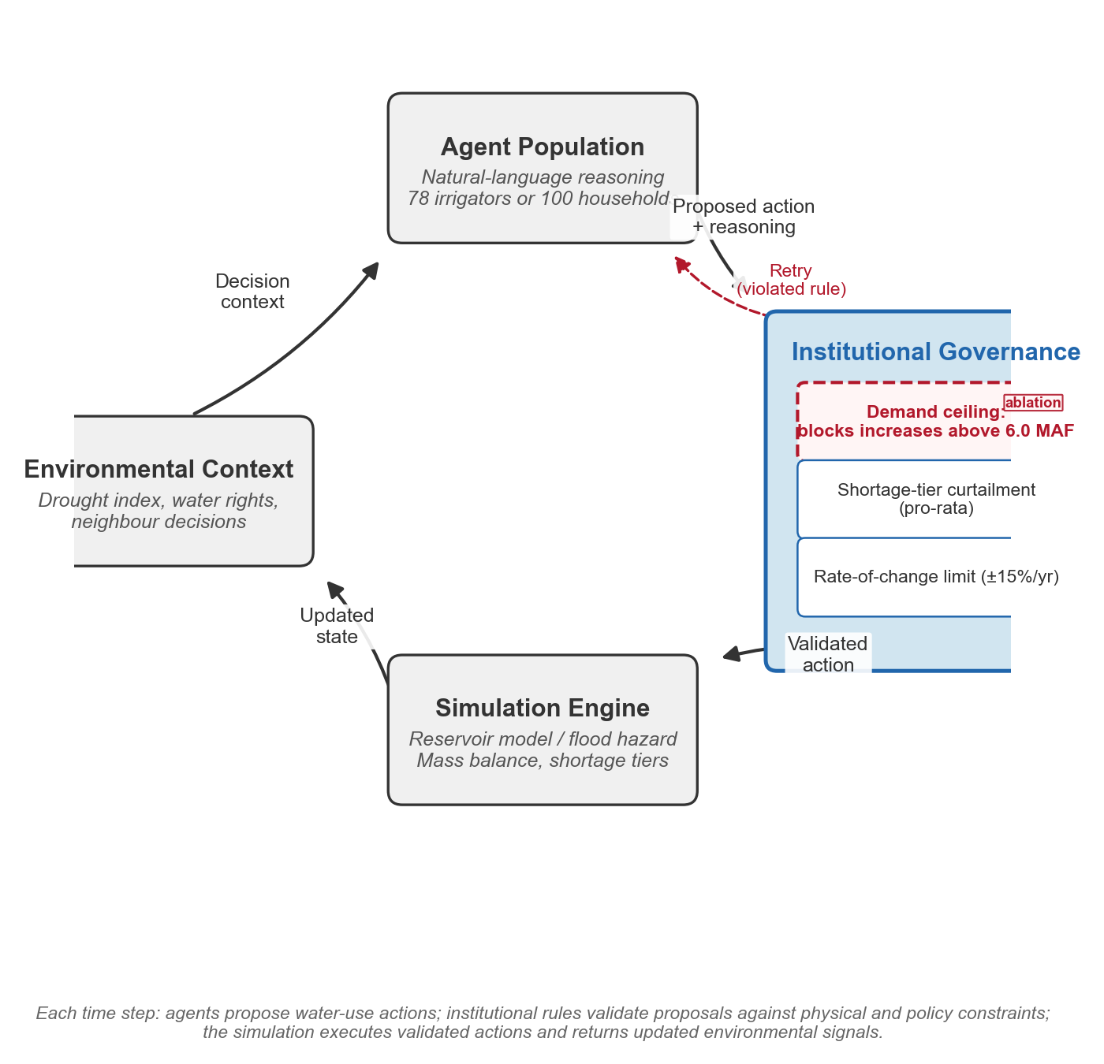
Figure 1. Water Agent Governance Framework architecture. At each decision step, an LLM agent receives contextual information (personal state, social observations, system indicators) and proposes an action with natural-language reasoning. The governance pipeline validates the proposal through six sequential checks: schema validation, action legality, physical feasibility, institutional compliance, magnitude plausibility, and theory consistency. Failed proposals receive structured feedback for revision (up to three attempts). All domain-specific knowledge is expressed through declarative configuration files (action registries, agent-type specifications, persona prompts), making the architecture transferable across water domains without code changes.
Results
Institutional rules enable adaptive exploitation of water resources
Three experimental conditions reveal complementary requirements for adaptive water management (Fig. 2, Extended Data Table 1; all irrigation results use Gemma-3 4B, 78 agents × 42 years). To assess whether agents make scarcity-appropriate decisions, we measure the Irrational Behaviour Rate (IBR): the fraction of decisions where an agent reports high water-shortage appraisal yet still proposes a demand increase. Governed language agents achieved high extraction (demand ratio — requested volume divided by historical baseline allocation — of 0.394) with low IBR (42%), indicating that most high-scarcity decisions avoided demand increases. A fuzzy Q-learning baseline (FQL; Hung and Yang, 2021) extracted nearly identical volumes (0.395), though this comparison is limited by FQL's narrower action space (2 versus 5 actions) and the fact that 84–89% of FQL decisions were rejected by governance rules rather than reflecting agent choice (see Methods and Supplementary Note 11). Ungoverned language agents showed low extraction (0.288) with extremely high IBR (91%), reflecting behavioural collapse — 77–82% of their decisions were demand increases (Fig. 2a, ungoverned sub-panel) even when agents themselves assessed water shortage as severe. Together, these results suggest that adaptive exploitation — high extraction with scarcity-appropriate restraint — emerges when natural-language reasoning operates within institutional boundaries, and is substantially weakened when either component is removed (Fig. 2b; Supplementary Note 11).
Governed agents extracted more water yet responded more sensitively to drought. Lake Mead was consequently lower under governance (42-year mean 1,094 ft versus 1,173 ft) and governed agents triggered shortage conditions more frequently (13.3 versus 5.0 of 42 years). The higher shortage frequency reflects the costs of aggressive resource exploitation rather than system failure: governed agents utilized more water during recovery periods while ungoverned agents could not adjust. The minimum Mead elevation was comparable (governed 1,002 ft versus ungoverned 1,001 ft), confirming that both systems reached the physical floor during severe early drought; the divergence occurred during recovery, where governed agents adaptively adjusted demand while ungoverned agents could not.
This pattern — higher extraction during abundance, proportionate response to scarcity signals — is consistent with adaptive exploitation under drought-responsive allocation rules inspired by Colorado River management, where users maintain full diversions until drought-tier curtailment begins. In real Colorado River management, shortage tiers and delivery obligations enable senior rights holders to utilize water aggressively in normal years because those rules guarantee curtailment during drought. Governed agents display a structurally analogous dynamic: institutional governance rules made it safe to extract more water by ensuring that drought-inappropriate proposals were blocked before execution. The water-system consequence is that governance shifts the equilibrium demand level upward without degrading drought responsiveness.
Extended Data Table 1. Water-system outcomes and behavioural diversity across four experimental conditions (irrigation domain, Gemma-3 4B, 78 agents × 42 years, 3 runs each). "No Ceiling" removes only the demand-ceiling rule while retaining all 11 other governance rules. FQL = fuzzy Q-learning baseline (Hung and Yang, 2021; see Methods and Supplementary Note 11).
Metric | Governed | Ungoverned | No Ceiling | FQL Baseline
Mean demand ratio | 0.394 ± 0.004 | 0.288 ± 0.020 | 0.440 ± 0.012 | 0.395 ± 0.008
42-yr mean Mead elevation (ft) | 1,094 | 1,173 | 1,069 | 1,065
IBR (%) | 42.0 ± 4.2 | 90.6 ± 1.3 | 49.4 ± 1.4 | —
Shortage years (/42) | 13.3 ± 1.5 | 5.0 ± 1.7 | 25.3 ± 1.5 | 24.7 ± 9.1
Min Mead elevation (ft) | 1,002 ± 1 | 1,001 ± 0.4 | 984 ± 11 | 1,020 ± 4
Behavioural diversity (EHE) | 0.738 ± 0.017 | 0.637 ± 0.017 | 0.793 ± 0.002 | —

Three independent runs per condition (seeds 42, 43, 44). Demand ratio = requested volume / historical baseline allocation. IBR = Irrational Behaviour Rate: fraction of high-scarcity decisions (agent-reported WSA = H or VH) where the agent proposed a demand increase (lower is better; null expectation under uniform random action = 40%). Behavioural diversity (EHE) = normalized Shannon entropy H/log₂(k) over k action types (0 = all agents choose the same action; 1 = actions uniformly distributed; see Methods). For the flood domain, IBR measures PMT-inconsistent decisions (see Extended Data Table 2 and Methods). "No ceiling" removes only the demand-ceiling rule (see next section). FQL uses the same reservoir model and governance rules but replaces natural-language reasoning with a Q-learning decision module (2-action: increase/decrease); IBR and behavioural diversity are not computed because 84–89% of FQL actions were rejected by governance rules rather than reflecting agent choice (Supplementary Note 11). See Supplementary Table 6 for additional water-system metrics.
A single institutional rule separates adaptive from arbitrary diversity
To identify which institutional rules enforce scarcity-appropriate behaviour, we removed a single rule — the demand-ceiling rule, which blocks demand-increase proposals when aggregate basin demand exceeds 6.0 million acre-feet (MAF) — while retaining all eleven other rules (the "no-ceiling" condition; see Methods).
Removing this one rule of twelve increased IBR from 42% to 49%, nearly doubled shortage years from 13.3 to 25.3, and dropped minimum Mead elevation to 984 ft below the Tier 3 shortage threshold (Extended Data Table 1, "no ceiling" column). Yet removing the ceiling increased behavioural diversity from 0.738 to 0.793. Agents diversified further — but into extraction patterns that ignored their own scarcity assessments, producing higher demand ratios (0.440 versus 0.394) with more frequent shortage.
This establishes a distinction central to interpreting the governance effect: between diversity (a wider action distribution) and adaptive diversity (a wider action distribution where agents act consistently with their own scarcity appraisals; Fig. 2b, c). The demand ceiling does not suppress diversity; it channels diversity toward scarcity-appropriate patterns. Without it, agents diversify into individually rational but collectively maladaptive extraction — the hallmark of commons dilemmas that Ostrom (1990) identified as the target of institutional design.
The demand ceiling is the only one of twelve governance rules linking individual proposals to aggregate basin state. Its removal demonstrates that governance-induced diversity is functionally adaptive, not a statistical artefact of constraint-based rejection. This experimental decomposition — isolating one institutional rule's contribution to behavioural coherence — would be impossible in conventional agent-based models where institutional rules are embedded in code and cannot be independently manipulated.
Governance generates behavioural diversity beyond what hand-coded models can represent
Governed agents exhibited higher behavioural diversity than both ungoverned agents and a hand-coded Protection Motivation Theory baseline across both water domains. In irrigation, governed behavioural diversity (0.738 ± 0.017) exceeded ungoverned (0.637 ± 0.017) with zero distributional overlap across three seeds (Extended Data Table 1). In flood adaptation, the ordering was consistent: governed language agents (0.636 ± 0.044) exceeded rule-based PMT agents (0.486 ± 0.011), which exceeded ungoverned language agents (0.307 ± 0.059; Extended Data Table 2). Ungoverned agents collapsed into behavioural monoculture (near-uniform adoption of a single action): 77–82% demand increases in irrigation, 85.9% inaction in flood.
This diversity is generated by agents reasoning within governance, not filtered into existence by governance rules. Proposals submitted before any governance feedback already showed higher diversity (first-attempt behavioural diversity 0.761 governed versus 0.640 ungoverned; irrigation domain), indicating that the governance context shapes the reasoning process, rather than diversity being created post hoc by the rejection-retry mechanism (Supplementary Note 3).
The rule-based PMT agent's diversity stems entirely from parameterized variation: agents differ in income, flood zone, and prior experience, producing different threshold crossings, but all follow identical decision logic. Governed language agents achieve higher diversity through qualitatively different reasoning paths — agents develop rationales referencing personal trade-offs, contextual factors, and institutional constraints in ways that threshold-based rules cannot represent. Under identical physical conditions (same year, same shortage tier, same reservoir elevation), four governed agents selected four different actions through distinct cognitive frames: opportunity-seeking under self-assessed confidence, reflective learning from consolidated memory of past failure, tradition-anchored inertia despite the agent's own memory advising otherwise, and social responsibility referencing neighbour dependence (Supplementary Tables 3–5 present full reasoning traces and a taxonomy of 10 distinct cognitive frames). This is not a marginal improvement in the same representational format; it is a shift from parameterized homogeneity to reasoning-generated heterogeneity.
Extended Data Table 2. Behavioural diversity: governed LLM vs rule-based PMT vs ungoverned LLM (flood domain, Gemma-3 4B, 100 agents × 10 years, 3 runs each).
Condition | Behavioural diversity | IBR (%) | do_nothing (%) | insurance (%) | elevation (%) | relocation (%)
Governed language agent | 0.636 ± 0.044 | 0.86 | 35.6 | 50.7 | 10.6 | 3.0
Rule-based PMT | 0.486 ± 0.011 | 0.0 | 69.7 | 21.3 | 8.7 | 0.0
Ungoverned language agent | 0.307 ± 0.059 | 1.15 | 85.9 | 11.7 | 2.3 | 0.0

Behavioural diversity = mean of per-year normalized Shannon entropy H/log₂(k) over active years (0 = monoculture; 1 = uniform); mean ± s.d. over 3 runs. Action percentages for rule-based agents are computed from yearly state transitions (new actions only); combined insurance-and-elevation events (<1%) are counted as elevation. IBR = Irrational Behaviour Rate: fraction of decisions classified as physically impossible or inconsistent with the agent's own threat perception via post-hoc PMT rules (see Methods). Note: IBR and BRI are domain-specific metrics — IBR measures PMT-inconsistent decisions (flood), while BRI measures scarcity-appropriate restraint (irrigation; see Extended Data Table 1). For Gemma-3 4B shown here, governance does not significantly reduce IBR (0.86% vs 1.15%); large IBR reductions occur for other models (Supplementary Table 1). Rule-based agent uses deterministic PMT threshold logic with parameterized agent heterogeneity. Post-relocation agent-years excluded.
The governance effect generalizes across water hazard types and model architectures
The governance mechanism that produces adaptive exploitation in chronic drought also generates higher behavioural diversity under acute flood hazard (Fig. 3). Fig. 3 shows how cumulative protection states evolve across three conditions: governed language agents (Fig. 3a) progressively diversify into insurance, elevation, and relocation over 10 years; rule-based PMT agents (Fig. 3b) achieve moderate diversification dominated by insurance but with no relocation; ungoverned language agents (Fig. 3c) remain largely unprotected, with over 80% of agents taking no action throughout the simulation. In the flood domain, 100 household agents made protective decisions (insurance, elevation, relocation, or inaction) over 10 years with stochastic flood events, a fundamentally different water context from continuous irrigation allocation. For the six-model comparison below, "governed" refers to agents with full governance validation and cognitively inspired memory (see Methods: Flood Domain Setup); for Gemma-3 4B, both memory configurations produced identical behavioural diversity (0.636 ± 0.044), suggesting that — at least for this model — the governance effect operates primarily through the rule-checking process rather than the memory subsystem. Governance reduced irrational behaviour rates for four of six models (p < 0.01), with directionally consistent reductions in all six (IBR = 0.1–1.7% governed versus 0.8–11.6% ungoverned; Supplementary Table 1). For Gemma-3 4B, the IBR difference was not statistically significant (0.86% versus 1.15%; Extended Data Table 2), because both conditions exhibited low baseline violation rates. The largest reductions occurred in models exhibiting the highest ungoverned violation rates (Ministral 14B: 11.6% → 0.4%; Ministral 3B: 8.9% → 1.7%).
Six models spanning two families and three parameter scales (3.2B to 27B parameters) showed positive governance effects on behavioural diversity for five of six models, with three statistically significant (Fig. 4). The effect was strongest where ungoverned agents exhibited behavioural monoculture: Gemma-3 4B (Δ = +0.329) and Ministral 3B (+0.198). Three models produced non-significant effects: Gemma-3 12B (+0.027), Ministral 14B (+0.034), and Ministral 8B (−0.024), reflecting stronger baseline diversity at larger scales that left less room for governance to expand (Supplementary Table 1). The direction of the diversity effect is sensitive to the treatment of composite actions for models near the significance boundary (Supplementary Table 7).
The consistency across two water domains — with positive effects in five of six models, three statistically significant, and near-complete elimination of irrational behaviour — provides converging evidence that institutional governance enables adaptive behavioural diversity. Because both domains use the same governance architecture with domain-specific rule configurations rather than redesigned decision logic, the framework addresses a longstanding limitation of agent-based water models: the need to rebuild decision modules for each application domain.
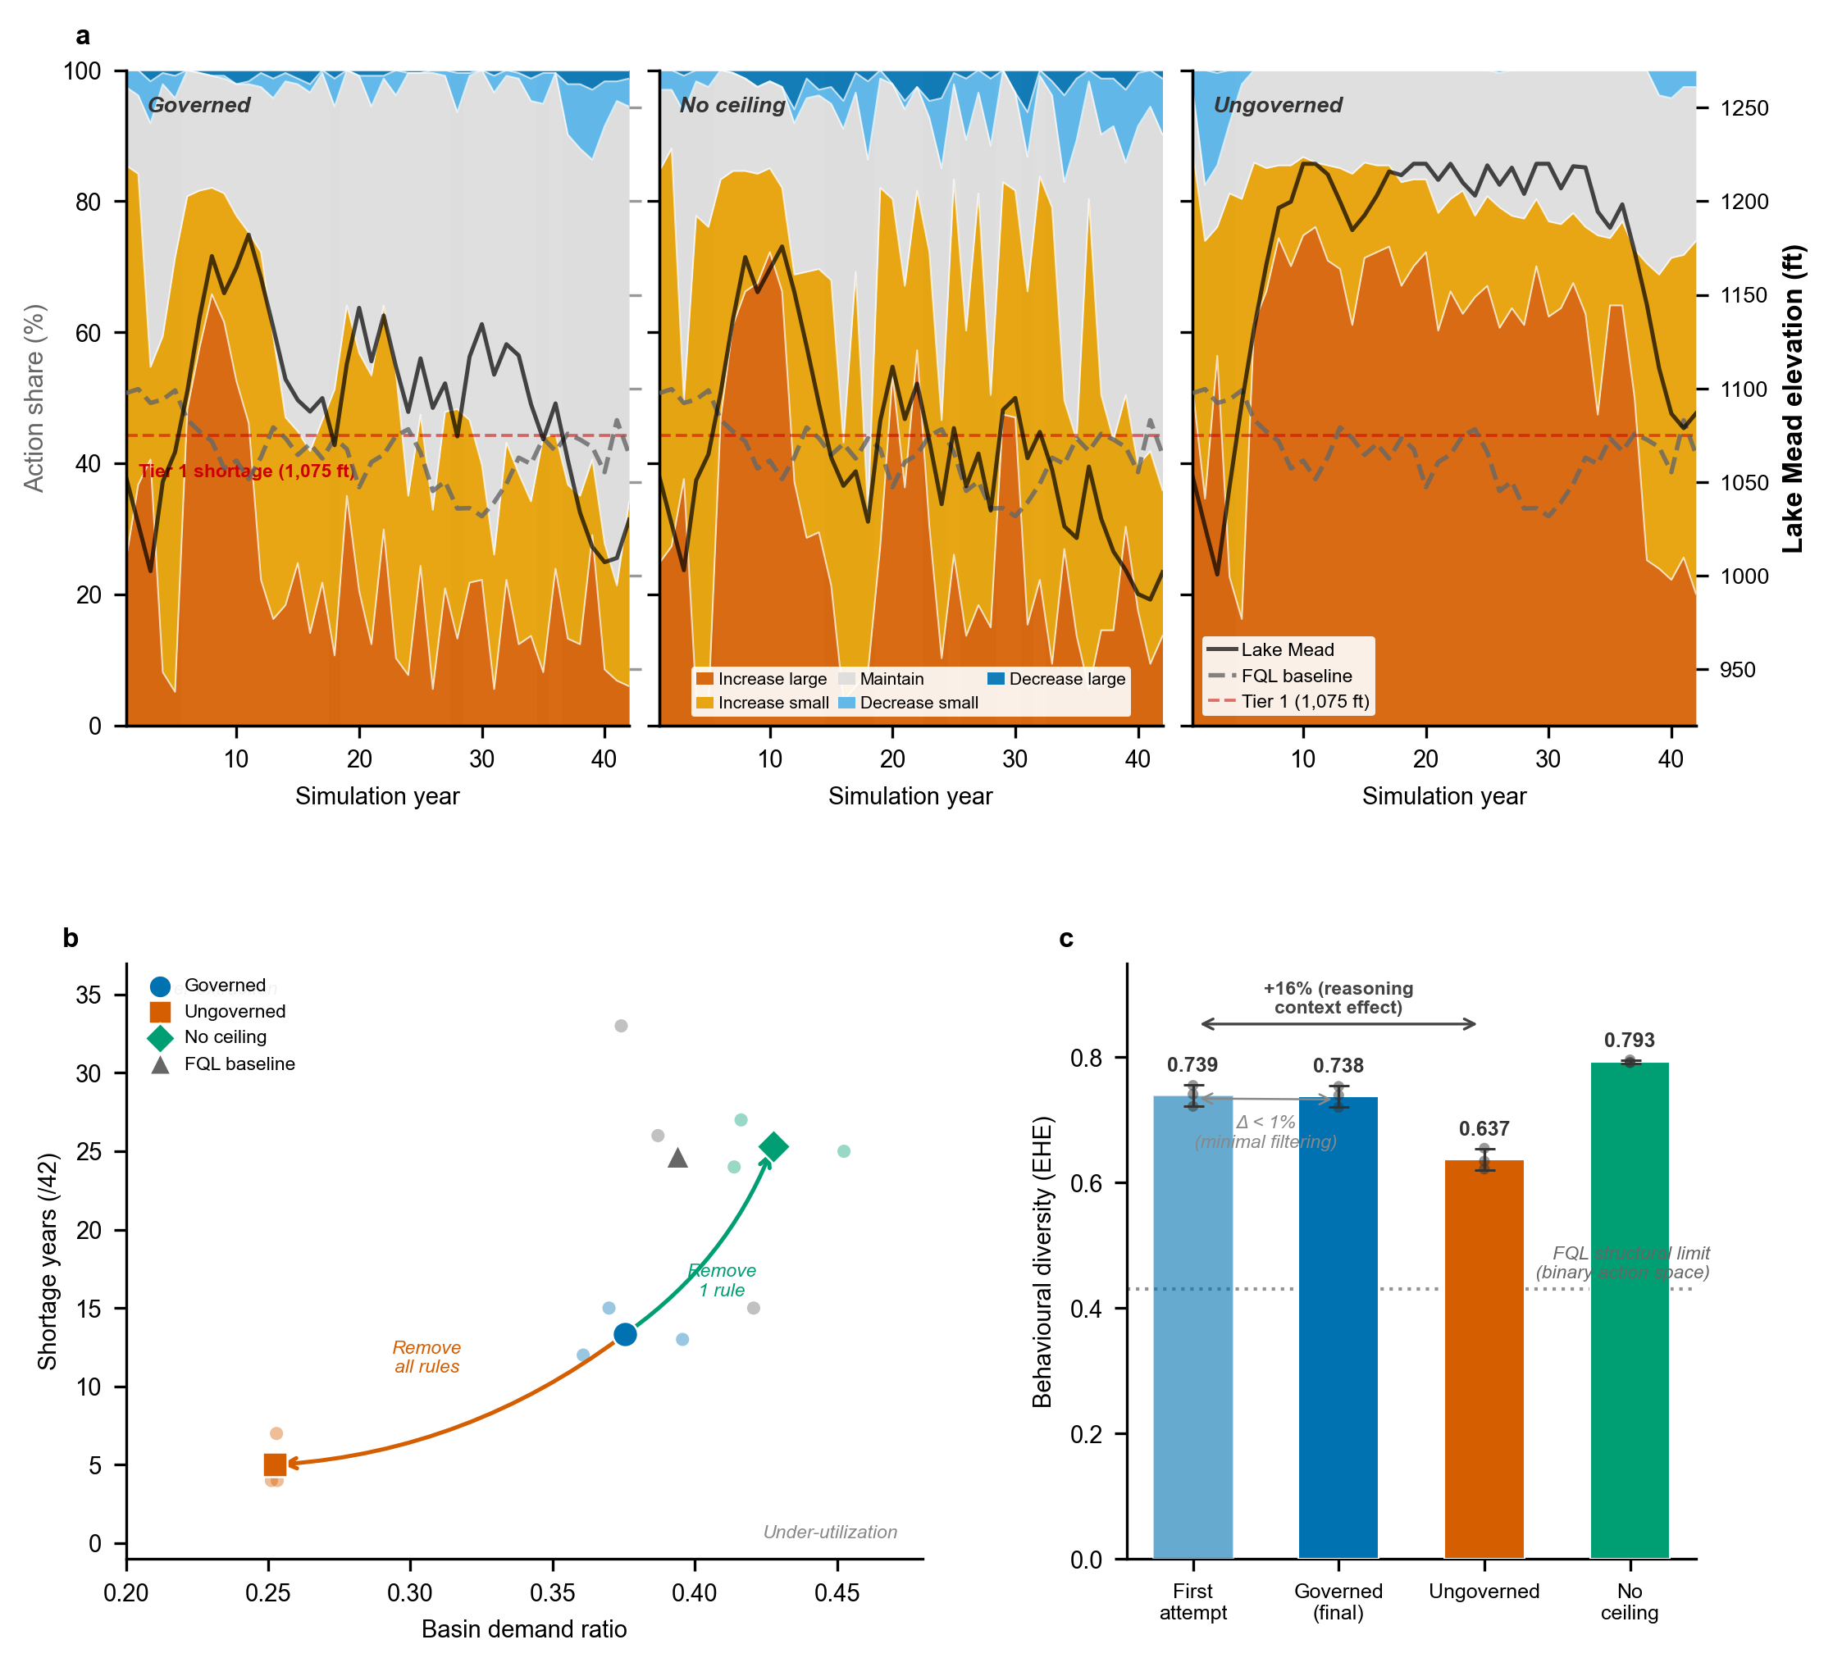
Figure 2. Governance shapes adaptive exploitation in the irrigation domain (78 agents × 42 years, Gemma-3 4B, 3 seeds). (a) Action composition over time for three conditions: governed (with demand-ceiling rule), no ceiling (demand-ceiling removed), and ungoverned (all governance removed). Stacked areas show ensemble-mean action shares (cross-seed s.d. < 3%). Black solid line: condition-specific Lake Mead level (right axis); grey dashed line: fuzzy Q-learning (FQL) baseline (Hung and Yang, 2021). Red dashed line: Tier 1 shortage threshold (1,075 ft); grey shading: drought periods. (b) Demand ratio (requested volume / historical baseline) versus shortage years (years with mean Lake Mead below 1,075 ft). Each small dot represents one seed; large markers show condition means. Arrows trace ablation: removing the demand-ceiling rule alone (‘Remove 1 rule’) shifts the system toward over-extraction with doubled shortage; removing all governance rules (‘Remove all rules’) collapses extraction entirely. Governed agents occupy the adaptive exploitation zone (high extraction, moderate shortage). (c) Behavioural diversity (EHE; normalised Shannon entropy H/log₂(k), k = 5; 0 = monoculture, 1 = uniform). ‘First attempt’: EHE computed from agents’ initial proposals before any governance feedback; ‘Governed (final)’: after governance filtering. Near-identical heights (Δ < 1%) confirm that governance does not filter diversity—it is generated by reasoning within institutional context (+16% over ungoverned). No-ceiling agents achieve the highest diversity but at the cost of over-extraction (panel b). Dotted line: FQL theoretical diversity ceiling (EHE = 0.43; with only 2 actions, Q-learning cannot structurally exceed this bound). Error bars: ± 1 s.d. across 3 seeds.
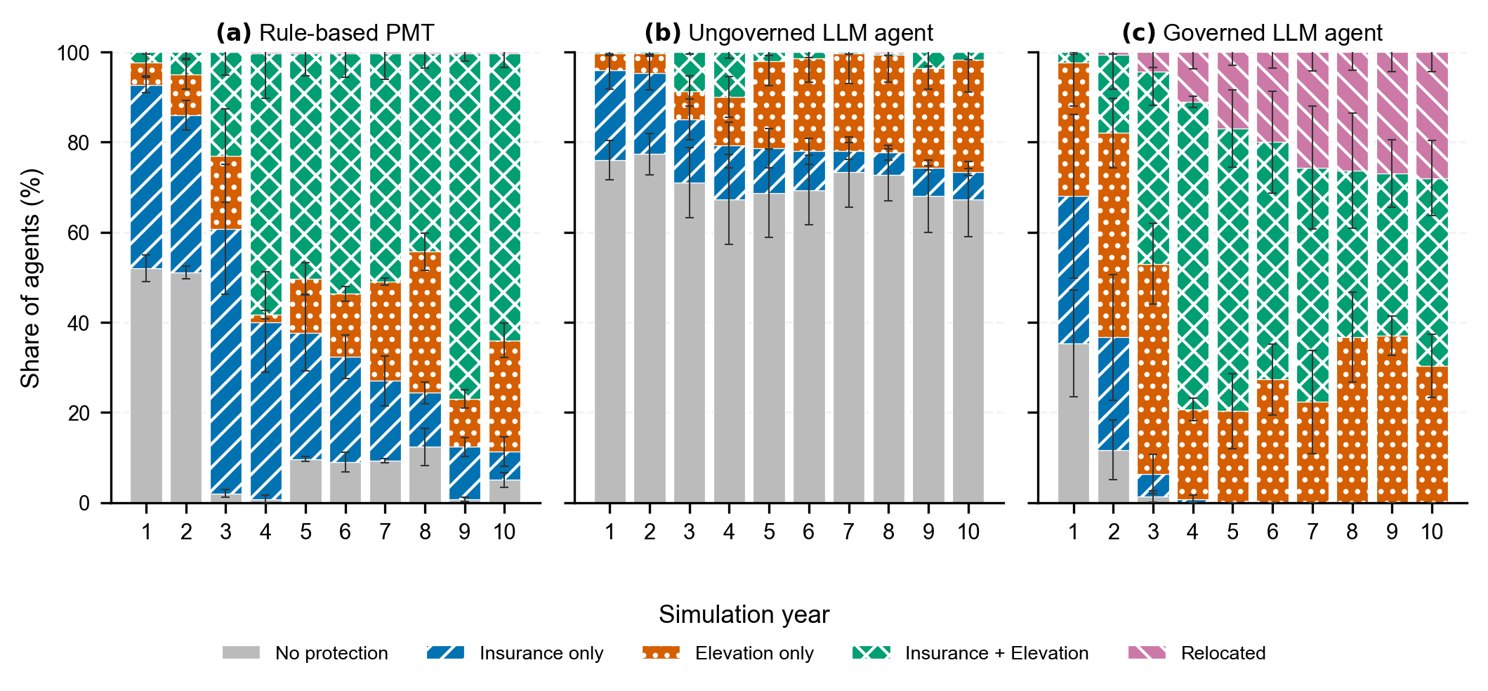
Figure 3. Flood-adaptation trajectories across agent types (100 agents × 10 years, Gemma-3 4B). Bars show 3-seed means of active (non-relocated) agents; error whiskers show ± 1 s.d. across seeds. Numbers above bars indicate mean relocated agents (excluded from denominators in subsequent years). (a) Rule-based Protection Motivation Theory (PMT) agents converge rapidly to elevation-dominated protection. (b) Ungoverned language agents stagnate in unprotected states. (c) Governed language agents develop a diverse mix of protection strategies; relocation counts are annotated above bars. Insurance requires annual renewal; elevation is permanent.
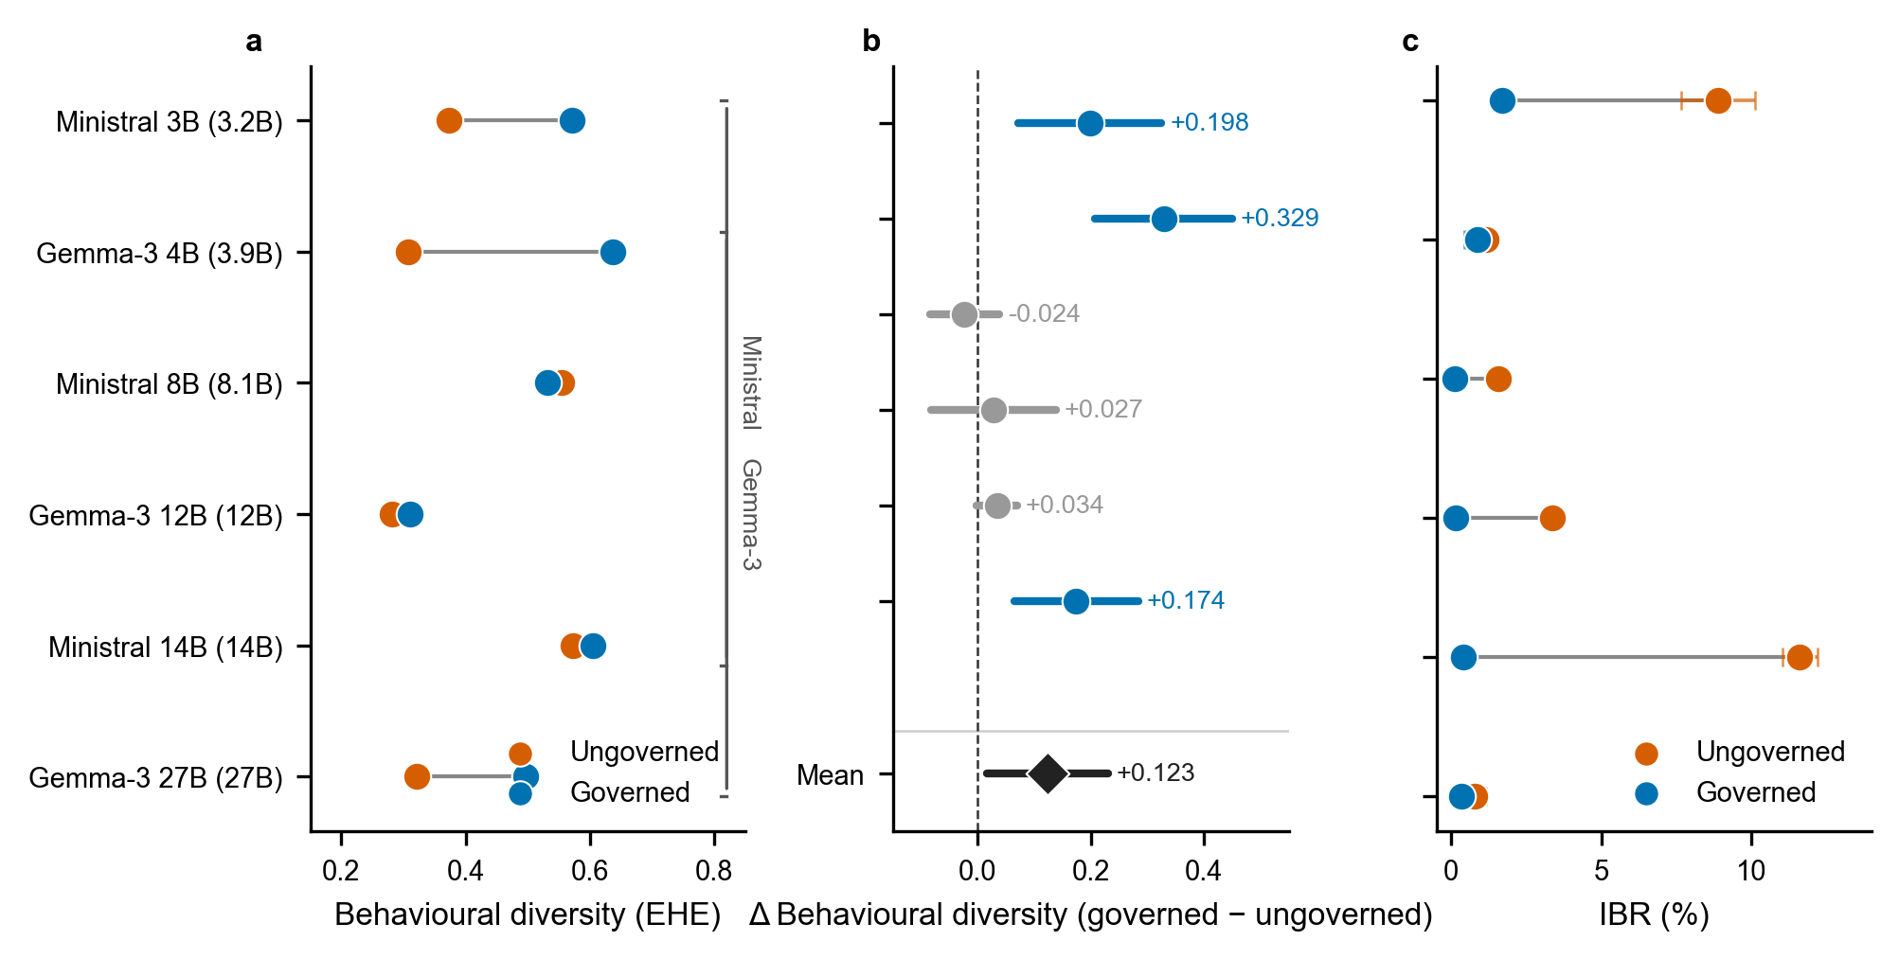
Figure 4. Governance effect on behavioural diversity and rationality across six language models (flood domain, 100 agents × 10 years, 3 runs per condition). Models sorted by parameter count (3.2B to 27B). (a) Paired dot plot showing ungoverned (vermillion) versus governed (blue) behavioural diversity (normalised Shannon entropy H/log₂(k), k = 4 action types); connecting lines indicate effect direction. (b) Forest plot of governance effect (Δ = governed − ungoverned) with 95% CIs; blue = statistically significant, grey = non-significant. Diamond shows mean effect across all six models (+0.123). (c) IBR (Irrational Behaviour Rate, %; fraction of physically impossible or PMT-inconsistent decisions) for each model. Governance reduced IBR in all six models, with the largest reductions for Ministral 14B (11.6% → 0.4%) and Ministral 3B (8.9% → 1.7%). Error bars: ± 1 s.d. across 3 seeds. Full IBR decomposition in Supplementary Table 1.
Discussion
Governed language-based agents exploit water resources more aggressively during favourable conditions and curtail proportionately during drought — a pattern of adaptive exploitation that emerges from institutional boundary enforcement rather than programmed decision rules. This addresses the central question of whether computational governance can create conditions for adaptive water management: not by prescribing behaviour, but by defining institutional boundaries within which diverse strategies become viable. Governed agents achieved low irrational behaviour (IBR 42% versus 91% ungoverned) while extracting a larger share of their water entitlements. In systems with drought-responsive allocation rules, this parallels how shortage-sharing mechanisms enable users to extract their full entitlement in normal years because those rules ensure proportionate curtailment during drought — the institution does not reduce water use, it makes higher use safe.
The demand ceiling ablation reveals the mechanism. Removing this single rule — which links individual demand proposals to aggregate basin state — increased diversity but raised IBR and nearly doubled shortage frequency. This separates two properties that institutional theory has long distinguished but seldom quantified computationally: diversity (wider repertoire of actions used) and adaptive diversity (actions consistent with agents' own scarcity assessments). We note that removing a governance rule simultaneously eliminates both the constraint and the informational feedback it provides; the increased IBR may therefore reflect the loss of either or both mechanisms. Ostrom (1990) observed that well-designed institutions for common-pool resource management create structured arenas within which diverse adaptive strategies become viable. Our computational results produce a structurally analogous outcome: governance rules define feasibility boundaries within which language models generate a wider range of valid strategies consistent with their own scarcity assessments. Without these boundaries, agents collapse into repetitive patterns — not because they lack capacity, but because unconstrained generation produces invalid proposals that crowd out meaningful variation. We emphasize that the parallel is structural: Ostrom's analysis involves strategic interaction and norm internalization, whereas our governance rules evaluate each proposal independently without memory of previous decisions. Whether informal norms emerge from repeated agent interaction remains untested.
The capacity to experimentally decompose institutional rules transforms language-based agents from simulation tools into computational laboratories for water governance. In the ablation demonstrated here, removing one of twelve rules isolated the mechanism linking individual decisions to basin-wide scarcity. The same approach could test variations in shortage-sharing thresholds (for example, shifting Tier 1 from 1,075 ft to 1,050 ft), alternative allocation regimes (proportional versus priority-based curtailment), premium structures for flood insurance, or drought contingency plan triggers — observing how populations of reasoning agents endogenously adapt their strategies within physically valid bounds. This capacity is distinct from exploratory modelling (Bankes, 1993) and sensitivity analysis in that the behavioural responses are generated, not sampled from predefined parameter spaces. The rule-based PMT comparison quantifies the representational gain: governed language agents produced higher behavioural diversity than hand-coded agents using the same behavioural theory with parameterized heterogeneity, because language-based reasoning generates qualitatively different strategies that threshold-based rules cannot represent. A fuzzy Q-learning baseline (Hung & Yang, 2021) achieved comparable demand ratios but with 84–89% of decisions rejected by governance rules; although the comparison is limited by FQL's narrower action space (2 versus 5 actions), it suggests that governance constraints without flexible reasoning are insufficient to produce the adaptive exploitation pattern (Supplementary Note 11).
Governance also reveals reasoning patterns that illuminate how agents behave at institutional boundaries. Because the governance process records every blocked proposal alongside the agent's natural-language reasoning, governance creates an audit trail of decisions that agents attempted but the institution prevented. During Tier 3 shortage, for example, an agent reasoned: "my previous aggressive increase failed... given my scepticism of forecasts, I will cautiously increase" — acknowledging failure while repeating it (see Supplementary Note 2 for paired reasoning traces). Across all governed runs, 42% of high-scarcity decisions still attempted demand increases despite the agent's own high water-shortage appraisal (Supplementary Note 2). Governed IBR (42%) approximates the null expectation under uniform random action selection (40%), indicating that governance eliminates the directional increase-bias of ungoverned agents (IBR 91%) rather than optimizing decisions toward rationality (Extended Data Table 1). The 42% irrational rate is concentrated in agents reporting both high water-shortage appraisal and high adaptive capacity — a pattern that one interpretation attributes to anticipatory extraction ("use it or lose it") rather than random noise (Supplementary Note 2). Governance does not eliminate maladaptive water-use reasoning; it intercepts the proposal before execution and records the reasoning trace that produced it. This diagnostic capacity has no analogue in conventional water-resource agent models, where agents execute programmed allocation rules and cannot generate proposals that violate those rules.
The tendency of governed agents to attempt demand increases during scarcity has empirical precedent in drought-responsive allocation systems, where irrigators historically increase diversions in anticipation of curtailment. Our governance architecture suppresses these proposals; future designs could distinguish between physically infeasible allocations and institutionally prohibited-but-observed diversion strategies, preserving them as diagnostic windows into water-use reasoning under scarcity. This distinguishes boundary constraints (what agents cannot do) from prescriptive constraints (what agents should do) — the majority of our rules enforce the former, leaving strategy selection to the agent.
Several scope conditions apply. The governance effect on behavioural diversity is strongest for the smallest models (Gemma-3 4B: +0.329) and weakest for the largest (Ministral 8B: −0.024, Ministral 14B: +0.034). This pattern is consistent with two interpretations: governance compensates for limited model capability, or larger models already approach their diversity ceiling, leaving less room for governance to expand. The current design cannot distinguish these mechanisms; experiments with models of equivalent scale but different capability profiles would clarify. Only one model (Gemma-3 4B) was tested in the irrigation domain; the multi-scale analysis is limited to flood. Both model families are general-purpose language models trained to follow natural-language instructions; generalization to models specifically designed for multi-step reasoning remains untested.
The reservoir model simplifies the full CRSS system to a single reservoir; results should be interpreted as stylized institutional dynamics. Each experimental condition was replicated with three independent seeds, consistent with standard practice in agent-based water modelling but limiting formal inferential power; future work should increase replication to strengthen statistical claims. Each domain required substantial configuration (agent descriptions, governance rules, action definitions); transferability refers to the governance architecture, not the configuration effort. We note that doubling the insurance premium rate reversed the governance diversity effect in the flood domain (Supplementary Note 5), indicating that the adaptive diversity we observe depends on the institutional parameter configuration and is not an unconditional property of governance.
Despite these limitations, the consistency of the governance effect — positive for five of six model scales on diversity (three statistically significant, three non-significant including one negative), with significant reduction of irrational behaviour for four of six (directionally consistent in all six), across both water domains, and against a hand-coded baseline — suggests that institutional boundary enforcement is a robust mechanism for enabling adaptive behavioural diversity in language-based water simulation. The question for water research shifts from whether language-based agents can represent human water reasoning to what institutional designs best govern that reasoning — and what those designs reveal about the adaptive capacity institutions create.
Methods
Broker Architecture and Governance Pipeline
The Water Agent Governance Framework implements a three-layer architecture: an LLM agent layer, a governance pipeline, and a simulation engine. At each decision step, the framework assembles the information available to the agent — personal state variables, social observations from network neighbours, and system-level indicators (drought indices, flood forecasts, institutional announcements) — bounded to what the agent's role and location would permit access to. The agent produces a structured JSON output comprising a proposed action, natural-language reasoning, and psychological construct labels where applicable. The governance pipeline then evaluates this proposal through a six-step validation sequence:
1. Schema validation: Confirms the output conforms to the required JSON structure.
2. Action legality: Verifies the proposed action belongs to the agent's type-specific action registry.
3. Physical feasibility: Checks mass balance, capacity limits, and domain-specific physical constraints.
4. Institutional compliance: Validates against policy rules (drought-responsive shortage tiers, programme eligibility).
5. Magnitude plausibility: Assesses whether proposed changes fall within empirically calibrated bounds (e.g., year-over-year demand shifts within +/-15%).
6. Theory consistency: For domains with explicit behavioural theory framing (e.g., Protection Motivation Theory), verifies alignment between stated reasoning constructs and the proposed action.
This six-step sequence defines the pipeline architecture (the order in which checks execute). Individual validators within each step are classified by domain function — physical, institutional, social, behavioural, or epistemic — as detailed in Supplementary Tables SN-A and SN-B.
When a proposal fails validation, the governance pipeline returns a structured explanation identifying the violated rule. The agent receives this feedback and may revise its proposal (up to three attempts). If the same rule blocks consecutive attempts, the revision cycle terminates and a domain-appropriate default action (typically "do nothing") executes, ensuring simulation advancement. Failed proposals, revision attempts, and governance explanations are recorded in structured decision logs for post-hoc analysis.
The governance architecture is fixed code requiring no modification across domains. All domain-specific knowledge is expressed through declarative configuration files:
• Action registries (YAML): Define the decision vocabulary per agent type.
• Agent-type specifications (YAML): Map state variables, decision attributes, and governance rule bindings.
• Persona prompts (natural language): Establish cognitive framing, institutional context, and behavioural theory orientation per agent type.
• Governance rules (YAML): Specify validator stacks, thresholds, and severity levels (WARNING vs. ERROR).
LLM Configuration and Inference
All experiments used locally hosted publicly available language models via Ollama, a local inference platform. The primary model was Gemma-3 4B (Gemma Team, 2025; Ollama tag gemma3:4b); cross-scale comparisons included Gemma-3 12B (gemma3:12b) and 27B (gemma3:27b), and Ministral 3B, 8B, and 14B (a model series by Mistral AI; Ollama tags ministral:3b/8b/14b). Temperature (a parameter controlling output randomness; higher values produce more variable responses) was set to 0.8 with top_p = 0.9 (a complementary randomness parameter) and a maximum input length of 8,192 tokens (approximately 6,000 words). The temperature value follows common practice in generative agent studies (Park et al., 2023). Because temperature directly affects output diversity, the absolute values of behavioural diversity reflect this parameter choice. No temperature sensitivity analysis was conducted; the governance effect (governed minus ungoverned) may vary at different temperatures. Future work should systematically test temperature sensitivity across the range [0.2, 1.0]. Structured machine-readable output was enforced through formatted text responses with rule-based preprocessing that corrects common formatting errors before parsing. Fixed random seeds (reported per domain below) ensured reproducibility across runs. No additional training or calibration of the language models was performed; all behavioural shaping occurred through prompt design and governance constraints. Full agent description templates and governance rule specifications (configuration files) are provided in the Supplementary Information.
Irrigation Domain Setup
The irrigation application represents 78 agents corresponding to Colorado River Simulation System (CRSS) demand nodes across the Upper and Lower Colorado River Basin. Each agent manages a continuous water-allocation decision over a 42-year horizon (simulating conditions from 1981 to 2022). Agent reasoning follows a dual-appraisal framework — Water Shortage Appraisal (WSA) and Adaptive Capacity Appraisal (ACA) — derived from fuzzy-quantitative-linguistic persona heuristics that extend the institutional decision logic of Hung and Yang (2021). Agents are characterized by seniority (priority date), storage access, historical demand flexibility, and basin membership (Upper vs. Lower). Five actions define the decision vocabulary: increase demand (large or small), decrease demand (large or small), and maintain demand. Each action triggers bounded Gaussian magnitude sampling (mean from persona heuristics, sigma from cluster parameters) clamped to [0, water_right], ensuring physical feasibility independent of governance. Twelve validators enforce constraints: 5 physical (mass balance, capacity limits, rate-of-change bounds, supply-gap detection), 1 economic (demand-floor stabiliser), 2 institutional (the demand-ceiling rule — linking individual proposals to aggregate basin state, tested in the no-ceiling ablation — and drought-severity scaling), 2 social (curtailment awareness, compact allocation), 1 temporal (consecutive-increase cap; disabled in production), and 1 behavioural (WSA-ACA construct-action alignment). See Supplementary Table SN-A for the complete validator inventory.
To isolate the governance contribution, we conducted a two-condition ablation:
• Governed: Full governance pipeline (12 validators, WARNING and ERROR severity levels, retry loop with early exit). WARNING-level violations issue feedback but allow execution; ERROR-level violations block the proposal and trigger retries (max 3).
• Ungoverned: Identical agent personas, environment, and magnitude sampling, but with governance disabled (no validators, no retry loop). The LLM freely selects any action; physical bounds are maintained solely through the code-level clamp in the simulation engine.
A third condition tested targeted ablation:
• No ceiling: Full governance pipeline minus the demand-ceiling rule, which blocks demand-increase proposals when aggregate basin demand exceeds 6.0 MAF. Removing this single rule isolates whether the diversity effect requires the specific constraint that links individual decisions to aggregate basin state, while retaining all 11 other validators.
Each condition was run with 3 replicate seeds (42, 43, 44) for a total of 9 irrigation runs. Because magnitude is code-generated in all conditions, the ablation cleanly isolates the governance effect on action selection quality.
Reservoir Simulation
Agent decisions drive Lake Mead through an endogenous mass-balance model. At each annual timestep, the simulation computes:
Storage(t+1) = Storage(t) + Inflows(t) − ΣWithdrawals(t) − Evaporation(t) − Downstream(t)
where Inflows comprise natural flow at Lee Ferry (base 12.0 MAF/yr, scaled by Upper Basin precipitation from historical CRSS traces for 1981–2022, clamped to [6, 17] MAF) plus Lower Basin tributaries (1.0 MAF/yr fixed); Withdrawals are the sum of all 78 agents' fulfilled diversions from the previous year (simultaneous update: all agents observe the same Mead state at the start of each year, make decisions, and withdrawals affect Mead at the start of the following year); Evaporation is elevation-dependent (0.6–0.8 MAF/yr); and Downstream includes Mexico Treaty deliveries (1.5 MAF/yr) and non-agricultural municipal demand (1.2 MAF/yr). Storage-to-elevation conversion uses a USBR-derived lookup table interpolated across 10 control points (895–1,220 ft). The simulation clamps storage changes to ±3.5 MAF/yr to prevent numerical instabilities.
Shortage tiers activate at elevation thresholds following the 2007 Interim Guidelines: Tier 1 at 1,075 ft (5% curtailment), Tier 2 at 1,050 ft (10%), Tier 3 at 1,025 ft (20%). Shortage tiers reduce all agents' fulfilled diversions by the tier percentage — a simplification of the seniority-based curtailment sequence used in actual Colorado River operations, where junior rights are curtailed before senior rights. Upper Basin diversions are additionally constrained by a minimum Powell release of 7.0 MAF/yr and infrastructure capacity of 5.0 MAF/yr, with proportional reduction when aggregate Upper Basin demand exceeds the effective cap.
The demand-ceiling rule — tested in the ablation analysis — blocks demand-increase proposals when total basin demand exceeds 6.0 MAF. This operates at the governance layer (pre-execution), distinct from the code-level clamp that bounds fulfilled diversions post-execution.
Our simulation uses a simplified single-reservoir representation of the CRSS system; the full Bureau of Reclamation CRSS includes 12 reservoirs, hydropower constraints, and operational rules not represented here. Results should be interpreted as stylized institutional dynamics, not predictive water-supply forecasts.
Flood Domain Setup
The flood-adaptation application models 100 household agents making protective decisions over 10 simulated years. Agents are initialized from census-tract demographic profiles with heterogeneous attributes: flood zone (HIGH, MODERATE, LOW), income level, tenure type (owner vs renter), and prior adaptation state (none, insured, elevated). Flood events occur stochastically with annual probability 0.2; when a flood occurs, agents experience inundation depths drawn from zone-specific log-normal distributions (HIGH zone: μ=1.2 ft, σ=0.8; MODERATE: μ=0.4, σ=0.5; LOW: μ=0.1, σ=0.3), with spatial correlation within zones but independence across zones. Agent reasoning follows Protection Motivation Theory (Rogers, 1983): threat appraisal (perceived probability x severity) combines with coping appraisal (response efficacy x self-efficacy - response cost) to motivate action selection. Four actions are available: purchase flood insurance, elevate home, relocate, or do nothing. The elevation action is permanently blocked once completed.
The experiment uses a three-group factorial design:
• Ungoverned: LLM with window memory and governance validation disabled — establishes the baseline behavioural quality. Critically, ungoverned agents receive identical prompt templates, PMT-based response format requirements, and environmental context signals as governed agents; the only difference is that proposed decisions bypass governance validation and execute directly.
• Governed: LLM with window memory (5-year window) and full governance validation — isolates the governance effect.
• Governed (HumanCentric memory): LLM with a cognitively inspired memory system (Lin and Buelo, in preparation) featuring surprise-weighted encoding (events deviating from expectation receive higher salience), arousal-gated consolidation (high-impact events have greater probability of long-term storage), and exponential temporal decay, plus full governance validation — tests whether cognitively inspired memory improves native alignment. For Gemma-3 4B, main-text comparisons use ungoverned vs governed (window memory); for the cross-model comparison (six models, Fig. 4), ungoverned vs governed (HumanCentric memory) were run because the window-memory governed condition was conducted only for Gemma-3 4B. Both governed conditions share identical governance validators; they differ only in memory subsystem (see Supplementary Table 1 note).
The governance pipeline enforces three tiers of validation (Supplementary Tables SN-A and SN-B). Four behavioural governance rules derived from Protection Motivation Theory enforce coherence between cognitive appraisals and protective action: high threat appraisal blocks inaction (ERROR), low threat appraisal blocks relocation (ERROR) and elevation (ERROR), and low coping appraisal discourages costly protective measures (WARNING). Five domain constraints enforce physical, financial, and institutional feasibility (e.g., preventing re-elevation of already-elevated homes, blocking property modifications by renters, checking affordability). Four epistemic guardrails detect LLM-specific reasoning errors including fabricated references to neighbours' actions, false references to past events that did not occur, and reasoning that contradicts the agent's known state. The Irrational Behaviour Rate (IBR; see Validation Protocol) is evaluated using the same PMT rules applied post-hoc to executed behaviour, measuring violations that either bypassed governance (governed agents) or were never intercepted (ungoverned agents). Each group was run with 3 replicate seeds (43, 44, 45) for a total of 9 runs per model scale.
Strategy diversity metric. For both domains, behavioural diversity is measured from each agent's annual action selection — the decision submitted in each yearly round — rather than from cumulative protection states. This ensures methodological consistency: irrigation diversity reflects yearly allocation choices among five actions; flood diversity reflects yearly protective-action choices among four actions (purchase insurance, elevate home, relocate, or do nothing). Elevation is a permanent one-time action; insurance must be actively renewed each year, creating a tradeoff in which choosing elevation implicitly forgoes insurance renewal. The annual-decision metric captures these tradeoffs, whereas cumulative protection states (e.g., an agent who has both insurance and elevation) conflate current-year choices with historical decisions. Ungoverned agents occasionally selected composite actions (simultaneously purchasing insurance and elevating); these were split into constituent single-action decisions for diversity computation (k = 4). Sensitivity of the diversity metric to alternative composite-action specifications is reported in Supplementary Table 7.
Rule-Based PMT Agent
To benchmark language-based agents against the traditional ABM approach, we implemented a stochastic rule-based agent using Protection Motivation Theory. This agent computes utility scores for each action based on threat appraisal (TA; derived from flood zone and prior flood experience) and coping appraisal (CA; derived from income, insurance status, and adaptation state), then selects actions probabilistically via a softmax function (temperature τ = 0.5). Base utilities are calibrated to empirical PMT patterns (Bubeck et al., 2012): do nothing U₀ = 0.6, insurance 0.3, elevation 0.1, relocation −1.5, with flood-experience and grant-availability modifiers that shift utilities toward protective actions after flooding (full parameterization in Supplementary Note 12). The rule-based agent uses the same 100 agent profiles, 10-year horizon, stochastic flood events, and evaluation protocol as the LLM-based experiments. Three independent runs with different random seeds were conducted. Unlike language agents (which select one action per year), the rule-based agent can simultaneously recommend insurance and elevation when utility scores for both exceed baseline (42.8% of raw decisions). These composite recommendations are split into constituent single-action decisions for behavioural diversity computation. This comparison isolates the representational contribution of language-based reasoning: both approaches use PMT as the behavioural theory, but the rule-based agent maps numerical scores to actions through fixed thresholds, while the language agent reasons through natural language within governance boundaries.
Validation Protocol
We adopted a multi-level validation protocol informed by pattern-oriented modelling principles (Grimm et al., 2005).
Level 1 — Micro-behavioural coherence. The Irrational Behaviour Rate (IBR) quantifies the percentage of executed decisions that violate the same PMT rules used in the runtime governance pipeline, applied post-hoc to final behaviour. For the flood domain, IBR counts two violation types: relocating or elevating under low threat appraisal (corresponding to the runtime rules `relocation_threat_low` and `elevation_threat_low`). A third rule — do-nothing under extreme threat with adequate coping — is excluded because governance intercepted all violations before execution (Supplementary Note 1). For governed agents, IBR measures violations that escaped the governance pipeline; for ungoverned agents, it measures all PMT-inconsistent behaviour. For the irrigation domain, IBR decomposes into three rule sets: (A) physical impossibilities — proposing demand increases at the water-right cap, below minimum utilisation, during supply gaps (fulfilment < 70%), or during Tier 2+ mandatory curtailment; (B) dual-appraisal incoherence — mismatches between the agent's self-assessed WSA/ACA labels and its proposed action, evaluated against a 25-cell coherence matrix mapping each (WSA, ACA) combination to its theoretically rational action set; and (C) temporal violations — four or more consecutive demand increases during drought (drought index >= 0.7). The Construct-Action Coherence Rate (CACR = 1 - IBR_coherence) provides a direct analog to the flood domain's PMT coherence metric. Both metrics are computed per agent per decision step and aggregated across the simulation. In the main text, we report IBR for both domains. For the flood domain, IBR measures PMT-inconsistent decisions (percentage of decisions violating post-hoc PMT rules). For the irrigation domain, IBR measures the fraction of high-scarcity decisions (agent-reported WSA = H or VH) where the agent proposed a demand increase (null expectation under uniform random action = 40%, since 2 of 5 actions are increases).
Level 2 — Population-level patterns. We quantify behavioural diversity using the effective heterogeneity entropy (EHE), a normalized Shannon entropy over the distribution of actions chosen by agents across all decision periods (see Supplementary Note 2 for formal definition). Specifically, behavioural diversity is computed as H / log₂(k), where H is the Shannon entropy of the action frequency distribution and k is the number of actions in the agent's designed decision interface (k = 4 for flood, k = 5 for irrigation). A value of 0 indicates behavioural monoculture (all agents choose the same action); a value of 1 indicates a perfectly uniform distribution across all available actions. Cognitive lifespan T_life is defined as the number of simulated years during which behavioural diversity exceeds 0.4, capturing when a population collapses into repetitive behaviour. For irrigation, aggregate demand ratio against CRSS baseline serves as the primary population-level calibration target. IBR for the irrigation domain measures the fraction of high-scarcity decisions (agent-reported WSA = H or VH) where the agent proposed a demand increase; lower values indicate more scarcity-appropriate behaviour (null expectation under uniform random action = 40%, since 2 of 5 actions are increases).
Level 3 — Cross-scale comparison. To assess whether governance compensates for model scale, we compare governed 4B agents against ungoverned agents at 12B and 27B scales using Mann-Whitney U tests, Cohen's d effect sizes, and bootstrap confidence intervals on behavioural diversity differences.
Statistical Analysis
Each experimental condition was replicated with three independent random seeds. This ensemble size is consistent with standard practice in agent-based water-resource modelling, where individual runs aggregate hundreds to thousands of agent decisions and replicate seeds serve as robustness checks on stochastic initialisation rather than formal hypothesis tests (Schlüter et al., 2017). Each seed generates 1,000 agent-year decisions (100 agents × 10 years) for flood and 3,276 (78 agents × 42 years) for irrigation. We report means ± s.d. across seeds and 95% confidence intervals from the paired t-distribution (df = 2); given the small sample size (n = 3), these should be interpreted as exploratory effect estimates rather than confirmatory hypothesis tests. All governance effects on IBR were directionally consistent across every seed for all six models tested. For agent-level analyses, we computed chi-squared tests on aggregate action distributions pooled across seeds, which provide adequate power given the large number of agent-decisions per condition (3,000 for flood, 9,828 for irrigation). To decompose the governance contribution, we computed CACR on proposed actions (pre-validation) and final actions (post-validation), yielding a governance improvement metric. All analyses were conducted in Python 3.11 using NumPy, SciPy, and pandas.
References
An, L. Modeling human decisions in coupled human and natural systems: review of agent-based models. Ecol. Model. 229, 25–36 (2012).
Bankes, S. Exploratory modeling for policy analysis. Oper. Res. 41, 435–449 (1993).
Berglund, E. Z. Using agent-based modeling for water resources planning and management. J. Water Resour. Plan. Manage. 141, 04015025 (2015).
Blair, P. & Buytaert, W. Socio-hydrological modelling: a review asking 'why, what and how?'. Hydrol. Earth Syst. Sci. 20, 443–478 (2016).
Bonabeau, E. Agent-based modeling: methods and techniques for simulating human systems. Proc. Natl Acad. Sci. USA 99, 7280–7287 (2002).
Bubeck, P. et al. A review of risk perceptions and other factors that influence flood mitigation behavior. Risk Anal. 32, 1481–1495 (2012).
Castilla-Rho, J. C. et al. An agent-based platform for simulating complex human–aquifer interactions in managed groundwater systems. Environ. Model. Softw. 73, 305–323 (2015).
Di Baldassarre, G. et al. Sociohydrology: scientific challenges in addressing the sustainable development goals. Water Resour. Res. 55, 6327–6355 (2019).
Epstein, J. M. & Axtell, R. Growing Artificial Societies: Social Science from the Bottom Up (MIT Press, 1996).
Guo, T. et al. Large language model based multi-agents: a survey of progress and challenges. Preprint at https://arxiv.org/abs/2402.01680 (2024).
Gemma Team. Gemma 3 Technical Report. Preprint at https://arxiv.org/abs/2503.19786 (2025).
Grimm, V. et al. Pattern-oriented modeling of agent-based complex systems: lessons from ecology. Science 310, 987–991 (2005).
Haer, T., Botzen, W. J. W., de Moel, H. & Aerts, J. C. J. H. Integrating household risk mitigation behavior in flood risk analysis: an agent-based model approach. Risk Anal. 37, 1977–1992 (2017).
Huang, L. et al. A survey on hallucination in large language models: principles, taxonomy, challenges, and open questions. ACM Trans. Inf. Syst. 43, 1–55 (2025).
Hung, F. & Yang, Y.-C. E. Assessing adaptive irrigation impacts on water scarcity in nonstationary environments — a multi-agent reinforcement learning approach. Water Resour. Res. 57, e2020WR029262 (2021).
Liu, J. et al. Complexity of coupled human and natural systems. Science 317, 1513–1516 (2007).
Maass, A. et al. Design of Water-Resource Systems: New Techniques for Relating Economic Objectives, Engineering Analysis, and Governmental Planning (Harvard Univ. Press, 1962).
Müller, B. et al. Describing human decisions in agent-based models — ODD+D, an extension of the ODD protocol. Environ. Model. Softw. 48, 37–48 (2013).
Ostrom, E. Governing the Commons: The Evolution of Institutions for Collective Action (Cambridge Univ. Press, 1990).
Park, J. S. et al. Generative agents: interactive simulacra of human behavior. In Proc. 36th ACM Symp. on User Interface Software and Technology 1–22 (2023).
Rogers, R. W. Cognitive and physiological processes in fear appeals and attitude change: a revised theory of protection motivation. In Social Psychophysiology: A Sourcebook (eds Cacioppo, J. T. & Petty, R. E.) 153–176 (Guilford, 1983).
Schlüter, M. et al. A framework for mapping and comparing behavioural theories in models of social-ecological systems. Ecol. Econ. 131, 21–35 (2017).
Sivapalan, M. et al. Socio-hydrology: a new science of people and water. Hydrol. Process. 26, 1270–1276 (2012).
Vezhnevets, A. S. et al. Generative agent-based modeling with actions grounded in physical, social, or digital space using Concordia. Preprint at https://arxiv.org/abs/2312.03664 (2023).
Data Availability
All simulation output data, agent decision traces, and governance audit logs generated in this study will be deposited in Zenodo upon acceptance (DOI to be assigned). Raw CRSS demand data for the irrigation domain are publicly available from the US Bureau of Reclamation (https://www.usbr.gov/lc/region/g4000/NaturalFlow/). Flood depth grids were generated from publicly available FEMA flood maps. Census-tract demographic profiles were derived from the US Census Bureau American Community Survey.
Code Availability
The Water Agent Governance Framework (WAGF) source code, including the broker architecture, governance validators, configuration files for both domains, and all analysis scripts used to generate the figures and tables in this paper, will be archived on Zenodo and made available on GitHub upon acceptance (DOI and URL to be assigned). Experiments were run using Ollama (v0.5.x) with open-weight models (Gemma-3 and Ministral families); no proprietary APIs were required.
Author Contributions
W.Y.: Conceptualization, Methodology, Software, Validation, Formal Analysis, Investigation, Data Curation, Writing — Original Draft, Visualization. [Additional authors TBD]: Supervision, Writing — Review & Editing, Funding Acquisition.
Competing Interests
The authors declare no competing interests.
Acknowledgements
[To be added — funding sources, computational resources, etc.]

