Text S1 Behavioral Parameter Initialization
For each census tract $j$, two independent sets of behavioral parameters are initialized to represent marginalized (MG) and non-marginalized (NMG) groups. Five behavioral parameters are considered: threat perception (TP), coping perception (CP), stakeholder perception (SP), social capital (SC), and place attachment (PA). For each parameter $p∈\{TP,CP,SP,SC,PA\}$, group-specific Beta distribution parameters are inferred from a household flood adaptation survey using a method-of-moments approach:
 | $$α_{p,g}=\left(\frac{μ_{p,g}(1-μ_{p,g})}{σ_{p,g}^{2}} − 1\right)μ_{p,g}$$ | (1)
 | $$\begin{matrix} & β_{p,g}=\left(\frac{μ_{p,g}(1-μ_{p,g})}{σ_{p,g}^{2}} − 1\right)(1-μ_{p,g}), & & \end{matrix}$$ | (2)
where $μ_{p,g}$and $σ_{p,g}^{2}$denote the empirical mean and variance of the coded survey responses for parameter $p$ and group $g∈\{MG,NMG\}$.
The resulting Beta distributions are used to sample initial tract-level behavioral parameters for each group. Group-specific parameter values used for model initialization are reported in Table S3. The sampled values are assigned uniformly to all households belonging to the corresponding group within the tract. Households do not maintain individual perception states; instead, these collective tract-level parameters influence household decision-making through weighted adoption probabilities.

Text S2. Bayesian regression models for flood adaptation decisions
Household adaptation decisions are governed by pre-estimated Bayesian regression models that map TP, CP, and SP to action-specific adoption probabilities. For each adaptation action, the probability of adoption is computed using a logistic response function of the form
 | $$p=sigmoid\left(w_{0} + w_{1} TP + w_{2} CP + w_{3} SP\right)$$ | (3)
where TP denotes threat perception, CP denotes coping perception, and SP denotes stakeholder perception. The coefficients $w_{0},w_{1},w_{2},$and $w_{3}$are estimated via Bayesian inference, and are inferred separately for MG and NMG using household flood adaptation survey data.
The Bayesian models are calibrated prior to simulation and serve as fixed behavioral response functions within the agent-based model. During each simulation year, households query these models to obtain action adoption probabilities conditional on current tract-level psychological states. The models are not updated during simulation and do not perform online learning. Predicted adoption probabilities are evaluated sequentially following tenure-specific decision hierarchies. A household adopts an action if a uniform random draw falls below the predicted probability, ensuring stochastic yet behaviorally grounded decision-making.

Text S3. Calibration of threat perception memory decay
TP dynamics follow the decay formulation described in the main text, with a time-varying half-life function capturing heterogeneous memory persistence across social groups. Model parameters are calibrated separately for MG and NMG before simulation.
Calibration is conducted using a hybrid procedure. The weighting parameters α and β are selected via grid search over bounded ranges, while the half-life parameters τ₀, τ∞, and k are estimated using bounded numerical optimization. The parameter set minimizing both root mean square error (RMSE) and mean absolute error (MAE) between simulated and reference TP trajectories is selected for each group. The resulting calibrated parameters are reported in Table S4.
Uncertainty in calibrated TP decay trajectories is further assessed using nonparametric bootstrapping (N = 200). Bootstrap-derived 95% confidence intervals indicate robust separation and consistent decay patterns across MG and NMG (Figure S1).

Text S4. Initialization of structures and context replacement cost value
Household-level structural replacement cost values (RCV) are initialized using a data-constrained disaggregation approach based on the USACE National Structure Inventory (NSI) for New Jersey. NSI building-level structure values are used to estimate tenure-specific coefficients of variation (CV) under a lognormal assumption (Table S3). These CVs are imposed on tract-level total structural values $T_{t}^{\left(g\right)}$and household counts $N_{t}^{\left(g\right)}$to construct tract-specific lognormal distributions for owner- and renter-occupied households. Structural RCVs are randomly drawn and proportionally rescaled to exactly reproduce tract-level totals.
Household contents values are derived from simulated structural RCVs using a fixed contents-to-structure value ratio (CSVR = 0.57) (USACE, 2006). Renters are assigned contents-only values, while homeowners retain both structural and contents RCVs. This initialization preserves empirically observed heterogeneity while maintaining consistency with tract-level inventory constraints.

Table S1. Initialized values of insurance status
Tract type | Household type | Initialized value | References
flood-prone | Homeowner | 25% | (Bradt et al., 2020; Dixon, 2006; Kousky et al., 2018)
 | Renter | 8% | (Bradt et al., 2020; Kousky et al., 2018)
non-flood-prone | Homeowner | 3% | (David D. Evans et al., 2020)
 | Renter | 1% | (David D. Evans et al., 2020)

Table S2. Model parameters and settings used in the simulation
Category | Parameter | Description | Values | Unit
TP decay | $$θ$$ | Threshold of flood damage ratio | 0.5 | -
 | $$c_{s}$$ | Shock scale | 0.3 | -
Adaptation actions | $$h_{elevate}$$ | One-time elevation increment | 5 | ft
Exposure | $$CSVR$$ | Content-to-Structure ratio value | 0.57 | -
Vulnerability | $$FFE$$ | First-Finished-Floor elevation | 1 | ft
Finance | $$r_{1k,s}$$ | Base rate (premium per 1K RCV) | 3.56 | -
 | $$r_{1k,c}$$ | Base rate (premium per 1K contents value) | 4.98 | -
 | $${DD}_{s}$$ | Deductible for structure-based insurance | $1,000 | USD
 | $${DD}_{c}$$ | Deductible for content-based insurance | $1,000 | USD
 | $$L_{s}$$ | Limit for structure-based insurance | $250,000 | USD
 | $$L_{c}$$ | Limit for content-based insurance | $100,000 | USD
 | $$R$$ | Reserve fund factor | 1.15 | -
 | $$F$$ | Small fee including federal policy fee, increased cost of compliance premium, etc. | 100 | USD

Table S3. Beta Distribution Parameters for Behavioral State Initialization
Parameter | Group | α | β
Threat perception (TP) | MG | 4.44 | 2.89
 | NMG | 5.35 | 3.62
Coping perception (CP) | MG | 4.07 | 3.30
 | NMG | 5.27 | 4.18
Stakeholder perception (SP) | MG | 1.37 | 1.69
 | NMG | 1.73 | 1.93
Social capital (SC) | MG | 2.37 | 3.11
 | NMG | 4.56 | 2.39
Place attachment (PA) | MG | 2.56 | 2.17
 | NMG | 4.01 | 2.79

Table S4. Calibrated TP decay parameters and validation metrics for MG and NMG
Parameter / Metric | MG | NMG | Validation Range | Unit
α | 0.50 | 0.22 | [0.10, 0.50] | –
β | 0.21 | 0.10 | [0.10, 0.50] | –
τ₀ | 1.00 | 2.72 | [1, 12] | years
τ∞ | 32.19 | 50.10 | [5, 60] | years
k | 0.03 | 0.01 | [0.01, 0.08] | 1/year
RMSE | 0.15 | 0.16 | – | –
MAE | 0.14 | 0.12 | – | –

Table S5. Lognormal parameters for RCV used in model initialization (New Jersey)
Agent types | ln μ | ln σ | Mean RCV (USD) | CV
Homeowner | 12.46 | 0.63 | 313,250 | 0.69
Renter | 12.82 | 1.20 | 766,352 | 1.81
Note: For renter-occupied units, RCV values represent average building-level structural valuations allocated to renter households under the tract-level disaggregation scheme.

Table S6. ODD+D Protocol
Category | Section | Detailed Guiding Questions | Model Description
1. Overview | 1.1 Purpose | - What is the model's purpose? | To examine how tenure-based household flood adaptation under social heterogeneity shapes long-term flood damage and financial outcomes.
1. Overview | 1.1 Purpose | - For whom is the model designed? | For researchers and practitioners studying flood adaptation outcomes and housing tenure.
1. Overview | 1.2 Entities | - What kinds of entities are in the model? | Household agents (homeowners and renters; n=52090) and census tracts as contextual units.
1. Overview | 1.2 Entities | - By what attributes are these entities characterized? | Households: tenure, RCV, insurance status, and adaptation state (i.e., elevated or not).  Tracts: MG share and perception states.
1. Overview | 1.2 Entities | - What are the exogenous factors/drivers? | Annual flood depths from the 1K-DHM hydrological model and fixed institutional insurance settings.
1. Overview | 1.2 Entities | - How is space included? | At the census-tract level; grid-level flood depths are aggregated to tract means.
1. Overview | 1.2 Entities | - What are the temporal and spatial resolutions? | Annual time steps; census-tract scale within the Passaic River Basin.
1. Overview | 1.3 Process | What is the process of overview and scheduling? | Annual loop: apply hazard, compute damage and finance, update perceptions (i.e., TP), then make probabilistic adaptation decisions.
2. Design Concepts | 2.1 Theory | - Which general concepts, theories or hypotheses underlie the model’s design? What is the link to complexity and the purpose of the model? | The model is grounded in Protection Motivation Theory (PMT) and the Protective Action Decision Model (PADM), framing flood adaptation as a contextual, perception-conditioned process that evolves with repeated flood experience, enabling analysis of long-term, path-dependent outcomes under social heterogeneity.
2. Design Concepts | 2.1 Theory | - On what assumptions is/are the agents’ decision model(s) based? | Agents are boundedly rational and do not hold individual perception states; decisions are conditioned on tract- and group-level (MG/NMG) contextual perceptions rather than optimization or foresight.
2. Design Concepts | 2.1 Theory | - Why is/are certain decision model(s) chosen? | PMT and PADM are chosen for their established use in hazard adaptation research and their ability to link perception and coping capacity to action without assuming full rationality.
2. Design Concepts | 2.1 Theory | - If the model / decision model is based on empirical data, where does the data come from? | It captures adaptive behavior under risk without assuming perfect rationality and aligns with empirical flood behavior studies.
2. Design Concepts | 2.1 Theory | - At which level of aggregation were the data available? | Data are collected at the individual survey level and aggregated to census-tract–level MG and NMG profiles for model initialization and decision-making.
2. Design Concepts | 2.2 Individual Decision Making | - What are the subjects and objects of decision-making? On which level is decision-making modeled? | Subjects: household agents  Objects: flood adaptation actions (e.g., insurance uptake, elevation, relocation)  Decision-making occurs at the household level, conditioned on tract-level contextual perception states.
2. Design Concepts | 2.2 Individual Decision Making | - What is the basic rationality behind agents’ decision-making? | Agents do not pursue explicit utility maximization; instead, they follow probabilistic adoption tendencies conditioned on contextual perception states and tenure constraints.
2. Design Concepts | 2.2 Individual Decision Making | - How do agents make their decisions? | Action-specific adoption probabilities are estimated via a Bayesian regression model using tract-level perception states and realized through stochastic sampling at the household level.
2. Design Concepts | 2.2 Individual Decision Making | - Do agents adapt their behavior to changing endogenous and exogenous state variables? If yes, how? | Behavior adapts indirectly as tract-level perception states are updated in response to flood losses, which subsequently modifies household-level adoption probabilities
2. Design Concepts | 2.2 Individual Decision Making | - Do social, spatial, and temporal aspects influence the decision process? | Social, spatial, and temporal effects enter via group-specific contextual perceptions, tract-level exposure, and experience-driven perception dynamics.
2. Design Concepts | 2.2 Individual Decision Making | - To which extent and how is uncertainty included in decision rules? | Uncertainty is represented through probabilistic decisions and stochastic parameter sampling.
2. Design Concepts | 2.3 Learning | - Is individual learning included? | No.
2. Design Concepts | 2.3 Learning | - Is collective learning implemented? | Apparent learning emerges from tract-level perception updates shared by households.
2. Design Concepts | 2.4 Individual Sensing | - What endogenous and exogenous variables do individuals sense? Is sensing erroneous? | Households are assumed to have access to tract-level flood damage and contextual perception states; sensing is simplified and uniform within tracts.
2. Design Concepts | 2.4 Individual Sensing | - What state variables of other individuals can an individual perceive? | None explicitly. Interactions are mediated through aggregated tract-level variables.
2. Design Concepts | 2.4 Individual Sensing | - What is the spatial scale of sensing? | Census-tract level.
2. Design Concepts | 2.4 Individual Sensing | - Are information acquisition mechanisms modeled explicitly? | No. Agents are assumed to know current tract-level contextual states.
2. Design Concepts | 2.4 Individual Sensing | - Are costs for cognition or information gathering included? | No
2. Design Concepts | 2.5 Individual Prediction | Prediction of future conditions and errors? | No explicit prediction or forecasting is implemented.
2. Design Concepts | 2.6 Interaction | Are interactions direct or indirect? On what do interactions, depend /communication/networks? | Interactions are indirect, mediated through tract-level aggregation; no communication networks are modeled.
2. Design Concepts | 2.7 Collectives | Are collectives represented? How are collectives represented? | Households belong to tenure groups, MG/NMG groups, and census tracts, represented through contextual perception profiles and constraints.
2. Design Concepts | 2.8 Heterogeneity | Are agents heterogeneous? | Heterogeneity arises from tenure, RCV, insurance status, and MG/NMG-specific perception parameters.
2. Design Concepts | 2.9 Stochasticity | Where is stochasticity used? | Stochasticity is used in initialization and probabilistic action selection.
2. Design Concepts | 2.10 Observation | What data are collected from the ABM? What key results emerge from individual behavior? | Annual outputs include action share, damages, insurance outcomes, and emergent tenure-based divergences.
3. Details | 3.1 Implementation | - How is the model implemented? | Implemented in Python as a coupled ABM–catastrophe modeling framework.
3. Details | 3.1 Implementation | - Is the model accessible? | The model is not publicly available, and the details are provided in the main text and supplementary materials.
3. Details | 3.1 Implementation | - What is the initial state at t=0? | The behavioral parameters are set based on the Beta distribution. Household’s insurance status and RCV are given based on the empirical distribution.
3. Details | 3.1 Implementation | - Does initialization vary across runs? | No. A fixed random seed is used, resulting in identical initialization across simulation runs.
3. Details | 3.1 Implementation | - Are initial values data-based? | Yes. All initial values are derived from empirical data sources (survey data).
 | 3.2 Input Data | Does the model use external input data? | Yes. External flood, exposure, and demographic data are used (see Section 3.1.2).
 | 3.3 Modules | What modules represent model processes? | The framework includes behavioral decision, hazard, vulnerability, and finance modules (see Sections 3.2–3.3).
 | 3.3 Modules | What are the model parameters? | All parameters, dimensions, and reference values are documented in the Supplementary Materials.
 | 3.3 Modules | How were modules designed and tested? | Modules follow established practice and were evaluated via scenario and sensitivity analyses.

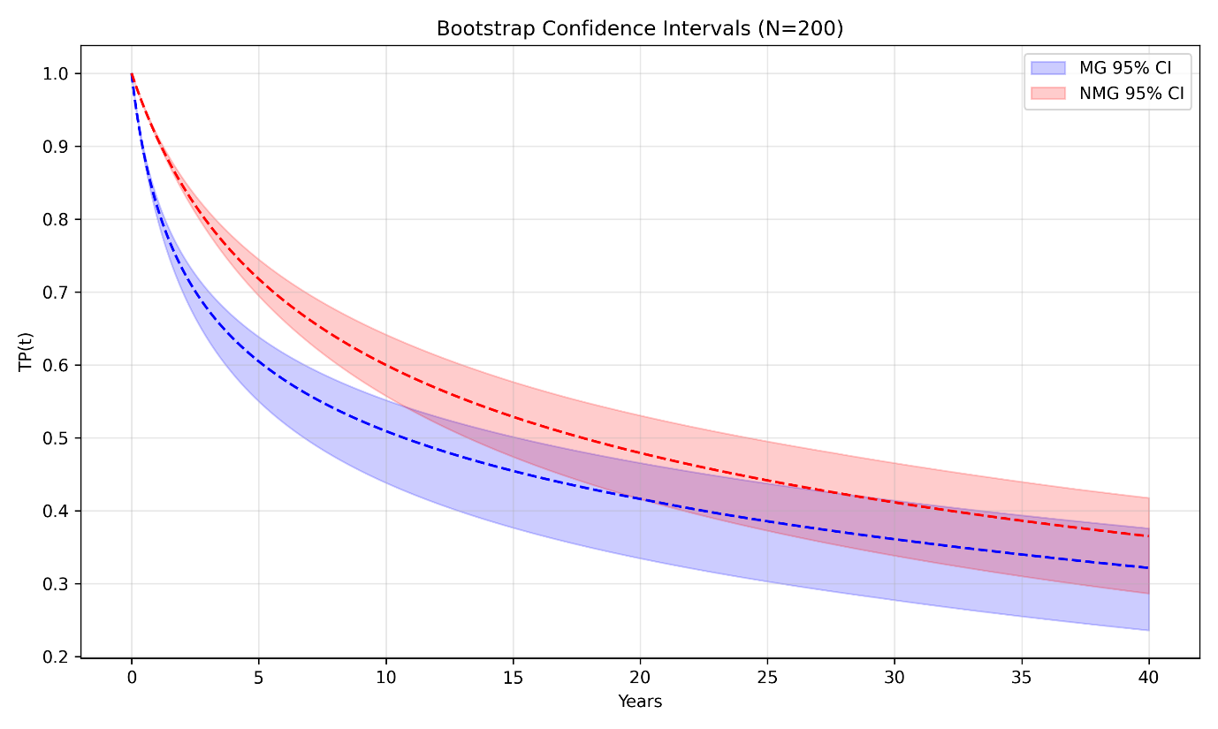
Figure S1. Temporal decay of TP for MG and NMG with bootstrap-derived 95% confidence intervals (N = 200). Shaded bands denote uncertainty from resampling, highlighting group differences in perception persistence over time.
References
Bradt, J., Kousky, C., & Linder-Baptie, Z. (2020). The National Flood Insurance Program and New Jersey. https://njclimateresourcecenter.rutgers.edu/climate_change_101/the-national-flood-insurance-program-and-new-jersey/
David D. Evans, Cody Webb, Elias Braunstein, Jonathan Glowacki, Andrew Netter, Brandon Katz, & Dag Lohmann. (2020). Residential Flood Risk in the United States. https://www.soa.org/globalassets/assets/files/resources/research-report/2020/soa-flood-report.pdf
Dixon, L. (2006). The National Flood Insurance Program’s Market Penetration Rate: Estimates and Policy Implications. https://www.rand.org/pubs/technical_reports/TR300.html
Kousky, C., Howard Kunreuther, Brett Lingle, & Leonard Shabman. (2018). The Emerging Private Residential Flood Insurance Market in the United States. Wharton Risk Management and Decision Processes Center, University of Pennsylvania. https://riskcenter.wharton.upenn.edu/wp-content/uploads/2018/07/Emerging-Flood-Insurance-Market-Report.pdf
USACE. (2006). Depth-Damage Relationships for Structures, Contents, and Vehicles and Content-to-Structure Value Ratios (CSVR) in Support of the Donaldsonville to the Gulf, Louisiana, Feasibility Study (Nos. DACW29-00-D-0001, Delivery Order No. 0038). U.S. Army Corps of Engineers, New Orleans District.

