Paper draft (Without abstract)
- Journal: Sustainable Cities and Society
- The format follows the requirement of SCC
Household Flood Adaptation and Financial Outcomes under Social Heterogeneity: A Coupled Agent-Based and Catastrophe Modeling Framework

Abstract
Keywords: Human–environment interactions, Flood risk, Flood exposure
, Insurance uptake, Tenure-based constraints

- Introduction
    - Flood Adaptation and Behavioral Dynamics
Flood adaptation has become a critical component of climate resilience as flood hazards intensify in both frequency and magnitude worldwide. Between 2000 and 2018, global flood exposure increased by more than 20% (Tellman et al., 2020), and climate projections indicate that flood risk will continue to rise under climate change (IPCC, 2022). Effective flood adaptation depends not only on structural protection but also on how individuals and communities perceive risk, learn from past events, and adjust their behavior over time. Incorporating behavioral processes into flood-risk assessment helps capture feedback between human decisions and environmental change. Agent-based modeling (ABM) has therefore been widely used to represent such human–environment feedbacks (Aerts et al., 2018).

    - Social Heterogeneity (MG/NMG) in Flood Adaptation
Recent research further emphasizes that flood adaptation is shaped by pronounced social heterogeneity. While many ABM frameworks incorporate agent-level diversity, they often assume homogeneity at the community level and overlook broader social and political contexts that influence household decision-making (de Ruig et al., 2023; Haer et al., 2017; Michaelis et al., 2020; Tonn et al., 2020). Marginalized groups (MG), defined by poverty, high housing cost burden, and immobility, face persistent constraints that limit their ability to prepare for, respond to, and recover from floods. In the absence of sufficient financial resources or institutional support, these households frequently rely on short-term coping strategies rather than long-term risk reduction (Mendis et al., 2023; Pathak & Emah, 2017). Importantly, such heterogeneity functions not only at the individual level but also as a neighborhood-scale structural context that shapes shared perceptions, constraints, and adaptation opportunities. However, its long-term implications for flood resilience remain insufficiently understood. Among the structural conditions through which social heterogeneity shapes household adaptation, housing tenure represents a key structural mechanism.

    - Housing Tenure as a Structural Constraint (SQ1)
Within socially heterogeneous contexts, housing tenure, whether households occupy their dwelling as homeowners or renters, constitutes a structural condition that shapes property rights, decision authority, and feasible adaptation actions, rather than merely serving as a proxy for socioeconomic status (Lee & Van Zandt, 2019; Peacock et al., 2014). Homeowners generally possess the capacity to invest in long-term structural measures such as elevation, retrofitting, or voluntary buyouts, whereas renters have limited control over their dwellings and depend on landlords or public support (Shcheglovitova & Lee, 2024). Empirical studies consistently show that renters exhibit lower preparedness and slower recovery following flood events, reflecting constrained autonomy and reduced access to resources (Cutter et al., 2003; Elliott et al., 2023; McCarthy & Friedman, 2023; Rufat et al., 2015). Despite these well-documented contrasts, few modeling studies examine how tenure-based constraints shape the cumulative effects of continued behavioral adaptation relative to a static no-action condition. This gap motivates the first scientific question (SQ1): how does long-term flood adaptation, compared with no action, differentially affect long-term flood outcomes for renters and homeowners?

    - Behavioral Adaptation Trajectories under Repeated Floods (SQ2)
Because structural constraints associated with housing tenure shape households’ decision authority and feasible adaptation actions, renters and homeowners are expected to exhibit distinct behavioral responses under repeated flood exposure (Lee & Van Zandt, 2019). Existing ABM studies have examined how households perceive flood risk, update flood experiences, and decide whether to take protective actions (Han et al., 2022). However, most focus on a narrow set of responses, typically insurance purchase or a single structural measure (Han et al., 2022; Nabinejad et al., 2024). In practice, households may follow broader and sequential adaptation trajectories, including relocation, buyouts, or sustained inaction, particularly when flood events recur. How renters and homeowners differ in their adaptation trajectories following severe flood events remains insufficiently explored. This limitation motivates the second scientific question (SQ2): how do renters and homeowners differ in their adaptation trajectories following major flood events?

    - Financial Consequences of Tenure-Based Adaptation (SQ3)
Flood adaptation shapes not only physical risk outcomes but also how flood losses are financially allocated and compensated over time. While ABM studies have advanced understanding of household decision-making under flood risk (Haer et al., 2017, 2019; Nabinejad et al., 2024), financial consequences are often treated in an aggregated manner. Recent efforts coupling ABM with catastrophe and finance models have begun to examine losses, premiums, and insurance participation (de Ruig et al., 2023; Moradzadeh & Ahmadi, 2024; Tierolf et al., 2023). Yet insurance structures that differ systematically by housing tenure remain weakly represented. Homeowners typically hold insurance covering both structures and contents, whereas renters are limited to contents-only coverage. How these coverage asymmetries interact with tenure-differentiated adaptation trajectories to shape long-term insurance payouts and out-of-pocket (OOP) losses remain unclear. This gap motivates the third scientific question (SQ3): how do tenure-based insurance coverage differences shape long-term financial outcomes under repeated flood exposure?

    - Research Objective
To address these gaps, this study develops a coupled agent-based and catastrophe modeling framework that integrates housing tenure, behavioral adaptation, and financial outcomes under historical flood events. Rather than examining isolated decisions or short-term responses, the framework captures how adaptive behaviors accumulate, persist, or dissipate over time, and how these dynamics differ systematically between renters and homeowners. By explicitly representing social heterogeneity as a tract-level structural context, the model enables assessment of how tenure-based constraints and shared social environments jointly shape long-term flood damage, insurance participation, and actual financial losses.

    - Paper section
This paper is organized as follows. Section 2 introduces the study area and data. Section 3 describes the coupled modeling framework and scenario design. Section 4 presents the simulation results. Section 5 discusses implications, limitations, and sensitivity analyses. Section 6 concludes the paper.
- Study Area
- Overview of the Passaic River Basin

This research centers on the Passaic River Basin (PRB) in northern New Jersey (Figure 1), recognized as one of the most flood-susceptible areas in the northeastern United States. PRB experiences recurrent inland flooding driven by heavy rainfall and tropical cyclones (USACE, 2024). Past events, including Hurricanes Irene (2011) and Ida (2021), caused record-high inundation, leading to more than 40 fatalities and economic losses exceeding USD 13 billion (FEMA, 2021a; NJDEP, 2023). The basin’s mixed land-use pattern, dense urban development, and complex river network, including the Passaic, Pompton, and Rockaway Rivers, exacerbate runoff accumulation and downstream flooding.

- Targeted Tract and Share of Marginalized Groups

The analysis focuses on 27 census tracts located within Morris, Passaic, and Essex Counties, which overlap with the hydrodynamic flood-model domain along the Passaic and Pompton Rivers (Figure 1). The proportion of MG in each tract was estimated using the HAZUS tract-level National Inventory (FEMA, 2023) and tract-level demographic data obtained from the American Community Survey (ACS) 5-Year Estimates (U.S. Census Bureau, 2023). Across these tracts, the MG share ranges from 1 % to 20 %, with higher concentrations observed along flood-prone corridors near the Passaic and Pompton Rivers. This spatial variation provides a quantitative basis for evaluating how social heterogeneity influences household adaptation and financial outcomes under flood risk. In the subsequent modeling framework, the tract-level MG proportion is incorporated as a weighting factor that shapes the overall adoption probability of adaptation actions, linking social composition directly to behavioral dynamics.

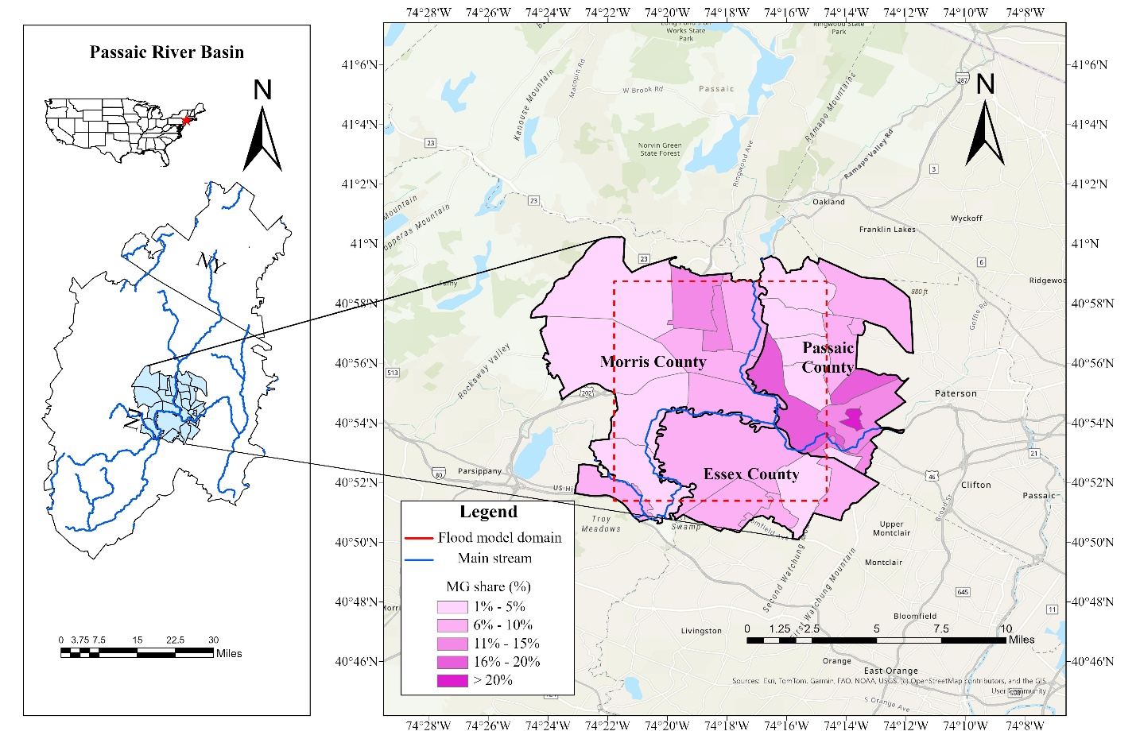Figure 1. Study area and flood model domain with MG distribution.

- Methodology
- Model framework
- Coupled Framework
- Overview
The coupled framework integrates the ABM with a catastrophe model (CAT) to simulate dynamic household adaptation behavior, flood damage, and financial outcomes (Figure 2). The CAT comprises four major modules, exposure, hazard, vulnerability, and finance, that estimate flood impacts and quantify households’ associated financial consequences. The ABM captures the behavioral dimension of adaptation, representing household adaptive behaviors, which are shaped by evolving flood perceptions and the experience of flood shocks. Together, these components form dynamic feedback that couples human decision-making with physical flood processes, enabling the assessment of long-term household and community resilience.

- Interaction and feedback mechanism

The ABM and CAT are linked through an annual feedback loop that connects behavioral decisions with physical and financial outcomes. In each simulation year, the catastrophe model estimates tract-level flood damages, which update the behavioral parameters of MG and NMG groups. The behavioral decision-making process in the ABM is theoretically grounded in Protection Motivation Theory (PMT) and the Protective Action Decision Model (PADM) (Lindell & Perry, 2012; R. W. Rogers, 1975; RW. Rogers, 1983), which conceptualizes household adaptation as a function of perceived threat, coping capacity, and institutional context. These parameters, threat perception (TP), coping perception (CP), stakeholder perception (SP), social capital (SC), and place attachment (PA), jointly determine each tract’s adaptation tendency and evolve in response to flood shocks. Among them, TP is dynamically updated based on cumulative flood experience and directly influences the probability of adopting adaptation actions in subsequent years. This loop operates bidirectionally: adaptation decisions modify exposure and vulnerability through actions such as elevation, relocation, and buyouts, while flood losses update behavioral parameters, allowing physical and behavioral processes to co-evolve over time. Through this iterative linkage between behavior and physical impact, the model simulates how social heterogeneity drives divergent adaptation pathways across different communities. This study follows the ODD+D protocol to provide a standardized description of the ABM (Grimm et al., 2020), and a full ODD+D specification is provided in the supplementary material (Table S6).
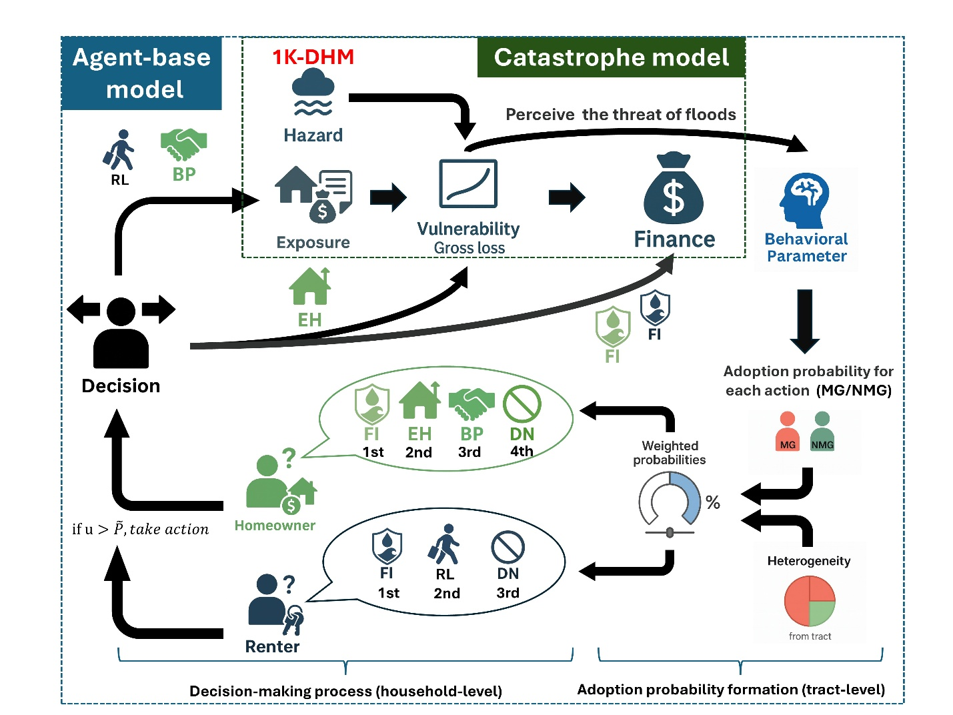
Figure 2. Coupled agent-based and catastrophe modeling framework.

- Model Initialization
Initialization establishes the baseline behavioral, physical, and financial conditions for both ABM and the CAT model at the start of the simulation (base year = 2011). To avoid redundancy, all initialization procedures are summarized here. For the ABM, each tract is assigned two behavioral profiles representing MG and NMG. Five behavioral parameters are sampled from calibrated Beta distributions derived from the flood adaptation survey (Text S1). These parameters define the initial behavioral environment and serve as inputs to the Bayesian adoption probability model, which estimates MG‑ and NMG‑specific adaptation tendencies. Initial TP values also provide the starting point for the memory‑decay process, whose calibrated parameters govern how perceived threat evolves in the absence or presence of flood shocks. Detailed behavioral parameter definitions, probability model specifications, and memory‑decay calibration are explained in Section 3.2.

- Initialization of the catastrophe model
For the CAT model, baseline physical and financial conditions are initialized through exposure, hazard, vulnerability, and insurance components. Household‑level structural and contents replacement cost values (RCV) are generated from national inventories and scaled to tract‑level totals. Tract‑level flood depths are derived from pre‑run hydrological simulations, and depth–damage curves define the initial damage response for structures and contents. Baseline insurance status, differentiated by tenure and tract‑level NFIP participation, is assigned at initialization and summarized in Table S1. A complete list of model parameters, definitions, and calibrated values used across the ABM and CAT components is provided in Table S2.
- Agent-based model
- Household adaptation actions
- Types of agents and adaptation options
The agents in our ABM represent renters and homeowners with assigned structural and contents RCV. Adaptation options differ according to property ownership. Renters can purchase contents-only flood insurance, relocate to another area, or take no action. Homeowners, in contrast, can adopt structural and financial measures, including purchasing flood insurance for houses and contents, elevating their houses, participating in buyout programs, or taking no action. Each agent is permitted to adopt one adaptation strategy per simulation year.

- Logic of actions
The relative order and availability of adaptation options for renters and homeowners are illustrated in Figure 2. This structure reflects empirical evidence that major flood-related decisions rarely occur simultaneously, as households typically face financial, informational, and logistical constraints that limit them to one substantive adaptation action per year. Adaptation hierarchies are defined based on each option’s cost, impact, and accessibility. Homeowners generally prioritize flood insurance as the most immediate measure, followed by elevation and buyout participation, while renters tend to choose between insurance, relocation, or inaction. Elevation is implemented as a one-time 5-ft increase in the first-finished-floor elevation, consistent with the adaptation action settings. This prioritization mirrors observed behavioral patterns in flood adaptation studies and provides a decision pathway for simulating heterogeneous household responses.

- Tract-level adoption probability formation
- Behavioral parameters (TP, CP, SP) and socioeconomic heterogeneity
Following PMT and PADM, household adaptation is modeled as a perception-driven process in which TP, CP, and SP jointly shape protective action decisions. At the tract level, adaptation behavior is driven by TP, CP, and SP for both MG and NMG. TP reflects the perceived likelihood and the threat of floods based on their experiences. CP represents the perceived ability to lower the risk and perceived effectiveness of flood adaptation strategies, while SP captures their trust, trustworthiness, and confidence toward different stakeholders, such as the government and insurance companies. These perceptions jointly form how different communities evaluate risk and decide whether to adopt adaptation actions. Each tract contains two distinct parameter sets for MG and NMG, reflecting socioeconomic heterogeneity in risk perception and adaptive capacity across communities.

- Adoption probability prediction and weighting
The adoption probability of each adaptation action is estimated using a Bayesian regression model (Text S2). The tract-level MG share is treated as a stable structural characteristic because relocation flows are small relative to tract populations and do not substantially alter neighborhood socioeconomic composition over the simulation horizon. The general form of the adoption probability equation is expressed as:
 | ${\tilde{P}}_{a,i}=w_{MG}P_{a,i}^{MG}+\left(1-w_{MG}\right)P_{a,i}^{NMG}$. | (1)
where $w_{MG}$ denotes the tract-level proportion of MG, and $P_{a,i}^{MG}$ and $P_{a,i}^{NMG}$represent the predicted adoption probabilities for MG and NMG toward action $a$ at tract $i$, respectively.

- Memory decay of threat perception
- Introduction of the decay of threat perception
The collective memory of flood experiences, which is closely linked to perceived flood threat, tends to fade over time in the absence of flood events (McEwen et al., 2017; Ridolfi et al., 2020). Previous studies have shown that this fading mechanism influences residents’ decision-making and long-term resilience to flood risk (Del Missier et al., 2013; McEwen et al., 2017). Recent ABM efforts have incorporated this process as a key dynamic in human–environment interactions, quantifying flood shocks to represent sharp increases in perceived risk and the reinforcing effects of social networks (Michaelis et al., 2020; Moradzadeh & Ahmadi, 2024).

- Explanation of the decay equation
This coupled framework also regards the memory decay of TP as a key interaction between psychological conditions and physical flood impacts. The formulation is modified to incorporate the moderating influence of SC and PA across different communities. SC reflects the degree of trust, cooperation, and information exchange within a community, whereas PA represents the emotional and identity-based connection residents have with their living environment. Empirical analysis of survey data indicates that PA is positively correlated with TP (Holley et al., 2022). Communities with stronger attachment tend to sustain higher perceived threat after floods, whereas SC shows a negative impact, as strong networks may reduce perceived risk through collective coping and shared recovery capacity (Hudson et al., 2020). The rate of change in TP is expressed as:
 | $\frac{d{TP}_{i}}{dt}=Δ\left(ψ\left(t\right)\right)⋅\frac{G_{i}}{RCV_{i}}⋅c_{s}-μ{TP}_{i}$. | (2)
where $G_{i}$ represents the total gross loss (i.e., flood damage) in tract $i$ at the previous year, $RCV_{i}$ is the total RCV at tract $i$ and $Δ\left(ψ\left(t\right)\right)$ is an activation function that equals 1 when the loss ratio $G_{t}/RCV_{t}$ exceeds a threshold $θ$, and 0 otherwise. The parameter $c_{s}$ is the shock scale, controlling the sensitivity of TP to flood losses. The decay rate is defined as:
 | $$μ=\frac{ln⁡(2) [α\text{ (1-}{PA}_{i}\text{)}+β {SC}_{i}]}{τ(t)}$$ | (3)
where $α$and $β$ are weighting parameters, $PA_{i}$and $SC_{i}$represent tract-level PA and SC, respectively, and $τ(t)$ is a continuous half-life function governing flood memory persistence:
 | $$τ(t)=τ_{∞}-(τ_{∞}-τ_{0})e^{-kt},τ_{∞}>τ_{0}>0, k>0.$$ | (4)
All parameters ($α,β,τ_{0},τ_{∞},k$) are calibrated using the flood adaptation survey data (Text S3). This formulation captures both the reinforcement of TP following major flood events and its gradual decline during flood-free periods, linking social context with the psychological adaptation processes that shape long-term community resilience.

- Catastrophe Model
- Exposure module
- Data sources and household-level RCV specifications
Exposure module defines the spatial and monetary representation of residential assets across tracts and provides the baseline conditions for subsequent hazard and damage calculations. Structural and contents RCV are derived from the National Structure Inventory (NSI) (USACE, 2022) using New Jersey residential records and scaled to match tract-level total residential RCV from HAZUS Inventory National Database (FEMA, 2023). For each tract, household-level RCV are generated following the distributions, with owners represented by single-unit structures and renters by multi-unit buildings. The details of initialization are shown in Text S4.

- Model assumptions
Since detailed spatial locations of individual households are unavailable, the model assumes that households are uniformly distributed within each tract, implying that all agents within the same tract are exposed to the tract-level mean flood depth. This aggregation ensures consistency with the hazard module’s tract-level flood representation while maintaining computational tractability. Each household is initialized with a first-floor elevation of 1 ft.

- Dynamic updates between exposure and agent’s adaptation
Exposure database is updated dynamically through the agent’s adaptation actions. A buyout permanently removes the participating homeowner and their associated asset from the simulation, thus reducing both the total number of households and the tract’s aggregate RCV. A relocation, in contrast, reallocates exposure by transferring a renter to another tract with an equal or lower flood depth, modifying the spatial distribution of exposure across the whole tract. These updates reshape the physical asset base that interacts with the hazard and finance modules over time.

- Hazard modules
- Flood inundation model (1K-DHM) and tract-level average flood depth
Hazard module uses pre-run outputs from the 1K-DHM, a distributed hydrological model based on the kinematic wave (Tachikawa & Tanaka, 2018). The model operates at a 30 m spatial resolution and provides grid-level peak flood depth for each simulated event from 2011 to 2023. For each tract $i$ and year $t$, the mean tract-level peak flood depth is computed as the arithmetic average of all grid-level peak flood depths within the tract:
 | $${\overset{ˉ}{d}}_{t}^{(i)}=\frac{1}{N_{i}}\sum_{g=1}^{N_{i}}{d_{g,i}^{peak}}$$ | (5)
Where $N_{i}$ denotes the number of grids within tract $j$, and $d_{g,i}^{peak}$represents the peak flood depth at grid $g$ at year $t$. All households within a tract are assumed to experience the same flood conditions; thus, ${\overset{ˉ}{D}}_{t}^{\left(i\right)}$serves as the flood hazard input to the vulnerability module.

- Vulnerability modules
- Explanation of the depth-damage curve on contents and structures
The vulnerability module estimates household flood damage using depth–damage curves for residential structures and contents provided by the U.S. Army Corps of Engineers (USACE, 2006). These curves describe the relationship between the flood depth above the first floor and the fraction of the RCV damaged for structures and contents.

- Gross loss estimation
For household $g$located in tract $i$, the tract-level mean peak flood depth ${\overset{ˉ}{D}}_{t}^{\left(i\right)}$is converted into percentage damages using the depth–damage functions $f_{\text{str}}$for structures and $f_{\text{cnt}}$for contents. Household-level flood damage is calculated as:
 | $$D_{g,i,t}^{str}=f_{str}({\overset{ˉ}{d}}_{t}^{(i)})∙{RCV}_{g}^{str}$$ | (6)
 | $$D_{g,i,t}^{cnt}=f_{cnt}({\overset{ˉ}{d}}_{t}^{(i)})∙{RCV}_{g}^{cnt}$$ | (7)
where $D_{g,i,t}^{\text{str}}$and $D_{g,i,t}^{\text{cnt}}$denote flood damage to structures and contents, respectively.
Total household flood damage is defined as:
 | $$D_{g,i,t}^{\text{owner}}=D_{g,i,t}^{\text{str}}+D_{g,i,t}^{\text{cnt}},$$ | (8)
 | $$D_{g,i,t}^{\text{renter}}=D_{g,i,t}^{\text{cnt}}$$ | (9)
where $D_{g,i,t}^{\text{str}}$and $D_{g,i,t}^{\text{cnt}}$denote flood damage to structures and contents of household $g$in tract $i$at year $t$, respectively. For homeowners, total flood damage includes both structural and contents damage, whereas for renters, flood damage consists of contents damage only.
- Finance modules
- Introduction of NFIP and different coverage of renters and homeowners
The finance module evaluates household-level financial outcomes of flood events by calculating insurance premiums, payouts, and OOP costs. The National Flood Insurance Program (NFIP) is adopted as the reference insurance framework for modeling flood coverage and financial mechanisms. The NFIP is a federal insurance program administered by the Federal Emergency Management Agency (FEMA) to provide standardized flood protection for residential and commercial properties in flood-prone areas (FEMA, 2025a). In this framework, homeowners are assumed to hold policies covering both building structure and household contents, whereas renters are restricted to contents-only coverage.

- Calculation of premium, payout, and out-of-pocket
For insured households, the finance module converts household-level flood damage $D_{i}$, estimated by the vulnerability module, into insurance payouts and OOP costs using an NFIP-style policy structure. Coverage limits $L_{i}$are defined based on the insured RCV, subject to NFIP coverage caps of $250,000 for building (structure) coverage and $100,000 for contents coverage (FEMA, 2025b). Homeowners are assumed to insure both structure and contents up to these limits, whereas renters insure contents only. A uniform deductible of $1,000 is applied across all policies. Given a realized loss $G_{i}$, insurance payout $P_{i}$ is calculated as:
 | $$P_{i}=max⁡\{0,\min\left(G_{i},L_{i}\right)-D\}$$ | (10)
and the corresponding OOP cost is
 | $${OOP}_{i}=G_{i}-P_{i}$$ | (11)
This formulation captures cases where losses fall below the deductible, are partially covered, or exceed the policy limit.
Annual insurance premiums are calculated using a simplified NFIP-style rating structure. The premium formulation follows the Premium Calculation Worksheet Examples under the NFIP Risk Rating 2.0 framework, which combines coverage amount, deductible choice, reserve loading, and fixed policy fees (FEMA, 2021b). Base rates per $1,000 of coverage are empirically estimated from policy-level observations in New Jersey using the FIMA NFIP Redacted Policies v2 dataset released through OpenFEMA (FEMA, 2025c). Based on these data, NJ-specific base rates of $3.56 per $1,000 for building coverage and $4.98 per $1,000 for contents coverage are applied.
The annual premium for household $i$is computed as:
 | $Premium=(\frac{Coverage }{1000}$ $∙r_{1k}∙max⁡(0.001, 1-\frac{D}{L_{i}}))∙R+F$ | (12)
where $r_{1k}$denotes the NJ-specific base rate per $1,000 of coverage, $D$is the deductible, and $L_{i}$is the coverage limit. The reserve fund rate $R$is applied as an annual loading to ensure long-term program sustainability. The fixed fee $F$(approximately $100 per policy) consolidates standard NFIP-related charges, including the federal policy fee, the Increased Cost of Compliance surcharge, and other administrative components.

- Scenario Definition for
- Baseline and counterfactual worst-case scenarios
To support comparative analysis in the Results section, two simulation settings are evaluated: a baseline scenario and a counterfactual worst-case scenario. In the baseline scenario, households are allowed to adopt adaptive behaviors throughout the simulation period, and household states may evolve endogenously in response to flood experience and insurance outcomes.
The worst-case scenario represents a counterfactual setting in which no adaptive behaviors are permitted during the simulation horizon. Household exposure, vulnerability, and location remain fixed at their initial states, and insurance coverage remains fixed at its baseline level in the worst‑case scenario. Insured households retain their initial policies, while uninsured households remain uninsured, and no new insurance uptake or other adaptation actions are allowed during the simulation period. Both scenarios are simulated using the same flood event sequence and temporal horizon, ensuring that differences in outcomes can be attributed solely to the presence or absence of adaptive household behavior.

- Result
- Model Diagnostics
- Validation approach and aggregation
To assess empirical consistency, simulated insurance payouts are compared with observed NFIP claims at the county level. Because the 27 targeted census tracts do not align cleanly with county boundaries, tract‑level validation is not feasible. Simulated payouts are therefore aggregated to the county scale and standardized using z‑scores to emphasize relative temporal fluctuations rather than absolute magnitudes. This normalization enables evaluation of whether the model reproduces year‑to‑year variation in flood‑related financial outcomes across Essex, Morris, and Passaic Counties.

- Warm-up treatment and evaluation window
The first two simulation years (2011-2012) are designated as a warm-up period (indicated by gray shading in Figure 3). During this initialization phase, agents establish baseline behavioral states, insurance coverage stabilizes, and threat perception dynamics equilibrate following the initial sampling from calibrated distributions. Validation metrics are computed exclusively from the post-warm-up period (2013-2023) to ensure that model performance reflects stabilized behavioral dynamics rather than transient initialization effects.

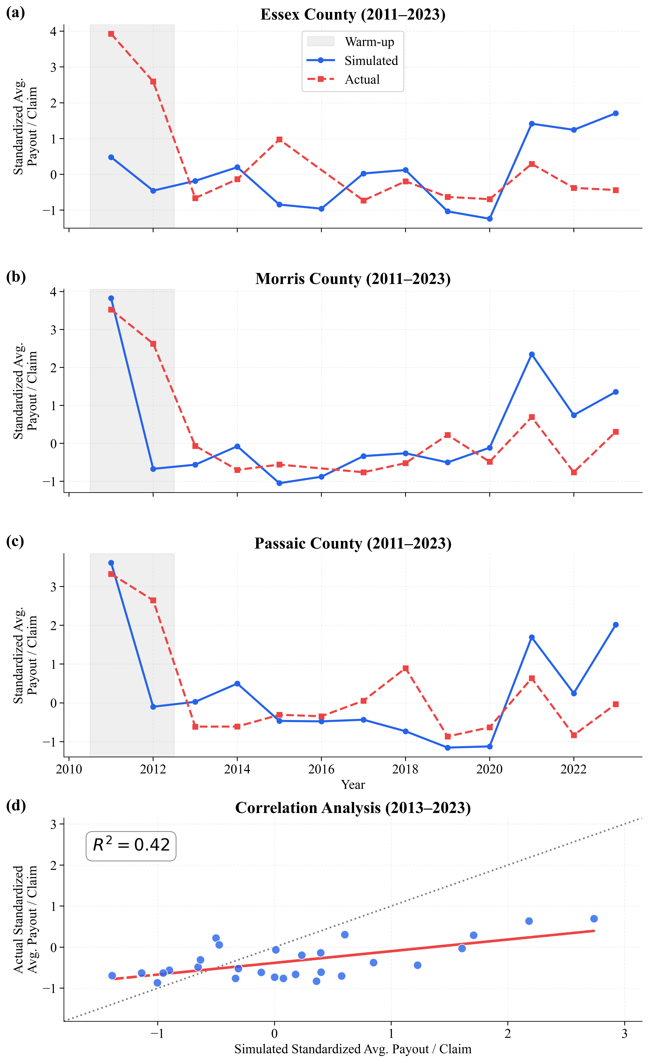
Figure 3. Comparison of simulated and observed insurance payouts. (a) Essex County, (b) Morris County, (c) Passaic County, and (d) correlation between simulated and observed standardized NFIP payouts (2011–2023; warm-up period shaded).

- Comparison of baseline and worst scenario
- Cumulative flood damage and payout per household
Over the full simulation horizon from 2011 to 2023, cumulative flood outcomes diverge systematically between the baseline and worst-case scenarios for both homeowners and renters (Figure 4). Under the worst-case scenario, cumulative average flood damage increases steadily for both tenure groups, whereas the baseline scenario consistently limits long-term damage accumulation. Homeowners incur substantially higher absolute flood damages than renters across all years, reflecting greater exposure and asset values. Despite lower overall damage levels, renters display a pronounced separation between scenarios over time. When insurance payouts are accounted for, cumulative actual losses remain markedly lower in the baseline scenario for both groups, with the gap between scenarios widening progressively and producing increasingly distinct long-term financial trajectories.

- Flood damage and financial outcome in the early and late periods
Disaggregating cumulative outcomes into early and late periods clarifies how scenario differences evolve when accumulation is evaluated within distinct time windows (Figure 5). For each period, flood damages and insurance outcomes are cumulatively aggregated from the beginning of that period, allowing direct comparison of scenario divergence under comparable accumulation lengths. During the early period (2011–2016), tract-level flood damages remained broadly similar between baseline and worst-case scenarios for both homeowners and renters, with damage ratios close to one. By contrast, in the late period (2017–2023), scenario divergence intensifies markedly. Tract-level flood damage ratios increase sharply, particularly for homeowners, indicating substantially greater damage under the worst-case scenario. At the same time, differences in insurance payout rates expand for both tenure groups. Renters experience a comparatively larger relative widening in payout rate gaps during the late period, indicating growing financial divergence between scenarios as flood impacts accumulate within each period.
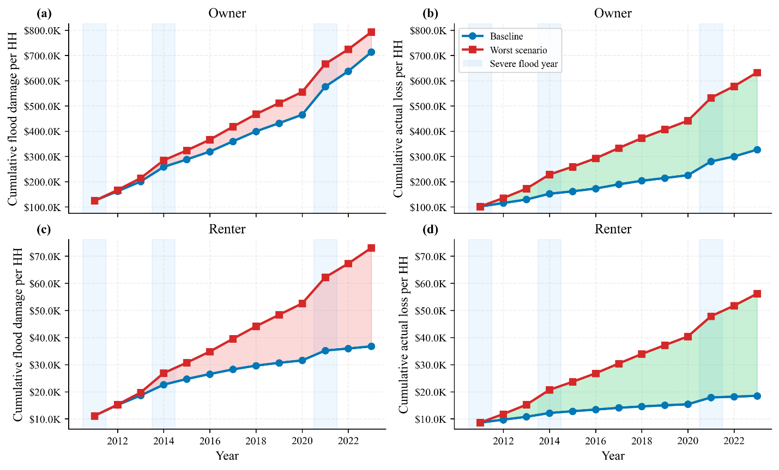
Figure 4. Cumulative flood damage and actual loss per household (HH). (a)(c) flood damage and (b)(d) actual loss for homeowners and renters.
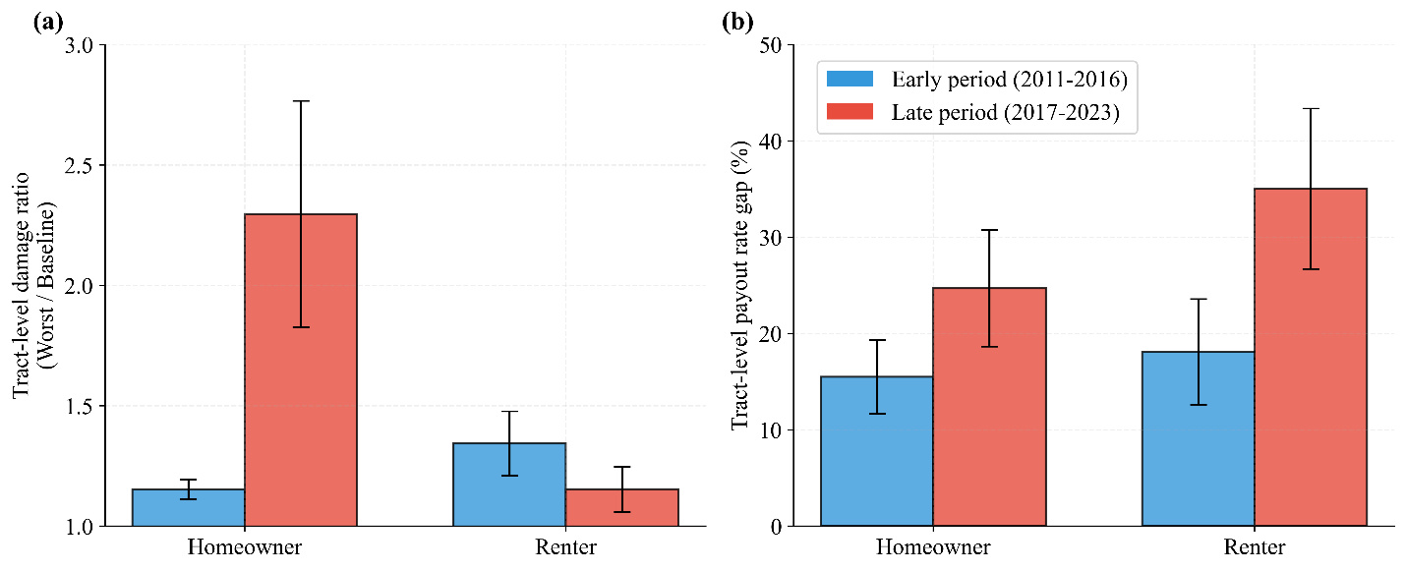
Figure 5. Early- and late-period comparison of scenario divergence. (a) tract-level flood damage ratio (worst-case/baseline) and (b) insurance payout rate gap for homeowners and renters. Shaded bars indicate the magnitude of divergence between baseline and worst-case scenarios.

- Behavioral patterns of renters and homeowners
- Overall behavioral composition of renters and homeowners
Over the simulation period, homeowners and renters exhibit markedly different cumulative behavioral compositions (Figure 6). The stacked distributions summarize the proportion of households in each behavioral state at a given year, reflecting the persistence of previously adopted actions rather than annual action frequencies. Among homeowners, adaptive behaviors show clear accumulation, with a steady increase in elevation-related states and combined elevation–insurance strategies. Severe flood years are associated with visible shifts in homeowner behavior, most notably a pronounced increase in the share adopting both elevation and insurance following the 2021 event. Once adopted, these elevated states are largely maintained, resulting in an increasingly layered behavioral structure. In contrast, renters display limited structural change in cumulative behavioral composition. Renter behaviors remain concentrated in non-adaptive, insurance-only, and relocation states, with only modest fluctuations following severe flood events. Even when short-term changes occur, the overall composition stabilizes rapidly, indicating convergence toward a dynamic equilibrium rather than sustained accumulation of adaptive strategies. These contrasts highlight insurance uptake as a key adaptive behavior that responds sharply to flood experience yet differs markedly in persistence across tenure groups.

- Change in the insurance take-up rate before and after severe flood years
Following severe flood years, changes in insurance take-up rates exhibit pronounced spatial and tenure-based heterogeneity (Figure 7). The maps show tract-level changes in insurance participation relative to the year preceding severe flood events in 2014 and 2021. For homeowners, flood-prone tracts, identified by recurrent flood exposure over the study period, consistently exhibit increases in insurance take-up during severe flood years and maintain elevated participation one to two years post-event. In contrast, homeowners in non–flood-prone tracts tend to show declining insurance uptake following severe floods. Renters display a more transient response. Across both flood-prone and non–flood-prone tracts, increases in renter insurance take-up are generally short-lived, with participation rates declining within one to two years after severe flood events, despite localized heterogeneity.
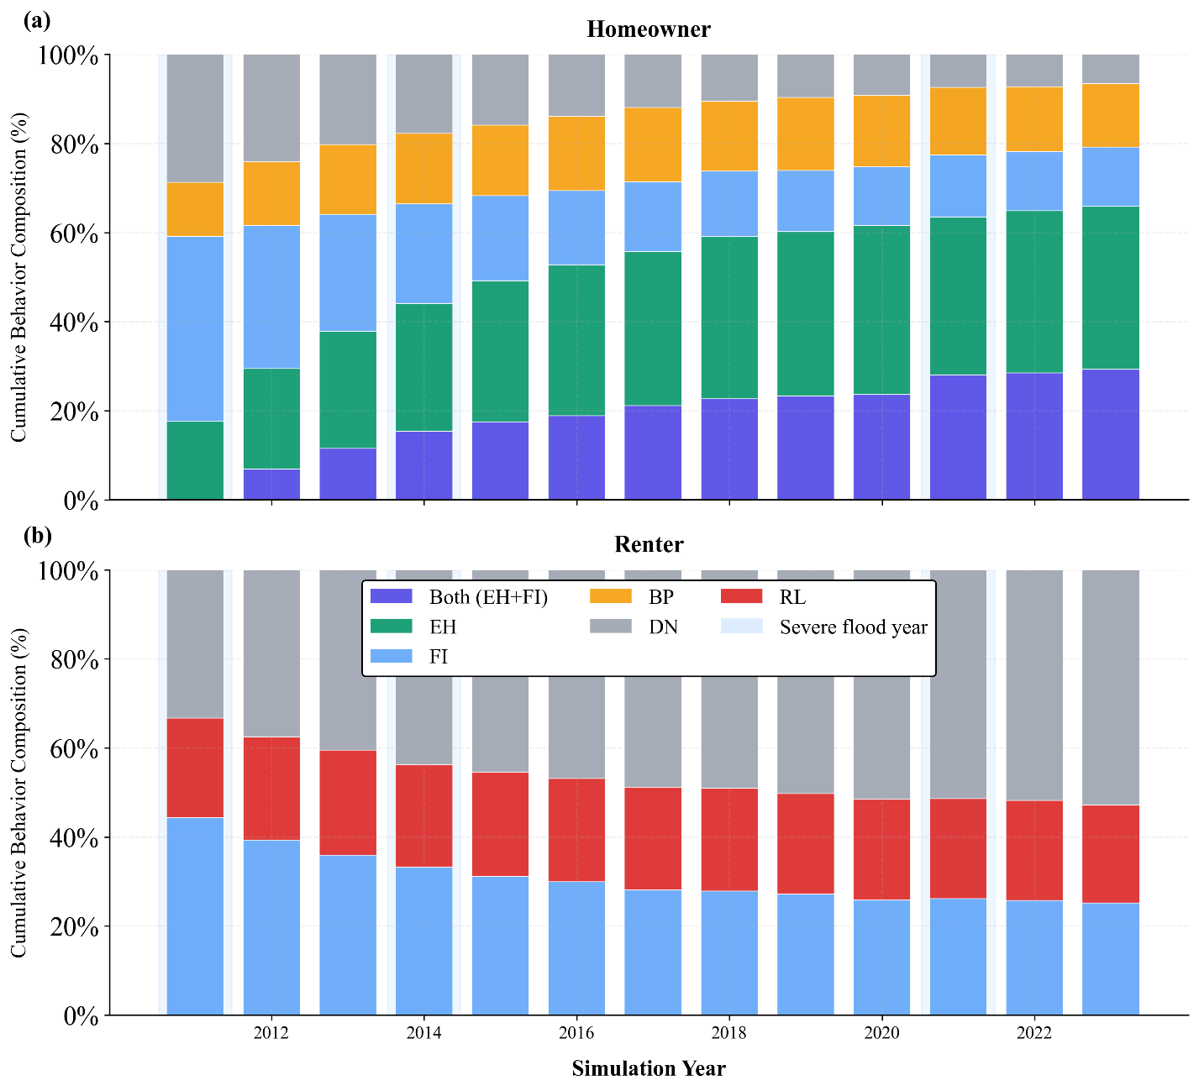
Figure 6. Cumulative behavioral composition of homeowners and renters. (a) homeowners and (b) renters, showing the proportion of households in each behavioral state over time. Shaded bars indicate severe flood years.

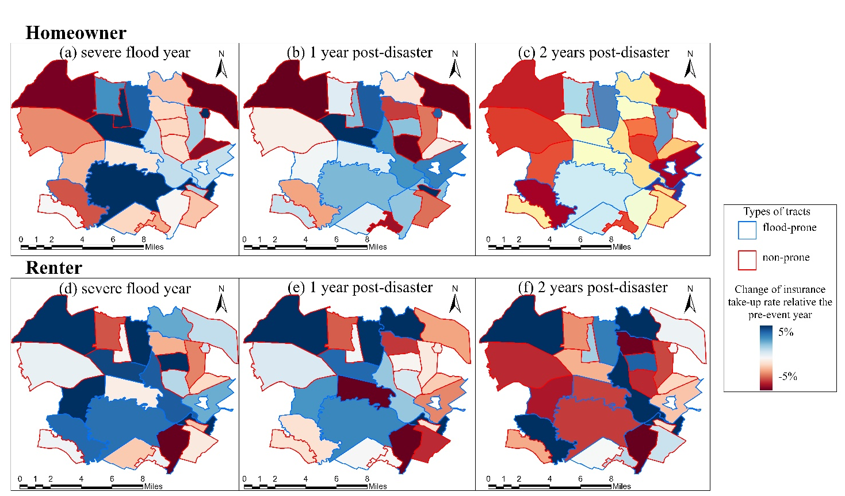
Figure 7. Post-disaster changes in insurance take-up rates for homeowners and renters.

- Flood damage and financial outcomes
- Flood damage of renters and owners per household
Flood impacts exhibit pronounced differences between homeowners and renters under adaptive conditions. Flood damage accumulates very differently for the two tenure groups over time (Figure 8). Homeowners experience consistently high per-household flood damage throughout the simulation period, with severe flood years producing pronounced damage peaks that dominate cumulative losses. Even outside these events, average homeowner flood damage remains elevated, indicating sustained exposure across the hazard sequence. Renters, by contrast, follow a markedly different trajectory: average flood damage per household declines progressively over time, and damage levels during later severe flood years (e.g., 2021–2023) remain lower than those observed earlier in the simulation. Consequently, the disparity in flood damage between homeowners and renters widens over time, despite both groups being exposed to identical flood hazards.

- Payout and financial cost (OOP + premium) of renters and homeowners
Differences in flood damage between homeowners and renters are reflected in contrasting financial burdens. Here, the insurance payout rate denotes the share of flood damage covered by insurance, whereas the OOP rate denotes the share borne directly by households. When accounting for premiums and OOP expenses, homeowners consistently face substantially higher financial costs than renters. The OOP share of total flood damage for homeowners remains relatively stable in lower-damage years but increases sharply during severe flood years, indicating persistent financial exposure under high-risk conditions (Figure 9). In contrast, renters incur markedly lower financial costs overall, with both absolute OOP amounts and OOP shares remaining comparatively small and generally declining over time. Insurance payouts provide substantial coverage for both tenure groups, with payout rates averaging around 70% across most years and remaining relatively stable over time, despite clear differences in underlying flood damage magnitudes (Figure 10).

- Loss attribution of renters and homeowners
The composition of flood losses reveals distinct patterns in how financial impacts are distributed between homeowners and renters. For homeowners, insurance-covered losses constitute the dominant share of total flood damage in most years; however, uninsured losses and losses exceeding policy limits persist and become more prominent during severe flood years. Renters exhibit a structurally different loss attribution profile. A larger share of renter flood losses remains uninsured across most years, and the uninsured share increases sharply in specific years, most notably in 2021, despite relatively low absolute flood damage. This contrast highlights that shifts in uninsured proportions are not necessarily associated with higher damage severity (Figure 11).

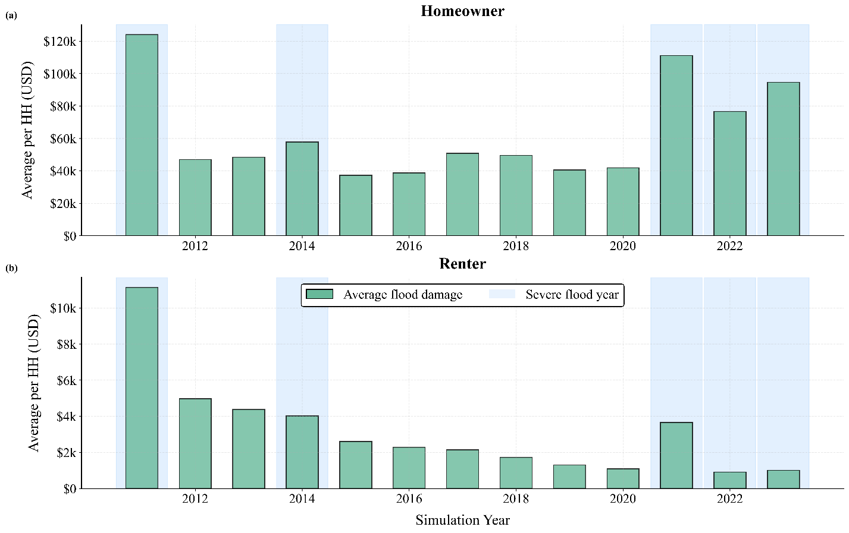
Figure 8. Annual average flood damage per HH. for (a) homeowners and (b) renters from 2011 to 2023. Shaded bands indicate severe flood years.
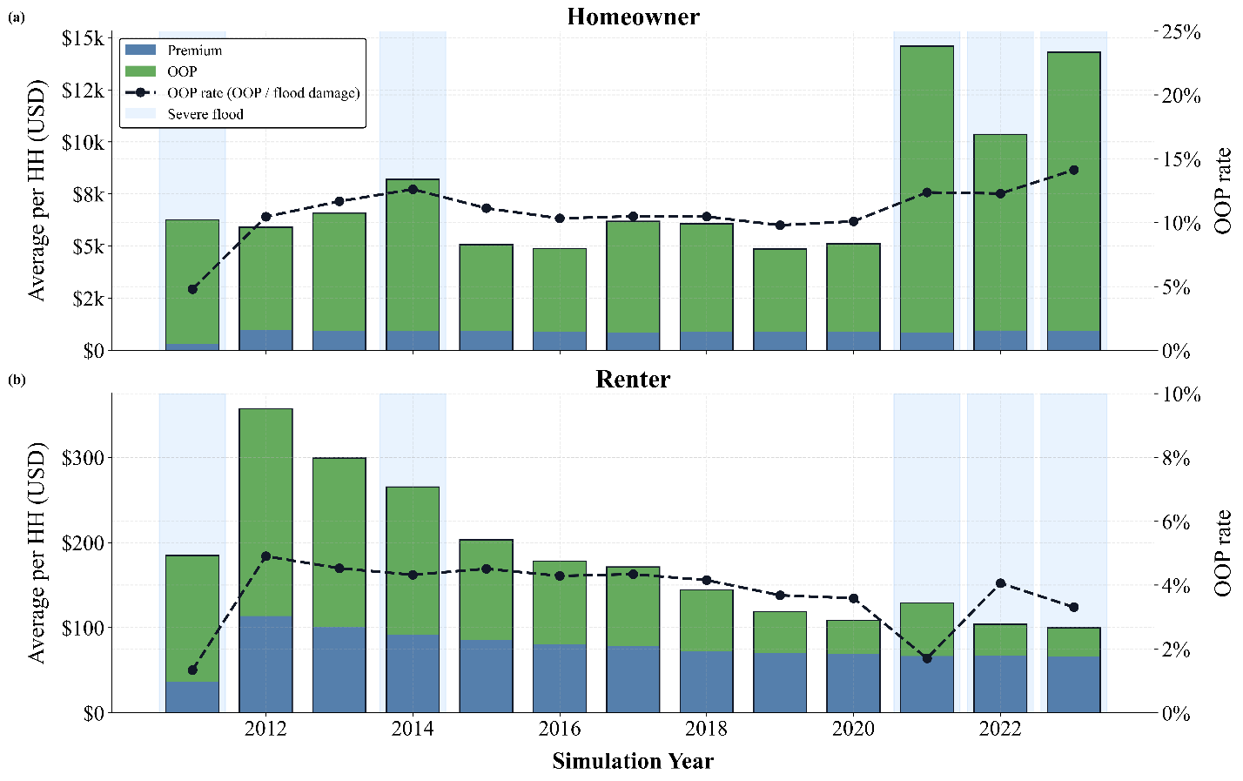
Figure 9. Annual insurance premiums, OOP losses, and OOP rates per HH for (a) homeowners and (b) renters.
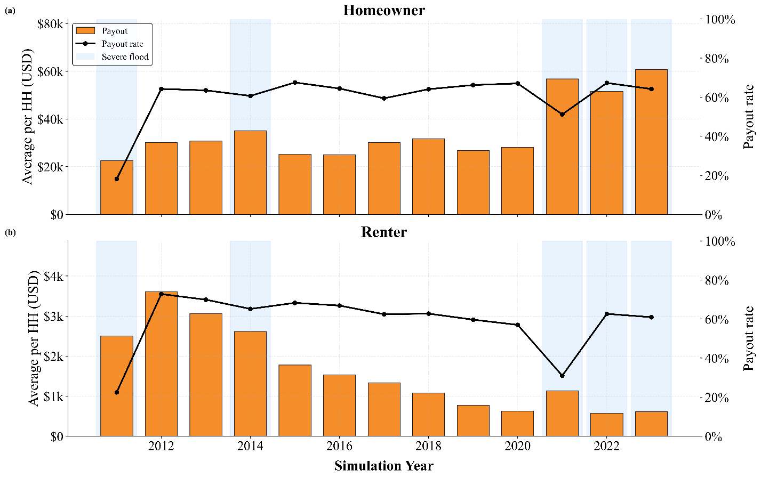
Figure 10. Annual insurance payouts and payout rates per HH for (a) homeowners and (b) renters from 2011 to 2023, with shaded bands indicating severe flood years.

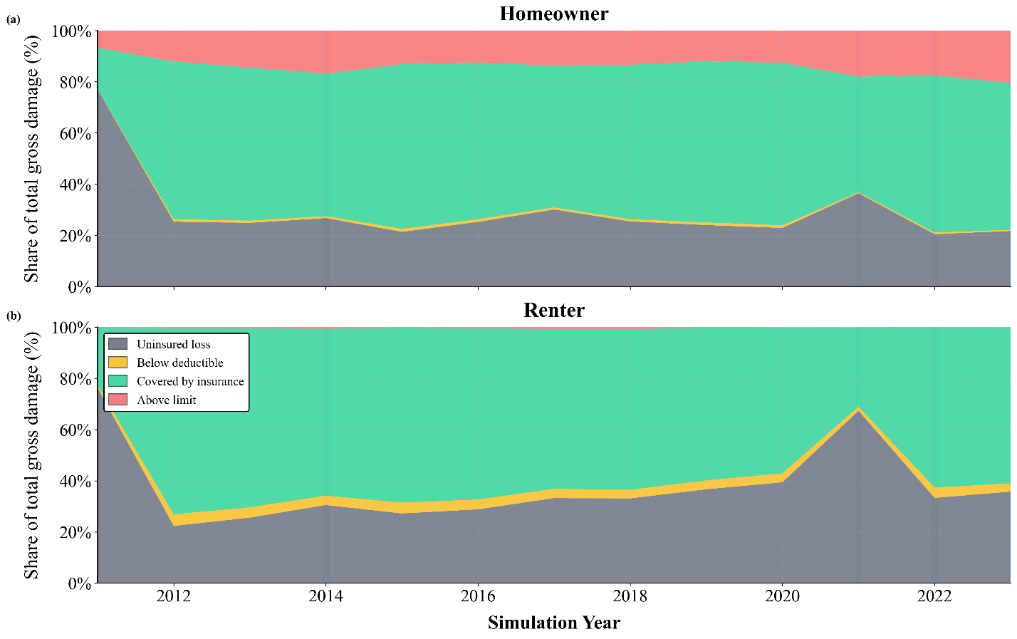
Figure 11. Composition of total flood damage by insurance coverage status for (a) homeowners and (b) renters over time.

- Discussion and Limitation
- Sensitivity of flood damage and financial outcomes to threat perception mechanisms

- Motivation for sensitivity analysis
Sensitivity analysis is conducted to assess whether the observed behavioral and financial outcomes are robust to alternative specifications of the TP updating mechanism, rather than being artifacts of a particular parameter choice. Two parameters are central to this process: the flood damage ratio and the shock scale. The flood damage ratio determines whether a flood event is salient enough to exceed the threshold required to update TP, thereby governing which events are behaviorally “remembered.” In contrast, the shock scale controls the magnitude of TP change once the threshold is crossed, shaping how strongly households respond to severe floods. Together, these parameters define how physical flood impacts are translated into behavioral responses, making them critical for evaluating the stability of adaptation dynamics under extreme MG/NMG configurations.

- Analysis of flood damage ratio threshold
Across extreme MG and NMG configurations, the flood damage ratio determines whether severe flood events activate behavioral responses that alter long-term flood outcomes (Figure 12). When TP responses are dominated by NMG, cumulative flood damage per household continues to increase for both owners and renters, alongside rising cumulative insurance payout rates. This pattern suggests that, although perceptual updating occurs, behavioral responses do not substantially modify system-level exposure or vulnerability and are associated with increased financial compensation. In contrast, when TP responses include households whose actions influence aggregate losses, cumulative flood damage declines, and payout growth slows or reverses. These extremes indicate that exceeding the flood damage ratio threshold is necessary to trigger responses, but insufficient to ensure risk reduction.

- Analysis of shock scale
Sensitivity to the shock scale shows that increasing TP intensity amplifies existing response patterns relative to the conservative baseline (Figure 13). Under configurations where TP responses are dominated by NMG, larger shock scales mainly accelerate growth in cumulative insurance payouts while flood damage continues to rise. When responses also occur among households whose actions affect aggregate losses, higher shock scales accelerate declines in cumulative flood damage with more moderate payout growth. These results indicate that the shock scale acts as an amplifier of existing response distributions, reinforcing either compensation-driven or risk-reducing outcomes depending on where behavioral change is concentrated.

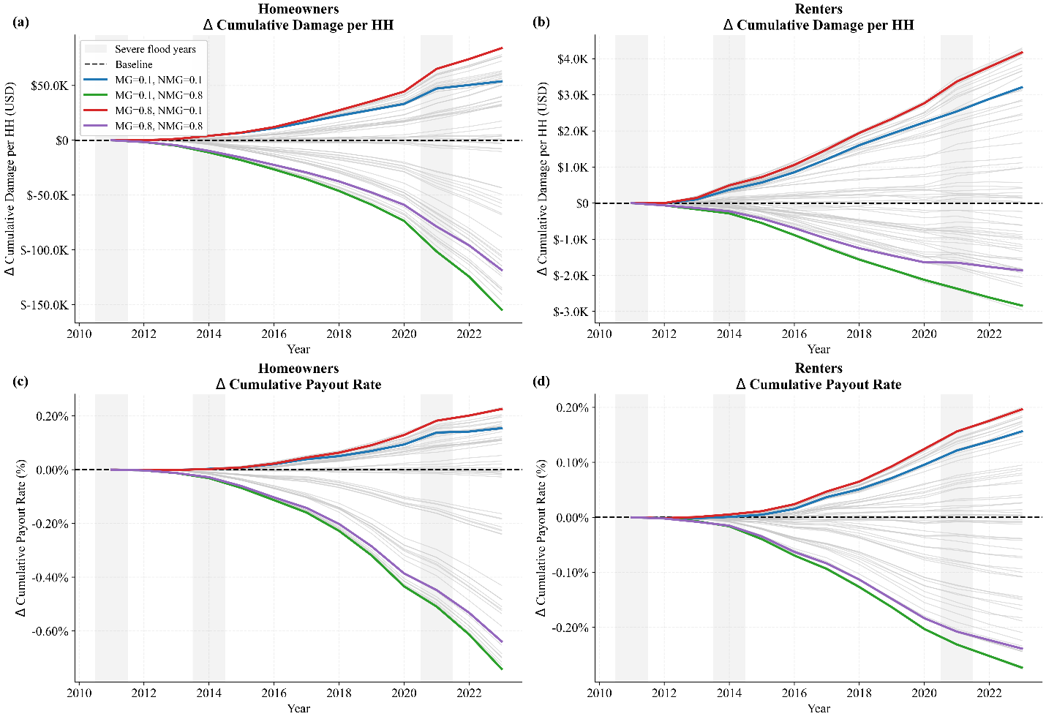
Figure 12. Sensitivity of cumulative damage and payout outcomes to flood damage ratio (0.1–0.8) across MG–NMG configurations.

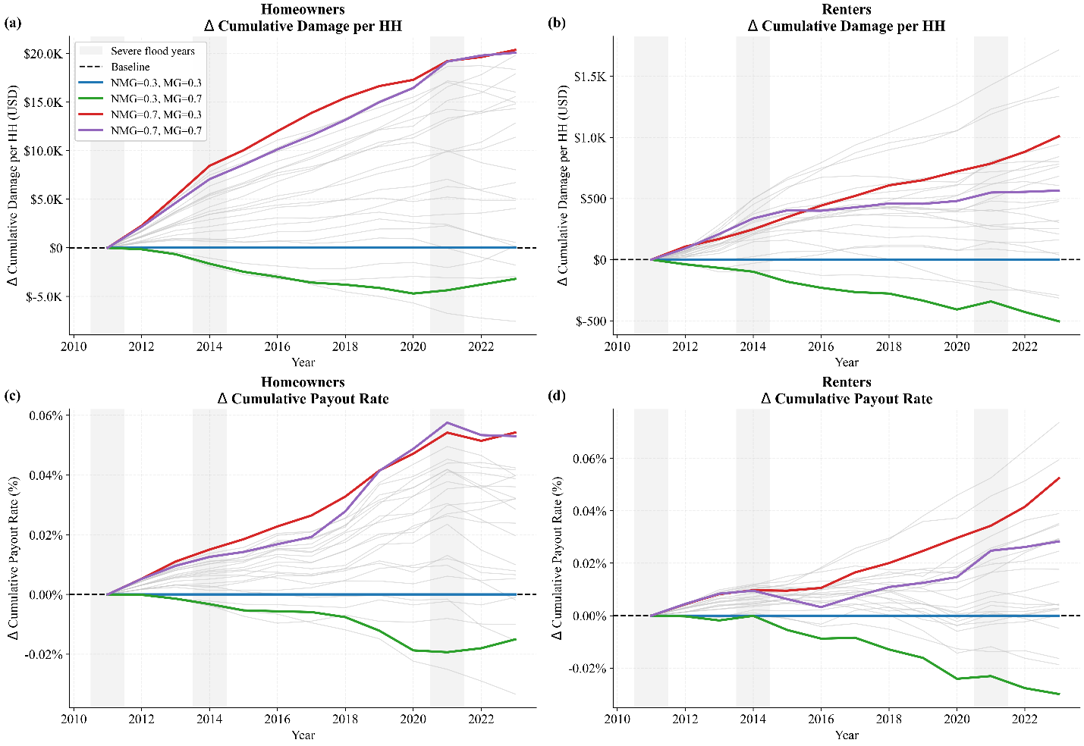
Figure 13. Sensitivity of cumulative damage and payout outcomes to shock scale (0.3–0.7) across MG–NMG configurations.

- Implications of behavioral adaptation pathways

- Decoupling between flood damage and financial compensation
The results indicate that improvements in financial outcomes do not necessarily correspond to long-term reductions in flood risk. Across scenarios with identical hazard sequences, cumulative insurance payouts and actual losses can diverge substantially from cumulative flood damage, revealing a separation between financial compensation and physical risk trajectories. While insurance mechanisms can reduce actual losses at the household level, they do not necessarily alter the accumulation of flood damage over time. This separation aligns with the broader distinction between risk transfer and risk reduction that has been widely discussed in flood risk management and insurance-as-adaptation research (Filatova, 2014; Wang et al., 2022). From a system-level perspective, these findings caution against interpreting rising insurance payouts or declining actual losses as evidence of reduced flood risk, particularly when compensation pathways expand without corresponding changes to the processes that drive repeated flood impacts (Hudson et al., 2017; Thistlethwaite et al., 2020).

- Behavioral responses and their persistence across tenure and space
Building on this decoupling, the results indicate that the effectiveness of adaptation pathways depends on how behavioral responses are distributed and sustained across tenure groups and space. Behavioral adjustments following severe flood events vary markedly in persistence and spatial alignment with flood exposure, with homeowners exhibiting more durable and spatially anchored adaptive shifts over time. In contrast, renter responses are largely short-lived, with increases in insurance participation and other adaptive actions dissipating within one to two years after severe flood events, even under repeated exposure. This tenure-based asymmetry is consistent with evidence that renters face distinct constraints on sustained risk reduction, including limited control over structural measures and higher residential mobility (Lee & Van Zandt, 2019; Shcheglovitova & Lee, 2024). Moreover, the attenuation of post-event responses aligns with findings that disaster-triggered risk salience and insurance demand can decay over time, even after severe events (Borsky & Hennighausen, 2022; Gallagher, 2014; Kousky, 2017). Together, these patterns suggest that short-term responsiveness alone is insufficient to alter long-term flood outcomes; sustained adaptation aligned with recurrent flood risk is required to translate behavioral change into lasting reductions in aggregate flood impacts.

- Divergent risk and financial burdens across tenure groups

These differences in behavioral persistence translate into divergent distributions of flood risk and financial burdens across tenure groups. Despite being exposed to identical hazard sequences, homeowners and renters experience markedly different long-term outcomes. Homeowners consistently incur higher per-household flood damage and financial costs, reflecting the accumulation of losses during severe flood years, while renters experience lower absolute damage but a persistently higher share of uninsured losses. This pattern underscores that uninsured exposure is not necessarily proportional to damage severity, but instead reflects structural differences in access to and continuity of financial protection (Choi et al., 2024; Kousky & Wiley, 2022). At the system level, these results indicate that compensation-based adaptation pathways can coexist with widening disparities in residual risk, particularly when sustained adaptation is uneven across tenure groups. Similar tenure-based disparities in disaster impacts and recovery capacity have been documented in studies of social vulnerability and housing tenure in flood-prone communities (Lee & Van Zandt, 2019; Shcheglovitova & Lee, 2024; Wilson et al., 2021)

- Limitation

- Exposure and financial representation
To place the results in their appropriate modeling context, several limitations should be noted. The representation of exposure and financial losses in this study is constrained by data availability and necessary abstraction. Household-level property characteristics and precise locations are not observed. As a result, RCV is synthesized, and households are not explicitly geocoded. This limits the model’s ability to capture within-tract variation in exposure, micro-scale spatial heterogeneity, and fine-grained loss differentiation. In addition, premium calculations and flood damage accounting rely on simplified functional forms rather than reproducing the full institutional complexity of insurance pricing, coverage design, and claims processes. These modeling choices are appropriate for isolating behavioral and tenure-based mechanisms, but the resulting financial outcomes should be interpreted as stylized representations rather than exact estimates of real-world insurance costs or losses.

- Behavioral realism and generalizability
Beyond these structural simplifications in exposure and finance, the behavioral dynamics are also subject to scope-related limitations. Household decision rules are parameterized using survey-based measures of households’ stated willingness to adopt insurance or other adaptive actions. While this approach strengthens empirical grounding and allows behavioral heterogeneity to be incorporated explicitly, it also implies a gap between modeled willingness and realized behavior in practice. Actual adaptation decisions may be shaped by additional constraints, frictions, or institutional factors that are not fully captured by stated preferences alone. Moreover, the model does not represent adaptive learning beyond the specified threat perception updating mechanism, nor does it explicitly incorporate social interactions, post-disaster government assistance, or evolving policy environments. Finally, although identical hazard sequences across scenarios enable clear identification of behavioral and financial pathways, the findings should be interpreted as illustrating general adaptation dynamics under social heterogeneity rather than providing directly transferable predictions across regions or institutional contexts.

- Conclusion
This study uses a coupled agent-based and catastrophe modeling framework to examine how behavioral adaptation under social heterogeneity shapes long-term flood outcomes across renter and homeowner households. By holding hazard sequences constant across scenarios, the analysis isolates the role of behavioral and financial mechanisms in driving divergence in flood damage and losses.
Consistent with the baseline and worst-case comparison, adaptation action substantially reduces long-term flood damage and actual losses for both homeowners and renters, with scenario differences becoming more pronounced over time. While early-period outcomes remain similar, cumulative flood impacts diverge in later years, indicating that adaptation influences long-term trajectories rather than short-term responses alone. Importantly, improvements in financial outcomes through insurance payouts do not necessarily coincide with proportional reductions in cumulative flood damage. Differences in behavioral persistence help explain these patterns. Homeowners exhibit cumulative and durable adaptive shifts, particularly following severe flood events and in flood-prone areas, whereas renter responses are largely transient and decay within one to two years. These differences in behavioral persistence contribute to unequal long-term outcomes despite identical hazard exposure. As a result, homeowners experience higher absolute flood damage and financial costs, while renters face a persistently higher share of uninsured losses, even when overall damages decline.
Together, these findings highlight that financial compensation can expand without corresponding reductions in physical flood risk when sustained adaptation is uneven across tenure groups. The framework provides a mechanism-focused foundation for evaluating flood adaptation pathways in socially heterogeneous urban systems, emphasizing how who adapts, and for how long, matters as much as the availability of financial protection.

Appendix A.1
Acronym | Full term
ABM | Agent-Based Model
ACS | American Community Survey
CAT | Catastrophe Model
CP | Coping Perception
CSVR | Content-to-Structure Value Ratio
FEMA | Federal Emergency Management Agency
HH | Household
ICC | Increased Cost of Compliance
IPCC | Intergovernmental Panel on Climate Change
MG | Marginalized Group
NFIP | National Flood Insurance Program
NMG | Non-Marginalized Group
NSI | National Structure Inventory
ODD | Overview, Design Concepts, and Details
OOP | Out-of-Pocket
PA | Place Attachment
PADM | Protective Action Decision Model
PMT | Protection Motivation Theory
PRB | Passaic River Basin
RCV | Replacement Cost Value
SC | Social Capital
SP | Stakeholder Perception
SQ1 | Scientific Question 1
SQ2 | Scientific Question 2
SQ3 | Scientific Question 3
TP | Threat Perception
USD | U.S. Dollars

Declaration of Competing Interest
The authors declare that they have no known competing financial interests or personal relationships that could have appeared to influence the work reported in this paper.

Data availability
Data will be made available on request.

Acknowledgements

References
Borsky, S., & Hennighausen, H. (2022). Public Flood Risk Mitigation and the Homeowner’s Insurance Demand Response. Land Economics, 98(4), 537–559. https://doi.org/10.3368/le.98.4.061720-0088R2
Choi, J., Diffenbaugh, N. S., & Burke, M. (2024). The Effect of Flood Exposure on Insurance Adoption Among US Households. Earth’s Future, 12(7), e2023EF004110. https://doi.org/10.1029/2023EF004110
Cutter, S. L., Boruff, B. J., & Shirley, W. L. (2003). Social Vulnerability to Environmental Hazards *. Social Science Quarterly, 84(2), 242–261. https://doi.org/10.1111/1540-6237.8402002
de Ruig, L. T., Haer, T., de Moel, H., Orton, P., Botzen, W. J. W., & Aerts, J. C. J. H. (2023). An agent-based model for evaluating reforms of the National Flood Insurance Program: A benchmarked model applied to Jamaica Bay, NYC. Risk Analysis, 43(2), 405–422. https://doi.org/10.1111/risa.13905
Del Missier, F., Mäntylä, T., Hansson, P., Bruine de Bruin, W., Parker, A. M., & Nilsson, L.-G. (2013). The multifold relationship between memory and decision making: An individual-differences study. Journal of Experimental Psychology: Learning, Memory, and Cognition, 39(5), 1344–1364. https://doi.org/10.1037/a0032379
Elliott, J. R., Loughran, K., & Brown, P. L. (2023). Divergent Residential Pathways from Flood-Prone Areas: How Neighborhood Inequalities Are Shaping Urban Climate Adaptation. Social Problems, 70(4), 869–892. https://doi.org/10.1093/socpro/spab059
FEMA. (2021a). FEMA Risk Rating 2.0 – Equity in Action vs Old Rating Methodology: NFIP New York Rate Analysis Comparison. Federal Emergency Management Agency. https://www.fema.gov/sites/default/files/documents/fema_new-york-state-profile_04-2025.pdf
FEMA. (2021b). National Flood Insurance Program Risk Rating 2.0: Premium Calculation Worksheet Examples. https://www.fema.gov/sites/default/files/documents/fema_risk-rating_PCW_Rating_Examples.xlsx
FEMA. (2023). HAZUS Inventory National Database. Federal Emergency Management Agency. https://www.fema.gov/flood-maps/products-tools/hazus
FEMA. (2025a). A Brief Introduction to the National Flood Insurance Program [Legislation]. https://www.congress.gov/crs-product/IF10988
FEMA. (2025b). National Flood Insurance Program Flood Insurance Manual. Federal Emergency Management Agency. https://www.fema.gov/flood-insurance-manual
FEMA. (2025c). OpenFEMA Dataset: FIMA NFIP Redacted Policies, Version 2. https://www.fema.gov/openfema-data-page/fima-nfip-redacted-policies-v2
Filatova, T. (2014). Market-based instruments for flood risk management: A review of theory, practice and perspectives for climate adaptation policy. Environmental Science & Policy, 37, 227–242. https://doi.org/10.1016/j.envsci.2013.09.005
Gallagher, J. (2014). Learning about an Infrequent Event: Evidence from Flood Insurance Take-Up in the United States. American Economic Journal: Applied Economics, 6(3), 206–233. https://doi.org/10.1257/app.6.3.206
Grimm, V., Railsback, S. F., Vincenot, C. E., Berger, U., Gallagher, C., Deangelis, D. L., Edmonds, B., Ge, J., Giske, J., Groeneveld, J., Johnston, A. S. A., Milles, A., Nabe-Nielsen, J., Polhill, J. G., Radchuk, V., Rohwäder, M. S., Stillman, R. A., Thiele, J. C., & Ayllón, D. (2020). The ODD protocol for describing agent-based and other simulation models: A second update to improve clarity, replication, and structural realism. Journal of Artificial Societies and Social Simulation, 23(2). https://eprints.bournemouth.ac.uk/33918/
Haer, T., Botzen, W. J. W., & Aerts, J. C. J. H. (2019). Advancing disaster policies by integrating dynamic adaptive behaviour in risk assessments using an agent-based modelling approach. Environmental Research Letters, 14(4), 044022. https://doi.org/10.1088/1748-9326/ab0770
Haer, T., Botzen, W. J. W., de Moel, H., & Aerts, J. C. J. H. (2017). Integrating Household Risk Mitigation Behavior in Flood Risk Analysis: An Agent-Based Model Approach. Risk Analysis, 37(10), 1977–1992. https://doi.org/10.1111/risa.12740
Han, Y., Mao, L., Chen, X., Zhai, W., Peng, Z.-R., & Mozumder, P. (2022). Agent-based Modeling to Evaluate Human–Environment Interactions in Community Flood Risk Mitigation. Risk Analysis, 42(9), 2041–2061. https://doi.org/10.1111/risa.13854
Holley, J. R., McComas, K. A., Lambert, C. E., Snider, N. P., & Tucker, G. K. (2022). Responding to flood risk in Louisiana: The roles of place attachment, emotions, and location. Natural Hazards, 113(1), 615–640. https://doi.org/10.1007/s11069-022-05316-9
Hudson, P., Botzen, W. J. W., Czajkowski, J., & Kreibich, H. (2017). Moral Hazard in Natural Disaster Insurance Markets: Empirical Evidence from Germany and the United States. Land Economics, 93(2), 179–208. https://doi.org/10.3368/le.93.2.179
Hudson, P., Hagedoorn, L., & Bubeck, P. (2020). Potential Linkages Between Social Capital, Flood Risk Perceptions, and Self-Efficacy. International Journal of Disaster Risk Science, 11(3), 251–262. https://doi.org/10.1007/s13753-020-00259-w
IPCC. (2022). Climate Change 2022: Impacts, Adaptation, and Vulnerability. Contribution of Working Group II to the Sixth Assessment Report of the Intergovernmental Panel on Climate Change. Cambridge University Press. https://doi.org/10.1017/9781009325844
Kousky, C. (2017). Disasters and Risk Perception. Annual Review of Resource Economics, 9, 83–104. https://doi.org/10.1146/annurev-resource-100516-053409
Kousky, C., & Wiley, H. (2022). Improving the Post-Flood Financial Resilience of Lower-Income Households through Insurance. Environmental Defense Fund. https://www.edf.org/sites/default/files/2022-09/Improving-LMI-Household-Flood-Insurance-Options_Issue-Brief.pdf
Lee, J. Y., & Van Zandt, S. (2019). Housing Tenure and Social Vulnerability to Disasters: A Review of the Evidence. Journal of Planning Literature, 34(2), 156–170. https://doi.org/10.1177/0885412218812080
Lindell, M. K., & Perry, R. W. (2012). The Protective Action Decision Model: Theoretical Modifications and Additional Evidence. Risk Analysis, 32(4), 616–632. https://doi.org/10.1111/j.1539-6924.2011.01647.x
McCarthy, S., & Friedman, S. (2023). Disaster Preparedness and Housing Tenure: How Do Subsidized Renters Fare? Housing Policy Debate, 33(5), 1100–1123. https://doi.org/10.1080/10511482.2023.2224309
McEwen, L., Garde-Hansen, J., Holmes, A., Jones, O., & Krause, F. (2017). Sustainable flood memories, lay knowledges and the development of community resilience to future flood risk. Transactions of the Institute of British Geographers, 42(1), 14–28. https://doi.org/10.1111/tran.12149
Mendis, K., Thayaparan, M., Kaluarachchi, Y., & Pathirage, C. (2023). Challenges Faced by Marginalized Communities in a Post-Disaster Context: A Systematic Review of the Literature. Sustainability, 15(14), Article 14. https://doi.org/10.3390/su151410754
Michaelis, T., Brandimarte, L., & Mazzoleni, M. (2020). Capturing flood-risk dynamics with a coupled agent-based and hydraulic modelling framework. Hydrological Sciences Journal, 65(9), 1458–1473. https://doi.org/10.1080/02626667.2020.1750617
Moradzadeh, M., & Ahmadi, M. (2024). Unraveling the interplay of human decisions and flood risk: An agent-based modeling approach. International Journal of Disaster Risk Reduction, 107, 104486. https://doi.org/10.1016/j.ijdrr.2024.104486
Nabinejad, S., Schüttrumpf, H., Nabinejad, S., & Schüttrumpf, H. (2024). Agent-Based Modeling for Household Decision-Making in Adoption of Private Flood Mitigation Measures: The Upper Kan Catchment Case Study. Water, 16(14). https://doi.org/10.3390/w16142027
NJDEP. (2023). Blue Acres CDBG-DR Policy Manual. New Jersey Department of Community Affairs. https://www.nj.gov/dca/ddrm/pdf_docs/Blue%20Acres%20CDBG-DR%20Policy%20Manual%20V2_508.pdf
Pathak, S., & Emah, I. E. (2017). Gendered approach towards disaster recovery: Experiences from 2011 floods in Pathumthani province, Thailand. International Journal of Disaster Risk Reduction, 24, 129–134. https://doi.org/10.1016/j.ijdrr.2017.06.007
Peacock, W. G., Van Zandt, S., Zhang, Y., & Highfield, W. E. (2014). Inequities in Long-Term Housing Recovery After Disasters. Journal of the American Planning Association, 80(4), 356–371. https://doi.org/10.1080/01944363.2014.980440
Ridolfi, E., Mondino, E., & Di Baldassarre, G. (2020). Hydrological risk: Modeling flood memory and human proximity to rivers. Hydrology Research, 52(1), 241–252. https://doi.org/10.2166/nh.2020.195
Rogers, R. W. (1975). A Protection Motivation Theory of Fear Appeals and Attitude Change1. The Journal of Psychology, 91(1), 93–114. https://doi.org/10.1080/00223980.1975.9915803
Rogers, RW. (1983). Cognitive and physiological processes in fear appeals and attitude change: A revised theory of protection motivation. Social Psychology : A Source Book, 153–176.
Rufat, S., Tate, E., Burton, C. G., & Maroof, A. S. (2015). Social vulnerability to floods: Review of case studies and implications for measurement. International Journal of Disaster Risk Reduction, 14, 470–486. https://doi.org/10.1016/j.ijdrr.2015.09.013
Shcheglovitova, M., & Lee, G. (2024). Merging Federal Flooding and Housing Data to Gain Insight into Flood Impacts on Federally Assisted Households. Cityscape, 26(1), 35–60.
Tachikawa, Y., & Tanaka, T. (2018). User Manual for Distributed Hydrological Model: 1K-DHM-event (version 2.22). Kyoto University, Hydrology and Water Resources Research Laboratory. https://hywr.kuciv.kyoto-u.ac.jp/products/1K-DHM/1K-DHM.html
Tellman, B., Schank, C., Schwarz, B., Howe, P. D., & de Sherbinin, A. (2020). Using Disaster Outcomes to Validate Components of Social Vulnerability to Floods: Flood Deaths and Property Damage across the USA. Sustainability, 12(15), Article 15. https://doi.org/10.3390/su12156006
Thistlethwaite, J., Henstra, D., Brown, C., & Scott, D. (2020). Barriers to Insurance as a Flood Risk Management Tool: Evidence from a Survey of Property Owners. International Journal of Disaster Risk Science, 11(3), 263–273. https://doi.org/10.1007/s13753-020-00272-z
Tierolf, L., Haer, T., Botzen, W. J. W., de Bruijn, J. A., Ton, M. J., Reimann, L., & Aerts, J. C. J. H. (2023). A coupled agent-based model for France for simulating adaptation and migration decisions under future coastal flood risk. Scientific Reports, 13(1), 4176. https://doi.org/10.1038/s41598-023-31351-y
Tonn, G., Guikema, S., & Zaitchik, B. (2020). Simulating Behavioral Influences on Community Flood Risk under Future Climate Scenarios. Risk Analysis, 40(4), 884–898. https://doi.org/10.1111/risa.13428
U.S. Census Bureau. (2023). American Community Survey 5-Year Data (2009-2023). Census.Gov. https://www.census.gov/data/developers/data-sets/acs-5year.html
USACE. (2006). Depth-Damage Relationships for Structures, Contents, and Vehicles and Content-to-Structure Value Ratios (CSVR) in Support of the Donaldsonville to the Gulf, Louisiana, Feasibility Study (Nos. DACW29-00-D-0001, Delivery Order No. 0038). U.S. Army Corps of Engineers, New Orleans District.
USACE. (2022). National Structure Inventory: Technical Documentation. U.S. Army Corps of Engineers, Hydrologic Engineering Center. https://www.hec.usace.army.mil/confluence/nsi/technicalreferences/2022/technical-documentation
USACE. (2024). Fact Sheet: Passaic River Mainstem and Tributaries, NJ. https://www.nan.usace.army.mil/Media/Fact-Sheets/Fact-Sheet-Article-View/Article/487436/fact-sheet-passaic-river-mainstem-and-tributaries-nj/
Wang, L., Cui, S., Li, Y., Huang, H., Manandhar, B., Nitivattananon, V., Fang, X., & Huang, W. (2022). A review of the flood management: From flood control to flood resilience. Heliyon, 8(11), e11763. https://doi.org/10.1016/j.heliyon.2022.e11763
Wilson, B., Tate, E., & Emrich, C. T. (2021). Flood Recovery Outcomes and Disaster Assistance Barriers for Vulnerable Populations. Frontiers in Water, 3, 752307. https://doi.org/10.3389/frwa.2021.752307

