ECON570 Assignment 3

Group16: Wenyu Li (4974223367); Yirui Zhang (8146584007); Wenyuan Yang (6687262123); Chang Liu (4865285214)

Question1

(1)

“nodegree” has the largest normalized difference.

(2)

E74, U75 are selected linear term, and there is not second-order term.

(3)

Cut offs = 0.1

There is not any data dropped out.

Observation 和没drop 之前是一样的。

(4)

The sample is split into 2 propensity bins.

Stratum1: sample size: control group: 184, treated group: 76; propensity score: Min: 0.231, Max: 0.385; average propensity: controls: 0.383, treated: 0.384; raw-diff: 1.857

Stratum2: sample size: control group: 76, treated group: 72; propensity score: Min: 0.396, Max: 0.505; average propensity: controls: 0.481, treated: 0.481; raw-diff: 1.475

(5)

ATE: OLS: 1.744; matching: 1.840 blocking无结果

The difference is 0.096

Question2

Topics (20): 'alt.atheism', ’comp.graphics', 'comp.os.ms-windows.misc', 'comp.sys.ibm.pc.hardware', 'comp.sys.mac.hardware', 'comp.windows.x', 'misc.forsale', 'rec.autos', 'rec.motorcycles', 'rec.sport.baseball', 'rec.sport.hockey', 'sci.crypt', 'sci.electronics', 'sci.med', 'sci.space', 'soc.religion.christian', 'talk.politics.guns', 'talk.politics.mideast', 'talk.politics.misc', 'talk.religion.misc'

Dimensionality:

130107 words.

See in output

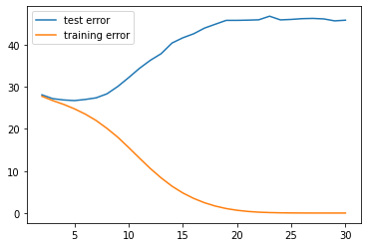

Max depth: 5

Highest accuracy: -26.63577742501829 (negative mean square error)

这个好奇怪，是用mean test score 吗？