Developing an Innovative AI Strategy Framework for Canada: A Data‑Driven Analysis
MIE1624 Final Project

By: Group 7 (Edison Guo, Alex She, Ruogu Xu,
Wenyue Yang, Yi Zhang, Stella Zhao)
Date: March 29, 2026
Table of Contents
1 Introduction 3
2 Data Collection and AI Competitiveness Measurement Summary 4
2.1 Implementation 4
2.1.1 Talent 4
2.1.2 Infrastructure 5
2.1.3 Operating Environment 6
2.2 Innovation 8
2.2.1 Research & Development 8
2.3 Investment 9
2.3.1 Government Strategy 9
2.3.2 Commercial 9
3 Develop Proposal for Canada’s AI Strategy 10
3.1 Diagnosis 10
3.2 Canada’s Existing AI Frameworks 10
3.3 Canada's AI Strategy 2026–2030: Vision and Four Pillars 11
3.4 Key Recommendations 12
4 Practical Steps For Implementing Ai Strategy 15
4.1 Implementation Introduction 15
4.2 National AI Talent Bridge Program 15
4.2.1 Current Status Quo And Implementation Gap 15
4.2.2 Proposed Practical Steps 15
4.2.3 Responsible Ministries And Delivery Partners 15
4.2.4 Estimated Cost And Funding Logic 16
4.2.5 Implementation Timeline (1–3 Years) 16
4.2.6 Success Metric 16
4.3 Canadian AI Compute Access Fund and Sovereign Compute Expansion 16
4.3.1 Current Status Quo and Implementation Gap 16
4.3.2 Proposed Practical Steps 16
4.3.3 Responsible Ministries And Delivery Partners 16
4.3.4 Estimated Cost And Funding Logic 16
4.3.5 Implementation Timeline (1–3 Years) 17
4.3.6 Success Metric 17
4.4 AI Governance Sprint and Canadian AI Safety and Accountability Office 17
4.4.1 Current Status Quo and Implementation Gap 17
4.4.2 Proposed Practical Steps 17
4.4.3 Responsible Ministries And Delivery Partners 17
4.4.4 Estimated Cost And Funding Logic 17
4.4.5 Implementation Timeline (1–3 Years) 17
4.4.6 Success Metric 18
4.5 AI Venture Accelerator and Commercialization Instruments Recalibration 18
4.5.1 Current Status Quo and Implementation Gap 18
4.5.2 Proposed Practical Steps 18
4.5.3 Responsible Ministries And Delivery Partners 18
4.5.4 Estimated Cost And Funding Logic 18
4.5.5 Implementation Timeline (1–3 Years) 19
4.5.6 Success Metric 19
5 Conclusion 19
References 21

1 Introduction
In today's rapidly developing technological world, the strategic development of artificial intelligence (AI) has become important for countries to maintain their technological competitiveness through continuous innovation. According to the Tortoise Media Global AI Index ranking, Canada is one of the global leaders in AI, ranking 8th globally, with only the United States, China, Singapore, the United Kingdom, France, South Korea, and Germany outperforming Canada overall (as shown in Figure 1) [1].  As consultants appointed by the University of Toronto, to ensure Canada continues its leadership in the AI field, our primary objective is assess Canada's position in artificial intelligence innovation compared to other AI global-leading countries, improve Canada’s current AI strategies, and propose implementable steps for innovation. Therefore, to achieve this goal, we first established a benchmark for comparison. | 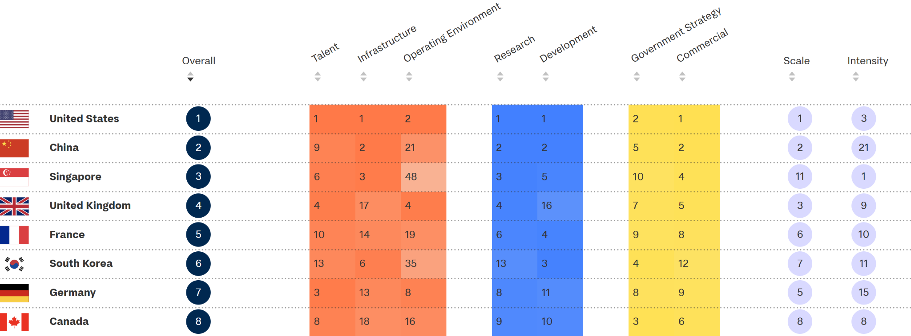  Figure 1. Tortoise Media Global AI Index Ranking of Countries in AI Competitiveness [1]
To obtain an authoritative ranking of AI competitiveness for countries around the world, we adapted the AI capacity ranking table published on Tortoise Media’s Global AI Index as our ranking of countries’ AI competitiveness. As mentioned earlier, Canada ranks 8th globally in AI competitiveness, with only the United States, China, and 7 other countries, outperforming Canada overall. Therefore, in our subsequent analysis, we will focus on these 7 countries, exploring the AI ​​strategies they have implemented that have enabled them to outperform Canada overall.
We will also adapt the 6 major AI indicators (talent, infrastructure, operating environment, research & development, government strategy, and commercial) summarized by Tortoise Media as our AI indicators [1], forming the basis for our assessment of countries' AI competitiveness. Under each key AI indicator, we will then introduce sub-indicators, explaining their composition in detail. By leveraging these indicators, we aim to conduct data-driven analysis to identify the specific drivers of AI competitiveness. This approach allows us to spot where Canada falls behind the top 7 countries specifically, thereby being able to establish AI ​innovation strategies and practical implementation steps.

2 Data Collection and AI Competitiveness Measurement Summary

2.1 Implementation

2.1.1 Talent
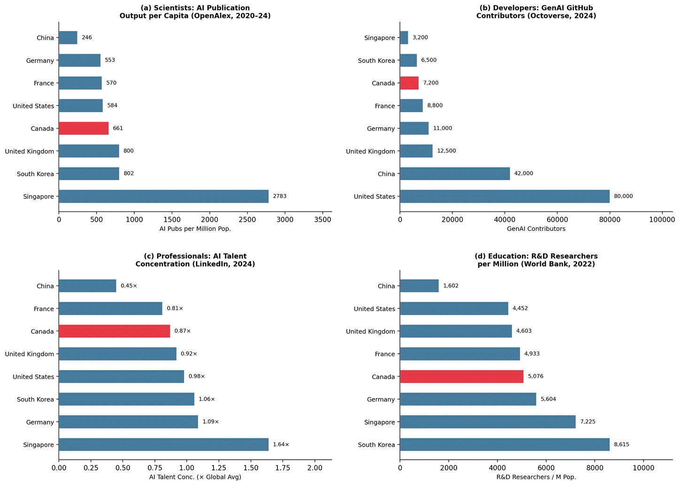
Figure 2. Talent sub-indicator benchmark across four pipelines: (a) per-capita AI publication output, (b) generative AI developer community, (c) AI professional concentration, and (d) R&D researcher density.
Sources: OpenAlex API (2020–2024); GitHub Octoverse (2024); LinkedIn/OECD.AI (2024); World Bank/UNESCO UIS (2022).

In AI publication output per capita, measured using OpenAlex's topic-filtered publication data (covering machine learning, computer vision, NLP, deep learning, and reinforcement learning) from 2020 to 2024 [1], Singapore leads by a very large margin at 2,783 publications per million population [5], reflecting its dense concentration of research institutions. South Korea (802) and the United Kingdom (800) follow, while Canada ranks fourth at 661 per million, outperforming the United States (584), France (570), and Germany (553) on a per-capita basis. As for generative AI contributors on GitHub [2], the United States dominates with approximately 80,000 contributors, far ahead of China (42,000). Canada has around 7,200 contributors, placing it in the lower half of the group alongside South Korea (6,500) and Singapore (3,200). In AI talent concentration, which measures the proportion of LinkedIn members classified as AI professionals relative to the global average [3], Singapore leads at 1.64× followed by Germany (1.09×) and South Korea (1.06×). Canada records 0.87×, placing it below the global average. Lastly, in R&D researchers per million population from the World Bank's UNESCO UIS dataset [4], South Korea leads with 8,615 researchers per million, followed by Singapore (7,225) and Germany (5,604). Canada records 5,076, ranking fourth and outperforming France, the United Kingdom, and the United States on this metric. To conclude, Canada's education pipeline and academic research output are relatively strong (ranking 4th on both per-capita publications and R&D researchers), but the commercial translation of this talent is weak (ranking 6th on both professional concentration and developer activity). This pattern suggests a research-to-industry conversion gap: talent is being trained in Canadian universities but is not being retained or absorbed into the domestic commercial AI workforce at sufficient scale. It is important that Canada strengthen industry-academic collaboration, expand AI talent retention programs, and create incentives for AI professionals to build careers domestically. Singapore, South Korea, and the United States are the key countries Canada can learn from in this domain.

2.1.2 Infrastructure
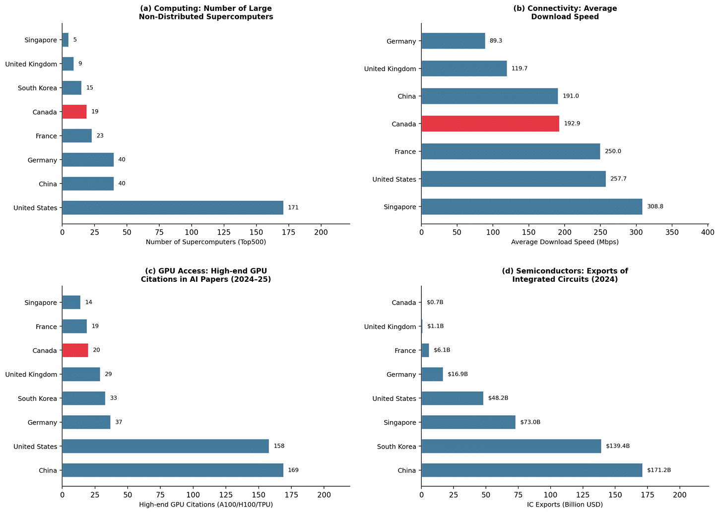
Figure 3. Infrastructure sub-indicator benchmark across four categories: (a) computing capacity, (b) connectivity, (c) GPU access, and (d) semiconductor trade.
Sources: Top500; Speedtest; OpenAlex; OEC (2024).
In the number of large non-distributed supercomputers on the Top500 list, the United States dominates with 171 systems, far ahead of China and Germany (both 40). Canada has 19 systems, placing it in the lower half of the benchmark group alongside France (23), South Korea (15), the United Kingdom (9), and Singapore (5). As for average download speed, Singapore leads at 308.8 Mbps, followed by the United States (257.7 Mbps) and France (250.0 Mbps). Canada records 192.9 Mbps, ranking in the middle tier and slightly outperforming China (191.0 Mbps), but trailing the leading countries. Note that South Korea data was not available for this sub-indicator. In GPU access measured by the number of AI research papers citing high-end GPUs (A100, H100, or TPU) in 2024–2025, China (169) and the United States (158) far outpace all other countries. Canada recorded only 20 high-end GPU citations, slightly above France (19) but notably behind Germany (37), South Korea (33), and the United Kingdom (29). Lastly, in integrated circuit exports, China ($171.2B) and South Korea ($139.4B) lead significantly, followed by Singapore ($73.0B) and the United States ($48.2B). Canada’s IC exports are the lowest in this group at $0.7B, reflecting its minimal role in semiconductor manufacturing. To conclude, Canada’s infrastructure gap is most pronounced in computing capacity and semiconductor manufacturing. While connectivity is relatively adequate, the shortfall in high-performance computing systems and GPU access suggests that Canada should prioritize investments in sovereign compute infrastructure and semiconductor supply chain participation to improve its AI competitiveness. The United States, China, and South Korea are the key countries Canada can learn from in this domain.

2.1.3 Operating Environment
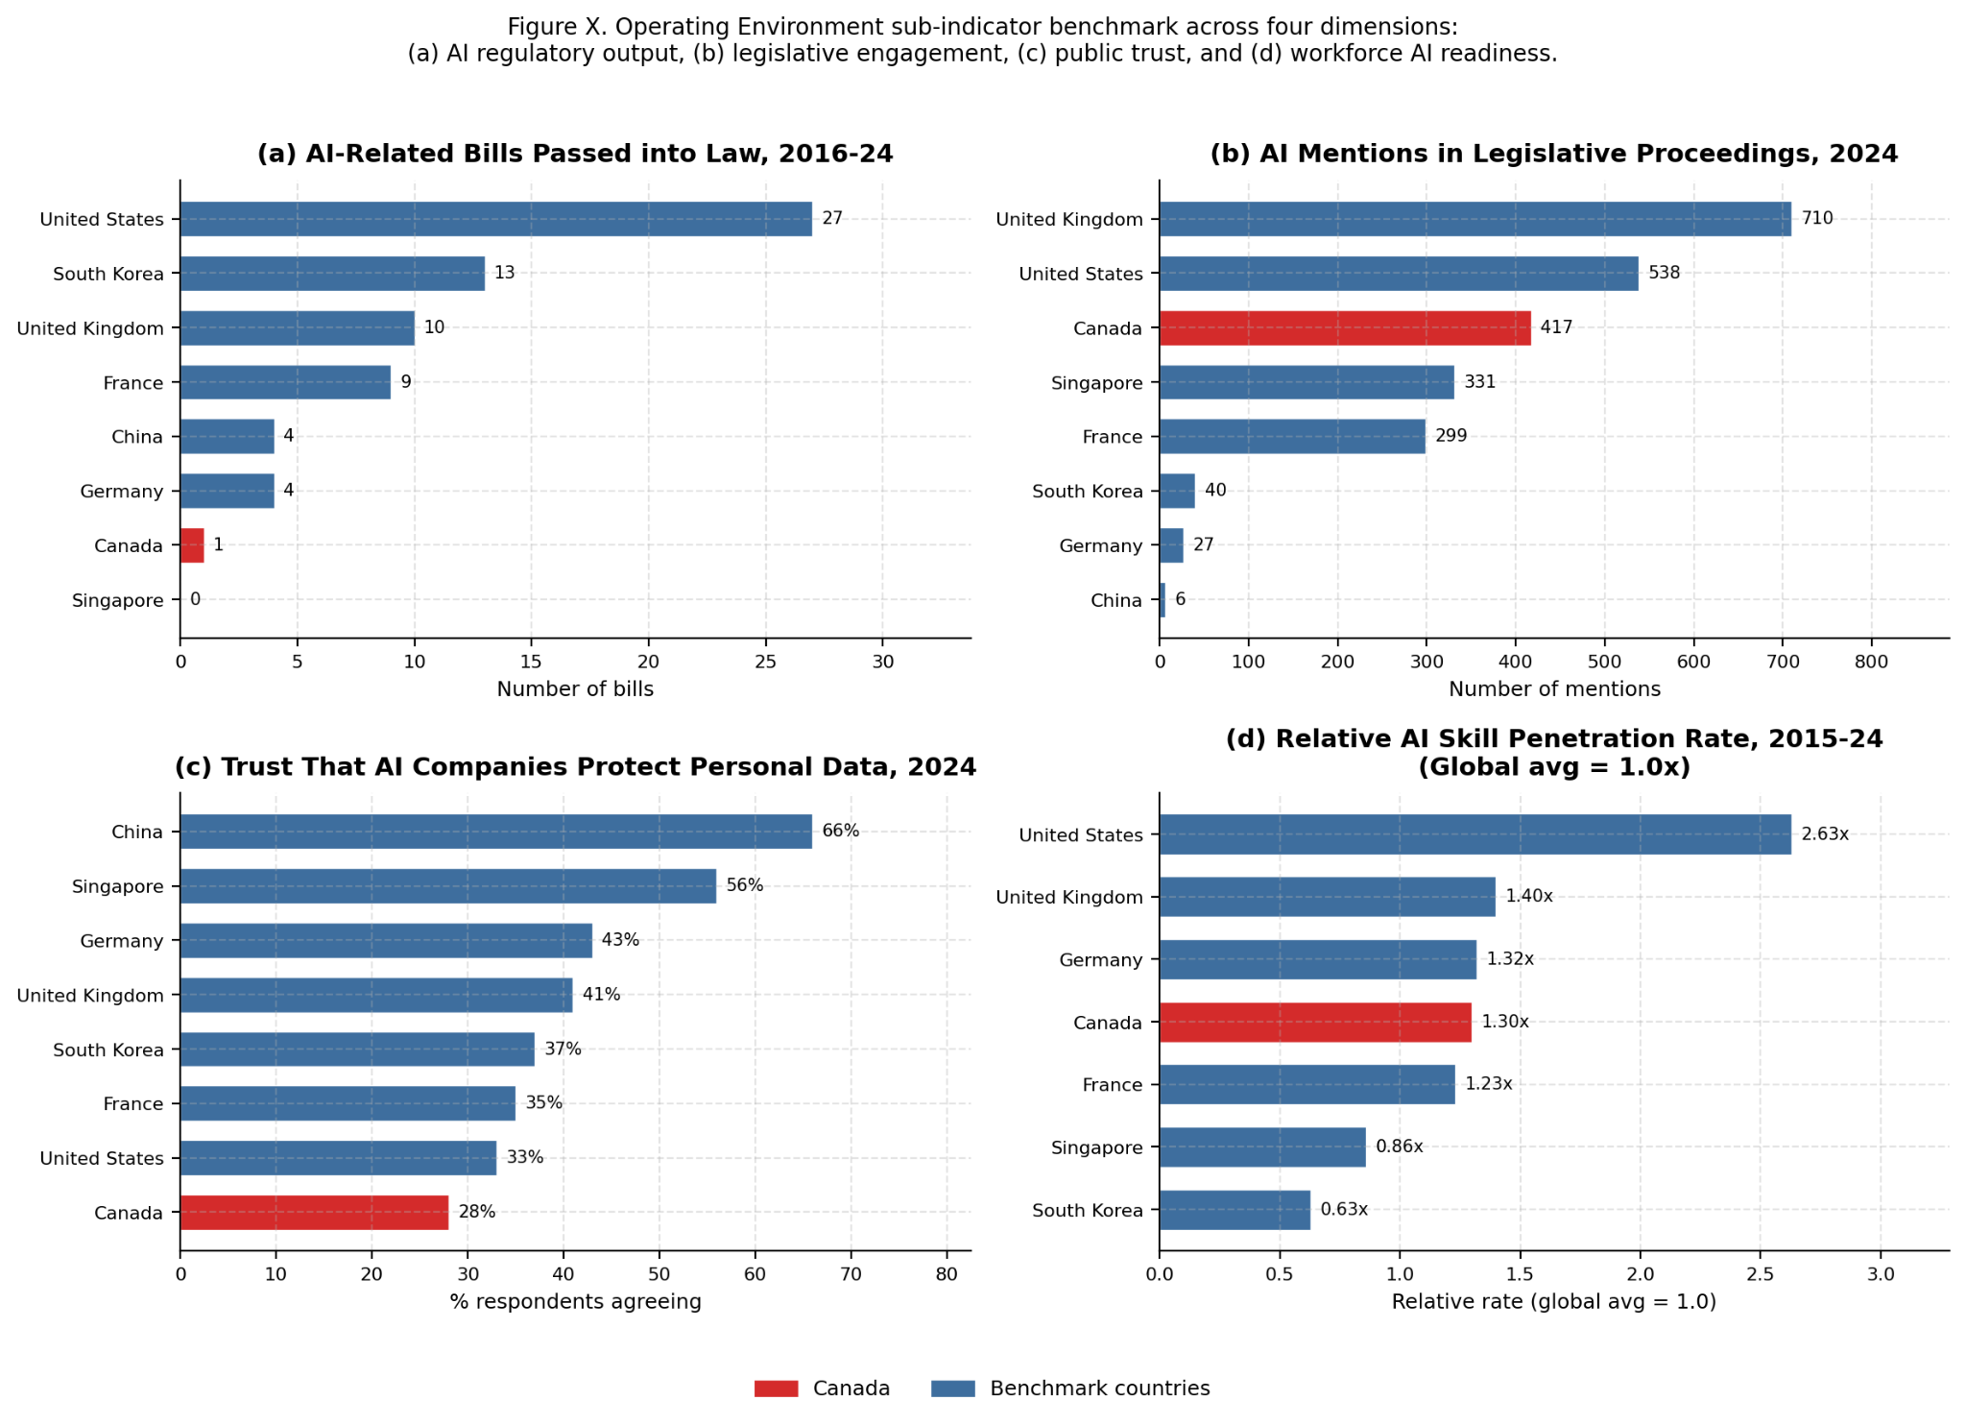
Figure 4
In AI regulatory output, measured by the total number of AI-related bills passed into law between 2016 and 2024 (Stanford AI Index 2025, Figure 6.2.1), the United States leads the benchmark group with 27 enacted bills, followed by South Korea (13), the United Kingdom (10), and France (9). Germany and China each recorded 4 bills, while Canada passed only 1 bill throughout this nine-year period, and Singapore enacted zero formal AI legislation. Canada therefore ranks seventh of the eight benchmark countries in this sub-indicator — second-lowest alongside Singapore, which governs AI primarily through non-legislative executive policy rather than statute. This shortfall indicates that Canada’s formal legislative pipeline for AI has yet to match the ambition of its policy rhetoric.
In legislative engagement, measured by the number of times AI was mentioned in parliamentary or congressional proceedings in 2024 (Stanford AI Index 2025, Figure 6.2.16), the United Kingdom leads with 710 mentions, followed by the United States (538) and Canada (417). Canada therefore ranks third among benchmark countries on political discourse about AI — ahead of Singapore (331), France (299), South Korea (40), Germany (27), and China (6). This result reveals a notable disconnect in Canada’s operating environment: AI attracts substantial parliamentary attention, yet this awareness has not translated into a proportionate volume of enacted legislation.
In public trust, measured by the share of respondents who agreed that “companies using AI will protect my personal data” in 2024 (Stanford AI Index 2025, Figure 8.1.3), China leads with 66%, followed by Singapore (56%), Germany (43%), the United Kingdom (41%), South Korea (37%), France (35%), and the United States (33%). Canada records 28% — the lowest value among all eight benchmark countries and 15 percentage points below the United Kingdom. This points to a significant social-licence deficit: weak public trust could constrain both AI adoption and public support for government AI investment.
In workforce AI readiness, measured by the relative AI skill penetration rate over 2015–2024 (Stanford AI Index 2025, Figure 4.2.15), the United States leads at 2.63 times the global average, followed by the United Kingdom (1.40×), Germany (1.32×), Canada (1.30×), France (1.23×), Singapore (0.86×), and South Korea (0.63×). Canada ranks fourth in this sub-indicator among countries with available data (China not included in the LinkedIn dataset), sitting in the upper-middle tier but trailing the two most advanced English-speaking AI economies by a meaningful margin.
To conclude, Canada’s operating environment is characterised by a pronounced gap between legislative rhetoric and regulatory output, critically weak public trust in AI data practices, and a formal AI legal framework that is among the thinnest in the benchmark group. Despite ranking third in legislative mentions, Canada has enacted only one AI-related bill since 2016 — behind even China (4) and Germany (4), and far behind South Korea (13). Canada must prioritise building both transparent regulatory frameworks and visible accountability mechanisms to close the trust gap and convert parliamentary intent into durable law. The United States, United Kingdom, and South Korea are the key countries Canada can learn from in this domain.

2.2 Innovation

2.2.1 Research & Development
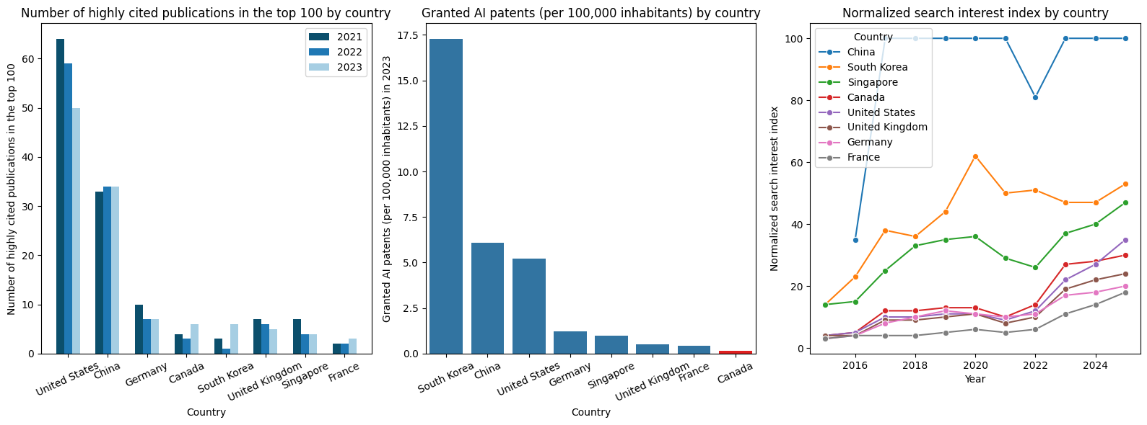
Figure 5. Research & development sub-indicator benchmark across three categories: (a) highly cited publications in the top 100 [1], (b) granted AI patents [1], and (c) AI search index [2]

Among the global top 100 highly cited publications (2021-23), the United States contributed to more than half (>50) of the publications every year, followed by China which contributed to about one third (>33) every year. For the 6 remaining countries including Canada, the contributions were all very low with no significant difference. As for the number of granted AI patents per 100,000 inhabitants, in 2023, it was recorded that South Korea had a significantly higher number (~17 patents) compared to all other 7 countries, followed by China (~6 patents) and the United States (~5 patents). The remaining countries had nearly negligible numbers (i.e., 0-1), with Canada ranking last (~0.17 patents). Lastly, from the data of google searches in AI which reflects public interest in AI, China, South Korea, and Singapore outperformed significantly throughout 2015 to 2025 compared to other countries. Canada ranked mostly in 4th place, performing relatively better than the remaining countries. To conclude, Canada has a lot of room for improvement in all 3 sub-indicator categories, especially in the contribution in the number of highly cited publications in the top 100 and the number of granted AI patents per 100,000 inhabitants. It is important that Canada starts to pay more attention in AI research & development.

2.3 Investment

2.3.1 Government Strategy
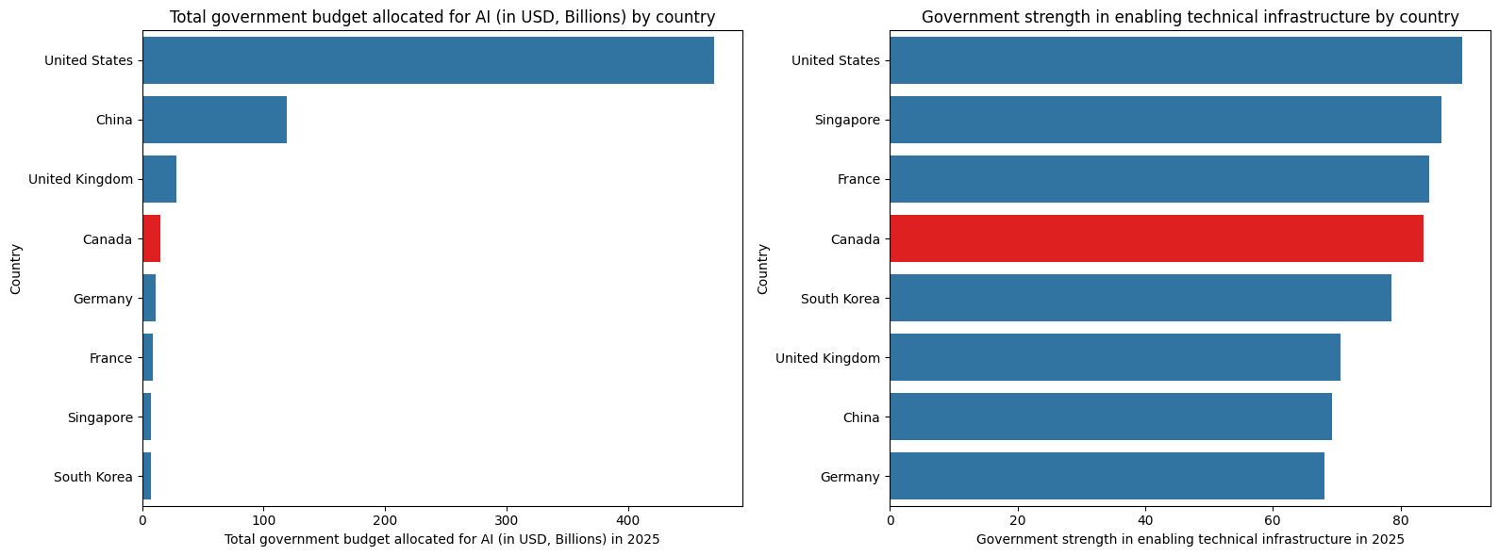
Figure 6. Government strategy sub-indicator benchmark across two categories: (a) government budget for AI [3], and (b) government strength in enabling technical infrastructure [4]

As seen from the total allocated budget for AI in each country, the United States and China were spending much more than the rest of the countries in 2025. Specifically for Canada, the United States (~490 billion USD) was spending about 30 times more than Canada (~15 billion USD). While in the government's strength to enable technical infrastructure for AI implementation in 2025 (scored on a scale from 0 to 100), Canada’s performance was average. These data suggest that Canada is investing in AI, but the level of investment is falling behind. Hence, Canada can consider raising its financial commitment in AI, while maintaining its strength in enabling technical infrastructure.

2.3.2 Commercial
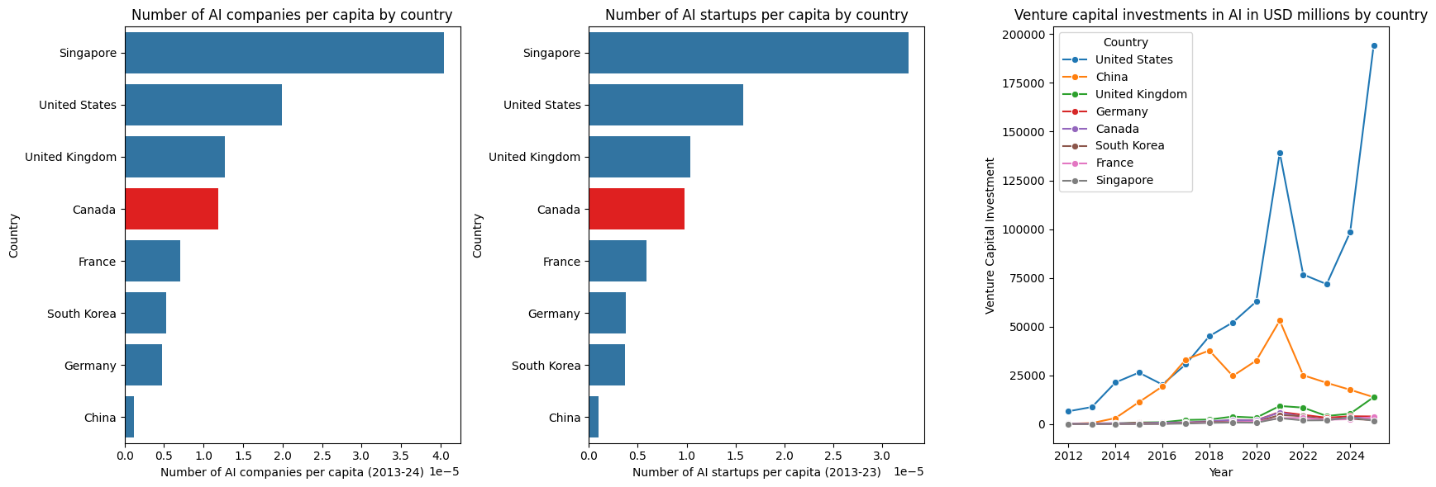
Figure 7. Commercial sub-indicator benchmark across three categories: (a) AI companies [1][5], (b) AI startups [5][6], and (c) venture capital investments in AI [2]

Based on the total number of newly funded AI companies and AI startups per capita over the past decade, we see Canada performing average, with only Singapore having noticeably more compared to all other countries. In terms of the venture capital investments in AI, over the years, the United States is accelerating sharply in VC investments, outdistancing all other countries. In 2025, the United States’s VC investment was 194,115 millions USD, which is over 60 times more than Canada (3,078 millions USD). China, on the other hand, although showing a decline in VC investments in recent years, its total is still outstanding compared to the remaining countries. Therefore, Canada can have better improvement in the commercial domain by expanding targeted venture capital investment support for AI.

3 Develop Proposal for Canada’s AI Strategy

3.1 Diagnosis
Observing the data collected in Part 2, Canada's 8th overall ranking on the Tortoise Media Global AI Index reveals a structural problem: Canada consistently outperforms on inputs — academic research, R&D researcher density, and parliamentary discourse — while underperforming on outputs — commercial AI activity, enacted legislation, venture capital, and compute infrastructure. A machine-learning feature importance analysis (ensemble of Random Forest, Gradient Boosting, Lasso, and Pearson Correlation across 19 features) was conducted and shown in Appendix A. The ML analysis confirms this pattern quantitatively: AI Publications per Million and AI Talent Concentration rank 19th and 18th out of 19 features (importance 0.18 each), while the top-ranked features are all output-side metrics where Canada's gaps are largest. More specifically, Canada faces four structural challenges:

First, Canada is facing a talent conversion gap. Despite ranking 4th in per-capita AI publications and 4th in R&D researchers per million, Canada ranks 6th in both AI professional concentration and generative AI developer activity. The ML analysis ranks GenAI GitHub Contributors as the #1 most important feature (importance = 0.92), with Canada's normalized gap at +0.31 versus the top-5 leader average — confirming that talent is being trained but not commercially retained.

Second, Canada's infrastructure position is fragile. With only 19 supercomputers on the Top500 list, 20 high-end GPU citations in 2024–25 AI research papers, and integrated circuit exports of just $0.7 billion — the lowest in the benchmark group — Canada lacks sovereign compute capacity. Government AI Budget is the 5th most important feature (importance = 0.67) and Canada's $15 billion is 3% of the United States' $490 billion commitment.

Third, Canada's regulatory environment lacks implementation. Although AI was mentioned 417 times in parliamentary proceedings in 2024 (3rd globally), Canada enacted only one AI-related bill between 2016 and 2024 (7th globally). Public Trust in AI is the 3rd most important feature overall (importance = 0.71) and Canada's largest single gap (+0.479), with public trust at just 28% — the lowest among all benchmark countries. Critically, AI Legislative Mentions ranks only 14th in importance, confirming that parliamentary discourse without enacted law does not predict competitiveness.

Lastly, Canada's commercial AI ecosystem is underfunded. Canada attracted only $3.1 billion in AI venture capital in 2025 — 63 times less than the United States ($194.1 billion). AI Companies per Capita ranks 4th in feature importance (0.70) and Venture Capital Investment ranks 7th (0.62), together confirming that growth-stage capital and commercial firm density are among the strongest structural predictors of AI competitive rank.

3.2 Canada’s Existing AI Frameworks
Looking at the existing Canadian AI frameworks, three strategies currently anchor Canada’s national AI approach. First of all, the Pan-Canadian AI Strategy, administered by CIFAR across three national institutes (such as Mila, Vector Institute, and Amii), successfully established Canada as a hub for fundamental AI research and built the academic talent pipeline reflected in Canada's strong per-capita publication metrics [1]. However, it was designed for research capacity, not commercial translation, which causes the talent-to-industry conversion gap as shown in Section 2.1.1. Moreover, the $2 billion Sovereign AI Compute Strategy is directionally correct in addressing infrastructure sovereignty, but is insufficient in scale against a United States commitment of approximately $490 billion, and does not address near-term GPU access or semiconductor supply chain participation, further proving Canada's most acute infrastructure vulnerability as shown in Section 2.1.2 [2][3]. Lastly, the AI Strategy for the Federal Public Service 2025–2027 targets internal government efficiency rather than national competitiveness, and does not address the legislative gap or public trust deficit identified in Section 2.1.3 [4].

Thus, Canada’s existing AI framework addresses one dimension of the problem in isolation: research capacity, compute infrastructure, and internal government adoption, respectively. However, none of them provides the solution to the deficient areas in commerce, infrastructure to access, or legislative intent to enact law.

3.3 Canada's AI Strategy 2026–2030: Vision and Four Pillars
Given the deficiencies identified in Canada's existing AI frameworks, this strategy proposes a vision for Canada to be recognized as a top-five AI nation by 2030 through converting world-class research into globally competitive AI products, maintaining sovereign compute infrastructure, governing AI with clarity and public trust, and retaining the talent it develops.

This vision is grounded in Canada's existing strengths, which are its research institutions, multicultural talent pipeline, trusted multilateral relationships, and established democratic governance. It is achievable within a five-year horizon if the four strategic pillars described below are pursued with the funding, coordination, and institutional accountability they require.

Pillar 1: Talent retention and commercial conversion. Canada will close the gap between its strong academic AI output and its weak commercial AI workforce by implementing structured industry-academia transition programs, expanding AI-specific immigration pathways, and creating financial incentives for AI professionals to build careers and companies domestically. The target is to raise Canada's AI talent concentration from 0.87× the global average to at least 1.20× by 2028, and to double the number of Canadian-based generative AI contributors on GitHub by 2030 [5]. Singapore's approach of anchoring AI professionals through targeted immigration and industry co-investment, achieving the highest benchmark concentration of 1.64×, and South Korea's sustained STEM pipeline yielding 8,615 R&D researchers per million serve as the primary models for this pillar [5][6].

Pillar 2: Sovereign compute and infrastructure. Canada will expand its sovereign compute investment beyond the initial $2 billion commitment, targeting 60 or more Top500 supercomputing systems by 2030, tripling the current count of 19, alongside a dedicated national GPU access program providing subsidized high-performance computing to Canadian AI researchers and enterprises [2][7]. Canada will also pursue formal participation in allied semiconductor supply chains through bilateral agreements with South Korea and the United States, targeting an increase in integrated circuit export value from $0.7 billion to $5 billion by 2030 [9]. The United States (171 Top500 systems, 158 GPU citations), South Korea ($139.4 billion IC exports), and the United Kingdom's bilateral GPU access model serve as the primary models for this pillar [7][8][9].

Pillar 3: Regulation, governance, and public trust. Canada will enact a minimum of 8 additional AI-related bills by 2028, bringing its cumulative total from 1 to 9, on par with the United Kingdom's current position [8]. This legislative sprint will be supported by a standing Parliamentary AI Committee, a mandatory 90-day public consultation process for all AI-related legislation, and the establishment of a Canadian AI Safety and Accountability Office responsible for public reporting on AI governance outcomes. The target is to raise public trust in AI data practices from 28% to 40% by 2028 [8]. The United Kingdom's AI Safety Institute and South Korea's 13 enacted AI bills [8] serve as the primary models for this pillar [8].

Pillar 4: Commercialization and venture capital. Canada will implement a dedicated AI Venture Accelerator, a public-private co-investment fund of at least $3 billion, targeting Series A and Series B AI companies with a demonstrated path to global scale. This will be complemented by AI-specific R&D tax credits, a national AI procurement commitment creating domestic demand for Canadian AI products within government operations, and a diaspora engagement program connecting Canadian AI professionals abroad with domestic investment opportunities. The target is to grow annual AI venture capital investment from $3.1 billion to $15 billion by 2030 [8]. Singapore's Enterprise Singapore co-investment model and highest per-capita AI startup density serve as the primary model for this pillar [10].

3.4 Key Recommendations
The four strategic pillars above each correspond to one key recommendation below. Together, these represent the interventions most directly supported by the evidence in Section 2 and most likely to produce measurable improvements in Canada's AI competitiveness ranking.

Recommendation 1: Launch a National AI Talent Bridge Program. Canada's talent gap is not a supply problem, but rather a retention and conversion problem. As Section 2.1.1 demonstrates, Canada ranks 4th in per-capita AI publications and 4th in R&D researcher density, yet falls to 6th in both commercial AI workforce concentration and generative AI developer activity [5][6][8][11]. The talent exists; the domestic commercial pathways to absorb it do not. Singapore's AI talent concentration of 1.64× the global average and South Korea's R&D researcher density of 8,615 per million, both achieved through structured industry-academia linkages and domestic employment incentives documented in Section 2.1.1, demonstrate that commercial talent absorption requires deliberate policy beyond research funding alone [5][6]. Canada already has a proven model in Mitacs; the recommendation is to scale it with an explicit commercial conversion mandate, directing public investment toward the transition from academic AI research to domestic industry rather than research output alone [12].

Recommendation 2: Establish a Canadian AI Compute Access Fund and expand the Sovereign Compute Strategy. Canada's infrastructure deficit is both a research constraint and a commercial competitiveness problem. As Section 2.1.2 shows, Canada recorded only 20 high-end GPU citations in AI research papers in 2024–2025 — below Germany (37), South Korea (33), and the United Kingdom (29) [8] — and holds the lowest integrated circuit export value among all benchmark countries at $0.7 billion [8][9]. The existing Sovereign Compute Strategy is directionally correct but insufficient in scale and does not address near-term GPU access [2]. The United States' 171 Top500 systems and dominant GPU access, South Korea's $139.4 billion semiconductor export position, and the United Kingdom's bilateral GPU access agreements, all documented in Section 2.1.2, demonstrate that sovereign compute investment and semiconductor supply chain participation are complementary strategic assets, not alternatives [7][8][9]. Canada must pursue both simultaneously, with near-term subsidized access bridging the gap while longer-term domestic capacity is built.

Recommendation 3: Enact an AI Governance Sprint and establish a Canadian AI Safety and Accountability Office. Canada's regulatory gap is a prioritization and process failure, not a resource problem. As Section 2.1.3 shows, Canada ranks 3rd globally in parliamentary AI discourse with 417 mentions in 2024, yet has enacted only one AI-related bill since 2016, ranking 7th among benchmark countries [8]. Simultaneously, it records the lowest public trust in AI data practices among all eight benchmark countries at 28% [8]. These two findings are connected: legislative ambiguity and the absence of visible accountability institutions are primary drivers of public distrust. The United Kingdom's 10 enacted AI bills and AI Safety Institute, and South Korea's 13 enacted bills, both documented in Section 2.1.3, demonstrate that high legislative output is achievable without sacrificing innovation pace when regulatory design is iterative and industry co-developed [8]. Canada must convert its parliamentary AI awareness into enacted law and institutional accountability structures, or risk both investment uncertainty and sustained public opposition to AI adoption.

Recommendation 4: Establish a dedicated AI Venture Accelerator and recalibrate commercial AI instruments. Canada's commercial AI ecosystem is structurally underfunded and institutionally misaligned. As Section 2.3.2 shows, Canada attracted only $3.1 billion in AI venture capital in 2025
— over 60 times less than the United States ($194.1 billion) — and its AI startup density is not producing companies that scale to global significance at a competitive rate [8]. The root cause is not a lack of early-stage activity but a lack of growth-stage capital and commercially targeted government instruments. Canada's existing tools — the Business Development Bank of Canada, Export Development Canada, and the Strategic Innovation Fund — are broadly oriented and not calibrated to the specific risk profile, commercialization timeline, and global scaling requirements of AI ventures. Singapore's highest per-capita AI startup density, achieved through direct government co-investment via Enterprise Singapore and preferential tax treatment for AI ventures documented in Section 2.3.2, demonstrates that targeted public co-investment through a dedicated vehicle is the mechanism most directly correlated with high AI venture activity among peer nations [10]. Canada should establish a dedicated AI Venture Accelerator — a public-private co-investment fund of at least $3 billion — focusing exclusively on Series A and Series B AI companies with demonstrated paths to global scale, complemented by AI-specific R&D tax credits and a national AI procurement commitment.

[1] CIFAR, "Pan-Canadian Artificial Intelligence Strategy: Impact Assessment Report," Canadian Institute for Advanced Research, Toronto, ON, Canada, 2023. [Online]. Available: https://cifar.ca/ai/pan-canadian-artificial-intelligence-strategy
[2] Government of Canada, "Canadian Sovereign AI Compute Strategy," Innovation, Science and Economic Development Canada, Ottawa, ON, Canada, 2024. [Online]. Available: https://ised-isde.canada.ca
[3] Oxford Insights, "Government AI Readiness Index 2025," Oxford Insights Ltd., Oxford, UK, 2025. [Online]. Available: https://oxfordinsights.com/ai-readiness
[4] Government of Canada, "Artificial Intelligence Strategy for the Federal Public Service 2025–2027," Treasury Board of Canada Secretariat, Ottawa, ON, Canada, 2025. [Online]. Available: https://canada.ca
[5] LinkedIn / OECD.AI, "AI Talent Concentration Index," Organisation for Economic Co-operation and Development, Paris, France, 2024. [Online]. Available: https://oecd.ai
[6] World Bank / UNESCO UIS, "Researchers in R&D per Million People," World Bank Open Data, Washington, DC, USA, 2022. [Online]. Available: https://data.worldbank.org
[7] TOP500 Project, "TOP500 Supercomputer List," TOP500.org, November 2024. [Online]. Available: https://www.top500.org
[8] Stanford University Human-Centered AI, "Artificial Intelligence Index Report 2025," Stanford HAI, Stanford, CA, USA, 2025. [Online]. Available: https://hai.stanford.edu/ai-index/2025-ai-index-report
[9] Observatory of Economic Complexity (OEC), "Integrated Circuits — Trade Data 2024," OEC World, Boston, MA, USA, 2024. [Online]. Available: https://oec.world
[10] Tortoise Media, "Global AI Index 2025," Tortoise Media Ltd., London, UK, 2025. [Online]. Available: https://www.tortoisemedia.com/data/global-ai
[11] GitHub, Inc., "Octoverse 2024: The State of Open Source," GitHub, Inc., San Francisco, CA, USA, 2024. [Online]. Available: https://octoverse.github.com
[12] Mitacs, "Mitacs Annual Report 2024," Mitacs Inc., Vancouver, BC, Canada, 2024. [Online]. Available: https://www.mitacs.ca/en/about/reports

4 Practical Steps For Implementing AI Strategy

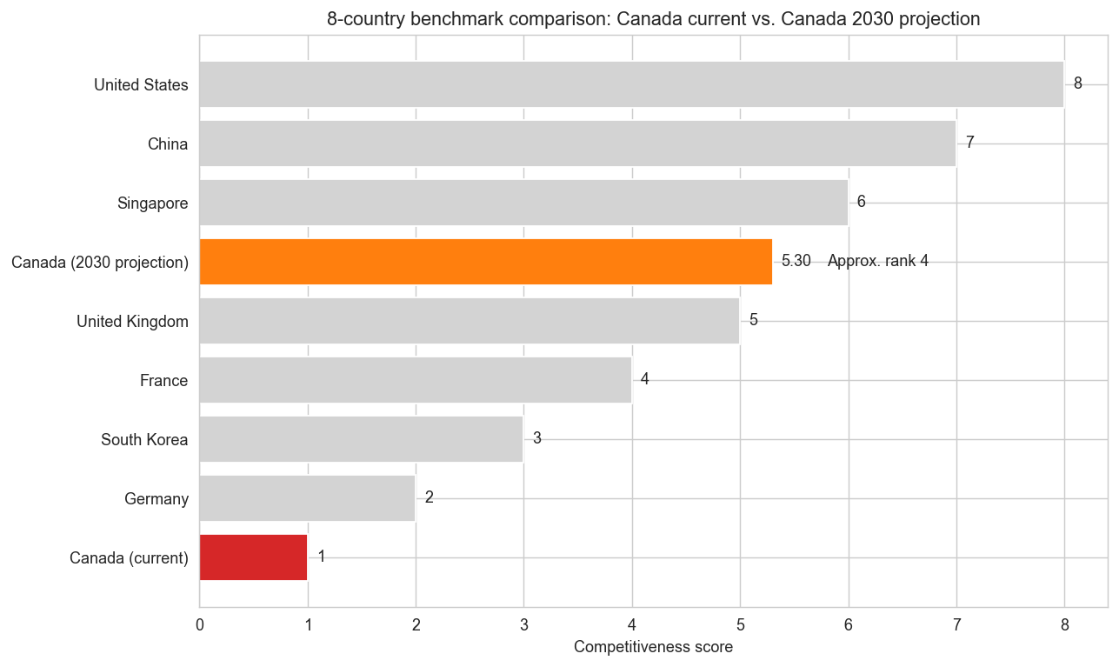
4.1 Implementation Introduction
As the previous section proposed a four-pillar strategy to strengthen Canada’s AI competitiveness by addressing the country’s most vulnerable weaknesses: weak talent retention, under-scaled computing infrastructure, lack of government regulation, and limited commercial space for AI.
This section translates each provided recommendation for improvement into practical implementation steps which are data driven, realistic and aligned with the current Canadian political environment.

4.2 National AI Talent Bridge Program

4.2.1 Current Status Quo And Implementation Gap
Canada’s AI talent shortage is more of a commercial conversion gap than a research supply gap. While Canada has built a strong research environment through the Pan-Canadian AI Strategy and institutes such as Mila, Vector, and Amii, business adoption of AI remains limited. Statistics Canada reported that only 6.1% of businesses used AI to produce goods or deliver services in the 12 months before Q2 2024, rising to 12.2% in Q2 2025. This suggests that Canada is producing talent and research capacity but lacks a bridge from research institutions to domestic industries, leaking talents to other countries.

4.2.2 Proposed Practical Steps
To close the gap between AI talent training and domestic industry absorption, Canada should implement the National AI Talent Bridge Program, which is built around three practical measures. First, the Federal Government will expand existing industry-academic pathways by creating a dedicated AI stream within programs such as Mitacs and Canadian universities AI programs, with placements targeted at startups, scaleups, and applied AI teams. Second, short-term wage support federal budget around C$60-100 million per year for fellowship/co-op funding or start-up firms hiring Canadian university AI related program graduates should be in place as financial incentives, supporting roughly 5,000-8,000 AI-related jobs. Third, the program should be complemented by attracting AI talents around the world through Canada’s already existing fast-track immigration pathways to help Canadian companies recruit about 3,000-5,000 highly skilled AI professionals yearly.

4.2.3 Responsible Ministries And Delivery Partners
The National AI Talent Bridge Program should be led by Innovation, Science and Economic Development Canada (ISED), since it is the federal department responsible for Canada’s AI ecosystem and innovation strategy. Mitacs would be a practical delivery partner for industry-academic placements because it already operates internship and collaboration programs at national scale. Immigration, Refugees and Citizenship Canada (IRCC) should support the international talent component through fast-track high-skill entry pathways.

4.2.4 Estimated Cost And Funding Logic
A reasonable starting budget for the National AI Talent Bridge Program is C$80 million per year. This level of funding would be sufficient to support several thousand AI-focused placements annually.

4.2.5 Implementation Timeline (1–3 Years)
In year 1 of the National AI Talent Bridge Program, the Canadian Federal Government is to design the program and launch pilot placements through existing partners. Year 2 should be used on nation-wide expansion of the program with the introduction of wage-support and start-up funding incentive. By year 3 the program should be fully operational and evaluated based on retention, placement, and industry absorption outcomes.

4.2.6 Success Metric
Percentage of AI workers retained in Canadian firms after 12 months. This measure directly captures whether the program is improving the transition of AI talent from research and training into long-term domestic industry employment.

4.3 Canadian AI Compute Access Fund and Sovereign Compute Expansion

4.3.1 Current Status Quo and Implementation Gap
In Budget 2024, the Federal Government announced C$2 billion over five years for a new AI Compute Access Fund and a Canadian Sovereign AI Compute Strategy, confirming that compute capacity is now seen as essential to national competitiveness. However, the government’s own consultation summary also shows that stakeholders continue to view access to affordable, high-performance computers as a major barrier for Canadian AI developments. This suggests that Canada’s current approach is directionally correct, but still needs faster and stronger implementation.

4.3.2 Proposed Practical Steps
Canada should improve its computing ability through two concrete ways. First, the short term disbursement of the AI Compute Access Fund should be utilized by the Federal Government to subsidize cloud and computing purchases for Canadian SMEs, start-ups and scale-ups who wish to invest in AI commercialization. Especially for companies facing computing costs of C$100,000-C$5,000,000, which is the funding range already defined by the program. Second, Canada should expand domestic sovereign capacity by accelerating projects under the AI Compute Challenge, which is designed to support new or expanded Canadian AI data centres and increase the domestic availability of advanced GPUs.

4.3.3 Responsible Ministries And Delivery Partners
This project should be led by Innovation, Science and Economic Development Canada (ISED), since it oversees Canada’s AI strategy. The main delivery partners should include the National Research Council of Canada (NRC) for research and industrial coordination, the Digital Research Alliance of Canada for national research-computing access, and private-sector infrastructure partners selected through the AI Compute Challenge to expand domestic GPU and data-centre capacity.

4.3.4 Estimated Cost And Funding Logic
The AI Compute Access Fund already provides up to C$300 million to help Canadian companies pay for computing resources, while the AI Compute Challenge is expected to support domestic AI data-centre expansion with up to C$700 million in federal investment. It is more important to redirect these existing funds towards affordable GPU access rather than recommending an entirely new number.

4.3.5 Implementation Timeline (1–3 Years)
In Year 1, the government can scale access to GPU and cloud resources through the AI Compute Access Fund to address affordability constraints. In Year 2, funding will expand toward domestic infrastructure including new or upgraded data centres. By Year 3, Canada should achieve increased domestic GPU computing capacity.

4.3.6 Success Metric
The primary success metric should be the number of Canadian firms and research teams accessing subsidized GPU computing resources annually. This directly reflects whether the program is improving access to high-performance computing.

4.4 AI Governance Sprint and Canadian AI Safety and Accountability Office

4.4.1 Current Status Quo and Implementation Gap
At the federal level, governance tools such as the Directive on Automated Decision-Making and the new AI Strategy for the Federal Public Service 2025–2027 mainly focus on responsible AI use within government, rather than providing a broad national governance framework for the general public.

4.4.2 Proposed Practical Steps
To strengthen AI governance, Canada should adopt a structured and time-bound implementation approach. First, the Federal Government should launch an AI Governance Sprint, bringing together policymakers, industries, and research institutions to accelerate the development of targeted AI legislation. Second, a standing Parliamentary AI Committee should be established to ensure continuous oversight and coordination. Third, Canada should create a dedicated AI Safety and Accountability Office responsible for monitoring AI deployment, publishing annual reports, and enforcing transparency.

4.4.3 Responsible Ministries And Delivery Partners
This implementation should be led jointly by Innovation, Science and Economic Development Canada (ISED) and the Treasury Board of Canada Secretariat (TBS). ISED is the most appropriate lead for national AI policy and legislation, while TBS already plays a central role in responsible AI governance within the federal public service. Key delivery partners should include the Department of Justice Canada for legislative design and compliance, and Parliament through a standing committee structure for ongoing oversight.

4.4.4 Estimated Cost And Funding Logic
Not Applicable

4.4.5 Implementation Timeline (1–3 Years)
In Year 1, the Federal Government is to launch the AI Governance Sprint and establish the standing parliamentary oversight structure. In Year 2, the first package of targeted AI governance regulation will be introduced and the AI Safety and Accountability Office should begin operations. By Year 3, the governance framework should be fully active, with regular public reporting, oversight, and policy review.

4.4.6 Success Metric
The primary success metric should be the number of AI-related policies or legislative measures enacted within the three-year period, reflecting progress in moving from discussion to implementation. A complementary indicator could be the level of public trust in AI systems, measured through surveys.

4.5 AI Venture Accelerator and Commercialization Instruments Recalibration

4.5.1 Current Status Quo and Implementation Gap
Canada has a growing AI and venture capital environment, but commercialization support remains weak, especially for firms trying to scale beyond the early stages. Business Development Bank of Canada’s 2025 venture capital review shows that Canadian venture capital activity improved in 2024, with strong interest in investing in new AI companies, but scale-up financing remains a critical weak point. At the same time, recent federal engagement on Canada’s next AI strategy emphasized the need for stronger support to help domestic AI firms scale and attract investment.

4.5.2 Proposed Practical Steps
To strengthen commercialization, Canada needs to launch a dedicated AI Venture Accelerator with a federal commitment of about C$500 million to co-invest in high-potential Canadian AI firms at the Series A and Series B stages, where expansion funding is often the hardest to secure. The accelerator should be paired with existing SR&ED support, which currently provides a 35% refundable tax credit for eligible CCPCs on up to C$3 million of qualified annual expenditures, helping Canadian firms with expenditures through R&D tax relief. Together, these measures would improve access to growth capital, strengthen domestic demand, and give more Canadian AI firms a realistic pathway to global scale.

4.5.3 Responsible Ministries And Delivery Partners
This implementation is to be executed by Innovation, Science and Economic Development Canada (ISED), since it is responsible for Canada’s national AI and innovation strategy. While Business Development Bank of Canada is the main delivery partner for co-investment. The Department of Finance Canada should support alignment with tax-based incentives such as SR&ED.

4.5.4 Estimated Cost And Funding Logic
The AI Venture Accelerator will be structured as a C$500 million federal commitment, focused on co-investing in Canadian AI firms at the Series A and Series B stages. This funding level is consistent with existing Canadian growth-capital benchmarks, such as BDC’s recent expansion of its Growth Venture Fund, which also operates at a comparable scale. The accelerator should be designed as a co-investment model, where public funding is matched by private capital, allowing the total investment to pool approximately C$1–1.5 billion.
In addition to equity financing, the program should include a targeted procurement stream of C$50–100 million per year, enabling federal departments to pilot and adopt Canadian AI solutions. Finally, the accelerator should be aligned with existing SR&ED tax incentives, which already provide up to a 35% refundable tax credit for eligible Canadian corporations, thereby lowering the effective cost of R&D.

4.5.5 Implementation Timeline (1–3 Years)
Year 1, the government may establish the fund structure and secure private co-investment partners. In Year 2, the first round of investments and procurement pilots should be launched. By Year 3, the accelerator should be fully operational, with multiple funding cycles completed and early-stage results evaluated.

4.5.6 Success Metric
The primary success metric should be the amount of venture capital invested in Canadian AI firms annually, particularly at the Series A and B stages. A complementary indicator could be the number of AI firms successfully scaling beyond early-stage funding, reflecting improved commercialization outcomes.

Ref.
- CIFAR. (2023). AICan: The impact of the Pan-Canadian AI Strategy. Canadian Institute for Advanced Research.
- Statistics Canada. (2024, June 20). Analysis on artificial intelligence use by businesses in producing goods or delivering services over the last 12 months, second quarter of 2024.
- Statistics Canada. (2025, June 16). Analysis on artificial intelligence use by businesses in producing goods or delivering services over the last 12 months, second quarter of 2025.
- Immigration, Refugees and Citizenship Canada. (2026). Global Skills Strategy for workers: Get faster processing. Government of Canada.
- Mitacs. (2025). Business Strategy Internship. Mitacs.
- Innovation, Science and Economic Development Canada. (2025, March 26). What we heard report: Consultations on AI compute. Government of Canada.
- Innovation, Science and Economic Development Canada. (2025, October 31). Canadian Sovereign AI Compute Strategy. Government of Canada.
- Innovation, Science and Economic Development Canada. (2026, February 5). Engagements on Canada’s next AI strategy: Summary of inputs. Government of Canada.
- Digital Research Alliance of Canada. (2026). About the Alliance.
- National Research Council Canada. (2026). Artificial intelligence. Government of Canada.
- Treasury Board of Canada Secretariat. (2025, June 24). Guide on the scope of the Directive on Automated Decision-Making. Government of Canada.
- Treasury Board of Canada Secretariat. (2026, February 25). AI Strategy for the Federal Public Service 2025–2027: Overview. Government of Canada.
- Business Development Bank of Canada. (2025). Canada’s venture capital landscape 2025.
- Canada Revenue Agency. (2025, August 12). Get an investment tax credit (ITC) – Scientific Research and Experimental Development (SR&ED).
- Department of Finance Canada. (2024, December 13). Reforming and enhancing the Scientific Research and Experimental Development (SR&ED) tax incentive program.
- Public Services and Procurement Canada. (2026). Departmental plan 2026–2027.
- OpenAlex. (2026). OpenAlex API.
- GitHub Staff. (2024, October 29). Octoverse: AI leads Python to top language as the number of global developers surges. The GitHub Blog.
- Siu, E. (2025, April 10; updated April 11). Here are 10 countries with the highest concentration of AI talent globally, according to new LinkedIn data. CNBC.
- World Bank. (2026). Researchers in R&D per million people (SP.POP.SCIE.RD.P6).
- Worldometer. (2026). Countries in the world by population (2026).

5 Visualization

6 Conclusion

References

Appendix

Appendix A: Machine Learning Methods for Ranking Feature Importance
This appendix provides a brief explanation of the four supervised learning methods used in the feature importance analysis, and describes how their results are combined into a single ensemble ranking.

A.1 Feature Importance Methods
- Random Forest. A Random Forest builds a large number of decision trees (500 in this analysis), each trained on a random bootstrap sample of the data with a random subset of features considered at each split. Feature importance is measured by Mean Decrease in Impurity (MDI): how much each feature reduces prediction error across all trees on average. Features that consistently produce cleaner splits receive higher importance scores. The ensemble of many trees reduces overfitting and stabilises the ranking.
- Gradient Boosting. Gradient Boosting also uses decision trees, but builds them sequentially: each new tree is trained to correct the residual errors of the previous ones. Feature importance is computed as the total weighted reduction in prediction error attributable to each feature across all trees. Because each tree focuses on the hardest-to-predict cases, Gradient Boosting tends to highlight features that differentiate the extreme ends of the ranking (e.g., what separates the United States from Canada).
- Lasso (L1) Regression. Lasso fits a linear regression model with an L1 penalty that shrinks the coefficients of less informative features exactly to zero, effectively removing them from the model. The absolute value of the remaining non-zero coefficients is used as the importance score. Lasso selected 6 of the 19 features as non-zero, providing a sparse, interpretable signal of the most linearly relevant predictors. In this analysis it assigned the highest coefficient to GenAI GitHub Contributors (1.12) and the second highest to Public Trust in AI (0.86).
- Pearson Correlation. For each feature, the absolute Pearson correlation coefficient |r| with the competitiveness score is computed. This is a model-free, bivariate measure that does not assume any interaction between features. It serves as a simple interpretable baseline. GenAI GitHub Contributors had the strongest correlation (|r| = 0.74), followed by GPU Citations (0.71) and Highly-Cited Publications (0.70).

Method | Importance Signal | Key Property
Random Forest | Mean Decrease in Impurity (MDI) | Captures non-linear interactions; stable over many trees
Gradient Boosting | Weighted impurity reduction per split | Sequential correction reduces bias; sensitive to influential samples
Lasso (L1) | Absolute regression coefficient | Drives unimportant features to zero; best linear signal
Pearson Correlation | Absolute correlation |r| with score | Model-free baseline; interpretable but assumes linearity

A.2 Ensemble Rank Aggregation
Because each method has different assumptions and blind spots, results are combined using Borda count rank aggregation. Each feature is ranked 1–19 by every method (1 = most important). The four rank positions are averaged into a single ensemble rank score — lower is better. This approach is robust: a feature must consistently rank highly across all four methods to reach the top of the ensemble, reducing the risk that any single model's noise drives the final ranking. GenAI GitHub Contributors, for example, ranked 7th (RF), 1st (GB), 1st (Lasso), and 1st (Correlation), yielding an average rank of 2.50 — the best in the ensemble.

A.3 Unsupervised Methods
- PCA (Principal Component Analysis). PCA transforms the 19 correlated features into a smaller set of orthogonal components that capture the most variance. The first three components explained 81.1% of total variance (PC1: 40.6%, PC2: 22.7%, PC3: 17.8%). The biplot visualises countries in this reduced space and overlays feature loading vectors to show which features drive each axis.
- K-Means Clustering. K-Means partitions countries into k groups by minimising within-cluster variance across all 19 features. With k = 3, the algorithm identified an AI Leader cluster (United States), an AI Challenger cluster (China), and an AI Emerging cluster (the remaining six countries including Canada). Canada's position within the Emerging cluster — closest to the United Kingdom and Singapore — is consistent with the policy benchmarks recommended in Section 3.
- Leave-One-Out Cross-Validation (LOO-CV). With only 8 observations, LOO-CV is the most appropriate validation strategy. Each country is held out once as the test case while the model trains on the remaining 7. The Random Forest achieved an RMSE of 2.88 on the 8-point score scale. The small sample size limits predictive precision, but the consistent agreement across all four importance methods provides confidence that the feature rankings reflect genuine signal.

A.4 ML-validated Diagonsis Summary
Challenge | Top ML Signal | Key Finding
Talent Conversion Gap | #1 GenAI Contributors (imp. 0.92, gap +0.31) | AI Pubs/Million ranks last (#19, imp. 0.18) — inputs do not drive rank
Fragile Infrastructure | #5 Govt AI Budget (imp. 0.67, gap +0.25) | GPU Citations #6 (gap +0.37); IC Exports #12 (gap +0.35)
Regulatory Environment Gap | #3 Public Trust (imp. 0.71) — largest gap +0.479 | AI Bills #9 (gap +0.33); Legislative Mentions #14 — discourse ≠ rank
Underfunded Commercial | #4 AI Companies/Capita (imp. 0.70) | VC Investment #7 (imp. 0.62, gap +0.22); 63× below US
imp. (importance) is a normalized score from 0 to 1 indicating how strongly a feature predicts AI competitiveness rank across the 8 benchmark countries, based on the ML ensemble analysis. A higher score means the feature is a more powerful differentiator between high- and low-ranked nations.
gap is the normalized difference between Canada's value and the average of the top-5 countries on that feature, on a 0–1 scale. A positive gap means Canada falls below the leader average — the larger the number, the further Canada lags. For example, a gap of +0.479 on Public Trust means Canada sits nearly half a normalised unit below the top-5 average on that dimension.

