

**《C#程序设计》选修课期末大作业报告**



题 目**：**

学 院：

专 业： 班 级：

学 号： 学 生：

授课教师：

时 间：

1. 摘要 4

2. 程序目的及意义 4

3. 需求设计及分析 4

4. 程序代码设计 4

4.1. 帐户登录 4

4.1.1. Html 4

4.1.2. 界面 9

4.2. 帐户注册 9

4.2.1. Html 9

4.2.2. 界面 13

4.3. 预约消息 14

4.3.1. Html 14

4.3.2. 界面 22

4.4. 意见反馈 22

5. 数据库设计 23

5.1. 表的设计 23

5.2. 字段设计 23

# 摘要

Rel 全民康复系统采用ASP.NET技术以及SQL SERVER 2019联合开发。提供了预约消息模块，患者信息模块，病例查询模块，线上咨询模块，意见反馈模块。文章从程序目的意义及需求分析到程序界面进行描述。

# 程序目的及意义

为了解决广大患者线下预约信息及医院的病历存放问题，本项目采用网上服务器的方式来存储各信息。提供存放平台，方便统一的管理。优化操作，以及更加人性化的设计管理。

# 需求设计及分析

用户的注册，登录，以及忘记密码需找回之后的操作。提供预约消息，患者信息病例查询，线上咨询和意见反馈功能。通过连接sql server数据库来实现数据的存储与绑定。

# 程序代码设计

## 帐户登录

### Html

<%@ Page Language="C#" AutoEventWireup="true" CodeBehind="register.aspx.cs" Inherits="Rel.register" %>

<!DOCTYPE html>

<html xmlns="http://www.w3.org/1999/xhtml"><head runat="server"><meta http-equiv="Content-Type" content="text/html; charset=utf-8"/>

<title></title>

<style>

body

{

margin-left:30px;

margin-right:30px;

}

.text_head{

color:white;

margin-left:100px;

float:left;

}

/*注册信息列表*/

.messeges{

margin-top:100px;

margin-right:300px;

}

#Label1{

margin-left:0px;

}

#Label2{

margin-left:320px;

}

#Label7{

margin-left:0px;

}

/*注册信息的 年龄*/

#Label3{

margin-left:-267px;

}

#RadioButtonList1{

margin-left:500px;

}

/*register 个人信息*/

#zhiwei{

margin-left:250px;

float:left;

}

#CheckBoxList1{

margin-left:520px;

}

#t1{

margin-left:-80px;

}

#Label4{

margin-left:-80px;

}

#Button2{

margin-left:505px;

}

</style></head><body style="text-align: center">

<form id="form1" runat="server">

<div>

注册

</div>

<asp:Panel ID="Panel1" runat="server" BackColor="#9999FF" Height="700px" >

<div class="auto-style2">

<p class="text_head">账号信息</p><br />

<div class="messeges">

<asp:Label ID="Label1" runat="server" BackColor="White" Text="姓名"></asp:Label>

<asp:TextBox ID="TextBox1" runat="server"></asp:TextBox>

<asp:RequiredFieldValidator ID="RequiredFieldValidator1" runat="server" ControlToValidate="TextBox1" ErrorMessage="账号不能为空" ForeColor="#333333"></asp:RequiredFieldValidator><br /><br /><br />

<asp:Label ID="Label2" runat="server" BackColor="White" Text="密码"></asp:Label>

<asp:TextBox ID="TextBox2" runat="server"></asp:TextBox>

<asp:RegularExpressionValidator ID="RegularExpressionValidator1" runat="server" ControlToValidate="TextBox2" ErrorMessage="密码长度为8到20位,必须包含字母和数字，字母区分大小写" ForeColor="#333333" ValidationExpression="^(?=.*[0-9])(?=.*[a-zA-Z])(.{8,20})$"></asp:RegularExpressionValidator><br /><br /><br />

<asp:Label ID="Label7" runat="server" BackColor="White" BorderColor="White" Text="确认密码"></asp:Label>

<asp:TextBox ID="TextBox3" runat="server"></asp:TextBox>

<asp:CompareValidator ID="CompareValidator1" runat="server" ErrorMessage="密码不一致！！！" ControlToValidate="TextBox3" Operator="Equal" Type="String" ForeColor="#333333" ControlToCompare="TextBox2"></asp:CompareValidator><br /><br /><br />

<asp:Label ID="Label3" runat="server" BackColor="White" Text="性别"></asp:Label>

<asp:RadioButtonList ID="RadioButtonList1" runat="server" OnSelectedIndexChanged="RadioButtonList1_SelectedIndexChanged">

<asp:ListItem>男</asp:ListItem>

<asp:ListItem Value="女"></asp:ListItem>

</asp:RadioButtonList>

</div>

</div>

<%-- <asp:Label ID="Label4" runat="server" Text="请选择你的职业："></asp:Label>

<asp:DropDownList ID="DropDownList1" runat="server" OnSelectedIndexChanged="DropDownList1_SelectedIndexChanged">

<asp:ListItem>主任医师</asp:ListItem>

<asp:ListItem>教授</asp:ListItem>

<asp:ListItem>硕士生导师</asp:ListItem>

<asp:ListItem>大学生</asp:ListItem>

</asp:DropDownList>

<br />

<asp:Label ID="Label6" runat="server" BackColor="White" Width="120px" Height="30px"></asp:Label>

<br />--%>

<br />

<asp:Button ID="Button1" runat="server" BackColor="#66FFCC" ForeColor="Gray" OnClick="Button1_Click" style="margin-bottom: 98px" Text="继续" />

</asp:Panel>

<asp:Panel ID="Panel2" runat="server" BackColor="#66FFCC" Height="700px" Visible="False">

<div class="auto-style2">

<p class="text_head">个人信息</p>

</div>

<br /> <br />

<div id="zhiwei">你的职位</div>

<br />

<asp:CheckBoxList ID="CheckBoxList1" runat="server">

<asp:ListItem>主任医师&nbsp;&nbsp;&nbsp;</asp:ListItem>

<asp:ListItem>教授&nbsp;&nbsp;&nbsp;&nbsp;&nbsp;&nbsp;&nbsp;&nbsp;&nbsp;&nbsp;</asp:ListItem>

<asp:ListItem>硕士生导师</asp:ListItem>

<asp:ListItem>副教授&nbsp;&nbsp;&nbsp;&nbsp;&nbsp;&nbsp;&nbsp;</asp:ListItem>

<asp:ListItem>院长&nbsp;&nbsp;&nbsp;&nbsp;&nbsp;&nbsp;&nbsp;&nbsp;&nbsp;&nbsp;</asp:ListItem>

</asp:CheckBoxList>

<br /><br /><br />

<asp:Label ID="t1" runat="server" Text="请输入你的个人简历：" />

<asp:TextBox id="txt1" runat="server" Width="379px" />

<br /><br /><br />

<asp:Label ID="Label4" runat="server" Text="请输入你的电话号码：" />

<asp:TextBox id="TextBox4" runat="server" Width="379px" />

<br /><br /><br />

<p>上传头像 </p>

<asp:FileUpload ID="FileUpload1" runat="server" />

<br /><br /><br />

<asp:Button ID="Button2" runat="server" BackColor="#9999FF" OnClick="Button2_Click" Text="完成" />

</asp:Panel>

<asp:SqlDataSource ID="SqlDataSource1" runat="server" ConnectionString="<%$ ConnectionStrings:czbConnectionString %>" SelectCommand="SELECT * FROM [doctors]"></asp:SqlDataSource>

</form></body></html>

### 界面

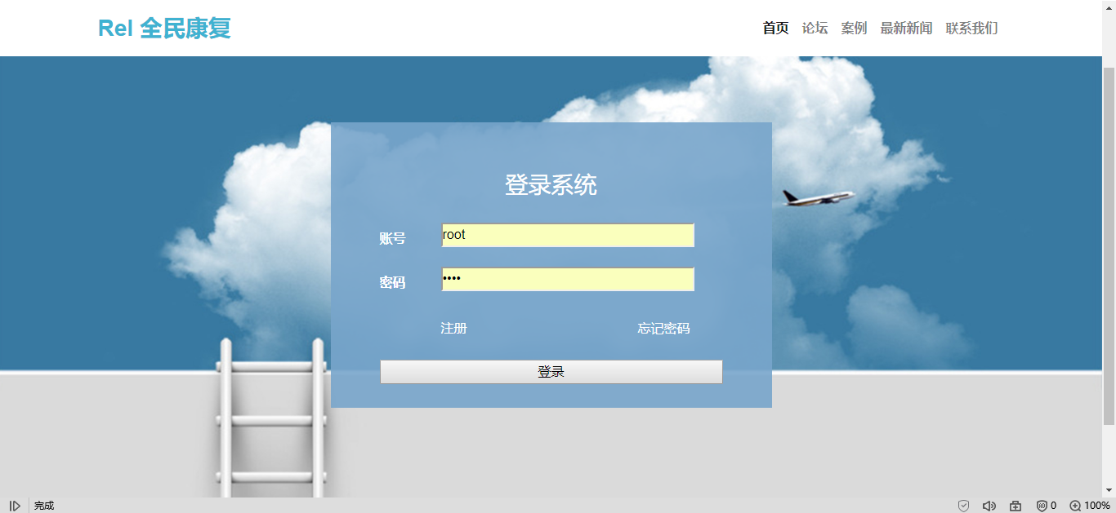

## 帐户注册

### Html

<%@ Page Language="C#" AutoEventWireup="true" CodeBehind="register.aspx.cs" Inherits="Rel.register" %>

<!DOCTYPE html>

<html xmlns="http://www.w3.org/1999/xhtml"><head runat="server"><meta http-equiv="Content-Type" content="text/html; charset=utf-8"/>

<title></title>

<style>

body

{

margin-left:30px;

margin-right:30px;

}

.text_head{

color:white;

margin-left:100px;

float:left;

}

/*注册信息列表*/

.messeges{

margin-top:100px;

margin-right:300px;

}

#Label1{

margin-left:0px;

}

#Label2{

margin-left:320px;

}

#Label7{

margin-left:0px;

}

/*注册信息的 年龄*/

#Label3{

margin-left:-267px;

}

#RadioButtonList1{

margin-left:500px;

}

/*register 个人信息*/

#zhiwei{

margin-left:250px;

float:left;

}

#CheckBoxList1{

margin-left:520px;

}

#t1{

margin-left:-80px;

}

#Label4{

margin-left:-80px;

}

#Button2{

margin-left:505px;

}

</style></head><body style="text-align: center">

<form id="form1" runat="server">

<div>

注册

</div>

<asp:Panel ID="Panel1" runat="server" BackColor="#9999FF" Height="700px" >

<div class="auto-style2">

<p class="text_head">账号信息</p><br />

<div class="messeges">

<asp:Label ID="Label1" runat="server" BackColor="White" Text="姓名"></asp:Label>

<asp:TextBox ID="TextBox1" runat="server"></asp:TextBox>

<asp:RequiredFieldValidator ID="RequiredFieldValidator1" runat="server" ControlToValidate="TextBox1" ErrorMessage="账号不能为空" ForeColor="#333333"></asp:RequiredFieldValidator><br /><br /><br />

<asp:Label ID="Label2" runat="server" BackColor="White" Text="密码"></asp:Label>

<asp:TextBox ID="TextBox2" runat="server"></asp:TextBox>

<asp:RegularExpressionValidator ID="RegularExpressionValidator1" runat="server" ControlToValidate="TextBox2" ErrorMessage="密码长度为8到20位,必须包含字母和数字，字母区分大小写" ForeColor="#333333" ValidationExpression="^(?=.*[0-9])(?=.*[a-zA-Z])(.{8,20})$"></asp:RegularExpressionValidator><br /><br /><br />

<asp:Label ID="Label7" runat="server" BackColor="White" BorderColor="White" Text="确认密码"></asp:Label>

<asp:TextBox ID="TextBox3" runat="server"></asp:TextBox>

<asp:CompareValidator ID="CompareValidator1" runat="server" ErrorMessage="密码不一致！！！" ControlToValidate="TextBox3" Operator="Equal" Type="String" ForeColor="#333333" ControlToCompare="TextBox2"></asp:CompareValidator><br /><br /><br />

<asp:Label ID="Label3" runat="server" BackColor="White" Text="性别"></asp:Label>

<asp:RadioButtonList ID="RadioButtonList1" runat="server" OnSelectedIndexChanged="RadioButtonList1_SelectedIndexChanged">

<asp:ListItem>男</asp:ListItem>

<asp:ListItem Value="女"></asp:ListItem>

</asp:RadioButtonList>

</div>

</div>

<%-- <asp:Label ID="Label4" runat="server" Text="请选择你的职业："></asp:Label>

<asp:DropDownList ID="DropDownList1" runat="server" OnSelectedIndexChanged="DropDownList1_SelectedIndexChanged">

<asp:ListItem>主任医师</asp:ListItem>

<asp:ListItem>教授</asp:ListItem>

<asp:ListItem>硕士生导师</asp:ListItem>

<asp:ListItem>大学生</asp:ListItem>

</asp:DropDownList>

<br />

<asp:Label ID="Label6" runat="server" BackColor="White" Width="120px" Height="30px"></asp:Label>

<br />--%>

<br />

<asp:Button ID="Button1" runat="server" BackColor="#66FFCC" ForeColor="Gray" OnClick="Button1_Click" style="margin-bottom: 98px" Text="继续" />

</asp:Panel>

<asp:Panel ID="Panel2" runat="server" BackColor="#66FFCC" Height="700px" Visible="False">

<div class="auto-style2">

<p class="text_head">个人信息</p>

</div>

<br /> <br />

<div id="zhiwei">你的职位</div>

<br />

<asp:CheckBoxList ID="CheckBoxList1" runat="server">

<asp:ListItem>主任医师&nbsp;&nbsp;&nbsp;</asp:ListItem>

<asp:ListItem>教授&nbsp;&nbsp;&nbsp;&nbsp;&nbsp;&nbsp;&nbsp;&nbsp;&nbsp;&nbsp;</asp:ListItem>

<asp:ListItem>硕士生导师</asp:ListItem>

<asp:ListItem>副教授&nbsp;&nbsp;&nbsp;&nbsp;&nbsp;&nbsp;&nbsp;</asp:ListItem>

<asp:ListItem>院长&nbsp;&nbsp;&nbsp;&nbsp;&nbsp;&nbsp;&nbsp;&nbsp;&nbsp;&nbsp;</asp:ListItem>

</asp:CheckBoxList>

<br /><br /><br />

<asp:Label ID="t1" runat="server" Text="请输入你的个人简历：" />

<asp:TextBox id="txt1" runat="server" Width="379px" />

<br /><br /><br />

<asp:Label ID="Label4" runat="server" Text="请输入你的电话号码：" />

<asp:TextBox id="TextBox4" runat="server" Width="379px" />

<br /><br /><br />

<p>上传头像 </p>

<asp:FileUpload ID="FileUpload1" runat="server" />

<br /><br /><br />

<asp:Button ID="Button2" runat="server" BackColor="#9999FF" OnClick="Button2_Click" Text="完成" />

</asp:Panel>

<asp:SqlDataSource ID="SqlDataSource1" runat="server" ConnectionString="<%$ ConnectionStrings:czbConnectionString %>" SelectCommand="SELECT * FROM [doctors]"></asp:SqlDataSource>

</form></body></html>

### 界面

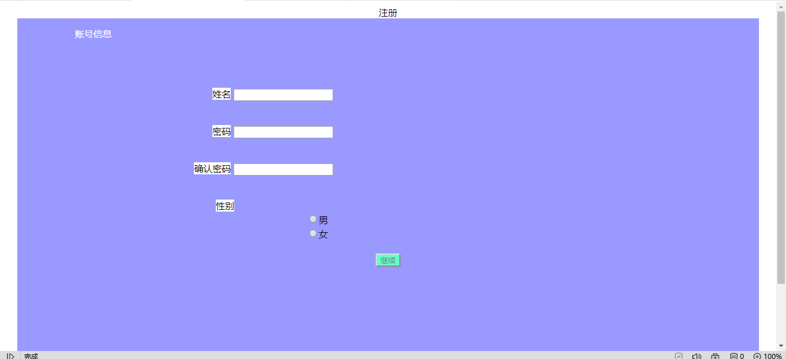

## 预约消息

### Html

<%@ Page Language="C#" AutoEventWireup="true" CodeBehind="index.aspx.cs" Inherits="Rel.index" %>

<!DOCTYPE html><html><head lang="en">

<!-- Required meta tags -->

<meta charset="utf-8">

<meta name="viewport" content="width=device-width, initial-scale=1, shrink-to-fit=no">

<!--引入animate.css + wow.js-->

<link rel="stylesheet" href="css/animate.css" />

<!-- Bootstrap CSS -->

<link rel="stylesheet" href="css/bootstrap.min.css" type="text/css">

<!--引入自定义样式-->

<link rel="stylesheet" href="css/style_index.css" />

<title></title></head><body>

<form id="form1" runat="server">

<nav class="navbar navbar-expand-lg navbar-light fixed-top nav_bk">

<div class="container">

<a class="navbar-brand" href="#" id="REL">

<img src="img/index_toux.png" width="50" height="50" alt="">

<h4>REL 全民康复</h4>

<p>REL NATIONAL REHABILITATION </p>

</a>

<input class="form-control mr-sm-2" type="search" placeholder="请输入关键字" aria-label="Search">

<asp:Button ID="Button1" runat="server" Text="搜索" OnClick="Button1_Click1" />

&nbsp;</div>

</nav>

<div class="container-fluid main-bk">

<!--跑马灯部分-->

<div class="row">

<section id="marquee">

<div class="container">

<div class="row ">

<div class="col-md-12 mg_pd-0">

<div id="carouselExampleInterval" class="carousel slide" data-ride="carousel">

<ol class="carousel-indicators">

<li data-target="#carouselExampleIndicators" data-slide-to="0" class="active"></li>

<li data-target="#carouselExampleIndicators" data-slide-to="1"></li>

<li data-target="#carouselExampleIndicators" data-slide-to="2"></li>

<li data-target="#carouselExampleIndicators" data-slide-to="3"></li>

<li data-target="#carouselExampleIndicators" data-slide-to="4"></li>

</ol>

<div class="carousel-inner">

<div class="carousel-item active" data-interval="10000">

<img src="img/homepage_pao01.jpg" class="d-block w-100" alt="...">

</div>

<div class="carousel-item" data-interval="2000">

<img src="img/homepage_pao02.jpg" class="d-block w-100" alt="...">

</div>

<div class="carousel-item">

<img src="img/homepage_pao03.jpg" class="d-block w-100" alt="...">

</div>

<div class="carousel-item">

<img src="img/homepage_pao04.jpg" class="d-block w-100" alt="...">

</div>

<div class="carousel-item">

<img src="img/homepage_pao05.jpg" class="d-block w-100" alt="...">

</div>

</div>

<a class="carousel-control-prev" href="#carouselExampleInterval" role="button" data-slide="prev">

<span class="carousel-control-prev-icon" aria-hidden="true"></span>

<span class="sr-only">Previous</span>

</a>

<a class="carousel-control-next" href="#carouselExampleInterval" role="button" data-slide="next">

<span class="carousel-control-next-icon" aria-hidden="true"></span>

<span class="sr-only">Next</span>

</a>

</div>

</div>

</div>

</div>

</section>

</div>

<!--信息部分-->

<div class="row">

<section id="information">

<div class="container">

<div class="row">

<div class="col-md-3 information-center">

<%--<img src="img/index_dct.png" alt="" />--%>

<asp:Image ID="Image1" runat="server" style="width:120px;height:120px;border-radius:50%"/>

<br />

<asp:Label ID="Label1" runat="server"></asp:Label>

<button type="button" id="information-appoint-bt" class="btn btn-dark btn-lg btn-block">&nbsp;&nbsp;&nbsp;&nbsp;&nbsp;&nbsp;&nbsp;&nbsp;&nbsp;&nbsp;&nbsp;&nbsp;预约消息&nbsp;&nbsp;&nbsp;&nbsp;&nbsp;&nbsp;&nbsp;&nbsp;&nbsp;》</button>

<button type="button" id="information-patient-bt" class="btn btn-dark btn-lg btn-block">&nbsp;&nbsp;&nbsp;&nbsp;&nbsp;&nbsp;&nbsp;&nbsp;&nbsp;&nbsp;&nbsp;&nbsp;患者信息&nbsp;&nbsp;&nbsp;&nbsp;&nbsp;&nbsp;&nbsp;&nbsp;&nbsp;》</button>

<button type="button" id="information-news-bt" class="btn btn-dark btn-lg btn-block">&nbsp;&nbsp;&nbsp;&nbsp;&nbsp;&nbsp;&nbsp;&nbsp;&nbsp;&nbsp;&nbsp;&nbsp;病例查询&nbsp;&nbsp;&nbsp;&nbsp;&nbsp;&nbsp;&nbsp;&nbsp;&nbsp;》</button>

<button type="button" id="information-inquiry-bt" class="btn btn-dark btn-lg btn-block">&nbsp;&nbsp;&nbsp;&nbsp;&nbsp;&nbsp;&nbsp;&nbsp;&nbsp;&nbsp;&nbsp;&nbsp;线上咨询&nbsp;&nbsp;&nbsp;&nbsp;&nbsp;&nbsp;&nbsp;&nbsp;&nbsp;》</button>

<button type="button" id="information-feedback-bt" class="btn btn-dark btn-lg btn-block">&nbsp;&nbsp;&nbsp;&nbsp;&nbsp;&nbsp;&nbsp;&nbsp;&nbsp;&nbsp;&nbsp;&nbsp;意见反馈&nbsp;&nbsp;&nbsp;&nbsp;&nbsp;&nbsp;&nbsp;&nbsp;&nbsp;》</button>

</div>

<div class="col-md-9 information-right">

<div id="information-appoint">

<asp:GridView ID="GridView1" runat="server" AllowSorting="True" AutoGenerateColumns="False" CellPadding="4" DataSourceID="SqlDataSource1" ForeColor="#333333" GridLines="None" OnSelectedIndexChanged="GridView1_SelectedIndexChanged">

<AlternatingRowStyle BackColor="White" />

<Columns>

<asp:BoundField DataField="appointment_id" HeaderText="appointment_id" SortExpression="appointment_id" />

<asp:BoundField DataField="appointment_contnet" HeaderText="appointment_contnet" SortExpression="appointment_contnet" />

<asp:BoundField DataField="appointment_org" HeaderText="appointment_org" SortExpression="appointment_org" />

<asp:BoundField DataField="appointment_time" HeaderText="appointment_time" SortExpression="appointment_time" />

<asp:BoundField DataField="appointment_describle" HeaderText="appointment_describle" SortExpression="appointment_describle" />

</Columns>

<EditRowStyle BackColor="#2461BF" />

<FooterStyle BackColor="#507CD1" Font-Bold="True" ForeColor="White" />

<HeaderStyle BackColor="#507CD1" Font-Bold="True" ForeColor="White" />

<PagerStyle BackColor="#2461BF" ForeColor="White" HorizontalAlign="Center" />

<RowStyle BackColor="#EFF3FB" />

<SelectedRowStyle BackColor="#D1DDF1" Font-Bold="True" ForeColor="#333333" />

<SortedAscendingCellStyle BackColor="#F5F7FB" />

<SortedAscendingHeaderStyle BackColor="#6D95E1" />

<SortedDescendingCellStyle BackColor="#E9EBEF" />

<SortedDescendingHeaderStyle BackColor="#4870BE" />

</asp:GridView>

</div>

<div id="information-patient" style="display: none; ">

<asp:GridView ID="GridView2" runat="server" AutoGenerateColumns="False" CellPadding="4" DataSourceID="SqlDataSource2" ForeColor="#333333" GridLines="None" Width="809px">

<AlternatingRowStyle BackColor="White" ForeColor="#284775" />

<Columns>

<asp:BoundField DataField="user_id" HeaderText="user_id" SortExpression="user_id" />

<asp:BoundField DataField="user_name" HeaderText="user_name" SortExpression="user_name" />

<asp:BoundField DataField="user_tel" HeaderText="user_tel" SortExpression="user_tel" />

<asp:BoundField DataField="user_email" HeaderText="user_email" SortExpression="user_email" />

<asp:BoundField DataField="user_weather" HeaderText="user_weather" SortExpression="user_weather" />

<asp:BoundField DataField="user_regDate" HeaderText="user_regDate" SortExpression="user_regDate" />

</Columns>

<EditRowStyle BackColor="#999999" />

<FooterStyle BackColor="#5D7B9D" Font-Bold="True" ForeColor="White" />

<HeaderStyle BackColor="#5D7B9D" Font-Bold="True" ForeColor="White" />

<PagerStyle BackColor="#284775" ForeColor="White" HorizontalAlign="Center" />

<RowStyle BackColor="#F7F6F3" ForeColor="#333333" />

<SelectedRowStyle BackColor="#E2DED6" Font-Bold="True" ForeColor="#333333" />

<SortedAscendingCellStyle BackColor="#E9E7E2" />

<SortedAscendingHeaderStyle BackColor="#506C8C" />

<SortedDescendingCellStyle BackColor="#FFFDF8" />

<SortedDescendingHeaderStyle BackColor="#6F8DAE" />

</asp:GridView>

<asp:SqlDataSource ID="SqlDataSource2" runat="server" ConnectionString="<%$ ConnectionStrings:czbConnectionString %>" SelectCommand="SELECT [user_id], [user_name], [user_tel], [user_email], [user_weather], [user_regDate] FROM [users]"></asp:SqlDataSource>

</div>

<div id="information-news" style="background-color: #5ffd30; display: none">

</div>

<div id="information-inquiry" style="background-color: #32fdee; display: none">无</div>

<div id="information-feedback" style="background-color: #5e4cfd; display: none">无</div>

</div>

</div>

</div>

</section>

</div>

<!--位置部分-->

<div class="row">

<section id="location">

<div class="container">

<div class="row">

<div class="col-md-12" style="background-color: #0094ff;">

<div class="location-right" >

<a href="#" id="location-a" class="location-right">今日预约</a>

<p class="location-right">></p>

<a href="#" class="location-right">网站首页</a>

<p class="location-right">你现在所在的位置></p>

</div>

</div>

</div>

</div>

</section>

</div>

<!-- 底部footer-->

<div class="row">

<section id="footer">

<div class="container">

<div class="row">

<div class="col-md-12">

<p>医院地址：南充市顺庆区三公街43号</p>

<p>咨询电话：0880-2365412 0880-2145632</p>

<p>投诉电话：17765523505</p>

<p>企业邮箱：rel@20171334.com</p>

<p>事业单位 四川省人民医院 四川省医学会 </p>

</div>

</div>

</div>

</section>

</div>

</div>

<asp:SqlDataSource ID="SqlDataSource1" runat="server" ConnectionString="<%$ ConnectionStrings:czbConnectionString %>" SelectCommand="SELECT [appointment_id], [appointment_contnet], [appointment_org], [appointment_time], [appointment_describle] FROM [appointments]"></asp:SqlDataSource>

</form>

<!-- Optional JavaScript -->

<!-- jQuery first, then Popper.js, then Bootstrap JS -->

<script type="text/javascript" src="js/jquery-3.4.0.min.js"></script>

<script type="text/javascript" src="js/popper.min.js"></script>

<script type="text/javascript" src="js/bootstrap.min.js"></script>

<script src="js/wow.js" type="text/javascript"></script>

<!--把wow插件进行初始化-->

<script>

new WOW().init();

</script>

<script type="text/javascript">

$(document).ready(function () {

$("#information-appoint-bt").click(function () {

$("#information-appoint").show();

$("#information-patient").hide();

$("#information-news").hide();

$("#information-inquiry").hide();

$("#information-feedback").hide();

$("#location-a").text("今日预约");

});

$("#information-patient-bt").click(function () {

$("#information-patient").show();

$("#information-appoint").hide();

$("#information-news").hide();

$("#information-inquiry").hide();

$("#information-feedback").hide();

$("#location-a").text("患者信息");

});

$("#information-news-bt").click(function () {

$("#information-news").show();

$("#information-appoint").hide();

$("#information-patient").hide();

$("#information-inquiry").hide();

$("#information-feedback").hide();

$("#location-a").text("新闻中心");

});

$("#information-inquiry-bt").click(function () {

$("#information-inquiry").show();

$("#information-appoint").hide();

$("#information-patient").hide();

$("#information-news").hide();

$("#information-feedback").hide();

$("#location-a").text("线上咨询");

});

$("#information-feedback-bt").click(function () {

$("#information-feedback").show();

$("#information-appoint").hide();

$("#information-patient").hide();

$("#information-news").hide();

$("#information-inquiry").hide();

$("#location-a").text("意见反馈");

});

});

</script>

</body></html>

### 界面

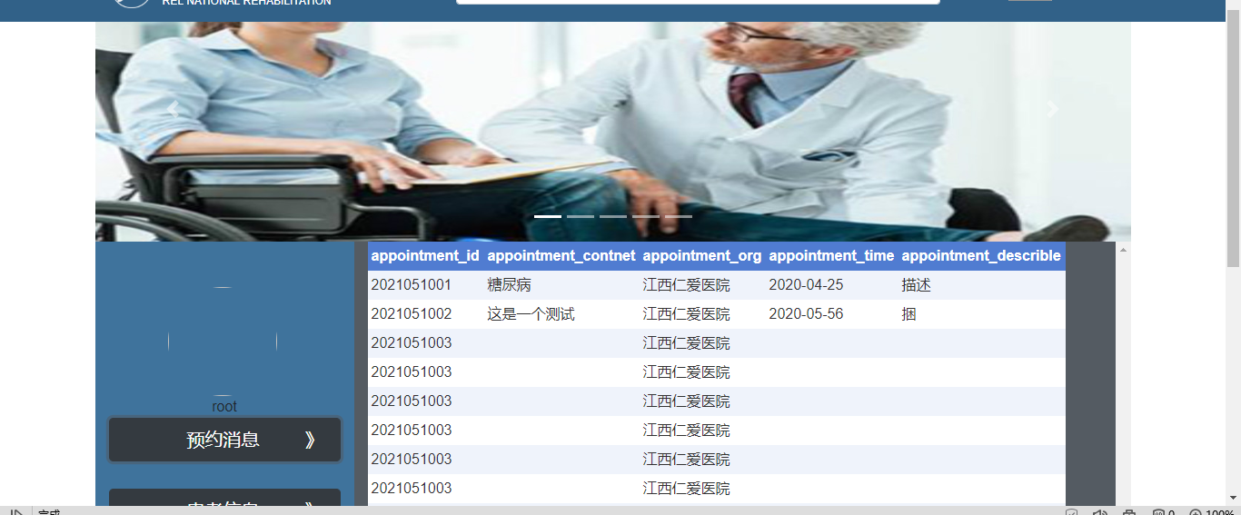

## 意见反馈

意见反馈平台可以朝开发者反馈在使用的途中遇见的问题，方便完善系统。

# 数据库设计

## 表的设计

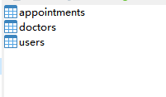

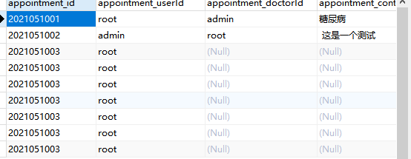

## 字段设计

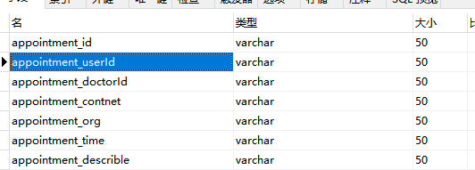

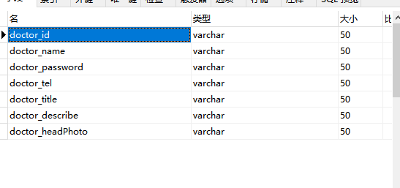

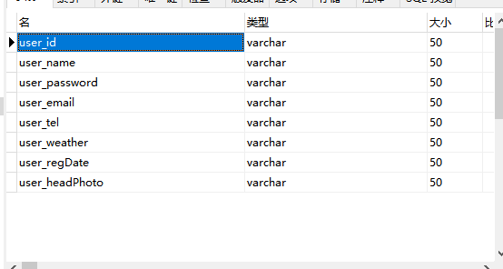

# 总结

Rel康复系统记录每个人员的信息，可以直观的了解每个人员的基本信息。在编写项目的时候也发现了自身的很多弱点，相信在以后的学习中一定能消灭这些弱点。总的来说，编写项目给自己带来了很大的提升，明白了很多编程的理念，更加熟悉了ASP,NET的编程结构，很多在书本上学习不到的知识点都得以体现。