1. 问题描述 2

2. 基本要求 2

3. 概要设计 2

3.1. 设计表guestInfo用户信息表 2

3.2. GuestType表 2

3.3. OpInfo管理员信息表 3

4. 详细设计 3

4.1. 用户删除代码： 3

4.2. 用户新增代码 6

4.3. 房间新增代码 11

5. 运行与测试 13

6. 总结与心得 14

# 问题描述

在系统使用的同时，需要有一个权限高的管理员用户来修改系统中的信息。管理员可以修改用户的登录信息，包括身份证号，密码，性别等。可以更改用户的入住信息，房间的信息等。在系统管理中有举足轻重的作用。

# 基本要求

在进行管理员操作之前必需要进行管理员登录操作，如未登录应跳转到登录界面进行登录操作。并且由于管理员权限较高，一些敏感操作的时候要有智能提示，例如在修改完成时显示相应的消息通知。

能够连接数据库，直接修改数据库数据，达到正确修改的目的。修改密码的时候要求二次输入 ，防止出现密码丢失的现象发生。

修改后的数据能即时反馈到前台展示 ，不影响用户的正常使用。

# 概要设计

## 设计表guestInfo用户信息表

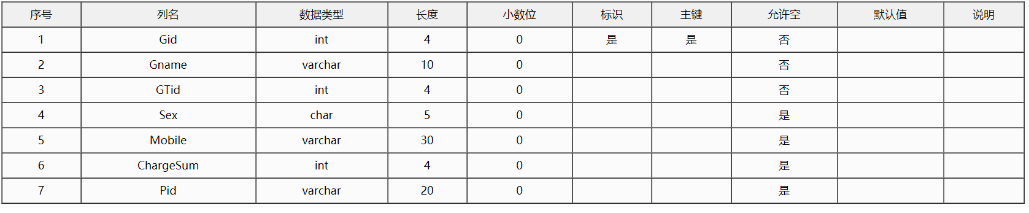

## GuestType表

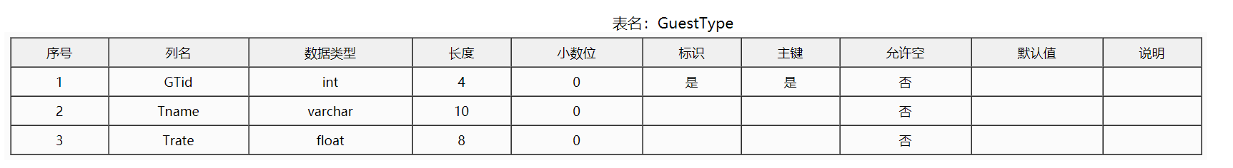

## OpInfo管理员信息表

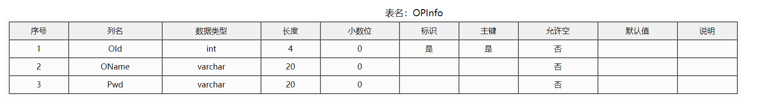

# 详细设计

## 用户删除代码：

<%@ Page Title="" Language="C#" MasterPageFile="~/MasterPage.master" AutoEventWireup="true" CodeBehind="GuestMan.aspx.cs" Inherits="HotelManage.GuestMan" %>

<asp:Content ID="Content1" ContentPlaceHolderID="head" runat="server">

<title> 客户信息（客户管理）</title>

<style type="text/css">

body{text-align:center; overflow-y:auto;overflow-X:auto;}

.gd{font-size:14px; position:relative; top:10px;text-align: center;}

#bk{ border: solid 2px gray;border-radius:15px; width:1170px ; height:630px; position:relative;top:-7px; background-color:White}

#research{ height:200px; background-color:White; width:100%;border-radius:15px 15px 0px 0px; font-size:15px; color:#343434;-webkit-box-shadow:White 0px 0px 10px;-moz-box-shadow:#666 0px 0px 10px}

.bt{ width:170px; height:22px}

.button{ position:relative; left:110px;border-style: none;border-color: inherit;border-width: 0px;background: #00AA68;border-radius:5px; width:90px; height:29px; font-family:微软雅黑; color:White; font-size:18px;cursor:pointer; }

.button1{border-style: none;border-color: inherit;border-width: 0px;background: #00AA68;border-radius:5px; width:90px; height:29px; font-family:微软雅黑; color:White; font-size:18px;cursor:pointer; }

.style1{text-align: center;

height: 161px;

width: 1168px;

}

.style2{text-align: right;}

a{ text-decoration:none;}

a:hover{ text-decoration:none;}

.tcdPageCode{text-align:left;color: #ccc; position:relative; top:19px; left:65px; width:500px; }

.tcdPageCode a{display: inline-block;color: #00aa68;display: inline-block;height: 25px; line-height: 25px; padding: 0 10px;border: 1px solid #00aa68; margin: 0 2px;border-radius: 4px;vertical-align: middle;}

.tcdPageCode a:hover{text-decoration: none;border: 1px solid #00aa68;}

.tcdPageCode span.current{display: inline-block;height: 25px;line-height: 25px;padding: 0 10px;margin: 0 2px;color: #fff;background-color: #00aa68; border: 1px solid #00aa68;border-radius: 4px;vertical-align: middle;}

.tcdPageCode span.disabled{ display: inline-block;height: 25px;line-height: 25px;padding: 0 10px;margin: 0 2px; color: #bfbfbf;background: #f2f2f2;border: 1px solid #bfbfbf;border-radius: 4px;vertical-align: middle;}

.search{ position:relative; top:-8000px; left:-366px; }

</style>

<script language="javascript" type="text/javascript">

</script>

</asp:Content>

<asp:Content ID="Content2" ContentPlaceHolderID="cphRight" runat="server">

<div id="bk" class="style2">

<%--<asp:ScriptManager ID="ScriptManager1" runat="server"></asp:ScriptManager>--%>

<asp:UpdatePanel ID="UpdatePanel1" runat="server">

<ContentTemplate>

<div id="research">

<br />

<br />

<br />

<div class="style1">

顾客编号：<asp:TextBox ID="txtGid" runat="server" CssClass="bt" ></asp:TextBox>

&nbsp;&nbsp;顾客姓名：<asp:TextBox ID="txtGname" runat="server" CssClass="bt"></asp:TextBox>

<br />

<br />

手机号码：<asp:TextBox ID="txtMobile" runat="server" CssClass="bt" ></asp:TextBox>

&nbsp;&nbsp;身份证号：<asp:TextBox ID="txtPid" runat="server" CssClass="bt"></asp:TextBox>

<br />

<br />

&nbsp;&nbsp;&nbsp;&nbsp;&nbsp;&nbsp;&nbsp;&nbsp;&nbsp;&nbsp;<asp:Button ID="btnSearch" runat="server" Text="查询" CssClass="button"

onclick="btnSearch_Click" />

&nbsp; &nbsp;&nbsp; &nbsp;&nbsp; &nbsp;&nbsp; &nbsp;&nbsp; &nbsp;&nbsp; &nbsp;&nbsp; &nbsp;&nbsp;<asp:Button ID="btnAdd" runat="server" CssClass="button" Text="新增"

onclick="btnAdd_Click" />

<asp:Button ID="btnPaging" runat="server"

onclick="btnPaging_Click" Text="新增" CssClass="search" />

<asp:TextBox ID="txtPages" runat="server" Text="a" CssClass="search"></asp:TextBox>

&nbsp;</div>

<br />

</div>

<asp:GridView ID="GridView1" runat="server" AutoGenerateColumns="False"

Width="1038px" DataKeyNames="Gid"

align="center" AllowSorting="True" hearshow="True"

EmptyDataText="暂无数据" CssClass="gd" BackColor="White" BorderColor="#CCCCCC"

BorderStyle="None" BorderWidth="1px" CellPadding="3"

onrowcommand="GridView1_RowCommand" onrowdatabound="GridView1_RowDataBound"

>

<Columns>

<asp:BoundField DataField="Gid" HeaderText="编号" />

<asp:BoundField DataField="Gname" HeaderText="姓名" />

<asp:BoundField DataField="Sex" HeaderText="性别" />

<asp:BoundField DataField="mobile" HeaderText="手机号" />

<asp:BoundField DataField="ChargeSum" HeaderText="累计消费金额" />

<asp:BoundField DataField="pid" HeaderText="身份证号" />

<asp:BoundField DataField="Tname" HeaderText="会员等级" />

<asp:TemplateField HeaderText="信息修改">

<ItemTemplate>

<asp:Button ID="btnEdit" runat="server" CommandArgument='<%#Eval("Gid")%>' CommandName="bj" CssClass="button1" Text="信息修改" />

</ItemTemplate>

</asp:TemplateField>

<asp:TemplateField HeaderText="顾客升级">

<ItemTemplate>

<a onclick="JavaScript:return confirm('是否确认升级该顾客？')"> <asp:Button ID="btnUpgrade" runat="server" Text="顾客升级" CommandArgument='<%#Eval("Gid")%>' CommandName="sj" CssClass="button1"/></a>

</ItemTemplate>

</asp:TemplateField>

<asp:TemplateField HeaderText="删除顾客">

<ItemTemplate>

<a onclick="JavaScript:return confirm('确定删除吗？')"><asp:Button ID="btnDel" runat="server" Text="删除" CommandName="sc" CommandArgument='<%#Eval("Gid")%>' CssClass="button1"/></a>

</ItemTemplate>

</asp:TemplateField>

</Columns>

<FooterStyle BackColor="White" ForeColor="#343434" />

<HeaderStyle BackColor="#C4DCF8" Font-Bold="True" ForeColor="#343434" />

<PagerStyle BackColor="White" ForeColor="#343434" HorizontalAlign="Left" />

<RowStyle ForeColor="#343434" />

<SelectedRowStyle BackColor="#669999" Font-Bold="True" ForeColor="#343434" />

<SortedAscendingCellStyle BackColor="#F1F1F1" />

<SortedAscendingHeaderStyle BackColor="#007DBB" />

<SortedDescendingCellStyle BackColor="#CAC9C9" />

<SortedDescendingHeaderStyle BackColor="#00547E" />

</asp:GridView>

</ContentTemplate></asp:UpdatePanel>

<div style=" float:left">

<div class="tcdPageCode">

</div> <asp:TextBox ID="txtCPage" runat="server" CssClass="search"></asp:TextBox>

<asp:Label

ID="Label1" runat="server"></asp:Label></div>

</div>

<script src="js/jquery.min.js" type="text/javascript"></script>

<script src="js/jquery.page.js" type="text/javascript"></script>

<script type="text/jscript">

$(".tcdPageCode").createPage(

{

pageCount:<%=ye()%>,

current: 1,

backFn: function (p) {

document.getElementById("<%=txtCPage.ClientID %>").value = p;

var myLink = document.getElementById("<%=btnPaging.ClientID %>");

myLink.click();

}

}

);

</script>

</asp:Content>

## 用户新增代码

<%@ Page Title="" Language="C#" MasterPageFile="~/MasterPage.master" AutoEventWireup="true" CodeBehind="GuestReg.aspx.cs" Inherits="HotelManage.GuestReg" %>

<asp:Content ID="Content1" ContentPlaceHolderID="head" runat="server">

<title> 新增客户（客户管理）/新增用户信息登记（表）</title>

<style type="text/css">

table {

border: solid 1px #747474

}

tr {

border: solid 1px #747474

}

td {

border: solid 1px #747474

}

#table {

font-size: 16px;

font-family: 微软雅黑;

position: relative;

/*top: 50px;

left: 201px;*/

top: 35%;

left: 13%;

border-radius: 15px 15px 0px 0px;

}

.tdstyle {

background-color: #ffffff;

text-align:center;

}

.text {

margin-left: 0px;

Height: 40px;

width: 272px;

border: 0px;

font-size: 20px;

font-family: 微软雅黑;

background-color: #ffffff

}

.buttom {

background: #00AA68;

width: 100px;

height: 30px;

cursor: pointer;

font-size: 20px;

font-family: 微软雅黑;

border: 1px solid #CCCCCC;

border-radius: 8px;

}

body {

text-align: center;

overflow:auto;

}

.gd {

font-size: 14px;

position: relative;

top: 10px;

text-align: center;

}

#bk {

border: solid 2px gray;

border-radius: 15px;

width: 1170px;

height: 630px;

position: relative;

top: -7px;

background-color: #ffffff

}

#research {

height: 400px;

background-color: #ffffff;

width: 100%;

border-radius: 15px 15px 0px 0px;

font-size: 15px;

color: #343434;

-webkit-box-shadow: #fff 0px 0px 10px;

-moz-box-shadow: #666 0px 0px 10px

}

.auto-style1 {

width: 270px;

}

</style>

</asp:Content>

<asp:Content ID="Content2" ContentPlaceHolderID="cphRight" runat="server">

<div id="bk" class="style2">

<div id="research">

<div id="table">

<table cellpadding="0" cellspacing="0" width="900">

<tr>

<td class="tdstyle" colspan="4" height="52"><span style="font-size: 24px;">新增顾客信息登记表</span>

</td>

</tr>

<tr>

<td class="tdstyle" width="115">顾客姓名：

</td>

<td width="270">

<asp:TextBox ID="txtGname" runat="server" CssClass="text"></asp:TextBox>

</td>

<td width="115" class="tdstyle">顾客性别：

</td>

<td height="40" class="auto-style1">

<asp:RadioButton ID="rdoMale" runat="server" GroupName="a" Text="男" Checked="True" Font-Size="14pt" />

&nbsp;&nbsp;&nbsp;&nbsp;&nbsp;&nbsp;&nbsp;&nbsp;

<asp:RadioButton ID="rdoFemale" runat="server" GroupName="a" Text="女" Font-Size="14pt" />

</td>

</tr>

<tr>

<td class="tdstyle">联系方式：

</td>

<td class="style3">

<asp:TextBox ID="txtMobile" runat="server" CssClass="text"></asp:TextBox>

<asp:RequiredFieldValidator ID="RequiredFieldValidator2" runat="server" ErrorMessage="*" ControlToValidate="txtMobile"></asp:RequiredFieldValidator>

</td>

<td class="tdstyle">顾客等级：

</td>

<td height="37" class="auto-style1">

<asp:DropDownList ID="ddlGTid" runat="server" CssClass="text"></asp:DropDownList>

</td>

</tr>

<tr>

<td class="tdstyle">身份证号：

</td>

<td>

<asp:TextBox ID="txtPid" runat="server" CssClass="text"></asp:TextBox>

<asp:RequiredFieldValidator ID="RequiredFieldValidator1" runat="server" ErrorMessage="*" ControlToValidate="txtPid"></asp:RequiredFieldValidator>

</td>

<td class="tdstyle">累计消费：

</td>

<td height="37" class="auto-style1">

<asp:TextBox ID="txtChargeSum" runat="server" CssClass="text">0</asp:TextBox>

</td>

</tr>

<tr>

<td width="93" style="height: 101px;" class="tdstyle">备注信息：

</td>

<td colspan="3">

<asp:TextBox ID="TextBox7" runat="server" Width="660" Height="101"

TextMode="MultiLine" Font-Names="微软雅黑" Font-Size="16pt" BackColor="#ffffff"></asp:TextBox>

</td>

</tr>

<tr>

<td colspan="4" style="height: 40px" class="tdstyle">

<asp:Button ID="btnSubmit" runat="server" Text="提交" CssClass="buttom"

OnClick="btnSubmit_Click" BorderColor="Black" />

&nbsp; &nbsp; &nbsp; &nbsp; &nbsp; &nbsp; &nbsp; &nbsp; &nbsp; &nbsp; &nbsp; &nbsp; &nbsp; &nbsp; &nbsp; &nbsp; &nbsp; &nbsp; &nbsp;<asp:Button ID="btnCancel" runat="server" CssClass="buttom" Text="取消" />

</td>

</tr>

</table>

</div>

</div>

</div>

</asp:Content>

## 房间新增代码

<%@ Page Title="" Language="C#" MasterPageFile="~/MasterPage.master" AutoEventWireup="true" CodeBehind="CreRoom.aspx.cs" Inherits="HotelManage.CreRoom" %>

<asp:Content ID="Content1" ContentPlaceHolderID="head" runat="server">

<title>房间开通登记（表）</title>

<style type="text/css">

table{border:solid 1px #747474}

tr{border:solid 1px #747474}

td{border:solid 1px #747474}

#table{ font-size:16px; font-family:微软雅黑; position:relative; top:50px; left:201px;border-radius:15px 15px 0px 0px;}

.tdstyle{ background-color:#ffffff;text-align:center}

.text{margin-left: 0px;Height:40px; width:272px; border:0px; font-size:20px; font-family:微软雅黑; background-color:#ffffff}

.buttom{ background:#00AA68; width:100px; height:30px; cursor:pointer;font-size:20px; font-family:微软雅黑; border:1px solid #CCCCCC;border-radius:8px;}

body{text-align:center; overflow-y:auto;overflow-X:auto;}

.gd{font-size:14px; position:relative; top:10px;text-align: center;}

#bk{ border: solid 2px White;border-radius:15px; width:1170px ; height:630px; position:relative;top:-7px; background-color:#ffffff}

#research{ height:400px; background-color:#ffffff; width:100%;border-radius:15px 15px 0px 0px; font-size:15px; color:#000000;-webkit-box-shadow:#ffffff 0px 0px 10px;-moz-box-shadow:#666 0px 0px 10px}

</style>

</asp:Content>

<asp:Content ID="Content2" ContentPlaceHolderID="cphRight" runat="server">

<div id="bk" class="style2">

<div id="research">

<%--<asp:ScriptManager ID="ScriptManager1" runat="server"></asp:ScriptManager>--%>

<asp:UpdatePanel ID="UpdatePanel1" runat="server">

<ContentTemplate>

<div id="table">

<table cellpadding="0" cellspacing="0" width="765">

<tr>

<td class="tdstyle" colspan="4" height="52"><span style=" font-size:24px;">&nbsp; 房间开通登记表</span></td>

</tr>

<tr>

<td class="tdstyle" width="115" >&nbsp; 房间序号：</td>

<td width="270" >

<asp:TextBox ID="txtRoomId" runat="server" CssClass="text" ></asp:TextBox>

</td>

<td width="115" class="tdstyle">&nbsp; 输入名称：</td>

<td width="270" height="40">

<asp:TextBox ID="txtRoomName" runat="server" CssClass="text" placeholder="请输入名称 如:C025" ></asp:TextBox>

</td>

</tr>

<tr>

<td class="tdstyle">&nbsp; 选择楼层：</td>

<td class="style3">

<asp:DropDownList ID="ddlFName" runat="server" AutoPostBack="True"

CssClass="text">

</asp:DropDownList>

</td>

<td class="tdstyle">&nbsp; 房间类型：</td>

<td height="37">

<asp:TextBox ID="txtRTName" runat="server" CssClass="text"></asp:TextBox>

</td>

</tr>

<tr>

<td width="93" style="height:101px;" class="tdstyle">&nbsp; 备注信息：</td>

<td colspan="3" >

<asp:TextBox ID="TextBox7" runat="server" Width="660" Height="101"

TextMode="MultiLine" Font-Names="微软雅黑" Font-Size="16pt" BackColor="#ffffff" ></asp:TextBox>

</td>

</tr>

<tr>

<td colspan="4" style="height:40px" class="tdstyle">

<asp:Button ID="btnSubmit" runat="server" Text="提交" CssClass="buttom"

onclick="btnSubmit_Click" />

&nbsp;&nbsp;&nbsp;&nbsp;&nbsp;&nbsp;&nbsp;&nbsp;&nbsp;&nbsp;&nbsp;&nbsp;&nbsp;&nbsp;&nbsp;&nbsp;&nbsp;&nbsp;&nbsp;&nbsp;&nbsp;&nbsp;&nbsp;&nbsp;

<input type="button" onclick="javascript:window.history.go(-1);"value="返回" class="buttom">

</td>

</tr>

</table>

</div>

</ContentTemplate></asp:UpdatePanel>

</div>

</div>

</asp:Content>

# 运行与测试

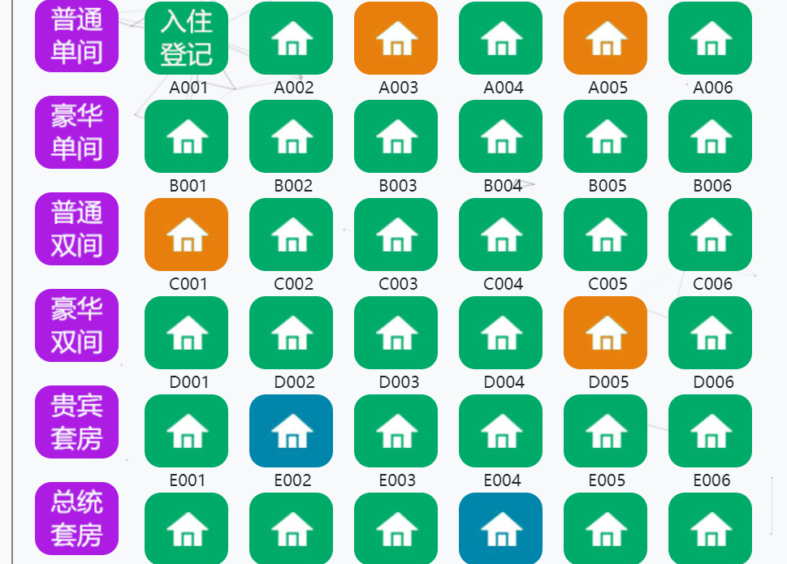

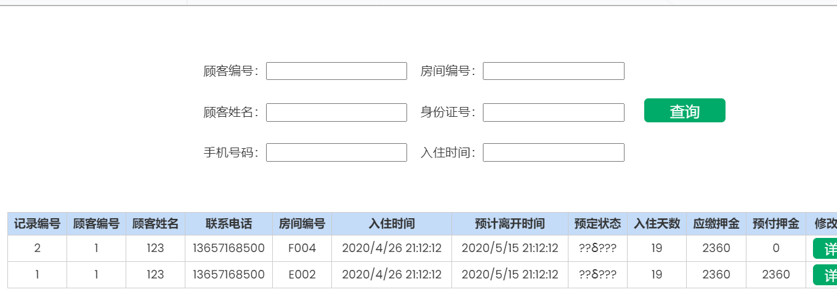

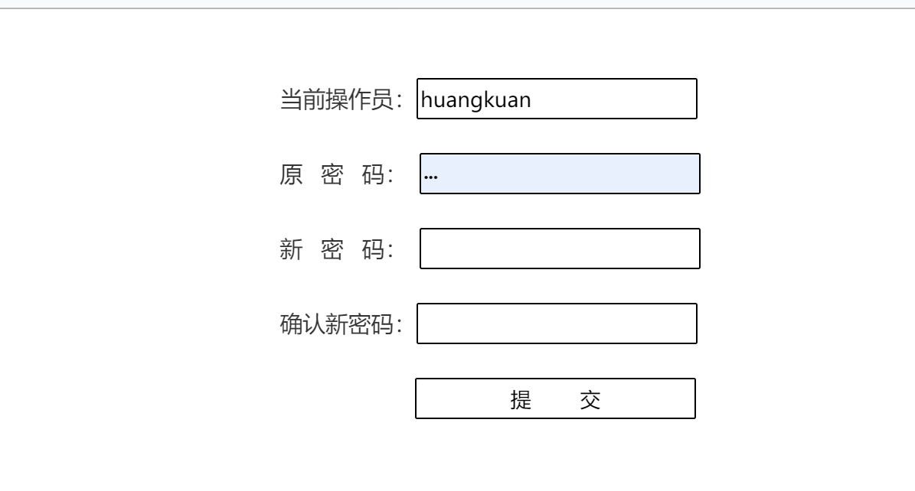

# 总结与心得

通过对该系统的设计、开发和调试，一方面让我了解了MIS系统的开发过程与方法，另一方面，让我初步掌握了ASP.NET开发工具的使用方法，同时，在制作过程中遇到了不少问题和困难，通过查阅书籍及互连网得到了不小的收获。