1. 问题描述 2

2. 基本要求 2

3. 概要设计 2

3.1. 顾客信息表 2

3.2. 房间状态表 3

3.3. 房间类型表 3

3.4. 房间结算表 4

4. 详细设计 4

4.1. GuestReg前台（用户注册）代码 4

4.2. 后台： 8

4.3. guestMan（用户信息）前台 10

4.4. 后台 14

5. 运行与测试 20

6. 总结与心得 21

# 问题描述

网站在运营的同时 免不了要对房间信息进行添加删除或修改操作，为了规范管理者管理操作和简化管理员要进行的操作而需要编写出房间管理模块。而为了管理使用的用户，则必要开发用户管理模块。

# 基本要求

在用户或管理员使用系统的时候能提供较好的界面来展示且第一步操作完之后需要告知使用者操作是否成功。每个模块遵循低耦合高内聚的基本原则。能明了的显示出要表达的信息。每个房间的类型及条件应当能完整显示

# 概要设计

## 顾客信息表

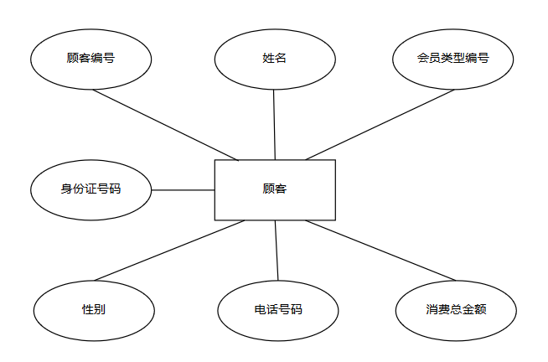

## 房间状态表

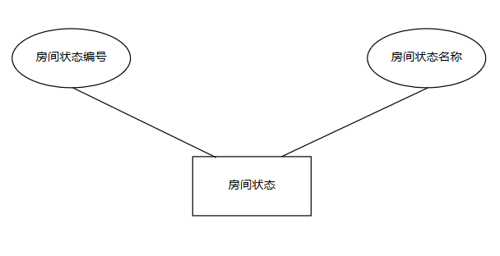

## 房间类型表

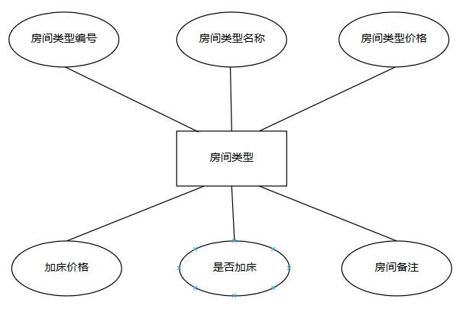

## 房间结算表

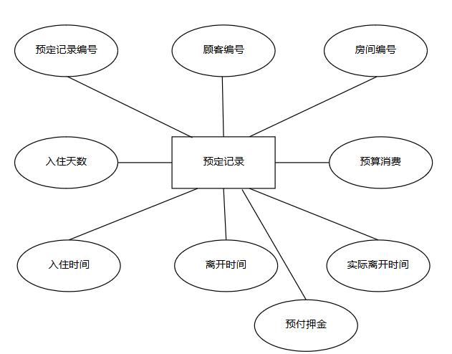

# 详细设计

## GuestReg前台（用户注册）代码

<%@ Page Title="" Language="C#" MasterPageFile="~/MasterPage.master" AutoEventWireup="true" CodeBehind="GuestReg.aspx.cs" Inherits="HotelManage.GuestReg" %>

<asp:Content ID="Content1" ContentPlaceHolderID="head" runat="server">

<title> 新增客户（客户管理）/新增用户信息登记（表）</title>

<style type="text/css">

table {

border: solid 1px #747474

}

tr {

border: solid 1px #747474

}

td {

border: solid 1px #747474

}

#table {

font-size: 16px;

font-family: 微软雅黑;

position: relative;

/*top: 50px;

left: 201px;*/

top: 35%;

left: 13%;

border-radius: 15px 15px 0px 0px;

}

.tdstyle {

background-color: #ffffff;

text-align:center;

}

.text {

margin-left: 0px;

Height: 40px;

width: 272px;

border: 0px;

font-size: 20px;

font-family: 微软雅黑;

background-color: #ffffff

}

.buttom {

background: #00AA68;

width: 100px;

height: 30px;

cursor: pointer;

font-size: 20px;

font-family: 微软雅黑;

border: 1px solid #CCCCCC;

border-radius: 8px;

}

body {

text-align: center;

overflow:auto;

}

.gd {

font-size: 14px;

position: relative;

top: 10px;

text-align: center;

}

#bk {

border: solid 2px gray;

border-radius: 15px;

width: 1170px;

height: 630px;

position: relative;

top: -7px;

background-color: #ffffff

}

#research {

height: 400px;

background-color: #ffffff;

width: 100%;

border-radius: 15px 15px 0px 0px;

font-size: 15px;

color: #343434;

-webkit-box-shadow: #fff 0px 0px 10px;

-moz-box-shadow: #666 0px 0px 10px

}

.auto-style1 {

width: 270px;

}

</style>

</asp:Content>

<asp:Content ID="Content2" ContentPlaceHolderID="cphRight" runat="server">

<div id="bk" class="style2">

<div id="research">

<div id="table">

<table cellpadding="0" cellspacing="0" width="900">

<tr>

<td class="tdstyle" colspan="4" height="52"><span style="font-size: 24px;">新增顾客信息登记表</span>

</td>

</tr>

<tr>

<td class="tdstyle" width="115">顾客姓名：

</td>

<td width="270">

<asp:TextBox ID="txtGname" runat="server" CssClass="text"></asp:TextBox>

</td>

<td width="115" class="tdstyle">顾客性别：

</td>

<td height="40" class="auto-style1">

<asp:RadioButton ID="rdoMale" runat="server" GroupName="a" Text="男" Checked="True" Font-Size="14pt" />

&nbsp;&nbsp;&nbsp;&nbsp;&nbsp;&nbsp;&nbsp;&nbsp;

<asp:RadioButton ID="rdoFemale" runat="server" GroupName="a" Text="女" Font-Size="14pt" />

</td>

</tr>

<tr>

<td class="tdstyle">联系方式：

</td>

<td class="style3">

<asp:TextBox ID="txtMobile" runat="server" CssClass="text"></asp:TextBox>

<asp:RequiredFieldValidator ID="RequiredFieldValidator2" runat="server" ErrorMessage="*" ControlToValidate="txtMobile"></asp:RequiredFieldValidator>

</td>

<td class="tdstyle">顾客等级：

</td>

<td height="37" class="auto-style1">

<asp:DropDownList ID="ddlGTid" runat="server" CssClass="text"></asp:DropDownList>

</td>

</tr>

<tr>

<td class="tdstyle">身份证号：

</td>

<td>

<asp:TextBox ID="txtPid" runat="server" CssClass="text"></asp:TextBox>

<asp:RequiredFieldValidator ID="RequiredFieldValidator1" runat="server" ErrorMessage="*" ControlToValidate="txtPid"></asp:RequiredFieldValidator>

</td>

<td class="tdstyle">累计消费：

</td>

<td height="37" class="auto-style1">

<asp:TextBox ID="txtChargeSum" runat="server" CssClass="text">0</asp:TextBox>

</td>

</tr>

<tr>

<td width="93" style="height: 101px;" class="tdstyle">备注信息：

</td>

<td colspan="3">

<asp:TextBox ID="TextBox7" runat="server" Width="660" Height="101"

TextMode="MultiLine" Font-Names="微软雅黑" Font-Size="16pt" BackColor="#ffffff"></asp:TextBox>

</td>

</tr>

<tr>

<td colspan="4" style="height: 40px" class="tdstyle">

<asp:Button ID="btnSubmit" runat="server" Text="提交" CssClass="buttom"

OnClick="btnSubmit_Click" BorderColor="Black" />

&nbsp; &nbsp; &nbsp; &nbsp; &nbsp; &nbsp; &nbsp; &nbsp; &nbsp; &nbsp; &nbsp; &nbsp; &nbsp; &nbsp; &nbsp; &nbsp; &nbsp; &nbsp; &nbsp;<asp:Button ID="btnCancel" runat="server" CssClass="buttom" Text="取消" />

</td>

</tr>

</table>

</div>

</div>

</div>

</asp:Content>

## 后台：

using BLL;

using System;

using System.Collections.Generic;

using System.Data;

using System.Linq;

using System.Web;

using System.Web.UI;

using System.Web.UI.WebControls;

namespace HotelManage

{

public partial class GuestReg : System.Web.UI.Page

{

protected void Page_Load(object sender, EventArgs e)

{

bind();

}

public void bind()

{

DataTable dt = BLL_Hotel.bind_GuestTname();

this.ddlGTid.DataSource = dt;

this.ddlGTid.DataValueField = "GTid";

this.ddlGTid.DataTextField = "Tname";

this.ddlGTid.DataBind();

}

//提交新增客户信息到数据库

protected void btnSubmit_Click(object sender, EventArgs e)

{

string name = this.txtGname.Text;

string mobile = this.txtMobile.Text;

string pid = this.txtPid.Text;

int chargesum = Convert.ToInt32(this.txtChargeSum.Text);

int GTid = Convert.ToInt32(this.ddlGTid.SelectedValue);

string sex = "男";

if (this.rdoFemale.Checked == true)

{

sex = "女";

}

BLL_Hotel.Add_GuestInfo(name, GTid, sex, mobile, chargesum, pid);//新增顾客信息

Response.Write("<script>alert('客户信息添加成功！');location.href='Guestinfo.aspx';</script>");

}

}

}

## guestMan（用户信息）前台

<%@ Page Title="" Language="C#" MasterPageFile="~/MasterPage.master" AutoEventWireup="true" CodeBehind="GuestMan.aspx.cs" Inherits="HotelManage.GuestMan" %>

<asp:Content ID="Content1" ContentPlaceHolderID="head" runat="server">

<title> 客户信息（客户管理）</title>

<style type="text/css">

body{text-align:center; overflow-y:auto;overflow-X:auto;}

.gd{font-size:14px; position:relative; top:10px;text-align: center;}

#bk{ border: solid 2px gray;border-radius:15px; width:1170px ; height:630px; position:relative;top:-7px; background-color:White}

#research{ height:200px; background-color:White; width:100%;border-radius:15px 15px 0px 0px; font-size:15px; color:#343434;-webkit-box-shadow:White 0px 0px 10px;-moz-box-shadow:#666 0px 0px 10px}

.bt{ width:170px; height:22px}

.button{ position:relative; left:110px;border-style: none;border-color: inherit;border-width: 0px;background: #00AA68;border-radius:5px; width:90px; height:29px; font-family:微软雅黑; color:White; font-size:18px;cursor:pointer; }

.button1{border-style: none;border-color: inherit;border-width: 0px;background: #00AA68;border-radius:5px; width:90px; height:29px; font-family:微软雅黑; color:White; font-size:18px;cursor:pointer; }

.style1{text-align: center;

height: 161px;

width: 1168px;

}

.style2{text-align: right;}

a{ text-decoration:none;}

a:hover{ text-decoration:none;}

.tcdPageCode{text-align:left;color: #ccc; position:relative; top:19px; left:65px; width:500px; }

.tcdPageCode a{display: inline-block;color: #00aa68;display: inline-block;height: 25px; line-height: 25px; padding: 0 10px;border: 1px solid #00aa68; margin: 0 2px;border-radius: 4px;vertical-align: middle;}

.tcdPageCode a:hover{text-decoration: none;border: 1px solid #00aa68;}

.tcdPageCode span.current{display: inline-block;height: 25px;line-height: 25px;padding: 0 10px;margin: 0 2px;color: #fff;background-color: #00aa68; border: 1px solid #00aa68;border-radius: 4px;vertical-align: middle;}

.tcdPageCode span.disabled{ display: inline-block;height: 25px;line-height: 25px;padding: 0 10px;margin: 0 2px; color: #bfbfbf;background: #f2f2f2;border: 1px solid #bfbfbf;border-radius: 4px;vertical-align: middle;}

.search{ position:relative; top:-8000px; left:-366px; }

</style>

<script language="javascript" type="text/javascript">

</script>

</asp:Content>

<asp:Content ID="Content2" ContentPlaceHolderID="cphRight" runat="server">

<div id="bk" class="style2">

<%--<asp:ScriptManager ID="ScriptManager1" runat="server"></asp:ScriptManager>--%>

<asp:UpdatePanel ID="UpdatePanel1" runat="server">

<ContentTemplate>

<div id="research">

<br />

<br />

<br />

<div class="style1">

顾客编号：<asp:TextBox ID="txtGid" runat="server" CssClass="bt" ></asp:TextBox>

&nbsp;&nbsp;顾客姓名：<asp:TextBox ID="txtGname" runat="server" CssClass="bt"></asp:TextBox>

<br />

<br />

手机号码：<asp:TextBox ID="txtMobile" runat="server" CssClass="bt" ></asp:TextBox>

&nbsp;&nbsp;身份证号：<asp:TextBox ID="txtPid" runat="server" CssClass="bt"></asp:TextBox>

<br />

<br />

&nbsp;&nbsp;&nbsp;&nbsp;&nbsp;&nbsp;&nbsp;&nbsp;&nbsp;&nbsp;<asp:Button ID="btnSearch" runat="server" Text="查询" CssClass="button"

onclick="btnSearch_Click" />

&nbsp; &nbsp;&nbsp; &nbsp;&nbsp; &nbsp;&nbsp; &nbsp;&nbsp; &nbsp;&nbsp; &nbsp;&nbsp; &nbsp;&nbsp;<asp:Button ID="btnAdd" runat="server" CssClass="button" Text="新增"

onclick="btnAdd_Click" />

<asp:Button ID="btnPaging" runat="server"

onclick="btnPaging_Click" Text="新增" CssClass="search" />

<asp:TextBox ID="txtPages" runat="server" Text="a" CssClass="search"></asp:TextBox>

&nbsp;</div>

<br />

</div>

<asp:GridView ID="GridView1" runat="server" AutoGenerateColumns="False"

Width="1038px" DataKeyNames="Gid"

align="center" AllowSorting="True" hearshow="True"

EmptyDataText="暂无数据" CssClass="gd" BackColor="White" BorderColor="#CCCCCC"

BorderStyle="None" BorderWidth="1px" CellPadding="3"

onrowcommand="GridView1_RowCommand" onrowdatabound="GridView1_RowDataBound"

>

<Columns>

<asp:BoundField DataField="Gid" HeaderText="编号" />

<asp:BoundField DataField="Gname" HeaderText="姓名" />

<asp:BoundField DataField="Sex" HeaderText="性别" />

<asp:BoundField DataField="mobile" HeaderText="手机号" />

<asp:BoundField DataField="ChargeSum" HeaderText="累计消费金额" />

<asp:BoundField DataField="pid" HeaderText="身份证号" />

<asp:BoundField DataField="Tname" HeaderText="会员等级" />

<asp:TemplateField HeaderText="信息修改">

<ItemTemplate>

<asp:Button ID="btnEdit" runat="server" CommandArgument='<%#Eval("Gid")%>' CommandName="bj" CssClass="button1" Text="信息修改" />

</ItemTemplate>

</asp:TemplateField>

<asp:TemplateField HeaderText="顾客升级">

<ItemTemplate>

<a onclick="JavaScript:return confirm('是否确认升级该顾客？')"> <asp:Button ID="btnUpgrade" runat="server" Text="顾客升级" CommandArgument='<%#Eval("Gid")%>' CommandName="sj" CssClass="button1"/></a>

</ItemTemplate>

</asp:TemplateField>

<asp:TemplateField HeaderText="删除顾客">

<ItemTemplate>

<a onclick="JavaScript:return confirm('确定删除吗？')"><asp:Button ID="btnDel" runat="server" Text="删除" CommandName="sc" CommandArgument='<%#Eval("Gid")%>' CssClass="button1"/></a>

</ItemTemplate>

</asp:TemplateField>

</Columns>

<FooterStyle BackColor="White" ForeColor="#343434" />

<HeaderStyle BackColor="#C4DCF8" Font-Bold="True" ForeColor="#343434" />

<PagerStyle BackColor="White" ForeColor="#343434" HorizontalAlign="Left" />

<RowStyle ForeColor="#343434" />

<SelectedRowStyle BackColor="#669999" Font-Bold="True" ForeColor="#343434" />

<SortedAscendingCellStyle BackColor="#F1F1F1" />

<SortedAscendingHeaderStyle BackColor="#007DBB" />

<SortedDescendingCellStyle BackColor="#CAC9C9" />

<SortedDescendingHeaderStyle BackColor="#00547E" />

</asp:GridView>

</ContentTemplate></asp:UpdatePanel>

<div style=" float:left">

<div class="tcdPageCode">

</div> <asp:TextBox ID="txtCPage" runat="server" CssClass="search"></asp:TextBox>

<asp:Label

ID="Label1" runat="server"></asp:Label></div>

</div>

<script src="js/jquery.min.js" type="text/javascript"></script>

<script src="js/jquery.page.js" type="text/javascript"></script>

<script type="text/jscript">

$(".tcdPageCode").createPage(

{

pageCount:<%=ye()%>,

current: 1,

backFn: function (p) {

document.getElementById("<%=txtCPage.ClientID %>").value = p;

var myLink = document.getElementById("<%=btnPaging.ClientID %>");

myLink.click();

}

}

);

</script>

</asp:Content>

## 后台

using BLL;

using System;

using System.Collections.Generic;

using System.Data;

using System.Linq;

using System.Web;

using System.Web.UI;

using System.Web.UI.WebControls;

namespace HotelManage

{

public partial class GuestMan : System.Web.UI.Page

{

protected void Page_Load(object sender, EventArgs e)

{

if (!IsPostBack)

{

bind();

}

}

public int ye()

{

if (!IsPostBack)

{

return Convert.ToInt32(this.txtPages.Text);

}

else

{

return 0;

}

}

public void hehe()

{

int allye = Convert.ToInt32(BLL_Hotel.Cha_Cus().Rows.Count.ToString());

if (allye % 6 == 0)

{

this.txtPages.Text = (allye / 6).ToString();

}

else

{

this.txtPages.Text = (allye / 6 + 1).ToString();

}

}

public void bind()

{

DataTable dt = BLL_Hotel.Cha_CusFenYe(1);

this.GridView1.DataSource = dt;

this.GridView1.DataBind();

hehe();

}

//对客户进行修改、删除、升级会员等级

protected void GridView1_RowCommand(object sender, GridViewCommandEventArgs e)

{

if (e.CommandName == "bj") //如果用户点击“修改用户信息”

{

int gid = Convert.ToInt32(e.CommandArgument);

Response.Redirect("ChangeGuest.aspx?gid=" + gid);//重定向到客户信息修改页面ChangeGuest.aspx

}

if (e.CommandName == "sc")//如果用户点击删除

{

int gid = Convert.ToInt32(e.CommandArgument);

BLL_Hotel.Del_GuestInfo(gid);//删除顾客

ScriptManager.RegisterClientScriptBlock(UpdatePanel1, this.GetType(), "click", "alert('删除成功！');", true);

bind();

}

if (e.CommandName == "sj")//如果用户点击"升级顾客"

{

int gid = Convert.ToInt32(e.CommandArgument);

DataTable dt = BLL_Hotel.Cha_Guestinfo(gid);//根据顾客编号查询该顾客的个人信息

if (dt.Rows[0]["gtid"].ToString() == "4")

{

ScriptManager.RegisterClientScriptBlock(UpdatePanel1, this.GetType(), "click", "alert('当前顾客等级为顶级钻石会员，暂无法升级！');", true);

}

else

{

BLL_Hotel.UpdateGuest(gid);//顾客升级

ScriptManager.RegisterClientScriptBlock(UpdatePanel1, this.GetType(), "click", "alert('顾客升级成功！');", true);

bind();

}

}

}

//查询顾客

protected void btnSearch_Click(object sender, EventArgs e)

{

if (this.txtGid.Text != "" && this.txtGname.Text == "" && this.txtMobile.Text == "" && this.txtPid.Text == "")

{

this.Label1.Text = "Gid";

int idd = Convert.ToInt32(this.txtGid.Text);

DataTable dt = BLL_Hotel.Cha_GuestInfoByGid(idd);//根据顾客编号查询顾客信息

this.GridView1.DataSource = BLL_Hotel.Cha_GuestInfoByGid(idd, 1); //根据顾客编号查询顾客信息(分页)

int ye = fenye(dt.Rows.Count);//获取分页后总页数

this.txtPages.Text = ye.ToString();

this.GridView1.DataBind();

ScriptManager.RegisterClientScriptBlock(UpdatePanel1, this.GetType(), "click", "$('.tcdPageCode').createPage({pageCount:" + ye + ",current:1,});", true);

}

else if (this.txtGid.Text == "" && this.txtGname.Text != "" && this.txtMobile.Text == "" && this.txtPid.Text == "")

{

string Gname = this.txtGname.Text;

this.Label1.Text = "Gname";

DataTable dt = BLL_Hotel.Cha_GuestInfoByGname(Gname);//根据顾客姓名查询顾客信息

this.GridView1.DataSource = BLL_Hotel.Cha_GuestInfoByGname(Gname, 1);//根据顾客姓名查询顾客信息（分页）

int ye = fenye(dt.Rows.Count);//获取分页后总页数

this.txtPages.Text = ye.ToString();

this.GridView1.DataBind();

ScriptManager.RegisterClientScriptBlock(UpdatePanel1, this.GetType(), "click", "$('.tcdPageCode').createPage({pageCount:" + ye + ",current:1,});", true);

}

else if (this.txtGid.Text == "" && this.txtGname.Text == "" && this.txtMobile.Text != "" && this.txtPid.Text == "")

{

string Mobile = this.txtMobile.Text;

this.Label1.Text = "Mobile";

DataTable dt = BLL_Hotel.Cha_GuestInfoByMobile(Mobile);//根据顾客手机号查询顾客信息

this.GridView1.DataSource = BLL_Hotel.Cha_GuestInfoByMobile(Mobile, 1);//根据顾客手机号查询顾客信息(分页)

int ye = fenye(dt.Rows.Count);//获取分页后总页数

this.txtPages.Text = ye.ToString();

this.GridView1.DataBind();

ScriptManager.RegisterClientScriptBlock(UpdatePanel1, this.GetType(), "click", "$('.tcdPageCode').createPage({pageCount:" + ye + ",current:1,});", true);

}

else if (this.txtGid.Text == "" && this.txtGname.Text == "" && this.txtMobile.Text == "" && this.txtPid.Text != "")

{

string pid = this.txtPid.Text;

this.Label1.Text = "Pid";

DataTable dt = BLL_Hotel.Cha_GuestInfoByPid(pid); //根据顾客身份证号查询顾客信息

this.GridView1.DataSource = BLL_Hotel.Cha_GuestInfoByPid(pid, 1);//根据顾客身份证号查询顾客信息（分页）

int ye = fenye(dt.Rows.Count);//获取分页后总页数

this.txtPages.Text = ye.ToString();

this.GridView1.DataBind();

ScriptManager.RegisterClientScriptBlock(UpdatePanel1, this.GetType(), "click", "$('.tcdPageCode').createPage({pageCount:" + ye + ",current:1,});", true);

}

else

{

bind();

}

}

//新增顾客

protected void btnAdd_Click(object sender, EventArgs e)

{

Response.Redirect("GuestReg.aspx");//重定向到新增顾客页GuestReg.aspx填写新顾客信息

}

protected void GridView1_RowDataBound(object sender, GridViewRowEventArgs e)

{

if (e.Row.RowType == DataControlRowType.DataRow)

{

e.Row.Attributes.Add("OnMouseOut", "this.style.backgroundColor='White';this.style.color='#343434'");

e.Row.Attributes.Add("OnMouseOver", "this.style.backgroundColor='#C8F2D5';this.style.color='#343434'");

//设置悬浮鼠标指针形状为"小手"

e.Row.Attributes["style"] = "Cursor:hand";

}

}

//获取分页后总页数

public int fenye(int allye)

{

int ye = 0;

if (allye % 6 == 0)

{

ye = allye / 6;

}

else

{

ye = allye / 6 + 1;

}

return ye;

}

//动态分页

protected void btnPaging_Click(object sender, EventArgs e)

{

if (this.Label1.Text == "Gid")

{

ScriptManager.RegisterClientScriptBlock(UpdatePanel1, this.GetType(), "click", "$('.tcdPageCode').createPage({pageCount:" + this.txtPages.Text + ",current:" + this.txtCPage.Text + "});", true);

int hehe = Convert.ToInt32(this.txtCPage.Text);

DataTable dt = BLL_Hotel.Cha_GuestInfoByGid(Convert.ToInt32(this.txtGid.Text), hehe);

this.GridView1.DataSource = dt;

this.GridView1.DataBind();

}

else if (this.Label1.Text == "Gname")

{

ScriptManager.RegisterClientScriptBlock(UpdatePanel1, this.GetType(), "click", "$('.tcdPageCode').createPage({pageCount:" + this.txtPages.Text + ",current:" + this.txtCPage.Text + "});", true);

int hehe = Convert.ToInt32(this.txtCPage.Text);

DataTable dt = BLL_Hotel.Cha_GuestInfoByGname(this.txtGname.Text, hehe);

this.GridView1.DataSource = dt;

this.GridView1.DataBind();

}

else if (this.Label1.Text == "Mobile")

{

ScriptManager.RegisterClientScriptBlock(UpdatePanel1, this.GetType(), "click", "$('.tcdPageCode').createPage({pageCount:" + this.txtPages.Text + ",current:" + this.txtCPage.Text + "});", true);

int hehe = Convert.ToInt32(this.txtCPage.Text);

DataTable dt = BLL_Hotel.Cha_GuestInfoByMobile(this.txtMobile.Text, hehe);

this.GridView1.DataSource = dt;

this.GridView1.DataBind();

}

else if (this.Label1.Text == "Pid")

{

ScriptManager.RegisterClientScriptBlock(UpdatePanel1, this.GetType(), "click", "$('.tcdPageCode').createPage({pageCount:" + this.txtPages.Text + ",current:" + this.txtCPage.Text + "});", true);

int hehe = Convert.ToInt32(this.txtCPage.Text);

DataTable dt = BLL_Hotel.Cha_GuestInfoByPid(this.txtPid.Text, hehe);

this.GridView1.DataSource = dt;

this.GridView1.DataBind();

}

else

{

ScriptManager.RegisterClientScriptBlock(UpdatePanel1, this.GetType(), "click", "$('.tcdPageCode').createPage({pageCount:" + this.txtPages.Text + ",current:" + this.txtCPage.Text + "});", true);

int hehe = Convert.ToInt32(this.txtCPage.Text);

DataTable dt = BLL_Hotel.Cha_CusFenYe(hehe);

this.GridView1.DataSource = dt;

this.GridView1.DataBind();

}

}

}

}

## 房间管理前台

<%@ Page Title="" Language="C#" MasterPageFile="~/MasterPage.master" AutoEventWireup="true" CodeBehind="CreRoom.aspx.cs" Inherits="HotelManage.CreRoom" %>

<asp:Content ID="Content1" ContentPlaceHolderID="head" runat="server">

<title>房间开通登记（表）</title>

<style type="text/css">

table{border:solid 1px #747474}

tr{border:solid 1px #747474}

td{border:solid 1px #747474}

#table{ font-size:16px; font-family:微软雅黑; position:relative; top:50px; left:201px;border-radius:15px 15px 0px 0px;}

.tdstyle{ background-color:#ffffff;text-align:center}

.text{margin-left: 0px;Height:40px; width:272px; border:0px; font-size:20px; font-family:微软雅黑; background-color:#ffffff}

.buttom{ background:#00AA68; width:100px; height:30px; cursor:pointer;font-size:20px; font-family:微软雅黑; border:1px solid #CCCCCC;border-radius:8px;}

body{text-align:center; overflow-y:auto;overflow-X:auto;}

.gd{font-size:14px; position:relative; top:10px;text-align: center;}

#bk{ border: solid 2px White;border-radius:15px; width:1170px ; height:630px; position:relative;top:-7px; background-color:#ffffff}

#research{ height:400px; background-color:#ffffff; width:100%;border-radius:15px 15px 0px 0px; font-size:15px; color:#000000;-webkit-box-shadow:#ffffff 0px 0px 10px;-moz-box-shadow:#666 0px 0px 10px}

</style>

</asp:Content>

<asp:Content ID="Content2" ContentPlaceHolderID="cphRight" runat="server">

<div id="bk" class="style2">

<div id="research">

<%--<asp:ScriptManager ID="ScriptManager1" runat="server"></asp:ScriptManager>--%>

<asp:UpdatePanel ID="UpdatePanel1" runat="server">

<ContentTemplate>

<div id="table">

<table cellpadding="0" cellspacing="0" width="765">

<tr>

<td class="tdstyle" colspan="4" height="52"><span style=" font-size:24px;">&nbsp; 房间开通登记表</span></td>

</tr>

<tr>

<td class="tdstyle" width="115" >&nbsp; 房间序号：</td>

<td width="270" >

<asp:TextBox ID="txtRoomId" runat="server" CssClass="text" ></asp:TextBox>

</td>

<td width="115" class="tdstyle">&nbsp; 输入名称：</td>

<td width="270" height="40">

<asp:TextBox ID="txtRoomName" runat="server" CssClass="text" placeholder="请输入名称 如:C025" ></asp:TextBox>

</td>

</tr>

<tr>

<td class="tdstyle">&nbsp; 选择楼层：</td>

<td class="style3">

<asp:DropDownList ID="ddlFName" runat="server" AutoPostBack="True"

CssClass="text">

</asp:DropDownList>

</td>

<td class="tdstyle">&nbsp; 房间类型：</td>

<td height="37">

<asp:TextBox ID="txtRTName" runat="server" CssClass="text"></asp:TextBox>

</td>

</tr>

<tr>

<td width="93" style="height:101px;" class="tdstyle">&nbsp; 备注信息：</td>

<td colspan="3" >

<asp:TextBox ID="TextBox7" runat="server" Width="660" Height="101"

TextMode="MultiLine" Font-Names="微软雅黑" Font-Size="16pt" BackColor="#ffffff" ></asp:TextBox>

</td>

</tr>

<tr>

<td colspan="4" style="height:40px" class="tdstyle">

<asp:Button ID="btnSubmit" runat="server" Text="提交" CssClass="buttom"

onclick="btnSubmit_Click" />

&nbsp;&nbsp;&nbsp;&nbsp;&nbsp;&nbsp;&nbsp;&nbsp;&nbsp;&nbsp;&nbsp;&nbsp;&nbsp;&nbsp;&nbsp;&nbsp;&nbsp;&nbsp;&nbsp;&nbsp;&nbsp;&nbsp;&nbsp;&nbsp;

<input type="button" onclick="javascript:window.history.go(-1);"value="返回" class="buttom">

</td>

</tr>

</table>

</div>

</ContentTemplate></asp:UpdatePanel>

</div>

</div>

</asp:Content>

## 后台：

using BLL;

using System;

using System.Collections.Generic;

using System.Data;

using System.Linq;

using System.Web;

using System.Web.UI;

using System.Web.UI.WebControls;

namespace HotelManage

{

public partial class CreRoom : System.Web.UI.Page

{

protected void Page_Load(object sender, EventArgs e)

{

if (!IsPostBack)

{

bind();

}

}

//将房间信息查询结果绑定到控件

public void bind()

{

this.ddlFName.DataSource = BLL_Hotel.Bind_LouCeng();//查看楼层信息

this.ddlFName.DataTextField = "Fname";

this.ddlFName.DataValueField = "Fid";

this.ddlFName.DataBind();

int roomid = Convert.ToInt32(Request.QueryString["roomid"]);//接收要开通的房间编号

DataTable dt = BLL_Hotel.Cha_One(roomid); //根据房间ID查询房间信息

this.txtRTName.Text = dt.Rows[0]["RTname"].ToString();

this.txtRoomId.Text = roomid.ToString();

this.txtRoomId.Enabled = false;

this.txtRTName.Enabled = false;

}

// 提交房间开通信息到数据库

protected void btnSubmit_Click(object sender, EventArgs e)

{

int rommid = Convert.ToInt32(this.txtRoomId.Text);//房间编号

string mark = this.TextBox7.Text;//房间备注

int louceng = Convert.ToInt32(this.ddlFName.SelectedValue);//楼层

string name = this.txtRoomName.Text;//房间名称

BLL_Hotel.Add_Room(name, louceng, mark, rommid);

ScriptManager.RegisterClientScriptBlock(UpdatePanel1, this.GetType(), "click", "alert('房间新增成功');location.href='Right.aspx'", true);

}

}

}

# 运行与测试

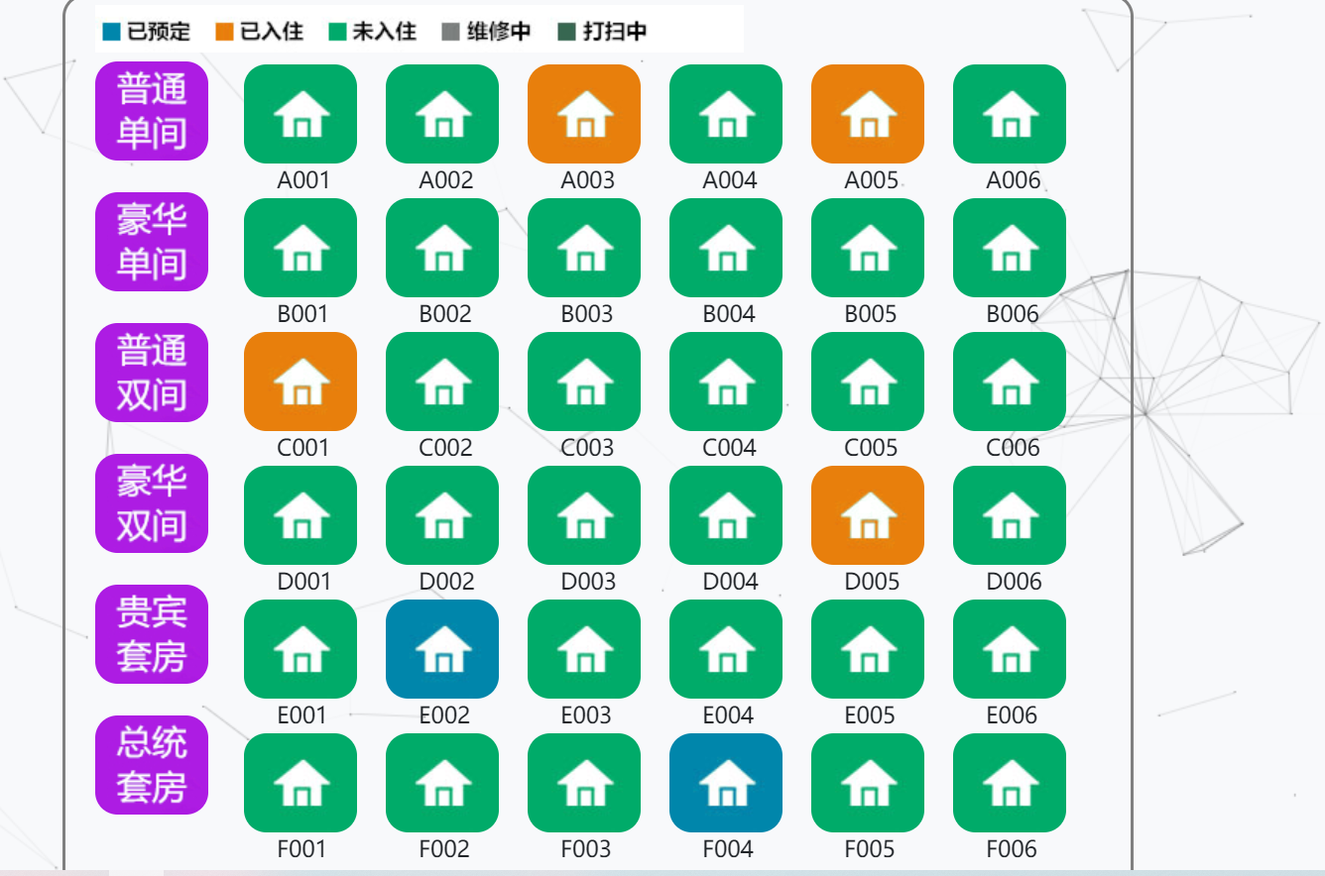

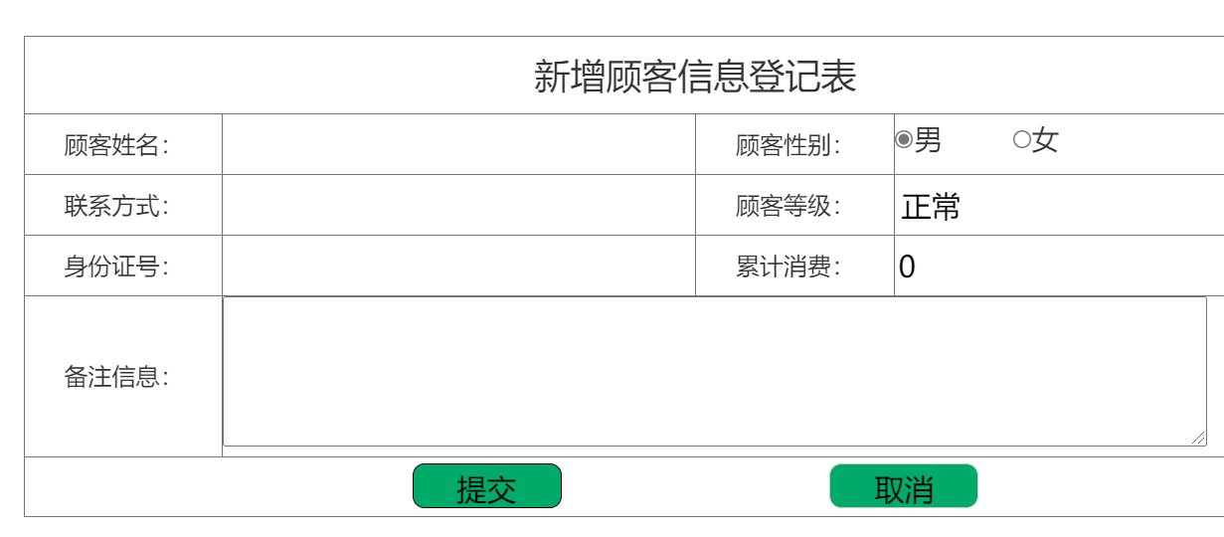

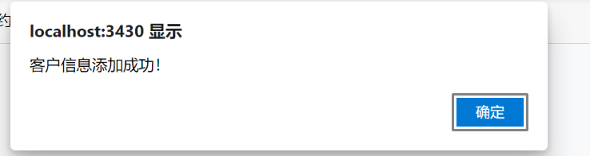

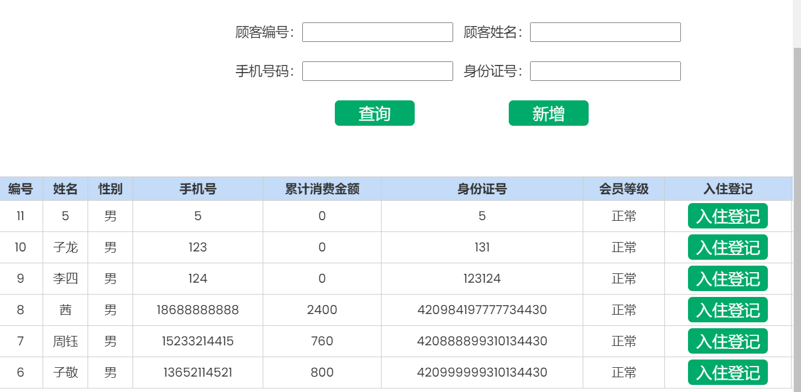

# 总结与心得

这次的课程设计让我学到了很多。一方面对vs的使用更加熟练，另一方面也学到了很多书本上学不到的东西。过程中也有很多问题，不过在努力之下也一个个的全都克服了。希望以后的学习生活中能有更好的表现。