Internet

216.104.205.202/48

Internet - VSAT

10.132.48.162

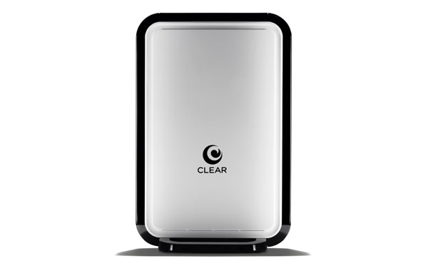10.132.48.161

VSAT MODEM

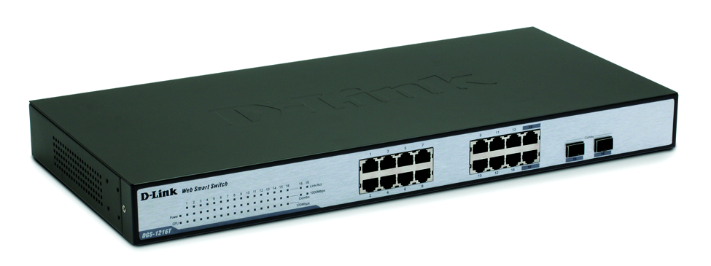

Fibre Switch

Firewall / Router

192.168.0.8

Navision Server

192.168.0.47

NAS

192.168.0.11

Biometrics box 192.168.0.16



POE Switch

AFENET Network Users POE



Catalyst Switch 3750G



D-link Switch



Catalyst Switch 2960

DVR Surveillance 192.168.0.13

Project Server

192.168.0.124

Offsite DR

192.168.0.121

SUN server

192.168.0.46



PABX 192.168.0.10

File Server

192.168.0.7



Catalyst Switch 2960G

Mail Server

192.168.0.12

Secondary Domain Controller   
192.168.0.9

File Server

192.168.0.5

Domain Controller  
192.168.0.4