
Biotherm is a French skin care company owned by L'Oréal, acquired in 1970.
In the early 20th century, the French doctor Jos Jullien discovered mineral thermal spring waters under Pyrenees Mountain in the southern part of France which contained thermal plankton, supposedly a key to healthy skin and a potent skin rejuvenator. In 1952, intellectual property rights were acquired, and he used it in skin care products. Thus, therm in Biotherm comes from thermal plankton, an ingredient found in all Biotherm products. Bio comes from the profession of the founder biologist.
Biotherm offers a wide range of men’s and women’s skincare as well as bodycare products.
Biotherm products contains no parabens, no fragrance allergens and are enriched with Life Plankton™, pure thermal plankton extract that contains 35 nutrients, proteins, vitamins, amino acids, glucids, lipids and trace elements that help revive the skin's vital functions and which are essential to its health.

Amazon stores:
SP+PT: Amazon.es : Biotherm - no official store
UK: Amazon.co.uk : Biotherm - no official store

Within the file you will find key words, please use crtl+F to find the info quickly in case of need
Quick tips:
- Basic routine will usually contain a cleanser + nourishment (serum, essence) + a moisturizer
- To advance the routine you’ll add (in general order): an eye-cream, a toner, exfoliators, masks, lip-care

DRY SKIN
AQUAPOWER: MEN
Main ingredient: Life Plankton™, pure thermal plankton extract that contains 35 nutrients, proteins, vitamins, amino acids, glucids, lipids and trace elements that help revive the skin's vital functions and which are essential to its health.

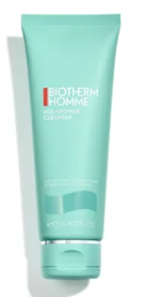
Basic routine: cleanser >> toning lotion >> moisturizing gel (comfort or advanced)

1. Aquapower Facial Cleanser
Main ingredients: Life Plankton
Texture: cooling gel to creamy foam
How to use: morning and night; use a dab of product and apply on the wet face, avoiding eye-area. Lather the cleanser with light circular motions and rinse with water; pat your face dry
Instant refreshing and revitalizing; dual-action formula removes impurities while nourishing the skin barrier. Gentle on the skin, with non-stripping cleansing agents to attract and rinse away daily dirt. Suitable for all skin types; for dry, dull complexions. It replenishes lost moisture to leave the skin soft, bright and smooth. Its hydrating texture makes it ideal pre-shave, supporting an easy glide and fresh finish. Use as the first step in your skincare program morning and night, before following with your favorite lotion, serum and cream.

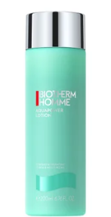
2. Aquapower Lotion
Main ingredients: Life Plankton, blend of nourishing plant oils and oligo sugars
Texture: milky, refreshingly light texture, quick-absorbing
How to use: apply directly after shaving, on rinsed, dry skin, avoiding the eye area. No rinsing needed.
Replenishing skin with moisture, the lotion hydrates, tones and soothes the skin, while helping to prevent razor burn. The formula utilizes Life Plankton, a nutrient-rich active, to instantly refresh the skin. Supported by a blend of nourishing plant oils and oligo sugars, the men's toner works to minimize feelings of sensitivity and tightness upon application, while lessening the appearance of redness. Use before moisturizing for soft and supple results.

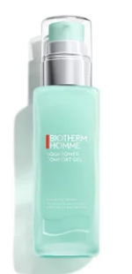
3A. Aquapower Comfort Gel Moisturizer
Main ingredients: Life Plankton™, blend of nourishing plant oils and oligo sugars
Texture: gel-cream hybrid; ultra-light and breathable water-gel texture. Non-sticky, non-oily. Immediate cooling effect. Quick penetration. Fast absorbing.
How to use: morning and/or evening, depending on the skin needs (e.g. maybe in the evening the customer would prefer something richer), it can be cleansing your skin with the right face cleanser, after finishing your shaving routine, or anytime you feel you have dry or dehydrated skin; pump one dose onto the palm of the hand and using both hands, smooth over the face in an outward motion, starting from the centre; finish with the neck, avoid eye area
Refresh and nourish the face. It tackles dryness and external aggressors to leave skin feeling comfortable. It hydrates without the heaviness, designed specifically for the needs of men's skin. The formula provides a cooling effect after application, providing both immediate and long-lasting freshness that is favored post-shave. With an innovative eco-designed airless glass bottle and hygienic pump.

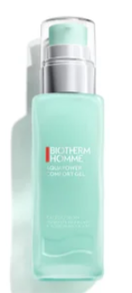
3B. Aquapower Gel Advanced Moisturizer (alternatively)
Main ingredients: Biotech Plankton TM and Vitamin C, plus 2% Niacinamide
Texture: gel-cream hybrid; ultra-light and breathable water-gel texture. Non-sticky, non-oily. Immediate cooling effect. Quick penetration. Fast absorbing.
How to use: apply to a cleansed skin, morning and/or evening; pump one dose onto the palm of the hand and using both hands, smooth over the face in an outward motion, starting from the center; finish with the neck, avoid eye area
Discover the new Aqupaower advanced gel, formulated for deep hydration. Skin feels immediately moisturized, strengthened, hydrated, brightened and powered up with
To advance the routine:
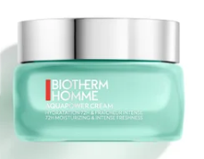
Aquapower 72 Hour Moisturizer (might be an alternative to the moisturizing gels or an additional step)
Main ingredients: Life Plankton, a blend of mannose and hyaluronic acid
Texture: ultra-light, gel-like, aquatic consistency, instant cooling sensation upon application
How to use: apply a dose onto the palm of your hand and using both hands, smooth over the face in outward pattern, starting from the center and finish by the neck, avoid eye-contour, morning and/or evening on cleansed skin after shaving
This 72 hour Moisturizer is a long-duty face cream for men that provides up to 72 hours of hydration. It’s an ultra-light men's facial moisturizer that works dually to recharge the skin and support its function, leaving it refreshed and rejuvenated. The formula protects against drying environmental elements, locking in nourishment to support a stronger skin barrier.

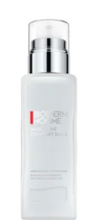
Soothing and Nourishing After-Shave
Main ingredients: Life Plankton™, pure thermal plankton extract that contains 35 nutrients, proteins, vitamins, amino acids, glucids, lipids and trace elements that help revive the skin's vital functions and which are essential to its health
Texture: leave-on, rich and nourishing balm that envelops the skin in a soothing and comforting sensation
How to use: apply directly after shaving, on rinsed, dry skin, avoiding the eye area. No rinsing needed.
A moisturizing and soothing balm, "Cashmere" technology, to fight against skin discomfort and shaving sensations. Its unique formula reproduces the benefits and sensations of cashmere on the skin. It leaves on the skin the incredible lightness of a lotion and all the comfort of a balm. Its rich texture both enveloping and soothing, penetrates instantly for extreme aftershave comfort without greasy effect.

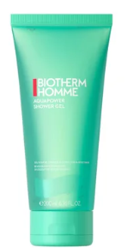
Bodycare + haircare: Aquapower Showergel
Main ingredients: cleansing Coco-Betaine, Salicylic Acid and Life Plankton™ to softly cleanse the skin, leaving it smooth and hydrated
Texture: cooling, fresh gel texture that transforms into a light foam. Easy to rinse off, it leaves the skin perfectly clean and soft
How to use: apply on wet body and hair, gently lather, massaging it into your skin and hair then rinse thoroughly and pat dry; follow up with a body moisturizer for perfectly cleansed and hydrated skin for ultimate hydration
This refreshing body wash for men gently cleanses the body and hair by eliminating toxins and impurities. Its paraben free formula enriched with Life Plankton™ water leaves a powerful sensation of hydration and intense freshness on the skin. Amplified by Blue sciences, this shower gel is fueled by the power of natural ingredients and the packaging integrates recycled materials.

HYDRATION FOR WOMEN
Basic routine: cleanser >> serum >> cream

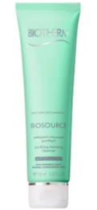
1. Biosource Purifying Foaming Cleanser
Main ingredients: balancing zinc, micro-beads, Life Plankton
Texture: light gel that transforms into a gentle lather upon application. Easy to rinse-off, it leaves the skin clean and soft
How to use: use daily, dampen your face and neck, gently massage in small circular movements, avoiding eye-area, rinse with water and pat dry
This translucent cleansing gel with balancing zinc, enriched with micro-beads produces a gentle lather that combines cleansing with in-depth exfoliation. Rids skin of impurities and dead skin cells, the skin is stimulated, smoothed, and looks more even. The complexion is instantly radiant and prepared for hydration. Exfoliating cleansing gel for Normal to Combination Skin. Exfoliating and complexion brightening, leaving the skin radiant.

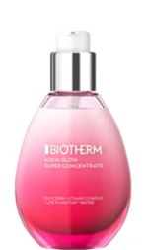
2A. Aqua Glow Super Concentrate
Main ingredients: Life Plankton™ water and vitamin complex
Texture: lightweight emulsion, micro-emulsified fluid formula, quickly penetrates the skin to promote hydration and glow
How to use: every morning and evening, on cleansed skin; using both hands, gently smooth a dose onto the face, avoiding eye contour; finish with neck
It intensely heals dull skin, uneven skin tone and dehydrated skin by boosting your skin's natural ability to glow for a healthier-looking dewy skin. It tackles dull skin, rough skin and unhealthy complexion. Instantly and day after day, it improves and perfects skin unevenness and beautifies your skin natural glow. It helps maintain 24h of moisture for your skin, making it our best moisturiser for glowing skin. If needed, combine with Aqua Pure Salicylic Acid Moisturizer to get rid of imperfections.

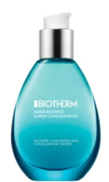
2B. Aqua Bounce Super Concentrate
Main ingredients: Life Plankton™ water and hyaluronic acid
Texture: lightweight serum that quickly penetrates the skin to hydrate it deeply for 24 hours, fast-absorbing
How to use: every morning and evening, on cleansed skin; using both hands, gently smooth a dose onto the face, avoiding eye contour; finish with neck
It intensely heals rough skin and dry flaky skin by retaining moisture for a healthier-looking soft skin. Your intense life affects your skin: dry skin, tightness and signs of dehydration. It boosts your skin's natural ability to bounce back. Instantly, regain maximum hydration and plumpness, get smooth skin and get rid of dry skin patches. The formula attracts and maintain 24h moisture for your dehydrated skin, making the aqua bounce our best face moisturiser for dry and dehydrated skin. If needed, combine it with Aqua Glow for that extra Vitamin C boost and skin glow.

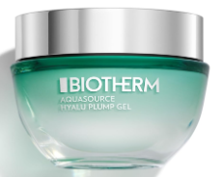
3A. Aquasource Hyalu Plump Gel (light cream)
Main ingredients: Life Plankton™, hyaluronic acid
Texture: lightweight and breathable, cooling gel texture, fresh and non-sticky
How to use: every morning and/or evening, using a small amount of the cream and apply on the face with light strokes on the cheeks, forehead, chin and neck; massage into skin
Refresh & moisturize your skin with this iconic plumping gel. This lightweight cooling texture gives a visible plumper & glowing skin. This iconic cooling gel texture women have loved for decades: A fresh lightweight touch, 100%* women agree on that it melts on the skin and that is enriched by regenerating Biotech Plankton & Hyaluronic Acid. It fights daily aggressions for visibly plumped, and revitalized skin. Suitable for all skin types including sensitive.
The Biotherm Aquasource range, tailored for women, focuses on hydration with daily-use products such as cleansers, lotions, creams, and gels that cater to all skin types, especially those prone to dehydration.
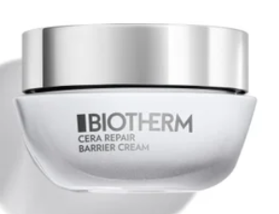
3B. Cera Repair Barrier Cream (richer alternative)
Main ingredients: Life Plankton™ probiotic extracts and Ceramides, that are both clean and safe.
Texture: lightweight and breathable cream, thin texture, for a wrapping yet light sensation, thanks to a patented second-skin technology
How to use: using a small amount of the cream, warm it and spread into the palms of your hands, then apply on the face with light strokes on the cheeks, forehead, chin and neck; massage into skin by pressing down on your face outward from the jaw up to the forehead to improve circulation; use day and night after serum.
Cera Repair has been tested dermatologically on sensitive skin. It reinforces and repairs the skin barrier for soothed, stronger and healthier-looking skin from the first use. This potent anti-aging technology gives your skin the inner power to regenerate, repair and resist urban aggressions. The cream stimulates skin regeneration, repairs the skin barrier reinforces and soothes skin from the 1st use ensure skin is stabilized, stronger and healthier-looking.

To advance the routine:

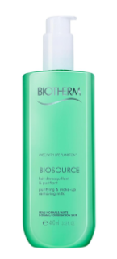
Biosource Biosource Lait Demaq PNM
Main ingredients: Life Plankton, L. saccharina extract
Texture: gentle cleansing water, milky textur
How to use: daily, morning and/or evening; spread small amount on your face with hands or a cotton pad, gently massage in circular motions and let it work; no rinsing required
Puryfying and makeup removing milk, suitable for dry and sensitive skin. Gentle cleansing while removing makeup and impurities for fresh and radiant look. The gentle cleansing milk, enriched with L. saccharina extract, ensures a particularly thorough cleansing and is suitable for dry and sensitive skin. Thanks to the included Life Plankton, make-up and impurities are effectively removed without drying or irritating the skin. Biosource Lait Demq cleanses dry skin gently but thoroughly. The milky texture of the micellar water gently envelops and invigorates the skin. The result: deep pore cleansing and a fresh skin feeling. The gentle cleansing water is easy to use and specially designed to meet the needs of dry skin. In a pleasant way, impurities from everyday environmental influences as well as make-up are removed.

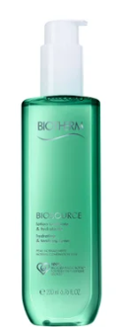
Biosource Hydrating & Tonifying Toner
Main ingredients: Life Plankton
Texture: soft and refreshing toner that gently cleanses the skin while invigorating it
How to use: soak a cotton pad with toner and smooth over the entire face starting from the center and moving outwards; repeat until the cotton pad wipes clean
Toning the skin is one of the most important steps of your daily skin care routine. This refreshing face toner reaches the deep dirt that cleansers cannot. More than a simple toner, it works as an exfoliant, ridding your skin of impurities and dead cells, revealing its natural radiance. Tones and leaves skin feeling clean and fresh. Normal to combination skin.

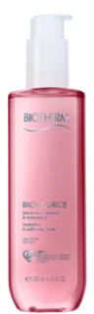
Biosource Hydrating & Softening Toner
Main ingredients: Life Plankton
Texture: soft and refreshing toner that gently cleanses the skin while invigorating it
How to use: soak a cotton pad with toner and smooth over the entire face starting from the center and moving outwards; repeat until the cotton pad wipes clean
Toning the skin is one of the most important steps of your daily skin care routine. This soft and refreshing toner reaches the deep dirt that cleansers cannot. More than a simple toner, it works as an exfoliant, ridding your skin of impurities and dead cells, revealing its natural radiance. Tones and leaves skin feeling clean and fresh.

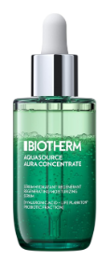
Aquasource Aura Concentrate
Main ingredients: Life Plankton probiotic fraction, Aqua Leaf, Hyaluronic Acid
Texture: dual texture, quick-absorption
How to use: Shake well before each use to activate the power of millions of micro-drops. Apply 3-4 drops of the moisturising serum daily in the morning and evening to the cleansed face in circular motions
The Aquasource Serum from Biotherm with the legendary Aura Leaf provides the skin with optimal moisture and gives it a natural glow. The dual texture instantly blends into the skin and absorbs quickly. The face serum has been specially developed to promote optimally nourished, delicate and radiant skin. The formula of the serum provides long-lasting moisture. The serum is ideal for daily care and provides an effective solution for radiant skin. The serum is especially suitable for dry skin and can be applied as a base under your day cream.. You get radiant skin that is moisturised all day long.

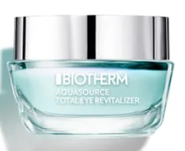
Aquasource Total Eye Revitalizer Gel
Main ingredients: Life Plankton, niacinamide, caffeine,
Texture: ultra-fresh, ultra-light texture that provides a natural finish and coverage with a silky feel
How to use: apply to eye-contour every morning and evening, using fingertips in a gentle outward motion around the eye-area; gently tap fingertips around your eyes, above upper eyelids, fallowing the line of your eyebrows and then under your eye
The eye cream awakener gives your eyes a totally revitalized look. Formulated with the hydration agents and enriched with a combination of cooling, de-puffing, lightening and blurrung complex, this eye revitalizer provides an instant cooling effect and a fresh eyes sensation. Bags are depuffed, dark circles reduced, dehydration lines smoothed, eye contour continuously hydrated. *skin temperature measurement after 2 minutes - 26 women
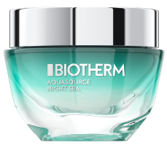
Aquasource Night Spa
Main ingredients: Life Plankton, niacinamide, caffeine,
Texture: rich balm/gel like texture, smooth on the skin
How to use: after evening cleansing, apply to the face and décolleté and gently massage in. Spread the firming cream with your fingertips from the chin to the forehead in wavy movements
This night balm provides a smooth complexion with its soothing and smoothing effect. Applied as a mask, the cream works overnight and provides more moisture. Tension feelings and dryness wrinkles are reduced. Suitable for all skin types. Experience a fresh and rested complexion in the morning. Tip: use it as a cloth mask by applying the balsam-in-gel generously and covering the face with a cloth. Leave it to work for 5 minutes, remove excess cream and lightly tap the face area.

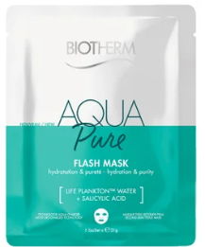
Aqua Pure Flash Mask
Main ingredients: Salicylic Acid and Life Plankton water
How to use: apply on cleansed skin every week or when needed; unfold and place on the skin, remove the blue film and smooth the mask on your face; leave for 15 minutes, remove and massage any remaining product - don’t rinse off; follow with a cream
Aqua Pure Flash Mask is a second-skin hydrating mask that deeply infuses skin with intense skin hydration, ensuring pure skin in one application. One sheet mask is enough to deeply replenish and refine your skin, with pores appearing tighter, less visible and skin looking purified and fresh.
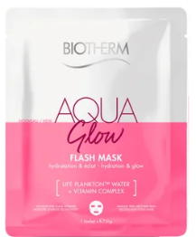
Aqua Glow Flash Mask
Main ingredients: Vitamin C and Life Plankton water
How to use: apply on cleansed skin every week or when needed; unfold and place on the skin, remove the blue film and smooth the mask on your face; leave for 15 minutes, remove and massage any remaining product - don’t rinse off; follow with a cream
Aqua Glow Flash Mask is a second-skin hydrating face mask that deeply infuses skin with intense hydration. Thanks to this powerful combination of Vitamin C and Life Plankton water, skin is more glowing with one application. One moisturizing sheet mask is enough to deeply replenish and revive your skin's natural ability to glow.
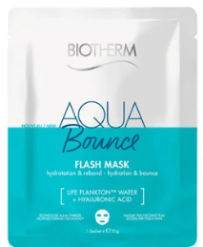
Aqua Bounce Flash Mask
Main ingredients: Hyaluronic Acid and Life Plankton water
How to use: apply on cleansed skin every week or when needed; unfold and place on the skin, remove the blue film and smooth the mask on your face; leave for 15 minutes, remove and massage any remaining product - don’t rinse off; follow with a cream
Aqua Bounce Flash Mask is a second-skin hydrating face mask that deeply infuses skin with intense hydration, powered by the combination of Hyaluronic Acid and Life Plankton water for bouncy skin in one application. One moisturizing sheet mask is enough for deeply replenished, suppler and super dewy skin.
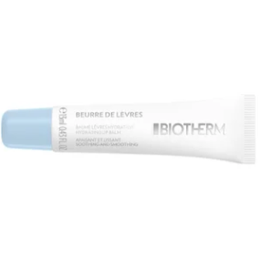
Lip Balm Beurre De Levres
Main ingredients: 5 naturally derived vegetable oils and acacia sugar
Texture: soft butter-like texture, melting balm that leaves a matte finish
How to use: apply on cleansed skin every week or when needed; unfold and place on the skin, remove the blue film and smooth the mask on your face; leave for 15 minutes, remove and massage any remaining product - don’t rinse off; follow with a cream
Beurre de lèvres, is Biotherm's replumping and smoothing lip balm. The soft butter-like texture nourishes and hydrates to leave skin plumped with moisture and lips feeling smoother. The deliciously addictive melting balm leaves a matte finish, perfect for men, women and for use under makeup. The delicate fragrance includes extracts of peach, lemon and rose.

BODYCARE:
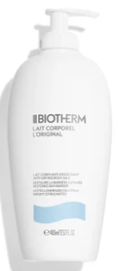
Lait Corporel Moisturizing Lotion
Main ingredients: Life Plankton™ combined with antioxidant vitamin E and nourishing lipids
Texture: quick-penetrating body milk with citrus essences, a delicate fragrance and light texture that is neither sticky nor greasy; ultra-light formula, quick and easy to apply, releasing a delicate and smooth finish on the skin. Easily absorbed into the skin.
How to use: apply daily, all over the body to cleansed and dried skin; pour into the palm of your hand and massage into the skin.
This nourishing body milk combats dryness by delivering up to 48 hours of intense hydration. It helps to smooth and refine skin texture, while restoring barrier strength to defend against environmental aggressors. Ingredients are working to rehydrate skin and reduce flakiness. Absorbing quickly for a residue-free finish, the lightweight lotion is enhanced with citrus extracts for a brightening effect and refreshing scent.

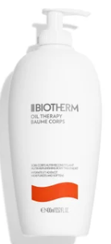
Oil Therapy Body Lotion
Main ingredients: Life Plankton™, Musk Rose Oil, Passiflora Oil and Apricot Oil
Texture: emollient, melting, quickly-absorbed body lotion with a delicate and fresh apricot scent
How to use: apply daily, all over the body to clean and dry skin; pour into the palm of your hand and massage into the skin, focus on the rougher skin areas
A nutri-replenishing body treatment enriched with apricot oil for a 24h nourished, supple and soft skin. Apricot scented, it smooths and softens the skin for 24hours nourishment.
MUSK ROSE OIL: rich in essential fatty acids with regenerating and strengthening.
PASSIFLORA OIL: omega 3 & 6 with nourishing and perfecting properties.
APRICOT OIL: rich in vitamin a & e with softening and smoothing properties.

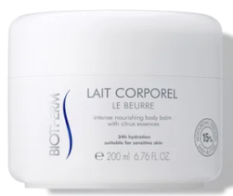
Lait Corporel Body Butter
Main ingredients: Life Plankton™, shea butter, Apricot Oil, Orange Peel Oil
Texture: rich balmy texture that quickly penetrates the skin without leaving it feeling greasy
How to use: apply daily, all over the body to cleansed and dried skin; massage into the skin with your hands
Find the invigorating citrus scent of the legendary Body Milk and succumb to the texture of this new body care delicately enriched with shea butter. Specially designed for dry to very dry skin, Body Butter gives your skin softness and intense hydration, without leaving a greasy film. This anti-drying butter soothes, repairs and protects your skin.

2. OILY SKIN
T-PUR: MEN
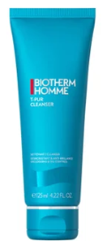
T-Pur Anti-Oil and Shine Purifying Cleanser
Main ingredients: sea minerals complex (anti-bacterial sea algae extract + zinc) and absorbing mineral perlite
Texture: white clay-like facial cleanser has a unique pumice-based scrub texture that turns into a gentle lather to unclog pores, cooling effect
How to use: use every morning before shaving and at the end of the day, apply a small amount all over the face, lather in circular movements avoiding the eyes, rinse thoroughly with lukewarm water.
T-pur facial cleanser helps to protect skin against shine. Excess sebum is neutralized, excess sweat is reduced. Skin is radically mattified and feels neat and clean all day long. Its white clay-like texture helps neutralizing impurities caused by dust, sebum, pollution and sweat.
After 4 weeks of usage, skin looks more purified, cleaner and healthier; impurities are eliminated and pores are unclogged and tightened.
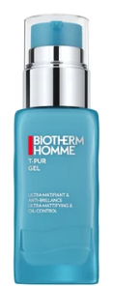
T-PUR Moisturizing Gel
Main ingredients: purifying French sea salts
Texture: lightweight gel texture is quickly absorbed, hydrating the skin and leaving it with a non-sticky, non-greasy, matte finish, quick-absorbing.
How to use: every morning and evening on cleansed skin, pump one dose of gel into the palm of the hand and using both hands, smooth over the face in an outward pattern starting from the center, avoiding the eye contour. Finish by the neck.
This ultra-mattifying gel moisturizer instantly absorbs skin excess sebum and shine, leaving skin matte and moisturized for 8H, even under extreme conditions. It makes skin feel less oily for a smoother and clearer appearance. The iconic product and formula you love, now made with an innovative eco-designed glass packaging. Amplified by BLUE SCIENCES: fueled by the power of natural ingredients.
For normal to oily skin.

To complete the routine, you will look for a serum with either salicylic acid or moisturizing ingredients.

AQUA PURE: WOMEN
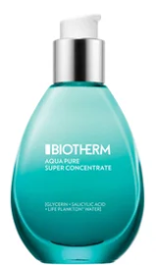
Aqua Pure Super Concentrate
Main ingredients: Life Plankton™ water and salicylic acid
Texture: lightweight serum that quickly penetrates the skin to hydrate it and promote shine control
How to use: every morning and evening, on cleansed skin; using both hands, gently smooth a dose onto the face, avoiding eye contour; finish with neck
It intensely heals skin imperfections and reduces excess sebum for a healthier-looking clear skin. It is designed to refine skin texture. After 7 days, the appearance of enlarged pores is less visible, skin is less shiny for a healthier-looking dewy skin. It acts on dehydrated skin to heal skin imperfections, enlarged pores and rebalance excess sebum. It leaves the skin feeling super pure + super hydrated making it our best face moisturiser for clear skin.

Aqua Pure Flash Mask
Main ingredients: Salicylic Acid and Life Plankton water
How to use: apply on cleansed skin every week or when needed; unfold and place on the skin, remove the blue film and smooth the mask on your face; leave for 15 minutes, remove and massage any remaining product - don’t rinse off; follow with a cream
Aqua Pure Flash Mask is a second-skin hydrating mask that deeply infuses skin with intense skin hydration, ensuring pure skin in one application. One sheet mask is enough to deeply replenish and refine your skin, with pores appearing tighter, less visible and skin looking purified and fresh.
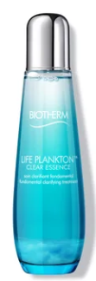
Life Plankton™ Clear Essence
Main ingredients: Life Plankton™
Texture: lightweight as cosmetic water, as effective as a serum; quickly absorbing, non-sticky, non-greasy
How to use: use on cleansed skin after your lotion, morning and evening, shake well before use; put few droplets on the palm of your hand and lightly spread on the face with fingers.
This high efficacy Essence contains the highest concentration of the most powerful ingredient known for its regenerative properties: Life Plankton™, a rare natural living ingredient with extraordinary skin healing powers. Isolated & amplified through a natural bio-fermentation process, its proven results reignites skin's regenerating powers. It enables a miraculous transformation starting today & in the future, making your skin look younger, clearer and brighter. In 8 days, a newborn pristine skin starts to surface. In 28 days, it generates an optimum skin regeneration. Pore refining, brightening and purifying, anti-age. Suitable for oily skin.

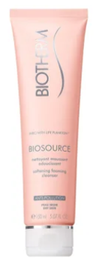
Biosource Softening Foaming Cleanser
Main ingredients: Life Plankton, Kaolin
Texture: light gel that transforms into a rich foam upon application, gently cleansing face & neck while comforting dry skin
How to use: apply a small amount into the palm of the hand and blend with water until a creamy, rich foam appears, gently massage onto wet face and neck in small circular movements, avoiding the eye contour area. Rinse thoroughly with lukewarm water.
A rich facial cleanser which foams on contact with water to cleanse skin, removing makeup. Leaves dry skin clean, supple and comfortable. Suitable for sensitive skin. Radiance boosting, creamy and gentle on the skin.
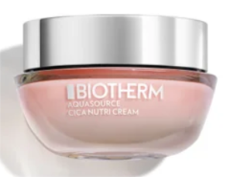
Aquasource Cica Nutri Cream
Main ingredients: centella asiatica and Life Plankton™ probiotic extract
Texture: creamy and fresh and melts perfectly into the skin for an intensely nourishing experience, this deep hydrating cream melts into the skin for continuous comfort
How to use: use in the morning and/or evening onto a cleansed and toned face, using a small amount, massage it into the face in outwards motions from the center; avoid eye-contour
The face moisturizer for dry and sensitive skin delivers intense, long-lasting hydration for up to 48 hours, leaving complexion plump and radiant. The potent formula visibly soothes, softens and brightens skin, granting all-day luminosity. Perfect for dry skin types; helps reinforce the skin's natural defenses and restores lost moisture for continuous nourishment. The creamy yet fresh texture melts into the skin, boosting radiance and leaving your skin soft, bouncy and hydrated.
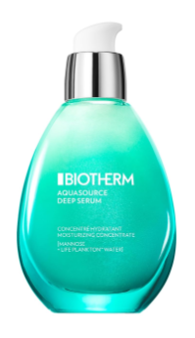
Aquasource Deep Serum
Main ingredients: Life Plankton and Mannos
Texture: delicate texture is easy to apply
How to use: Apply a small amount of serum to the face, neck and décolleté in the morning or evening after facial cleansing and gently massage in. The texture absorbs quickly without leaving a greasy film. Daily use before day or night cream is recommended for optimal results. Give your skin intense moisture with just a few drops and feel the invigorating freshness in a short time.
Enriched with Life Plankton and Mannose, it provides intensive moisture, invigorates and regenerates the skin. The rose micro beads give a natural glow. The delicate texture is easy to apply and provides long-lasting comfort. With unique formula and high-quality ingredients, it ensures that your skin is delicately nourished and hydrated.
3. SENSITIVE SKIN
AFTER SHAVE CARE: MEN
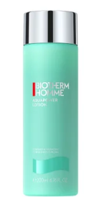
Aquapower Lotion
Main ingredients: Life Plankton, blend of nourishing plant oils and oligo sugars
Texture: milky, refreshingly light texture, quick-absorbing
How to use: apply directly after shaving, on rinsed, dry skin, avoiding the eye area. No rinsing needed.
Replenishing skin with moisture, the lotion hydrates, tones and soothes the skin, while helping to prevent razor burn. The formula utilises Life Plankton, a nutrient-rich active, to instantly refresh the skin. Supported by a blend of nourishing plant oils and oligo sugars, the men's toner works to minimize feelings of sensitivity and tightness upon application, while lessening the appearance of redness. Use before moisturizing for soft and supple skin.

Soothing and Nourishing After-Shave
Main ingredients: Life Plankton™, pure thermal plankton extract that contains 35 nutrients, proteins, vitamins, amino acids, glucids, lipids and trace elements
Texture: leave-on, rich and nourishing balm that envelops the skin in a soothing and comforting sensation
How to use: apply directly after shaving, on rinsed, dry skin, avoiding the eye area. No rinsing needed.
A moisturizing and soothing balm, "Cashmere" technology, to fight against skin discomfort and shaving sensations. Its unique formula reproduces the benefits and sensations of cashmere on the skin. It leaves on the skin the incredible lightness of a lotion and all the comfort of a balm. Its rich texture both enveloping and soothing, penetrates instantly for extreme aftershave comfort without greasy effect.

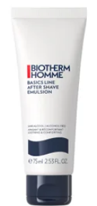
After-shave Emulsion
Main ingredients: shea butter, Life Plankton,
Texture: leave-on emulsion with the rich & nourishing texture of a balm that envelops the skin in a soothing and comforting sensation
How to use: apply directly after shaving, on rinsed, dry skin, without rinsing. Avoid eye area - in case of contact with eye, rinse thoroughly.
This alcohol-free (ethanol free) after-shave emulsion is tested under dermatological control on sensitive skin. It soothes the burning sensations and reduces irritations caused by shaving for smoother and more comfortable skin

WOMEN

Biosource Softening Foaming Cleanser
Main ingredients: Life Plankton, Kaolin
Texture: light gel that transforms into a rich foam upon application, gently cleansing face & neck while comforting dry skin
How to use: apply a small amount into the palm of the hand and blend with water until a creamy, rich foam appears, gently massage onto wet face and neck in small circular movements, avoiding the eye contour area. Rinse thoroughly with lukewarm water.
A rich facial cleanser which foams on contact with water to cleanse skin, removing makeup. Leaves dry skin clean, supple and comfortable. Suitable for sensitive skin. Radiance boosting, creamy and gentle on the skin.
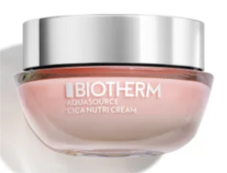
Aquasource Cica Nutri Cream
Main ingredients: centella asiatica and Life Plankton™
probiotic extract
Texture: creamy and fresh and melts perfectly into the skin for an intensely nourishing experience, this deep hydrating cream melts into the skin for continuous comfort
How to use: every morning and/or evening, using a small amount of the cream and apply on the face with light strokes on the cheeks, forehead, chin and neck; massage into skin
The face moisturizer for dry and sensitive skin delivers intense, long-lasting hydration for up to 48 hours, leaving complexion plump and radiant. The potent formula visibly soothes, softens and brightens skin, granting all-day luminosity. Perfect for dry skin types; helps reinforce the skin's natural defenses and restores lost moisture for continuous nourishment. The creamy yet fresh texture melts into the skin, boosting radiance and leaving your skin soft, bouncy.
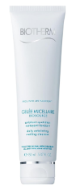
Biosource Gelee Cleansing Exfoliant
Main ingredients: Life Plankton, L.Saccharina extract and natural micro beads.
Texture: exfoliating gel, melting texture
How to use: Apply 1 to 2 times a week to cleansed, moist facial skin. Massage gently, leave to work briefly and rinse with lukewarm water. Avoid the eye area.
The exfoliating gel contains Life Plankton, L.Saccharina extract and natural micro beads. It is ideal for all skin types, even sensitive skin, and cleans the skin deep into the pores. Polyethylene free: this formula is 89% biodegradable. The skin is gently cleaned and at the same time deep pores. The complexion is refined and even the smallest impurities are removed. Biosource Exfoliate Cleanser with its melting texture is optimal for intense, yet gentle facial cleansing.

Biosource Biosource Lait Demaq PNM
Main ingredients: Life Plankton, L. saccharina extract
Texture: gentle cleansing water, milky texture
How to use: daily, morning and/or evening; spread small amount on your face with hands or a cotton pad, gently massage in circular motions and let it work; no rinsing required
Puryfying and makeup removing milk, suitable for dry and sensitive skin. Gentle cleansing while removing makeup and impurities for fresh and radiant look. The gentle cleansing milk, enriched with L. saccharina extract, ensures a particularly thorough cleansing and is suitable for dry and sensitive skin. Thanks to the included Life Plankton, make-up and impurities are effectively removed without drying or irritating the skin. Biosource Lait Demq cleanses dry skin gently but thoroughly. The milky texture of the micellar water gently envelops and invigorates the skin. The result: deep pore cleansing and a fresh skin feeling. The gentle cleansing water is easy to use and specially designed to meet the needs of dry skin. In a pleasant way, impurities from everyday environmental influences as well as make-up are removed.
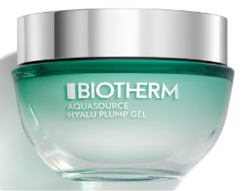
Aquasource Hyalu Plump Gel (light cream)
Main ingredients: Life Plankton™, hyaluronic acid
Texture: lightweight and breathable, cooling gel texture, fresh and non-sticky
How to use: every morning and/or evening, using a small amount of the cream and apply on the face with light strokes on the cheeks, forehead, chin and neck; massage into skin
Refresh & moisturize your skin with this iconic plumping gel. This lightweight cooling texture gives a visible plumper & glowing skin. This iconic cooling gel texture women have loved for decades: A fresh lightweight touch, 100%* women agree on that it melts on the skin and that is enriched by regenerating Biotech Plankton & Hyaluronic Acid. It fights daily aggressions for visibly plumped, and revitalized skin. Suitable for all skin types including sensitive.
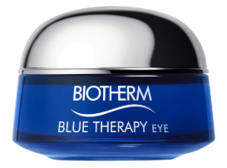
Blue Therapy Eye Cream
Main ingredients: Life Plankton and Amino Acids
Texture: lightweight cream
How to use: Apply the eye balm morning and evening to cleansed skin before day or night care. Then gently tap in with the ring finger and massage in for a better result.
The Eye Cream has been specially developed for the sensitive eye area. It prevents and reduces wrinkles, bags and crow's feet. At the same time, the eye cream moisturises and gives the skin elasticity. Experience smoother and more youthful skin around the eyes.

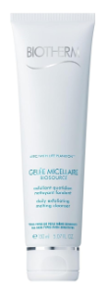
Cera Cream to Foam Cleanser
Main ingredients: Life Plankton Probiotic and Niacinamides
Texture: cleansing cream to foam formula
How to use: Apply a small amount of facial cleansing to moistened skin and massage gently until a rich lather forms. Spread the foam in a circular motion and then rinse thoroughly with lukewarm water until all residue is removed. Avoid the eye area.
A cleansing cream that turns into a gentle lather on the skin. Thanks to the combination of Life Plankton Probiotic and Niacinamides, the skin is gently cleansed, and the skin protection barrier is protected. The formula gently cleanses and is suitable for sensitive skin. Cera Foam Cleanser thoroughly cleanses the skin without drying it out. The texture feels particularly comfortable to the face cleansing.

Cera Repair Barrier Cream
Main ingredients: Life Plankton™ probiotic extracts and Ceramides, that are both clean and safe.
Texture: lightweight and breathable cream, thin texture, for a wrapping yet light sensation, thanks to a patented second-skin technology
How to use: using a small amount of the cream, warm it and spread into the palms of your hands, then apply on the face with light strokes on the cheeks, forehead, chin and neck; massage into skin by pressing down on your face outward from the jaw up to the forehead to improve circulation; use day and night after serum.
Cera Repair has been tested dermatologically on sensitive skin. It reinforces and repairs the skin barrier for soothed, stronger and healthier-looking skin from the first use. This potent anti-aging technology gives your skin the inner power to regenerate, repair and resist urban aggressions. The cream stimulates skin regeneration, repairs the skin barrier reinforces and soothes skin from the 1st use ensure skin is stabilized, stronger and healthier-looking.

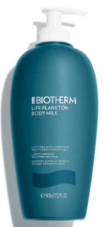
Life Plankton™ Multi-Corrective Body Milk
Main ingredients: high concentration of our advanced Life Plankton™ complex; a blend of botanical oils and shea butter
Texture: easy-to-apply milky texture, leaving a refined musky veil on your skin, quick-absorbed
How to use: apply daily, all over the body to cleansed and dried skin; pour into the palm of your hand and massage into the skin.
It instantly nourishes the skin to leave smooth, supple results. The silky-soft formula plumps the skin with moisture to minimize the look of uneven textures, while lending its nutrient-rich benefits to visibly brighten and unify tone over time. It encourages a firmer appearance, alongside providing light, non-oily hydration, making it an ideal lotion for sensitive skin. What's more, a fresh, musk-laced fragrance delicately scents the skin as you glide the milk on, supporting an elevated body care ritual with each application.

4. NORMAL TO COMBINATION SKIN
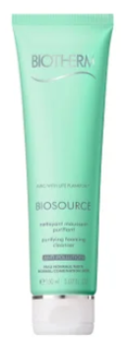
Biosource Purifying Foaming Cleanser
Main ingredients: balancing zinc, enriched with micro-beads
Texture: light gel that transforms into a gentle lather upon application. Easy to rinse-off, it leaves the skin clean and soft
How to use: daily, gently massage into wet skin using circular motions until the foam forms, rinse with lukewarm water, avoid eye-area
This translucent cleansing gel produces a gentle lather that combines cleansing with in-depth exfoliation. Rids skin of impurities and dead skin cells, the skin is stimulated, smoothed, and looks more even. The complexion is instantly radiant and prepared for hydration. Exfoliating cleansing gel for Normal To Combination Skin. Daily use.
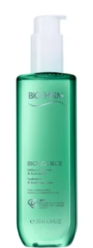
Biosource Hydrating & Tonifying Toner
Main ingredients: Life Plankton
Texture: soft and refreshing toner that gently cleanses the skin while invigorating it
How to use: soak a cotton pad with toner and smooth over the entire face starting from the center and moving outwards; repeat until the cotton pad wipes clean
Toning the skin is one of the most important steps of your daily skin care routine. This refreshing face toner reaches the deep dirt that cleansers cannot. More than a simple toner, it works as an exfoliant, ridding your skin of impurities and dead cells, revealing its natural radiance. Tones and leaves skin feeling clean and fresh. Normal to combination skin.

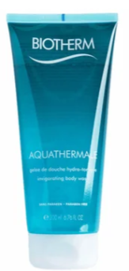
Aquathermale Shower Gel
Main ingredients: Life Plankton
Texture: fresh gel texture that turns into a lightweight, easy-to-rinse-off foam that gently cleanses the skin
How to use: apply onto wet body, massage and lather, then rinse
Bring Spa-like experience to your own home. This shower Gel will cleanse your body, brighten and smoothe the skin while hydrating it, leaving you energized and refreshed.
5. ANTI-AGING
FORCE SUPREME: MEN
FORCE SUPREME line is designed to address the unique needs of mature skin types, offering advanced anti-aging products that target fine lines, wrinkles and a loss of firmness. The range includes creams, serums, eye treatments and face masks that work as a comprehensive skincare routine to reduce the visible signs of aging.

Main ingredients (may vary from product to product):
- BLUE ALGAE EXTRACT: rich in proteins, amino-acids, and vitamins, sourced in Klamath Lake (rare and protected ecosystem in Oregon, US); harvested during its peak reproductive season and dried using a patented bioscience technique. They boost collagen and help restructure aging tissue to smooth wrinkles.
- PRO-XYLANE™: boosts the production of GAGs (glycosaminoglycans) for more hydrated and firmer skin
- LIFE PLANKTON™ PROBIOTIC EXTRACT: stabilize skin and rebalance moisture by increasing the production of its essential constituents and reactivating skin cell renewal. Contains 35 nutrients that deliver intense regenerating hydration for soothed, soft and luminous skin. 100% natural, renewable and biodegradable.

Basic routine: Cleanser >> Serum >> Rich Cream or Light Moisturizing Gel
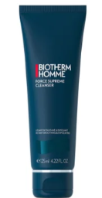
1. Force Supreme Anti-Aging Cleanser
Main ingredients: blue algae, cedar bud extract + smoothing micro-spheres (exfoliator)
Texture: creamy and foaming with exfoliating microparticles for instant smoothing of the skin; cooling and comfortable
How to use: before shaving every morning + evening; lather gently all over the face avoiding eye-area, rinse with luke-warm water
Skin type: mature/aging, sensitive, normal, combination
2in1 face wash and exfoliator for daily use that deep cleans, removes dead cells and impurities and provides youth-boosting benefits thanks to a blend of blue algae and cedar bud extract. Ingredients work in unision to protect against elasticity loss and support cellular regeneration. This creamy cleanser features smoothing micro-spheres to gently decongest the pores and exfoliate which helps to refine the skin texture, prevent discoloration, pigmentation and dark spots.
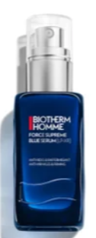
2. Force Supreme Blue Serum [LP-XR]
Main ingredients: Pro-Retinol, signature aquatic micro-organism Life Plankton, re-densifying Pro-Xylane
Texture: gel-like, quickly absorbing
How to use: apply onto cleansed skin, morning and/or evening alone or before the cream; apply 1-2 pumps with gentle strokes, smoothing the product outwards, from the center of the face - for best result, use a gentle massage: using your indexes and thumbs, pinch the skin tissues and twist simultaneously on both sides of the face. Target the oval of the face and cheekbones. Repeat 3x.
Skin type: aging, sensitive (if irritation occurs, stop using), normal, combination
It visibly corrects 10 signs of aging* to leave skin looking firmer, smoother and more youthful. Formulated to hydrate and protect the skin barrier, with Pro-Retinol, the formula helps to minimize the appearance of fine lines, wrinkles and uneven skin tone. The aquatic micro-organism Life Plankton™ with 35 nutrients is combined with re-densifying Pro-Xylane™ to improve elasticity, contour definition and firmness.
*firmness, elasticity, tightness, contour definition, wrinkles, fine lines, refined texture, skin strength, complexion and tone evenness
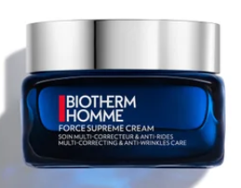
3A. Force Supreme Youth Architect Cream
Main ingredients: Youth Algae™ extract, Life Plankton™ and Pro-Xylane,
Texture: non-sticky, silky, lightweight cream-gel texture, absorbs quickly, free of any greasy residue
How to use: every morning and/or evening onto cleansed skin, place a dose onto the palm and using both hands smooth over the face in an outward pattern starting from the center, finish by the neck, avoid eye-area
Skin type: all skin types
Advanced 3in1 formula works to tone, firm and strengthen skin and leave it replenished with moisture. Specifically formulated for men over 40, to visibly enhance facial contours, strengthen the skin barrier, and soften fine lines for a revitalized appearance.

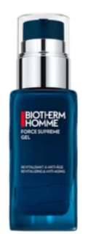
3B. Force Supreme Anti-Aging Moisturizing Gel (alternative to cream)
Main ingredients: Blue Algae Extract, Pro-Xylane, Life plankton™ probiotic extract
Texture: ultra-fresh & thin-on-skin, and non-sticky lightweight smooth gel-cream texture that penetrates the skin quickly to energize it
How to use: use every morning and evening on a cleansed face, gently smooth in outwards motions, from the center of the face towards the edges, can be used alone (for people who prefer a lighter texture over a rich cream) or before face cream
Skin type: all skin types, including mature
Fortified with energizing blue algae extract and pro-xylane, it helps to fight the signs of aging, wrinkles and loss of skin structure. The protein-rich blue algae extract gives the appearance of plump skin and helps stimulate collagen production. Pro-xylane, a molecular xylose derivative, seeks to lock water into every layer of the skin, helping to maintain bounce, brightness and elasticity.
To advance this routine add:
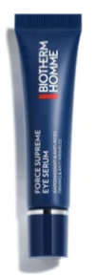
1. Force Supreme Eye Architect Serum
Main ingredients: Caffeine, Blue Algae Extract, Japanese Cedar Bud extract, Adenosine
Texture: deep-penetrating, quickly absorbed gel-serum, ultra-fresh, non-greasy and non-shiny
How to use: daily morning and/or evening, massage into the eye-area with fingers or with a cold applicator for the best de-puffing anti-bags effect
It smooths the look of fine lines, while firming and refreshing skin, giving your eye area a rested look. The cooling innox applicator works like a post-workout recovery for your eyes, gliding across the skin to reduce puffiness. Ideal for daily use, whether starting your day or winding down, the anti-aging eye serum delivers optimal results for a firmer, more refreshed appearance. all skin types, including sensitive, mature.
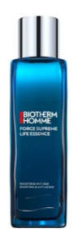
2. Force Supreme Life Peel Essence
Main ingredients: exfoliating glycolic and salicylic acids, soothing Biotherm Life Plankton™
Texture: lightweight, non-sticky and fast-absorbing, watery; essence-like texture
How to use: shake before use, use daily morning & evening, after cleansing but before moisturizer; gently smoothe over the skin and pat until absorbed and proceed with skincare; avoid eye and lip areas. In case of contact with eyes, rinse thoroughly with lukewarm water. Avoid sun exposure after application or use an SPF 30 or +. In case of persistent irritation, stop using the product.
Anti-fine lines and pore-tightening peel adapted to suit the needs of sensitive skin. The ingredients remove dead skin cells, reduce the appearance of wrinkles, resurface texture and minimize pores. Gentle on sensitive skin. Skin is smooth, refined and prepped for subsequent products in your anti-aging skincare program. 100% vegan, 99% biodegradable and 98% natural formula. Skin type: mature/aging, sensitive, normal, combination

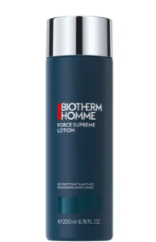
3. Force Supreme Lotion
Main ingredients: cedar bud extract, pro-xylane, life plankton extract
Texture: light-weight lotion
How to use: shake before use, on clean skin after shaving, apply by splashing onto dry skin or with a cotton pad.
Skin type: all skin types
Corrects and helps improve the signs of aging. The alcohol-free lotion is powered by two unique active ingredients, cedar bud extract and pro-xylane to minimize the appearance of wrinkles, all while plumping, brightening and strengthening. Suitable for all skin types, the lightweight anti-aging lotion is blended with life plankton extract for a hit of refreshing hydration.

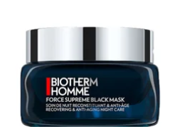
4. Force Supreme Black Mask Night Care
Main ingredients: Life Plankton™, pure thermal plankton extract that contains 35 nutrients, algae extract
Texture: a night face mask with a black gel-cream texture that melts into the skin to re-energize it deeply
How to use: apply a generous amount to clean face and neck every evening, gently massage for 1min avoiding lips and eyes, do not rinse
Regenerating care, enriched with algae extract cultivated in the dark, has a "fusion texture". The skin appears replenished with new energy overnight. It appears vital and resistant. The skin appears firmer, and wrinkles are reduced.All skin types.
___________________________________________________________________________________________________________________________
BLUE THERAPY: WOMEN
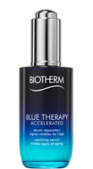
Blue Therapy Accelerated Anti-Aging Serum
Main ingredients: Life Plankton™ and Algae of Youth; a cocktail of essential vitamins, minerals and phytonutrients
Texture: lightweight, fast-absorbing texture
How to use: squeeze 3 drops of serum onto your fingertips; apply in a circular motion; for better results gently pinch your skin to improve circulation; use your thumb and index finger to pinch dark spots for a radiant skin result
It works to reduce appearance of fine lines, dark spots and loss of firmness, revealing a smoother, firmer complexion over time. Serum melts into your skin to nourish and replenish lost moisture. From the first application, skin feels instantly softer, more supple and illuminated. An effective serum for dark spots, fine lines and wrinkles. Blue Therapy offers visible long-term benefits - the more you use it, the better your skin appears. Use in combination with Blue Therapy Accelerated Anti-Aging Cream to maximize anti-aging efficacy.
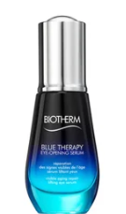
Blue Therapy Eye Opening Serum
Main ingredients: Life Plankton™ and Algae of Youth
Texture: lightweight, fast-absorbing texture with innovative pearl applicator suitable for lash too; cooling feel
How to use: remove the excess product along the neck of the bottle and slide the pearl around the wide eye contour to refresh and depuff; move the pearl softly around the eyes, starting from eyelids; apply on lashes from root to tip to strengthen lashes to strengthen them and ease mascara application
It combines extracts of algae of youth and an innovative pearl-applicator to act on the 3 signs of eye-opening loss: lids look lifted, under eye bags look depuffed and wrinkles appear smoothed. Eyes look visibly more open after 4 weeks. Leaves a matte finish perfect for makeup application. Also helps to repair dry skin. Dermatologically and ophtalmologically tested. Suitable for contact lens users. Finish by using mascara or by layering Blue Therapy eye cream.

Blue Therapy Eye Cream
Main ingredients: Life Plankton and Amino Acids
Texture: lightweight cream
How to use: Apply the eye balm morning and evening to cleansed skin before day or night care. Then gently tap in with the ring finger and massage in for a better result.
The Eye Cream has been specially developed for the sensitive eye area. It prevents and reduces wrinkles, bags and crow's feet. At the same time, the eye cream moisturises and gives the skin elasticity. Experience smoother and more youthful skin around the eyes.
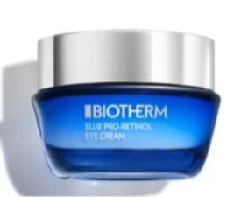
Blue Pro-retinol Eye Cream
Main ingredients: Pro-Retinol, Life Plankton, peptides, caffeine
Texture: unique melting balm texture is quickly absorbed for optimal formula delivery, enveloping the eye contour area in comfort
How to use: day and night care; apply a rice-grain amount of the eye cream morning and night to the eye contour; gently dab the eye cream below and above the eye contour
With a high level of efficacy in reducing wrinkles around the eye contour, this innovative anti-wrinkle eye cream is gentle yet powerful. It combines regenerative Life Plankton with resurfacing Pro-Retinol to amplify its effectiveness. Approved by opthamologist day and night eye care acts on the eye contour to target wrinkles, firm, reduce the appearance of dark circles, hydrate and brighten. Its melt-in balm texture glides into skin effortlessly.
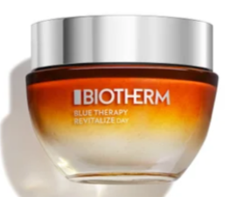
Blue Therapy Revitalize Moisturizing Day Cream
Main ingredients: revitalizing Amber Algae (Laminaria Ochroleuca) that fuels cells with energy for a healthy skin glow, and a potent blend of nutrients [Fortifying Calcium + Vegetal Oils + Shea Butter] that bring intense moisture and reinforce skin barrier
Texture: innovative texture inspired by Korean technology: a thick-to-thin-to-thick, velvety day cream that envelops skin with comfort without leaving a greasy film. It contains rosy, illuminating micro-pearls that instantly give skin a healthy glow.
How to use: use daily in the morning on clean, dry skin; apply on face, neck & décolleté with light strokes on cheeks, forehead & chin
This daily cream moisturizes, repairs and delivers healthy, glowing skin thanks to its rosy, illuminating micro-pearls; it delivers younger, intensely revitalized and revived-looking skin. Skin feels deeply moisturized, firmer, fine lines and wrinkles appear reduced.

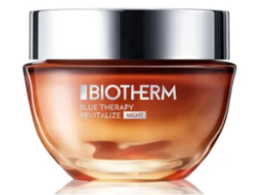
Blue Therapy Revitalize Moisturizing Night Cream
Main ingredients: revitalizing Amber Algae (Laminaria Ochroleuca) that fuels cells with energy for a healthy skin glow, and by skin regenerating Resveratrol which reduces the appearance of wrinkles and fine lines.
Texture: inspired by Korean beauty, velvety cream infused with pink microbeads; non-greasy texture that melts on the skin to restore its glow
How to use: apply to cleansed face, neck and decollete every evening; smooth over cheeks, forehead and chin with light strokes, finish with neck and neckline
An ultra-nourishing anti-aging night cream that repairs, strengthens and regenerates skin for a fresh and youthful glow in the morning; it works overnight to visibly nourish skin and plump away crow's feet, fine lines and wrinkles for youthful, glowing skin in the morning.
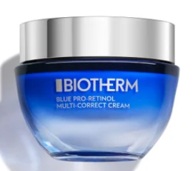
Blue Pro-Retinol Multi-Correct Cream
Main ingredients: Pro-Retinol that accelerates skin cell regeneration; niacinamide, which protects, soothes and brightens skin; and Life Plankton that amplifies the efficacy of pro-retinol and niacinamide while providing intense hydration and a softening effect on the skin.
Texture: fresh, melt-in cream formula
ake a small amount with a clean finger, warm it and spread it into the palm of your hands. Apply on face with light strokes on cheeks, forehead, chin and neck; massage into skin by pressing and curling out your fingers from the center of your face outward from the jaw up to the forehead, like the pattern of waves - this will improve the circulation of static fluids below the epidermis for a healthy glow.
It's clinically proven to smooth out skin texture and promote skin evenness for all skin types. The Blue Pro-Retinol Multi-Correct Cream replaces the Blue Therapy Accelerated cream. Good for your skin, good for our oceans: a 92% natural formula. It is also infused with 100% natural, renewable and biodegradable Life Plankton probiotic extracts which stimulate skin regeneration. The plastic cap is 100% recycled and the glass jar is made of 40% recycled glass that is 100% recyclable. Expert tip: Always apply a sunscreen when using retinol (minimum SPF 50+). We recommend following with the Blue Pro-Retinol Multi-Correct Cream every day & night.

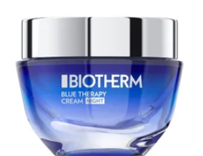
Blue Therapy Anti-Aging Night Cream
Main ingredients: Life Plankton™ complex to target the three prominent signs of aging, wrinkles, dark spots, and loss of firmness, to visibly renew and support regular skin function.
Texture: rich, creamy texture melts into the skin upon application
How to use:
It‘s a multi-action, anti-aging moisturizer that amplifies skin hydration and revitalizes its appearance thanks to a blend of potent active ingredients It offers long-lasting bounce and brightness after you wake. An ideal anti-aging night cream for mature skin, the blue therapy range promises to restore the look of elasticity, radiance and suppleness with continued use.

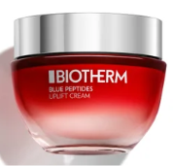
Blue Peptides Uplift Day Cream + Night Cream
Main ingredients: Life Plankton™, Collagen peptide fractions
Texture: rich creams
How to use: apply daily in the morning, after your day serum, to face and neck; combine with the night cream for best results; avoid direct contact with eyes.
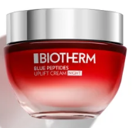
Blue Peptides Uplift Day Cream's formula is 100% vegan and made of 92% natural ingredients; Night Cream is 94% natural ingredients
Hydrating and firming moisturizers that visibly firm and plump skin while reducing the look of wrinkles. Hydrate and boost glow, leaving skin with a radiant rosy finish. Suitable for all skin types.
LIFE PLANKTON: WOMEN
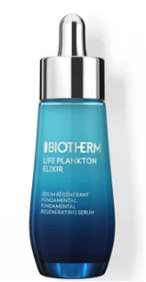
Life Plankton™ Elixir Anti-Aging Serum
Main ingredients: Vitamin-C, hyaluronic acid, 5% Life Plankton™
Texture: fast-absorbing texture that is incredibly light, fast-fusing and fresh; non-comedogenic and has a dermatologically tested formulation, which can be used even on the skin around the eyes
How to use: apply after toner and before face care; take 3 to 4 drops and warm in the palm of your hand, then massage on to face, neck and décolleté. For more targeted action apply before your regular skin serum and add a face mask to your skincare routine.
Supercharge your skincare routine with a vitamin C-infused formula that provides daily hydration, protection and resilience to all skin types.
Rich in antioxidants, the brightening serum helps defend against dark spots and discoloration, supporting an even skin tone with a radiant, refreshed finish. Hyaluronic acid works to strengthen the skin barrier, prevent water loss and plump fine lines. Meanwhile, 5% Life Plankton™ helps revive lackluster complexions, lending its nutrient-dense composition to help maintain the skin's normal functions. If you suffer from skin sensitivity, you don't have to be concerned: this hyaluronic acid serum has been tested and its suitable for sensitive skin

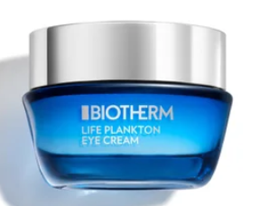
Life Plankton™ Anti-Aging Eye Cream
Main ingredients: Life Plankton™ complex to target the three prominent signs of aging, wrinkles, dark spots, and loss of firmness, to visibly renew and support regular skin function.
Texture: light, creamy texture
How to use: apply to cleansed face, neck and decollete every evening; smooth over cheeks, forehead and chin with light strokes, finish with neck and neckline
Powered by the highest concentration of Life Plankton™, the anti-aging eye cream helps diminish the appearance of fine lines, puffiness and dark circles. The formula intensely nourishes, while visibly smoothing and softening the skin around the eye contours. Dermatologist and ophthalmologist tested; it's ideal for sensitive skin, working to defend against visible signs of ageing and external aggressors. Expect a firmer, more resilient eye contour that feels supple and replenished with moisture.

Life Plankton™ Clear Essence
Main ingredients: Life Plankton™
Texture: lightweight as cosmetic water, as effective as a serum; quickly absorbing, non-sticky, non-greasy
How to use: use on cleansed skin after your lotion, morning and evening, shake well before use; put few droplets on the palm of your hand and lightly spread on the face with fingers.
This high efficacy Essence contains the highest concentration of the most powerful ingredient known for its regenerative properties: Life Plankton™, a rare natural living ingredient with extraordinary skin healing powers. Isolated & amplified through a natural bio-fermentation process, its proven results reignite skin's regenerating powers. It enables a miraculous transformation starting today & in the future, making your skin look younger, clearer and brighter. In 8 days, a newborn pristine skin starts to surface. In 28 days, it generates an optimum skin regeneration. Pore refining, brightening and purifying, anti-age. Suitable for oily skin. Hydrating.

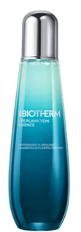
Life Plankton™ Essence
Main ingredients: Life Plankton™ , probiotic extracts
Texture: fast-absorbing formula, non-sticky texture; lightweight essence texture that leaves no sticky residue
How to use: use twice daily; apply with dabbing movements on the foreheads, cheeks, chin, and neck; tap the skin with your fingertips like falling rain all over the face and neck. Take about 2 more drops of skin essence and reapply on some areas where the skin can be particularly dry.
The first step in your skincare routine, it’s as lightweight as toner but as powerful as a serum. The high-performance essence is packed with the brand's highest concentration of Life Plankton™, a probiotic ingredient scientifically proven to enhance skin renewal for visible results. It instantly sinks into the skin, delivering an intense boost of hydration that leaves your complexion firm, plump and glowing. It instantly preps your skin, creating a clear canvas for the rest of your ritual. Rich in nutrients, the facial essence is perfect for all skin types, designed to be used twice daily to achieve a supple, glowing complexion.
Suitable for all skin types.


Life Plankton™ Anti-Aging Eye Cream
Main ingredients: Life Plankton™ complex to target the three prominent signs of aging, wrinkles, dark spots, and loss of firmness, to visibly renew and support regular skin function.
Texture: light, creamy texture
How to use: apply to cleansed face, neck and decollete every evening; smooth over cheeks, forehead and chin with light strokes, finish with neck and neckline
Powered by the highest concentration of Life Plankton™, the anti-aging eye cream helps diminish the appearance of fine lines, puffiness and dark circles. The formula intensely nourishes, while visibly smoothing and softening the skin around the eye contours. Dermatologist and ophthalmologist tested; it's ideal for sensitive skin, working to defend against visible signs of ageing and external aggressors. Expect a firmer, more resilient eye contour that feels supple and replenished with moisture.
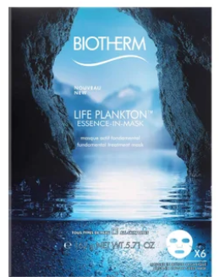
Life Plankton™ Essence-In-Mask (Box of 6)
Main ingredients: Life Plankton™ complex to target the three prominent signs of aging, wrinkles, dark spots, and loss of firmness, to visibly renew and support regular skin function.
Texture: light, creamy texture
How to use: apply to a cleansed face, smoothing the mask all over the skin and let it sit for 8 minutes - then remove it and gently massage the residual product until it’s absorbed; no need to rinse.
After 1 application, skin feels regenerated, healthy, like after a facial treatment: perfectly soothed, intensely hydrated & youthfully glowing skin. In 8 days: healed, younger & smooth skin. It’s infused with Life Plankton, aiming to rejuvenate the skin, balance and hydrate it while providing with anti-aging benefits.
6. REDNESS (SHAVING): MEN
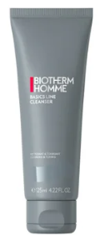
Cleansing Gel
Main ingredients: Life Plankton™
Texture: refreshing gel texture that turns into a light foam upon application. Easy to rinse off, it leaves the skin perfectly clean and soft
How to use: apply onto a wet face, gently lather with small circular movements, avoiding eye area. Rinse with lukewarm water.
This Biotherm Homme cleanser thoroughly cleanses and rids skin of impurities while prospecting the skin's surface. Preps skin for shaving without leaving a greasy film on the skin, leaving it clean, fresh, and toned. It’s a deep-cleansing product suitable for all skin types, it’s gel formula gently cleanses the skin without irritating it.


Soothing and Nourishing After-Shave
Main ingredients: Life Plankton™, pure thermal plankton extract that contains 35 nutrients, proteins, vitamins, amino acids, glucids, lipids and trace elements that help revive the skin's vital functions and which are essential to its health
Texture: leave-on, rich and nourishing balm that envelops the skin in a soothing and comforting sensation
How to use: apply directly after shaving, on rinsed, dry skin, avoiding the eye area. No rinsing needed.
A moisturizing and soothing balm, "Cashmere" technology, to fight against skin discomfort and shaving sensations. Its unique formula reproduces the benefits and sensations of cashmere on the skin. It leaves on the skin the incredible lightness of a lotion and all the comfort of a balm. Its rich texture both enveloping and soothing, penetrates instantly for extreme aftershave comfort without greasy effect.
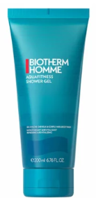
Aquafitness Shower Gel
Main ingredients: ocean water and oligoelements & minerals
Texture: light gel formula that transforms into a gentle foam when applied. It easily rinses off, leaving your skin perfectly clean and soft
How to use: apply on wet body and hair, gently lather, massaging it into your skin and hair then rinse thoroughly and pat dry; follow up with a body moisturizer for perfectly cleansed and hydrated skin for ultimate hydration
Formula with ocean water and oligoelements & minerals. Instant freshness and revitalizing effect. Leaves hair soft. Skin feels moisturized. It’s cleansing, hydrating and energizing. Smooths and revives the skin. No parabens.

7. BODY CARE

Life Plankton™ Multi-Corrective Body Milk
Main ingredients: high concentration of our advanced Life Plankton™ complex; a blend of botanical oils and shea butter
Texture: easy-to-apply milky texture, leaving a refined musky veil on your skin, quick-absorbed
How to use: apply daily, all over the body to cleansed and dried skin; pour into the palm of your hand and massage into the skin
It instantly nourishes the skin to leave smooth, supple results. The silky-soft formula plumps the skin with moisture to minimize the look of uneven textures, while lending its nutrient-rich benefits to visibly brighten and unify tone over time. It encourages a firmer appearance, alongside providing light, non-oily hydration, making it an ideal lotion for sensitive skin.
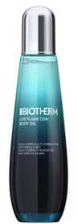
Life Plankton™ Multi-Corrective Body Oil
Main ingredients: Life Plankton™ Water
Texture: fresh oil with a musky fragrance that glides effortlessly onto the skin for quick absorption, leaving no oily residue.
How to use: apply morning and/or evening onto a cleansed skin; use a generous amount of oil and massage it all over your body, paying special attention to extra dry areas, do not use on chapped skin
Multi-corrective body oil enriched with Life Plankton™ Water to deliver visible results in 28 days It repairs the skin, hydrates and is perfect for dry to normal skin types. It reduces the appearance of stretch marks.
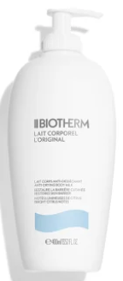
Lait Corporel Moisturizing Lotion
Main ingredients: Life Plankton™ combined with antioxidant vitamin E and nourishing lipids
Texture: quick-penetrating body milk with citrus essences, a delicate fragrance and light texture that is neither sticky nor greasy; ultra-light formula, quick and easy to apply, releasing a delicate and smooth finish on the skin. Easily absorbed into the skin.
How to use: apply daily, all over the body to cleansed and dried skin; pour into the palm of your hand and massage into the skin.
This nourishing body milk combats dryness by delivering up to 48 hours of intense hydration. It helps to smooth and refine skin texture, while restoring barrier strength to defend against environmental aggressors. Ingredients are working to rehydrate skin and reduce flakiness.

Oil Therapy Body Lotion
Main ingredients: Life Plankton™, Musk Rose Oil, Passiflora Oil and Apricot Oil
Texture: emollient, melting, quickly-absorbed body lotion with a delicate and fresh apricot scent
How to use: apply daily, all over the body to clean and dry skin; pour into the palm of your hand and massage into the skin, focus on the rougher skin areas
A nutri-replenishing body treatment enriched with apricot oil for a 24h nourished, supple and soft skin. Apricot scented, it smooths and softens the skin for 24hours nourishment.
MUSK ROSE OIL: rich in essential fatty acids with regenerating and strengthening.
PASSIFLORA OIL: omega 3 & 6 with nourishing and perfecting properties.
APRICOT OIL: rich in vitamin a & e with softening and smoothing properties.

Lait Corporel Body Butter
Main ingredients: Life Plankton™, shea butter, Apricot Oil, Orange Peel Oil
Texture: rich balmy texture that quickly penetrates the skin without leaving it feeling greasy
How to use: apply daily, all over the body to cleansed and dried skin; massage into the skin with your hands
Find the invigorating citrus scent of the legendary Body Milk and succumb to the texture of this new body care delicately enriched with shea butter. Specially designed for dry to very dry skin, Body Butter gives your skin softness and intense hydration, without leaving a greasy film. This anti-drying butter soothes, repairs and protects your skin.
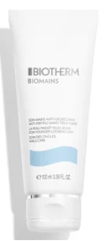
Biomains Hand Cream
Main ingredients: Life Plankton™, vitamin F, D-panthenol, Glycerin
Texture: soft, hydrating, light cream texture which is immediately absorbed, with a fresh aromatic scent
How to use: massage daily into hands and nails
An age-delaying and nail strengthening hand cream for hydrated and younger looking hands. It creates a protective layer on the hands. Hydrating, nourishing and soothing – this cream improves skin’s texture, leaving them
he appearance of signs of aging: regular use delays signs of aging and appearance of brown spots thanks to an anti-free radical system.
OTHER BODY LOTIONS AND SHOWER GELS
Biotherm Body Cream - Anti-Drying Body Milk with Citrus Extracts - Body Lotion for Dry Skin 400 ml : Amazon.de: Beauty - body lotion
Biotherm Eau Pure Body Milk, Nourishing Body Lotion for Women, Moisturising Body Milk with Life Plankton, Vitamins and Oils, for a Smoothly Soft Body Feel, 400 ml : Amazon.de: Beauty - body lotion
Biotherm Eau Vitaminee Body Milk, Moisturising Body Lotion for Women, Revitalising Body Milk with Life Plankton, Ceramides & Vitamin B5, for a Smooth Skin Feeling, 400 ml : Amazon.de: Beauty - body milk
Biotherm Eau Energy Body Milk, Moisturising Body Lotion for Women, Nourishing Body Milk with Oils and Citrus Fruits, for Revitalised and Refreshed Skin, 400 ml : Amazon.de: Beauty - body lotion
Biotherm Eau d'Energy Shower Gel, Refreshing Shower Gel with Life Plankton and Essential Oils of Orange and Lemon, Nourishing Shower Soap for Women for a Fresh Body Feeling, 200 ml : Amazon.de: Beauty - shower gel
Biotherm Eau Pure Shower Gel, Refreshing Shower Gel for Women, Gentle Shower Soap with Lime, Green Tea and Kiwi Essential Oils for Smooth Skin and Fresh Fragrance 200ml : Amazon.de: Beauty - shower gel
Biotherm Eau Vitaminee Shower Gel, Refreshing Shower Gel for Women, Invigorating Shower Cream, for Smooth Skin Feeling and Hydrated Skin, 200 ml : Amazon.de: Beauty - shower gel
Biotherm Lait De Douche Shower Milk : Amazon.de: Beauty - shower milk
Biotherm Cleansing Shower Milk 400 ml : Amazon.de: Beauty - shower milk

8. FRAGRANCES

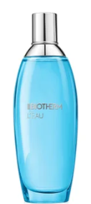
L'eau The Fragrance of Lait Corporel
Shake before use and spray from a distance.
A deliciously tangy orange scent and a twist with unexpected accords of ginger and spice, to refresh, energize and invigorate - and last all day.
A zesty fragrance where the sparkling essential oils of orange, tangerine and bergamot fuse with the smooth accords of freesia and notes of cedar wood.
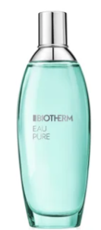
Eau Pure Mist
Shake before use and spray from a distance.
A vivifying fragrance inspired by a white water cascade. Enriched with notes of kiwi and lime it leaves the skin feeling illuminated and intensely refreshed. Enriched with essential oils of sage and lime.
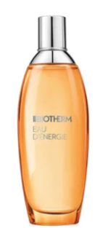
Eau D'Energie Mist
Shake before use and spray from a distance.
Unlock your skin's energy eau d'énergie perfumes, refreshes, softens a perfumed mist, energised with the awakening and stimulating notes of orange pulp, mandarin, physalis, lemon, apricot pulp, fresh jasmine and cyclamen.
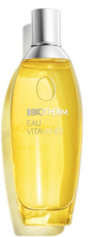
Eau Vitaminée Eau de Toilette
Shake before use and spray from a distance.
The Eau Vitaminée Body Spray is a refreshing and invigorating solution for hot summer days or everyday use. With its citrus fragrance, it gives you a pleasant aromatic cooling. Simply spray on the skin and enjoy the fragrance. The body spray ensures a pleasant freshness. `

SUNCARE Amazon.de: Biotherm: Car Sun Shade
AFTER SUN LOTIONS Biotherm Cream Nacrée After Sun Lotion for the Body, After Sun Lotion with Oligo Minerals, Life Plankton and Vitamins, Intensive Care After Sunbathing, 200 ml : Amazon.de: Beauty
Biotherm After Sun Lotion After Sun Body Milk, Moisturising After Sun Lotion for the Body, Intensive Care Lotion After Sunbathing, for Hydrated Skin, 400 ml : Amazon.de: Beauty
BB CREAM Biotherm Aquasource BB Cream, Tinted Day Cream with Life Plankton, Nourishing Cream with Moisturising Effect and SPF15, for Optimal Complexion, 30 ml : Amazon.de: Beauty -
DEODORANTS Amazon.de: Biotherm: Deodorants

