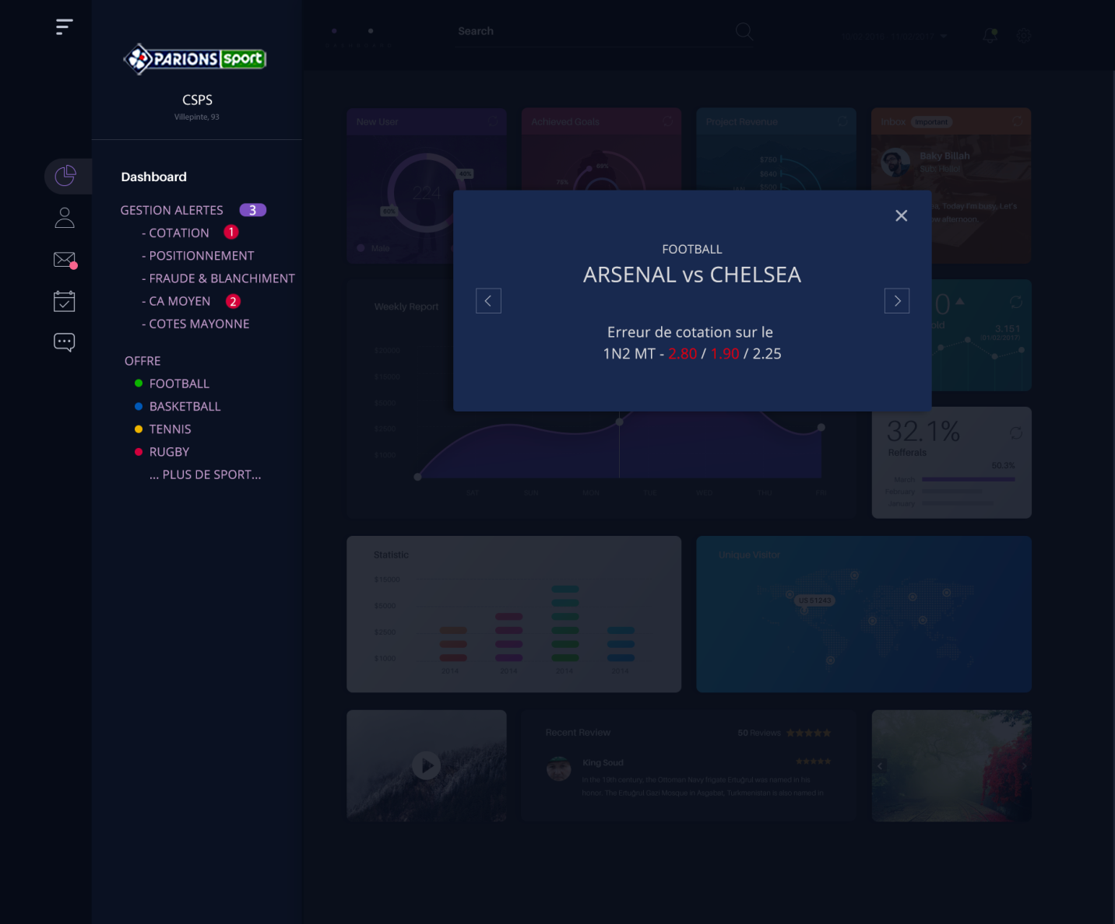

**COTATION PAGE**

I have merged two section the popup (FOOTBALL - ARSENAL vs CHELSEA - 1N2 MT) and new window (Erreur de cotation sur le 1N2 MT - 2.80 / 1.90 / 2.25) because we have enough space to accomodate both sections in one. It will also reduced number of clicks and saves users time as the user will be able to see both sections data on one screen.

**Suggestions**

we can improve the left navigation dashboard menu. Right now the current navigatioin is confusing from user prespective which tab is active. The active tab needs to be highlighed.

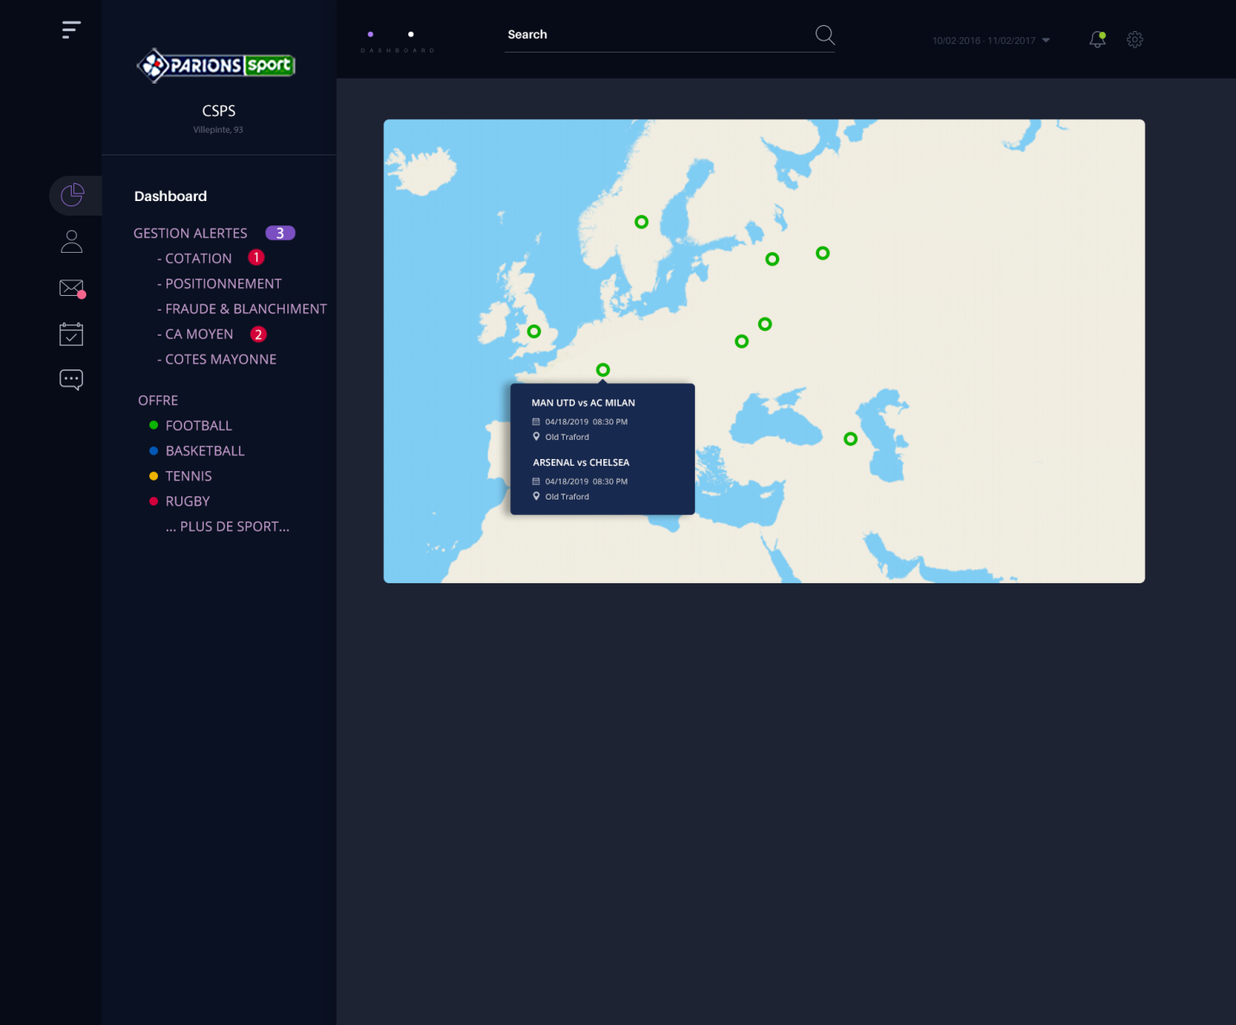

**Offre – Football**

Color bullets added to each sport in the navigation so the user can easily identify which sporting events they are looking for on the map. Plus tooltip added on the map section. On hover on any of the marker on the map will display the information of matches, date, time and location.