Wesley Linkmeyer
ST10481890
CLDV POE PART 2

Contents
Submission information: 1
Student Number: 1
Module Code: 1
Github URL: 1
Youtube Video URL: 1
Site functionality: 2
Blob Storage: 7
Theory: 8
References 9

Submission information:

Student Number:
ST10481890

Module Code:
CLDV6211

Github URL:
https://github.com/Wesley1511/CLDVPOE

Youtube Video URL:
https://youtu.be/w00vhWH0ltc

Site functionality:



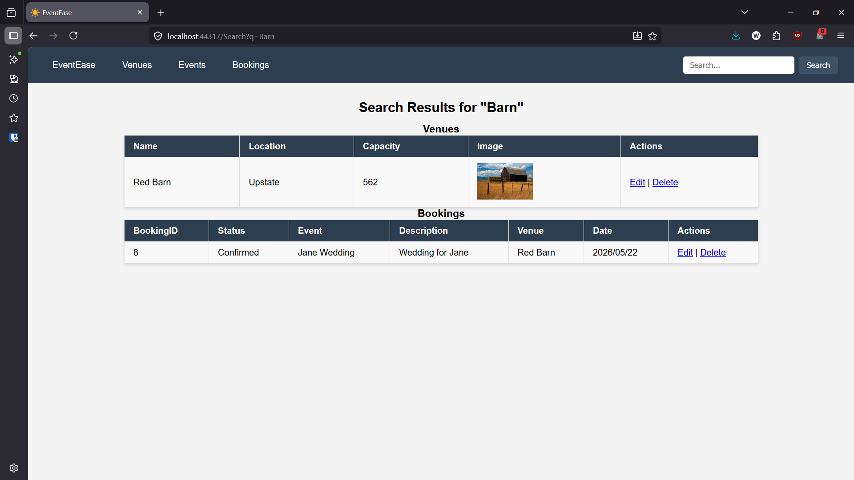

Blob Storage:


Theory (Rubric Section D):
Azure Cognitive Search is different from traditional search engines by using artificial intelligence to improve how data is understood and retrieved. Traditional search engines mainly rely on keyword matching, cognitive search can interpret meaning, extract key information, and work with both structured and unstructured data such as PDFs, images, and scanned documents. This allows it to deliver more relevant and context aware results. For example a legal firm it can search through thousands of contracts and highlight important clauses, in e-commerce it can improve product recommendations based on user intent, and in healthcare it can extract medical terms from patient records to help doctors find critical information quickly. (Canorea, n.d.)
Database normalisation is important because it organises data in a way that reduces redundancy and improves data integrity. By storing data in separate, well-structured tables, it ensures that updates are consistent and prevents anomalies such as duplicated or conflicting data. This makes databases easier to maintain and more reliable over time, especially in systems where accuracy is critical, such as banking or inventory management systems. (Maiqani, 2020)
Normalised and denormalised database structures have different impacts on performance and scalability. A normalised database minimises duplication and is efficient for write operations, but it often requires multiple table joins, which can slow down read performance. In contrast, a denormalised database combines data into fewer tables, reducing the need for joins and improving read speed, which is useful in systems like reporting dashboards or data warehouses. However, denormalisation increases redundancy and can lead to inconsistencies if not managed carefully. Therefore, normalised structures are better suited for transactional systems, while denormalised structures are often preferred for read-heavy applications where performance is a priority. (Maiqani, 2020)

References
Canorea, E., n.d. Azure Cognitive Search | Introduction. [Online]
Available at: https://www.plainconcepts.com/azure-cognitive-search-introduction/
[Accessed 05 05 2026].
Maiqani, E., 2020. Database Normalization vs. Denormalization. [Online]
Available at: https://medium.com/analytics-vidhya/database-normalization-vs-denormalization-a42d211dd891
[Accessed 04 05 2026].

