Wesley Linkmeyer
ST10481890
CLDV6211 POE PART 1

Contents
Part 1: 1
A) 1
B) (SCREENSHOTS) 1
C) (SCREENSHOTS) 1
D) 1
Differences Between Cloud and On-Premises Application Deployment: 1
Differences Between IaaS, PaaS, and SaaS: 3
References 4

Student Number: ST10481890
Module code: CLDV6211

Part 1:

A)
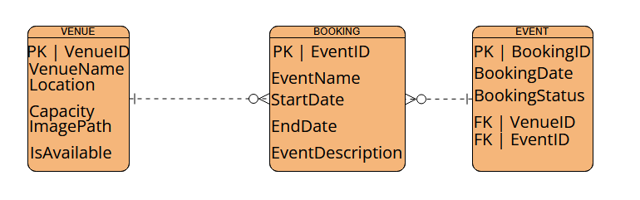

B) (SCREENSHOTS)

C) (SCREENSHOTS)

D)

Differences Between Cloud and On-Premises Application Deployment:

When talking about cloud deployment, we mean the installation of software on the cloud-based platform like AWS, Microsoft Azure, or Google Cloud. On-premises deployment occurs when a software program is hosted on the company's physical computers. Both types vary widely in security measures, deployment time, and resource control.

In terms of Security:
The cloud service provider offers various security options like encryption, firewalls, identity management, automatic backup, and threat monitoring. Providers continuously upgrade the system's software with the latest security patches.
In case EventEase uses its bookings stored in Azure's database, the system will have the data encryption feature and role-based access control with MFA key differences include:
The entire responsibility for the security of servers, network connections, software updates, and backups falls solely upon the company.
If EventEase chooses to deploy its application on its office server, it needs to install an anti-virus package, configure firewall settings, and take care of backing up the software data key differences include:
The cloud environment involves the sharing of responsibilities for security measures between a provider and customer. On-premises deployment assumes that all security responsibilities are placed on the company.

Speed of Deployment
Deployment on cloud services will be easy and fast; setting up the servers, database, and software takes only minutes, an example of this is that
suppose EventEase requires another testing server for its developers; then it can be set up easily using Microsoft Azure in a matter of minutes.
The process of deployment will be time-consuming because all the equipment needs to be acquired, configured, and maintained before running any application
an example of this is if EventEase requires additional server capacity due to heavy traffic; it would require weeks of preparation to deploy a difference between them is that
Deployment on cloud services is far faster than deployment on premises

Resource Management
Resource utilization can be increased or decreased according to demand, and businesses will be charged only for their consumption for instance
If EventEase has too much traffic when customers book holidays, cloud-based servers will scale up to cope with extra traffic and then scale back down.
Available resources are dependent on physical hardware, and upgrading will need the acquisition of new servers, and even if they go underutilized, they will charge you this is because
If EventEase purchases an extra-large server to cope with traffic peaks, the server will remain underutilized during other times while
Cloud computing makes use of elastic and efficient resource management

Differences Between IaaS, PaaS, and SaaS:
Model | Description | User Manages | Example
IaaS | Provides virtual servers, storage, and networking. | Applications, OS, middleware, data | Amazon EC2, Azure Virtual Machines
PaaS | Provides a ready-made platform for developing and deploying apps. | Applications and data | Azure App Service, Google App Engine
SaaS | Ready-to-use software accessed through the internet. | Only user settings/data | Gmail, Microsoft 365, Salesforce

Common cloud computing services are generally categorized into three different models. These models include the following. First, there is Infrastructure as a Service (IaaS) which involves renting virtualized resources including servers, storage, and networking from a provider. Next, Platform as a Service (PaaS) offers a complete environment including the necessary computing resources for developing and deploying applications. Finally, the Software as a Service (SaaS) model entails renting and using fully functional software applications hosted by the provider over the web. Under each cloud service model, there are different responsibilities and requirements from both the provider and customer.
IaaS offers customers the flexibility to configure the operating system, application software, and data on rented virtual resources, which means customers have complete control over how the resources are used. In case EventEase uses an IaaS solution, it will rent virtual machines on platforms such as AWS and Azure and configure the booking system manually. The disadvantage of IaaS solutions is that customers require significant skills in managing computing resources manually, and it requires constant maintenance and upgrades.
As already mentioned, PaaS entails renting a complete cloud environment for developing and deploying applications. Customers have no control over the infrastructure and operating system. However, they have more control over applications and runtime. It means that EventEase will rent computing resources on a certain platform and upload an application onto it. Using PaaS, customers can focus solely on developing and maintaining applications and do not spend time on maintaining the underlying infrastructure and operating systems. PaaS is a great solution for companies developing custom software.
PaaS is the most suitable solution for EventEase because developers will be able to focus solely on developing and updating software applications without taking care of hardware and infrastructure. Moreover, the platform will enable the company to scale its application quickly when many people try to log in during the holidays. For example, thousands of people will be able to use the application during holidays without any lags or problems. Also, developers will be able to roll out new updates more quickly.
Additionally, many providers offer built-in services. For instance, developers will not need to implement authentication features for EventEase because the platform will provide a ready-to-use solution. Additionally, EventEase will benefit from the availability of monitoring and analytics built into the platform.

References
There are no sources in the current document.

