 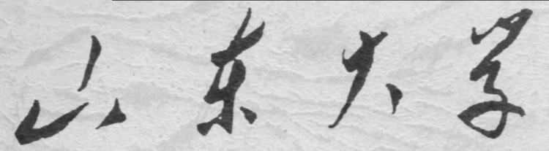

**信息科学与工程学院**

**2019－2020学年第二学期**

实 验 报 告

课程名称： 电子设计自动化

实验名称： 实验三 乘法器和除法器设计

专 业 班 级 通信工程 二班

学 生 学 号 201800121050

学 生 姓 名 孟麟芝

实 验 时 间 2020年4月

实验报告

【实验目的】

1.掌握使用VHDL语言进行硬件设计的基本方法

2.掌握基本的Quartus Ⅱ使用方法

3.学会testbench的编写，掌握波形仿真的基本方法

【实验要求】

1.移位相加型8位硬件乘法器设计。

2.高速硬件除法器设计。

3.串行静态显示控制电路设计。

【实验具体内容】

### 【第一个实验】

1.实验原理

该电路模拟人手算乘法时的算法而设计，根据电路图，详细操作步骤如下：

（1）一个时钟沿到来且选通端为0时，八位右移寄存器将输入的A0右移一位，QB输出了A0目前的最低位传给选通与门。

（2）若该位为0，则选通与门输出DOUT为“00000000”，若该位为1，则DOUT输出为B0

（3）十六位锁存器的低8位右移一位

（4）十六位锁存器高8位和选通与门输出的结果通过八位全加器相加

（5）十六位锁存器从D口接受全加器的结果，存到高9位

（6）重复操作上述步骤，第八个时钟沿到来时完成乘法

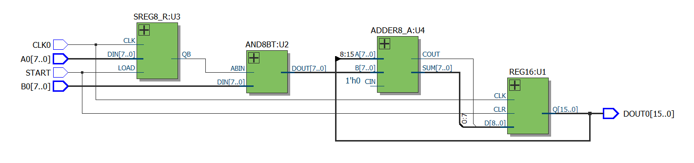

2.设计模块代码（Design Block）

（1）16位锁存器

LIBRARY IEEE;

USE IEEE.STD_LOGIC_1164.ALL;

ENTITY REG16 IS

PORT ( CLK,CLR : IN STD_LOGIC;

D : IN STD_LOGIC_VECTOR(8 DOWNTO 0);

Q : OUT STD_LOGIC_VECTOR(15 DOWNTO 0):="0000000000000000"

);

END REG16;

ARCHITECTURE behav OF REG16 IS

SIGNAL R16S :STD_LOGIC_VECTOR(15 DOWNTO 0);

BEGIN

PROCESS(CLK,CLR)

BEGIN

IF CLR = '1' THEN R16S <= (OTHERS =>'0');

ELSIF CLK'EVENT AND CLK = '1' THEN

R16S(6 DOWNTO 0) <= R16S(7 DOWNTO 1);

R16S(15 DOWNTO 7) <= D;

END IF;

END PROCESS;

Q <= R16S;

END behav;

（2）8位右移寄存器

LIBRARY IEEE;

USE IEEE.STD_LOGIC_1164.ALL;

USE IEEE.STD_LOGIC_UNSIGNED.ALL;

ENTITY SREG8_R IS

PORT(CLK : IN STD_LOGIC;

LOAD: IN STD_LOGIC;

DIN : IN STD_LOGIC_VECTOR(7 DOWNTO 0);

QB : OUT STD_LOGIC

);

END SREG8_R;

ARCHITECTURE BHV OF SREG8_R IS

SIGNAL REG8: STD_LOGIC_VECTOR(7 DOWNTO 0);

BEGIN

PROCESS(CLK,LOAD)

BEGIN

IF (LOAD = '1') THEN

REG8 <= DIN;

ELSE

IF(CLK'EVENT AND CLK ='1') THEN

REG8(6 DOWNTO 0) <= REG8(7 DOWNTO 1);

END IF;

END IF;

END PROCESS;

QB <= REG8(0);

END BHV;

（3）选通与门

LIBRARY IEEE;

USE IEEE.STD_LOGIC_1164.ALL;

ENTITY AND8BT IS

PORT ( ABIN : IN STD_LOGIC;

DIN : IN STD_LOGIC_VECTOR(7 DOWNTO 0);

DOUT : OUT STD_LOGIC_VECTOR(7 DOWNTO 0));

END AND8BT;

ARCHITECTURE BHV OF AND8BT IS

BEGIN

PROCESS(ABIN,DIN)

BEGIN

FOR I IN 0 TO 7 LOOP

DOUT(I) <= DIN(I) AND ABIN;

END LOOP;

END PROCESS;

END BHV;

（4）8位全加器

LIBRARY IEEE;

USE IEEE.STD_LOGIC_1164.ALL;

USE IEEE.STD_LOGIC_UNSIGNED.ALL;

ENTITY ADDER8_A IS

PORT (A : IN STD_LOGIC_VECTOR(7 DOWNTO 0);

B : IN STD_LOGIC_VECTOR(7 DOWNTO 0);

CIN : IN STD_LOGIC;

SUM : OUT STD_LOGIC_VECTOR(7 DOWNTO 0);

COUT : OUT STD_LOGIC

);

END ENTITY ADDER8_A;

ARCHITECTURE BHV OF ADDER8_A IS

SIGNAL DATA :STD_LOGIC_VECTOR(8 DOWNTO 0);

BEGIN

DATA <= ('0'&A) + ('0'&B) + ("00000000"&CIN);

COUT <= DATA(8);

SUM <= DATA(7 DOWNTO 0);

END ARCHITECTURE BHV;

（5）总设计：移位相加型8位硬件乘法器

LIBRARY IEEE;

USE IEEE.STD_LOGIC_1164.ALL;

ENTITY MULT8_B IS

PORT(CLK0,START : IN STD_LOGIC;

A0,B0 : IN STD_LOGIC_VECTOR(7 DOWNTO 0);

DOUT0 : BUFFER STD_LOGIC_VECTOR(15 DOWNTO 0)

);

END MULT8_B;

ARCHITECTURE BHV OF MULT8_B IS

COMPONENT REG16 IS

PORT ( CLK,CLR : IN STD_LOGIC;

D : IN STD_LOGIC_VECTOR(8 DOWNTO 0);

Q : OUT STD_LOGIC_VECTOR(15 DOWNTO 0)

);

END COMPONENT;

COMPONENT AND8BT IS

PORT ( ABIN : IN STD_LOGIC;

DIN : IN STD_LOGIC_VECTOR(7 DOWNTO 0);

DOUT : OUT STD_LOGIC_VECTOR(7 DOWNTO 0));

END COMPONENT;

COMPONENT SREG8_R IS

PORT(CLK : IN STD_LOGIC;

LOAD: IN STD_LOGIC;

DIN : IN STD_LOGIC_VECTOR(7 DOWNTO 0);

QB : OUT STD_LOGIC

);

END COMPONENT;

COMPONENT ADDER8_A IS

PORT (A : IN STD_LOGIC_VECTOR(7 DOWNTO 0);

B : IN STD_LOGIC_VECTOR(7 DOWNTO 0);

CIN : IN STD_LOGIC;

SUM : OUT STD_LOGIC_VECTOR(7 DOWNTO 0);

COUT : OUT STD_LOGIC

);

END COMPONENT;

SIGNAL CONVEY1:STD_LOGIC_VECTOR(8 DOWNTO 0);

SIGNAL CONVEY2:STD_LOGIC;

SIGNAL CONVEY3:STD_LOGIC_VECTOR(7 DOWNTO 0);

SIGNAL CONVEY4:STD_LOGIC:='0';

BEGIN

U1:REG16 PORT MAP(CLK=>CLK0,CLR=>START,D=>CONVEY1,Q=>DOUT0);

U2:AND8BT PORT MAP(ABIN=>CONVEY2,DIN=>B0,DOUT=>CONVEY3);

U3:SREG8_R PORT MAP(CLK=>CLK0,LOAD=>START,DIN=>A0,QB=>CONVEY2);

U4:ADDER8_A PORT MAP(B=>CONVEY3,A=>DOUT0(15 DOWNTO 8),CIN=>CONVEY4,SUM=>CONVEY1(7 DOWNTO 0),COUT=>CONVEY1(8));

END BHV;

3.激励模块代码（Test Bench）

LIBRARY IEEE;

USE IEEE.STD_LOGIC_1164.ALL;

USE IEEE.STD_LOGIC_UNSIGNED.ALL;

ENTITY MULT8_BTB IS

END MULT8_BTB;

ARCHITECTURE ONE OF MULT8_BTB IS

COMPONENT MULT8_B

PORT(CLK0,START:IN STD_LOGIC;

A0,B0:IN STD_LOGIC_VECTOR(7 DOWNTO 0);

DOUT0:BUFFER STD_LOGIC_VECTOR(15 DOWNTO 0));

END COMPONENT;

SIGNAL CLK01:STD_LOGIC:='0';

SIGNAL START1:STD_LOGIC:='1';

SIGNAL A1:STD_LOGIC_VECTOR(7 DOWNTO 0);

SIGNAL B1:STD_LOGIC_VECTOR(7 DOWNTO 0);

SIGNAL DOUT1:STD_LOGIC_VECTOR(15 DOWNTO 0);

CONSTANT CLK_P: TIME:=500 ns;

BEGIN

I1:MULT8_B PORT MAP(CLK0=>CLK01,START=>START1,A0=>A1,B0=>B1,DOUT0=>DOUT1);

PROCESS BEGIN

CLK01<='0'; WAIT FOR CLK_P;

CLK01<='1'; WAIT FOR CLK_P;

END PROCESS;

START1<='1', '0' AFTER 800 ns;

A1<="11000010";

B1<="01010010";

END ONE;

4.仿真波形图

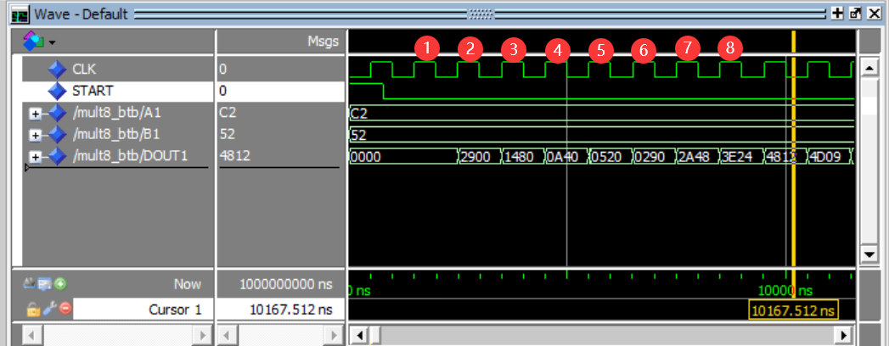

5.门级电路图

总设计：移位相加型8位硬件乘法器



十六位锁存器

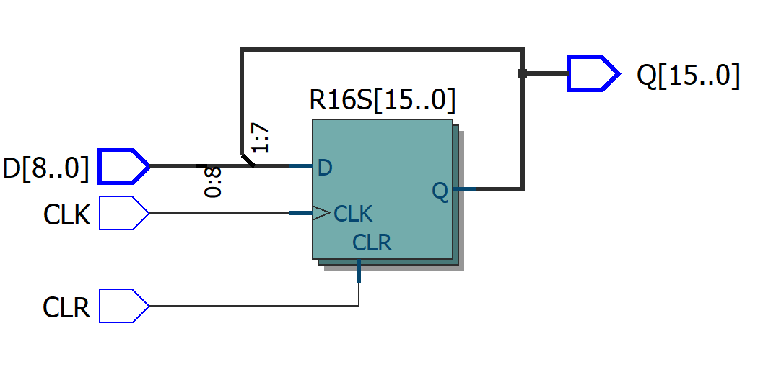

8位右移寄存器

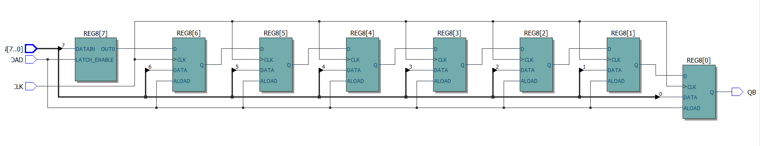

8位全加器

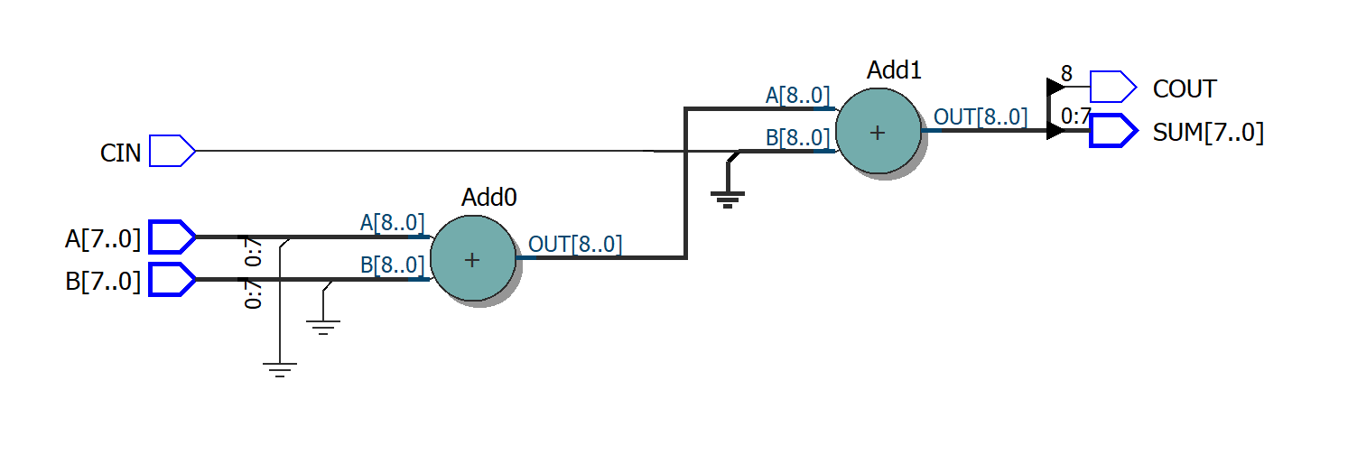

选通与门

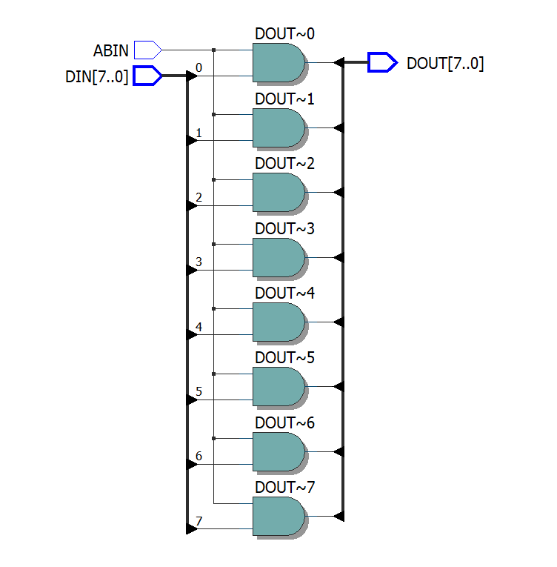

6.结果分析与思考

（1）一定要对十六位锁存器的输出设一个初值，不然选通端为0后第一个时钟沿到来时，会传给八位全加器的A口一个不定值，导致输出不定

（2）正确结果在选通端为0后的第八个时钟上升沿到来时出现，如波形仿真图所示，后续的结果并无意义

（3）该器件的缺点在于无法达到结果时自动停止，如果增加一个计数保持功能的子模块，则可能可以实现

（4）要注意该设计出于设计方便性考虑，一开始必须让LD为1一段时间才能使数据进入运算过程，

### 【第二个实验】

1.实验原理

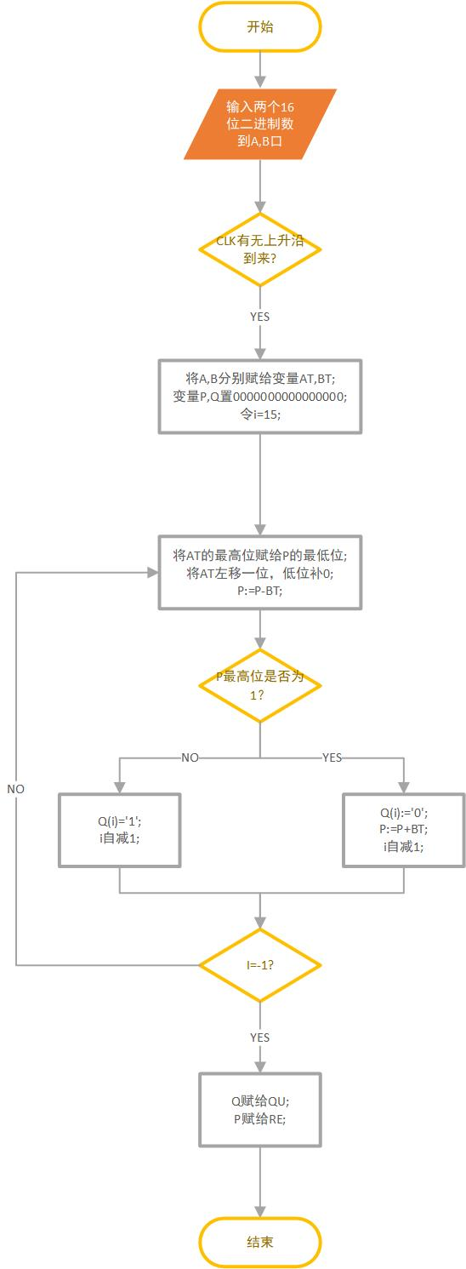

该程序模拟人手算乘法的过程，从被除数的高一位除起，若高一位即比除数大，那么商中的最高位就是1，若比除数小，则商中最高位为0，再从高两位除，与高一位的操作相似，依此类推得到商中的各位。

余数的得到方法是，若高x位时除被除数商0，则将高x位原封不动的保存在P中，若高x位时商1了，则将高x位与除数的差保留在P中，下一步将P中数据左移一位，最低位补成高第x+1位，对新的P进行相同的处理，依此类推，最后留在P中的就是余数

2.设计模块代码（Design Block）

LIBRARY IEEE;

USE IEEE.STD_LOGIC_1164.ALL;

USE IEEE.STD_LOGIC_UNSIGNED.ALL;

ENTITY DIV16_A IS

PORT(CLK : IN STD_LOGIC;

A,B : IN STD_LOGIC_VECTOR(15 DOWNTO 0);

QU,RE: OUT STD_LOGIC_VECTOR(15 DOWNTO 0)

);

END DIV16_A;

ARCHITECTURE BHV OF DIV16_A IS

BEGIN

PROCESS(CLK)

VARIABLE AT,BT,P,Q:STD_LOGIC_VECTOR(15 DOWNTO 0);

BEGIN

IF RISING_EDGE(CLK) THEN

AT:=A; BT:=B;

P:="0000000000000000";

Q:="0000000000000000";

FOR I IN QU'RANGE LOOP

P := P(14 DOWNTO 0)&AT(15);

AT:= AT(14 DOWNTO 0)&'0';

P := P-BT;

IF P(15)='1' THEN

Q(I):='0';

p := P+BT;

ELSE Q(I):='1';

END IF;

END LOOP;

END IF;

QU<=Q;

RE<=P;

END PROCESS;

END BHV;

3.激励模块代码（Test Bench）

LIBRARY ieee;

USE ieee.std_logic_1164.all;

ENTITY DIV16_A_vhd_tst IS

END DIV16_A_vhd_tst;

ARCHITECTURE DIV16_A_arch OF DIV16_A_vhd_tst IS

SIGNAL A1 : STD_LOGIC_VECTOR(15 DOWNTO 0);

SIGNAL B1 : STD_LOGIC_VECTOR(15 DOWNTO 0);

SIGNAL CLK1 : STD_LOGIC;

SIGNAL QU1 : STD_LOGIC_VECTOR(15 DOWNTO 0);

SIGNAL RE1 : STD_LOGIC_VECTOR(15 DOWNTO 0);

COMPONENT DIV16_A

PORT (

A : IN STD_LOGIC_VECTOR(15 DOWNTO 0);

B : IN STD_LOGIC_VECTOR(15 DOWNTO 0);

CLK : IN STD_LOGIC;

QU : OUT STD_LOGIC_VECTOR(15 DOWNTO 0);

RE : OUT STD_LOGIC_VECTOR(15 DOWNTO 0)

);

END COMPONENT;

BEGIN

i1 : DIV16_A

PORT MAP (

A => A1,

B => B1,

CLK => CLK1,

QU => QU1,

RE => RE1

);

CLK1 <= '0', '1' AFTER 1000 NS;

A1 <= "1100011001010001";

B1 <= "0101001000010011";

END DIV16_A_arch;

4.仿真波形图

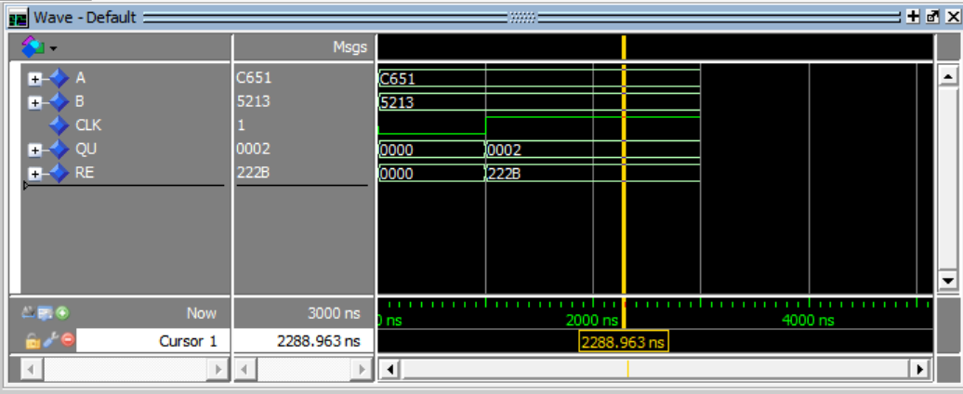

5.门级电路图

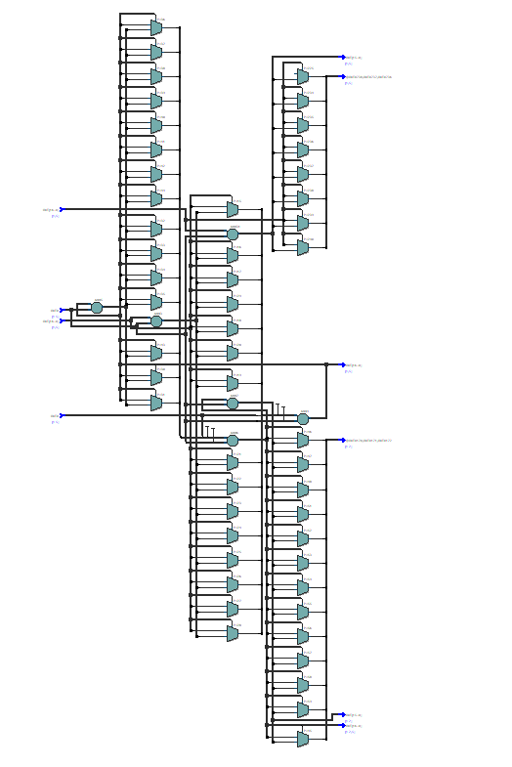

6.结果分析与思考

1. 从图中可见，到来一个时钟沿时除法器开始运算，得出的结果是正确的，5213*2+222B正好等于C651
2. 该除法器高速的原理在于模拟了人手算除法的过程，有多少位就需要循环多少次
3. 虽然实现了高速除法，但该除法器对硬件资源占用较大

### 【第三个实验】

1.实验原理

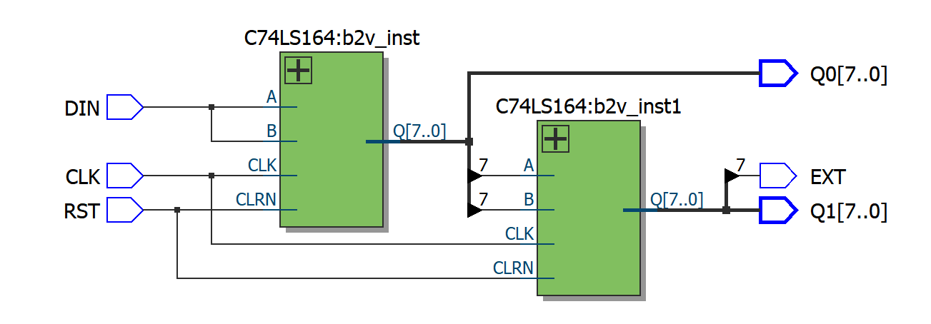

如图所示为一个两数码管显示控制电路，RST为高电平清零端，CLK为时钟接口在DIN口串行输入一个八位数据以后，经过八个时钟信号被锁存于Q0口，再经过8个时钟信号即移入Q1中，以此类推，在Q0，Q1口连接译码器以及数码管即可完成数字显示，EXT口为扩展口，用于连接下一个芯片

2.设计模块代码（Design Block）

74LS164设计：

LIBRARY ieee;

USE ieee.std_logic_1164.all;

LIBRARY work;

ENTITY C74LS164 IS

PORT

(

CLK : IN STD_LOGIC;

CLRN : IN STD_LOGIC;

B : IN STD_LOGIC;

A : IN STD_LOGIC;

Q : OUT STD_LOGIC_VECTOR(7 DOWNTO 0)

);

END C74LS164;

ARCHITECTURE bdf_type OF C74LS164 IS

SIGNAL DFF_9 : STD_LOGIC;

SIGNAL SYNTHESIZED_WIRE_0 : STD_LOGIC;

SIGNAL DFF_3 : STD_LOGIC;

SIGNAL DFF_4 : STD_LOGIC;

SIGNAL DFF_5 : STD_LOGIC;

SIGNAL DFF_6 : STD_LOGIC;

SIGNAL DFF_7 : STD_LOGIC;

SIGNAL DFF_8 : STD_LOGIC;

BEGIN

Q(6) <= DFF_9;

Q(5) <= DFF_8;

Q(4) <= DFF_7;

Q(3) <= DFF_6;

Q(2) <= DFF_5;

Q(1) <= DFF_4;

Q(0) <= DFF_3;

PROCESS(CLK,CLRN)

BEGIN

IF (CLRN = '1') THEN

Q(7) <= '0';

ELSIF (RISING_EDGE(CLK)) THEN

Q(7) <= DFF_9;

END IF;

END PROCESS;

SYNTHESIZED_WIRE_0 <= A AND B;

PROCESS(CLK,CLRN)

BEGIN

IF (CLRN = '1') THEN

DFF_3 <= '0';

ELSIF (RISING_EDGE(CLK)) THEN

DFF_3 <= SYNTHESIZED_WIRE_0;

END IF;

END PROCESS;

PROCESS(CLK,CLRN)

BEGIN

IF (CLRN = '1') THEN

DFF_4 <= '0';

ELSIF (RISING_EDGE(CLK)) THEN

DFF_4 <= DFF_3;

END IF;

END PROCESS;

PROCESS(CLK,CLRN)

BEGIN

IF (CLRN = '1') THEN

DFF_5 <= '0';

ELSIF (RISING_EDGE(CLK)) THEN

DFF_5 <= DFF_4;

END IF;

END PROCESS;

PROCESS(CLK,CLRN)

BEGIN

IF (CLRN = '1') THEN

DFF_6 <= '0';

ELSIF (RISING_EDGE(CLK)) THEN

DFF_6 <= DFF_5;

END IF;

END PROCESS;

PROCESS(CLK,CLRN)

BEGIN

IF (CLRN = '1') THEN

DFF_7 <= '0';

ELSIF (RISING_EDGE(CLK)) THEN

DFF_7 <= DFF_6;

END IF;

END PROCESS;

PROCESS(CLK,CLRN)

BEGIN

IF (CLRN = '1') THEN

DFF_8 <= '0';

ELSIF (RISING_EDGE(CLK)) THEN

DFF_8 <= DFF_7;

END IF;

END PROCESS;

PROCESS(CLK,CLRN)

BEGIN

IF (CLRN = '1') THEN

DFF_9 <= '0';

ELSIF (RISING_EDGE(CLK)) THEN

DFF_9 <= DFF_8;

END IF;

END PROCESS;

END bdf_type;

总设计：

LIBRARY ieee;

USE ieee.std_logic_1164.all;

ENTITY DISCTR_B IS

PORT

(

DIN : IN STD_LOGIC;

CLK : IN STD_LOGIC;

RST : IN STD_LOGIC;

EXT : OUT STD_LOGIC;

Q0 : OUT STD_LOGIC_VECTOR(7 DOWNTO 0);

Q1 : OUT STD_LOGIC_VECTOR(7 DOWNTO 0)

);

END DISCTR_B;

ARCHITECTURE bdf_type OF DISCTR_B IS

COMPONENT C74LS164

PORT(A : IN STD_LOGIC;

B : IN STD_LOGIC;

CLRN: IN STD_LOGIC;

CLK : IN STD_LOGIC;

Q : OUT STD_LOGIC_VECTOR(7 DOWNTO 0));

END COMPONENT;

SIGNAL Q_ALTERA_SYNTHESIZED0 : STD_LOGIC_VECTOR(7 DOWNTO 0);

SIGNAL Q_ALTERA_SYNTHESIZED1 : STD_LOGIC_VECTOR(7 DOWNTO 0);

BEGIN

b2v_inst : C74LS164

PORT MAP(A => DIN,

B => DIN,

CLRN => RST,

CLK => CLK,

Q => Q_ALTERA_SYNTHESIZED0);

b2v_inst1 : C74LS164

PORT MAP(A => Q_ALTERA_SYNTHESIZED0(7),

B => Q_ALTERA_SYNTHESIZED0(7),

CLRN => RST,

CLK => CLK,

Q => Q_ALTERA_SYNTHESIZED1);

EXT <= Q_ALTERA_SYNTHESIZED1(7);

Q0 <= Q_ALTERA_SYNTHESIZED0;

Q1 <= Q_ALTERA_SYNTHESIZED1;

END bdf_type;

3.激励模块代码（Test Bench）

由于缺少硬件数码管，无法进行仿真测试

4.仿真波形图

由于缺少硬件数码管，无法进行仿真测试

5.门级电路图



6.结果分析与思考

若加以合适的外部电路，如单片机，译码器，数码管等则可以实现串行显示