Chapter 41 The effect of changes in concentration and temperature on chemical equilibria

Section 41.1
ChemMCQ41001
Consider the following equilibrium system.
2CrO₄²⁻(aq) + 2H⁺(aq) Cr₂O₇²⁻(aq) + H₂O(l)
Which of the following changes can cause the colour of the solution to turn yellow?
(1) Add a few drops of dilute hydrochloric acid.
(2) Add a few drops of sodium carbonate solution.
(3) Add a few drops of sodium hydroxide solution.
A. (1) only
B. (2) only
C. (1) and (3) only
D. (2) and (3) only

Answer: D
(1): Adding dilute HCl(aq) increases the concentration of H⁺(aq). The equilibrium position shifts to the right.
(2): Na₂CO₃(aq) removes the H⁺(aq) and so the equilibrium position shifts to the left.
(3): NaOH(aq) removes the H⁺(aq) and so the equilibrium position shifts to the left.

ChemMCQ41002
Consider the following equilibrium system.
Cr₂O₇²⁻(aq) + H₂O(l) 2CrO₄²⁻(aq) + 2H⁺(aq)
Which of the following statements is/are correct?
(1) Both Cr₂O₇²⁻(aq) and CrO₄²⁻(aq) are present in the equilibrium mixture.
(2) The reversible reaction is a redox reaction.
(3) The solution becomes orange when sodium hydroxide solution is added to the mixture.
A. (1) only
B. (2) only
C. (1) and (3) only
D. (2) and (3) only

Answer: A
(2): The reversible reaction is not a redox reaction because the oxidation number of every element remains unchanged.
(3): Adding dilute NaOH(aq) removes the H⁺(aq) and this shifts the equilibrium position to the right. The solution becomes yellow.

ChemMCQ41003
Consider the following equilibrium system.
Cr₂O₇²⁻(aq) + H₂O(l) 2CrO₄²⁻(aq) + 2H⁺(aq)
A few drops of dilute sulphuric acid are added to the system and a new state of equilibrium is established. Which of the following statements about the new state of equilibrium is/are correct?
(1) The solution becomes more orange in colour.
(2) The solution becomes more yellow in colour.
(3) The value of K_{c} decreases.
A. (1) only
B. (2) only
C. (1) and (3) only
D. (2) and (3) only

Answer: A
Adding dilute H₂SO₄(aq) increases the concentration of H⁺(aq). The equilibrium position shifts to the left and the concentration of Cr₂O₇²⁻(aq) increases. The solution becomes more orange in colour. The value of K_{c} remains unchanged at a given temperature.

ChemMCQ41004
Consider the following equilibrium system.
Br₂(aq) + H₂O(l) H⁺(aq) + Br⁻(aq) + HOBr(aq)
Which of the following would be observed when a few drops of NaOH(aq) are added to the system?
(1) The colour of the mixture becomes deeper.
(2) The colour of the mixture becomes paler.
(3) Steamy fumes are given out.
A. (1) only
B. (2) only
C. (1) and (3) only
D. (2) and (3) only

Answer: B
When NaOH(aq) is added to the system, it neutralizes the H⁺(aq) and this reduces the concentration of H⁺(aq). The equilibrium position shifts to the right.

ChemMCQ41005
Consider the following equilibrium system.
Br₂(aq) + H₂O(l) HOBr(aq) + H⁺(aq) + Br⁻(aq)
Which of the following changes would make the colour of the mixture become paler?
(1) Adding dilute hydrochloric acid
(2) Adding dilute sodium hydroxide solution
(3) Adding concentrated potassium bromide solution
A. (1) only
B. (2) only
C. (1) and (3) only
D. (2) and (3) only

Answer: B
(1): Adding dilute HCl(aq) increases the concentration of H⁺(aq). The equilibrium position shifts to the left and the mixture becomes deeper in colour.
(2): Adding dilute NaOH(aq) reduces the concentration of H⁺(aq). The equilibrium position shifts to the right and the mixture becomes paler in colour.
(3): Adding concentrated KBr(aq) increases the concentration of Br⁻(aq). The equilibrium position shifts to the left and the mixture becomes deeper in colour.

ChemMCQ41006
Consider the following equilibrium system at 25°C.
HCOOH(aq) HCOO⁻(aq) + H⁺(aq)
If a small amount of HCl(aq) is added to the system at 25°C, which of the following statements are correct?
(1) The concentration of HCOO⁻(aq) will decrease.
(2) The concentration of HCOOH(aq) will increase.
(3) The value of K_{c} remains unchanged.
A. (1) and (2) only
B. (1) and (3) only
C. (2) and (3) only
D. (1), (2) and (3)

Answer: D
When adding HCl(aq) to the system, the equilibrium position shifts to the left, consuming some of the added H⁺(aq) and producing more HCOOH(aq). The value of K_{c} remains unchanged at a given temperature.

ChemMCQ41007
Consider the following equilibrium system.
Co²⁺(aq) + 4Cl⁻(aq) CoCl₄²⁻(aq)
What will happen to the concentration of Cl⁻(aq) if CoCl₄²⁻(aq) is removed from the system?
A. It remains unchanged.
B. It decreases at first and then remains unchanged.
C. It increases at first and then remains unchanged.
D. It decreases at first and then increases.

Answer: B
When the concentration of CoCl₄²⁻(aq) decreases, the equilibrium position shifts to the right, consuming some Co²⁺(aq) and Cl⁻(aq). Thus, the concentration of Cl⁻(aq) decreases until a new equilibrium is established.

ChemMCQ41008
Consider the following equilibrium system.
2CO(g) + O₂(g) 2CO₂(g)
If CO(g) is added to the system at constant temperature, which of the following statements is correct?
A. There is a change in concentrations of the reactants only.
B. There is a change in concentration of the product only.
C. There are changes in concentrations of both reactants and product.
D. There is no change in concentrations of either reactants or product.

Answer: C
When adding CO(g) to the system, the equilibrium position will shift in a way that opposes the disturbance. Hence, the concentrations of both reactants and product change.

ChemMCQ41009
Consider the following equilibrium system.
N₂O₄(g) 2NO₂(g)
colourless brown
N₂O₄(g) is added to the system at constant temperature and a new state of equilibrium is established. Which of the following statements is/are correct?
(1) The concentration of N₂O₄(g) remains unchanged when a new state of equilibrium is established.
(2) The equilibrium constant will decrease.
(3) The colour intensity of the reaction mixture increases.
A. (1) only
B. (2) only
C. (1) and (3) only
D. (2) and (3) only

Answer: C
(2): K_{c} only depends on temperature.
(3): The concentration of brown NO₂(g) increases when a new state of equilibrium is established.

ChemMCQ41010
Aspartic acid is an amino acid. The structure of aspartic acid is shown below.
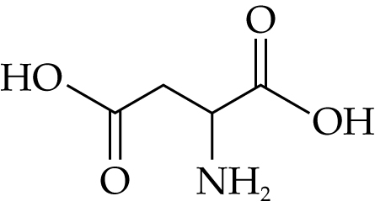
In water, aspartic acid exists in two ionic forms. The following equilibrium is attained.
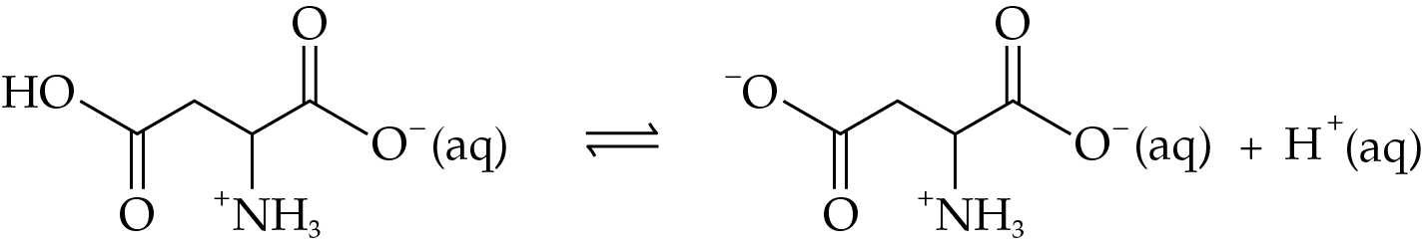
Which of the following statements are correct?
(1) The basicity of aspartic acid is 2.
(2) Aspartic acid is a weak acid.
(3) When a few drops of sodium hydroxide solution are added to the equilibrium mixture, the equilibrium position shifts to the right.
A. (1) and (2) only
B. (1) and (3) only
C. (2) and (3) only
D. (1), (2) and (3)

Answer: D

ChemMCQ41011
Consider the following equilibrium system.
CH₃CH₂COOH(aq) CH₃CH₂COO⁻(aq) + H⁺(aq)
Which of the following statements is correct?
A. The pH of 0.1 mol dm⁻³ propanoic acid is 1.
B. Propanoic acid is a monobasic acid.
C. Adding NaOH(aq) will have no effect on the amount of propanoic acid ionized.
D. Increasing the concentration of propanoic acid will increase K_{c}.

Answer: B
(A): Propanoic acid is a weak acid. The pH of 0.1 mol dm⁻³ propanoic acid is larger than 1 as the concentration of H⁺(aq) is lower than 0.1 mol dm⁻³.
(C): Adding NaOH(aq) will remove the H⁺(aq) and the equilibrium position shifts to the right. More propanoic acid will ionize.
(D): K_{c} only depends on temperature.

Section 41.2
ChemMCQ41012
Consider the following equilibrium system.
H₂(g) + I₂(g) 2HI(g)
What will be the change in colour intensity of the equilibrium system when the volume of the system decreases?
A. It increases and then decreases.
B. It increases and then remains unchanged.
C. It decreases and then increases.
D. It remains unchanged.

Answer: B
When the volume of the system decreases, the concentrations of all gases increase. The increase in concentration of purple I₂(g) makes the colour intensity of the system increases.
Since there are equal numbers of moles of gases on the two sides of the equation, the change in volume (pressure) has no effect on the equilibrium position. The colour intensity of the system remains unchanged.

ChemMCQ41013
In which of the following equilibria will an increase in volume at constant temperature increase the yield of product(s) of the reaction?
(1) 2SO₃(g) 2SO₂(g) + O₂(g)
(2) CO₂(g) + 3H₂(g) CH₃OH(g) + H₂O(g)
(3) H₂(g) + I₂(g) 2HI(g)
A. (1) only
B. (2) only
C. (1) and (3) only
D. (2) and (3) only

Answer: A
(1): Since there are a greater number of moles of gases on the right-hand side of the equation, an increase in volume (a decrease in pressure) shifts the equilibrium position to the right.
(2): Since there are a greater number of moles of gases on the left-hand side of the equation, an increase in volume (a decrease in pressure) shifts the equilibrium position to the left.
(3): Since there are equal numbers of moles of gases on the two sides of the equation, the change in volume (pressure) has no effect on the equilibrium position.

ChemMCQ41014
In which of the following equilibria will an increase in pressure at constant temperature NOT affect the yield of product(s) of the reaction?
A. Cl₂(g) + 3F₂(g) 2ClF₃(g)
B. PCl₅(g) PCl₃(g) + Cl₂(g)
C. H₂(g) + I₂(g) 2HI(g)
D. 4HCl(g) + O₂(g) 2H₂O(g) + 2Cl₂(g)

Answer: C
(C): Since there are equal numbers of moles of gases on the two sides of the equation, an increase in pressure has no effect on the equilibrium position.

ChemMCQ41015
In which of the following chemical equilibria will an increase in pressure at a constant temperature shift the equilibrium position to the right?
(1) 4HCl(g) + O₂(g) 2H₂O(g) + 2Cl₂(g)
(2) PF₃Cl₂(g) PF₃(g) + Cl₂(g)
(3) CO(g) + H₂O(g) H₂(g) + CO₂(g)
A. (1) only
B. (2) only
C. (1) and (3) only
D. (2) and (3) only

Answer: A
(1): Since there are a greater number of moles of gases on the left-hand side of the equation, an increase in pressure shifts the equilibrium position to the right.
(2): Since there are a greater number of moles of gases on the right-hand side of the equation, an increase in pressure shifts the equilibrium position to the left.
(3): Since there are equal numbers of moles of gases on the two sides of the equation, a change in pressure has no effect on the equilibrium position.

ChemMCQ41016
In which of the following equilibria will a change in volume at constant temperature NOT affect the equilibrium position?
(1) 2H₂O(g) 2H₂(g) + O₂(g)
(2) O₃(g) + NO(g) O₂(g) + NO₂(g)
(3) PCl₅(g) PCl₃(g) + Cl₂(g)
A. (1) only
B. (2) only
C. (1) and (3) only
D. (2) and (3) only

Answer: B
(2): Since there are equal numbers of moles of gases on the two sides of the equation, a change in volume has no effect on the equilibrium position.

ChemMCQ41017
Consider the following equilibrium system.
2N₂O(g) + O₂(g) 4NO(g)
Which of the following changes will increase the amount of NO(g) in the equilibrium mixture?
(1) Adding N₂O(g)
(2) Removing O₂(g)
(3) Decreasing the volume of the container
A. (1) only
B. (2) only
C. (1) and (3) only
D. (2) and (3) only

Answer: A
(1): Adding N₂O(g) will shift the equilibrium position to the right.
(2): Removing O₂(g) will shift the equilibrium position to the left.
(3): Decreasing the volume of the container will increase the pressure of the system. The equilibrium position will shift to the left.

ChemMCQ41018
Consider the following equilibrium system.
2A(g) + 2B(g) C(g)
The system is disturbed at time t. The following graph shows the changes in concentrations of the species with time.
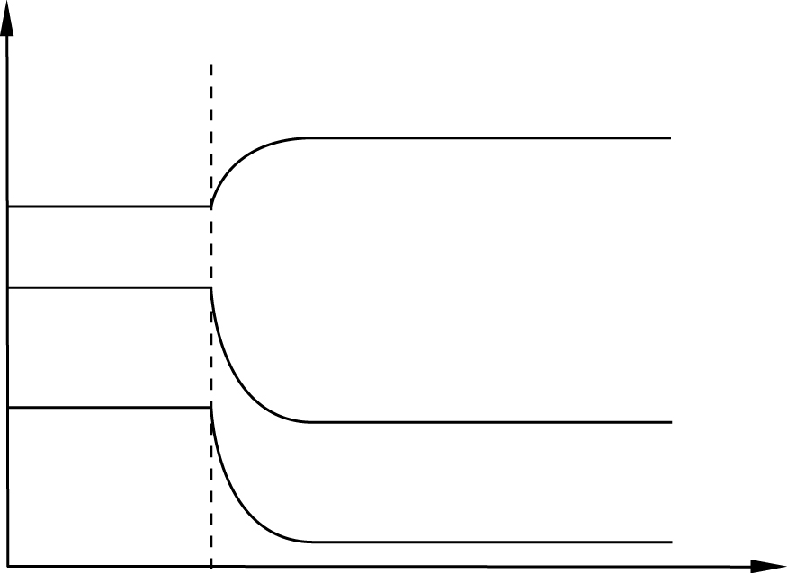
Time
A(g)
B(g)
C(g)
Concentration
t
Which of the following statements is/are correct?
(1) The equilibrium position has shifted to the right.
(2) C(g) is added to the equilibrium mixture at time t.
(3) The pressure of the system increases at time t.
A. (1) only
B. (2) only
C. (1) and (3) only
D. (2) and (3) only

Answer: A
(2): If C(g) were added to the equilibrium mixture at time t, the concentration of C(g) would have increased sharply.
(3): If the pressure were increased at time t, the concentrations of A(g), B(g) and C(g) would have increased sharply.

ChemMCQ41019
Consider the following equilibrium system.
CO(g) + 2H₂(g) CH₃OH(g)
The volume of the reaction vessel is suddenly halved at time t. Which of the following graphs correctly shows the change in concentration of CH₃OH(g) with time?
A. | 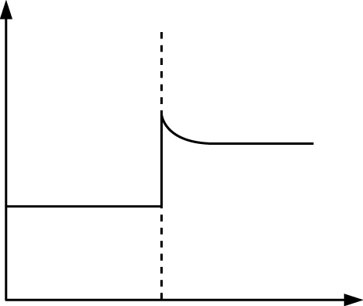  time  [CH₃OH(g)]  t | B. | 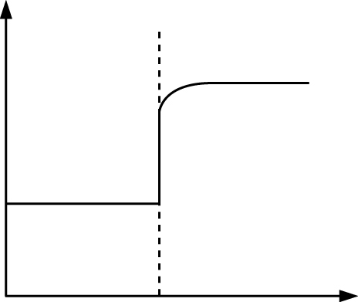  time  [CH₃OH(g)]  t
C. | 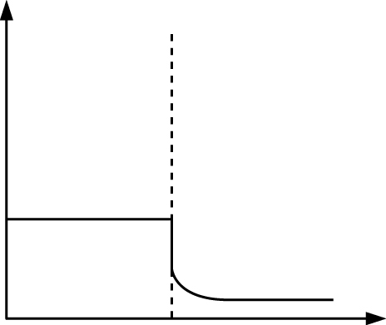  time  [CH₃OH(g)]  t | D. | 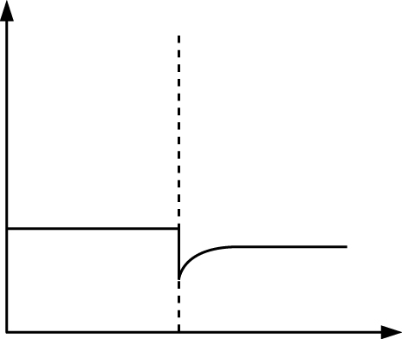  time  [CH₃OH(g)]  t

Answer: B
When the volume of the reaction vessel is suddenly halved, the concentration of CH₃OH(g) doubles. Since there are a greater number of moles of gases on the left-hand side of the equation, a decrease in volume (an increase in pressure) shifts the equilibrium position to the right, giving more CH₃OH(g).

ChemMCQ41020
A mixture of HI(g), H₂(g) and I₂(g) is allowed to attain equilibrium in a gas syringe at a certain temperature.
2HI(g) H₂(g) + I₂(g)

a gaseous mixture of H₂, I₂ and HI
plunger
rubber cap
gas syringe
The mixture in the gas syringe is compressed rapidly. Which of the following statements describes the expected observation?
A. The colour intensity of the mixture decreases.
B. The colour intensity of the mixture increases.
C. The colour intensity of the mixture decreases first and then increases.
D. The colour intensity of the mixture remains unchanged.

Answer: B
Since there are equal numbers of moles of gases on the two sides of the equation, a change in pressure has no effect on the equilibrium position. However, reducing the volume of the gases will cause an increase in concentrations of all gases. The concentration of purple I₂(g) increases.

ChemMCQ41021
Direction: Questions (a) and (b) refer to the decomposition of nitrosyl bromide (NOBr).
2NOBr(g) 2NO(g) + Br₂(g)
(a) At 373 K, an equilibrium mixture in a 3.00 dm³ closed vessel is found to contain 0.0176 mol of NOBr, 0.0616 mol of NO and 0.0157 mol of Br₂. What is the equilibrium constant for the reaction at 373 K?
A. 0.0550 mol dm⁻³
B. 0.0641 mol dm⁻³
C. 0.192 mol dm⁻³
D. 886 mol dm⁻³

Answer: B
K_{c} = $\frac{{\text{[}\text{NO}\text{(g)]}}_{\text{eqm}}^{\text{2}}{\text{[}\text{Br}\text{2}\text{(g)]}}_{\text{eqm}}^{}}{{\text{[}\text{NOBr}\text{(g)]}}_{\text{eqm}}^{\text{2}}}$ = $\frac{\text{(}\frac{\text{0.0616 mol}}{\text{3.00 dm}\text{3}}\text{)}\text{2}\text{(}\frac{\text{0.0157 mol}}{\text{3.00 dm}\text{3}}\text{)}}{\text{(}\frac{\text{0.0176 mol}}{\text{3.00 dm}\text{3}}\text{)}\text{2}}$ = 0.0641 mol dm⁻³

(b) Which of the following combinations is correct when increasing the volume of the vessel while keeping the temperature of the system unchanged?
 | Rate of forward reaction | Rate of backward reaction | Equilibrium constant
A. | Increases | Increases | Increases
B. | Remains unchanged | Remains unchanged | Decreases
C. | Decreases | Decreases | Remains unchanged
D. | Decreases | Increases | Remains unchanged

Answer: C
When the volume of the vessel increases, the concentrations of all gases decrease. The rates of forward and backward reactions decrease. As the temperature is constant, K_{c} remains unchanged.

ChemMCQ41022
The following equilibrium is established in a closed container kept at a certain temperature.
2NOCl(g) 2NO(g) + Cl₂(g)
Which of the following statements is INCORRECT when increasing the volume of the container at constant temperature?
A. K_{c} remains unchanged.
B. The yield of NO(g) increases.
C. The rate of decomposition of NOCl(g) decreases.
D. The rate of combination of NO(g) and Cl₂(g) decreases.

Answer: C
As the volume of the container increases, the pressure of the gaseous mixture decreases. Since there are a greater number of moles of gases on the right-hand side of the equation, a decrease in pressure shifts the equilibrium position to the right. Thus, the rate of decomposition of NOCl(g) increases.

ChemMCQ41023
Consider the following equilibrium system.
4NO(g) + 6H₂O(g) 4NH₃(g) + 5O₂(g)
Which of the following statements are correct?
(1) NO(g) is reduced while H₂O(g) is oxidized.
(2) When the pressure of the system increases at constant temperature, the equilibrium position will shift to the right.
(3) When the pressure of the system increases at constant temperature, K_{c} will increase.
A. (1) and (2) only
B. (1) and (3) only
C. (2) and (3) only
D. (1), (2) and (3)

Answer: A
(1): The oxidation number of N decreases from +2 to −3 while that of O increases from −2 to 0. Hence, NO(g) is reduced while H₂O(g) is oxidized.
(2): Since there are a greater number of moles of gases on the left-hand side of the equation, an increase in pressure shifts the equilibrium position to the right.
(3): As the temperature is constant, K_{c} remains unchanged.

ChemMCQ41024
Methanoic acid ionizes slightly in water to give methanoate ions and hydrogen ions.
HCOOH(aq) HCOO⁻(aq) + H⁺(aq)
Which of the following statements is/are correct?
(1) An increase in pressure does not affect the pH of the solution.
(2) After adding a few drops of sodium methanoate solution to methanoic acid, the pH of the resultant solution decreases.
(3) After adding a few drops of aqueous ammonia to methanoic acid, the pH of the resultant solution increases.
A. (1) only
B. (2) only
C. (1) and (3) only
D. (2) and (3) only

Answer: C
(1): As the system does not involve any gaseous species, a change in pressure has no effect on the equilibrium position.
(2): Adding HCOO⁻(aq) (from HCOONa(aq)) shifts the equilibrium position to the left. The concentration of H⁺(aq) decreases and the pH of the solution increases.
(3): Adding NH₃(aq) will remove H⁺(aq) and the concentration of H⁺(aq) decreases. Hence, the pH of the solution increases.

Section 41.3
ChemMCQ41025
Consider the following reaction.
Co²⁺(aq) + 4Cl⁻(aq) CoCl₄²⁻(aq)
The concentrations of Co²⁺(aq), Cl⁻(aq) and CoCl₄²⁻(aq) at a particular moment are x mol dm⁻³, y mol dm⁻³ and z mol dm⁻³ respectively. What is the reaction quotient for the above reaction at that particular moment?
A. Q_{c} = $\frac{\text{z}}{\text{xy}}$
B. Q_{c} = $\frac{\text{z}}{\text{xy}\text{4}}$
C. Q_{c} = $\frac{\text{xy}\text{4}}{\text{z}}$
D. Q_{c} = $\frac{\text{xy}}{\text{z}}$

Answer: B

ChemMCQ41026
The following equilibrium was established in a 1.0 dm³ sealed container maintained at a certain temperature.
PCl₅(g) PCl₃(g) + Cl₂(g) K_{c} = 0.0416 mol dm⁻³
The equilibrium has been disturbed and there are 0.45 mol of PCl₅, 0.15 mol of PCl₃ and 0.15 mol of Cl₂. Which of the following statements is/are correct?
(1) The reaction quotient (Q_{c}) at the moment when the equilibrium was disturbed is greater than K_{c}.
(2) More PCl₃(g) will be produced.
(3) The equilibrium position will shift to the left.
A. (1) only
B. (2) only
C. (1) and (3) only
D. (2) and (3) only

Answer: C
Q_{c} = $\frac{\text{[PCl}\text{3}\text{(g)][Cl}\text{2}\text{(g)]}}{\text{[PCl}\text{5}\text{(g)]}}$ = $\frac{\text{(0.15 mol dm}\text{3}\text{)}\text{(0.15 mol dm}\text{3}\text{)}}{\text{0.45 mol dm}\text{3}}$ = 0.050 mol dm⁻³
As Q_{c} > K_{c}, the equilibrium position will shift to the left.

ChemMCQ41027
Consider the following reversible reaction.
PCl₅(g) PCl₃(g) + Cl₂(g)
Four different reaction flasks (A, B, C and D) contain a mixture of PCl₃, Cl₂ and PCl₅ at the same temperature. The concentrations of the gases in each flask are shown in the table below.
Flask | [Cl₂(g)] / mol dm⁻³ | [PCl₃(g)] / mol dm⁻³ | [PCl₅(g)] / mol dm⁻³
A | 0.2 | 0.3 | 0.1
B | 0.3 | 0.4 | 0.2
C | 0.2 | 0.4 | 0.2
D | 0.5 | 0.6 | 0.5
If three of the four mixtures are at equilibrium, in which of the flasks is the system NOT at equilibrium?
A. A
B. B
C. C
D. D

Answer: C
Q_{c} = $\frac{\text{[PCl}\text{3}\text{(g)][Cl}\text{2}\text{(g)]}}{\text{[PCl}\text{5}\text{(g)]}}$
(A): Q_{c} = $\frac{\text{(0.3 mol dm}\text{3}\text{)}\text{(0.2 mol dm}\text{3}\text{)}}{\text{0.1 mol dm}\text{3}}$ = 0.6 mol dm⁻³
(B): Q_{c} = $\frac{\text{(0.4 mol dm}\text{3}\text{)}\text{(0.3 mol dm}\text{3}\text{)}}{\text{0.2 mol dm}\text{3}}$ = 0.6 mol dm⁻³
(C): Q_{c} = $\frac{\text{(0.4 mol dm}\text{3}\text{)}\text{(0.2 mol dm}\text{3}\text{)}}{\text{0.2 mol dm}\text{3}}$ = 0.4 mol dm⁻³
(D): Q_{c} = $\frac{\text{(0.6 mol dm}\text{3}\text{)}\text{(0.5 mol dm}\text{3}\text{)}}{\text{0.5 mol dm}\text{3}}$ = 0.6 mol dm⁻³

ChemMCQ41028
The following equilibrium is established in a closed container.
N₂(g) + 3H₂(g) 2NH₃(g)
When nitrogen gas is added to the closed container at constant temperature, what would be the change in K_{c} and Q_{c} respectively?
 | K_{c} | Q_{c}
A. | Increases | Increases
B. | Remains unchanged | Remains unchanged
C. | Remains unchanged | Decreases
D. | Decreases | Remains unchanged

Answer: C
K_{c} is a constant at a given temperature.
Q_{c} = $\frac{\text{[NH}\text{3}\text{(g)]}\text{2}}{\text{[N}\text{2}\text{(g)][H}\text{2}\text{(g)]}\text{3}}$
When [N₂(g)] increases, Q_{c} decreases.

ChemMCQ41029
The equilibrium constant for the following reaction at 40°C is 0.020.
2HI(g) H₂(g) + I₂(g)
In a system at 40°C, the concentrations of HI(g), H₂(g) and I₂(g) are 2.5 × 10⁻³ mol dm⁻³, 8.0 × 10⁻³ mol dm⁻³ and 4.1 × 10⁻⁵ mol dm⁻³ respectively. Which of the following statements about the system is correct?
A. The system is not at equilibrium and the equilibrium position will shift to the right.
B. The system is not at equilibrium and the equilibrium position will shift to the left.
C. The system is at equilibrium and the concentrations of all species remain unchanged.
D. The system is at equilibrium and the colour intensity of the system remains unchanged.

Answer: B
Q_{c} = $\frac{\text{[H}\text{2}\text{(g)][I}\text{2}\text{(g)]}}{\text{[HI(g)]}\text{2}}$ = $\frac{\text{(8.}\text{0 × 10}\text{3}\text{ mol dm}\text{3}\text{)}\text{(4.1}\text{ × 10}\text{5}\text{ mol dm}\text{3}\text{)}}{\text{(2}\text{.5 × 10}\text{3}\text{ mol dm}\text{3}\text{)}\text{2}}$ = 0.052
As Q_{c} > K_{c}, the equilibrium position will shift to the left.

ChemMCQ41030
The equilibrium constant for the dissociation of I₂(g) is 3.76 × 10⁻⁵ mol dm⁻³ at 1000 K. The equation for the dissociation is shown below.
I₂(g) 2I(g)
At a moment, 1.00 mol of I₂ and 5.00 × 10⁻³ mol of I are found in a 2.00 dm³ sealed flask at 1000 K. Which of the following statements about the system at this moment is/are correct?
(1) The system is in equilibrium.
(2) The system is not in equilibrium.
(3) The equilibrium position will shift to the right.
A. (1) only
B. (2) only
C. (1) and (3) only
D. (2) and (3) only

Answer: D
Q_{c} = $\frac{\text{[I(g)]}\text{2}}{\text{[I}\text{2}\text{(g)]}}$ = $\frac{\text{(}\frac{\text{5.00 × 10}\text{3}\text{ mol}}{\text{2.00 dm}\text{3}}\text{)}\text{2}}{\frac{\text{1.00 mol}}{\text{2.00 dm}\text{3}}}$ = 1.25 × 10⁻⁵ mol dm⁻³
As Q_{c} < K_{c}, the system is not in equilibrium and the equilibrium position will shift to the right.

ChemMCQ41031
The equilibrium constant for the following reaction at 298 K is 4.6 × 10⁻³¹.
N₂(g) + O₂(g) 2NO(g)
In an experiment, a scientist determined the value of $\frac{\text{[NO(g)]}\text{2}}{\text{[N}\text{2}\text{(g)][O}\text{2}\text{(g)]}}$ under some unknown conditions and found a result of 2.3 × 10⁻⁷. Which of the following could be the possible reasons?
(1) The reaction has not reached equilibrium.
(2) The reaction did not take place at 298 K.
(3) The reaction did not take place under 1 atm.
A. (1) and (2) only
B. (1) and (3) only
C. (2) and (3) only
D. (1), (2) and (3)

Answer: A

ChemMCQ41032
At a certain temperature, the K_{c} for the following reaction is 0.035.
2HI(g) H₂(g) + I₂(g)
In a vessel maintained at that temperature, the concentrations of HI(g), H₂(g) and I₂(g) are 2.0 mol dm⁻³, 0.50 mol dm⁻³ and 0.10 mol dm⁻³ respectively. Which of the following statements about the reaction quotient, Q_{c}, for the above system is correct?
A. Q_{c} is smaller than K_{c} and more H₂ and I₂ will be produced.
B. Q_{c} is smaller than K_{c} and more HI will be produced.
C. Q_{c} is larger than K_{c} and more H₂ and I₂ will be produced.
D. Q_{c} is larger than K_{c} and more HI will be produced.

Answer: A
Q_{c} = $\frac{\text{[H}\text{2}\text{(g)][I}\text{2}\text{(g)]}}{\text{[HI(g)]}\text{2}}$ = $\frac{\text{(0.50 mol dm}\text{3}\text{)}\text{(0.10 mol dm}\text{3}\text{)}}{\text{(2.0}\text{ mol dm}\text{3}\text{)}\text{2}}$ = 0.0125
As Q_{c} < K_{c}, the equilibrium position will shift to the right and more H₂ and I₂ will be produced.

ChemMCQ41033
Consider the following equilibrium system.
2NOCl(g) 2NO(g) + Cl₂(g)
The changes in concentrations of each gas in the above equilibrium are shown in the diagram below.
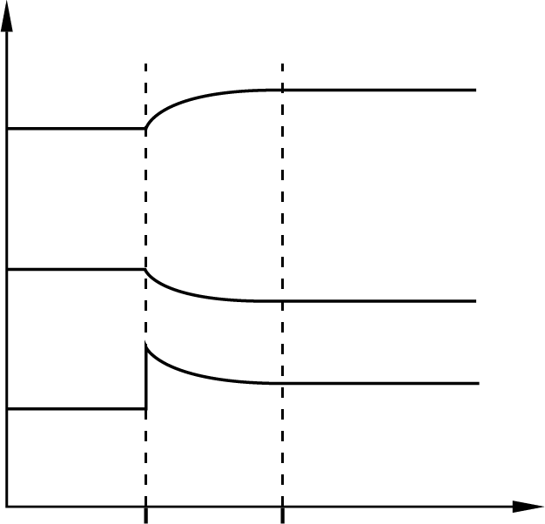
Concentration
Time
NO(g)
Cl₂(g)
NOCl(g)
t t’
Which of the following statements are correct?
(1) At time t, Cl₂(g) is added to the system at constant temperature.
(2) At time t, the reaction quotient is larger than the equilibrium constant.
(3) A new equilibrium is attained at time t’.
A. (1) and (2) only
B. (1) and (3) only
C. (2) and (3) only
D. (1), (2) and (3)

Answer: D
Q_{c} = $\frac{\text{[NO(g)]}\text{2}\text{[Cl}\text{2}\text{(g)]}}{\text{[NOCl(g)]}\text{2}}$
From the graph, there is a sharp increase in the concentration of Cl₂(g). Q_{c} will be larger than K_{c}.

Section 41.4
ChemMCQ41034
Which of the following statements must be correct if an equilibrium system is heated?
(1) The rate of forward reaction increases.
(2) The rate of backward reaction increases.
(3) The value of K_{c} increases.
A. (1) and (2) only
B. (1) and (3) only
C. (2) and (3) only
D. (1), (2) and (3)

Answer: A
An increase in temperature increases the rates of both forward and backward reactions but to the different extents. However, the change in K_{c} (increase or decrease) depends on whether the reversible reaction represented by the equation is exothermic or endothermic.

ChemMCQ41035
Which of the following changes will NOT change the equilibrium constant for a reversible reaction involving gases?
(1) Change in temperature of the reaction system
(2) Change in pressure of the reaction system
(3) Change in volume of the reaction flask
A. (1) and (2) only
B. (1) and (3) only
C. (2) and (3) only
D. (1), (2) and (3)

Answer: C
K_{c} only depends on temperature.

ChemMCQ41036
Which of the following statements about a chemical equilibrium is/are correct?
(1) Equilibrium can only be established in a closed system.
(2) When equilibrium is attained, the concentrations of reactants and products are the same.
(3) The equilibrium constant of an exothermic reaction increases with an increase in temperature.
A. (1) only
B. (2) only
C. (1) and (3) only
D. (2) and (3) only

Answer: A
(2): When equilibrium is established, the concentrations of reactants and products remain unchanged, but are not necessarily the same.
(3): An increase in temperature favours the endothermic change of an equilibrium system. K_{c} of an exothermic reaction decreases with an increase in temperature.

ChemMCQ41037
Which of the following statements about a reversible reaction that has reached equilibrium must be correct?
A. The rates of reactions in both directions become zero.
B. The reaction quotient is equal to the equilibrium constant.
C. The percentage yield of the product is 50%.
D. A change in temperature does not have any effect on the equilibrium system.

Answer: B
(A): The rates of reactions in both directions become equal.
(C): The percentage yield depends on the equilibrium constant.
(D): A change in temperature shifts the equilibrium position, depending on the ΔH of the reaction.

ChemMCQ41038
Consider the following chemical equilibrium.
CH₄(g) + 4NO(g) 2N₂(g) + CO₂(g) + 2H₂O(g) ΔH < 0
When the temperature of the equilibrium system is decreased at constant pressure, what are the effects on the K_{c} and the equilibrium position?
 | K_{c} | Equilibrium position
A. | Increases | Shifts to the right
B. | Increases | Shifts to the left
C. | Decreases | Shifts to the right
D. | Decreases | Shifts to the left

Answer: A
As the forward reaction is exothermic, a decrease in temperature shifts the equilibrium position to the right, giving more products. K_{c} increases.

ChemMCQ41039
Consider the following chemical equilibrium.
2H₂S(g) 2H₂(g) + S₂(g) ΔH = +170 kJ mol⁻¹
When the temperature of the equilibrium system is increased at constant pressure, what are the effects on the K_{c} and the equilibrium position?
 | K_{c} | Equilibrium position
A. | Increases | Shifts to the left
B. | Increases | Shifts to the right
C. | Decreases | Shifts to the left
D. | Decreases | Shifts to the right

Answer: B
As the forward reaction is endothermic, an increase in temperature shifts the equilibrium position to the right, giving more products. K_{c} increases.

ChemMCQ41040
Consider the following equilibrium system.
2H₂S(g) 2H₂(g) + S₂(g) ΔH > 0
Which of the following changes will shift the equilibrium position of the system?
(1) Introducing hydrogen gas to the system
(2) Increasing the temperature of the system at constant pressure
(3) Increasing the volume of the reaction vessel at constant temperature
A. (1) and (2) only
B. (1) and (3) only
C. (2) and (3) only
D. (1), (2) and (3)

Answer: D
(1): The equilibrium position shifts to the left.
(2): As the forward reaction is endothermic, an increase in temperature shifts the equilibrium position to the right.
(3): Since there are a greater number of moles of gases on the right-hand side of the equation, an increase in volume (a decrease in pressure) shifts the equilibrium position to the right.

ChemMCQ41041
Consider the following equilibrium system.
H₂(g) + I₂(g) 2HI(g) ΔH < 0
Which of the following changes will NOT shift the equilibrium position of the system?
(1) Increase the temperature of the system at constant pressure.
(2) Increase the volume of the system at constant temperature.
(3) Increase the concentration of HI(g).
A. (1) only
B. (2) only
C. (1) and (3) only
D. (2) and (3) only

Answer: B
(2): Since there are equal numbers of moles of gases on the two sides of the equation, a change in volume has no effect on the equilibrium position.

ChemMCQ41042
Consider the following equilibrium system.
H₂(g) + I₂(g) 2HI(g) ΔH < 0
Which of the following changes will change the value of K_{c}?
A. Increase the concentration of H₂(g).
B. Increase the concentration of HI(g).
C. Increase the pressure of the system at constant temperature.
D. Increase the temperature of the system at constant pressure.

Answer: D
K_{c} only depends on temperature.

ChemMCQ41043
Consider the following equilibrium system.
H₂(g) + I₂(g) 2HI(g) ΔH < 0
The changes in concentrations of each gas in the above system are shown in the diagram below.
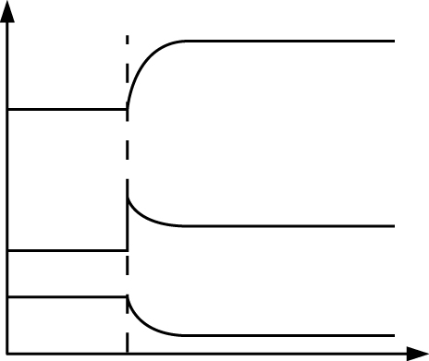
Concentration / M
Time / s
I₂(g)
H₂(g)
HI(g)
t
What has been done on the system at time t?
A. Increasing the temperature of the system
B. Introducing more HI(g) to the mixture
C. Introducing more I₂(g) to the mixture
D. Removing HI(g) from the mixture

Answer: C
There is a sudden increase in concentration of I₂(g) at time t, implying that I₂(g) is introduced to the mixture.

ChemMCQ41044
The following equilibrium is established in a closed vessel.
H₂(g) + I₂(g) 2HI(g) ΔH < 0
Which of the following statements is/are correct if the temperature of the system is decreased?
(1) The equilibrium constant of the reaction remains unchanged.
(2) The rates of both forward and backward reactions decrease.
(3) The pressure of the system remains unchanged.
A. (1) only
B. (2) only
C. (1) and (3) only
D. (2) and (3) only

Answer: B
(1) and (2): A decrease in temperature decreases the rates of both forward and backward reactions but to the different extents. Hence, the value of K_{c} changes.
(3): As the temperature of the system decreases, the energy of the particles decreases. The particles hit the wall of the vessel less frequently. Thus, the pressure of the system decreases.

ChemMCQ41045
Consider the following equilibrium system at constant pressure.
2SO₂(g) + O₂(g) 2SO₃(g) ΔH < 0
Which of the following statements is/are correct?
(1) An increase in temperature favours the backward reaction.
(2) An increase in concentration of SO₃(g) shifts the equilibrium position to the right.
(3) An increase in temperature lowers the value of K_{c}.
A. (1) only
B. (2) only
C. (1) and (3) only
D. (2) and (3) only

Answer: C
An increase in concentration of SO₃(g) shifts the equilibrium position to the left, consuming some of added SO₃(g).

ChemMCQ41046
When sulphur dioxide and oxygen react, the following equilibrium is established.
2SO₂(g) + O₂(g) 2SO₃(g)
The equilibrium constants for the reaction at 630°C and 850°C are 3300 mol⁻¹ dm³ and 21 mol⁻¹ dm³ respectively. Which of the following combinations is correct?
 | Sign of ΔH | Product yield as temperature increases
A. | + | Decreases
B. | + | Increases
C. | − | Decreases
D. | − | Increases

Answer: C
As the temperature increases, K_{c} decreases. That means less products form at a higher temperature. As a decrease in temperature favours an exothermic reaction, the forward reaction is exothermic.

ChemMCQ41047
Consider the following equilibrium system at constant pressure.
2CHClF₂(g) C₂F₄(g) + 2HCl(g) ΔH > 0
Which of the following statements are correct?
(1) An increase in temperature shifts the equilibrium position to the product side.
(2) An increase in concentration of C₂F₄(g) shifts the equilibrium position to the reactant side.
(3) A decrease in concentration of HCl(g) shifts the equilibrium position to the product side.
A. (1) and (2) only
B. (1) and (3) only
C. (2) and (3) only
D. (1), (2) and (3)

Answer: D

ChemMCQ41048
Consider the following equilibrium system at constant pressure.
I₂(g) + C₅H₈(g) C₅H₆(g) + 2HI(g) ΔH > 0
When the temperature of the equilibrium system is increased at constant pressure, what are the changes in K_{c} and the equilibrium position?
 | K_{c} | Equilibrium position
A. | Increases | Shifts to the left
B. | Increases | Shifts to the right
C. | Decreases | Shifts to the left
D. | Decreases | Shifts to the right

Answer: B
As the forward reaction is endothermic, an increase in temperature shifts the equilibrium position to the right. K_{c} increases.

ChemMCQ41049
Consider the following chemical equilibrium.
N₂O₄(g) 2NO₂(g) ΔH > 0
Which of the following statements about the equilibrium are correct?
(1) At equilibrium, the pressure of the system remains unchanged.
(2) When the temperature of the system increases at constant pressure, the colour of the reaction mixture will become deeper.
(3) When N₂O₄(g) is added to the system, Q_{c} will be larger than K_{c}.
A. (1) and (2) only
B. (1) and (3) only
C. (2) and (3) only
D. (1), (2) and (3)

Answer: A
Q_{c} = $\frac{\text{[NO}\text{2}\text{(g)]}\text{2}}{\text{[N}\text{2}\text{O}\text{4}\text{(g)]}}$
Q_{c} should be smaller than K_{c} when N₂O₄(g) is added.

ChemMCQ41050
Consider the following chemical equilibrium.
2NO₂(g) N₂O₄(g) ΔH < 0
Which of the following changes would cause an increase in the equilibrium constant for the reaction?
A. Adding more NO₂(g) to the equilibrium mixture
B. Increasing the temperature of the system
C. Decreasing the temperature of the system
D. Decreasing the pressure of the system

Answer: C
As the forward reaction is exothermic, a decrease in temperature shifts the equilibrium position to the right. K_{c} increases.

ChemMCQ41051
In which of the following cases would an increase in pressure and temperature produce more products?
A. X₂(g) + Y₂(g) Z₂(g) ΔH > 0
B. X₂(g) + Y₂(g) 3Z₂(g) ΔH > 0
C. X₂(g) + Y₂(g) Z₂(g) ΔH < 0
D. X₂(g) + Y₂(g) 3Z₂(g) ΔH < 0

Answer: A
For (A) and (B), as the forward reaction is endothermic, an increase in temperature shifts the equilibrium position to the right.
For (A), since there are a greater number of moles of gases on the left-hand side of the equation, an increase in pressure shifts the equilibrium position to the right.

ChemMCQ41052
The graph below shows the yields of a product of a reversible reaction involving gases at different temperatures and pressures.
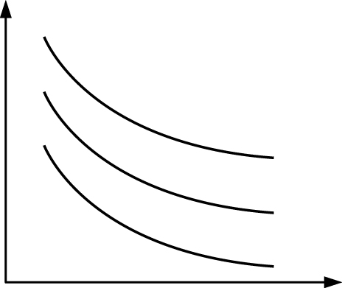
Pressure / atm
Yield of product / %
350°C
400°C
450°C
Which of the following reversible reactions could the above graph represent?
A. X₂(g) + 2Y₂(g) 2Z(g) ΔH < 0
B. X₂(g) + 2Y₂(g) 2Z(g) ΔH > 0
C. X₂(g) + Y₂(g) 3Z(g) ΔH < 0
D. X₂(g) + Y₂(g) 3Z(g) ΔH > 0

Answer: C
As the temperature increases, the yield of the product decreases. Hence, the forward reaction should be exothermic.
Besides, as the pressure increases, the yield of the product decreases. Hence, the right-hand side of the equation should have a greater number of moles of gases.

ChemMCQ41053
The following graph shows the percentage yield of a reversible reaction at different temperatures and pressure.
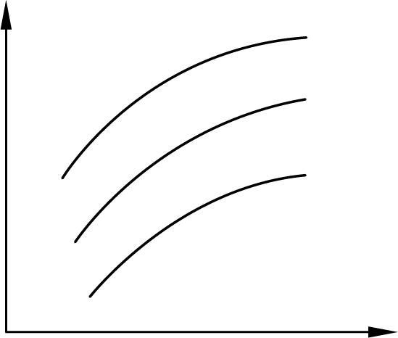
Temperature
Yield of product / %
10 atm
30 atm
50 atm
Which of the following combinations fits the relationship shown in the above graph?
 | Reversible reaction | Enthalpy change of reaction
A. | N₂(g) + 3H₂(g) 2NH₃(g) | ΔH < 0
B. | N₂(g) + 3H₂(g) 2NH₃(g) | ΔH > 0
C. | C₅H₁₂(g) + 5H₂O(g) 5CO(g) + 11H₂(g) | ΔH < 0
D. | C₅H₁₂(g) + 5H₂O(g) 5CO(g) + 11H₂(g) | ΔH > 0

Answer: D
According to the graph, a high temperature and a low pressure give a higher yield. A low pressure implies that the total number of moles of products is greater than that of reactants. Also, a high temperature implies that the forward reaction is endothermic.

ChemMCQ41054
The graph below shows the effect of temperature and pressure on the equilibrium yield of the product in a gaseous equilibrium system.
Temperature
Yield of product / %
60 atm
40 atm
20 atm
Which of the following reactions would have the relationship between the yield, temperature and pressure as shown in the graph?
(1) N₂F₄(g) 2NF₂(g) ΔH > 0
(2) N₂(g) + 2O₂(g) 2NO₂(g) ΔH > 0
(3) CO(g) + 2H₂(g) CH₃OH(g) ΔH < 0
A. (1) only
B. (2) only
C. (1) and (3) only
D. (2) and (3) only

Answer: B
The yield of the product increases with an increase in temperature. This implies that the forward reaction is endothermic.
The yield of the product increases with an increase in pressure. This implies the total number of moles of the reactants is greater than that of the products.

ChemMCQ41055
Consider the following chemical equilibrium.
A(aq) + B(aq) C(aq) + D(aq)
Upon a change in temperature, which of the following would also change?
(1) The value of K_{c}
(2) Concentrations of the reactants
(3) Concentrations of the products
A. (1) and (2) only
B. (1) and (3) only
C. (2) and (3) only
D. (1), (2) and (3)

Answer: D
Upon a change in temperature, there will be a change in K_{c}. The concentrations of reactants and products also change in order to attain a new equilibrium.

ChemMCQ41056
Consider the following chemical equilibrium.
A(aq) + B(aq) C(aq) ΔH < 0
Which of the following statements is/are correct when the temperature of the system increases?
(1) The equilibrium constant increases.
(2) The equilibrium constant decreases.
(3) The equilibrium position remains unchanged.
A. (1) only
B. (2) only
C. (1) and (3) only
D. (2) and (3) only

Answer: B
As the forward reaction is exothermic, an increase in temperature shifts the equilibrium position to the left. K_{c} decreases.

ChemMCQ41057
For a reversible reaction in which the forward reaction has a negative enthalpy change, which of the following will occur upon an increase in temperature at constant pressure?
A. K_{c} decreases and the equilibrium position shifts to the left.
B. K_{c} decreases and the equilibrium position shifts to the right.
C. K_{c} increases and the equilibrium position shifts to the left.
D. K_{c} increases and the equilibrium position shifts to the right.

Answer: A

ChemMCQ41058
Consider the following equilibrium system.
C(aq) A(aq) + B(aq) ΔH > 0
The following graph shows the changes in concentrations of the reactant and products with time.
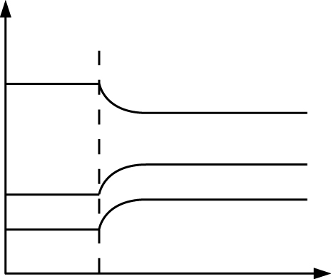
Concentration
Time
B(aq)
A(aq)
C(aq)
t
Which of the following changes is done to the system at time t?
A. Adding C(aq)
B. Removing C(aq)
C. Increasing the temperature
D. Decreasing the temperature

Answer: C
As the forward reaction is endothermic, an increase in temperature shifts the equilibrium position to the right. The concentrations of A(aq) and B(aq) will increase but the concentration of C(aq) will decrease until a new equilibrium is established.

ChemMCQ41059
Consider the following system at equilibrium.
H₂O(l) H⁺(aq) + OH⁻(aq) ΔH > 0
If the temperature of the system is raised, which of the following statements is/are correct?
(1) The rate of backward reaction decreases.
(2) The concentration of H⁺(aq) increases.
(3) Water will become acidic.
A. (1) only
B. (2) only
C. (1) and (3) only
D. (2) and (3) only

Answer: B
(1): An increase in temperature increases the rates of both forward and backward reactions but to the different extents.
(2): For an endothermic reaction, an increase in temperature shifts the equilibrium position to the right. The concentrations of both H⁺(aq) and OH⁻(aq) increase.
(3): As the concentrations of H⁺(aq) and OH⁻(aq) are the same, water remains neutral.

ChemMCQ41060
Consider the ionization of water.
H₂O(l) H⁺(aq) + OH⁻(aq)
The equilibrium constants are 1.00 × 10⁻¹⁴ mol² dm⁻⁶ at 25°C and 2.95 × 10⁻¹⁴ mol² dm⁻⁶ at 40°C. Which of the following statements is correct?
A. An increase in temperature will cause a decrease in concentration of H⁺(aq).
B. The ionization of water is endothermic.
C. The concentration of H⁺(aq) is greater than that of OH⁻(aq) at 40°C.
D. The equilibrium position lies mainly on the product side at 40°C.

Answer: B
As K_{c} increases with an increase in temperature, more products are present at a higher temperature. Hence, the ionization of water is endothermic.

ChemMCQ41061
The following equation shows the ionization of water.
H₂O(l) H⁺(aq) + OH⁻(aq) ΔH > 0
The equilibrium constant for the reaction is 1.00 × 10⁻¹⁴ mol² dm⁻⁶ at 25°C. At 50°C, what would be the equilibrium constant and pH of water?
 | Equilibrium constant | pH
A. | Greater than 1.00 × 10⁻¹⁴ | Above 7
B. | Greater than 1.00 × 10⁻¹⁴ | Below 7
C. | Less than 1.00 × 10⁻¹⁴ | Above 7
D. | Less than 1.00 × 10⁻¹⁴ | Below 7

Answer: B
For an endothermic reaction, an increase in temperature shifts the equilibrium position to the right. K_{c} increases. The concentration of H⁺(aq) increases and so the pH of water decreases.

ChemMCQ41062
Direction: Questions (a) and (b) refer to the ionization of methanoic acid in water.
HCOOH(aq) HCOO⁻(aq) + H⁺(aq) ΔH > 0
(a) At 25°C, the equilibrium constant, K_{c}, of the ionization is 1.78 × 10⁻⁴ mol dm⁻³. What is the pH of 1.0 M methanoic acid at 25°C?
A. 1.00
B. 1.88
C. 2.00
D. 3.75

Answer: B
Let the change in concentration of H⁺(aq) be x mol dm⁻³.
Concentration / mol dm⁻³ | HCOOH(aq) HCOO⁻(aq) + H⁺(aq)
Initial | 1.0 | 0 | 0
Change | −x | +x | +x
Equilibrium | 1.0 − x | x | x
K_{c} = $\frac{{\text{[}\text{HCOO}\text{(}\text{aq}\text{)]}}_{\text{eqm}}^{}{\text{[}\text{H}\text{+}\text{(}\text{aq}\text{)]}}_{\text{eqm}}^{}}{{\text{[}\text{HCOOH}\text{(}\text{aq}\text{)]}}_{\text{eqm}}^{}}$
1.78 × 10⁻⁴ = $\frac{\text{x}\text{2}}{\text{1.0} \text{x}}$
x² + 1.78 × 10⁻⁴x − 1.78 × 10⁻⁴ = 0
x = 0.0133 or x = −0.0134 (rejected)
pH = −log[H⁺(aq)] = −log (0.0133) = 1.88

(b) The temperature of the 1.0 M methanoic acid is raised to 35°C. Which of the following statements are correct?
(1) The concentrations of HCOO⁻(aq) and H⁺(aq) are the same.
(2) The value of K_{c} increases.
(3) The pH of the acid increases.
A. (1) and (2) only
B. (1) and (3) only
C. (2) and (3) only
D. (1), (2) and (3)

Answer: A
As the forward reaction is endothermic, increasing the temperature shifts the equilibrium position to the right. The concentration of H⁺(aq) increases and the pH of the acid decreases.

ChemMCQ41063
Methanoic acid ionizes slightly in water to give methanoate ion and hydrogen ion.
HCOOH(aq) HCOO⁻(aq) + H⁺(aq)
K_{c} for the above reaction increases when the temperature of the system increases. Which of the following statements is/are correct?
(1) The forward reaction is endothermic.
(2) The degree of ionization of methanoic acid increases with an increase in temperature.
(3) The pH of methanoic acid decreases with an increase in temperature.
A. (1) and (2) only
B. (1) and (3) only
C. (2) and (3) only
D. (1), (2) and (3)

Answer: D
(1): As an increase in temperature favours the endothermic change of an equilibrium system, the forward reaction is endothermic.
(2) and (3): An increase in K_{c} implies that more methanoic acid molecules ionize to give HCOO⁻(aq) and H⁺(aq). The concentration of H⁺(aq) increases and the pH of the acid decreases.

ChemMCQ41064
Consider the following equilibrium mixture.
Fe³⁺(aq) + SCN⁻(aq) Fe(SCN)²⁺(aq) ΔH < 0
yellow colourless dark red
Which of the following changes will cause the orange-yellow solution to become paler?
(1) Place the equilibrium mixture in a hot water bath.
(2) Place the equilibrium mixture in an iced water bath.
(3) Add sodium phosphate solution to remove Fe³⁺(aq).
A. (1) only
B. (2) only
C. (1) and (3) only
D. (2) and (3) only

Answer: C
(1) and (2): As the forward reaction is exothermic, an increase in temperature shifts the equilibrium position to the left.
(3): When Fe³⁺(aq) ions are removed from the equilibrium mixture, the equilibrium position shifts to the left and so the solution becomes paler.

ChemMCQ41065
Direction: Questions (a) and (b) refer to the following reversible reaction.
SO₂Cl₂(g) SO₂(g) + Cl₂(g)
(a) The standard enthalpy changes of formation of SO₂Cl₂(g) and SO₂(g) are −364.0 kJ mol⁻¹ and −296.8 kJ mol⁻¹ respectively. What is the standard enthalpy change of the forward reaction of the reversible reaction?
A. +67.2 kJ mol⁻¹
B. +660.8 kJ mol⁻¹
C. −67.2 kJ mol⁻¹
D. −660.8 kJ mol⁻¹

Answer: A
ΔH ^{ꝋ} = ΔH_{f}^{ꝋ} [SO₂(g)] + ΔH_{f}^{ꝋ} [Cl₂(g)] − ΔH_{f}^{ꝋ} [SO₂Cl₂(g)]
= [(−296.8) + 0 − (−364.0)] kJ mol⁻¹ = +67.2 kJ mol⁻¹

(b) Which of the following graphs represents the variation of the yield of SO₂(g) with temperature?
A. | 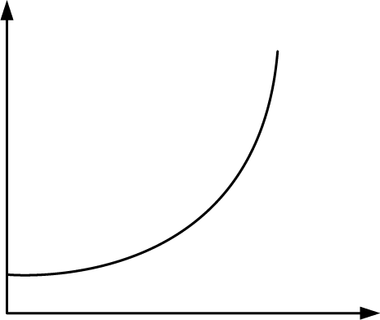  Temperature  Yield | B. | 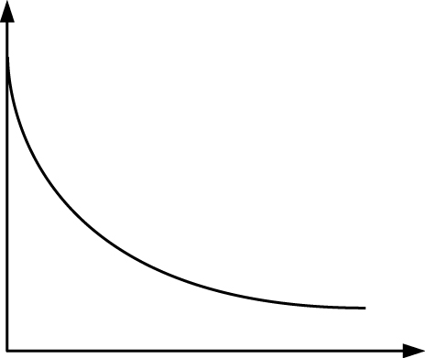  Temperature  Yield
C. | 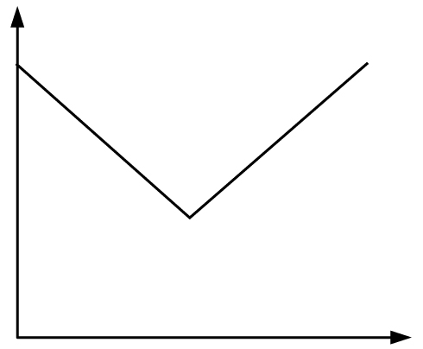  Temperature  Yield | D. | 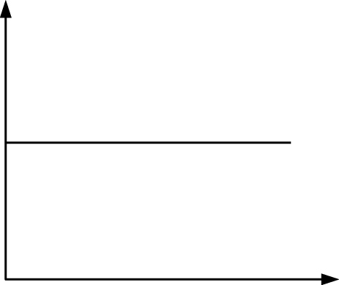  Temperature  Yield

Answer: A
As the forward reaction is endothermic, an increase in temperature shifts the equilibrium position to the right. The yield of SO₂(g) increases with an increase in temperature.

ChemMCQ41066
Consider the following equilibrium system in a closed container.
2ClF₃(g) Cl₂(g) + 3F₂(g) ΔH = +159 kJ mol⁻¹
Which of the following sets of conditions would give the highest yield of F₂(g)?
 | Temperature / °C | Pressure / atm
A. | 100 | 20
B. | 500 | 40
C. | 100 | 40
D. | 500 | 20

Answer: D
The forward reaction is endothermic. A higher temperature shifts the equilibrium position to the product side.
Since there are a greater number of moles of gases on the right-hand side of the equation, a lower pressure shifts the equilibrium position to the product side.

ChemMCQ41067
Consider the following reversible reaction.
PCl₃(g) + Cl₂(g) PCl₅(g)
The change in value of equilibrium constant (K_{c}) with temperature is shown in the graph below.
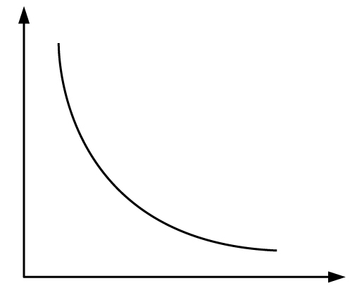
Temperature
K_{c}
Which of the following deductions can be made?
(1) The forward reaction is exothermic.
(2) The forward reaction is endothermic.
(3) At a higher temperature, the equilibrium mixture contains a greater amount of PCl₅(g).
A. (1) only
B. (2) only
C. (1) and (3) only
D. (2) and (3) only

Answer: A
From the graph, K_{c} decreases with an increase in temperature. The forward reaction is exothermic. At a higher temperature, the value of K_{c} is smaller. This implies that the equilibrium mixture contains a smaller amount of PCl₅(g).

Sections 41.5−41.6
ChemMCQ41068
Consider the following equilibrium system.
4HCl(g) + O₂(g) 2Cl₂(g) + 2H₂O(g) ΔH > 0
Which of the following changes will cause a shift in the equilibrium position of the reaction?
(1) Adding Cl₂(g)
(2) Removing O₂(g)
(3) Adding a catalyst
A. (1) and (2) only
B. (1) and (3) only
C. (2) and (3) only
D. (1), (2) and (3)

Answer: A
A catalyst has no effect on the equilibrium position.

ChemMCQ41069
Which of the following statements about the effect of catalysts on a reversible reaction are correct?
(1) Catalysts increase the rates of both forward and backward reactions.
(2) Catalysts shorten the time for a reversible reaction to reach equilibrium.
(3) Catalysts do not affect the yield of products of a reversible reaction.
A. (1) and (2) only
B. (1) and (3) only
C. (2) and (3) only
D. (1), (2) and (3)

Answer: D

ChemMCQ41070
Consider the following equilibrium system.
N₂(g) + 3H₂(g) 2NH₃(g)
Which of the following changes will increase the yield of ammonia?
(1) Using a higher concentration of nitrogen gas
(2) Decreasing the pressure of the system at constant temperature
(3) Adding a catalyst to the equilibrium mixture
A. (1) only
B. (2) only
C. (1) and (3) only
D. (2) and (3) only

Answer: A
(2): Since there are a greater number of moles of gases on the left-hand side of the equation, a decrease in pressure shifts the equilibrium position to the left.
(3): A catalyst has no effect on the equilibrium position.

ChemMCQ41071
Consider the following system at equilibrium.
3H₂(g) + N₂(g) 2NH₃(g) ΔH = −92 kJ mol⁻¹
Which of the following changes will increase the yield of ammonia?
A. Using iron powder as a catalyst
B. Increasing the volume of the reaction chamber
C. Decreasing the pressure of the system
D. Reducing the temperature of the system

Answer: D
As the forward reaction is exothermic, reducing the temperature shifts the equilibrium position to the right. The yield of ammonia increases.

ChemMCQ41072
Consider the following equilibrium system.
N₂(g) + 3H₂(g) 2NH₃(g) ΔH < 0
Which of the following changes will occur if the temperature of the system increases at constant pressure?
(1) The equilibrium position shifts to the left.
(2) K_{c} increases.
(3) The yield of NH₃(g) decreases.
A. (1) and (2) only
B. (1) and (3) only
C. (2) and (3) only
D. (1), (2) and (3)

Answer: B
As the forward reaction is exothermic, increasing the temperature shifts the equilibrium position to the left. K_{c} decreases.

ChemMCQ41073
The following equilibrium is attained in a sealed container at 25°C.
2HN₃(g) 3N₂(g) + H₂(g)
Which of the following statement concerning the equilibrium is INCORRECT?
A. The rate of formation of H₂(g) is half the rate of decomposition of HN₃(g).
B. The addition of a catalyst has no effect on the concentrations of all species.
C. When the volume of the container increases, the equilibrium position will shift to the left.
D. When the volume of the container increases, the K_{c} for the reaction increases.

Answer: C
Since there are a greater number of moles of gases on the right-hand side of the equation, an increase in volume (a decrease in pressure) shifts the equilibrium position to the right.

ChemMCQ41074
The manufacture of sulphuric acid involves the following reaction.
V₂O₅(s)
2SO₂(g) + O₂(g) 2SO₃(g) ΔH < 0
Which of the following statements about the above reaction is correct?
A. The decomposition of sulphur trioxide is exothermic.
B. The addition of O₂(g) increases the yield of SO₃(g).
C. An increase in pressure reduces the yield of SO₃(g).
D. Vanadium(V) oxide is a reactant in the reaction.

Answer: B
(A): The backward reaction (i.e. decomposition of sulphur trioxide) is endothermic.
(B): The addition of O₂(g) increases the yield of SO₃(g) by shifting the equilibrium position to the right.
(C): Since there are a greater number of moles of gases on the left-hand side of the equation, an increase in pressure shifts the equilibrium position to the right.
(D): Vanadium(V) oxide acts as a catalyst in the reaction.

ChemMCQ41075
Consider the following equilibrium system.
2SO₂(g) + O₂(g) 2SO₃(g) ΔH < 0
Which of the following changes will lower the K_{c}?
(1) Adding a catalyst
(2) Increasing the temperature of the system at constant pressure
(3) Decreasing the volume of the system at constant temperature
A. (1) only
B. (2) only
C. (1) and (3) only
D. (2) and (3) only

Answer: B
Since the forward reaction is exothermic, an increase in temperature shifts the equilibrium position to the left. K_{c} decreases.

ChemMCQ41076
Consider the following equilibrium system.
H₂(g) + I₂(g) 2HI(g) ΔH < 0
Which of the following changes will shift the equilibrium position to the right?
A. Add a catalyst.
B. Reduce the volume of the reaction chamber.
C. Reduce the pressure of the system.
D. Reduce the temperature of the system.

Answer: D
(A): A catalyst has no effect on the equilibrium position.
(B) and (C): Since there are equal numbers of moles of gases on the two sides of the equation, a change in pressure (or volume) has no effect on the equilibrium position.
(D): As the forward reaction is exothermic, reducing the temperature shifts the equilibrium position to the right.

ChemMCQ41077
Consider the following chemical equilibrium.
A(aq) + B(aq) C(aq) ΔH > 0
Which of the following changes would produce more C?
(1) Increasing the temperature of the system
(2) Adding a catalyst to the system
(3) Increasing the pressure of the system
A. (1) only
B. (2) only
C. (1) and (3) only
D. (2) and (3) only

Answer: A
(1): Since the forward reaction is endothermic, an increase in temperature shifts the equilibrium position to the right.
(2): A catalyst has no effect on the equilibrium position.
(3): As the reaction does not involve any gases, a change in pressure would not cause any shift of the equilibrium position.

ChemMCQ41078
The forward reaction of the equilibrium system below is an endothermic reaction.
A(g) + B(g) 2C(g)
Which of the following changes would increase the concentration of C?
(1) Introduce a catalyst to the system.
(2) Increase the temperature of the system.
(3) Reduce the volume of the reaction flask.
A. (1) only
B. (2) only
C. (1) and (3) only
D. (2) and (3) only

Answer: D
(1): A catalyst has no effect on the equilibrium position.
(2): Since the forward reaction is endothermic, an increase in temperature shifts the equilibrium position to the right.
(3): Since there are equal numbers of moles of gases on the two sides of the equation, a change in volume has no effect on the equilibrium position. However, as the volume of the reaction flask is reduced, the concentrations of all species increase.

ChemMCQ41079
At a certain temperature, 3.0 mol of CO and 1.5 mol of O₂ are placed in a 5 dm³ closed vessel and allowed to reach equilibrium.
2CO(g) + O₂(g) 2CO₂(g) ΔH < 0
The graph below shows the changes in concentrations of CO(g) and CO₂(g) in the system with time. A change was made to the system at time t₁ and t₂.
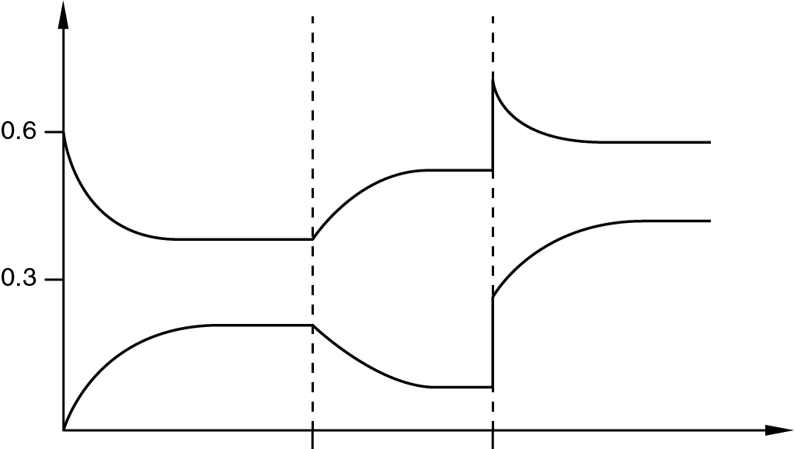
Concentration / mol dm⁻³
Time
CO(g)
CO₂(g)
t₁ t₂
What are the changes made at time t₁ and t₂ respectively?
 | At time t₁ | At time t₂
A. | Add a catalyst. | The volume of the vessel decreases.
B. | Add CO₂(g). | The temperature decreases.
C. | The temperature decreases. | Add O₂(g).
D. | The temperature increases. | The volume of the vessel decreases.

Answer: D
At t₁, an increase in temperature will shift the equilibrium position to the left. The concentration of CO(g) increases while that of CO₂(g) decreases.
At t₂, when the volume of the vessel decreases, the concentrations of both CO(g) and CO₂(g) increase. Since there are a greater number of moles of gases on the left-hand side of the equation, an increase in pressure shifts the equilibrium position to the right.

