Chapter 43 Isomerism

Sections 43.1−43.2
ChemMCQ43001
How many structural isomers can the molecular formula C₃H₆Cl₂ represent?
A. 2
B. 3
C. 4
D. 5

Answer: C
The molecular formula C₃H₆Cl₂ can represent four structural isomers.
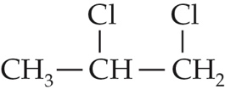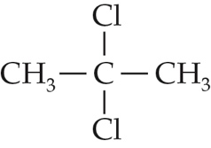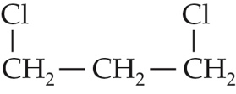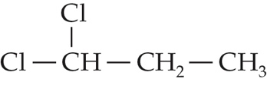

ChemMCQ43002
Which of the following statements about isomers are correct?
(1) A pair of position isomers belongs to the same homologous series.
(2) A pair of structural isomers has the same relative molecular mass.
(3) A pair of functional group isomers has different physical properties.
A. (1) and (2) only
B. (1) and (3) only
C. (2) and (3) only
D. (1), (2) and (3)

Answer: D
(2): A pair of structural isomers has the same relative molecular mass as they have the same molecular formula.

ChemMCQ43003
Which of the following statements about ethanoic acid and methyl methanoate are correct?
(1) They are functional group isomers.
(2) They have the same molecular formula.
(3) They have different chemical properties.
A. (1) and (2) only
B. (1) and (3) only
C. (2) and (3) only
D. (1), (2) and (3)

Answer: D
Ethanoic acid is a carboxylic acid while methyl methanoate is an ester. Since they have different functional groups, they have different chemical properties.

ChemMCQ43004
Which of the following compounds are the structural isomers of butanal?
(1) Butanone
(2) Methylpropanal
(3) But-3-en-1-ol
A. (1) and (2) only
B. (1) and (3) only
C. (2) and (3) only
D. (1), (2) and (3)

Answer: D
The molecular formulae of butanal, butanone, methylpropanal and but-3-en-1-ol are the same, i.e. C₄H₈O.

ChemMCQ43005
Which of the following compounds are the structural isomers of pent-1-ene?
(1) Pent-2-ene
(2) 3-methylbut-1-ene
(3) 2-methylbut-2-ene
A. (1) and (2) only
B. (1) and (3) only
C. (2) and (3) only
D. (1), (2) and (3)

Answer: D
The molecular formulae of pent-1-ene, pent-2-ene, 3-methylbut-1-ene and 2-methylbut-2-ene are the same, i.e. C₅H₁₀.

ChemMCQ43006
Which of the following compounds has/have the molecular formula C₅H₁₀O?
(1) 2-methylbutanal
(2) Propyl ethanoate
(3) Pentanal
A. (1) only
B. (2) only
C. (1) and (3) only
D. (2) and (3) only

Answer: C
The molecular formula of propyl ethanoate is C₅H₁₀O₂.

ChemMCQ43007
The structures of compounds P and Q are shown below.
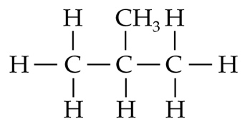 | 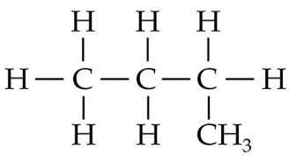
P | Q
Which of the following statements about P and Q is/are correct?
(1) They are position isomers.
(2) They belong to the same homologous series.
(3) Q has a higher boiling point than P.
A. (1) only
B. (2) only
C. (1) and (3) only
D. (2) and (3) only

Answer: D
(1): P (methylpropane) and Q (butane) are chain isomers.
(3): Q is a straight-chain alkane and P is a branched-chain alkane. Compared with the molecules of P, the molecules of Q have a greater area of contact between each other. Hence, the van der Waals’ forces between the molecules of Q are stronger.

ChemMCQ43008
Consider the following two compounds.
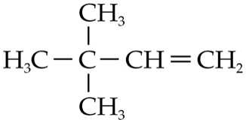 | 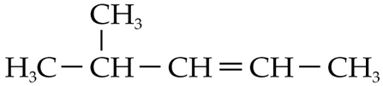
Which of the following statements about the two compounds is correct?
A. They have the same melting point.
B. They have the same boiling point.
C. They have the same percentage by mass of elements.
D. They have the same skeletal formula.

Answer: C
They are structural isomers which have the same molecular formula. The percentages by mass of each element in the compound are the same.

ChemMCQ43009
Consider the following two compounds.
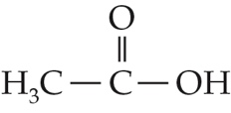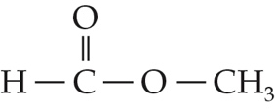
Which of the following statements about the two compounds is correct?
A. They are position isomers.
B. They have the same chemical properties.
C. Both of them are soluble in water.
D. Hydrogen bonds exist between their molecules.

Answer: C
There are no hydrogen bonds between methyl methanoate molecules.

ChemMCQ43010
Consider the following two compounds.
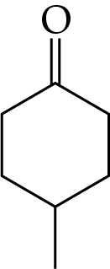 | 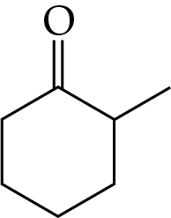
Which of the following statements about the two compounds is correct?
A. They have the same melting point.
B. They have the same solubility in methylbenzene.
C. They have the same structural formula.
D. They have the same functional group.

Answer: D
They are position isomers and have the same functional group.

ChemMCQ43011
Which of the following statements concerning 3,4-dibromopent-1-ene and 3,5-dibromopent-2-ene are correct?
(1) They have the same molecular formula of C₅H₈Br₂.
(2) They are position isomers.
(3) They have similar chemical properties.
A. (1) and (2) only
B. (1) and (3) only
C. (2) and (3) only
D. (1), (2) and (3)

Answer: D
They are position isomers because they differ only in the position of functional groups. They have the same functional groups and so similar chemical properties.

ChemMCQ43012
Consider the following four compounds.
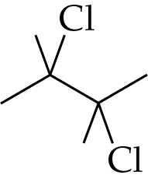 | 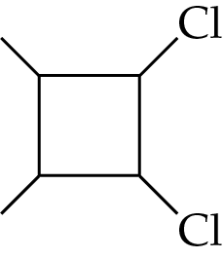 | 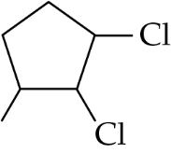 | 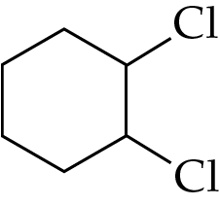
P | Q | R | S
Which of the above compounds is NOT the structural isomer of the others?
A. P
B. Q
C. R
D. S

Answer: A
The molecular formula of P is C₆H₁₂Cl₂ while those of Q, R and S are C₆H₁₀Cl₂.

ChemMCQ43013
A carbon compound has the formula C₄H₆Cl₂. Which of the following are the correct names of the isomers of the compound?
(1) 3,4-dichlorobut-3-ene
(2) 1,4-dichlorobut-2-ene
(3) 1,1-dichlorobut-1-ene
A. (1) and (2) only
B. (1) and (3) only
C. (2) and (3) only
D. (1), (2) and (3)

Answer: C
The correct name for (1) is 1,2-dichlorobut-1-ene.
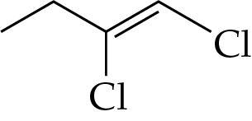

Section 43.3
ChemMCQ43014
Which of the following statements about cis-trans isomerism are correct?
(1) Cis-isomers and trans-isomers often have different physical properties.
(2) Cis-trans isomers result from the restricted rotation about the carbon-carbon double bond.
(3) 1,2-dichloroethene is a compound that exhibits cis-trans isomerism.
A. (1) and (2) only
B. (1) and (3) only
C. (2) and (3) only
D. (1), (2) and (3)

Answer: D

ChemMCQ43015
How many straight-chain structural isomers can the molecular formula C₄H₈ represent?
A. 3
B. 4
C. 5
D. 6

Answer: B
The molecular formula C₄H₈ can represent four straight-chain structural isomers.
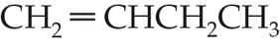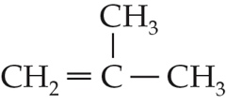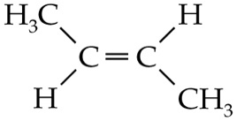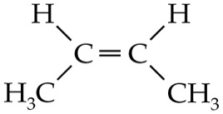

ChemMCQ43016
How many acyclic structural isomers can the molecular formula C₅H₁₀ represent?
A. 4
B. 5
C. 6
D. 7

Answer: C
The molecular formula C₅H₁₀ can represent six acyclic structural isomers.
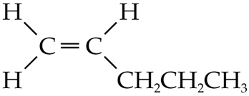 | 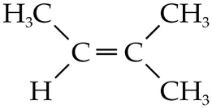 | 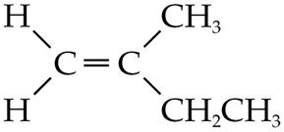
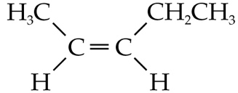 | 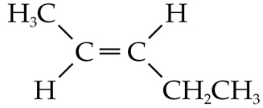 | 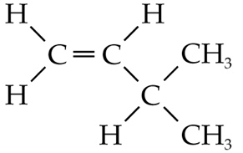

ChemMCQ43017
Which of the following compounds exhibit cis-trans isomerism?
(1) 3,4-dimethylhex-3-ene
(2) 2-methylpent-2-ene
(3) 1,6-dichlorohex-3-ene
A. (1) and (2) only
B. (1) and (3) only
C. (2) and (3) only
D. (1), (2) and (3)

Answer: B
(2): In 2-methylpent-2-ene, one of the doubly-bonded carbon atoms is attached to two −CH₃ groups. It does not exhibit cis-trans isomerism.

ChemMCQ43018
Which of the following compounds have a pair of cis-trans isomers?
(1) CH₂=CCl₂
(2) CH₃OCCH=CHCOCH₃
(3) CH₂BrCH=CHCH₂Cl
A. (1) and (2) only
B. (1) and (3) only
C. (2) and (3) only
D. (1), (2) and (3)

Answer: C
(1): In CH₂=CCl₂, each doubly-bonded carbon atom is attached to two identical atoms. It does not exhibit cis-trans isomerism.

ChemMCQ43019
Which of the following compounds exhibit cis-trans isomerism?
(1) CHCl=CHBr
(2) (CH₃)₂C=CH₂
(3) CH₃CH=CHCH₃
A. (1) and (2) only
B. (1) and (3) only
C. (2) and (3) only
D. (1), (2) and (3)

Answer: B
(2): In (CH₃)₂C=CH₂, one of the doubly-bonded carbon atoms is attached to two H atoms and another to two −CH₃ groups. It does not exhibit cis-trans isomerism.

ChemMCQ43020
Which of the following compounds exhibits cis-trans isomerism?
A. | 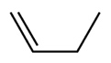 | B. | 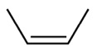
C. | 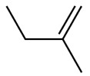 | D. | 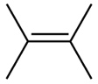

Answer: B
(B): In the compound, each doubly-bonded carbon atom is attached to a hydrogen atom and a methyl group. It exhibits cis-trans isomerism.

ChemMCQ43021
Which of the following compounds exhibits cis-trans isomerism?
A. CH₂=C(CH₃)₂
B. CHCl=CCl₂
C. CH₂=CHCH₃
D. CHCl=CHCl

Answer: D
(D): As each doubly-bonded carbon atom in the compound is attached to a hydrogen atom and a chlorine atom, it exhibits cis-trans isomerism.

ChemMCQ43022
Which of the following statements about cis-trans isomers is/are correct?
(1) The cis-isomer has a higher melting point than the trans-isomer.
(2) A pair of cis-trans isomers has the same functional group.
(3) Any alkenes with a carbon-carbon double bond have a pair of cis-trans isomers.
A. (1) only
B. (2) only
C. (1) and (3) only
D. (2) and (3) only

Answer: B
(1): The trans-isomer has a higher melting point than the cis-isomer as the molecules of the trans-isomer can pack more closely in the solid state.
(3): If one of the doubly-bonded carbon atoms is attached to two identical atoms or groups of atoms, there are no cis-trans isomers.

ChemMCQ43023
Consider the following compound.
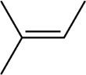
Which of the following statements concerning the compound is/are correct?
(1) Its systematic name is methylbut-2-ene.
(2) It is a cis-isomer.
(3) It has a pleasant fruity smell.
A. (1) only
B. (2) only
C. (1) and (3) only
D. (2) and (3) only

Answer: A
(2): The compound does not exhibit cis-trans isomerism as one of the doubly-bonded carbon atoms is attached to two methyl groups.
(3): Having a pleasant fruity smell is the characteristic of esters.

ChemMCQ43024
Which of the following statements concerning the cis-trans isomers of 2,3-dibromobut-2-ene is/are correct?
(1) They have the same boiling points.
(2) They have the same functional groups.
(3) The strength intermolecular forces between their molecules are identical.
A. (1) only
B. (2) only
C. (1) and (3) only
D. (2) and (3) only

Answer: B
The van der Waals’ forces between polar cis-2,3-dibromobut-2-ene molecules are stronger than those between non-polar trans-2,3-dibromobut-2-ene molecules. The strength of intermolecular forces is different and so they have different boiling points.

ChemMCQ43025
The structures of compounds Y and Z are shown below.
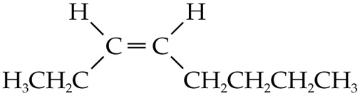 | 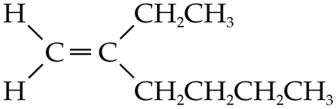
Y | Z
Which of the following statements about Y and Z is/are correct?
(1) They both can decolourize bromine (dissolved in an organic solvent).
(2) They have the same enthalpy change of combustion.
(3) They are cis-trans isomers.
A. (1) only
B. (2) only
C. (1) and (3) only
D. (2) and (3) only

Answer: A
Y (oct-3-ene) and Z (2-ethylhex-1-ene) can decolourize bromine (dissolved in an organic solvent) because they possess a carbon-carbon double bond.

Section 43.4
ChemMCQ43026
How many chiral carbon(s) does 3,6-dibromo-4-methylhept-4-en-2-ol have?
A. 1
B. 2
C. 3
D. 4

Answer: C
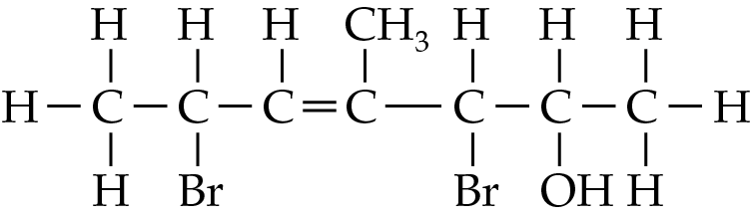
*
*
*

ChemMCQ43027
A compound with a hydroxyl group has a molecular formula C₄H₁₀O. What is the number of possible acyclic isomers of the compound?
A. 3
B. 4
C. 5
D. 6

Answer: C
The acyclic isomers of C₄H₁₀O are:
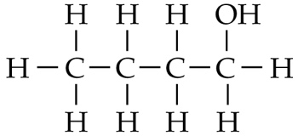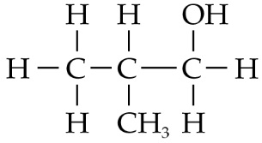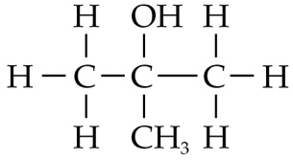
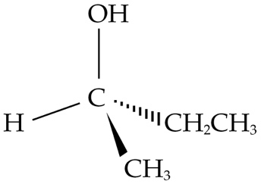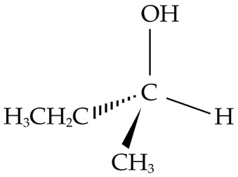

ChemMCQ43028
Which of the following pairs of compounds are stereoisomers?
(1) | 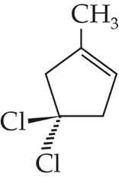 | and | 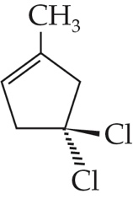
(2) | 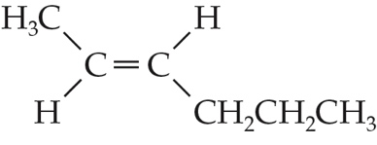 | and | 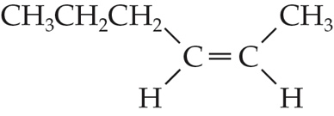
(3) | 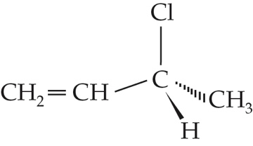 | and | 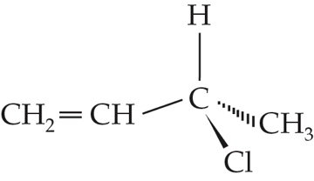
A. (1) and (2) only
B. (1) and (3) only
C. (2) and (3) only
D. (1), (2) and (3)

Answer: C
(1): The two compounds are identical.
(2): The two compounds are cis-trans isomers.
(3): The two compounds are enantiomers.

ChemMCQ43029
Which of the following compounds has a pair of enantiomers?
A. | 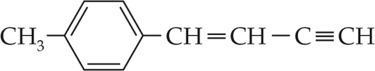 | B. | 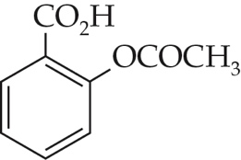
C. | 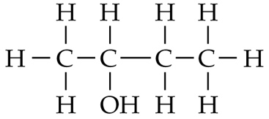 | D. | 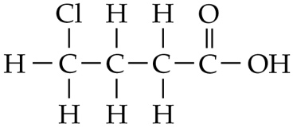

Answer: C
*

ChemMCQ43030
Which of the following pairs of compounds are stereoisomers?
(1) | 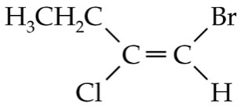 | and | 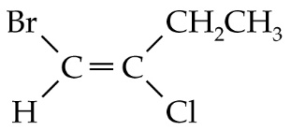
(2) | 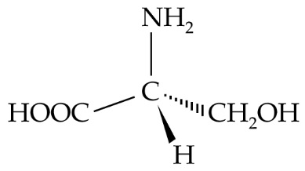 | and | 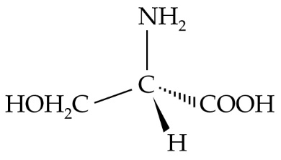
(3) | 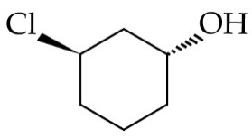 | and | 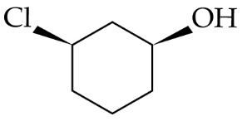
A. (1) and (2) only
B. (1) and (3) only
C. (2) and (3) only
D. (1), (2) and (3)

Answer: C
(1): They are identical.

ChemMCQ43031
Which of the following pairs of compounds are NOT identical?
A. | 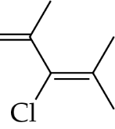 | and | 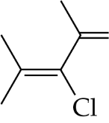
B. | 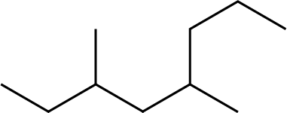 | and | 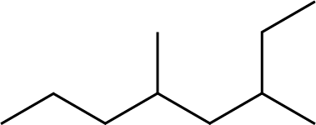
C. | 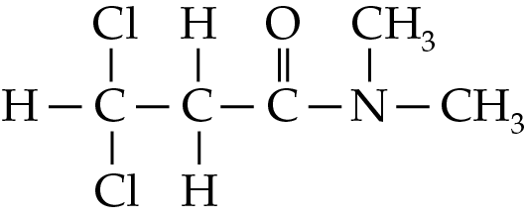 | and | 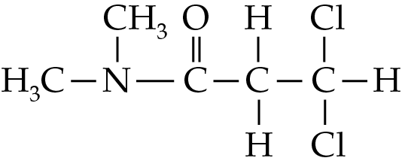
D. | 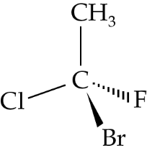 | and | 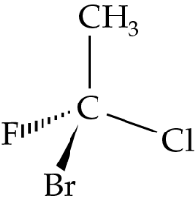

Answer: D
The two compounds in (D) are a pair of enantiomers.

ChemMCQ43032
Which of the following carbon compounds are identical?
(1) | 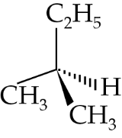 | (2) | 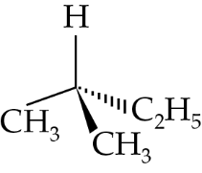 | (3) | 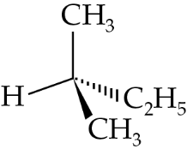
A. (1) and (2) only
B. (1) and (3) only
C. (2) and (3) only
D. (1), (2) and (3)

Answer: D
There are no chiral carbons in the three compounds. They are all methylbutane.

ChemMCQ43033
Which of the following molecules contains a chiral carbon?
A. | 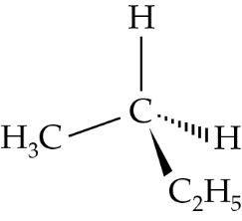 | B. | 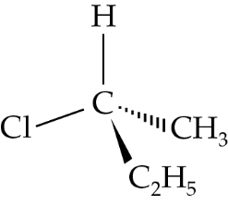
C. | 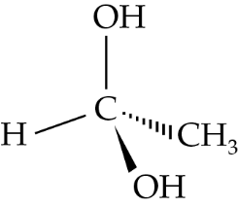 | D. | 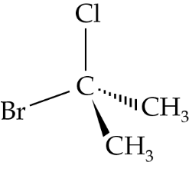

Answer: B
The carbon atom in (B) is bonded to four different atoms or groups of atoms.

ChemMCQ43034
Which of the following compounds have a chiral carbon atom?
(1) 3-bromopent-1-ene
(2) 1-chloro-2-methylbutane
(3) Butan-2-ol
A. (1) and (2) only
B. (1) and (3) only
C. (2) and (3) only
D. (1), (2) and (3)

Answer: D
The structural formulae of the three compounds are shown below.
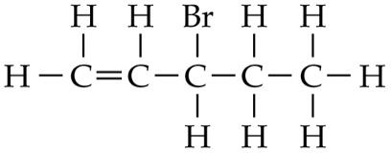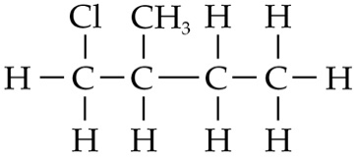
*
*
*

ChemMCQ43035
The structure of morphine is shown below.
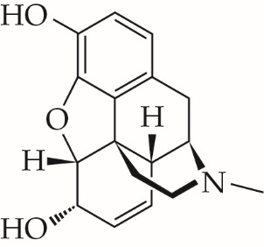
Which of the following statements about morphine are correct?
(1) There are five chiral carbons in a morphine molecule.
(2) It does not exhibit cis-trans isomerism.
(3) It is slightly soluble in water.
A. (1) and (2) only
B. (1) and (3) only
C. (2) and (3) only
D. (1), (2) and (3)

Answer: D
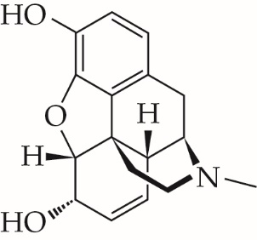
*
*
*
*
*

ChemMCQ43036
The structure of vitamin C is shown below.
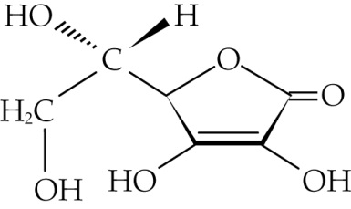
Which of the following statements about vitamin C is/are correct?
(1) Its molecular formula is C₆H₈O₆.
(2) It contains a ketone group.
(3) It has two chiral carbons.
A. (1) only
B. (2) only
C. (1) and (3) only
D. (2) and (3) only

Answer: C
*
*

ChemMCQ43037
Direction: Questions (a) and (b) refer to aldosterone, which is a hormone produced by the adrenal gland of our body. The structure of aldosterone is shown below.
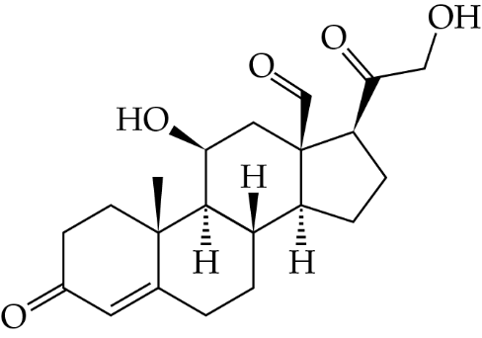
(a) How many chiral carbons are there in an aldosterone molecule?
A. 5
B. 6
C. 7
D. 8

Answer: C
*
*
*
*
*
*
*

(b) Which of the following functional groups can be found in aldosterone?
(1) Carbonyl
(2) Hydroxyl
(3) Carboxyl
A. (1) and (2) only
B. (1) and (3) only
C. (2) and (3) only
D. (1), (2) and (3)

Answer: A

ChemMCQ43038
Vitamin E can act as an antioxidant. Its structure is shown below.
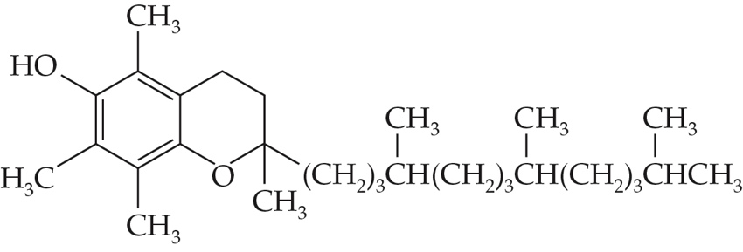
Which of the following statements about vitamin E is/are correct?
(1) It is soluble in oil.
(2) It is soluble in water.
(3) It has three chiral carbons.
A. (1) only
B. (2) only
C. (1) and (3) only
D. (2) and (3) only

Answer: C
(2): Vitamin E is insoluble in water because it has a long hydrocarbon chain.
(3): Vitamin E has three chiral carbons.
*
*
*

ChemMCQ43039
The structure of fructose is shown below.
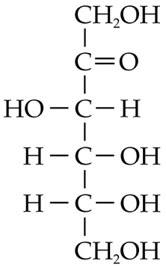
Which of the following statements about fructose is INCORRECT?
A. The molecular formula of fructose is C₆H₁₂O₆.
B. It is soluble in water.
C. It has a carbonyl group.
D. Its molecule has four chiral carbons.

Answer: D
(B): The hydroxyl groups can form hydrogen bonds with water molecules.
(D): A fructose molecule has three chiral carbons.
*
*
*

ChemMCQ43040
Consider the following compound.
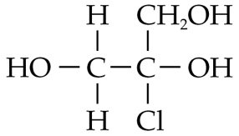
Which of the following statements about the compound are correct?
(1) Its systematic name is 2-chloropropane-1,2,3-triol.
(2) Hydrogen bonds exist between its molecules.
(3) It exhibits enantiomerism.
A. (1) and (2) only
B. (1) and (3) only
C. (2) and (3) only
D. (1), (2) and (3)

Answer: A
The structural formula of the compound can be expressed as:
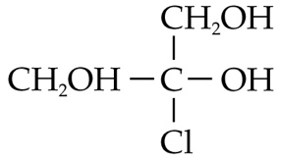
Two identical groups of atoms are attached to the C atom. The molecule is achiral.

ChemMCQ43041
Compound Y can be found in freshly cut leaves. Its structural formula is CH₃CH₂CH=CHCH₂CH₂OH. Which of the following statements about Y is INCORRECT?
A. Its systematic name is hex-3-en-1-ol.
B. It can form hydrogen bonds with water molecules.
C. It exhibits cis-trans isomerism.
D. It exhibits enantiomerism.

Answer: D
The structural formula of Y is shown below.
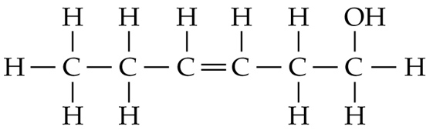
It does not contain any chiral carbon and so it does not exhibit enantiomerism.

ChemMCQ43042
Which of the following molecules is achiral?
A. 3-methylpent-1-ene
B. 2-chlorobutane
C. Methylpropanal
D. 1,1,2-trichlorobutane

Answer: C
The structural formulae of the four compounds are shown below.
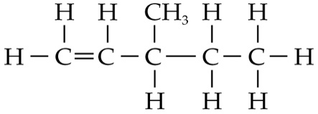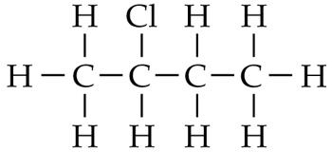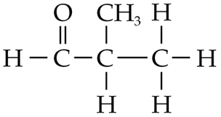
*
*
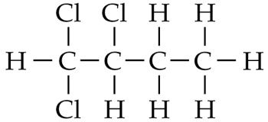
*
Methylpropanal does not have a chiral carbon and so it is achiral.

ChemMCQ43043
Which of the following compounds exhibit(s) enantiomerism?
(1) 3-bromobut-1-ene
(2) 4-bromobut-1-ene
(3) 2-bromobut-2-ene
A. (1) only
B. (2) only
C. (1) and (3) only
D. (2) and (3) only

Answer: A
The structural formulae of the three compounds are shown below.
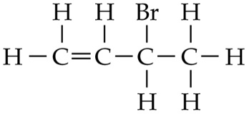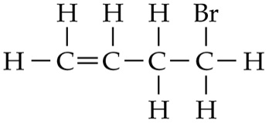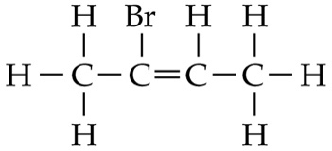
*

ChemMCQ43044
Which of the following compounds exhibit enantiomerism?
(1) 2-chlorobutane
(2) 3-chlorobut-1-ene
(3) 2-methylbutanal
A. (1) and (2) only
B. (1) and (3) only
C. (2) and (3) only
D. (1), (2) and (3)

Answer: D
The structural formulae of the three compounds are shown below.
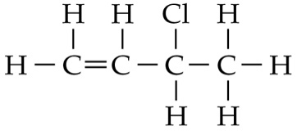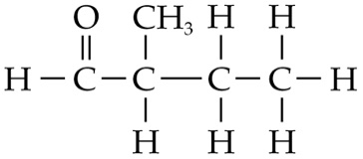
*
*
*

ChemMCQ43045
Which of the following compounds exhibit(s) enantiomerism?
(1) 1,1,2,2-tetrachloroethane
(2) 2-chloro-2-fluorobutane
(3) 5-chloro-3-methylpentanoic acid
A. (1) only
B. (2) only
C. (1) and (3) only
D. (2) and (3) only

Answer: D
The structural formulae of the three compounds are shown below.
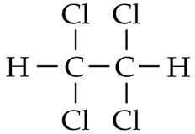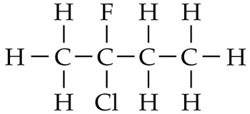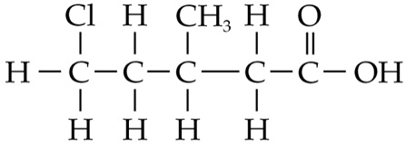
*
*

ChemMCQ43046
Which of the following compounds exhibit(s) optical isomersim?
(1) 2-chloro-1-fluorobutane
(2) 1,1-dibromo-1,2-dichloroethane
(3) Trans-5-chloro-5-fluoropent-2-ene
A. (1) only
B. (2) only
C. (1) and (3) only
D. (2) and (3) only

Answer: C
The structural formulae of the three compounds are shown below.
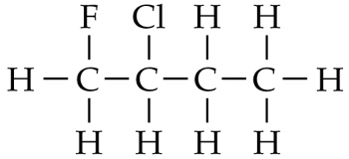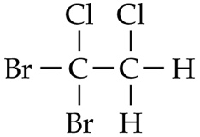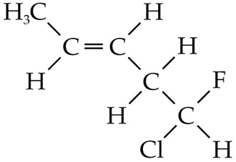
*
*

ChemMCQ43047
Which of the following compounds does NOT exhibit optical isomerism?
A. | 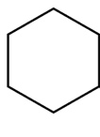 | B. | 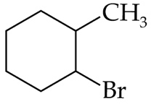
C. | 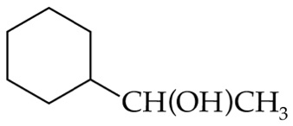 | D. | 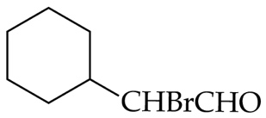

Answer: A
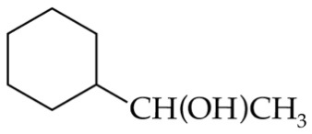
*
*
*
*

ChemMCQ43048
Which of the following compounds exhibits both cis-trans isomerism and enantiomerism?
A. | 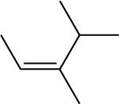 | B. | 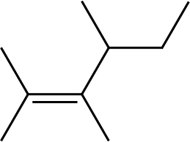
C. | 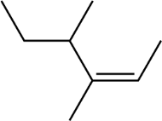 | D. | 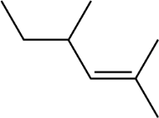

Answer: C
(A): It exhibits cis-trans isomerism only.
(B) and (D): They exhibit enantiomerism only.

ChemMCQ43049
Compound X is a carbon compound with a molecular formula C₄H₈O. Which of the following types of isomerism could X exhibit?
(1) Functional group isomerism
(2) Cis-trans isomerism
(3) Enantiomerism
A. (1) and (2) only
B. (1) and (3) only
C. (2) and (3) only
D. (1), (2) and (3)

Answer: D
(1): The functional group isomers are:
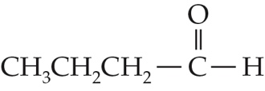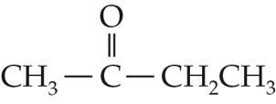
(2): The cis-trans isomers are:
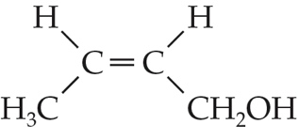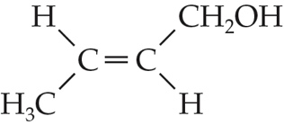
(3): The enantiomers are:
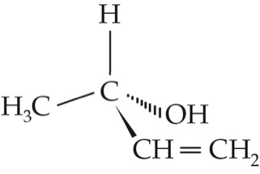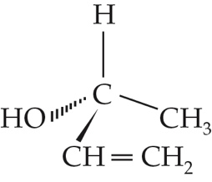

ChemMCQ43050
Consider the acyclic alcohols with the molecular formula C₅H₁₁OH. How many of them are optically active?
A. 3
B. 4
C. 5
D. 6

Answer: A
There are eight acyclic structural isomers of C₅H₁₁OH. Three of them have a chiral carbon in its molecule.
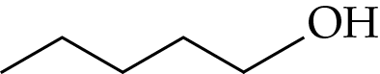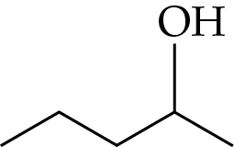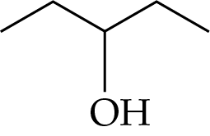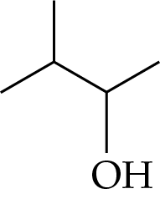
*
*
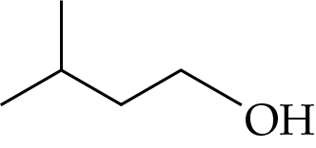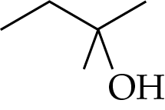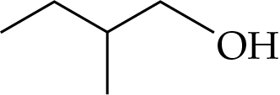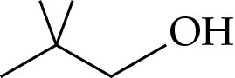
*

ChemMCQ43051
Which of the following combinations about 5-chloropenta-1,3-diene is correct?
 | Number of enantiomers | Number of cis-trans isomers
A. | 0 | 2
B. | 0 | 4
C. | 2 | 2
D. | 2 | 4

Answer: A
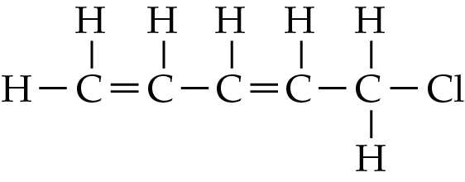
There is no chiral carbon in the molecule.
For the double bond between C-1 and C-2, C-1 is attached to two hydrogen atoms. Hence, cis-trans isomerism does not occur.
For the double bond between C-3 and C-4, two different atoms or groups of atoms are attached to each doubly-bonded carbon atom. Hence, cis-trans isomerism occurs.

ChemMCQ43052
Which of the following statements about structural isomerism is/are correct?
(1) Structural isomers are mirror images of each other.
(2) Structural isomers containing the same functional group have similar chemical properties.
(3) Structural isomers having the same number of carbon atoms have the same melting point.
A. (1) only
B. (2) only
C. (1) and (3) only
D. (2) and (3) only

Answer: B
Only enantiomers are mirror images of each other.

ChemMCQ43053
Consider the following compound.
CH₃CH=CHCH₂CHO
Which of the following statements about the compound are correct?
(1) It is optically inactive.
(2) It contains a hydroxyl group.
(3) It exhibits cis-trans isomerism.
A. (1) and (2) only
B. (1) and (3) only
C. (2) and (3) only
D. (1), (2) and (3)

Answer: B
The structural formula of the compound is shown below.
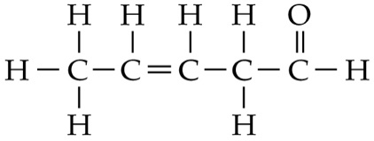
(1): The compound does not contain any chiral carbon atoms.
(2): It has a carbonyl / an aldehyde group.
(3): One hydrogen atom is attached to each doubly-bonded carbon atom.

ChemMCQ43054
Which of the following statements about the isomers of C₆H₁₂ is correct?
A. All isomers of C₆H₁₂ are optically inactive.
B. All isomers of C₆H₁₂ have the same melting point.
C. All isomers of C₆H₁₂ can decolourize bromine (dissolved in an organic solvent) in the dark.
D. All isomers of C₆H₁₂ burn completely in air to give carbon dioxide and water.

Answer: D
(A): 3-methylpent-1-ene is optically active.
(B): Isomers with different structures have different melting points.
(C): Cyclohexane does not decolourize bromine (dissolved in an organic solvent) in the dark.

ChemMCQ43055
Which of the following compounds is optically active?
A. CH₃CH=CHCH₃
B. CH₂=CHCHBrCH₃
C. CH₃CH₂COCH₃
D. CH₃CH₂CHClCH₂CH₃

Answer: B
In (B), the C-3 atom is attached to four different atoms or groups of atoms. Hence, it is chiral and optically active.

ChemMCQ43056
Which of the following compounds is optically active?
A. CH₃CH₂CH₂COCH₃
B. CH₃CH₂CH₂CH(CH₃)COCH₃
C. CH₃CH(CH₃)COCH₃
D. CH₃CH₂CHO

Answer: B
In (B), the C-3 atom is attached to four different atoms or groups of atoms. Hence, it is chiral and optically active.

ChemMCQ43057
Which of the following statements about enantiomers is INCORRECT?
A. Enantiomers can rotate the plane of polarization of a beam of plane polarized light.
B. Enantiomers have the same melting point.
C. There is at least one plane of symmetry in the molecules of enantiomers.
D. Enantiomers have the same molecular formula.

Answer: C
There is no plane of symmetry in a chiral molecule.

ChemMCQ43058
Consider the following three compounds:
(1) | 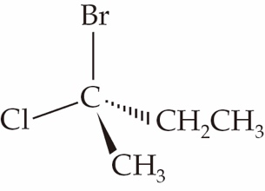 | (2) | 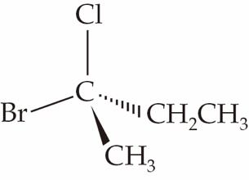 | (3) | 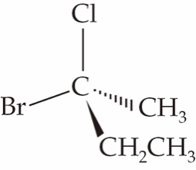
Which of the following compounds have the same density?
A. (1) and (2) only
B. (1) and (3) only
C. (2) and (3) only
D. (1), (2) and (3)

Answer: D
(1) and (2) are enantiomers while (1) and (3) are identical. The molecules of the three compounds have the same shape and their molecules are held together by intermolecular forces with the same strength. Hence, they have the same density.

ChemMCQ43059
Which of the following methods can be used to distinguish a pair of enantiomers?
(1) Measuring the optical activities of the enantiomers by using a polarimeter
(2) Comparing the boiling points of the enantiomers
(3) Comparing the densities of the enantiomers
A. (1) only
B. (2) only
C. (1) and (3) only
D. (2) and (3) only

Answer: A
A pair of enantiomers can rotate the plane of polarization of a beam of plane polarized light in opposite directions. Enantiomers have very similar physical properties.

ChemMCQ43060
Consider the following two compounds.
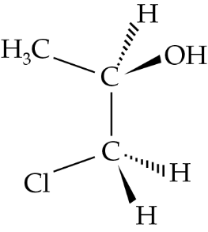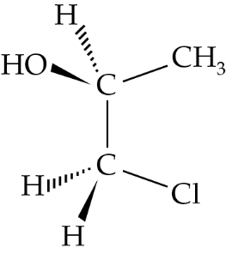
Which of the following statements about the two compounds are correct?
(1) They have the same solubility in water.
(2) They have the same standard enthalpy change of formation.
(3) They rotate the plane of polarization of a beam of plane polarized light in opposite directions.
A. (1) and (2) only
B. (1) and (3) only
C. (2) and (3) only
D. (1), (2) and (3)

Answer: D
The two compounds are a pair of enantiomers.

