Chapter 44 Typical reactions of various functional groups

Sections 44.1−44.2
ChemMCQ44001
Which of the following conditions is/are required for alkanes to undergo substitution reactions with bromine?
(1) Sunlight
(2) High pressure
(3) The presence of a catalyst
A. (1) only
B. (2) only
C. (1) and (3) only
D. (2) and (3) only

Answer: A

ChemMCQ44002
Which of the following compounds is the major product of the reaction between methane and excess chlorine?
A. Chloromethane
B. Dichloromethane
C. Trichloromethane
D. Tetrachloromethane

Answer: D

ChemMCQ44003
Which of the following statements about chloroform is/are correct?
(1) Hydrogen bonds exist between the molecules of chloroform.
(2) Chloroform molecules are polar.
(3) It is one of the products of the substitution reaction between methane and chlorine.
A. (1) only
B. (2) only
C. (1) and (3) only
D. (2) and (3) only

Answer: D
Chloroform is the trivial name of trichloromethane (CHCl₃).

ChemMCQ44004
Which of the following statements about the substitution reaction between propane and chlorine are correct?
(1) It does not take place in the dark at room temperature.
(2) It involves the breaking of C−H bonds in the initiation step.
(3) Hydrogen chloride is one of the products of the reaction.
A. (1) and (2) only
B. (1) and (3) only
C. (2) and (3) only
D. (1), (2) and (3)

Answer: B
The reaction takes place in the presence of sunlight or at high temperatures as energy is supplied to break the Cl−Cl bonds in the initiation step.

ChemMCQ44005
Which of the following statements about the reaction between methane and chlorine under sunlight is/are correct?
(1) It is an addition reaction.
(2) It is a substitution reaction.
(3) It involves the formation of chloride ions.
A. (1) only
B. (2) only
C. (1) and (3) only
D. (2) and (3) only

Answer: B

Section 44.3
ChemMCQ44006
Which of the following can be classified as an addition reaction?
(1) Reaction between methane and chlorine
(2) Reaction between ethene and hydrogen
(3) Reaction between chloroethene and hydrogen chloride
A. (1) only
B. (2) only
C. (1) and (3) only
D. (2) and (3) only

Answer: D
(1): The reaction between methane and chlorine is a substitution reaction.

ChemMCQ44007
Which of the following reactions are addition reactions?
(1) CH₂=CHCH=CH₂ + HCl
(2) CH₃CH₂CH₂CH₃ + Cl₂
(3) CH₂=CHCH₂CH₃ + H₂
A. (1) and (2) only
B. (1) and (3) only
C. (2) and (3) only
D. (1), (2) and (3)

Answer: B
(2): It is a substitution reaction.

ChemMCQ44008
Chlorogenic acid occurs naturally in coffee. Its structure is shown below.
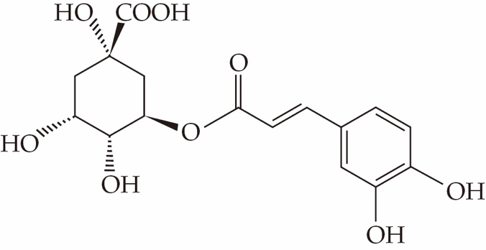
Which of the following statements concerning chlorogenic acid are correct?
(1) It has an ester group.
(2) It can decolourize bromine (dissolved in an organic solvent).
(3) It exhibits cis-trans isomerism.
A. (1) and (2) only
B. (1) and (3) only
C. (2) and (3) only
D. (1), (2) and (3)

Answer: D

ChemMCQ44009
Which of the following compounds is the product of the addition reaction between penta-1,4-diene and excess bromine?
A. 1,2-dibromopentane
B. 2,4-dibromopentane
C. 1,1,4,4-tetrabromopentane
D. 1,2,4,5-tetrabromopentane

Answer: D
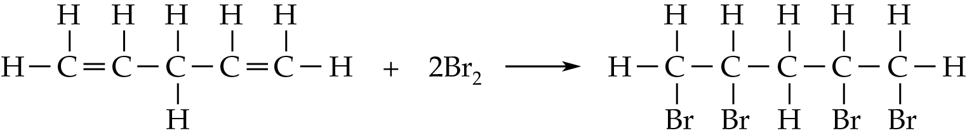

ChemMCQ44010
Which of the following compounds CANNOT be produced directly from ethene?
A. 1,2-dibromoethane
B. Ethyl ethanoate
C. Ethane
D. Carbon dioxide

Answer: B
(A): 1,2-dibromoethane can be produced by the addition of ethene with bromine.
(C): Ethane can be produced by the hydrogenation of ethene.
(D): Carbon dioxide can be produced by the combustion of ethene.

ChemMCQ44011
Consider the following compound.
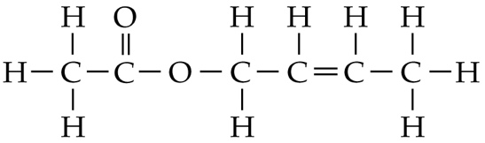
Which of the following statements about the compound are correct?
(1) It contains an ester group.
(2) It can decolourize bromine (dissolved in an organic solvent) in the dark.
(3) It is immiscible with water.
A. (1) and (2) only
B. (1) and (3) only
C. (2) and (3) only
D. (1), (2) and (3)

Answer: D

ChemMCQ44012
Which of the following compounds is the major product of the addition reaction between hydrogen chloride and propene?
A. 1-chloropropane
B. 2-chloropropane
C. 1,2-dichloropropane
D. 2,2-dichloropropane

Answer: B
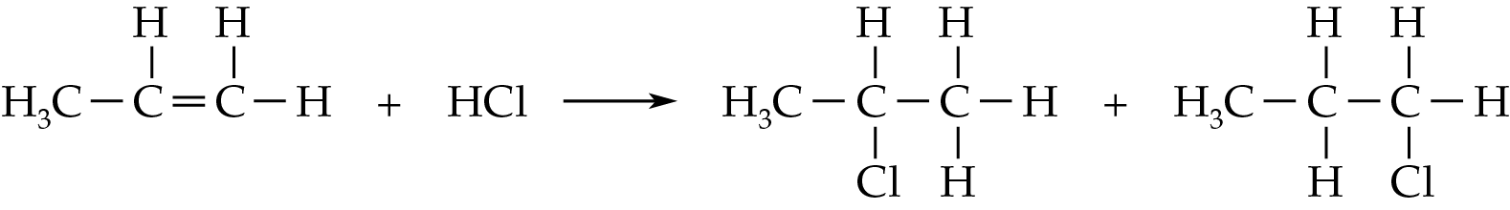
(major product) (minor product)

ChemMCQ44013
Which of the following statements about propene are correct?
(1) It reacts with hydrogen in the presence of platinum to give propane.
(2) It reacts with hydrogen chloride to give 1-chloropropane as the major product.
(3) It decolourizes bromine (dissolved in an organic solvent) in the dark.
A. (1) and (2) only
B. (1) and (3) only
C. (2) and (3) only
D. (1), (2) and (3)

Answer: B
According to Markovnikov’s rule, the major product of the reaction between propene and hydrogen chloride is 2-chloropropane.

ChemMCQ44014
Which of the following compounds is the major product of the reaction between methylpropene and hydrogen chloride?
A. 1-chloromethylpropane
B. 1,2-dichloromethylpropane
C. 2-chloromethylpropane
D. Methylpropane

Answer: C
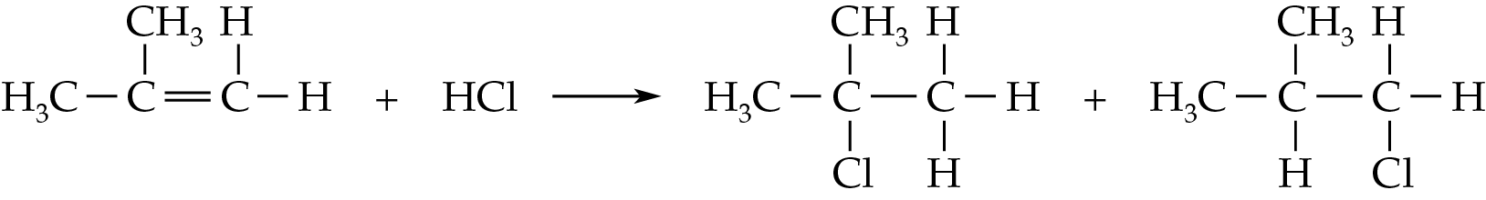
(major product) (minor product)

ChemMCQ44015
Which of the following combinations about some addition reactions is correct?
 | Addition reaction | Major product
A. | CH₃CH=CH₂ + HBr | CH₃CH₂CH₂Br
B. | (CH₃)₂C=CH₂ + HBr | (CH₃)₃CBrCH₃
C. | CHBr=CH₂ + HBr | CH₂BrCH₂Br
D. | (CH₃)₃CCH=CH₂ + HBr | (CH₃)₃CCH₂CH₂Br

Answer: B
According to Markovnikov’s rule, the major products of the reactions for (A), (C) and (D) should be CH₃CHBrCH₃, CHBr₂CH₃ and (CH₃)₃CCHBrCH₃ respectively.

ChemMCQ44016
Which of the following statements about but-1-ene are correct?
(1) It reacts with hydrogen chloride to give 1-chlorobutane as one of the products.
(2) It decolourizes acidified potassium permanganate solution.
(3) It undergoes hydrogenation in the presence of platinum.
A. (1) and (2) only
B. (1) and (3) only
C. (2) and (3) only
D. (1), (2) and (3)

Answer: D
(1): The reaction between but-1-ene and hydrogen chloride gives 1-chlorobutane and 2-chlorobutane. 2-chlorobutane is the major product.

ChemMCQ44017
Which of the following compounds is the major product of the reaction between 2,5-dimethylhexa-2,4-diene and excess hydrogen bromide?
A. 3,5-dibromo-2,5-dimethylhexane
B. 2,4-dibromo-2,5-dimethylhexane
C. 3,4-dibromo-2,5-dimethylhexane
D. 2,5-dibromo-2,5-dimethylhexane

Answer: D
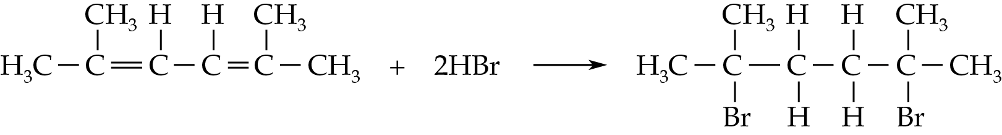
(major product)

ChemMCQ44018
Hydrogen bromide is allowed to react with excess 2,4,6,6-tetramethylhepta-2,4-diene.
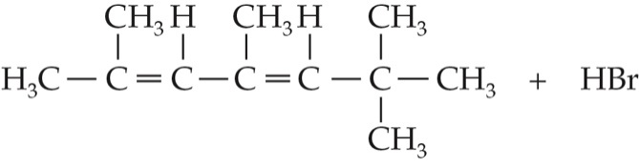
Which of the following compounds is/are the possible major product(s) of the reaction?
(1) | 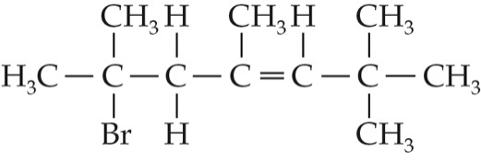
(2) | 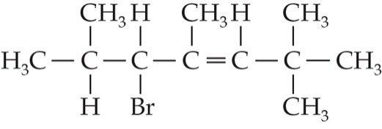
(3) | 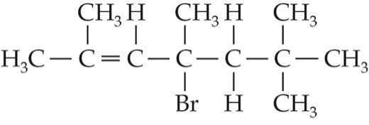
A. (1) only
B. (2) only
C. (1) and (3) only
D. (2) and (3) only

Answer: C
According to Markovnikov’s rule, the hydrogen atom in HBr is added to the carbon atom of the carbon-carbon double bond that already has the greater number of hydrogen atoms.

ChemMCQ44019
Which of the following compounds is the major product of the reaction between buta-1,3-diene and excess hydrogen iodide?
A. 1,3-diiodobutane
B 1,4-diiodobutane
C. 2,3-diiodobutane
D. 2,4-diiodobutane

Answer: C
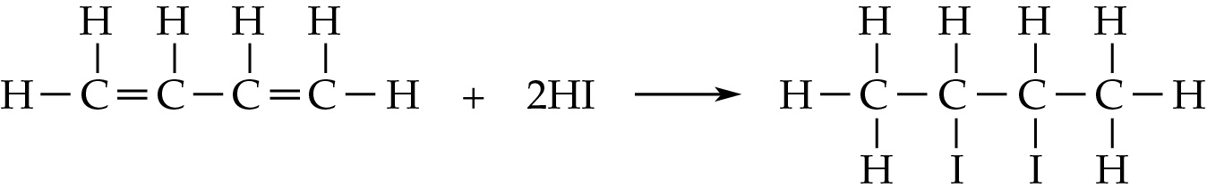
(major product)

ChemMCQ44020
Consider the following compound.
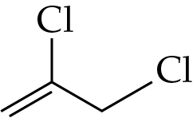
Which of the following statements about the compound is INCORRECT?
A. Its systematic name is 2,3-dichloropropene.
B. It is insoluble in water.
C. It reacts with hydrogen bromide to give 1-bromo-2,3-dichloropropane as the major product.
D. It reacts with chlorine (dissolved in an organic solvent) to give 1,2,2,3-tetrachloropropane.

Answer: C
(C): According to Markovnikov’s rule, the major product of the reaction is 2-bromo-2,3-dichloropropane.

ChemMCQ44021
The molecular formula of acyclic compound P is C₄H₆Br₂. Which of the following statements about P must be correct?
A. P is a saturated hydrocarbon.
B. P exhibits cis-trans isomerism.
C. P exhibits enantiomerism.
D. P can decolourize acidified potassium permanganate solution.

Answer: D
From the molecular formula, P is an unsaturated compound containing a C=C double bond. Consider the following structure:
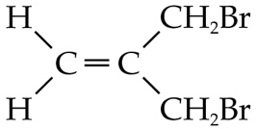
It does not exhibit cis-trans isomerism or enantiomerism.

ChemMCQ44022
Limonene is a colourless liquid with the smell of orange at room temperature. Its structure is shown below.
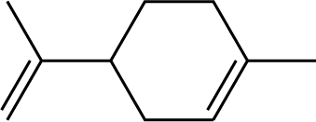
Which of the following statements about limonene is/are correct?
(1) It changes acidified potassium dichromate solution from orange to green.
(2) It exhibits enantiomerism.
(3) It becomes a saturated hydrocarbon when reacting with hydrogen in the presence of platinum.
A. (1) only
B. (2) only
C. (1) and (3) only
D. (2) and (3) only

Answer: D
It contains a chiral carbon.
*

ChemMCQ44023
Which of the following alkenes produces more than TWO products when treated with hydrogen bromide?
A. Methylpropene
B. But-1-ene
C. Cis-but-2-ene
D. Trans-but-2-ene

Answer: B
(A): The addition reaction between methylpropene and HBr produces 1-bromomethylpropane and 2-bromomethylpropane.
(B): The addition reaction between but-1-ene and HBr produces 1-bromobutane and 2-bromobutane. 2-bromobutane has a pair of enantiomers.
(C): The addition reaction between cis-but-2-ene and HBr produces 2-bromobutane. 2-bromobutane has a pair of enantiomers.
(D): The addition reaction between trans-but-2-ene and HBr produces 2-bromobutane. 2-bromobutane has a pair of enantiomers.

ChemMCQ44024
When 2.81 g of an alkene reacts with excess hydrogen chloride, 4.64 g of a chloroalkane forms. Which of the following is the molecular formula of the alkene?
(Relative atomic masses: H = 1.0, C = 12.0, Cl = 35.5)
A. C₃H₆
B. C₄H₈
C. C₅H₁₀
D. C₆H₁₂

Answer: B
Let the molecular formula of the alkene be C_{n}H_{2n}.
C_{n}H_{2n} + HCl → C_{n}H_{2n+1}Cl
From the equation, mole ratio of C_{n}H_{2n} to C_{n}H_{2n+1}Cl = 1 : 1.
$\frac{\text{2.81}}{\text{12.0 × }\text{n}\text{ + 1.0 × 2}\text{n}}$ = $\frac{\text{4.64}}{\text{12.0 × }\text{n}\text{ + 1.0 × 2}\text{n}\text{ + 1.0 + 35.5}}$
Solving for n, n = 4
∴the molecular formula of the alkene is C₄H₈.

ChemMCQ44025
Addition polymer X has the following structure.
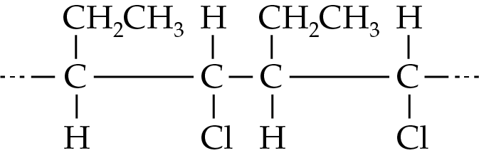
Which of the following statements concerning the monomer of X are correct?
(1) The systematic name of the monomer of X is 1-chlorobut-2-ene.
(2) The monomer of X can undergo addition reaction to give a saturated compound.
(3) Both the cis-isomer and the trans-isomer of the monomer of X can be polymerized.
A. (1) and (2) only
B. (1) and (3) only
C. (2) and (3) only
D. (1), (2) and (3)

Answer: C
(1): The systematic name of the monomer of X is 1-chlorobut-1-ene.

ChemMCQ44026
Which of the following statement concerning the reaction of excess but-2-ene with acidified potassium permanganate solution are correct?
(1) The acidified potassium permanganate solution is decolourized.
(2) The organic product can be further oxidized to a dicarboxylic acid.
(3) There will be no observable change if acidified potassium permanganate solution is replaced by acidified potassium dichromate solution.
A. (1) and (2) only
B. (1) and (3) only
C. (2) and (3) only
D. (1), (2) and (3)

Answer: B
(2): The organic product is butane-1,2-diol, which can be oxidized to butanedione.

Section 44.4
ChemMCQ44027
Which of the following statements about the reaction between bromoethane and sodium hydroxide solution are correct?
(1) Ethanol is one of the products.
(2) Heating is required to speed up the reaction.
(3) The reaction involves the breaking of the C−Br bond.
A. (1) and (2) only
B. (1) and (3) only
C. (2) and (3) only
D. (1), (2) and (3)

Answer: D

ChemMCQ44028
Which of the following reactions are substitution reactions?
(1) CH₃CH₂CH₂CH₂I + NaOH
(2) CH₃CH₂CH₂CH₃ + Cl₂
(3) CH₃CH=CHCH₃ + H₂
A. (1) and (2) only
B. (1) and (3) only
C. (2) and (3) only
D. (1), (2) and (3)

Answer: A
(3): It is an addition reaction.

ChemMCQ44029
Consider the following reaction.
Which of the following types of reaction is/are involved in the above reaction?
(1) Addition
(2) Substitution
(3) Neutralization
A. (1) only
B. (2) only
C. (1) and (3) only
D. (2) and (3) only

Answer: B

ChemMCQ44030
Which of the following statements about the reaction between 2-iodobutane and sodium hydroxide solution are correct?
(1) The products of the reaction are butan-2-ol and sodium iodide.
(2) It involves the formation of the C−O bond.
(3) It involves the breakage of the C−I bond.
A. (1) and (2) only
B. (1) and (3) only
C. (2) and (3) only
D. (1), (2) and (3)

Answer: D

ChemMCQ44031
A few drops of sodium hydroxide solution are added to 1-chloropropane in a test tube and the reaction mixture is heated. Acidified silver nitrate solution is then added to the resultant mixture. What will be observed?
A. Colourless gas bubbles form.
B. Some silvery solids form.
C. A white precipitate forms.
D. There is no observable change.

Answer: C
The products of the reaction are propan-1-ol and sodium chloride. Chloride ions react with silver ions to form a white precipitate (silver chloride).

Section 44.5
ChemMCQ44032
Which of the following compounds are NOT secondary alcohols?
(1) | 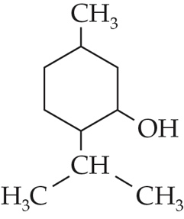 | (2) | 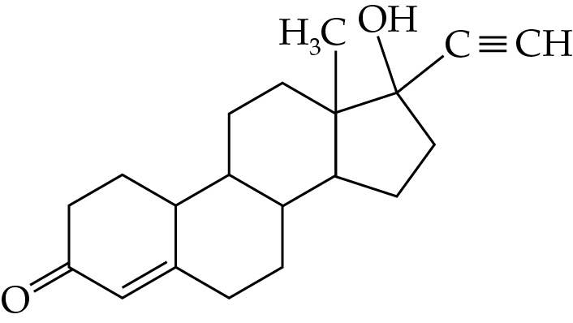
(3) | 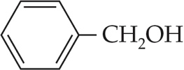
A. (1) and (2) only
B. (1) and (3) only
C. (2) and (3) only
D. (1), (2) and (3)

Answer: C
(1): It is a secondary alcohol.
(2): It is a tertiary alcohol.
(3): It is a primary alcohol.

ChemMCQ44033
Which of the following statements about the alcohol series is/are correct?
(1) The first two members are often used as solvents.
(2) The solubility of alcohols in water increases when the length of the hydrocarbon chain increases.
(3) The members react with concentrated hydrochloric acid in the presence of zinc chloride with heating to give chloroalkanes.
A. (1) only
B. (2) only
C. (1) and (3) only
D. (2) and (3) only

Answer: C
(1): Methanol and ethanol are often used as solvents.
(2): The solubility of alcohols in water decreases when the length of the hydrocarbon chain increases.

ChemMCQ44034
Which of the following reagents can be used to convert propan-2-ol to 2-bromopropane?
(1) HBr(g)
(2) Br₂(l) + CCl₄(l)
(3) PBr₃(l)
A. (1) and (2) only
B. (1) and (3) only
C. (2) and (3) only
D. (1), (2) and (3)

Answer: B
(2): Bromine (dissolved in an organic solvent) is a reagent used to convert an alkene to a dihaloalkane.

ChemMCQ44035
Which of the following reagents can be used to convert ethanol to bromoethane?
(1) Concentrated hydrobromic acid
(2) Phosphorus tribromide
(3) Sodium bromide solution
A. (1) and (2) only
B. (1) and (3) only
C. (2) and (3) only
D. (1), (2) and (3)

Answer: A

ChemMCQ44036
Which of the following reactions are substitution reactions?
(1) The reaction between hydrogen chloride and propan-1-ol
(2) The reaction between hydrogen bromide and ethene
(3) The reaction between bromine and methane
A. (1) and (2) only
B. (1) and (3) only
C. (2) and (3) only
D. (1), (2) and (3)

Answer: B
(2): It is an addition reaction.

ChemMCQ44037
Which of the following compounds is the major product of the reaction of 4-chloropent-4-en-1-ol with hydrogen chloride in the presence of zinc chloride?
A. | 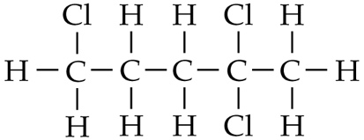 | B. | 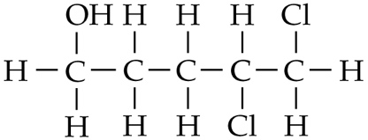
C. | 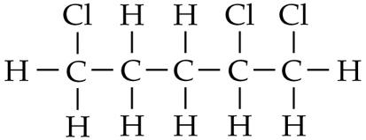 | D. | 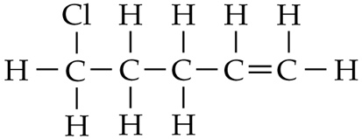

Answer: A
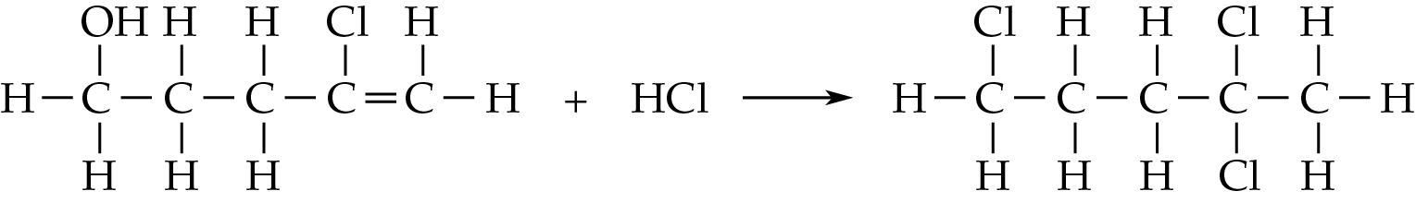
(major product)

ChemMCQ44038
Which of the following statements about phosphorus tribromide are correct?
(1) It is a liquid under room conditions.
(2) It can be used to convert butan-2-ol to 2-bromobutane.
(3) It can be used to convert but-2-ene to 2,3-dibromobutane.
A. (1) and (2) only
B. (1) and (3) only
C. (2) and (3) only
D. (1), (2) and (3)

Answer: A

ChemMCQ44039
Which of the following reactions can produce a haloalkane?
(1) The reaction between but-1-ene and hydrogen bromide
(2) The reaction between 2-chloropropene and hydrogen
(3) The reaction between butan-1-ol and phosphorus trichloride
A. (1) and (2) only
B. (1) and (3) only
C. (2) and (3) only
D. (1), (2) and (3)

Answer: D

ChemMCQ44040
Which of the following statements about the reaction between butan-1-ol and hydrogen bromide are correct?
(1) 1-bromobutane is one of the products of the reaction.
(2) The reaction involved is a substitution reaction.
(3) The reaction involved is a redox reaction.
A. (1) and (2) only
B. (1) and (3) only
C. (2) and (3) only
D. (1), (2) and (3)

Answer: A

ChemMCQ44041
Consider the following reaction.
3CH₃CH₂CH₂OH + PI₃ → 3CH₃CH₂CH₂I + X
What is X?
A. Phosphorus trioxide
B. Phosphorus pentoxide
C. Phosphorous acid
D. Phosphoric acid

Answer: C

ChemMCQ44042
1-chlorobutane can be prepared by heating butan-1-ol with concentrated hydrochloric acid in the presence of zinc chloride in a boiling tube. Two layers of liquid can be seen in the boiling tube. Which of the following statements are correct?
(1) 1-chlorobutane can only be found in the lower layer.
(2) Butan-1-ol can only be found in the upper layer.
(3) Zinc chloride acts as a catalyst.
A. (1) and (2) only
B. (1) and (3) only
C. (2) and (3) only
D. (1), (2) and (3)

Answer: B
1-chlorobutane is immiscible with water and has a higher density than water. Hence, the lower layer is 1-chlorobutane. Butan-1-ol is miscible with both water and 1-chlorobutane.

ChemMCQ44043
Consider the following compound.
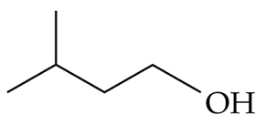
Which of the following compounds form(s) when the above compound is dehydrated?
(1) CH₂=C(CH₃)CH₂CH₃
(2) (CH₃)₂CHCH=CH₂
(3) (CH₃)₂C=CHCH₃
A. (1) only
B. (2) only
C. (1) and (3) only
D. (2) and (3) only

Answer: B

ChemMCQ44044
Which of the following substances would react with concentrated sulphuric acid?
(1) Copper
(2) Ethanol
(3) Polyvinyl chloride
A. (1) and (2) only
B. (1) and (3) only
C. (2) and (3) only
D. (1), (2) and (3)

Answer: A
(1): Cu(s) + 2H₂SO₄(l) → CuSO₄(s) + SO₂(g) + 2H₂O(l)
(2): Ethanol is dehydrated by concentrated sulphuric acid to give ethene.

ChemMCQ44045
The diagram below shows a set-up of an experiment.
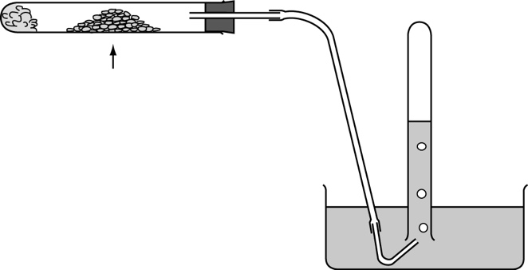
heat
water
gaseous product
aluminium oxide
ceramic wool soaked with butan-1-ol
Which of the following statements about the experiment is INCORRECT?
A. The reaction involved is dehydration.
B. Aluminium oxide is the catalyst.
C. The gaseous product is a mixture of alkanes and alkenes.
D. The gaseous product can decolourize acidified potassium permanganate solution.

Answer: C
The catalytic dehydration of butan-1-ol gives but-1-ene as the only gaseous product.

ChemMCQ44046
The structure of compound X is shown below.
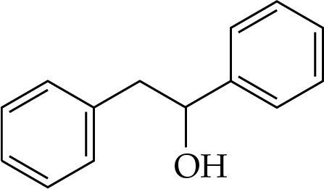
When X is heated with concentrated sulphuric acid, compound Y forms. Which of the following statements are correct?
(1) X is a tertiary alcohol.
(2) Concentrated sulphuric acid acts as a dehydrating agent.
(3) Y can decolourize bromine (dissolved in an organic solvent).
A. (1) and (2) only
B. (1) and (3) only
C. (2) and (3) only
D. (1), (2) and (3)

Answer: C
(1): X is a secondary alcohol.
(2) and (3): The dehydration of X produces an alkene, which can decolourize bromine (dissolved in an organic solvent).

ChemMCQ44047
X is an alcohol with the condensed formula of CH₃CH(OH)C₂H₅. Which of the following statements about X is/are correct?
(1) It is a secondary alcohol.
(2) It undergoes dehydration in the presence of dilute sulphuric acid with heating.
(3) It can be oxidized to butanoic acid.
A. (1) only
B. (2) only
C. (1) and (3) only
D. (2) and (3) only

Answer: A
Concentrated sulphuric acid should be used instead of dilute sulphuric acid for the dehydration of an alcohol. Since X is a secondary alcohol, it is oxidized to a ketone which is resistant to further oxidation.

ChemMCQ44048
Direction: Questions (a) and (b) refer to the reaction between butan-2-ol and concentrated sulphuric acid.
(a) Which of the following statements concerning the reaction are correct?
(1) A mixture of alkenes is produced.
(2) The reaction involved is dehydration.
(3) Heating is required for the reaction to occur.
A. (1) and (2) only
B. (1) and (3) only
C. (2) and (3) only
D. (1), (2) and (3)

Answer: D
The dehydration of butan-2-ol produces but-1-ene and but-2-ene.

(b) Which of the following set-ups can be used to collect the product(s)?
(1) | 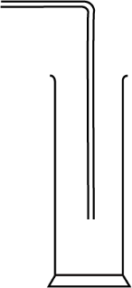 | (2) | 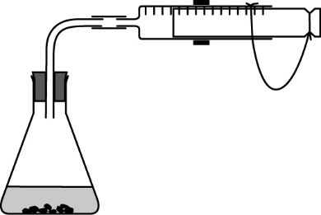  gas syringe | (3) | 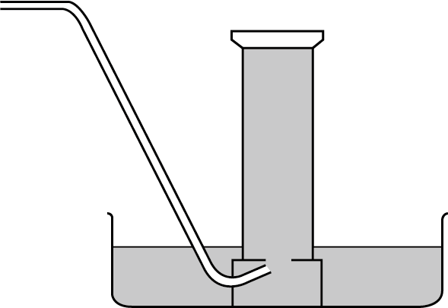  water
A. (1) and (2) only
B. (1) and (3) only
C. (2) and (3) only
D. (1), (2) and (3)

Answer: D
(1): As but-1-ene and but-2-ene are denser than air, the products can be collected by downward delivery.
(3): As but-1-ene and but-2-ene are insoluble in water, the products can be collected by displacement of water.

ChemMCQ44049
Which of the following statements about propan-1-ol are correct?
(1) It can be oxidized to propanal.
(2) It can be oxidized to propanoic acid.
(3) It can be dehydrated to give propene.
A. (1) and (2) only
B. (1) and (3) only
C. (2) and (3) only
D. (1), (2) and (3)

Answer: D
Propan-1-ol is a primary alcohol. It is first oxidized to propanal and is then further oxidized to propanoic acid.

ChemMCQ44050
Consider the following reaction.
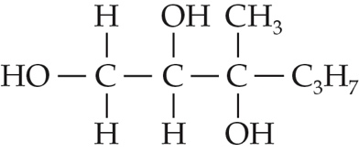
Cr₂O₇²⁻(aq)/H⁺(aq)
heat
Which of the following compounds is the major product of the reaction?
A. | 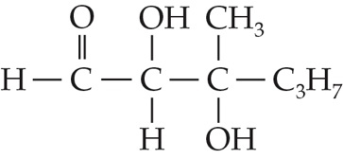 | B. | 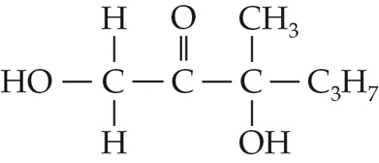
C. | 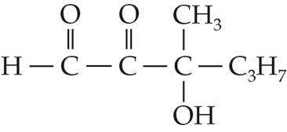 | D. | 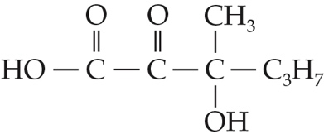

Answer: D
Primary alcohols are first oxidized to aldehydes and are then further oxidized to carboxylic acids. Secondary alcohols are oxidized to ketones which are resistant to further oxidation. Tertiary alcohols cannot be oxidized by acidified K₂Cr₂O₇(aq).

ChemMCQ44051
Which of the following statements about alcohols is INCORRECT?
A. Methylpropan-2-ol is a tertiary alcohol.
B. All alcohols can be oxidized to carboxylic acids.
C. An alcohol can be dehydrated to give an alkene by heating with concentrated sulphuric acid.
D. Phosphorus trihalides can be used to convert an alcohol to a haloalkane.

Answer: B
Only primary alcohols can be oxidized to carboxylic acids.

ChemMCQ44052
When compound W is heated with concentrated sulphuric acid, it forms a compound that decolourizes acidified potassium permanganate solution. Which of the following compounds may W be?
(1) CH₃OH
(2) CH₃CH₂OH
(3) (CH₃)₃COH
A. (1) and (2) only
B. (1) and (3) only
C. (2) and (3) only
D. (1), (2) and (3)

Answer: C
(1): Methanol cannot undergo dehydration.

ChemMCQ44053
Which of the following reactions are correct?
(1) 3CH₃CH(OH)CH₂CH₂CH₃ + PBr₃ → 3CH₃CHBrCH₂CH₂CH₃ + H₃PO₃
(2) CH₂(OH)CH₂(OH) + 4[O] → (COOH)₂ + 2H₂O
(3) CH₃CH₂Br + NaOH → CH₃CH₂OH + NaBr
A. (1) and (2) only
B. (1) and (3) only
C. (2) and (3) only
D. (1), (2) and (3)

Answer: D

ChemMCQ44054
Which of the following statements about pentan-2-ol are correct?
(1) It is a secondary alcohol.
(2) It undergoes dehydration to give pent-1-ene and pent-2-ene.
(3) It undergoes oxidation to give pentan-2-one.
A. (1) and (2) only
B. (1) and (3) only
C. (2) and (3) only
D. (1), (2) and (3)

Answer: D

ChemMCQ44055
Which of the following compounds are the possible products of the oxidation of methanol?
(1) Methanal
(2) Methanoic acid
(3) Carbon dioxide
A. (1) and (2) only
B. (1) and (3) only
C. (2) and (3) only
D. (1), (2) and (3)

Answer: D
Methanol is a primary alcohol. It is first oxidized to methanal and is then further oxidized to methanoic acid. The combustion (a kind of oxidation) of methanol produces carbon dioxide.

ChemMCQ44056
Which of the following compounds is/are the possible product(s) of the oxidation of butan-2-ol?
(1) Butanal
(2) Butanone
(3) Butanoic acid
A. (1) only
B. (2) only
C. (1) and (3) only
D. (2) and (3) only

Answer: B
Butan-2-ol is a secondary alcohol. It can be oxidized to butanone.

ChemMCQ44057
Which of the following compounds can be obtained from the oxidation of pentan-1-ol?
(1) Pentanoic acid
(2) Pentanal
(3) Pentanone
A. (1) and (2) only
B. (1) and (3) only
C. (2) and (3) only
D. (1), (2) and (3)

Answer: A
Pentan-1-ol is a primary alcohol. It is first oxidized to pentanal and is then further oxidized to pentanoic acid.

ChemMCQ44058
A mixture of acidified potassium dichromate solution and ethanol is heated under reflux. Which of the following statements about the reaction is INCORRECT?
A. Ethanal is the only product of the reaction.
B. The reaction mixture changes from orange to green.
C. The oxidation number of chromium decreases from +6 to +3.
D. The reaction is a redox reaction.

Answer: A
Water is also produced during the reaction. Ethanal produced will be further oxidized to ethanoic acid.

ChemMCQ44059
Consider the following compound.
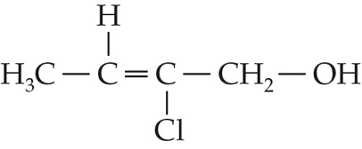
Which of the following statements about the compound is/are correct?
(1) It is a primary alcohol.
(2) It reacts with acidified potassium dichromate solution to give a ketone.
(3) It reacts with excess hydrogen chloride to give 2,2-dichlorobutan-1-ol as the major product.
A. (1) only
B. (2) only
C. (1) and (3) only
D. (2) and (3) only

Answer: A
(2): It reacts with acidified potassium dichromate solution to give a carboxylic acid.
(3): According to Markovnikov’s rule, the hydrogen atom in HCl is added to the carbon atom of the carbon-carbon double bond that already has a greater number of hydrogen atoms. Besides, the −OH group is substituted by Cl⁻. Hence, the major product should be 1,2,2-trichlorobutane.

ChemMCQ44060
The empirical formula of compound X is CH₂O. When a mixture of X and acidified potassium dichromate solution is heated under reflux, the reaction mixture changes from orange to green. Which of the following compounds may X be?
(1) CH₃CH₂COOCH₃
(2) CH₂(OH)CH₂CH₂CHO
(3) CH₂=CHCH(OH)CH₃
A. (1) and (2) only
B. (1) and (3) only
C. (2) and (3) only
D. (1), (2) and (3)

Answer: A
(1): The acid hydrolysis of CH₃CH₂COOCH₃ produces methanol and ethanoic acid. Methanol can be oxidized by acidified K₂Cr₂O₇(aq).
(3): The empirical formula of CH₂=CHCH(OH)CH₃ is C₄H₈O.

ChemMCQ44061
Which of the following conversions requires the use of acidified potassium dichromate solution?
A. CH₃CH₂CH₂Cl → CH₃CH₂CH₂OH
B. CH₃CH=CH₂ → CH₃CHOHCH₃
C. CH₃CH₂CH₂OH → CH₃CH₂CHO
D. CH₃CH₂COOH → CH₃CHOHCH₃

Answer: C

ChemMCQ44062
Which of the following reagents does NOT react with a tertiary alcohol?
A. Phosphorus trichloride
B. Concentrated sulphuric acid
C. Concentrated hydrochloric acid
D. Acidified potassium dichromate solution

Answer: D
(A) and (C): A tertiary alcohol undergoes substitution with PCl₃ or concentrated HCl.
(B): A tertiary alcohol undergoes dehydration with concentrated H₂SO₄.

ChemMCQ44063
Which of the following alcohols will produce a ketone when it reacts with acidified potassium dichromate solution?
A. Methylbutan-2-ol
B. Pentan-1-ol
C. 3-methylhexan-2-ol
D. Methylpropan-2-ol

Answer: C
(A) and (D): Methylbutan-2-ol and methylpropan-2-ol (tertiary alcohols) are resistant to oxidation.
(B): Pentan-1-ol (a primary alcohol) will be oxidized to pentanal.
(C): 3-methylhexan-2-ol (a secondary alcohol) will be oxidized to 3-methylhexan-2-one.

ChemMCQ44064
The following diagram shows the structure of pentaerythritol, which is used in the production of resins.
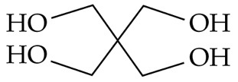
Which of the following statements about pentaerythritol is/are correct?
(1) The empirical formula of pentaerythritol is CH₃O.
(2) It can turn acidified potassium dichromate solution from orange to green.
(3) It can be dehydrated to give a product with four C=C double bonds.
A. (1) only
B. (2) only
C. (1) and (3) only
D. (2) and (3) only

Answer: B
(1): The empirical formula of pentaerythritol is C₅H₁₂O₄.

ChemMCQ44065
Carbon compound X can be prepared using the set-up shown in the diagram below.
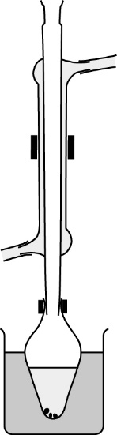
water in
water out
anti-bumping granule
reflux condenser
butan-2-ol + dilute sulphuric acid + potassium dichromate solution
heat
water bath
What is X?
A. Butanoic acid
B. Butanone
C. Butanal
D. But-2-ene

Answer: B
The oxidation of butan-2-ol (a secondary alcohol) produces butanone.

ChemMCQ44066
The set-up shown in the diagram below is used to study the reaction between propan-1-ol and acidified potassium dichromate solution.
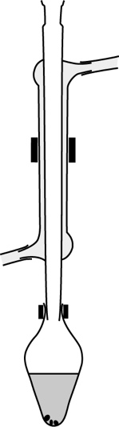
water out
water in
anti-bumping granule
reflux condenser
propan-1-ol + acidified potassium dichromate solution
heat
What modifications should be made in the set-up?
(1) Heating the reaction mixture in a water bath
(2) Reversing the direction of water flow in the reflux condenser
(3) Putting a stopper on the top of the reflux condenser
A. (1) and (2) only
B. (1) and (3) only
C. (2) and (3) only
D. (1), (2) and (3)

Answer: A
The reaction mixture should not be heated in a closed system.

ChemMCQ44067
Propan-1-ol is heated under reflux with acidified potassium permanganate solution. Which of the following statements is/are correct?
(1) The reactants undergo esterification.
(2) Propanoic acid forms.
(3) Permanganate ions are reduced.
A. (1) only
B. (2) only
C. (1) and (3) only
D. (2) and (3) only

Answer: D
Propan-1-ol undergoes oxidation to give propanoic acid.

ChemMCQ44068
Which of the following is the reason for using nitrogen in preserving wine?
A. Nitrogen converts ethanol in wine to a stable compound.
B. Nitrogen molecules have an octet structure.
C. Nitrogen reacts with oxygen so as to prevent the oxidation of ethanol.
D. Nitrogen drives out the oxygen in wine to prevent the oxidation of ethanol.

Answer: D

ChemMCQ44069
Which of the following reagents, when reacted with but-2-en-1-ol, would give a product that could decolourize bromine (dissolved in CCl₄)?
(1) Acidified potassium dichromate solution
(2) Acidified potassium permanganate solution
(3) Hydrogen chloride
A. (1) only
B. (2) only
C. (1) and (3) only
D. (2) and (3) only

Answer: A
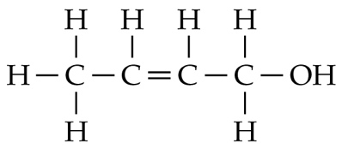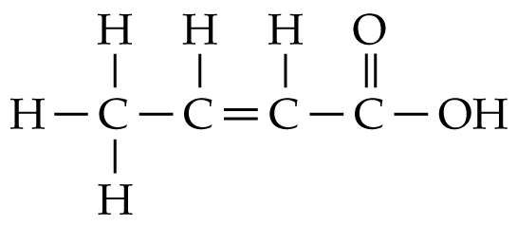
Cr₂O₇²⁻(aq)/H⁺(aq)
heat
The C=C double bond is retained in the product and so it can decolourize bromine (dissolved in CCl₄).

Section 44.6
ChemMCQ44070
Which of the following statements about propanone are correct?
(1) It has a lower boiling point than propanoic acid.
(2) It can be reduced to propan-2-ol.
(3) It can be oxidized to propanoic acid.
A. (1) and (2) only
B. (1) and (3) only
C. (2) and (3) only
D. (1), (2) and (3)

Answer: A

ChemMCQ44071
Which of the following compounds can change acidified potassium dichromate solution from orange to green?
(1) Butanal
(2) Pentan-2-one
(3) Hexan-1-ol
A. (1) and (2) only
B. (1) and (3) only
C. (2) and (3) only
D. (1), (2) and (3)

Answer: B
Pentan-2-one is a ketone which cannot be oxidized by acidified K₂Cr₂O₇(aq).

ChemMCQ44072
The structure of a carbon compound is shown below.
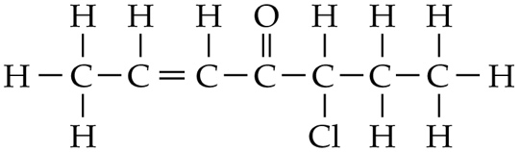
Which of the following statements about the compound is INCORRECT?
A. Its systematic name is 5-chlorohept-2-en-4-one.
B. It can be oxidized by acidified potassium dichromate solution.
C. It reacts with hydrogen chloride to give two major products.
D. It exhibits enantiomerism.

Answer: B
(A):
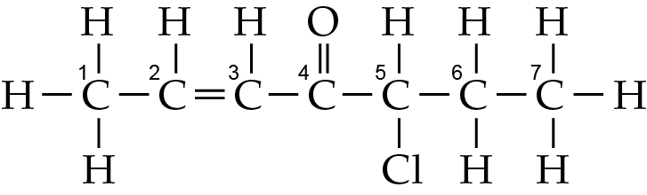
(B): Acidified K₂Cr₂O₇(aq) has no reaction with the C=C bond or the ketone group.
(C): The two carbon atoms in the C=C double bond are joined to the same number of H atoms. Hence, the reaction of the compound with HCl forms two major products.
(D): The C-5 atom is a chiral carbon.

ChemMCQ44073
No observable change can be made when acidified potassium dichromate solution is heated with
A. propan-2-ol.
B. propanone.
C. iron(II) sulphate.
D. potassium iodine.

Answer: B
Ketones cannot be oxidized by acidified K₂Cr₂O₇(aq).

ChemMCQ44074
The structure of an organic compound is shown below.
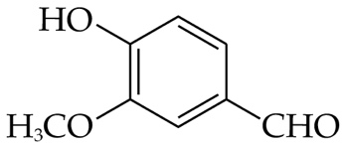
Which of the following statements about the compound is correct?
A. It exhibits enantiomerism.
B. Its molecular formula is C₈H₈O₃.
C. It cannot be oxidized by acidified K₂Cr₂O₇(aq).
D. It contains a ketone group.

Answer: B
The compound does not have a chiral carbon. The aldehyde group can be oxidized to a carboxyl group.

ChemMCQ44075
Which of the following compounds can be oxidized by acidified potassium dichromate solution?
A. HCOOH
B. CH₃CH₂OH
C. CH₃COCH₂CH₃
D. (CH₃)₃COH

Answer: B
CH₃COCH₂CH₃ is a ketone and (CH₃)₃COH is a tertiary alcohol. Both of them cannot be oxidized by acidified K₂Cr₂O₇(aq).

ChemMCQ44076
Compound X has five carbon atoms. It turns acidified potassium dichromate solution from orange to green. Which of the following compounds may X be?
A. 2-methylbutan-2-ol
B. 3-methylbutenone
C. Pent-4-en-2-ol
D. Hexanal

Answer: C
(A) and (B): 2-methylbutan-2-ol is a tertiary alcohol and 3-methylbutenone is a ketone. Both of them cannot be oxidized by acidified K₂Cr₂O₇(aq).
(D): A hexanal molecule has six carbon atoms.

ChemMCQ44077
Which of the following statements about lithium aluminium hydride are correct?
(1) The oxidation number of hydrogen is −1.
(2) Dry ether can be used as a solvent to dissolve it.
(3) It can reduce a ketone to a primary alcohol.
A. (1) and (2) only
B. (1) and (3) only
C. (2) and (3) only
D. (1), (2) and (3)

Answer: A
(3): LiAlH₄ can reduce a ketone to a secondary alcohol.

ChemMCQ44078
Consider the following reaction.
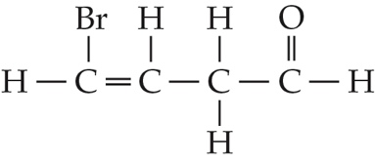
1. LiAlH₄, dry ether
2. H⁺(aq)
Which of the following compounds is the product of the reaction?
A. | 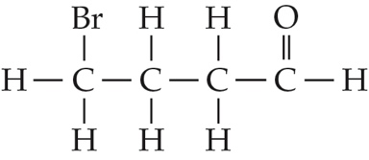 | B. | 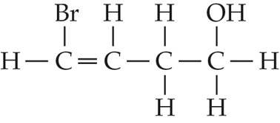
C. | 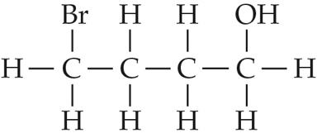 | D. | 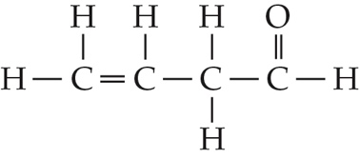

Answer: B
LiAlH₄ in dry ether has no reaction with C=C double bonds. It reduces an aldehyde to a primary alcohol.

ChemMCQ44079
Consider the following reaction.
CH₃CH₂CHO → CH₃CH₂CH₂OH
Which of the following reagents can be used in the above reaction?
(1) NaOH
(2) LiAlH₄
(3) NaBH₄
A. (1) and (2) only
B. (1) and (3) only
C. (2) and (3) only
D. (1), (2) and (3)

Answer: C

ChemMCQ44080
Which of the following compounds is the product of the reaction between butanedione and excess LiAlH₄ in dry ether followed by a dilute acid?
A. | 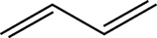 | B. | 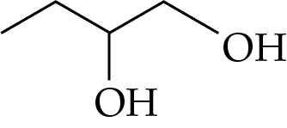
C. | 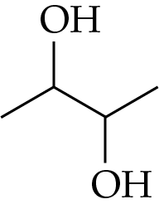 | D. | 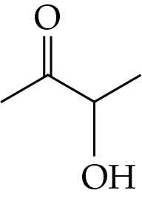

Answer: C
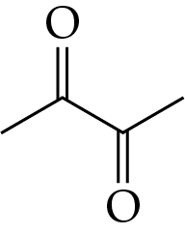
1. LiAlH₄, dry ether
2. H⁺(aq)

ChemMCQ44081
Consider the following compound.
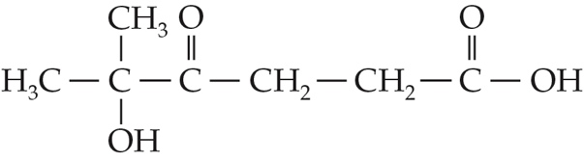
Which of the following statements about the compound are correct?
(1) It has no reaction with acidified potassium dichromate solution.
(2) It reacts with lithium aluminium hydride in dry ether, followed by dilute hydrochloric acid to give the following compound:
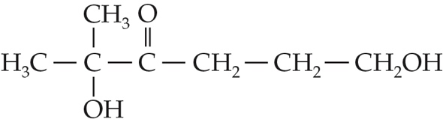
(3) It is optically inactive.
A. (1) and (2) only
B. (1) and (3) only
C. (2) and (3) only
D. (1), (2) and (3)

Answer: B
(2): The product of the reaction is:
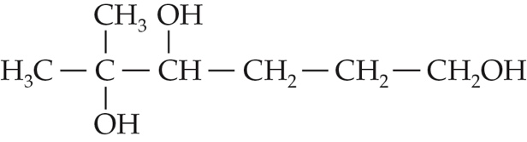

ChemMCQ44082
Which of the following compounds is the product of the reaction between 2-bromopent-3-one and sodium borohydride in water?
A. Pentane-2,3-diol
B. 2-bromopentan-3-ol
C. 2-hydroxypentan-3-one
D. 2-bromopentane-3,3-diol

Answer: B
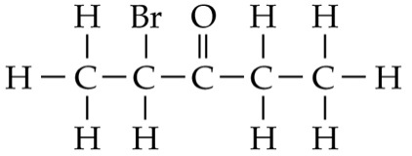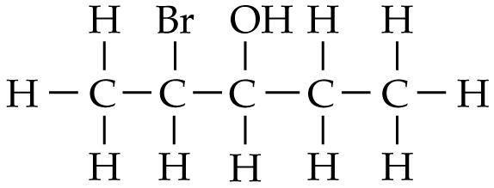
NaBH₄(aq)

ChemMCQ44083
Which of the following processes involve a redox reaction?
(1) Heating ethanol with acidified potassium dichromate solution
(2) Mixing propanone with lithium aluminium hydride in dry ether, and then treating with dilute hydrochloric acid
(3) Heating ethene with hydrogen
A. (1) and (2) only
B. (1) and (3) only
C. (2) and (3) only
D. (1), (2) and (3)

Answer: D
(1): Ethanol is oxidized to ethanoic acid.
(2): Propanone is reduced to propan-2-ol.
(3): Ethene is reduced to ethane.

ChemMCQ44084
If excess acidified potassium dichromate solution is added to 0.3 mol of each of the following compounds, which of them can reduce the greatest number of moles of acidified potassium dichromate solution?
A. CH₃CH₂CHO
B. CH₃CH₂OH
C. C₆H₅COOH
D. CH₃CH=CHCH₂CH=CHCH₂CH=CH₂

Answer: B
Only (A) and (B) can be oxidized to a carboxylic acid by acidified K₂Cr₂O₇(aq).
(A): 3CH₃CH₂CHO + Cr₂O₇²⁻ + 8H⁺ → 3CH₃CH₂COOH + 2Cr³⁺ + 4H₂O
Mole ratio of CH₃CH₂CHO to Cr₂O₇²⁻ = 3 : 1
(B): 3CH₃CH₂OH + 2Cr₂O₇²⁻ + 16H⁺ → 3CH₃COOH + 4Cr³⁺ + 11H₂O
Mole ratio of CH₃CH₂OH to Cr₂O₇²⁻ = 3 : 2
∴CH₃CH₂OH can reduce the greatest number of moles of acidified K₂Cr₂O₇(aq).

ChemMCQ44085
The following equation represents the reaction between vanillin and sodium borohydride in water.
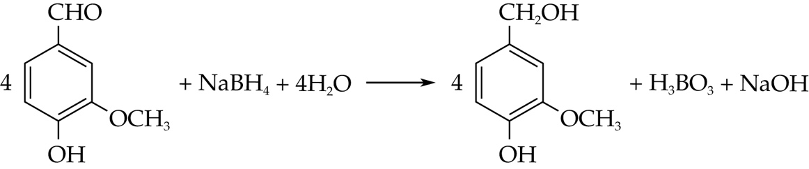
Which of the following substances is oxidized in the reaction?
A. Vanillin
B. Sodium ion
C. Borohydride ion
D. Water

Answer: C
NaBH₄ is a reducing agent. It is oxidized to boric acid (H₃BO₃) in the reaction.

ChemMCQ44086
Cortisone is one of the main hormones in our body. Its structure is shown below.
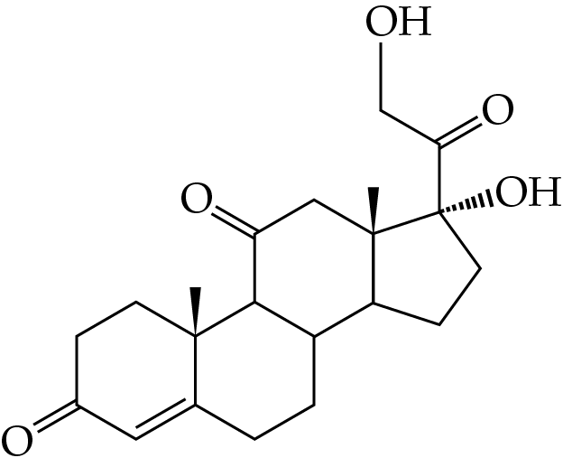
Which of the following statements about cortisone are correct?
(1) One of the hydroxyl groups acts as a tertiary alcohol.
(2) It can change acidified potassium dichromate solution from orange to green.
(3) It has three ketone groups.
A. (1) and (2) only
B. (1) and (3) only
C. (2) and (3) only
D. (1), (2) and (3)

Answer: D
It has a hydroxyl group acting as a primary alcohol and one acting as a tertiary alcohol. The primary alcohol reduces orange Cr₂O₇²⁻(aq) ions to green Cr³⁺(aq) ions.

ChemMCQ44087
Butanone can be reduced by lithium aluminium hydride to give a mixture of two products. Which of the following statements about the two products are correct?
(1) They are both alcohols.
(2) They have the same chemical properties.
(3) They are stereoisomers.
A. (1) and (2) only
B. (1) and (3) only
C. (2) and (3) only
D. (1), (2) and (3)

Answer: D
Butanone can be reduced by LiAlH₄ to give butan-2-ol, which exhibits enantiomerism. The enantiomers of butan-2-ol have the same chemical properties.

ChemMCQ44088
Which of the following alcohols CANNOT be produced directly from its corresponding carbonyl compounds?
A. | 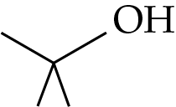 | B. | 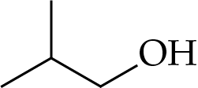
C. | 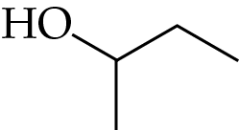 | D. | 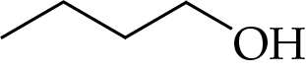

Answer: A
Tertiary alcohols cannot be produced directly from the reduction of carbonyl compounds.

ChemMCQ44089
Consider the following two compounds.
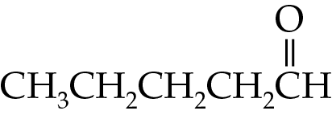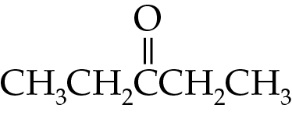
Which of the following statements concerning the two compounds is/are correct?
(1) They are structural isomers.
(2) They both form an ester with ethanol.
(3) They both decolourize bromine (dissolved in an organic solvent).
A. (1) only
B. (2) only
C. (1) and (3) only
D. (2) and (3) only

Answer: A
Both compounds neither react with ethanol nor bromine (dissolved in an organic solvent).

ChemMCQ44090
The structure of glucose is shown below.
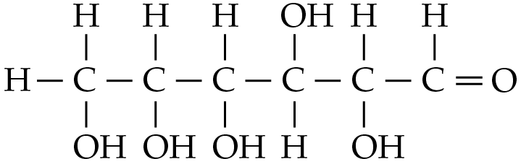
Which of the following statements concerning glucose are correct?
(1) It has four chiral carbon atoms.
(2) Its molecule can form hydrogen bonds with water molecules.
(3) It can be oxidized by acidified potassium dichromate solution.
A. (1) and (2) only
B. (1) and (3) only
C. (2) and (3) only
D. (1), (2) and (3)

Answer: D
*
*
*
*

Section 44.7
ChemMCQ44091
Vinegar contains acetic acid while spinach contains oxalic acid, (COOH)₂. Which of the following statements about acetic acid and oxalic acid are correct?
(1) Gas bubbles evolve when sodium carbonate solution is added to vinegar and spinach juice separately.
(2) One mole of acetic acid and one mole of oxalic acid require the same number of moles of sodium hydroxide for complete neutralization.
(3) Both of them are achiral compounds.
A. (1) and (2) only
B. (1) and (3) only
C. (2) and (3) only
D. (1), (2) and (3)

Answer: B
(1): Both of them are carboxylic acids that can react with Na₂CO₃(aq) to form CO₂(g).
(2): Acetic acid (ethanoic acid) is a monobasic acid while oxalic acid (ethanedioic acid) is a dibasic acid. One mole of oxalic acid requires a greater number of moles of NaOH for complete neutralization.
(3): Both of them do not have any chiral carbons.

ChemMCQ44092
Which of the following statements about primary alcohols is/are correct?
(1) They can be dehydrated to alkenes by heating with concentrated sulphuric acid.
(2) They can be produced by reacting ketones with LiAlH₄ in dry ether followed by a dilute acid.
(3) They can be produced by mixing carboxylic acids with NaBH₄ in water.
A. (1) only
B. (2) only
C. (1) and (3) only
D. (2) and (3) only

Answer: A
(2): Ketones are reduced to secondary alcohols.
(3): Carboxylic acids cannot be reduced using NaBH₄.

ChemMCQ44093
Which of the following statements about ethanoic acid is INCORRECT?
A. It has a formula CH₃COOH.
B. It is soluble in water.
C. It has a smell of vinegar.
D. It can be oxidized to ethanol.

Answer: D
Ethanoic acid can be reduced to ethanol.

ChemMCQ44094
Which of the following statements about lithium aluminium hydride and sodium borohydride is/are correct?
(1) Both of them do not react with water.
(2) Both of them reduce ketones to secondary alcohols.
(3) Both of them reduce carboxylic acids to primary alcohols.
A. (1) only
B. (2) only
C. (1) and (3) only
D. (2) and (3) only

Answer: B
(1): LiAlH₄ reacts violently with water.
(3): NaBH₄ cannot reduce carboxylic acids.

ChemMCQ44095
Which of the following reactions can produce a primary alcohol?
(1) CH₃CH₂CH₂Cl + OH⁻
(2) CH₃CH₂CH₂COOH + LiAlH₄ in dry ether, then H⁺(aq)
(3) CH₃COCH₃ + LiAlH₄ in dry ether, then H⁺(aq)
A. (1) and (2) only
B. (1) and (3) only
C. (2) and (3) only
D. (1), (2) and (3)

Answer: A
(3): The reaction produces propan-2-ol (a secondary alcohol).

ChemMCQ44096
Consider the following reaction.
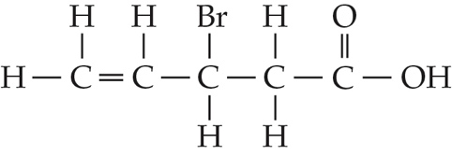
excess NaOH(aq)
heat
Which of the following compounds is the major product of the reaction?
A. | 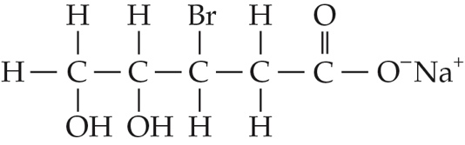 | B. | 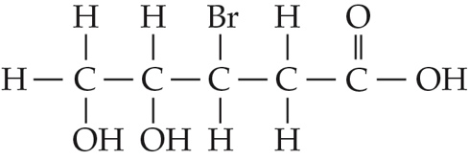
C. | 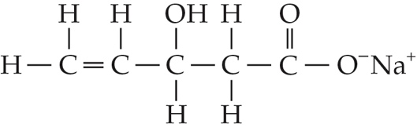 | D. | 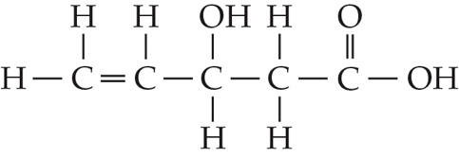

Answer: C
There are two types of reactions. One is a substitution reaction of the Br atom by a OH⁻ ion and the other is a neutralization reaction between the −COOH group and NaOH.

ChemMCQ44097
Which of the following statements about esterification is INCORRECT?
A. It is a reversible reaction.
B. Concentrated sulphuric acid is used as a catalyst.
C. The reaction mixture should be heated under reflux.
D. A carboxylic acid and an alcohol are produced in the process.

Answer: D
An ester and water are produced in the process.

ChemMCQ44098
Which of the following are the functions of concentrated sulphuric acid in the esterification of a carboxylic acid and an alcohol?
(1) It acts as a catalyst.
(2) It removes water produced from the reaction.
(3) It precipitates the ester produced.
A. (1) and (2) only
B. (1) and (3) only
C. (2) and (3) only
D. (1), (2) and (3)

Answer: A

ChemMCQ44099
A test tube containing a mixture of propanoic acid, propan-2-ol and a few drops of concentrated sulphuric acid is heated in a water bath. The mixture is then poured into a beaker of cold water. Which of the following statements about the experiment is INCORRECT?
A. The reaction involved is esterification.
B. The systematic name of the organic product is propyl propanoate.
C. A pleasant fruity smell is detected.
D. Two layers of liquids are observed in the beaker.

Answer: B
The systematic name of the ester produced is methylethyl propanoate.

ChemMCQ44100
A mixture of ethanoic acid, ethanol and a few drops of concentrated sulphuric acid is heated under reflux for an hour. Which of the following observations CANNOT be made when sodium carbonate solution is added to the resultant mixture?
A. A pleasant fruity smell is detected.
B. Effervescence occurs.
C. Two layers of liquids can be seen.
D. A white precipitate forms.

Answer: D
An ester forms in the process. As the ester is immiscible with Na₂CO₃(aq), two layers of liquids can be seen. There are ethanoic acid and sulphuric acid in the resultant mixture. Thus, the resultant mixture reacts with Na₂CO₃(aq) to give CO₂(g).

ChemMCQ44101
The following are some information about substance X.
(1) It has a molecular formula of C₄H₈O.
(2) It reacts with ethanoic acid in the presence of concentrated sulphuric acid to give a liquid with a pleasant fruity smell.
Which of the following may X be?
A. | 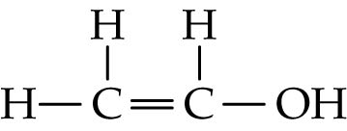 | B. | 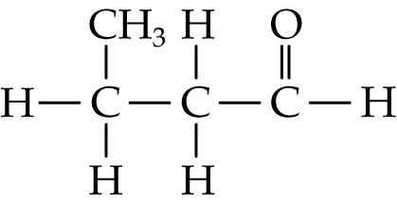
C. | 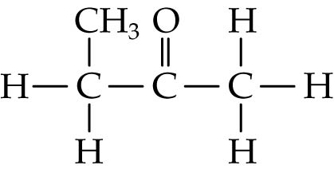 | D. | 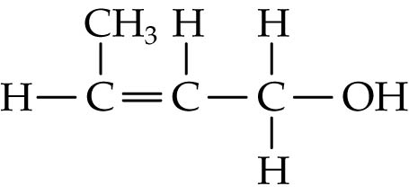

Answer: D
From (2), X contains an −OH group as it undergoes esterification with ethanoic acid.

ChemMCQ44102
The diagram below shows the structural formulae of three compounds.
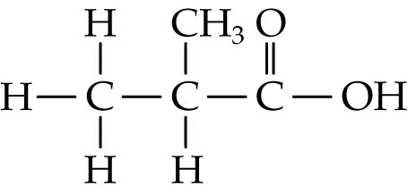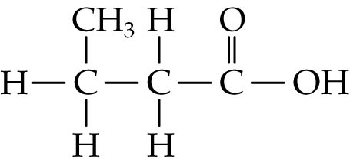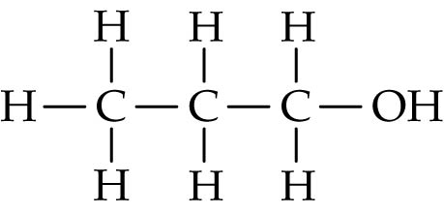
Which of the following statements about the three compounds is correct?
A. They are in the same homologous series.
B. They are soluble in water.
C. They can decolourize bromine (dissolved in an organic solvent).
D. They can undergo addition polymerization.

Answer: B

ChemMCQ44103
Which of the following statements about methanoic acid are correct?
(1) It reacts with ethanol to form ethyl methanoate and water.
(2) Its aqueous solution reacts with magnesium to give hydrogen.
(3) It undergoes complete combustion to give carbon dioxide and water.
A. (1) and (2) only
B. (1) and (3) only
C. (2) and (3) only
D. (1), (2) and (3)

Answer: D

ChemMCQ44104
Consider the following compound.
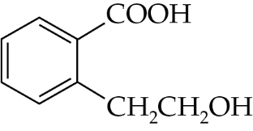
Which of the following statements about the compound are correct?
(1) It can be oxidized by acidified potassium dichromate solution.
(2) It can be reduced by sodium borohydride solution.
(3) It forms a cyclic ester when heated with concentrated sulphuric acid.
A. (1) and (2) only
B. (1) and (3) only
C. (2) and (3) only
D. (1), (2) and (3)

Answer: B
Carboxylic acids cannot be reduced by NaBH₄(aq).

ChemMCQ44105
α-linolenic acid can be found in many vegetable oils. The structure of α-linolenic acid is shown below.
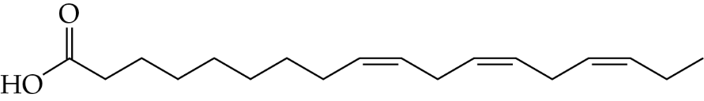
Which of the following reagents can react with α-linolenic acid?
(1) NaBH₄(aq)
(2) NaOH(aq)
(3) Acidified KMnO₄(aq)
A. (1) and (2) only
B. (1) and (3) only
C. (2) and (3) only
D. (1), (2) and (3)

Answer: C
(1): The carboxyl group in α-linolenic acid cannot be reduced by NaBH₄(aq).
(2): α-linolenic acid undergoes neutralization with NaOH(aq).
(3): α-linolenic acid undergoes addition with acidified KMnO₄(aq).

ChemMCQ44106
The three-dimensional structures of two compounds, X and Y, are shown below.
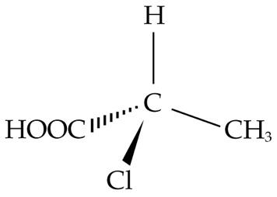 | 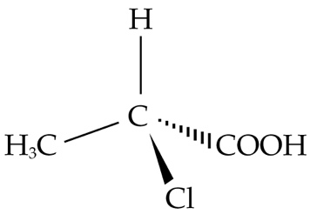
X | Y
Which of the following statements about X and Y is correct?
A. They turn acidified potassium dichromate solution from orange to green.
B. They are identical.
C. A mixture of X and Y can be separated by fractional distillation.
D. They are optically active.

Answer: D
X and Y is a pair of enantiomers. They have the same boiling point and so they cannot be separated by fractional distillation.

ChemMCQ44107
The molecular formula of compound D is C₅H₁₀O₂. When an aqueous solution of D is added to magnesium carbonate, effervescence occurs. D can rotate the plane of polarization of a beam of plane polarized light. Which of the following would D be?
(1) CH₃CH₂CH(CH₃)COOH
(2) CH₂(OH)CH₂CH₂CH(OH)CH₃
(3) C(CH₃)₃COOH
A. (1) only
B. (2) only
C. (1) and (3) only
D. (2) and (3) only

Answer: A
(A): CH₃CH₂CH(CH₃)COOH has a chiral carbon. The −COOH group reacts with MgCO₃ to give CO₂(g).

ChemMCQ44108
Which of the following chemicals are required for converting carboxylic acids to amides?
(1) PCl₃
(2) HNO₃
(3) NH₃
A. (1) and (2) only
B. (1) and (3) only
C. (2) and (3) only
D. (1), (2) and (3)

Answer: B

ChemMCQ44109
When compound X reacts with phosphorus trichloride and then with ammonia, compound Y is produced. The structure of Y is shown below.
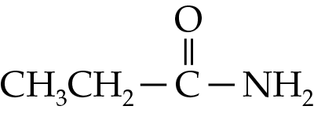
Which of the following statements is/are correct?
(1) Y is an acid derivative.
(2) X reacts with sodium hydrogencarbonate solution to give colourless gas bubbles.
(3) The systematic name of Y is propan-1-amine.
A. (1) and (2) only
B. (1) and (3) only
C. (2) and (3) only
D. (1), (2) and (3)

Answer: A
(2): X is propanoic acid.
(3): The systematic name of Y is propanamide.

Section 44.8
ChemMCQ44110
Compound Z decolourizes bromine (dissolved in an organic solvent) in the absence of light. It has no reaction with sodium hydroxide solution. Which of the following compounds may Z be?
A. | 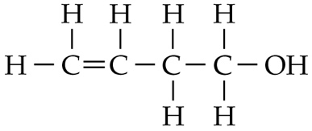 | B. | 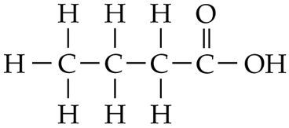
C. | 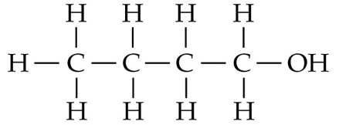 | D. | 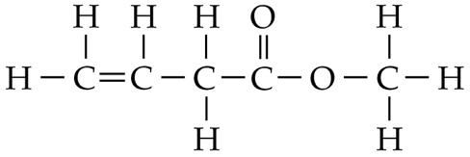

Answer: A
As Z decolourizes bromine (dissolved in an organic solvent) in the absence of light, it contains at least one carbon-carbon double bond. As Z has no reaction with NaOH(aq), it is not a carboxylic acid or an ester.

ChemMCQ44111
Which of the following statements about methyl ethanoate are correct?
(1) It is a colourless liquid with a pleasant fruity smell.
(2) It can be hydrolysed to ethanoic acid and methanol by heating under reflux with dilute hydrochloric acid.
(3) It can be produced by heating a mixture of ethanoic acid, methanol and concentrated sulphuric acid.
A. (1) and (2) only
B. (1) and (3) only
C. (2) and (3) only
D. (1), (2) and (3)

Answer: D

ChemMCQ44112
Which of the following statements about butan-1-ol are correct?
(1) It can be converted to but-1-ene by heating with concentrated sulphuric acid.
(2) It can be oxidized to butanoic acid by heating under reflux with acidified potassium dichromate solution.
(3) It is one of the products of the acid hydrolysis of butyl methanoate.
A. (1) and (2) only
B. (1) and (3) only
C. (2) and (3) only
D. (1), (2) and (3)

Answer: D
(3): The products for the acid hydrolysis of butyl methanoate are methanoic acid and butan-1-ol.

ChemMCQ44113
Which of the following statements about the acid hydrolysis of ethyl butanoate are correct?
(1) The products of the reaction are butanoic acid and ethanol.
(2) The reaction does not go to completion.
(3) Dilute hydrochloric acid can be used as a catalyst.
A. (1) and (2) only
B. (1) and (3) only
C. (2) and (3) only
D. (1), (2) and (3)

Answer: D
(2): The acid hydrolysis of an ester is a reversible reaction.

ChemMCQ44114
Which of the following reagents can be used to distinguish between CH₃COOCH₃ and CH₂(OH)CH₂CHO?
A. Bromine (dissolved in trichloromethane)
B. Sodium carbonate solution
C. Phenolphthalein
D. Acidified potassium dichromate solution

Answer: D
CH₂(OH)CH₂CHO reduces orange Cr₂O₇²⁻(aq) to green Cr³⁺(aq). CH₃COOCH₃ has no reaction with acidified K₂Cr₂O₇(aq).

ChemMCQ44115
Consider the following two compounds X and Y.
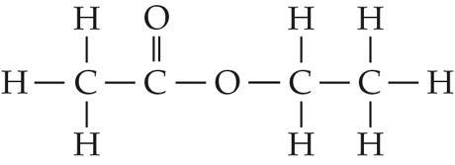 | 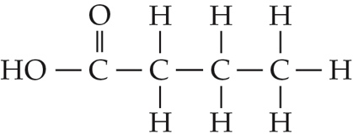
X | Y
Which of the following statements is INCORRECT?
A. The solubility of X in water is lower than that of Y.
B. Hydrogen bonds exist between both molecules.
C. X and Y are functional group isomers.
D. Both X and Y react with dilute sodium hydroxide solution.

Answer: B
Hydrogen bonds do not exist between the molecules of X.

ChemMCQ44116
Butyl ethanoate is heated under reflux with dilute sodium hydroxide solution. Which of the following statements about the reaction is INCORRECT?
A. The reaction goes to completion.
B. Dilute sodium hydroxide solution is used as the catalyst.
C. Butan-1-ol is one of the products of the reaction.
D. The resultant mixture turns universal indicator red.

Answer: D
The products of the reaction are sodium ethanoate and butan-1-ol. The resultant mixture is still alkaline. It turns universal indicator blue.

ChemMCQ44117
Compound Y (C₅H₁₀O₂) has a pleasant fruity smell. When it is heated under reflux with dilute sodium hydroxide solution, a vapour (molar mass = 46.0 g mol⁻¹) can be isolated. Which of the following compounds would Y probably be?
A. CH₃COOCH₂CH₂CH₃
B. HCOOCH₂CH(CH₃)₂
C. CH₃CH₂COOCH₂CH₃
D. CH₃COOCH(CH₃)₂

Answer: C
The alkaline hydrolysis of an ester gives an alcohol and a carboxylate. The vapour should be the more volatile alcohol. The molar mass of C₂H₅OH is 46.0 g mol⁻¹. Hence, the ester is probably ethyl propanoate.

ChemMCQ44118
Benzocaine can be used as an anesthetic. The structure of benzocaine is shown below.
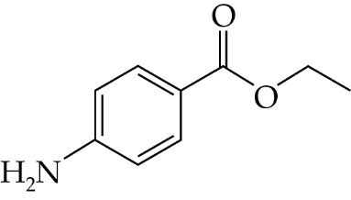
Which of the following statements concerning benzocaine is/are correct?
(1) It undergoes alkaline hydrolysis with dilute sodium hydroxide solution.
(2) It can be oxidized by acidified potassium dichromate solution.
(3) It does not rotate the plane of polarization of a beam of plane polarized light.
A. (1) only
B. (2) only
C. (1) and (3) only
D. (2) and (3) only

Answer: C
(1): The ester group can be hydrolysed by NaOH(aq).
(3): As benzocaine is achiral, it does not rotate the plane of polarization of a beam of plane polarized light.

ChemMCQ44119
Which of the following compounds do(es) NOT react with NaBH₄(aq)?
(1) C₆H₅CHO
(2) CH₃CO₂CH₃
(3) CH₃COCH₃
A. (1) only
B. (2) only
C. (1) and (3) only
D. (2) and (3) only

Answer: B
NaBH₄(aq) cannot reduce esters.

ChemMCQ44120
Consider the following compound.
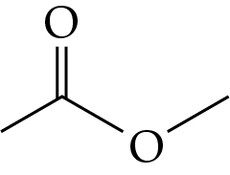
Which of the following are the products of the reaction between sodium hydroxide solution and the compound?
A. Ethanol and methanoic acid
B. Methanoic acid and water
C. Sodium methanoate and ethanol
D. Sodium ethanoate and methanol

Answer: D
CH₃COOCH₃ + NaOH → CH₃COO⁻Na⁺ + CH₃OH

ChemMCQ44121
Compound X is a structural isomer of aspirin (C₉H₈O₄). The complete hydrolysis of X produces the following two compounds only.
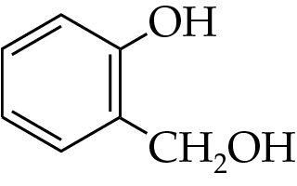 | 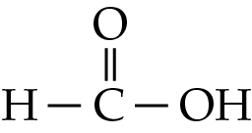
Which of the following is probably the structure of X?
A. | 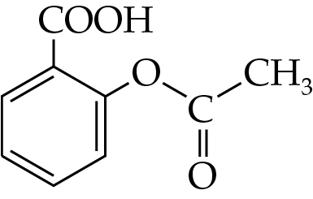 | B. | 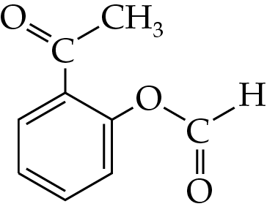
C. | 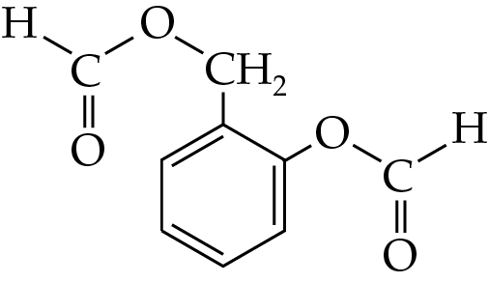 | D. | 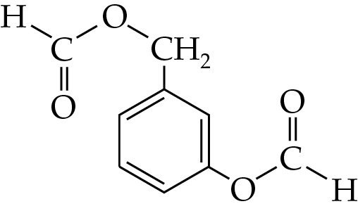

Answer: C

ChemMCQ44122
Compound Y gives the characteristic odour of a perfume. The structure of Y is shown below.
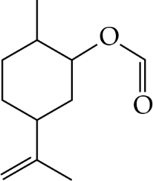
Which of the following reagents can react with Y to give one product only?
(1) Br₂ (dissolved in an organic solvent)
(2) HCl(g)
(3) H₂SO₄(aq)
A. (1) only
B. (2) only
C. (1) and (3) only
D. (2) and (3) only

Answer: A
(A):
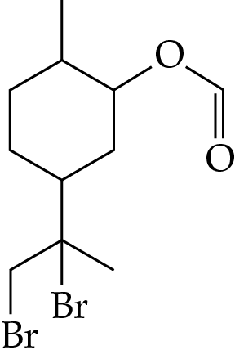
Br₂

(in organic solvent)
(B):
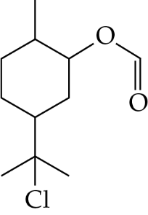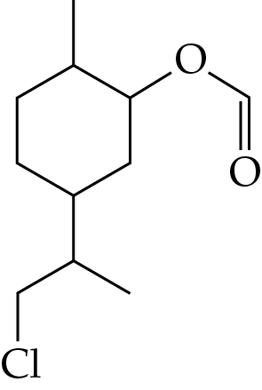
HCl(g)
+

(C):
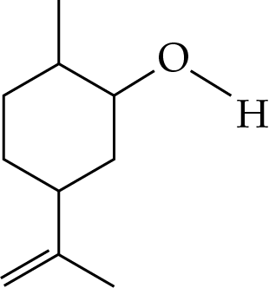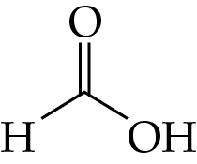
H₂SO₄(aq)
+

Section 44.9
ChemMCQ44123
Which of the following statements about an unsubstituted amide are correct?
(1) Hydrogen bonds exist between unsubstituted amide molecules.
(2) The alkaline hydrolysis of an unsubstituted amide gives ammonia.
(3) An unsubstituted amide forms when a carboxylic acid reacts with phosphorus trichloride and then with ammonia.
A. (1) and (2) only
B. (1) and (3) only
C. (2) and (3) only
D. (1), (2) and (3)

Answer: D

ChemMCQ44124
Which of the following compounds are the products of the alkaline hydrolysis of propanamide with sodium hydroxide solution?
A. Sodium propanoate and ammonium ion
B. Propanoic acid and ammonium ion
C. Propan-1-ol and ammonia
D. Sodium propanoate and ammonia

Answer: D

ChemMCQ44125
Which of the following reactions would give propanoic acid?
(1) Reaction between propan-2-ol and acidified potassium dichromate solution
(2) Reaction between methyl propanoate and dilute sulphuric acid
(3) Reaction between propanamide and dilute sodium hydroxide solution
A. (1) only
B. (2) only
C. (1) and (3) only
D. (2) and (3) only

Answer: B
(1): Propan-2-ol reacts with acidified K₂Cr₂O₇(aq) to give propanone.
(3): The alkaline hydrolysis of propanamide gives propanoate ion and ammonia.

ChemMCQ44126
Which of the following reactions would give butanoate ion as one of the products?
(1) Adding sodium hydroxide solution to butanoic acid
(2) Heating ethyl butanoate with dilute hydrochloric acid under reflux
(3) Heating butanamide with dilute sodium hydroxide solution under reflux
A. (1) and (2) only
B. (1) and (3) only
C. (2) and (3) only
D. (1), (2) and (3)

Answer: B
(2): Heating ethyl butanoate with dilute HCl(aq) under reflux will give butanoic acid and ethanol.

ChemMCQ44127
Consider the following reaction.
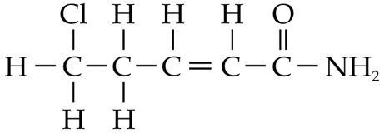
OH⁻(aq)
heat
Which of the following compounds are the products of the reaction?
A. | 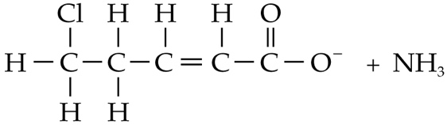
B. | 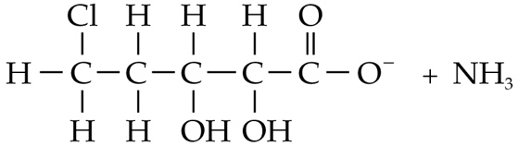
C. | 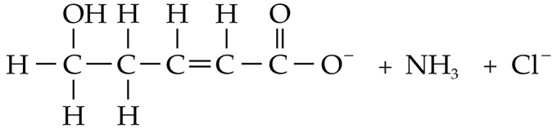
D. | 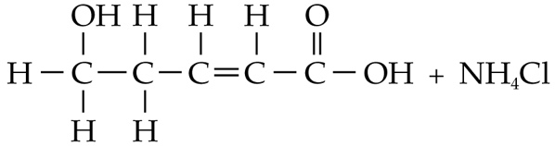

Answer: C
There are two types of reactions. One is a substitution reaction of the −Cl by OH⁻ ion and the other is an alkaline hydrolysis of the amide group to give a carboxylate ion and ammonia.

ChemMCQ44128
Which of the following compounds is/are the product(s) formed by heating a mixture of propanamide and dilute hydrochloric acid under reflux?
(1) Ammonia
(2) Ammonium ion
(3) Propanoic acid
A. (1) only
B. (2) only
C. (1) and (3) only
D. (2) and (3) only

Answer: D

ChemMCQ44129
Consider the following compound.
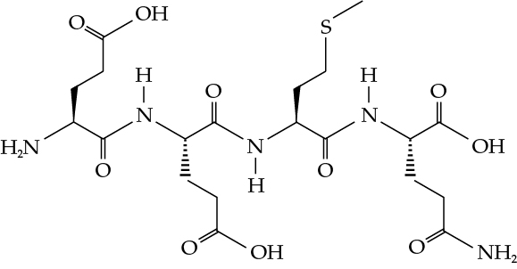
How many moles of NaOH will react with 1 mol of the compound when it is heated with excess sodium hydroxide solution under reflux?
A. 5
B. 6
C. 7
D. 8

Answer: C
There are three −COOH groups that can be neutralized and four −CONH− groups that can be hydrolysed by NaOH(aq).

ChemMCQ44130
When compound X is heated with dilute sulphuric acid under reflux, an acid is produced but no alcohol forms. Which of the following compounds may X be?
(1) CH₃CONH₂
(2) HCONH₂
(3) HCOOCH₂CH₃
A. (1) and (2) only
B. (1) and (3) only
C. (2) and (3) only
D. (1), (2) and (3)

Answer: A
(1) and (2): An unsubstituted amide undergoes acid hydrolysis with H₂SO₄(aq) to give a carboxylic acid and ammonium ion.
(3): An ester undergoes acid hydrolysis with H₂SO₄(aq) to give a carboxylic acid and an alcohol.

ChemMCQ44131
Consider the following compound.
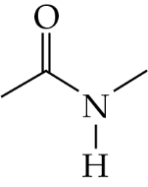
Which of the following statements concerning the reaction between sodium hydroxide solution and the compound is/are correct?
(1) The reaction is reversible.
(2) Methanamine is one of the products of the reaction.
(3) Ethanoic acid is one of the products of the reaction.
A. (1) only
B. (2) only
C. (1) and (3) only
D. (2) and (3) only

Answer: B
The alkaline hydrolysis of the compound gives sodium ethanoate and methanamine.

ChemMCQ44132
Which of the following conversions are regarded as hydrolysis?
(1) CH₃CH₂CONH₂ → CH₃CH₂COONa + NH₃
(2) CH₃CH₂COOH → CH₃CH₂CONH₂
(3) CH₃CH₂COOCH₃ → CH₃CH₂COONa + CH₃OH
A. (1) and (2) only
B. (1) and (3) only
C. (2) and (3) only
D. (1), (2) and (3)

Answer: B
(1) and (3) are regarded as alkaline hydrolysis. (2) is an amide formation.

