Chapter 42 Introduction to selected homologous series

Section 42.1
ChemMCQ42001
Consider the following compound.
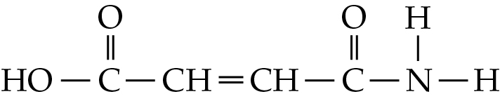
Which of the following functional groups is/are present in the compound?
(1) Carboxyl
(2) Carbonyl
(3) Amide
A. (1) only
B. (2) only
C. (1) and (3) only
D. (2) and (3) only

Answer: C

ChemMCQ42002
Ursolic acid is a compound that can be found in apple peels. The structure of ursolic acid is shown below.
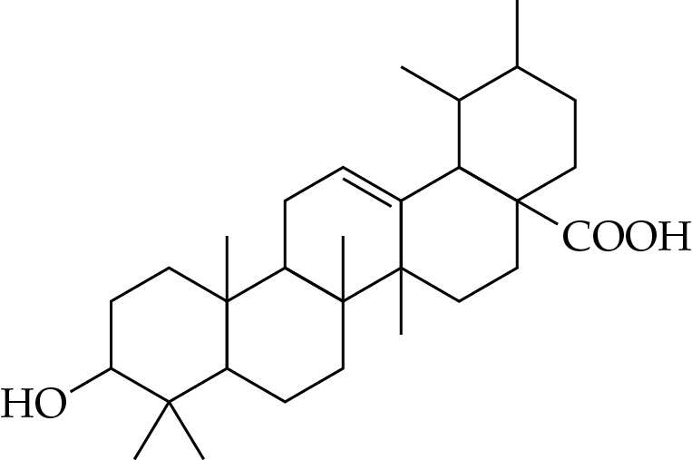
Which of the following functional groups are present in ursolic acid?
(1) Carbon-carbon double bond
(2) Carboxyl
(3) Hydroxyl
A. (1) and (2) only
B. (1) and (3) only
C. (2) and (3) only
D. (1), (2) and (3)

Answer: D

ChemMCQ42003
Pyrethrum flowers contain a natural insecticide called pyrethrin I. The structure of pyrethrin I is shown below.
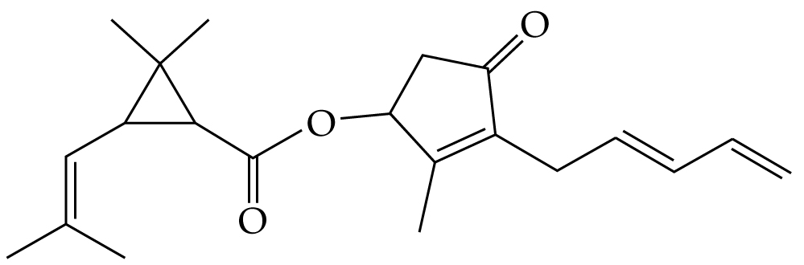
Which of the following functional groups are present in pyrethrin I?
(1) Carbon-carbon double bond
(2) Ester
(3) Carbonyl
A. (1) and (2) only
B. (1) and (3) only
C. (2) and (3) only
D. (1), (2) and (3)

Answer: D

ChemMCQ42004
Neotame is an artificial sweetener. The structure of neotame is shown below.
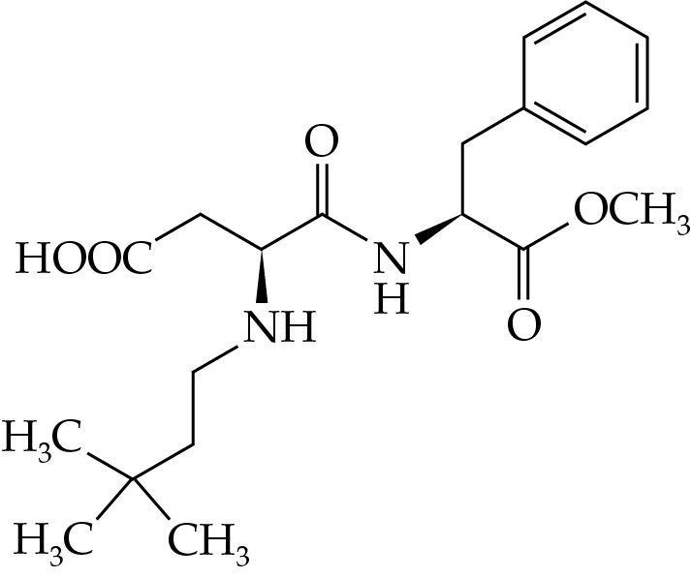
Which of the following functional groups is/are present in neotame?
(1) Ester
(2) Carbonyl
(3) Amide
A. (1) only
B. (2) only
C. (1) and (3) only
D. (2) and (3) only

Answer: C

ChemMCQ42005
Zanamivir is a drug used to treat influenza. The structure of zanamivir is shown below.
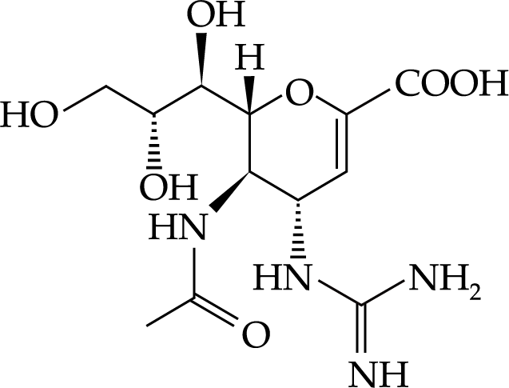
Which of the following functional groups are present in zanamivir?
(1) Hydroxyl
(2) Carbonyl
(3) Carboxyl
A. (1) and (2) only
B. (1) and (3) only
C. (2) and (3) only
D. (1), (2) and (3)

Answer: B

ChemMCQ42006
The structure of cholesterol is shown below.
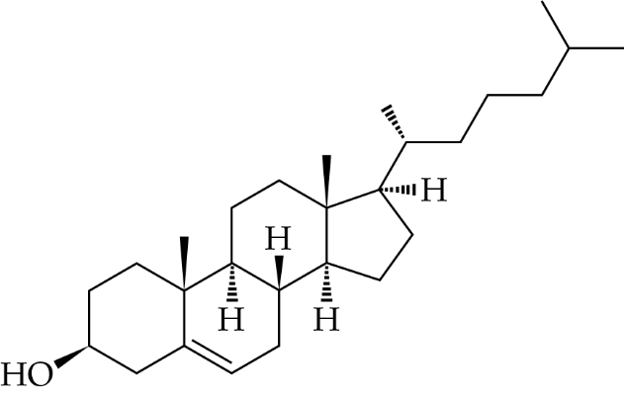
Which of the following statements concerning cholesterol are correct?
(1) It has 27 carbon atoms.
(2) It has one hydroxyl group.
(3) It has one carbon-carbon double bond.
A. (1) and (2) only
B. (1) and (3) only
C. (2) and (3) only
D. (1), (2) and (3)

Answer: D

Sections 42.2−42.4
ChemMCQ42007
Which of the following statements about pentane and dimethylpropane are correct?
(1) They have the same molecular formula.
(2) Pentane is a straight-chain alkane while dimethylpropane is a branched-chain alkane.
(3) The van der Waals’ forces between pentane molecules are weaker than those between dimethylpropane molecules.
A. (1) and (2) only
B. (1) and (3) only
C. (2) and (3) only
D. (1), (2) and (3)

Answer: A
Compared with pentane molecules, dimethylpropane molecules have a smaller area of contact between each other. Thus, the van der Waals’ forces between dimethylpropane molecules are weaker than those between pentane molecules.

ChemMCQ42008
Which of the following statements about pentane and methylbutane is/are correct?
(1) Pentane has a higher boiling point than methylbutane.
(2) Pentane has a larger relative molecular mass than methylbutane.
(3) Pentane has a higher water solubility than methylbutane.
A. (1) only
B. (2) only
C. (1) and (3) only
D. (2) and (3) only

Answer: A
(1): Compared with methylbutane molecules, pentane molecules have a larger area of contact between each other. Hence, the van der Waals’ forces between pentane molecules are stronger.
(2): Pentane and methylbutane have the same molecular formula. Hence, they have the same relative molecular mass.
(3): Both pentane and methylbutane are insoluble in water.

ChemMCQ42009
Which of the following are the common properties of alkanes and alkenes?
(1) Both are insoluble in water.
(2) Both are less dense than water.
(3) Both are gases under room conditions.
A. (1) and (2) only
B. (1) and (3) only
C. (2) and (3) only
D. (1), (2) and (3)

Answer: A
Many alkanes and alkenes are liquids under room conditions.

ChemMCQ42010
Which of the following statements about pent-1-ene and hex-2-ene are correct?
(1) They can decolourize bromine (dissolved in an organic solvent) in the dark.
(2) They are insoluble in water.
(3) They have the same empirical formula.
A. (1) and (2) only
B. (1) and (3) only
C. (2) and (3) only
D. (1), (2) and (3)

Answer: D
Pent-1-ene (C₅H₁₀) and hex-2-ene (C₆H₁₂) have the same empirical formula (CH₂).

ChemMCQ42011
What is the systematic name of the compound CHBr₂CHFCHClCH₃?
A. 4,4-dibromo-2-chloro-3-fluorobutane
B. 1,1-dibromo-2-fluoro-3-chlorobutane
C. 1,1-dibromo-2-fluoro-3-chloro-3-methylpropane
D. 1,1-dibromo-3-chloro-2-fluorobutane

Answer: D

ChemMCQ42012
What is the systematic name of the compound CH₃CBr=CHC(CH₃)=CHCl?
A. 2-bromo-5-chloro-4-methylpenta-1,3-diene
B. 4-bromo-1-chloro-2-methylpenta-1,3-diene
C. 2-bromo-5-chloro-4-methylpenta-2,4-diene
D. 4-bromo-1-chloro-2-methylpenta-2,4-diene

Answer: B
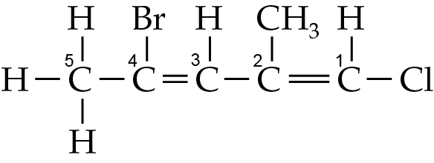

ChemMCQ42013
Which of the following is the condensed structural formula of 4-bromopent-2-ene?
A. CH₃CH=CHCHBrCH₃
B. CH₃CHCHCHBrCH₃
C. CH₃CBrCHCH₂CH₃
D. CH₃CBr=CHCH₂CH₃

Answer: A

Section 42.5
ChemMCQ42014
What is the systematic name of the following compound?
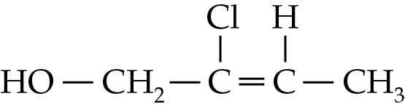
A. 2-chloro-1-hydroxybut-2-ene
B. 3-chloro-4-hydroxybut-2-ene
C. 2-chlorobut-2-en-1-ol
D. 3-chlorobut-2-en-4-ol

Answer: C

ChemMCQ42015
What is the systematic name of the following compound?
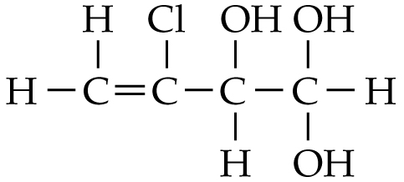
A. 2-chlorobuten-3,4,4-triol
B. 2-chlorobut-1-en-3,4,4-triol
C. 3-chlorobut-1-en-3,4,4-triol
D. 3-chlorobut-3-en-1,1,2-triol

Answer: D

ChemMCQ42016
Pentan-1-ol has a lower water solubility than ethanol because
A. pentan-1-ol molecules cannot form hydrogen bonds with water molecules while ethanol molecules can.
B. pentan-1-ol molecules have a longer hydrocarbon chain than ethanol molecules.
C. the carbon-carbon bonds in pentan-1-ol are stronger than those in ethanol.
D. pentan-1-ol is more polar than ethanol.

Answer: B

ChemMCQ42017
Equal volumes of the following pairs of liquids are mixed together and allowed to stand. Which pair will form two layers of liquids?
A. Propanoic acid and water
B. Pentane and ethanol
C. Trichloromethane and heptane
D. Octan-1-ol and water

Answer: D
The hydrophobic hydrocarbon chain in the octan-1-ol molecule hinders the formation of hydrogen bonds with water molecules.

Section 42.6
ChemMCQ42018
What is the systematic name of CH₃(CH₂)₂CHO?
A. Butan-1-ol
B. Butanal
C. 3-methylpropan-1-ol
D. 3-methylpropanal

Answer: B

ChemMCQ42019
What is the systematic name of the following compound?
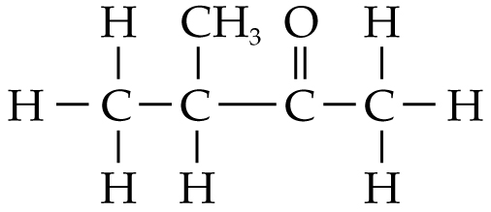
A. 2-methylbutanal
B. 3-methylbutanal
C. Butanone
D. Methylbutanone

Answer: D

ChemMCQ42020
What is the systematic name of the following compound?
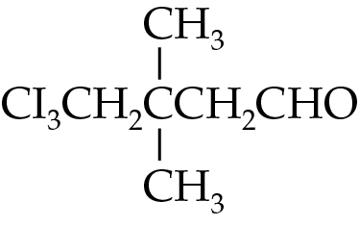
A. 1,1,1-triiodo-3,3-dimethylpentanal
B. 1,1,1-triiodo-3,3-dimethylpentan-5-al
C. 5,5,5-triiodo-3,3-dimethylpentanal
D. 5,5,5-triiodo-3,3-dimethylpentan-1-al

Answer: C

ChemMCQ42021
What is the systematic name of the following compound?
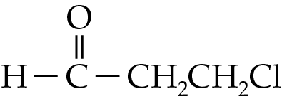
A. 1-chloropropan-3-al
B. Chloropropanal
C. 3-chloropropan-1-al
D. 3-chloropropanal

Answer: D

ChemMCQ42022
Which of the following is the structural formula of 3,5-dichlorohex-3-enal?
A. | 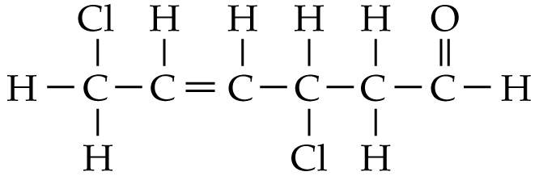 | B. | 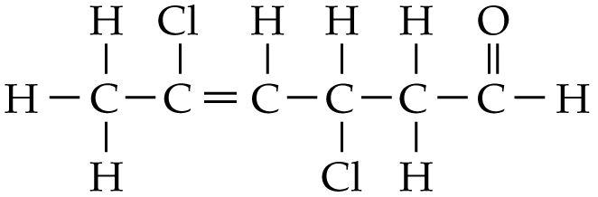
C. | 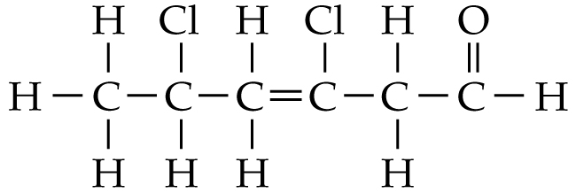 | D. | 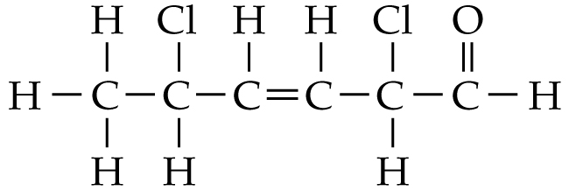

Answer: C

ChemMCQ42023
Which of the following combinations is INCORRECT?
 | Systematic name | Structural formula
A. | 3-ethyl-3-methylpent-1-ene | 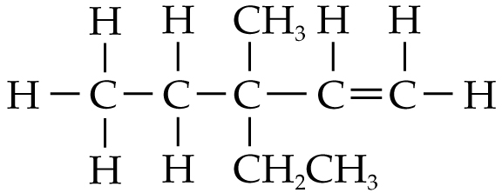
B. | 2-fluorobutanedial | 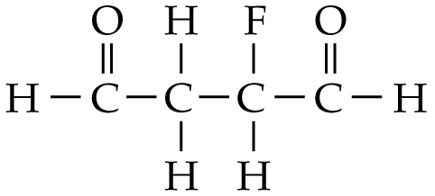
C. | 2-bromo-3-methylpentanal | 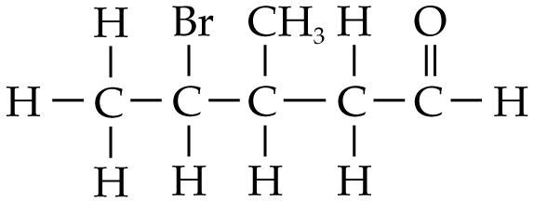
D. | 4-methylpent-3-en-2-one | 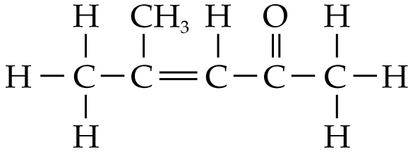

Answer: C
The correct name of the compound in (C) is 4-bromo-3-methylpentanal.

ChemMCQ42024
Which of the following compounds is the least soluble in water?
A. CH₃CH₂CH₂OH
B. CH₃CH₂CCl₃
C. CH₃COCH₃
D. CH₃CH₂CHO

Answer: B
Among the four compounds, only CH₃CH₂CCl₃ molecules cannot form hydrogen bonds with water molecules. Hence, CH₃CH₂CCl₃ is the least soluble in water.

ChemMCQ42025
Which of the following compounds is the most soluble in water?
A. CHCl₃
B. CH₃COCH₃
C. CH₃OH
D. CH₃CH₂CH₂OH

Answer: C
CH₃OH molecules, CH₃COCH₃ molecules and CH₃CH₂CH₂OH molecules can form hydrogen bonds with water molecules. As CH₃OH has the shortest carbon chain, CH₃OH is the most soluble in water.

Section 42.7
ChemMCQ42026
Which of the following are the common properties of alcohols and carboxylic acids?
(1) Both of them have higher boiling points than alkanes with a comparable relative molecular mass.
(2) Both of their molecules can form hydrogen bonds with each other.
(3) Members with fewer carbon atoms in both series are soluble in water.
A. (1) and (2) only
B. (1) and (3) only
C. (2) and (3) only
D. (1), (2) and (3)

Answer: D
Alcohol molecules and carboxylic acid molecules can form hydrogen bonds with each other. Therefore, alcohols and carboxylic acids have higher boiling points than alkanes with a comparable relative molecular mass.

ChemMCQ42027
Which of the following statements about methanoic acid and propane are correct?
(Relative atomic masses: H = 1.0, C = 12.0, O = 16.0)
(1) They have different relative molecular masses.
(2) Methanoic acid has a higher boiling point than propane.
(3) Van der Waals’ forces exist between methanoic acid molecules and between propane molecules.
A. (1) and (2) only
B. (1) and (3) only
C. (2) and (3) only
D. (1), (2) and (3)

Answer: D
Relative molecular mass of HCOOH = 1.0 × 2 + 12.0 + 16.0 × 2 = 46.0
Relative molecular mass of C₃H₈ = 12.0 × 3 + 1.0 × 8 = 44.0

ChemMCQ42028
Which of the following compounds are soluble in water?
(1) Propan-2-ol
(2) Butanoic acid
(3) 1-iodobutane
A. (1) and (2) only
B. (1) and (3) only
C. (2) and (3) only
D. (1), (2) and (3)

Answer: A
Propan-2-ol and butanoic acid are soluble in water because their molecules can form hydrogen bonds with water molecules.

ChemMCQ42029
Which of the following compounds is the least soluble in water?
A. Propan-1-ol
B. Propanoic acid
C. 1-chloropropane
D. Propane

Answer: D

Section 42.8
ChemMCQ42030
What is the systematic name of the following compound?
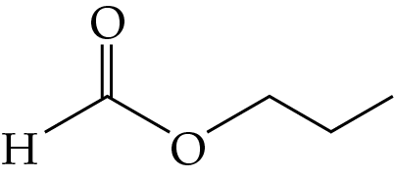
A. Pentanal
B. Pentanoic acid
C. Methyl propanoate
D. Propyl methanoate

Answer: D

ChemMCQ42031
What is the systematic name of the following compound?
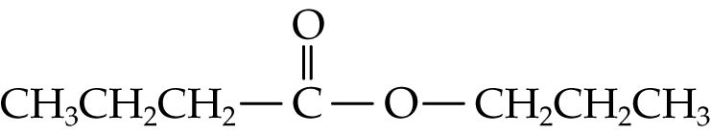
A. Propyl propanoate
B. Butyl propanoate
C. Propyl butanoate
D. Butyl butanoate

Answer: C

ChemMCQ42032
What is the systematic name of the following compound?
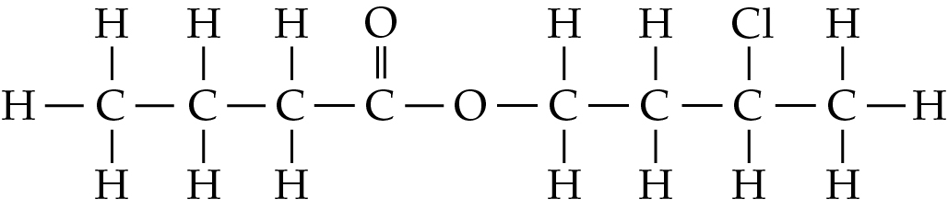
A. 3-chlorobutyl butanoate
B. 2-chlorobutyl butanoate
C. Butyl 2-chlorobutanoate
D. Propyl 4-chloropentanoate

Answer: A

ChemMCQ42033
Consider the following ester.
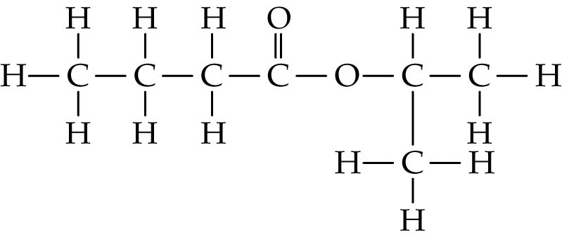
Which of the following compounds are the parent acid and the parent alcohol of the ester?
A. Butanoic acid and propan-1-ol
B. Butanoic acid and propan-2-ol
C. Propanoic acid and butan-1-ol
D. Propanoic acid and butan-2-ol

Answer: B

ChemMCQ42034
Consider the following compound.
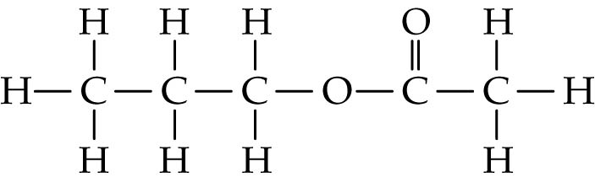
Which of the following statements concerning the compound is/are correct?
(1) Its parent alcohol and parent acid are propan-1-ol and ethanoic acid respectively.
(2) Its molecules can form hydrogen bonds with each other.
(3) It is very soluble in water.
A. (1) only
B. (2) only
C. (1) and (3) only
D. (2) and (3) only

Answer: A

ChemMCQ42035
For which of the following compounds are its molecular formula and empirical formula different?
A. Ethyl ethanoate
B. Propanal
C. Butanone
D. Pentanoic acid

Answer: A
Compound | Molecular formula | Empirical formula
Ethyl ethanoate | C₄H₈O₂ | C₂H₄O
Propanal | C₃H₆O | C₃H₆O
Butanone | C₄H₈O | C₄H₈O
Pentanoic acid | C₅H₁₀O₂ | C₅H₁₀O₂

ChemMCQ42036
Which of the following statements about esters are correct?
(1) Esters are often represented as RCOOR’.
(2) Ester molecules can form hydrogen bonds with each other.
(3) Esters with fewer carbon atoms are soluble in water.
A. (1) and (2) only
B. (1) and (3) only
C. (2) and (3) only
D. (1), (2) and (3)

Answer: B
In an ester molecule, there is no H atom attached to a highly electronegative atom (i.e. N, O and F). Hence, ester molecules cannot form hydrogen bonds with each other.

ChemMCQ42037
Which of the following statements about ethyl ethanoate are correct?
(1) It is a colourless liquid under room conditions.
(2) It is a volatile compound.
(3) It has a pleasant fruity smell.
A. (1) and (2) only
B. (1) and (3) only
C. (2) and (3) only
D. (1), (2) and (3)

Answer: D

ChemMCQ42038
Which of the following series of compounds CANNOT form hydrogen bonds with water molecules?
A. Aldehydes
B. Ketones
C. Esters
D. Alkanes

Answer: D

ChemMCQ42039
Which of the following correctly shows the carbon compounds in descending order of boiling point?
A. Propanoic acid, methyl ethanoate, propan-1-ol
B. Propan-1-ol, methyl ethanoate, propanoic acid
C. Propanoic acid, propan-1-ol, methyl ethanoate
D. Methyl ethanoate, propanoic acid, propan-1-ol

Answer: C
Both propanoic acid molecules and propan-1-ol molecules are held together predominantly by hydrogen bonds. However, propanoic acid molecules have more extensive hydrogen bonds than propan-1-ol molecules because both −C=O and −OH in the carboxyl group can participate in hydrogen bond formation. Methyl ethanoate molecules are held together by van der Waals’ forces only.

ChemMCQ42040
Which of the following statements concerning alcohol molecules and ester molecules with the same number of carbon atoms is correct?
A. Hydrogen bond exists between ester molecules but not between alcohol molecules.
B. Both alcohol molecules and ester molecules are polar.
C. Van der Waals’ forces do not exist between alcohol molecules and between ester molecules.
D. The intermolecular forces between ester molecules are stronger than those between alcohol molecules.

Answer: B
(A): Hydrogen bond exists between alcohol molecules but not between ester molecules.
(C): Van der Waals’ forces exist between all molecules.

ChemMCQ42041
Consider the following two compounds.
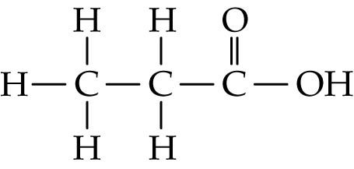 | 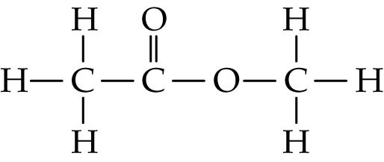
X | Y
Which of the following statements about the two compounds is correct?
A. Y has a higher boiling point than X.
B. They can turn moist pH paper red.
C. They have the same molecular formula.
D. They have the same odour.

Answer: C
(A): Molecules of X can form hydrogen bonds with each other while molecules of Y cannot. Hence, X has a higher boiling point than Y.
(B): Only X (a carboxylic acid) can turn moist pH paper red.
(D): X (a carboxylic acid) have a characteristic pungent smell while Y (an ester) has a pleasant fruity smell.

ChemMCQ42042
Which of the following statements about some carbon compounds is/are correct?
(1) CH₃CH₂COOH(l) has a higher boiling point than CH₃CH₂CH₂OH(l).
(2) CH₃CH₂Cl(g) has a higher water solubility than CH₃CH₂OH(l).
(3) CH₃COOH(aq) has a higher pH than CH₃COOCH₂CH₃(aq).
A. (1) only
B. (2) only
C. (1) and (3) only
D. (2) and (3) only

Answer: A
(2): CH₃CH₂OH molecules can form hydrogen bonds with water molecules while CH₃CH₂Cl molecules cannot. Hence, CH₃CH₂OH has a higher water solubility than CH₃CH₂Cl.
(3): CH₃COOH(aq) is acidic while CH₃COOCH₂CH₃(aq) is neutral.

Section 42.9
ChemMCQ42043
In which of the following compounds are their molecules held together by hydrogen bonds as well as van der Waals’ forces?
(1) Butan-2-ol
(2) Propanamide
(3) Pentanal
A. (1) and (2) only
B. (1) and (3) only
C. (2) and (3) only
D. (1), (2) and (3)

Answer: A
In a pentanal molecule, there is no H atom attached to a highly electronegative atom (i.e. N, O and F). Hence, pentanal molecules cannot form hydrogen bonds with each other.

ChemMCQ42044
Which of the following statements about methylpropanamide is/are correct?
(1) It is a substituted amide.
(2) It is soluble in water.
(3) It has a higher boiling point than methylpropanoic acid.
A. (1) only
B. (2) only
C. (1) and (3) only
D. (2) and (3) only

Answer: A
Methylpropanamide is an unsubstituted amide as the nitrogen atom is bonded to two hydrogen atoms.

ChemMCQ42045
Which of the following statements about unsubstituted amides is INCORRECT?
A. Unsubstituted amides are often represented as RCONH₂, where R is a hydrogen atom or an alkyl group.
B. Unsubstituted amides have higher boiling points than carboxylic acids with a comparable relative molecular mass.
C. The intermolecular forces between unsubstituted amide molecules are hydrogen bonds only.
D. Unsubstituted amides with fewer carbon atoms are soluble in water.

Answer: C
The intermolecular forces between unsubstituted amide molecules are hydrogen bonds and van der Waals’ forces.

ChemMCQ42046
In which of the following compounds are their molecules held together by hydrogen bonds as well as van der Waals’ forces?
(1) Methyl propanoate
(2) Methylpropanamide
(3) 2,3-dichloropropan-1-ol
A. (1) and (2) only
B. (1) and (3) only
C. (2) and (3) only
D. (1), (2) and (3)

Answer: C
Methyl propanoate molecules are held together by van der Waals’ forces only.

ChemMCQ42047
Which of the following correctly shows the carbon compounds in descending order of boiling point?
A. Ethanoic acid > ethanamide > chloroethane
B. Chloroethane > ethanamide > ethanoic acid
C. Chloroethane > ethanoic acid > ethanamide
D. Ethanamide > ethanoic acid > chloroethane

Answer: D
Chloroethane molecules are held together by van der Waals’ forces, while ethanamide molecules and ethanoic acid molecules are held together predominantly by hydrogen bonds. The intermolecular forces between chloroethane molecules are the weakest.
Each ethanamide molecule has two partially positively charged hydrogen atoms while each ethanoic acid molecule has one only. Ethanamide molecules can form more extensive hydrogen bonding with each other.

ChemMCQ42048
Which of the following correctly shows the carbon compounds in ascending order of boiling point?
A. Methyl ethanoate < propanoic acid < ethanamide
B. Methyl ethanoate < ethanamide < propanoic acid
C. Ethanamide < methyl ethanoate < propanoic acid
D. Ethanamide < propanoic acid < methyl ethanoate

Answer: A
Methyl ethanoate molecules are held together by van der Waals’ forces, while ethanamide molecules and propanoic acid molecules are held together predominantly by hydrogen bonds. The intermolecular forces between methyl ethanoate molecules are the weakest.
Each ethanamide molecule has two partially positively charged hydrogen atoms while each propanoic acid molecule has one only. Ethanamide molecules can form more extensive hydrogen bonding with each other.

Section 42.10
ChemMCQ42049
Which of the following groups of carbon compounds are acid derivatives?
(1) Amines
(2) Unsubstituted amides
(3) Esters
A. (1) and (2) only
B. (1) and (3) only
C. (2) and (3) only
D. (1), (2) and (3)

Answer: C
Both unsubstituted amides and esters can be directly made from the reactions of carboxylic acids.

ChemMCQ42050
Which of the following series of compounds does NOT have hydrogen bonds between its molecules?
A. Ketones
B. Alcohols
C. Primary amines
D. Carboxylic acids

Answer: A
In a ketone molecule, there is no H atom attached to a highly electronegative atom (i.e. N, O and F). Hence, ketone molecules cannot form hydrogen bonds with each other.

ChemMCQ42051
Which of the following statements about primary amines are correct?
(1) Primary amines are often represented by RNH₂, where R is an alkyl group.
(2) Primary amine molecules can form hydrogen bonds with each other.
(3) Pentan-3-amine is an example of primary amines.
A. (1) and (2) only
B. (1) and (3) only
C. (2) and (3) only
D. (1), (2) and (3)

Answer: D

ChemMCQ42052
Which of the following compounds are soluble in water?
(1) Ethyl methanoate
(2) Butan-1-amine
(3) Butanone
A. (1) and (2) only
B. (1) and (3) only
C. (2) and (3) only
D. (1), (2) and (3)

Answer: D
Since all molecules can form hydrogen bonds with water molecules, they are all soluble in water.

ChemMCQ42053
Which of the following statements about unsubstituted amides and primary amines is/are correct?
(1) Both of them are acid derivatives.
(2) Both of them are nitrogen-containing carbon compounds.
(3) Both of them have higher boiling points than alcohols with a comparable relative molecular mass.
A. (1) only
B. (2) only
C. (1) and (3) only
D. (2) and (3) only

Answer: B
(1): Unsubstituted amides are acid derivatives while primary amines are not.
(3): As each unsubstituted amide molecule has two partially positively charged hydrogen atoms, more extensive hydrogen bonds form between unsubstituted amide molecules than alcohol molecules. On the other hand, as N is less electronegative than O, the hydrogen bonds between primary amine molecules are generally weaker than those between alcohol molecules.

ChemMCQ42054
Which of the following statements about the compounds in the same homologous series are correct?
(1) Their boiling points increase with an increase in length of hydrocarbon chains.
(2) Their solubilities in water decrease with an increase in length of the hydrocarbon chains.
(3) They have similar chemical properties.
A. (1) and (2) only
B. (1) and (3) only
C. (2) and (3) only
D. (1), (2) and (3)

Answer: D

Section 42.11
ChemMCQ42055
Which of the following combinations is correct?
 | Systematic name | Trivial name
A. | Propan-1-ol | Isopropyl alcohol
B. | Ethanoic acid | Acetone
C. | Methanal | Formaldehyde
D. | Tetrachloromethane | Chloroform

Answer: C
The systematic names of isopropyl alcohol, acetone and chloroform are propan-2-ol, propanone and trichloromethane respectively.

ChemMCQ42056
Which of the following statements about ethanoic acid is INCORRECT?
A. It can exist as dimers in its vapour.
B. It is soluble in water.
C. Its trivial name is acetic acid.
D. There are no van der Waals’ forces between ethanoic acid molecules.

Answer: D
Van der Waals’ forces exist between all molecules.

ChemMCQ42057
Which of the following statements about the first member of the aldehyde series is correct?
A. Its condensed structural formula is CH₃CHO.
B. It is insoluble in water.
C. Its trivial name is methanal.
D. It can be used in the production of synthetic polymers.

Answer: D
The condensed structural formula of methanal is HCHO. Its trivial name is formaldehyde.

