Chapter 45 Inter-conversions of carbon compounds

Section 45.1
ChemMCQ45001
Consider the following synthetic route:
CH₃CH₂CH₂CH₂OH
X
conc. H₂SO₄
heat
Y + Z
HCl
Given that Y is the major product of the reaction between X and HCl. What is Y?
A. 1-chlorobutane
B. 2-chlorobutane
C. 1,2-dichlorobutane
D. 2,2-dichlorobutane

Answer: B
The dehydration of butan-1-ol produces but-1-ene (X). But-1-ene reacts with HCl to give 1-chlorobutane and 2-chlorobutane. According to Markovnikov’s rule, 2-chlorobutane is the major product.

ChemMCQ45002
Consider the following synthetic route:
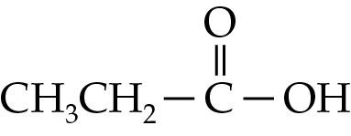
2. H⁺(aq)
A
1. LiAlH₄, dry ether
B
PBr₃
What is B?
A. | 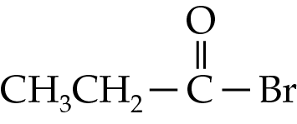 | B. | 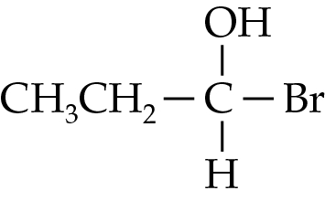
C. | CH₃CH₂CH₂Br | D. | CH₃CH=CHBr

Answer: C
LiAlH₄ in dry ether reduces propanoic acid to propan-1-ol (A). Propan-1-ol reacts with PBr₃ to give 1-bromopropane.

ChemMCQ45003
In a two-step synthesis converting ethanal to 1-bromoethane, which of the following reagents are needed?
(1) Hydrogen bromide
(2) Acidified potassium dichromate solution
(3) Sodium borohydride
A. (1) and (2) only
B. (1) and (3) only
C. (2) and (3) only
D. (1), (2) and (3)

Answer: B
CH₃CH₂OH
NaBH₄(aq)
CH₃CH₂Br

HBr
CH₃CHO

ChemMCQ45004
Consider the following synthetic route:
CH₃CH₂CH₂Cl
X
NaOH(aq)
heat
CH₃CH₂COOH
Y
heat
Which of the following combinations is correct?
 | X | Y
A. | CH₃CH₂CHO | H₂SO₄(l)
B. | CH₃CH₂CHO | Cr₂O₇²⁻(aq)/H⁺(aq)
C. | CH₃CH₂CH₂OH | H₂SO₄(l)
D. | CH₃CH₂CH₂OH | Cr₂O₇²⁻(aq)/H⁺(aq)

Answer: D
CH₃CH₂CH₂Cl undergoes substitution with OH⁻(aq) ions to give CH₃CH₂CH₂OH. CH₃CH₂CH₂OH is oxidized by Cr₂O₇²⁻(aq)/H⁺(aq) to give CH₃CH₂COOH.

ChemMCQ45005
Which of the following combinations for a two-step synthesis of butanone from 2-bromobutane is correct?
 | Reagent used in step 1 | Reagent used in step 2
A. | Sodium hydroxide solution | Acidified potassium dichromate solution
B. | Phosphorus trichloride | Concentrated sulphuric acid
C. | Sodium hydroxide solution | Lithium aluminium hydride in dry ether
D. | Acidified potassium dichromate solution | Sodium hydroxide solution

Answer: A
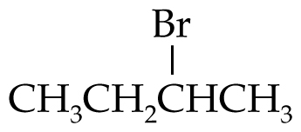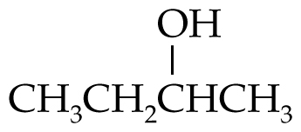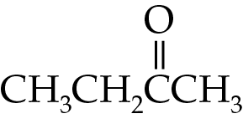
heat
Cr₂O₇²⁻(aq)/H⁺(aq)
OH⁻(aq)
heat

ChemMCQ45006
Which of the following reagents are needed for the conversion of propanamide to propane?
(1) Lithium aluminium hydride in dry ether
(2) Dilute hydrochloric acid
(3) Concentrated sulphuric acid
A. (1) and (2) only
B. (1) and (3) only
C. (2) and (3) only
D. (1), (2) and (3)

Answer: D
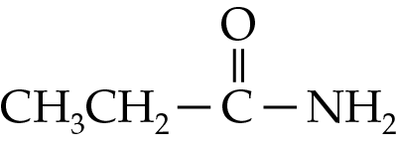
CH₃CH₂CH₂OH

H⁺(aq)
1. LiAlH₄, dry ether
2. H⁺(aq)

CH₃CH=CH₂

conc. H₂SO₄
heat

heat

CH₃CH₂CH₃
H₂, Pt

ChemMCQ45007
Which of the following reagents is NOT required for the conversion of 1-chloropropane to propanamide?
A. Phosphorus trichloride
B. Sodium hydroxide solution
C. Acidified potassium dichromate solution
D. Lithium aluminium hydride in dry ether

Answer: D
heat
CH₃CH₂CH₂OH

OH⁻(aq)
Cr₂O₇²⁻(aq)/H⁺(aq)
CH₃CH₂CH₂Cl
1. PCl₃
2. NH₃

heat

ChemMCQ45008
In a three-step synthesis converting propanamide to propene, which of the following reagents are needed?
(1) LiAlH₄ in dry ether
(2) Concentrated H₂SO₄
(3) Dilute H₂SO₄
A. (1) and (2) only
B. (1) and (3) only
C. (2) and (3) only
D. (1), (2) and (3)

Answer: D
CH₃CH₂CH₂OH

H⁺(aq)
1. LiAlH₄, dry ether
2. H⁺(aq)

CH₃CH=CH₂

conc. H₂SO₄
heat
heat

ChemMCQ45009
Which of the following statements about the conversion of propanone to propene are correct?
(1) The minimum number of steps for the conversion is two.
(2) A secondary alcohol is the organic intermediate.
(3) Lithium aluminium hydride in dry ether is one of the reagents used.
A. (1) and (2) only
B. (1) and (3) only
C. (2) and (3) only
D. (1), (2) and (3)

Answer: D
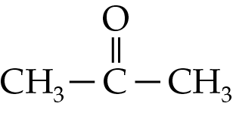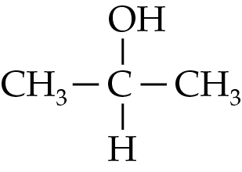
heat
2. H⁺(aq)
1. LiAlH₄, dry ether
conc. H₂SO₄
CH₃CH=CH₂

ChemMCQ45010
Consider the following synthetic route:
heat
A

Cl₂
Cr₂O₇²⁻(aq)/H⁺(aq)
CH₃CH=CH₂
OH⁻(aq)
B

CH₃CHClCH₂Cl
heat
Which of the following statements about the synthetic route is INCORRECT?
A. The first step involves an addition reaction.
B. The systematic name of A is a propane-1,2-diol.
C. A is reduced to B.
D. B contains a carboxyl group.

Answer: C
A (CH₃CH(OH)CH₂OH) is oxidized to B (CH₃COCOOH).

ChemMCQ45011
What is the minimum number of steps in converting an amide to an alkane?
A. 2
B. 3
C. 4
D. 5

Answer: C
The synthetic route is: amide → carboxylic acid → primary alcohol → alkene → alkane.

ChemMCQ45012
What is the minimum number of steps in converting a 1-haloalkane to a carboxylic acid?
A. 2
B. 3
C. 4
D. 5

Answer: A
The synthetic route is: 1-haloalkane → primary alcohol → carboxylic acid.

ChemMCQ45013
Which of the following statements about the conversion of 1-bromopropane to propanamide are correct?
(1) The minimum number of steps for the conversion is two.
(2) A primary alcohol is one of the intermediate compounds.
(3) Ammonia is one of the reagents required.
A. (1) and (2) only
B. (1) and (3) only
C. (2) and (3) only
D. (1), (2) and (3)

Answer: C
heat
Cr₂O₇²⁻(aq)/H⁺(aq)
CH₃CH₂CH₂Br

OH⁻(aq)
CH₃CH₂CH₂OH

1. PCl₃
2. NH₃
heat

ChemMCQ45014
Consider the following synthetic route:
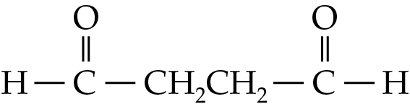
2. H⁺(aq)
A
1. LiAlH₄, dry ether
B
PCl₃
Which of the following combinations is correct?
 | A | B
A. | Butanedioic acid | 4-chlorobutanal
B. | Butanedioic acid | 4-chlorobutan-1-ol
C. | Butane-1,4-diol | 1,4-dichlorobutane
D. | Butane-1,4-diol | 1-chlorobutane

Answer: C
2. H⁺(aq)
HOCH₂CH₂CH₂CH₂OH
1. LiAlH₄, dry ether
ClCH₂CH₂CH₂CH₂Cl
PCl₃

ChemMCQ45015
Consider the following synthetic route:
CH₃CH=CH₂

heat
major product X + minor product Y
A
CH₃CH₂CH₂OH
HBr
Which of the following statements about the synthetic route are correct?
(1) A is concentrated sulphuric acid.
(2) X is 2-bromopropane.
(3) X and Y are position isomers.
A. (1) and (2) only
B. (1) and (3) only
C. (2) and (3) only
D. (1), (2) and (3)

Answer: D
A is concentrated sulphuric acid which dehydrates an alcohol to form an alkene. According to Markovnikov’s rule, the major product is 2-bromopropane.

ChemMCQ45016
Which of the following statements about the conversion of 1-bromo-3-chloropropane to propane-1,3-diol are correct?
(1) It involves a substitution reaction.
(2) Excess sodium hydroxide solution should be used.
(3) It is a one-step synthesis.
A. (1) and (2) only
B. (1) and (3) only
C. (2) and (3) only
D. (1), (2) and (3)

Answer: D
The bromine and chlorine atoms are substituted by the hydroxide ions.

ChemMCQ45017
Consider the following synthetic route:
CH₃CH=CHCH₃

A
Cl₂
B
excess OH⁻(aq)
heat
Cr₂O₇²⁻(aq)/H⁺(aq)
C
heat
Which of the following statements about the synthetic route are correct?
(1) A is a dihaloalkane.
(2) The molecular formula of B is C₄H₁₀O₂.
(3) C is butanedione.
A. (1) and (2) only
B. (1) and (3) only
C. (2) and (3) only
D. (1), (2) and (3)

Answer: D
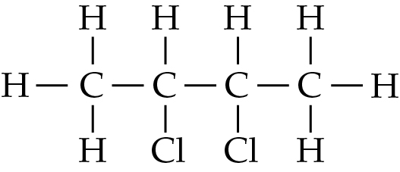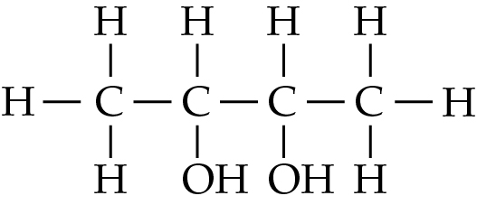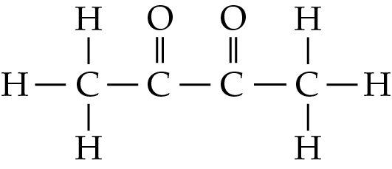
CH₃CH=CHCH₃

heat
Cl₂
excess OH⁻(aq)
heat
Cr₂O₇²⁻(aq)/H⁺(aq)

ChemMCQ45018
Which of the following statements about the conversion of butan-1-ol to butane-1,2-diol are correct?
(1) The minimum number of steps for the conversion is two.
(2) Concentrated sulphuric acid is one of the reagents needed.
(3) One of the intermediate compounds is a haloalkane.
A. (1) and (2) only
B. (1) and (3) only
C. (2) and (3) only
D. (1), (2) and (3)

Answer: A
CH₃CH₂CH=CH₂

heat
conc. H₂SO₄
CH₃CH₂CH₂CH₂OH
cold dilute MnO₄⁻(aq)/H⁺(aq)
CH₃CH₂CH(OH)CH₂OH

ChemMCQ45019
Which of the following reagents are needed for the conversion of ethanol to ethanamide?
(1) Ammonia
(2) Dilute sodium hydroxide solution
(3) Acidified potassium dichromate solution
A. (1) and (2) only
B. (1) and (3) only
C. (2) and (3) only
D. (1), (2) and (3)

Answer: B
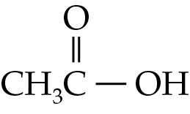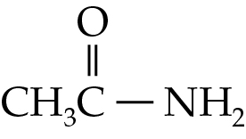
CH₃CH₂OH
1. PCl₃
heat
Cr₂O₇²⁻(aq)/H⁺(aq)
2. NH₃

ChemMCQ45020
Which of the following conversions involves the use of an inorganic acid?
(1) CH₃CH₂COOH → CH₃CH=CH₂
(2) CH₃CH₂CH₂OH → CH₃CH₂CONH₂
(3) CH₃CH₂COOCH₃ → CH₃CH₂CONH₂
A. (1) and (2) only
B. (1) and (3) only
C. (2) and (3) only
D. (1), (2) and (3)

Answer: D
(1): Propanoic acid is first reduced to propan-1-ol and then propan-1-ol is dehydrated to give propene. Propanoic acid can be reduced by treating it with LiAlH₄ in dry ether and then with a dilute acid.
(2): Propan-1-ol is first oxidized to propanoic acid and then propanoic acid is converted to propanamide. The oxidation involves the use of acidified K₂Cr₂O₇(aq). Hence, a dilute acid is used to acidify the solution.
(3): Methyl propanoate is first hydrolysed to give propanoic acid and then propanoic acid is converted to propanamide. A dilute acid is used as a catalyst in the hydrolysis.

ChemMCQ45021
Which of the following conversions involve the use of a reducing agent?
(1) CH₃CHO → CH₂=CH₂
(2) CH₂=CH₂ → CH₃CH₂OH
(3) CH₃COOH → CH₃CH₂Cl
A. (1) and (2) only
B. (1) and (3) only
C. (2) and (3) only
D. (1), (2) and (3)

Answer: B
(1): Ethanal is first reduced to ethanol and then ethanol is dehydrated to give ethene.
(2): Ethene is first converted to chloroethane and then chloroethane is converted to ethanol. The conversion does not involve the use of a reducing agent.
(3): Ethanoic acid is first reduced to ethanol and then ethanol is converted to chloroethane.

ChemMCQ45022
Consider the following synthetic route:
B

H₂, Pt

A

heat
conc. H₂SO₄
CH₃CH₂CH₂OH
What is B?
A. CH₃CH₂COOH
B. CH₃CH=CH₂
C. CH₃CH₂CH₃
D. CH₃CH₂CHO

Answer: C
The synthetic route is: CH₃CH₂CH₂OH → CH₃CH=CH₂ → CH₃CH₂CH₃.

ChemMCQ45023
Which of the following statements about converting 2-chloropropane to propanone are correct?
(1) The conversion involves a redox reaction.
(2) One of the reagents used is sodium hydroxide solution.
(3) A secondary alcohol is an intermediate compound.
A. (1) and (2) only
B. (1) and (3) only
C. (2) and (3) only
D. (1), (2) and (3)

Answer: D
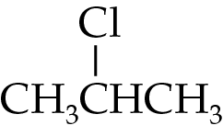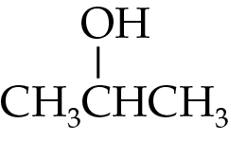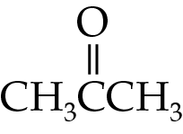
heat

Cr₂O₇²⁻(aq)/H⁺(aq)

OH⁻(aq)

heat

ChemMCQ45024
Propene can be converted to propanone by the following synthetic route.
Y

OH⁻(aq)

X

HCl
CH₃CH=CH₂
heat
Cr₂O₇²⁻(aq)/H⁺(aq)
heat
Which of the following combinations is correct?
 | X | Y
A. | Propan-1-ol | 1-chloropropane
B. | 1-chloropropane | Propan-1-ol
C. | Propan-2-ol | 2-chloropropane
D. | 2-chloropropane | Propan-2-ol

Answer: D
OH⁻(aq)

HCl
CH₃CH=CH₂
heat
Cr₂O₇²⁻(aq)/H⁺(aq)
heat

ChemMCQ45025
Which of the following reagents is NOT required for the conversion of ethene to ethanamide?
A. Ammonia gas
B. Sodium hydroxide solution
C. Chlorine gas
D. Acidified potassium dichromate solution

Answer: C
CH₃CH₂OH

OH⁻(aq)
CH₂=CH₂
HCl
CH₃CH₂Cl

CH₃COOH
Cr₂O₇²⁻(aq)/H⁺(aq)
heat
2. NH₃
CH₃CONH₂
1. PCl₃
heat

ChemMCQ45026
Consider the following synthetic route:
CH₃CH₂OH

Reaction A
CH₂=CH₂
Reaction B
CH₃CH₂Cl

Which of the following combinations about the reaction type involved is correct?
 | Reaction A | Reaction B
A. | Addition | Substitution
B. | Substitution | Hydrogenation
C. | Dehydration | Addition
D. | Dehydration | Substitution

Answer: C
In Reaction A, ethanol is dehydrated to give ethene. In Reaction B, HCl is added across the carbon-carbon double bond, converting ethene to chloroethane.

ChemMCQ45027
Which of the following types of reaction is/are involved in converting chloroethane to ethanoic acid?
(1) Substitution
(2) Addition
(3) Oxidation
A. (1) only
B. (2) only
C. (1) and (3) only
D. (2) and (3) only

Answer: C
Firstly, chloroethane is converted to ethanol by substitution. Then, ethanol is converted to ethanoic acid by oxidation.

ChemMCQ45028
Which of the following reagents is NOT required for the conversion of 2-bromomethylbutane to methylbutane?
A. Concentrated sulphuric acid
B. Acidified potassium dichromate solution
C. Hydrogen gas
D. Sodium hydroxide solution

Answer: B
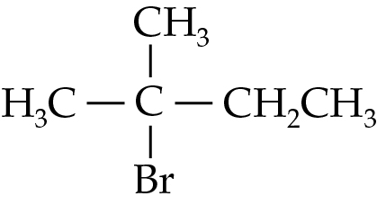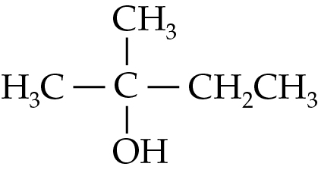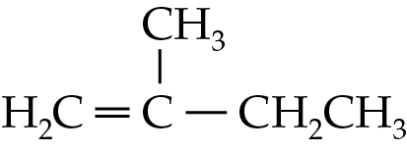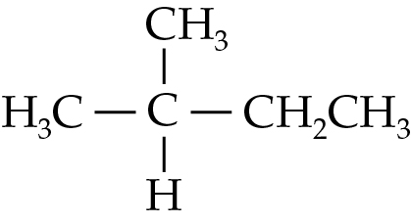
conc. H₂SO₄, heat

H₂, Pt
OH⁻(aq)
heat

ChemMCQ45029
Which of the following statements about the preparation of ethanal from ethanol are correct?
(1) Acidified potassium dichromate solution can be used in the reaction.
(2) The reaction mixture should be heated under reflux for about 30 minutes.
(3) The reaction mixture should be heated in a water bath.
A. (1) and (2) only
B. (1) and (3) only
C. (2) and (3) only
D. (1), (2) and (3)

Answer: B
To prepare ethanal from ethanol, the reaction mixture should be warmed to a temperature that is above the boiling point of ethanal but below that of ethanol. Ethanal is distilled off once it forms. As ethanol and ethanal are flammable, the reaction mixture should be heated in a water bath.

ChemMCQ45030
Which of the following reagents are required for the conversion of propanamide to 1-chloropropane?
(1) Dilute hydrochloric acid
(2) Phosphorus trichloride
(3) Lithium aluminium hydride in dry ether
A. (1) and (2) only
B. (1) and (3) only
C. (2) and (3) only
D. (1), (2) and (3)

Answer: D
CH₃CH₂CH₂OH
H⁺(aq)
1. LiAlH₄, dry ether
2. H⁺(aq)

CH₃CH₂CH₂Cl
PCl₃
heat

ChemMCQ45031
Consider the following synthetic route:
CH₂=CH₂

X
HCl
YB
OH⁻(aq)
heat under reflux
Cr₂O₇²⁻(aq)/H⁺(aq)
Z
heat
What is Z?
A. CH₃CH₃
B. CH₃CHO
C. CH₃COOH
D. CH₃CH₂OH

Answer: C
X, Y and Z are chloroethane, ethanol and ethanoic acid respectively.

ChemMCQ45032
Which of the following statements about the conversion of ethene to ethanoic acid are correct?
(1) An oxidizing agent is used in the conversion.
(2) A secondary alcohol is one of the intermediate compounds.
(3) Dilute sodium hydroxide solution is one of the reagents used.
A. (1) and (2) only
B. (1) and (3) only
C. (2) and (3) only
D. (1), (2) and (3)

Answer: B
CH₃COOH

CH₂=CH₂

CH₃CH₂Cl
HCl
CH₃CH₂OH
B
OH⁻(aq)
Cr₂O₇²⁻(aq)/H⁺(aq)
heat
heat

ChemMCQ45033
Which of the following statements about the conversion of CH₃CH₂OH to CCl₃CCl₃ are correct?
(1) The minimum number of steps for the conversion is two.
(2) A substitution reaction is involved.
(3) Excess Cl₂ (dissolved in an organic solvent) is one of the reagents used.
A. (1) and (2) only
B. (1) and (3) only
C. (2) and (3) only
D. (1), (2) and (3)

Answer: D
PCl₃
UV light
CH₂CH₂OH

excess Cl₂
CH₂CH₂Cl

CCl₃CCl₃

When excess Cl₂ is used in the second step, all H atoms in chloroethane are substituted by Cl atoms.

ChemMCQ45034
When ethanoic acid is treated with lithium aluminium hydride in dry ether and then with dilute sulphuric acid, compound X forms. Which of the following compounds is produced when X reacts with phosphorus trichloride?
A. Ethane
B. Ethanol
C. Chloroethane
D. Ethanamide

Answer: C
2. H⁺(aq)
CH₃CH₂OH
1. LiAlH₄, dry ether
CH₃CH₂Cl
PCl₃
CH₃COOH

ChemMCQ45035
Consider the following synthetic route:
X
C(CH₃)₃CHO
1. PCl₃
heat
Cr₂O₇²⁻(aq)/H⁺(aq)
2. NH₃
Y
What is Y?
A. Pentanamide
B. Dimethylpropanoic acid
C. Dimethylpropanamide
D. Dimethylpropanone

Answer: C
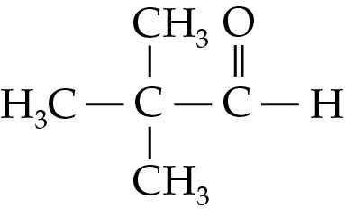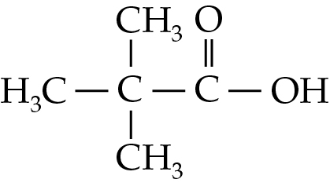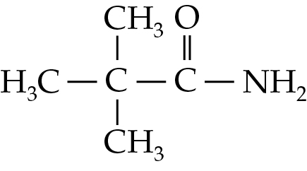
heat
Cr₂O₇²⁻(aq)/H⁺(aq)
1. PCl₃
2. NH₃

ChemMCQ45036
Which of the following reagents are required for the conversion of butanone to 2-chlorobutane?
(1) Phosphorus trichloride
(2) Sodium borohydride
(3) Dilute sodium hydroxide solution
A. (1) and (2) only
B. (1) and (3) only
C. (2) and (3) only
D. (1), (2) and (3)

Answer: A
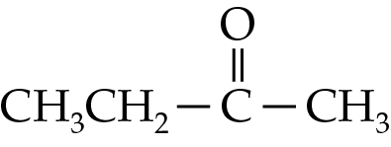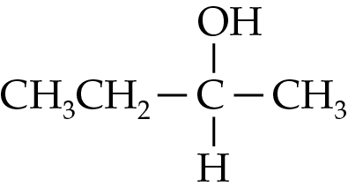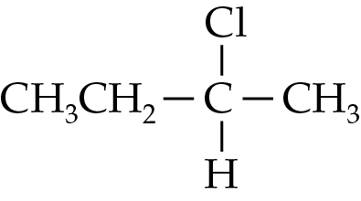
NaBH₄(aq)
PCl₃

ChemMCQ45037
Consider the following synthetic route:
heat under reflux
Cr₂O₇²⁻(aq)/H⁺(aq)
P + Q
1. OH⁻(aq), heat

CH₃COOCH₃

2. H⁺(aq)
P + R
Which of the following combinations is correct?
 | P | R
A. | HCHO | CH₃COOH
B. | HCOOH | CH₃COOH
C. | CH₃COOH | HCOOH
D. | CH₃COOH | HCHO

Answer: C

ChemMCQ45038
Which of the following statements about the conversion of ethanoic acid to chloroethane are correct?
(1) A primary alcohol is one of the intermediate compounds.
(2) The minimum number of steps for the conversion is two.
(3) Sodium borohydride is one of the reagents used.
A. (1) and (2) only
B. (1) and (3) only
C. (2) and (3) only
D. (1), (2) and (3)

Answer: A
2. H⁺(aq)
1. LiAlH₄, dry ether
CH₃COOH

CH₃CH₂OH

PCl₃
CH₃CH₂Cl

Carboxylic acids cannot be reduced using sodium borohydride.

ChemMCQ45039
Consider the following synthetic route:
B
C
1. LiAlH₄, dry ether
2. H⁺(aq)
CH₃CH₂COOH

heat
CH₃CH₂CONH₂
A
NaOH(aq)
Which of the following combinations is correct?
 | A | B | C
A. | CH₃CH₂CHO | NaOH(aq) | CH₃CH₂CH₂OH
B. | CH₃CH₂COOH | NaOH(aq) | CH₃COCH₃
C. | CH₃CH₂COONa | HCl(aq) | CH₃CH₂CH₂OH
D. | CH₃CH₂COONa | HCl(aq) | CH₃CH₂CHO

Answer: C
H⁺(aq)
CH₃CH₂CH₂OH
1. LiAlH₄, dry ether
2. H⁺(aq)
CH₃CH₂COOH

heat
CH₃CH₂CONH₂

CH₃CH₂COONa
NaOH(aq)

ChemMCQ45040
Which of the following statements about the conversion of propanamide to propan-1-ol are correct?
(1) The conversion can be done in two steps.
(2) Propanoic acid is one of the intermediate compounds.
(3) Lithium aluminium hydride is one of the reagents used.
A. (1) and (2) only
B. (1) and (3) only
C. (2) and (3) only
D. (1), (2) and (3)

Answer: D
H⁺(aq)
CH₃CH₂CH₂OH
2. H⁺(aq)
CH₃CH₂COOH

heat
CH₃CH₂CONH₂

1. LiAlH₄, dry ether

ChemMCQ45041
Consider the following synthetic route:
conc. H₂SO₄, heat
Z
Y
X

CH₃CH₂OH

heat under reflux
CH₃COOCH₂CH₃
Which of the following combinations is correct?
 | X | Y | Z
A. | Cr₂O₇²⁻(aq)/H⁺(aq) | CH₃COOH | CH₃OH
B. | conc. H₂SO₄ | CH₂=CH₂ | CH₃OH
C. | Cr₂O₇²⁻(aq)/H⁺(aq) | CH₃COOH | CH₃CH₂OH
D. | conc. H₂SO₄ | CH₂=CH₂ | CH₃CH₂OH

Answer: C

ChemMCQ45042
Consider the following synthetic route:
CH₂=CH₂

X
CH₂(OH)CH₂OH
(COOH)₂
Y

Which of the following combinations is correct?
 | X | Y
A. | cold dilute MnO₄⁻(aq)/H⁺(aq) | Cr₂O₇²⁻(aq)/H⁺(aq), heat
B. | NaOH(aq) | conc. H₂SO₄, heat
C. | H₂O(l) | H⁺(aq), heat
D. | Cr₂O₇²⁻(aq)/H⁺(aq), heat | NaBH₄(aq)

Answer: A

ChemMCQ45043
Which of the following compounds CANNOT be converted to an alcohol in a single step?
A. Propanone
B. Propanal
C. Propane
D. Propanoic acid

Answer: C
Propanoic acid and propanal can be reduced to propan-1-ol in a single step. Propanone can be reduced to propan-2-ol in a single step.

ChemMCQ45044
Which of the following compounds can be made from butan-1-ol in one step?
(1) Butanoic acid
(2) Butane
(3) 1-chlorobutane
A. (1) and (2) only
B. (1) and (3) only
C. (2) and (3) only
D. (1), (2) and (3)

Answer: B
(1): Butan-1-ol can be oxidized to butanoic acid by common oxidizing agents (e.g. acidified K₂Cr₂O₇).
(3): Butan-1-ol can undergo substitution reaction with HCl or PCl₃ to give 1-chlorobutane.

ChemMCQ45045
Consider the following conversion of carbon compounds.
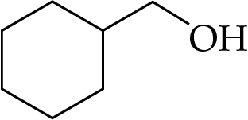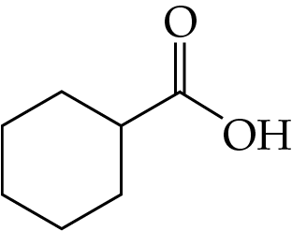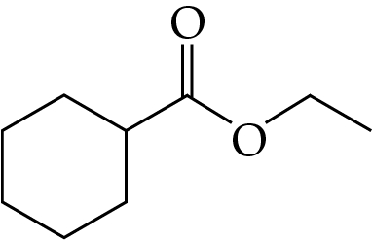
X
Y
Which of the following combinations is correct?
 | X | Y
A. | NaBH₄(aq) | Conc. H₂SO₄, heat
B. | 1. LiAlH₄, dry ether 2. H⁺(aq) | H⁺(aq), heat
C. | MnO₄⁻(aq)/H⁺(aq) | 1. LiAlH₄, dry ether 2. H⁺(aq)
D. | Cr₂O₇²⁻(aq)/H⁺(aq) | CH₃CH₂OH, conc. H₂SO₄, heat

Answer: D

ChemMCQ45046
Consider the following synthetic route:
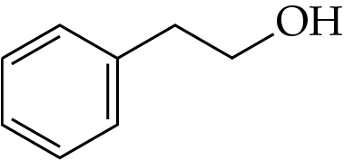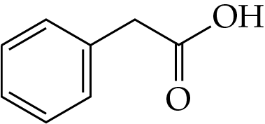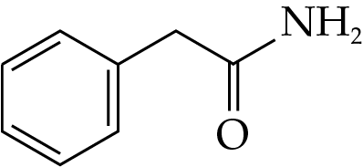
Y
X
Which of the following combinations is correct?
 | X | Y
A. | Cr₂O₇²⁻(aq)/H⁺(aq) | NO₂(g)
B. | Cr₂O₇²⁻(aq)/H⁺(aq) | 1. PCl₃ 2. NH₃
C. | CH₃COOH(aq) | 1. PCl₃ 2. NH₃
D. | CH₃COOH(aq) | NaOH(aq)

Answer: B

ChemMCQ45047
When 3-methylbut-1-ene is mixed with HCl(g), compounds W and X form. The major product X reacts with NaOH(aq) to give compound Y. When Y is heated with acidified K₂Cr₂O₇(aq), compound Z forms. Which of the following combinations is correct?
 | X | W | Z
A. | 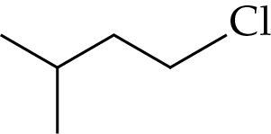 | 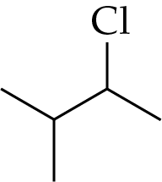 | 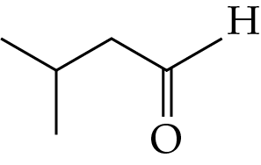
B. |  |  | 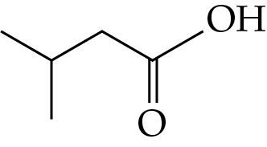
C. |  |  | 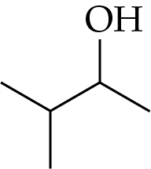
D. |  |  | 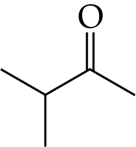

Answer: D
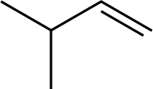
HCl
X (major product) W (minor product)
+
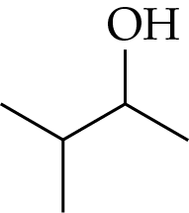
OH⁻(aq)
heat
Cr₂O₇²⁻(aq)/H⁺(aq)
heat
X Z

ChemMCQ45048
Consider the following conversion of carbon compounds.
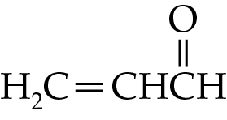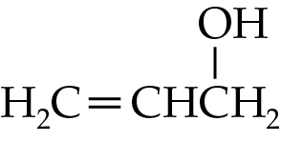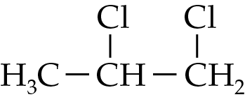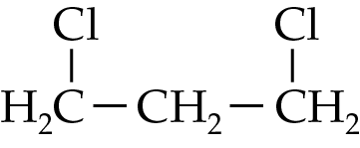
P
Step 1
Step 2
Q
+
Which of the following statements are correct?
(1) Step 1 involves a reduction reaction.
(2) Hydrogen chloride can be used in Step 2.
(3) P is the major product of the reaction in Step 2.
A. (1) and (2) only
B. (1) and (3) only
C. (2) and (3) only
D. (1), (2) and (3)

Answer: A
According to Markovnikov’s rule, Q is the major product of the reaction in Step 2.

ChemMCQ45049
Consider the following synthetic route:
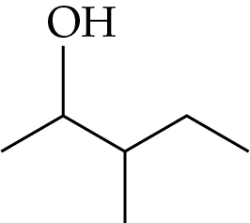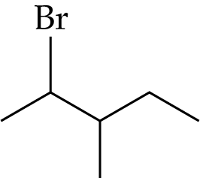
A + B

heat
conc. H₂SO₄
heat
OH⁻(aq)
Which of the following statements are correct?
(1) The first step involves a substitution reaction.
(2) Concentrated sulphuric acid is used as a dehydrating agent.
(3) A and B are position isomers.
A. (1) and (2) only
B. (1) and (3) only
C. (2) and (3) only
D. (1), (2) and (3)

Answer: D

ChemMCQ45050
Consider the following synthetic route:
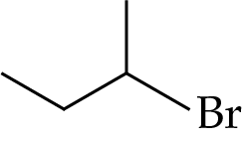
Y

heat
Cr₂O₇²⁻(aq)/H⁺(aq)
Step 1
heat
OH⁻(aq)
X

Which of the following statements are correct?
(1) The reagent used in Step 1 is HBr.
(2) X is a chiral compound.
(3) Y reacts with sodium carbonate solution to give colourless gas bubbles.
A. (1) and (2) only
B. (1) and (3) only
C. (2) and (3) only
D. (1), (2) and (3)

Answer: A
X is butan-2-ol, which has a chiral carbon.
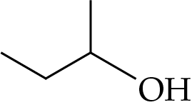
*
Y is butanone, which does not react with Na₂CO₃(aq).

Section 45.2
ChemMCQ45051
When 2.30 g of ethanol reacts with 4.85 g of hydrogen bromide, 3.27 g of bromoethane forms. What is the percentage yield of bromoethane?
(Relative atomic masses: H = 1.0, C = 12.0, O = 16.0, Br = 79.9)
A. 30.0%
B. 50.1%
C. 60.0%
D. 70.3%

Answer: C
CH₃CH₂OH + HBr → CH₃CH₂Br + H₂O
Number of moles of CH₃CH₂OH = $\frac{\text{2.30 g}}{\text{(12.0 × 2 + 1.}\text{0}\text{ × 6 + 16.0) g mol}\text{1}}$ = 0.050 mol
Number of moles of HBr = $\frac{\text{4.85}\text{ g}}{\text{(1.0 + }\text{79.9}\text{) g mol}\text{1}}$ = 0.060 mol
∴number of moles of CH₃CH₂Br formed = 0.050 mol
Theoretical mass of CH₃CH₂Br
= 0.050 mol × (12.0 × 2 + 1.0 × 5 + 79.9) g mol⁻¹ = 5.45 g
Percentage yield of CH₃CH₂Br = $\frac{\text{3.27 g}}{\text{5.45 g}}$ × 100% = 60.0%

ChemMCQ45052
When 4.6 g of ethanol is heated with concentrated sulphuric acid, 1.4 g of ethene is obtained. What is the percentage yield of ethene?
(Relative atomic masses: H = 1.0, C = 12.0, O = 16.0)
A. 10%
B. 30%
C. 50%
D. 61%

Answer: C
CH₃CH₂OH → CH₂=CH₂ + H₂O
Number of moles of CH₃CH₂OH = $\frac{\text{4.6}\text{ g}}{\text{(12.0 × 2 + 1.}\text{0}\text{ × 6 + 16.0) g mol}\text{1}}$ = 0.10 mol
∴number of moles of CH₂=CH₂ formed = 0.10 mol
Theoretical mass of CH₂=CH₂ = 0.10 mol × (12.0 × 2 + 1.0 × 4) g mol⁻¹ = 2.8 g
Percentage yield of CH₂=CH₂ = $\frac{\text{1.4}\text{ g}}{\text{2.8}\text{ g}}$ × 100% = 50%

ChemMCQ45053
When 7.00 g of chloroethane reacts with excess sodium hydroxide solution, 2.70 g of ethanol is obtained. What is the percentage yield of ethanol?
(Relative atomic masses: H = 1.0, C = 12.0, O = 16.0, Cl = 35.5)
A. 27.0%
B. 38.6%
C. 53.9%
D. 71.6%

Answer: C
CH₃CH₂Cl + OH⁻ → CH₃CH₂OH + Cl⁻
Number of moles of CH₃CH₂Cl = $\frac{\text{7.00}\text{ g}}{\text{(12.0 × 2 + 1.}\text{0}\text{ × }\text{5}\text{ + }\text{35.5}\text{) g mol}\text{1}}$ = 0.109 mol
∴number of moles of CH₃CH₂OH formed = 0.109 mol
Theoretical mass of CH₃CH₂OH
= 0.109 mol × (12.0 × 2 + 1.0 × 6 + 16.0) g mol⁻¹ = 5.01 g
Percentage yield of CH₃CH₂OH = $\frac{\text{2.70}\text{ g}}{\text{5.01}\text{ g}}$ × 100% = 53.9%

ChemMCQ45054
When 2.80 g of ethene reacts with excess hydrogen chloride, 3.80 g of chloroethane is obtained. Which of the following statements about the reaction is/are correct?
(Relative atomic masses: H = 1.0, C = 12.0, O = 16.0, Cl = 35.5)
(1) The reaction is an addition reaction.
(2) The reaction gives two different organic products.
(3) The percentage yield of the reaction is 58.9%.
A. (1) only
B. (2) only
C. (1) and (3) only
D. (2) and (3) only

Answer: C
CH₂=CH₂ + HCl → CH₃CH₂Cl
Number of moles of CH₂=CH₂ = $\frac{\text{2.80}\text{ g}}{\text{(12.0 × 2 + 1.}\text{0}\text{ × }\text{4}\text{) g mol}\text{1}}$ = 0.10 mol
∴number of moles of CH₃CH₂Cl formed = 0.10 mol
Theoretical mass of CH₃CH₂Cl
= 0.10 mol × (12.0 × 2 + 1.0 × 5 + 35.5) g mol⁻¹ = 6.45 g
Percentage yield of CH₃CH₂Cl = $\frac{\text{3.80}\text{ g}}{\text{6.45}\text{ g}}$ × 100% = 58.9%

Section 45.3
ChemMCQ45055
When 1.0 mol of ethanol is heated with excess acidified potassium dichromate solution under reflux, 0.8 mol of ethanoic acid is obtained. Which of the following statements about the reaction are correct?
(1) The percentage yield of ethanoic acid is 80%.
(2) The reaction is a redox reaction.
(3) Acidified potassium permanganate solution can be used to replace acidified potassium dichromate solution.
A. (1) and (2) only
B. (1) and (3) only
C. (2) and (3) only
D. (1), (2) and (3)

Answer: D
CH₃COOH
CH₃CH₂OH
heat
Cr₂O₇²⁻(aq)/H⁺(aq)
From the equation, mole ratio of CH₃CH₂OH to CH₃COOH = 1 : 1.
Percentage yield of ethanoic acid = $\frac{\text{0.8 mol}}{\text{1.0 mol}}$ × 100% = 80%

ChemMCQ45056
Butan-1-ol is heated with acidified potassium dichromate solution under reflux. The set-up of the experiment is shown in the diagram below.
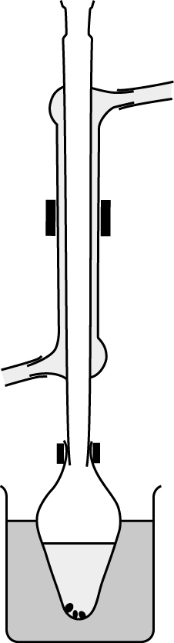
water in
water out
anti-bumping granule
apparatus Y
butan-1-ol + acidified potassium dichromate solution
heat
Which of the following statements about the experiment is INCORRECT?
A. The reaction mixture changes from orange to green.
B. Apparatus Y is a reflux condenser.
C. The organic product can be isolated from the reaction mixture by distillation.
D. The organic product has a pleasant fruity smell.

Answer: D
The organic product of the reaction is butanoic acid.

ChemMCQ45057
To prepare propanoic acid, a mixture of propan-1-ol and acidified potassium dichromate solution is heated under reflux. Which of the following apparatus is required in the process?
A. Fractionating column
B. Stopper
C. Thermometer
D. Water condenser

Answer: D

Section 45.4
ChemMCQ45058
Which of the following statements about the use of a reflux condenser in the laboratory preparation of an ester are correct?
(1) It condenses vapour formed from the reaction mixture during heating.
(2) It helps reduce the loss of volatile organic substances by evaporation during heating.
(3) It must be kept open to the air during heating.
A. (1) and (2) only
B. (1) and (3) only
C. (2) and (3) only
D. (1), (2) and (3)

Answer: D

ChemMCQ45059
In the laboratory preparation of an ester, a distillate is obtained after distilling the product mixture. Which of the following statements about the distillate are correct?
(1) The distillate has a much lower percentage of water.
(2) The distillate should be treated with excess sodium carbonate solution to remove any acidic substances.
(3) The distillate has to be redistilled to obtain the pure ester.
A. (1) and (2) only
B. (1) and (3) only
C. (2) and (3) only
D. (1), (2) and (3)

Answer: D

ChemMCQ45060
In the laboratory preparation of an ester, a mixture of an alcohol and a carboxylic acid is heated under reflux in the presence of an acid catalyst. Then, a distillate is obtained after distilling the product mixture. Which of the following reagents are used to treat the distillate to obtain the pure ester?
(1) Sodium carbonate solution
(2) Concentrated calcium chloride solution
(3) Anhydrous calcium chloride
A. (1) and (2) only
B. (1) and (3) only
C. (2) and (3) only
D. (1), (2) and (3)

Answer: D
(1): Na₂CO₃(aq) is used to remove any acidic substances in the distillate.
(2): Concentrated CaCl₂(aq) is used to remove any unreacted ethanol in the distillate.
(3): Anhydrous CaCl₂ is a drying agent that removes remaining traces of water from the distillate.

ChemMCQ45061
Which of the following experiments should NOT be performed in the school laboratory for safety concern?
(1) Heating a mixture of ethanoic acid and ethanol under reflux
(2) Adding a piece of rubidium to a beaker of water
(3) Adding water to concentrated sulphuric acid
A. (1) only
B. (2) only
C. (1) and (3) only
D. (2) and (3) only

Answer: D
(2): The reaction between rubidium (a Group I element below potassium) and water is very vigorous.
(3): Adding water to concentrated sulphuric acid produces a large amount of heat.

ChemMCQ45062
When 2.30 g of ethanol undergoes esterification with excess ethanoic acid, 1.06 g of ethyl ethanoate is obtained. What is the percentage yield of the ester in the reaction?
(Relative atomic masses: H = 1.0, C = 12.0, O = 16.0)
A. 46.1%
B. 24.1%
C. 23.0%
D. 12.0%

Answer: C
CH₃CH₂OH + CH₃COOH CH₃COOCH₂CH₃ + H₂O
Number of moles of CH₃CH₂OH = $\frac{\text{2.3}\text{ g}}{\text{(12.0 × 2 + 1.}\text{0}\text{ × 6 + 16.0) g mol}\text{1}}$ = 0.050 mol
∴number of moles of CH₃COOCH₂CH₃ formed = 0.050 mol
Theoretical mass of CH₃COOCH₂CH₃
= 0.050 mol × (12.0 × 4 + 1.0 × 8 + 16.0 × 2) g mol⁻¹ = 4.40 g
Percentage yield of CH₃COOCH₂CH₃ = $\frac{\text{1.06}\text{ g}}{\text{4.40}\text{ g}}$ × 100% = 24.1%

ChemMCQ45063
When 12.0 g of butan-1-ol and 10.2 g of ethanoic acid were heated under reflux with a few drops of concentrated sulphuric acid, 5.80 g of an ester was obtained. Which of the following statements about the reaction is INCORRECT?
(Relative atomic masses: H = 1.0, C = 12.0, O = 16.0)
A. The systematic name of the ester produced is butyl ethanoate.
B. Concentrated sulphuric acid acts as a catalyst.
C. The percentage yield of the reaction is 48.3%.
D. The reaction is reversible.

Answer: C
CH₃CH₂CH₂CH₂OH + CH₃COOH CH₃COOCH₂CH₂CH₂CH₃ + H₂O
Number of moles of CH₃CH₂CH₂CH₂OH used
= $\frac{\text{12.0}\text{ g}}{\text{(12.0 × }\text{4}\text{ + 1.}\text{0}\text{ × }\text{10}\text{ + 16.0) g mol}\text{1}}$ = 0.162 mol
Number of moles of CH₃COOH used
= $\frac{\text{10.2}\text{ g}}{\text{(12.0 × }\text{2}\text{ + 1.}\text{0}\text{ × }\text{4}\text{ + 16.0 × }\text{2}\text{) g mol}\text{1}}$ = 0.170 mol
∴number of moles of butyl ethanoate obtained = 0.162 mol
Theoretical mass of butyl ethanoate
= 0.162 mol × (12.0 × 6 + 1.0 × 12 + 16.0 × 2) g mol⁻¹ = 18.8 g
Percentage yield of butyl ethanoate = $\frac{\text{5.80 g}}{\text{18.8 g}}$ × 100% = 30.9%

ChemMCQ45064
When 10 cm³ of methanoic acid (density = 1.2 g cm⁻³) was heated under reflux with 10 cm³ of ethanol (density = 0.8 g cm⁻³) in the presence of an acid catalyst, 8.5 g of ethyl methanoate was obtained. What is the percentage yield of ethyl methanoate?
(Relative atomic masses: H = 1.0, C = 12.0, O = 16.0)
A. 42.5%
B. 44.0%
C. 67.5%
D. 70.8%

Answer: C
HCOOH + CH₃CH₂OH HCOOCH₂CH₃ + H₂O
Number of moles of methanoic acid = $\frac{\text{10 cm}\text{3}\text{ × 1.2 g cm}\text{3}}{\text{(12.0 + 1.}\text{0}\text{ × }\text{2}\text{ + 16.0 × }\text{2}\text{) g mol}\text{1}}$ = 0.26 mol
Number of moles of ethanol = $\frac{\text{10 cm}\text{3}\text{ × }\text{0.79}\text{ g cm}\text{3}}{\text{(12.0} \text{× }\text{2}\text{ + 1.}\text{0}\text{ × }\text{6}\text{ + 16.0) g mol}\text{1}}$ = 0.17 mol
∴number of moles of ethyl methanoate obtained = 0.17 mol
Theoretical mass of ethyl methanoate
= 0.17 mol × (12.0 × 3 + 1.0 × 6 + 16.0 × 2) g mol⁻¹ = 12.6 g
Percentage yield of ethyl methanoate = $\frac{\text{8.5}\text{ g}}{\text{12.6}\text{ g}}$ × 100% = 67.5%

Section 45.5
ChemMCQ45065
Consider the following compound.
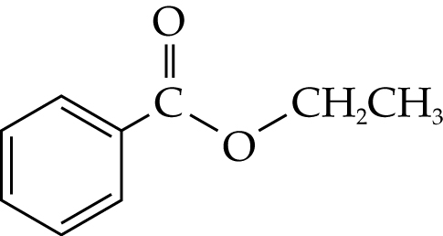
Which of the following statements about the compound are correct?
(1) The systematic name of the compound is ethyl benzoate.
(2) It is miscible with hexane.
(3) The alkaline hydrolysis of the compound gives ethanol and benzoate ion.
A. (1) and (2) only
B. (1) and (3) only
C. (2) and (3) only
D. (1), (2) and (3)

Answer: D

ChemMCQ45066
Which of the following reactions can produce benzoic acid from ethyl benzoate?
(1) Heating ethyl benzoate with NaBH₄(aq) under reflux
(2) Heating ethyl benzoate with HCl(aq) under reflux
(3) Heating ethyl benzoate with NaOH(aq) under reflux
A. (1) only
B. (2) only
C. (1) and (3) only
D. (2) and (3) only

Answer: B
Ethyl benzoate undergoes acid hydrolysis with HCl(aq) to give benzoic acid. It undergoes alkaline hydrolysis with NaOH(aq) to give sodium benzoate.

ChemMCQ45067
In an experiment, 1.05 g of methyl ethanoate was heated under reflux with a dilute acid to give ethanoic acid and methanol. Then, ethanoic acid was isolated. The acid required 10.00 cm³ of 0.50 M sodium carbonate solution for complete reaction. What is the percentage yield of ethanoic acid?
(Relative atomic masses: H = 1.0, C = 12.0, O = 16.0)
A. 35.2%
B. 57.1%
C. 70.4%
D. 81.1%

Answer: C
CH₃COOCH₃ + H₂O CH₃OH + CH₃COOH
Number of moles of methyl ethanoate used
= $\frac{\text{1.05}\text{ g}}{\text{(12.0 × }\text{3}\text{ + 1.}\text{0}\text{ × }\text{6}\text{ + 16.0 × }\text{2}\text{) g mol}\text{1}}$ = 0.0142 mol
∴number of moles of ethanoic acid obtained = 0.0142 mol
Theoretical mass of ethanoic acid
= 0.0142 mol × (12.0 × 2 + 1.0 × 4 + 16.0 × 2) g mol⁻¹ = 0.852 g
2CH₃COOH + Na₂CO₃ → 2CH₃COONa + H₂O + CO₂
Number of moles of Na₂CO₃ used = 0.50 mol dm⁻³ × $\frac{\text{10.00}}{\text{1000}}$ dm³ = 0.0050 mol
∴number of moles of ethanoic acid obtained = 0.0050 mol × 2 = 0.010 mol
Mass of ethanoic acid obtained = 0.010 mol × 60.0 g mol⁻¹ = 0.60 g
Percentage yield of ethanoic acid = $\frac{\text{0.60}\text{ g}}{\text{0.852}\text{ g}}$ × 100% = 70.4%

