Core Skills learning portfolio

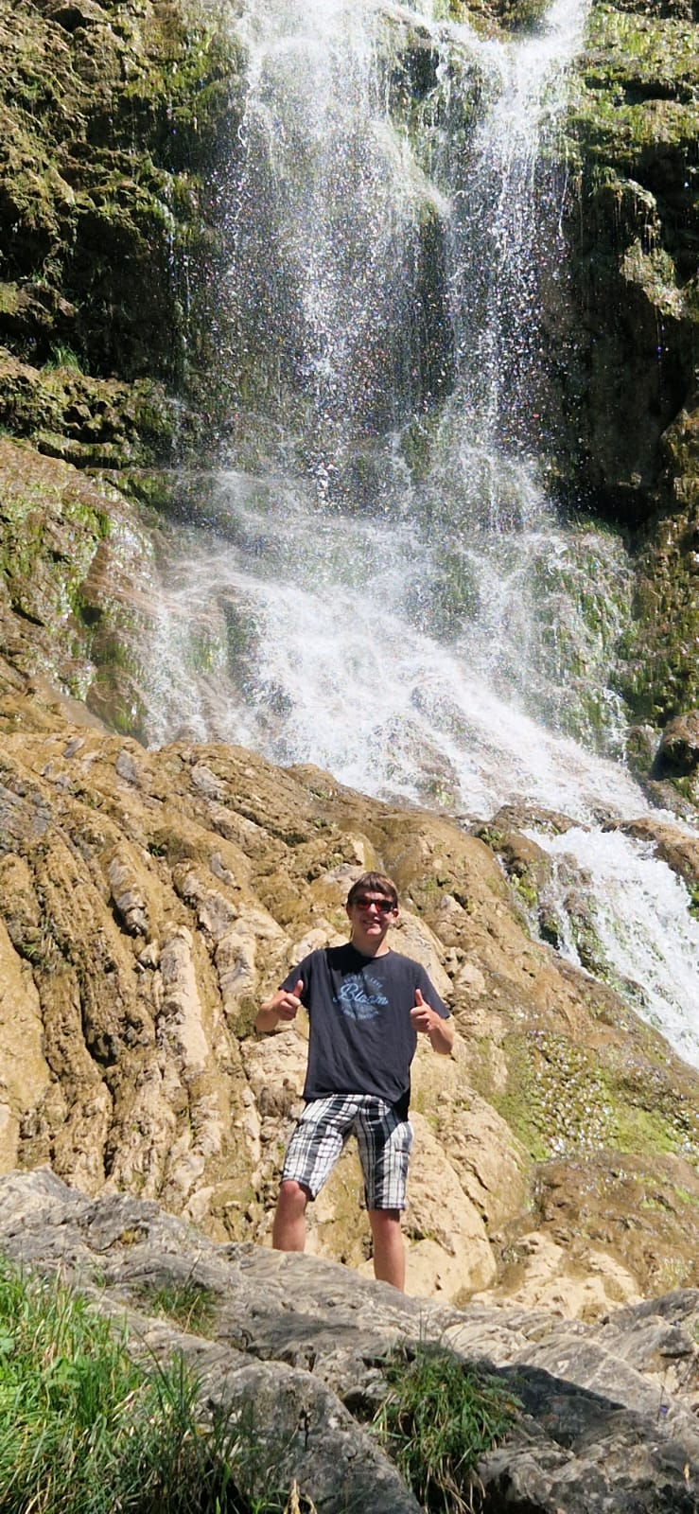

Name: Wesley van der Gragt
Class: ECM1V.EAGen2
Version: 1
Lab teacher: Rene Heijnen
Date: 20-3-2026
Table of Contents
Core Skills learning portfolio 1
Introduction 4
Week 5.1 5
“Post it” 5
“Good practices and room to improve” 6
“DISC test” 6
Presentation 7
Wrap up 8
Week 5.2 9
“Visual exercises” 9
“Real situations” 9
Disc Reflection 10
Understanding Others 10
Wrap up 11
Week 6.1 12
Lego Assignment 12
Drawing Assignment 13
Survival Assignment 14
Wrap up 15
Week 6.2 16
Cultural Confusion 16
Analysis & Reflection 17
Week 7.1 18
Case Study 18
Care Ethics assignment 19
Week 7.2 20
Kaleidoscope 20
Team dynamics 20
Team dynamics reflection 21
Leadership and cooperation 21
Reflection and goal setting 22
Self assessment 24
Week 11.1 26
Mindmap 26
Articles 26
Keywords 27
Formulating a research question 27
Week 11.2 28
Source Analysis 28
CRAAP Test 28
Week 12.1 31
Moodboard 31
Empathy canvas 32
Jobs to be done 32
Week 12.2 33
IceBreaker 33
Reverse Crazy 8s 33
What would X do? 34
Forced Connections 34
Reflection 35
Week 13.1 36
Selection methods (MoSCoW) 36
Reflection 36
COCD Box 37
Reflection 37
Week 13.2 39
Revisiting the research question 39
Research Question Reflection 39
Target audience Reflection 39
Designing Questions 40
Final reflection 40
Self-Assesment 40
APA 42
Week 1.1 42
Week 11.1 42

Introduction
My name is Wesley van der Gragt. I finished secondary school with a HAVO degree in Heerhugowaard and after that I did a year of Saxion CMGT with the old curriculum. For the year I did with the old curriculum, I gave a lot of suggestions and feedback for assignments and projects that were given in each semester. With coming back to Saxion CMGT, I hope to learn better programming skills and broaden my skills by also learning how to 3d model.

Week 5.1

“Post it”
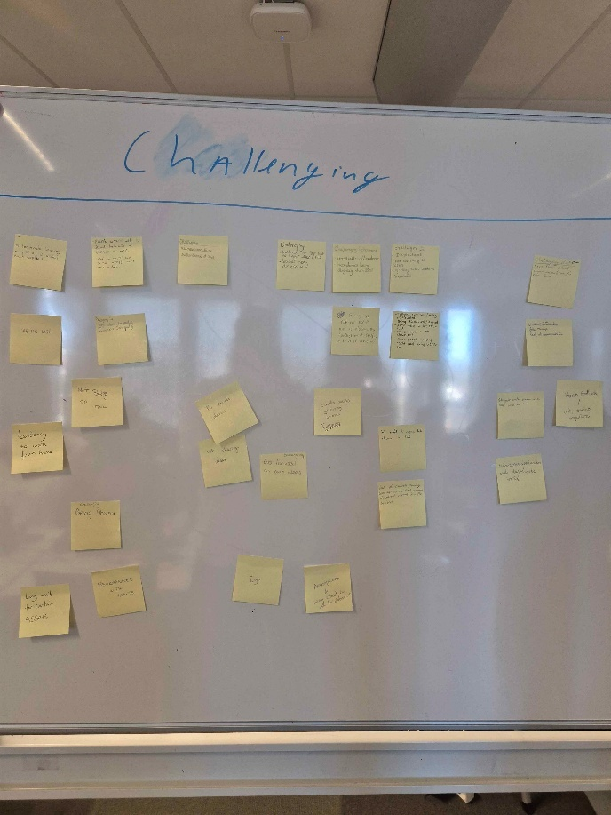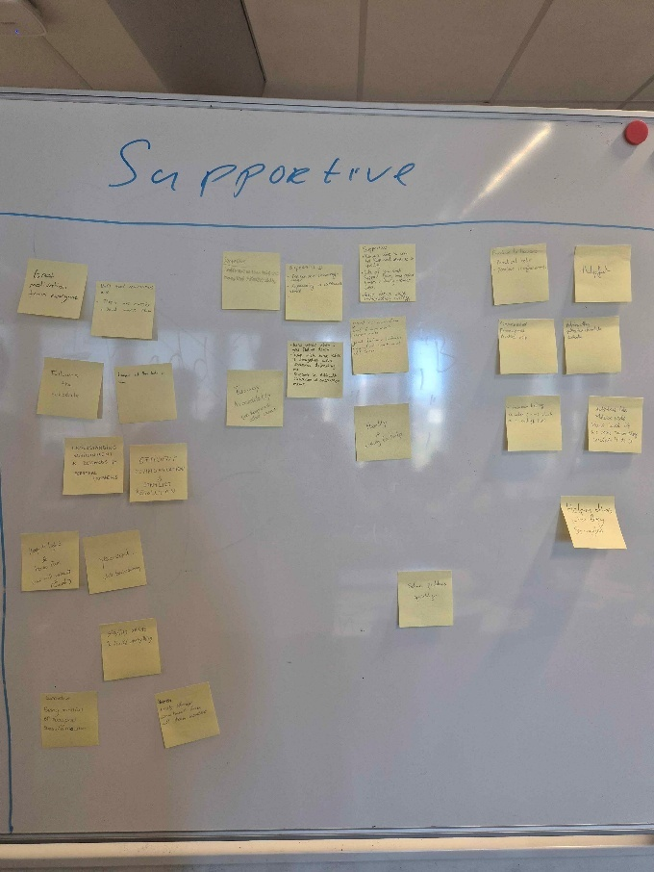

- Which of the supportive B+As do I recognize in myself? Which other ones could I try to emulate? (because your peers appreciated these!)

Staying up late to keep working on the project and solving problems quickly.

- Which of the challenging B+As do I recognize in myself? Which ones did you experience from others during the project weeks?

Disorganised with assets and assets not being made fast enough.

- What are the most often repeated B+As in both categories? Write them down.

Miscommunication and being too late.

“Good practices and room to improve”
- What good practices will you take into your next teamwork project?
Making sure everything gets made on time with good quality.

- What will you leave behind?
Not taking enough breaks when working on the project.

- What areas can you improve on?
Talking about the problems I got about the group with the group.

- Now set 2 goals (1 individual, 1 teamwork-related) to work on for the coming period.
Idividual: Take more breaks while working on projects and assignments.
teamwork-related: Talk earlier about the problems I have.

“DISC test”
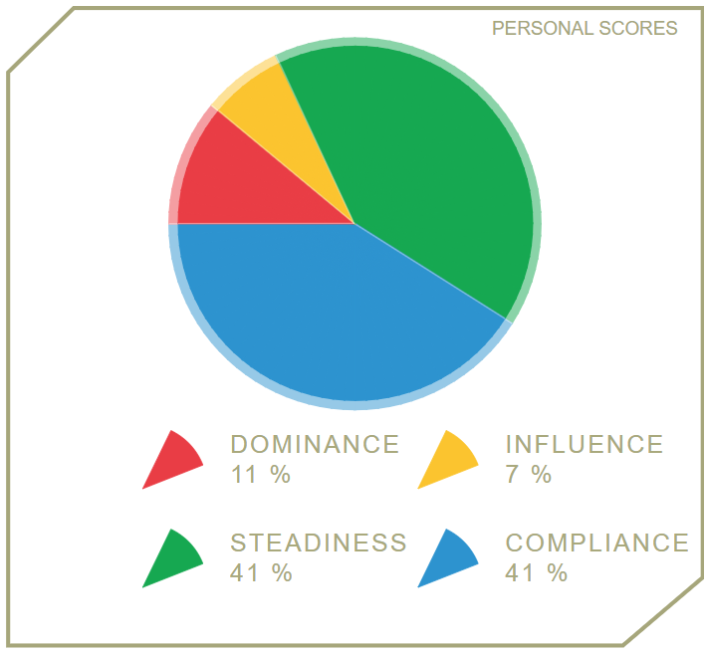

Presentation
This is all according to Steadiness since I had to do that one!
- What are the common strengths your behavioural colour brings to a team?
Our strengths are in being reliable and understanding.
We create low conflict environments.
- What are the challenges that your colour could bring to a team?
Not giving concrete feedback and being too passive at points.
- How does your colour typically approach conflict or disagreement in a team setting?
They try to keep it low-conflict and respond with patience and understanding.
- How can your colour’s traits complement or clash with those of other colours in a team?
With dominance they are both on the opposite sides of the wheel. They could clash with the dominance type since the dominance type could sound too fast and direct whereas Steadiness could sound too slow and not direct enough.
As for Influence they could also speak too fast and not allow space for Steadiness to talk. Whereas the Steadiness should communicate more openly and look at fresh perspectives that Influence gives.
With Compliance they are both on the passive side. When communicating the Compliance types should show more interest into the discussion then facts. As for Steadiness they should give more facts while speaking with Compliance.
- What are some traits that this colour could work on to improve teamwork?
The steadiness Type should be more open and speak clearly when talking to the rest of the DISC types.
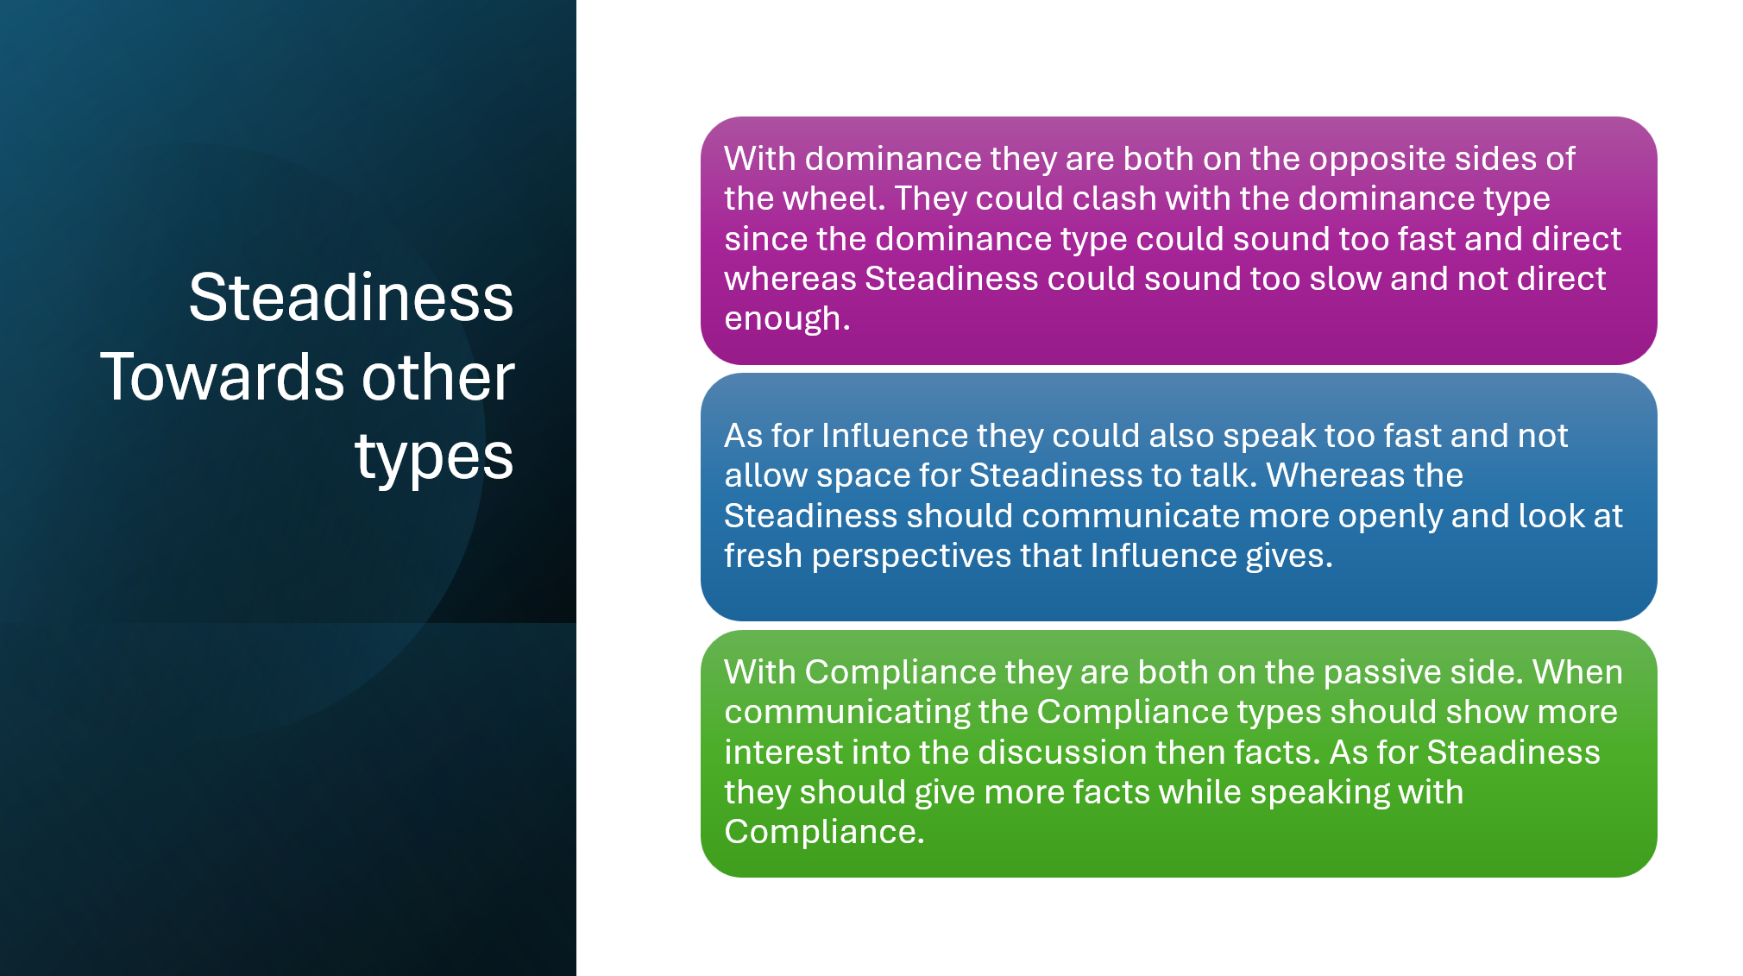

Wrap up
- What have you learned about yourself as a team player based on what you have learned during this workshop?
That I am someone that goes more factual with some talks and have a lot of patience.

- What will you be more aware of next time you work with a team?
That some people will talk way more then necessary and others wont tell enough.

- What will you work on to become a more valuable team member?
Try and understand everyone and if unsure, ask more about it.

- When is the next opportunity to try out these new practices
The next group projects at the end of this schoolyear.

Week 5.2

“Visual exercises”
• What worked well?
Telling the shapes and how/where to place them.

• Where do you notice miscommunication?
The left and right sometimes get switched around.

• What do you think about the quality of your communication?
Its good enough to work with each other with no real problems occurring.

• Give the other person constructive feedback on their communication skills
He could’ve been more detailed like with the sizes.

“Real situations”
• Describe the situation.
Someone that didn’t communicate during the projects.
And during the night said things that the rest already have decided a couple days before.

• Use a model to gain more insight into the situation.
Using the interactive model, there was a lot of noise between the 2 communicators and 1 of them didn’t say anything afterwards and only communicated while most are asleep.

• What went wrong?
Person doesn’t communicate well during the group meetings.

• What went well?
Nothing went well with this scenario. So the other people worked mostly with each other.

• What would have been a better approach
Communicate to that specific person and try to make him work with each other.

Disc Reflection
1.How does my DISC type affect the way I
communicate?
precision, analysis, and a cautious, factual approach
Calm, patient manner.

2.What are my strengths in communication,
based on my DISC type?
Talk about factual things with precision and analysis. While also maintaining a calm attitude.

3.What are my communication challenges, and
how do they impact my teamwork or
interactions?
Conflict avoidment, more thought out and factual/objective.

4.When do I feel most comfortable
communicating? When do I struggle?
When I know the subject from what we are talking about or just brainrot things
I struggle when I don’t know what its about or when I do not know the person I am talking to.

Understanding Others
1. How do different DISC types prefer to receive
information?
Dominance: Straightforward and determined
Influence: Persuasive and Optimistic
Steadiness: Patient and Consistant
Compliance: Accurate and Detailed

2. What type of communication does each DISC
personality find frustrating?
Dominance least likes Steadiness and vice versa
Influence least likes Compliance and vice versa.

3. How can you adjust your approach when giving
feedback to different types?
By putting more things beside info into the conversation and context of things it could help “influence” type people understand it and keep their attention. Which could also be used for Steadiness.
And for the Dominance its just best to go accurate and detailed.

4. If a team is deciding on a project deadline, what
conflicts could arise based on communication
differences?
Different people have different work speeds. So one could do it in a day but another could do it in a couple of days.

5. What could be the benefits of having different DISC
types in a team?
Each type could do different roles and help with teamwork and team dynamic.

Wrap up
- What was the most surprising insight you gained today about communication?
That people can be totally different from one another.

- What will you be more aware of next time you work with a team?
To check if its alright with each other and how the work is going with all.

- What will you do differently in (team) communication?
To tell if I have got any problems with the group or work.

- How can you use this knowledge to resolve conflicts or misunderstandings in the future?
By talking with each other and coming to a consensus.

Week 6.1

Lego Assignment
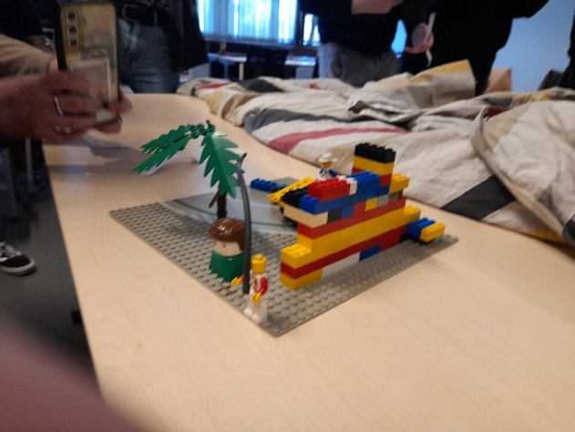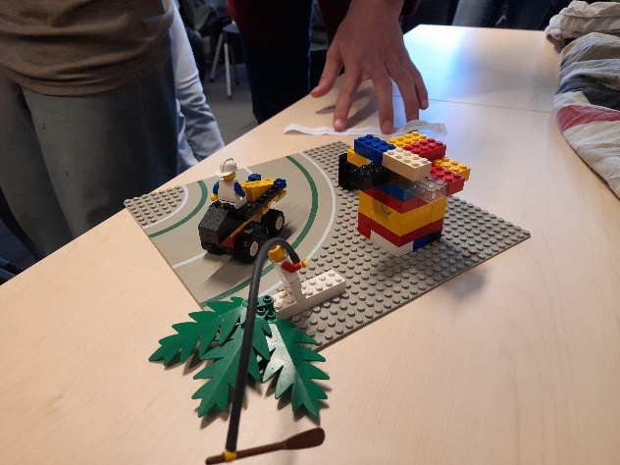

• How was the collaboration?
Good, everyone did what they were supposed to and worked together.

• How did you participate? Were you leading, following, opposing, or
cooperating?
I was mostly just following and cooperating in the first build.
And more leading and cooperating in the 2nd build.

• Was there a natural leader, or was there chaos?
At the first one there was a leader and at the 2nd build I was mostly the leader the first 3 layers and then let the rest go further.

• What happened during conflicts?
We signed to eachother and tried to understand everyone as best as we could.

• How did you resolve them?
By stopping the person and signing what has to be changed or show what your task is.

• What was the most fun moment
Building legos ofcourse!

Drawing Assignment
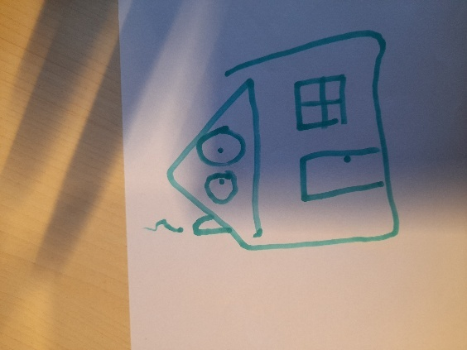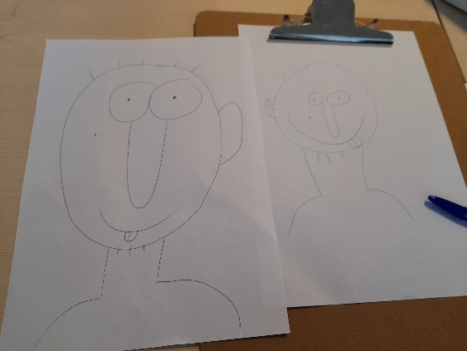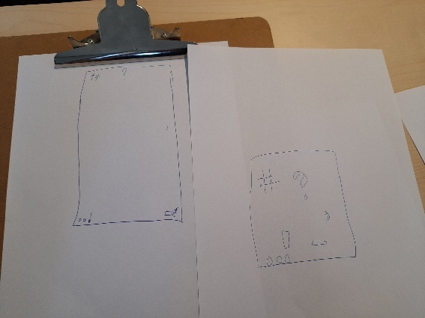

• How was the collaboration?
Going pretty good.

• Were you leading, following, opposing, or cooperating?
I cooperated in it and drew the chimney.

• Was there a natural leader?
No, everyone worked together to make the drawing.

• Did the leadership have a positive or negative effect on
the cooperation?
It was positive, since there was no real struggle to draw things.

• Were there any conflicts, and how were they resolved
No, everyone pretty much worked together.

Survival Assignment
Leadership:
• How did the leader approach the task?
Role assignment and checking if everyone is ok with it.

• What worked well, and what could have been done
better?
The tasks have been assigned accordingly.
Went a bit lost in details for a imaginary scenario.

Self-motivation:
• How did you feel responsible for your role?
I wouldn’t do motivator as how its written, more like just crack jokes whenever I can and if it’s a good time for it.

• Was there a moment when you felt more or less
involved?
We haven’t talked about where and what each roles are supposed to do during the day.

Empathy:
• How did you take each other’s ideas and emotions into
account?
Everyone was heard and looked at the facts and uses of their ideas.

Decisions:
• How were your choices made?
Looking at the facts and what each person could do with their current skills.

• With this experience, would you do anything differently?
Probably not.

Wrap up
- What have you learned about yourself as a team player based on what
you have learned during this workshop? (think about your Rose of Leary position )

I just mostly follow the group or leader and cooperate. Also tell if I have an idea in that current scenario.

- What insights did you gain about your own communication style during
this workshop? What went well? And what can you improve?

I gave my ideas and tried to remember facts and checked with a person that knows more about it.
I think I did pretty well and shouldn’t be less communicative or more of it.

- What will you be more aware of next time you work with a team
I think I’ve done good and don’t know what to be more aware off during. (Asked groupmembers about it.)

Week 6.2

Cultural Confusion
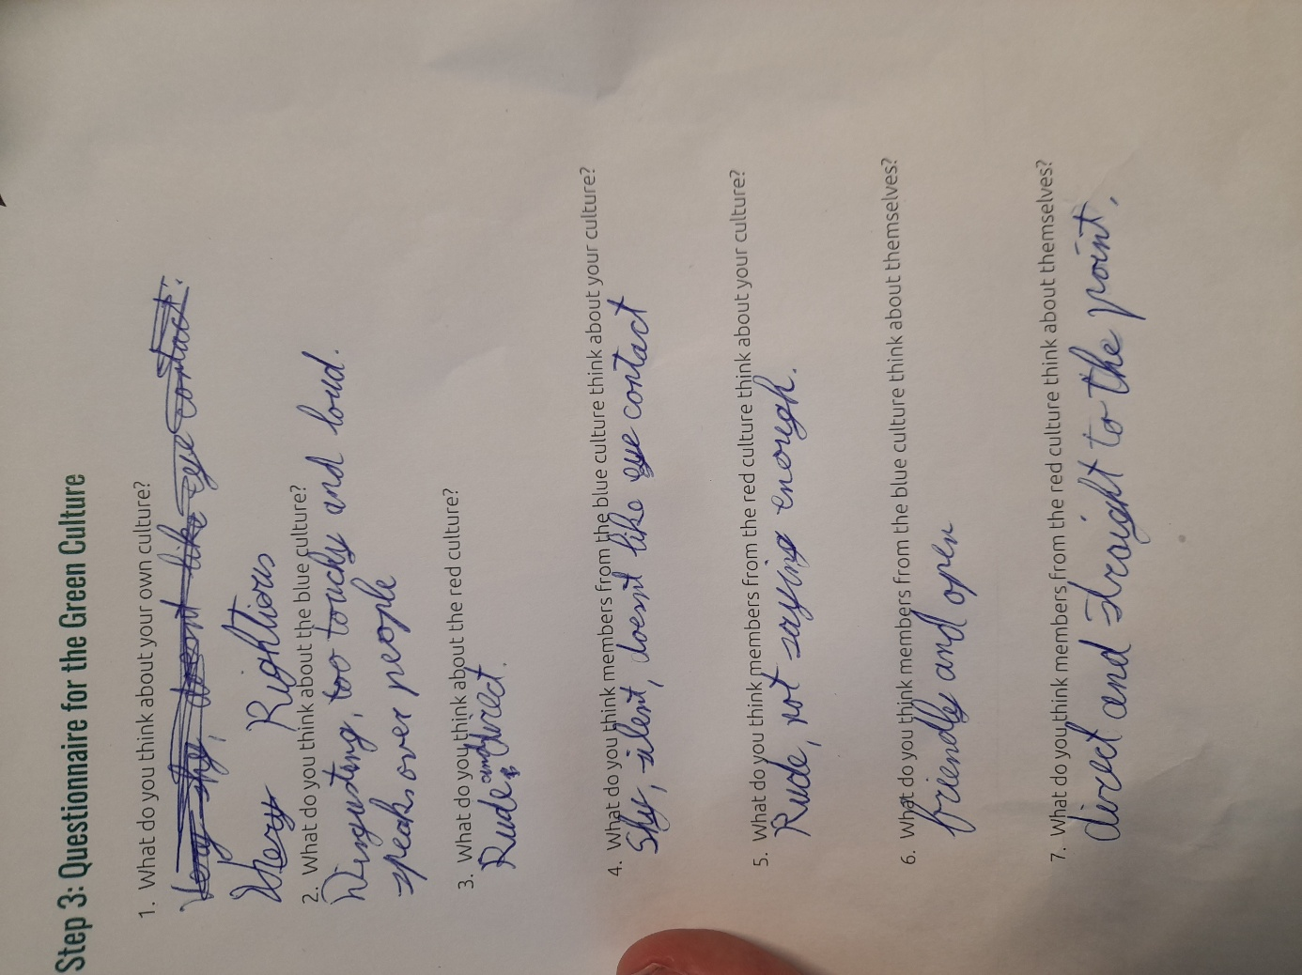
I found it terrible, and while working in the projects you usually just respect the other person.
I found myself to be most like the red culture.

Analysis & Reflection
In other countries the culture could look a lot like your own but it could also be totally different then what your used to. For instance my culture is more direct and straightforward and during projects this could lead to others feeling bit hurt and another could just be going all the way around the subject to get a point across and that could be annoying for my culture. While this can hurt the teamwork, it could also be good to talk about each others cultures if someone finds it especially rude. That way you can mitigate any tension in the group and have good teamwork afterwards.

Week 7.1

Case Study
- How might a utilitarian approach influence the decision?
They would do what’s best for most of the team. There is a chance that They would likely disregard the personal issues and would be on board to report Alex tot the manager.

- How would a deontologist respond to this situation?
They would follow the rules, and they wouldn’t want too harsh consequences on Alex. But they would go to the manager (or whatever consequences and empathy he would try to help Alex his own way.)

- What action would a virtue ethicist be in favour of?
Its based off the character of the virtue ethicist. If he values hard work and fairness he would go to the manager. If he values compassion and empathy he would try to help Alex in his own way.

- How would a care ethicist address Alex’s struggles?
This is depending on the team their bond. If they have a closer relationship with Alex, they would help Alex.
If they have a better relationship with the rest of the team they would try to lessen their stress.
If the entire team is good friends they would help Alex by encouraging to share his problems.
This way the team sticks together but they also have helped Alex lessen his workload by dividing it amongst the team or having the team sort out things in their own way.

- What solution could balance individual care and team success?
Probably help Alex with sharing the problems with the team and come to a solution together, this will probably be listening to Alex to what he can and cant do and then divide the work he cant do to the rest of the team.

Care Ethics assignment
- Decisions with compassion
Look at each others strengths and weaknesses and give them tasks depending on those.
And hearing everyone even those that haven’t spoken yet.

- Build a conflict-resolution system based on care
Talk things out with each other with another team member or teacher around so its easier to deescalate and understand each other.

- Extend care beyond the team
Make sure no one has any problems with the team and if there is that its easy to speak about them.
And if there are problems that it should be known in the group and able to move the work around where needed if the person needs help with things.

Week 7.2

Kaleidoscope
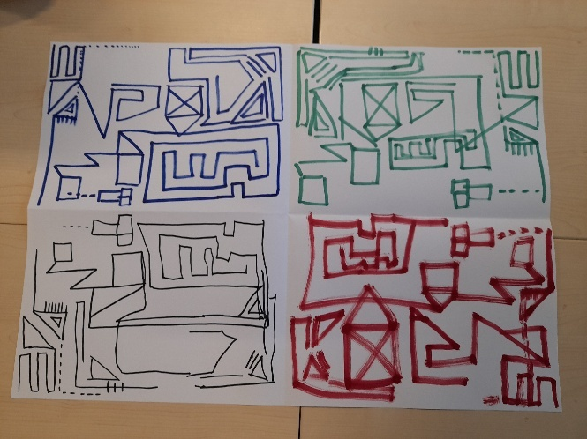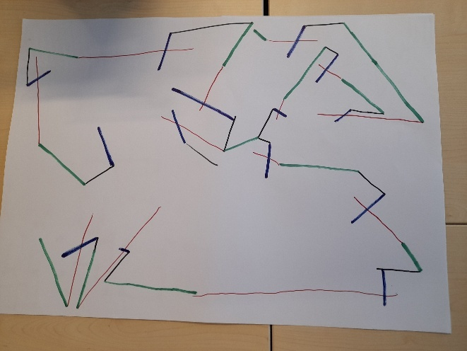

Team dynamics
- Joint responsibilities:
Giving everyone a choice to do you can share responsibility.

- Leadership:
Its better to have a single leader to check if everything is going the right way.

- Motivation:
Should be done by everyone in the team.

- Mutual respect and trust for one another:
Should trust other people to be able to share work and also talk about things that are currently happening.
Let everyone talk and not cut in while they are talking.

- Open communication and good atmosphere:
Depends on each person but is more related to motivation and respect.
Trust in each other is also important for a good atmosphere.

- Optimal team formation:
Having a leader that keeps the team organised and depending on each roles team size have another leader for those to keep it organised for that section of the team.

- Balanced distribution of roles, personalities and effort.
Looking at the DISC and Belbin tests you can give each person their corresponding role and work.

Team dynamics reflection
- Self-motivation, what motivates you?
Working in a team and things that I actually find interesting.

- How can you motivate others?
I don’t think I can motivate anyone on command. Perhaps in the moment but nothing more.

- Do you give (or how do you give) compliments?
I sometimes give compliments about work done in a project. And don’t really receive compliments myself all that well.

- What is the importance of empathy?
To know how to act to someone and have the team be in a good atmosphere.

- Collegiality, what does that mean to you?
I don’t even know that word, but after a google its just what a good team should be.

- Do you show leadership? (and how)
No, I like to just receive a task and complete that then think of tasks to give to others and keep everything organised.

Leadership and cooperation
- Clear project goals. (MVP & DOD)
The project goal is mainly what the client wants to have.
For MVP its having all needed mechanics done with some assets for visuals.
For DOD its refining and optimizing the MVP. And having mechanics and assets that they would like to have.

- Working methods and agreements.
Could work from home or at a certain location. Its wise to work together more and have regular checks on how everyone is working.
Having a scrum master to align the team on the tasks and what needs to be done.

- Meetings & updates. (methods and how often)
Daily stand ups where the updates are given like what they have done and what they will do.
And at the week have a big meeting where it has the daily standup info and also on what needs to be done for the next week.

- Team communication tools & channels.
Teams for important meetings and communication between people.

- Task & Time management.
Trello to organise tasks and quickly check on what needs to be done and what has been finished. Also to see the updates of other people and how long each task took.

- Keeping track of progress.
Using Trello you can easily track progress since it gives the timestamp on all updates and who updated it.

- Storage tools, Version control & Backup systems
Github for version control, backup and storage since your able to get a earlier version of a branch and you can storage it on the website.
You can also update the branches with 1 update at a time.

- Honest reflection on team functioning.
Would be good to have at the end of a project or at the end of each week.
This can help the team function better and have better teamwork after that point.

Reflection and goal setting
- How can you work well together? (your needs & wants)
Want to have regular checks and if online that there will be a response within an hour.
Also written somewhere with more information towards a specific task.

- What are your qualities? And what do you bring to the team?
Hard worker and can do late nights whenever needed.

- What is your working attitude and how does this influence others?
While working its more just work and less talking around. This could look unsocial to others.

- What underlies this behaviour? Your culture, your values framework, your ethical considerations?
Its most likely towards my values why I do it like this since other people in my culture most likely have other values and ethical considerations.

- What are the goals related to teamwork & communication you set for yourself this semester?
Talk earlier about the problems I have and take breaks while working instead of doing a long working time with no breaks.

Self assessment
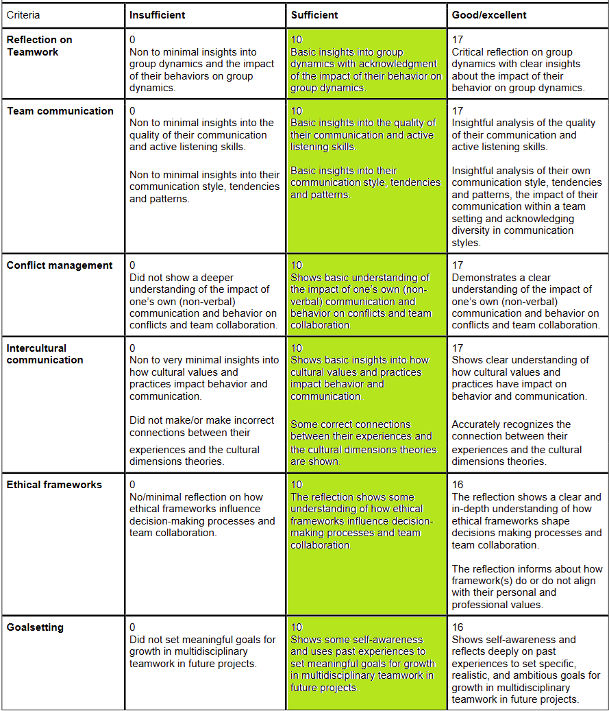
- Reflection on Teamwork
As shown in Week 5.1 its most about not taking enough breaks while working and also that I didn’t communicate my problems immediately.

- Team communication
As shown in Week 5.2 as shown in the DISC reflection. I mostly try to speak factual/objective and the context is there but its way more direct then what others might like to have it.
- Conflict management
As shown in Week 5.2 It says that I find myself to be conflict avoidant since I don’t like to be in such scenarios and don’t know how to calm the conflict down.
As shown Week 6.1 Reflection I am not a leader type and just go along with the group more.

- Interculture Communication
As shown in Week 6.2 it can cause a lot of issues if you aren’t respectful to one another’s culture and you should show respect to one another to keep the dynamic going well.

- Ethical Frameworks
As shown in Week 7.1 Case study it shows all the frameworks and the responses to a certain scenario. They can have totally different ways to think and act upon their actions.

- Goalsetting
As shown in Week 5.1 “Good practices and room to improve” it shows what my goals are towards the next project and its in short talking about my problems earlier and taking more breaks while working on tasks.

Week 11.1

Mindmap
Challenge: Help people make responsible choices regarding drug use
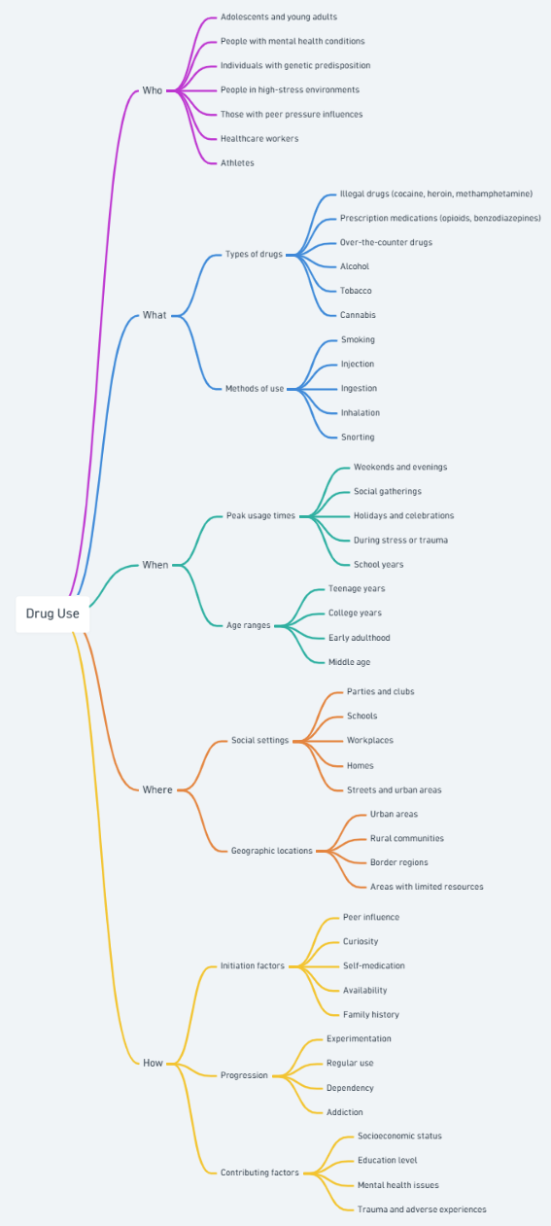

Articles
- Bancroft, A. (2017). Responsible use to responsible harm: illicit drug use and peer harm reduction in a darknet cryptomarket. Health, Risk & Society, 19(7–8), 336–350. https://doi.org/10.1080/13698575.2017.1415304

- Whiteacre, K. W., & Pepinsky, H. Controlling Drug Use. Criminal Justice Policy Review. https://doi.org/10.1177/0887403402131002

- Moreau, J. (2016). “I Learned it by Watching YOU!” The Partnership for a Drug-Free America and the Attack on “Responsible Use” Education in the 1980s. Journal of Social History, 49(3), 710-737. https://doi.org/10.1093/jsh/shv062
- Ti, L., Tzemis, D. & Buxton, J.A. Engaging people who use drugs in policy and program development: A review of the literature. Subst Abuse Treat Prev Policy 7, 47 (2012). https://doi.org/10.1186/1747-597X-7-47

- Chadda, Rakesh Kumar. Substance Use Disorders: Need for Public Health Initiatives. Indian Journal of Social Psychiatry 35(1):p 13-18, Jan–Mar 2019. https://doi.org/10.4103/ijsp.ijsp_117_18

Keywords
- What keywords worked and didn’t work?
drugs AND responsible use: Worked for a small amount of websites
drug disorders: gave a lot more but gave both abuse and responsible use.

- What Booleans did you use, and how did they help your search?
AND and NOT. But NOT didn’t work at all and just gave me more of that 2nd word.

- Where you able to find what you’re looking
In the end the 2 of us managed to find 5 links about drug use.

Formulating a research question
How do we let young adults in work and school positions who use drugs, be more responsible with drug use during freetime so they don’t hurt themselves using it?

Week 11.2

Source Analysis
https://doi.org/10.1080/13698575.2017.1415304
Crypto markets show a way to change the risk and harm with drug use. I examined the knowledge behind this. I argue that the expert divide creates a hierarchy of knowledge around drug use is undermined by the creations of knowledge communities by responsible drug users. I found out that the risk worked along 4 axes, cultural normalisation, chemical potency, legality and market. Each of which required practices to manage successfully. Drug users indicated that they used many harm reduction practices, while promoting responsible harm where they sought to own and take charge of the pain. This was made by the knowledge of drug users, vendors and professionals.

https://doi.org/10.1093/jsh/shv062
In the mid-1980s the Partnership for a Drug-Free America (PDFA) began the largest privately run public-service campaign in history. They entered a long-running debate in educational circles about how best to teach adolescents about drugs. Compelling narratives depicted the perils of drugs and demonstrated why even casual use leads inexorably to serious injury or death. Due to producers of legal drugs, the PFDA’S ads came to an unspoken distinction between the hazards of illicit substances, which were skilfully dramatized, and those of licit ones, which had to be ignored. That inconsistency provoked heated criticism as it exposed fault lines in the War on Drugs and Reagan era politics more generally, which uneasily balanced laissez-faire economics with calls for individual responsibility and a return to traditional values.

https://doi.org/10.1186/1747-597X-7-47
The literature review identified a consistent knowledge gap in the subject of peer engagement in relation to policy and program development and highlights how far behind we currently are in developing such initiatives with PWUD. With clearly effective outcomes for various populations, efforts to minimize stigmatizing attitudes towards PWUD among health and service professionals and policy makers may assist in improving peer collaboration in policy agendas. Moreover, future research should seek to further explore and document peer engagement in the context of policy and program development. Additionally, we recommend that individuals already involved in this area continue to publish their findings in peer-reviewed journals and elsewhere. Peers have an ethical and imperative right to be involved in the decisions affecting their lives and often, they are the ones who are the most knowledgeable on how to most effectively approach their population. A decision to involve peers in the policies and practices around their health will not only give strength to their voices but our collaborative efforts will more effectively address the needs of this community.

CRAAP Test
C1 2017, 2016, 2012
C2 Yes to all 3.
C3 Older sources would work aswell.
C4 links work on all 3.

R1 It talks about the info with drug use and the 2nd article talks about a way they tried before which failed.
R2 teens-young adults
R3 yes to all 3.
R4 yes to all 3.
R5 yes to 1 and 3, not 2.

A1.1
- A.Bancroft
- Oxford University Press
- LianPing Ti, Despina Tzemis and Jane A Buxton.
A1.2
- They have written about drug use multiple times.
- Unknown how much Oxford press knows about drug use.
- They all do something related to Medical and have written about drug use.
A1.3
1ST and 3rd I’d say yes. The oxford one not.
A1.4
You can find contacts for all.
A1.5
No, they are all .com.

A2.1
They all have citations related to drug use. Except Oxford only has 1 citation of it.
A2.2
Yes.
A2.3
1st one had to be accepted first to be shown. The other 2 don’t show it.
A2.4
If you look at other docs I would say yes.
A2.5
Yes.
A2.6
Not from what I saw.

P1
Its all to inform.
P2
Yea, 1st and 3rd want the people who use drugs (PWUD) to be more influential with the discussion of drug use.
P3
Mostly facts.
P4
It seems that they impartial since they want both parties to help eachother with PWUDS to help more.
P5
Not what I saw.

Week 12.1

Moodboard
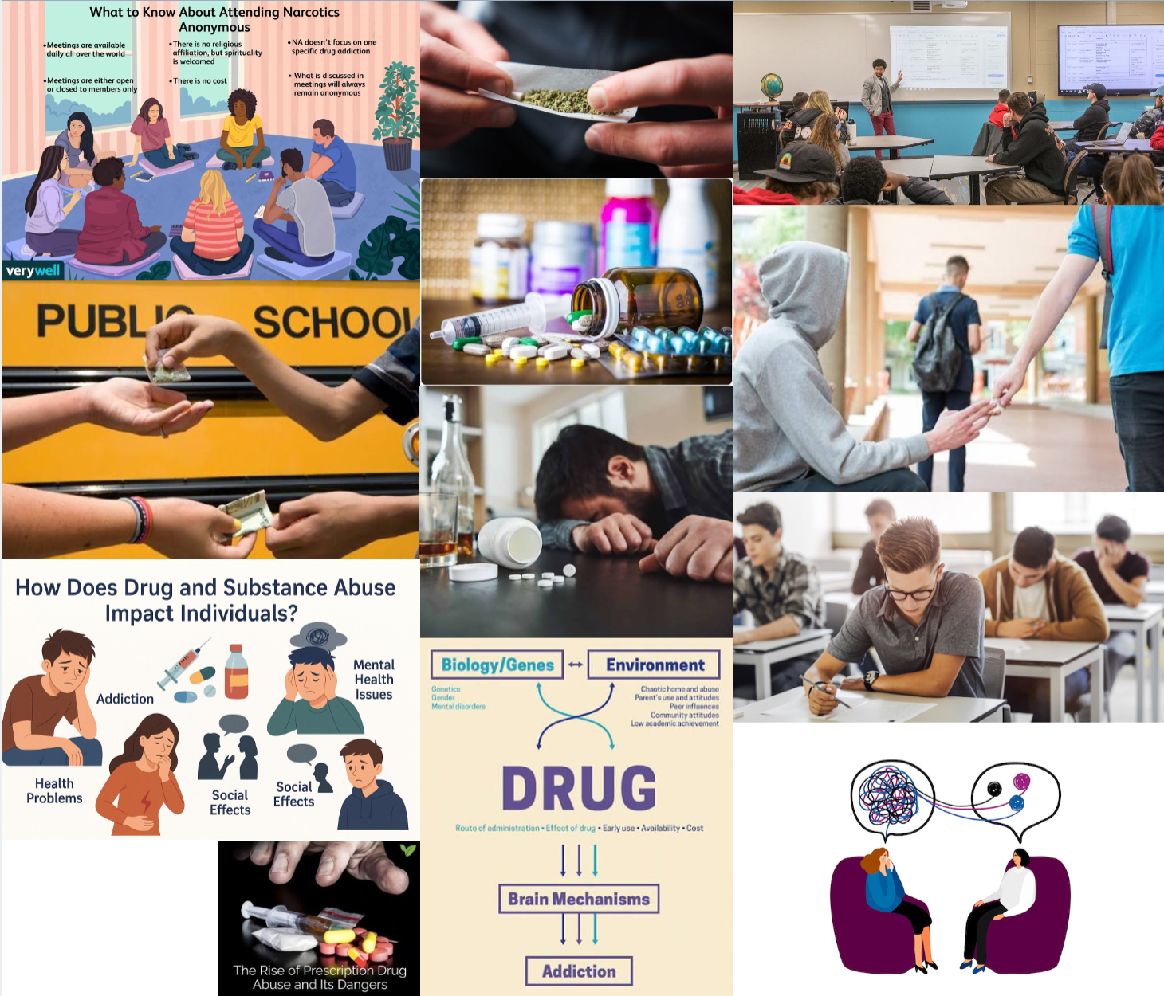

Empathy canvas
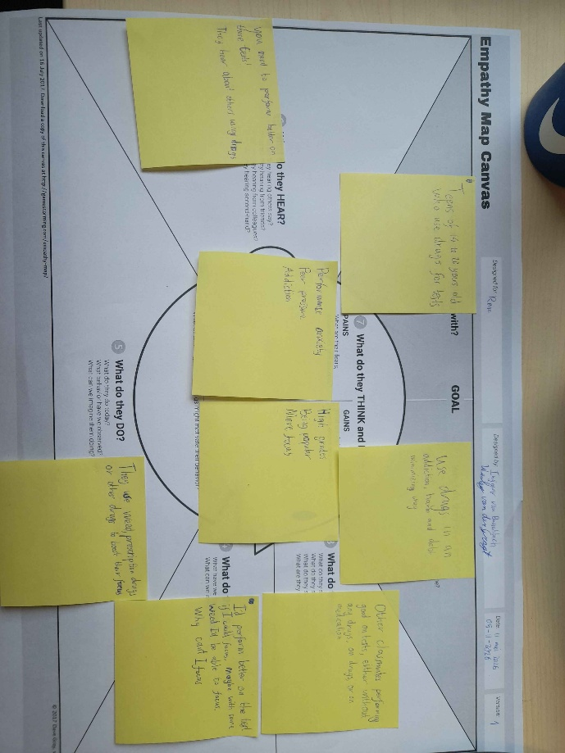

Jobs to be done
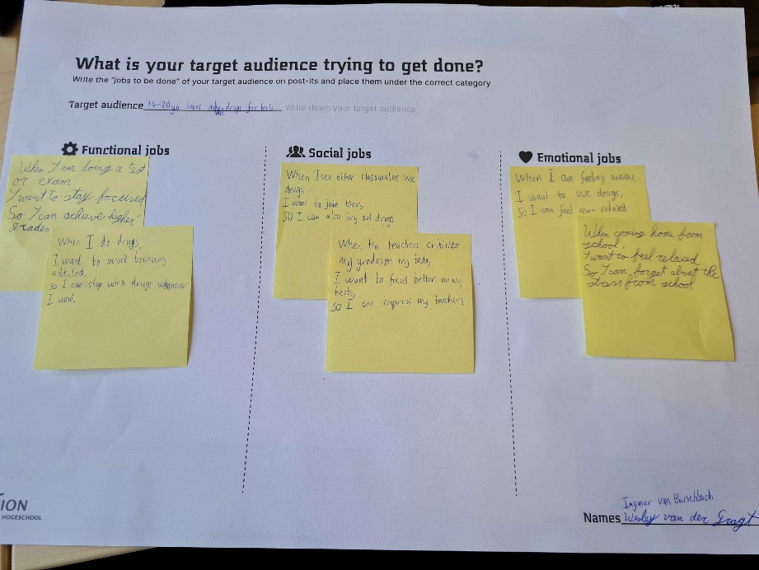

Week 12.2

IceBreaker
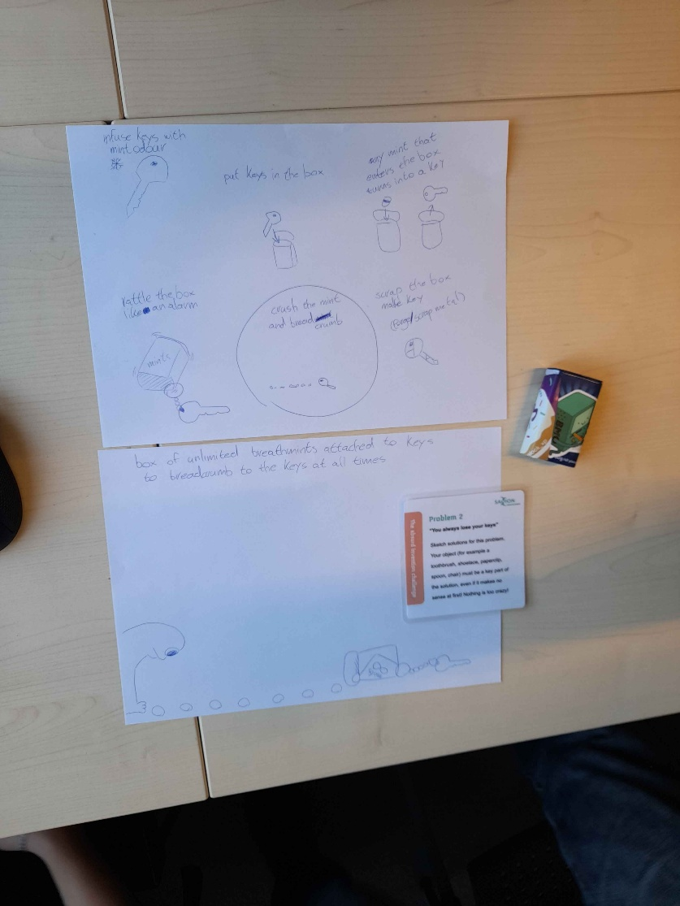

Reverse Crazy 8s
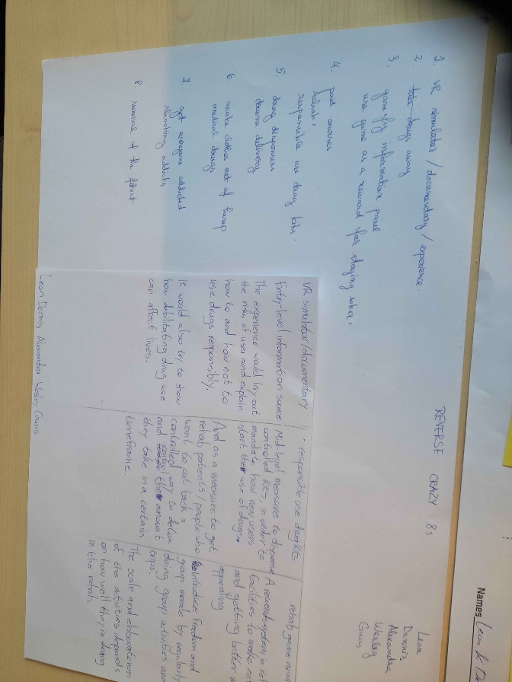

What would X do?
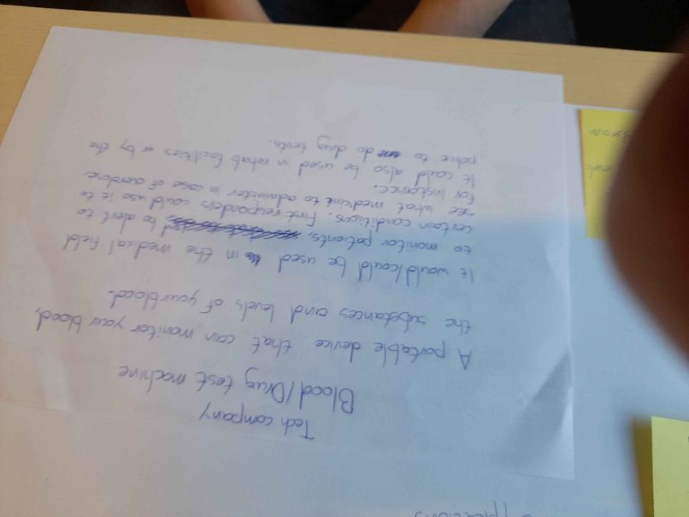

Forced Connections
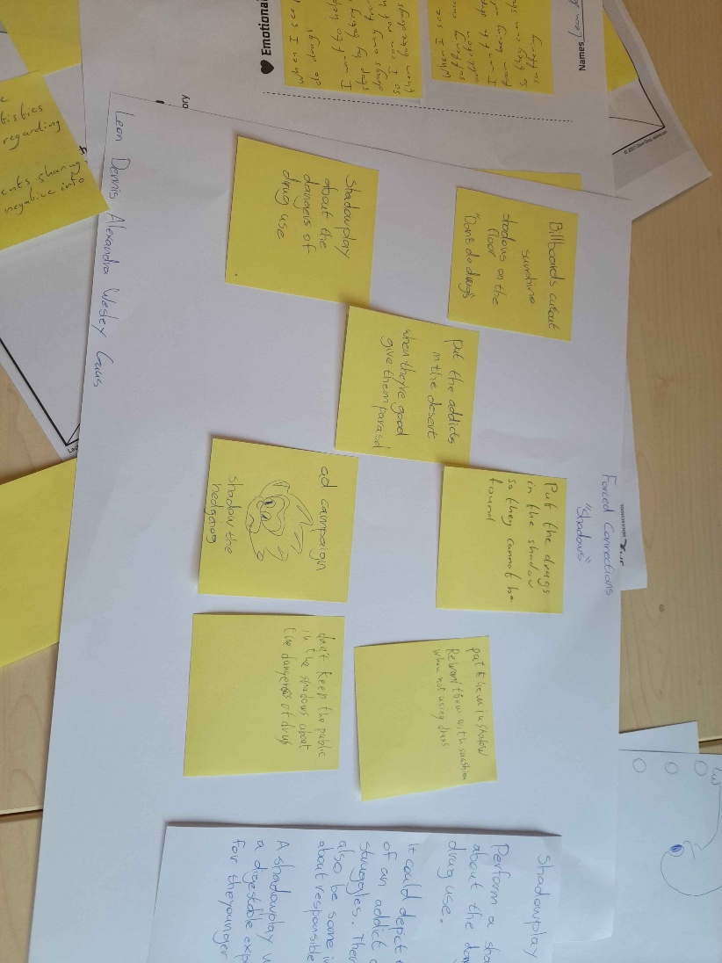

Reflection
- Which of the three brainstorming techniques felt most natural or effective to you? Why?
Reverse Crazy 8s since it would give us more room to think about them.

- Which technique surprised you the most in terms of the ideas it generated? Can you give an example of a surprising idea?
Forced connection, we came up with a shadow play to teach people about drugs.

- If you had to solve a creative problem in the future, which of these methods would you choose first — and why?
The Reverse Crazy 8s since you cant just only lock your vision into a single item or way. When there could be solutions in a different way.

Week 13.1

Selection methods (MoSCoW)
Using a system using
- Must-have (Non-negotiable requirements)
- Should-have (Important but not strictly essential)
- Could-have (Desirable but not necessary)
- Won’t-have (Wishes, for future cycles)
MoSCoW can be usefull in specific conext but it often leads teams astray by feature first thinking. The path to product start with a understanding of desired outcomes and in how they are achieved.
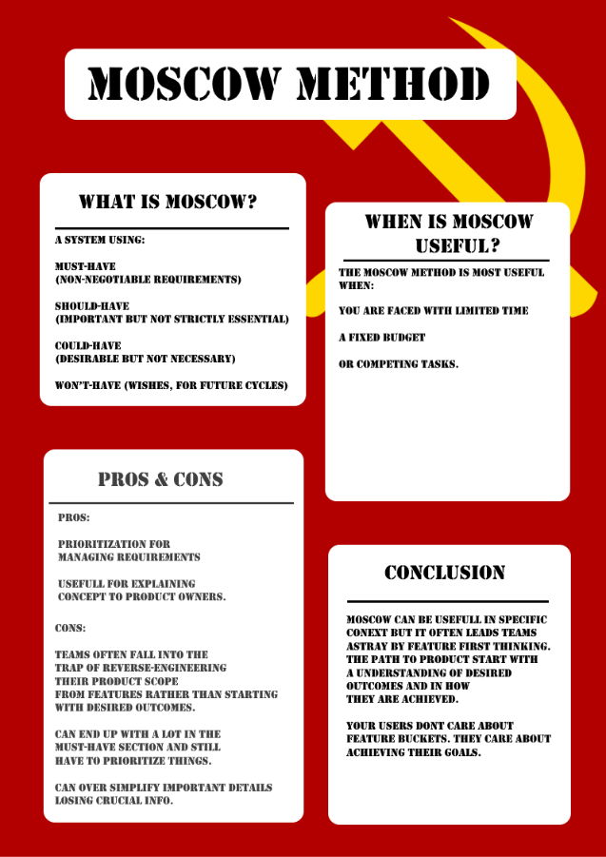

Reflection
- What did you learn about choosing ideas?
There more ways to choose then I thought

- Which of the presented methods seemed useful to you and why?
The weighted criteria seems useful since others can give points on how important they think it is.

- Can anything be added to the other methods according to you? What?
But some limits on it. Like the weighted criteria only gets a certain amount to vote so they cant just vote the same number on them all.

COCD Box
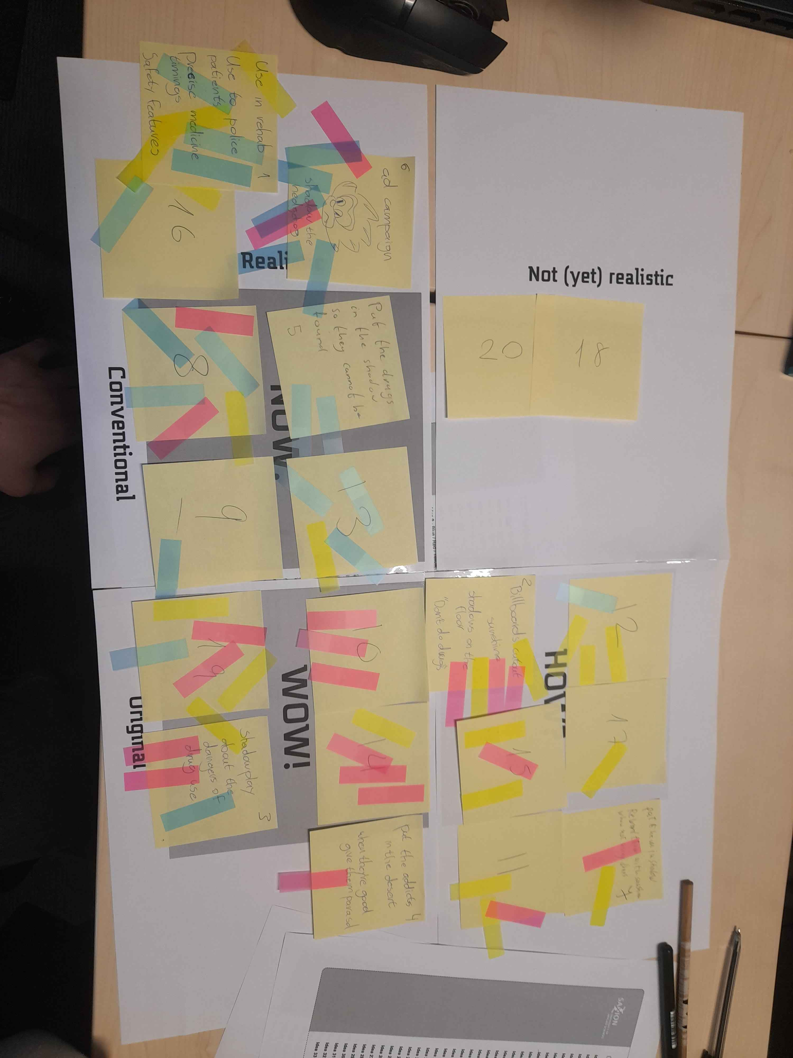

Reflection
- Which quadrant had the most ideas?
The NOW quadrant.
- Was it easy to agree as a group?
Group mostly yelled thru eachother till they found it right to put it in a certain quadrant.
- What surprised you about the results?
If even 1 person votes on a idea then that idea gets put in that quadrant even if it’s a terrible one.
- What were the WOW’s? Shortly explain the WOW ideas
We had a shadow ideas where everything was related to drugs and light/shadow. Like a billboard with holes in, shadowplay, shadow the hedgehog advertisement.
A gamified information panel which teaches people about drug use.
And a handheld device that can measure narcotic levels in the body so they can track the process of someone during rehab.

Week 13.2

Revisiting the research question
Old RQ: How can older generations keep the youth from falling into debilitating drug use?
New RQ: How can we steer society’s view on drugs to a more sustainable perspective?
Why change RQ?: The research question is to go into the right direction. Both when it comes to the solution, as well as what the problem is.
Solution: Gamified information panel to teach people about drug use.
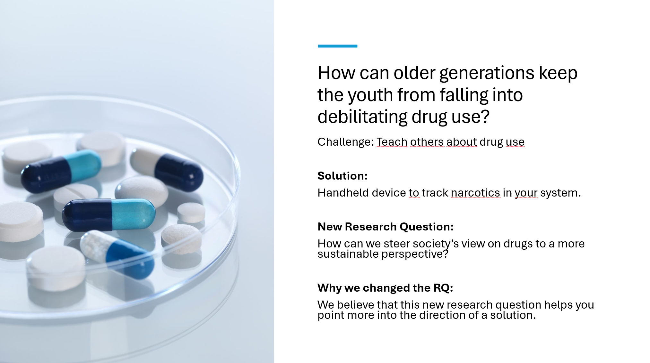

Research Question Reflection
What was the most important insight you’ve gained regarding formulating a research question?
There goes a lot of research into it to make a good research question and you should be able to answer the 5 Ws with the question itself mostly.
It’s a bit harder then I thought with the drug use since they aren’t all bad. Its in the way how you use them, so you should be thought when its dangerous and how to prevent addiction itself.

Target audience Reflection
What insights did you gain on the importance of having a well-defined target audience?
Depending on the target group, the solution can be into a fully different way.
And using the qualitative methodology it can help understand why and how people go into addiction and using drugs improperly.

Designing Questions
Since our solution is a handheld device that tracks narcotics in your system, it would be better to have both types of questions since each person could have a different experience.
So the questions I made are:
- How did it feel to be tested by the device?
- Do you think this could be helpful to others?
- What do you think this could be used for?
- Have you consumed any drugs in the past day?
- Do you take any medications?
I tried to make the questions in a way that there could be different scenarios with using the device. This way we can try changing the experience if its bad when used, get more ideas on how to use the results of the device and also test if its working right.

Final reflection
Throughout the weeks we have done assignments and tests that shown us what kind of person we are. These tasks told me according to the specific tests what kind of personality we have and how I approach certain situations. And besides these tasks we also had to create a research question and think of solutions for it. This showed that a simple question wont do and needs a lot more research and questions thrown towards it before creating a single good one. One area that I would like to continue learning is how to create good questions. I noticed that I am pretty bad at making those and researching what needs to go into it. I’m especially bad when the question isn’t related towards something I am doing and more towards a random subject.

Self-Assesment
- Analytical thinking (Sufficient)
I have gotten 5 scientific papers about drug use which is the topic I did and created a basic research question for it.

- Reliability of sources (Sufficient)
The sources found are from people who are into health and/or have written multiple research documents about the topic. I’ve also followed the CRAAP test with each which can be found in the relevant section.

- Lateral thinking (Sufficient)
As shown in this document, I’ve explored multiple design problems from different perspectives and got an empathy map and jobs framework.

- Divergent thinking (Sufficient)
During the bootcamps we used 3 different techniques which is inside the corresponding week.

- Decision-making framework (Sufficient)
Weve applied the COCD-box with a group which lets us put ideas into wow, now and never boxes depending on the type of votes each person had given the idea.

- Performance and Quality (Sufficient)
Ive done a basic reflection of the quality of the research and found improvements that can be made.

APA

Week 1.1
- sales-I Marketing Team. (2023). The Steadiness DISC Profile: A Blueprint for B2B Sales Success. https://www.sales-i.com/blog/steadiness-disc-profile-blueprint-b2b-sales-success

Week 11.1
- Bancroft, A. (2017). Responsible use to responsible harm: illicit drug use and peer harm reduction in a darknet cryptomarket. Health, Risk & Society, 19(7–8), 336–350. https://doi.org/10.1080/13698575.2017.1415304

- Chadda, Rakesh Kumar. Substance Use Disorders: Need for Public Health Initiatives. Indian Journal of Social Psychiatry 35(1):p 13-18, Jan–Mar 2019. https://doi.org/10.4103/ijsp.ijsp_117_18

- Moreau, J. (2016). “I Learned it by Watching YOU!” The Partnership for a Drug-Free America and the Attack on “Responsible Use” Education in the 1980s. Journal of Social History, 49(3), 710-737. https://doi.org/10.1093/jsh/shv062

- Ti, L., Tzemis, D. & Buxton, J.A. Engaging people who use drugs in policy and program development: A review of the literature. Subst Abuse Treat Prev Policy 7, 47 (2012). https://doi.org/10.1186/1747-597X-7-47

- Whiteacre, K. W., & Pepinsky, H. Controlling Drug Use. Criminal Justice Policy Review. https://doi.org/10.1177/0887403402131002

