Personal Branding & Portfolio 1
  - LEARNING PORTFOLIO
  - TEMPLATE VERSION 250901
Replace this placeholder with your own cover image

Name: Wesley van der Gragt
Student number: 549826
Teacher: Laura van de Mast
Date of submission: 8-1-2026

Table of contents
Week 5: Orientation on the creative industry 3
Assignment 5.1 3
Assignment 5.2 4
Assignment 5.3 5
Assignment 5.4 6
Week 6: Goal setting 7
Assignment 6.1 7
Assignment 6.2 9
Assignment 6.3 9
Week 7: Creating an online presence 10
Assignment 7.1 10
Assignment 7.2 12
Week 11: Visiting internship midterm presentations 13
Week 12: Learning from those ahead of you 14

After completing this document, please remove all the grey template text in this document and update the page numbers in this table of contents before converting this file to a PDF and submitting to Brightspace.

Week 5: Orientation on the creative industry

Assignment 5.1
Search online for platforms where creative industry jobs are posted (e.g., ArtStation, LinkedIn, Indeed, GamesIndustry.biz, Behance, GitHub). Find 3 job openings that are relevant to CMGT. Save the job postings and note:
- The job posting URL
- The job title
- Required skills and tools
- Level of experience (junior, medior, senior, internship)
- The company and location (if applicable)

URL | https://jobs.gamesindustry.biz/job/mid-level-programmer-indie-game-studio-hybrid-remote-42873
Job title | Mid-Level Programmer
Required skills and tools | - Proven experience shipping at least one indie AA title (ideally two), or mainstream AA/AAA game  - Strong proficiency in C++, Unity, or Unreal Engine  - Comfortable working independently and taking initiative  - Excellent problem-solving and debugging skills  - Ability to communicate clearly and collaborate across disciplines
Level of experience | Medior Programming
Company name and location | (Name not shown) and In The UK

URL | https://cdn.bfldr.com/S5BC9Y64/at/cm3c46qk48863v4s39zwg7h/Jr_Programmer_UJP_21824.pdf
Job title | Junior Programming
Required skills and tools | - Demonstrate the ability to use various APIs, use consistent code styles throughout your work, and follow general coding best practices.  - Review and understand code bases and expand on existing code while adhering to project standards.  - Diagnose and fix code that doesn’t compile or isn’t performing as expected.
Level of experience | Junior Programming
Company name and location | (Not shown)

URL | https://nl.indeed.com/viewjob?jk=d01c14be08bbe6fb&from=shareddesktop_copy
Job title | Senior Developer
Required skills and tools | - Je hebt ruime ervaring met programmeren en samenwerken in een team  - Je bent bereid elke dag te leren en bent breed inzetbaar in de organisatie  - je hebt bij voorkeur HBO/WO werk- en/of denkniveau op technisch gebied  - Je bent proactief, klant- en teamgericht en je kunt goed omgaan met tijdsdruk  - Kennis van OPS is een pré
Level of experience | Senior
Company name and location | Ultraware in Assen

Assignment 5.2
Based on your research, what is your opinion on the differences between junior, medior, and senior positions in your chosen field (e.g., junior concept artist vs. senior concept artist)?
You need more knowledge and work in the field to be able to achieve the requirements they ask of you for each level.

Juniors are mainly just looking/adding to code and works with Seniors.
Mediors are more towards taking initiative and things and working on multiple stuff.
Seniors need to have the most knowledge in the field and be able to do multiple stuff.

They all have to be able to work in a team.

Assignment 5.3
Search for professionals currently working in similar positions to the jobs you found. Use platforms like LinkedIn, ArtStation, GitHub, SoundCloud, social media (LinkedIn), or personal websites. Collect at least 3 profiles or portfolios of real people in these roles.
Analyze what makes these portfolios effective:
- How do they present their projects?
- What technical skills or tools do they highlight?
- How do they show their experience and credibility?
- What parts of their portfolio really convince you of their expertise?
Explain in 100-200 words what you would like to borrow or avoid when creating your own future portfolio. You are encouraged to support your reasoning with screenshots and source references.
Portfolio: https://shakiraliswe.com

- They show their work In a list between their certificates, contact info and education.
- They mainly highlight the certificates they have.
- They have all their projects and certificates next to eachother to show what he was done in the past.
- In their portfolio they have all their certificates which you can press a button to see the validation of each one of them.
Portfolio: https://mwamed.com/portfolio/

- You start off on a home screen and you can either scroll or press a button to go towards the skills, projects and contacts.
- They show the tools they work in with design. Front-end and back-end.
- They show a picture of the projects and a link to the github where it is.
- Doesn’t show much expertise since there is no description of the projects and the images shown with it arent even connected towards that project.
Portfolio: https://www.gaurshubham.com/#about

- They show where they have worked and their skills and projects.
- They don’t show any highlights but do show everything equally.
- They show their work where there is a link towards the company and with their projects you can go directly to them and check it out.
- They show descriptions on all their jobs and also either descriptions on projects or you can straight up play them immediately.
Borrow:
Have a home page with small introduction.
Have a page to show projects in a grid pattern.
Show skills that you have learned.
Have a topbar that goes with you with buttons to go back to homepage, skills and projects.
Have description on past jobs/projects.

Avoid:
If creating my own page that buttons, text and images stay in their position.
Don’t have different kinds of info next to eachother.

Reflect: do the professionals you looked up feel like your “competition,” or are they at a completely different stage in their careers?
These people have way more experience and knowledge using different tools and languages then I have currently.

Assignment 5.4
Create a powerpoint 1-pager which includes:
- What surprised you most while exploring the industry?
- What skills or experiences seem to be most in demand?
- What do you think you need to start working on to prepare yourself for your dream role?
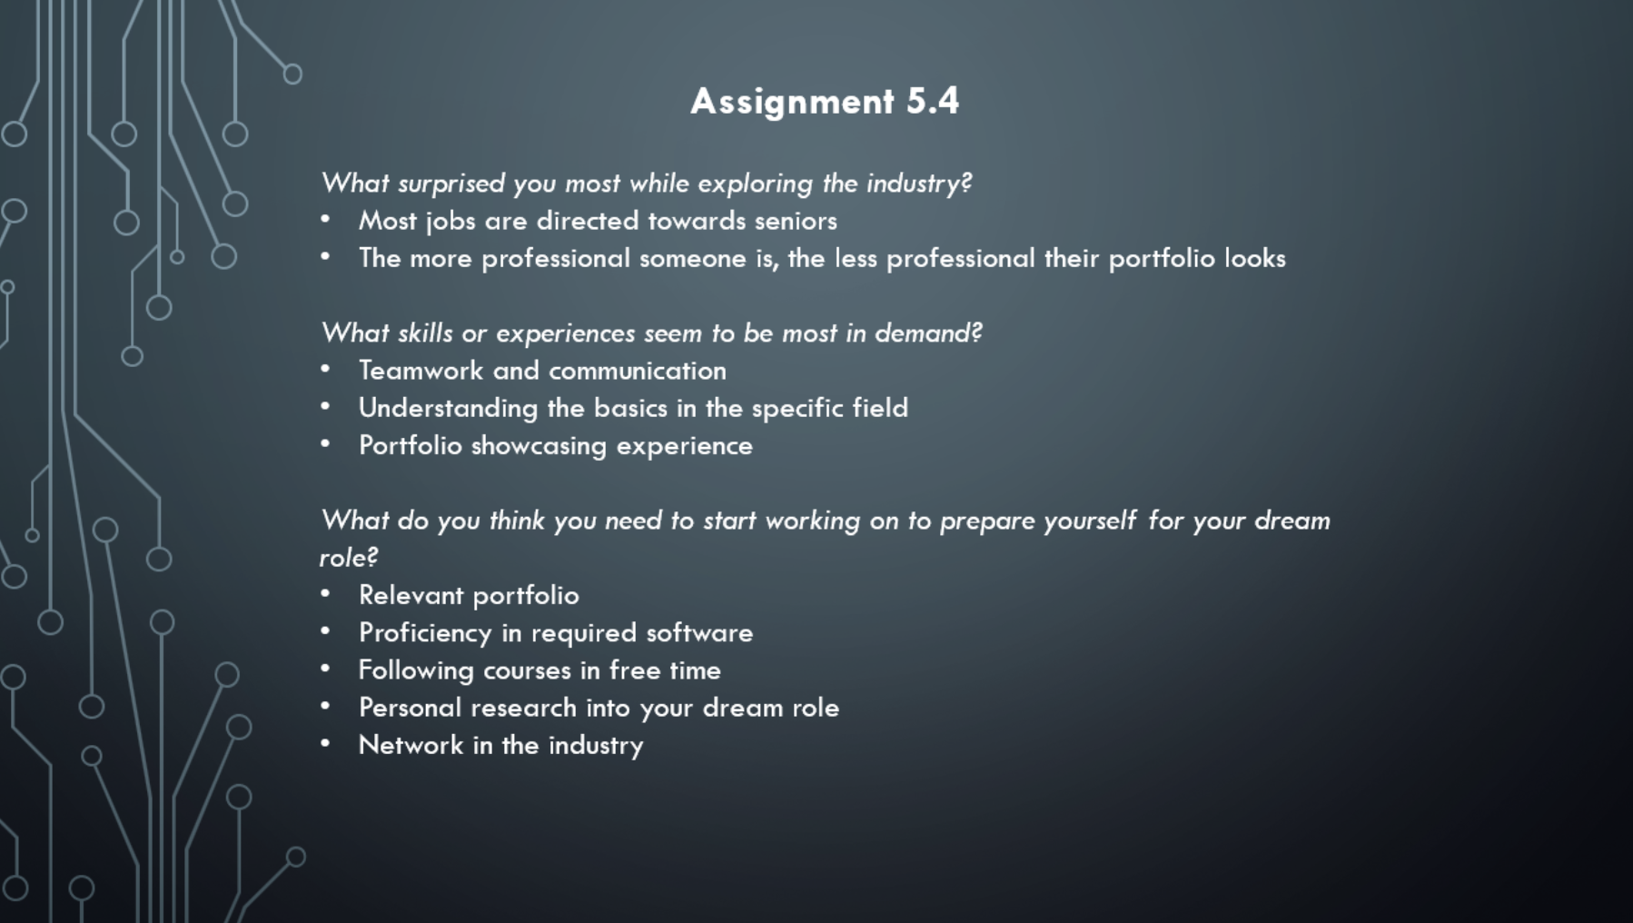

Week 6: Goal setting

Assignment 6.1
This questionnaire is designed to help you reflect on your strengths, learning style, goals, and interests as you start your studies in the CMGT program. By answering these questions honestly, you will give yourself and your instructors a better understanding of who you are as a student and what you hope to achieve. Your answers will help you:
- Identify your personal strengths and areas for growth.
- Think about your career aspirations and how your studies can support them.
- Reflect on what motivates you, both in your studies and in your life outside of school.
- Plan your time and activities to get the most out of your first year in videogame development.
Please take your time and answer each question as thoughtfully as you can. There are no right or wrong answers—this is all about understanding you better so that you can succeed and enjoy your studies.
- What are your key strengths?
Working on long periods of time.

- How do you learn most effectively?
While listening to music and turning off things like discord.

- What kind of role do you usually take in your group or student community?
Follower, I don’t like to lead the way on how things have to go. So I just ask what needs to be done and do that.

- What challenges or areas for development do you face in your studies?
I want to develop my coding skills and know how to 3d model things.

- Why did you choose to apply for the CMGT program?
It had more all around things then other programming courses.

- What type of job would you like to have after graduation?
I would like to become a gameplay engineer.

- What are your career aspirations, and what would you like to focus on during your studies?
I want to end up in a indie studio and focus on both programming and 3d models in the study.

- How can courses, summer jobs, hobbies, or student exchanges support your career aspirations?
By doing the courses I can learn the things I need to know and more.
Doing summer jobs could help if you have a bit of experience and work at a more technic place.
If you do these things as a hobby you can more easily learn new things.

- How do you take your career goals, international opportunities, and entrepreneurship into account in your personal study plan?
Ill have to intern at a studio to achieve my career goal.
With international opportunities I can broaden my connections and meet more people in the industry.
I don’t want to start my own company so I wont do much in that part.

- How are you feeling at the beginning of your studies?
I already knew most of the stuff in the lessons since I have been to this study before.

- How do you make sure your studies progress successfully?
By doing the assignments on time.

- Did your previous studies meet your expectations?
The previous time I did this study it was a lot of online lectures and I don’t learn all that great from those.

- What do you do outside of your studies?
I work and rarely do things with friends.

- How do you relax when you’re not studying?
Watching YouTube, playing a game, streaming and reading.

- What things are most meaningful to you in life?
Family and friends.

- How can you incorporate those values into your CMGT studies?
My working with my friends on things I can learn more since they have done this study for a while now.
Watching YouTube I can look at tutorials and how things work.
Playing a coding game could help with my coding skills.

Assignment 6.2
Define three long-term professional goals. Where do you want to be in five, ten or fifteen years from now? Be as specific as you can be. For example: “I want to be a senior game designer at a major studio within five years of graduating from CMGT.”
- I want to become a senior gameplay engineer at a indie studio within 5 years of graduating from CMGT.
- I want to have created a successful game that a ton of people play in within 15 years.
- I want to earn enough to live comfortably within 3 years.

Assignment 6.3
What are the essential skills, knowledge or certifications you need to reach your goals?
Tip 1: Our study program lets you develop 12 competences. These competences are determined at a national level to be necessary in the creative industry. Check out the CMGT competences document on Brightspace for inspiration on skills and knowledge you may need to reach your goals.
Tip 2: Job posts often list the required skills and knowledge for a particular position. Dig into what you’ve found in week 5 to complete your list of skills, knowledge and certifications.
Tip 3: Consider which of these are soft skills and which are hard skills. Which do you expect to be part of the CMGT curriculum and which do you need to develop elsewhere?
- Gameplay Programmer > Algorithms & data structures, Writing explanation, Self-management

Week 7: Creating an online presence

Assignment 7.1
Your online portfolio is one of the most important tools to showcase your work and skills to future employers, collaborators, and clients. Think of it as your digital business card: it should highlight your strengths, reflect your personality, and present your best work in a professional way.
Here are some tips to get started:
- Organize effectively. The way you structure your portfolio shows how you think. Always place your strongest piece first; recruiters and companies will assume this represents your best work. Choose wisely.
- Label and explain your work. Every piece should include context:
- What is it for?
- Why did you make it?
- What was the goal or challenge?
- Was it a team project? If yes, clearly describe your role and contributions.
- Tell stories. Give your projects depth. A character design should have a backstory, a user interface should describe its target user, and a level design should explain the design goals. Show your reasoning, not just the end result.
- Focus on quality, not quantity. A smaller number of excellent pieces is stronger than a large collection of average work. Four great projects will leave a better impression than ten mediocre ones.
- Highlight technical skills. Show the craft behind your work. For example:
- 3D models → include wireframes
- Programming → share code samples with comments
- UI design → show wireframes and iterations
- Game design → document mechanics, systems, and rules
- Show the process. Don’t only present finished products; demonstrate your workflow. Sketches, prototypes, and wireframes reveal how you think and solve problems. Employers love to see your process.
- Stay professional. Avoid clichés and irrelevant content. Unless you are specifically aiming for industries that want it, don’t include manga, or NSFW material. Keep your portfolio relevant to the jobs you want.
- Show range (where relevant).
- Artists: demonstrate versatility by showing different art styles and approaches.
- Designers & Engineers: highlight your specialties—whether that’s systems design, gameplay mechanics, UI/UX, or coding. If you’ve built something impressive, show it and explain it.
- Make contact easy. Always include clear contact information and links to your professional profiles (e.g., Itch.io, ArtStation, LinkedIn, GitHub). If people can’t reach you, they can’t hire you.
Provide a link to your online portfolio:
https://github.com/WesleyGragt

Add at least 2–3 screenshots of your online portfolio that clearly show:
- The landing page / homepage
- A project page or portfolio item
- Any section where you highlight your skills, experience, or contact info
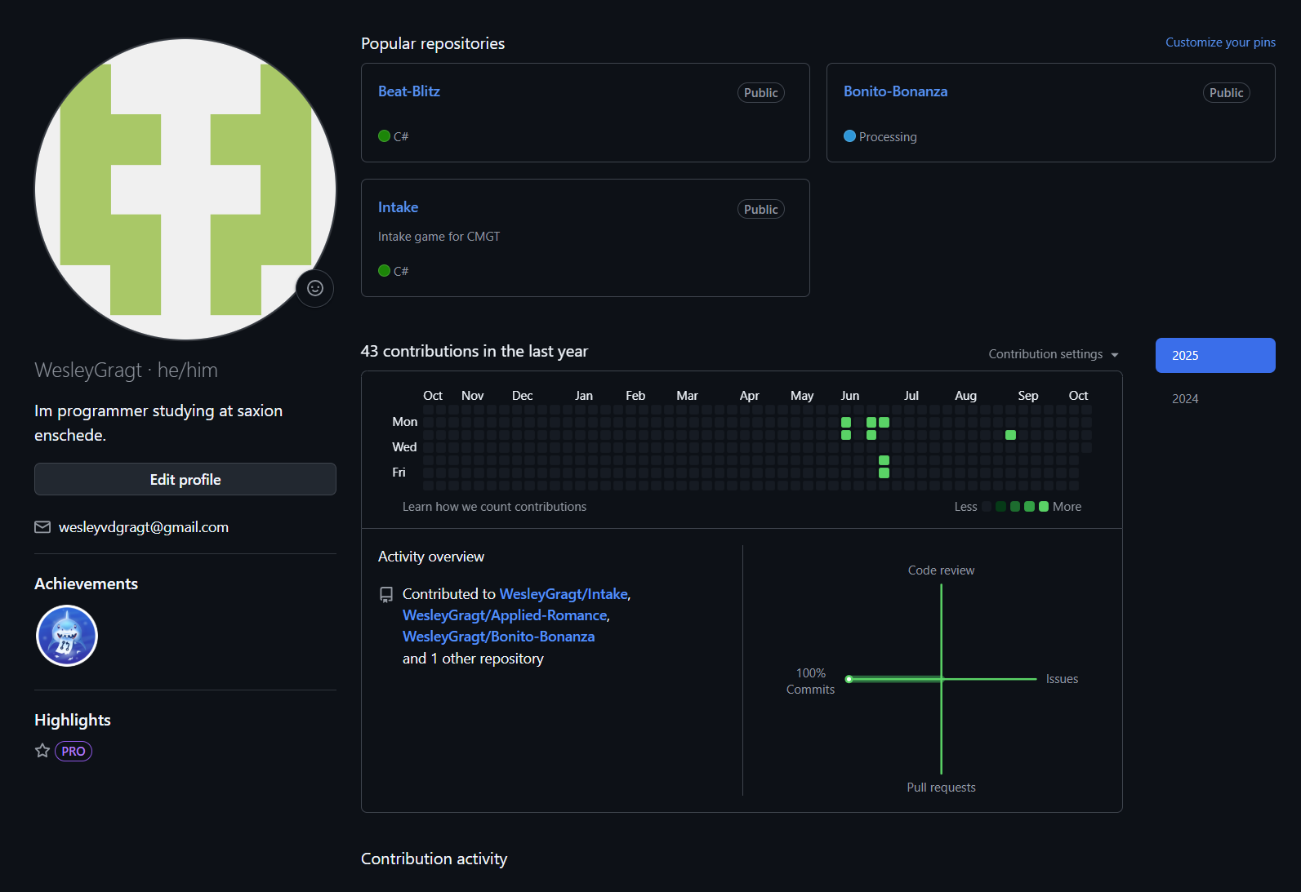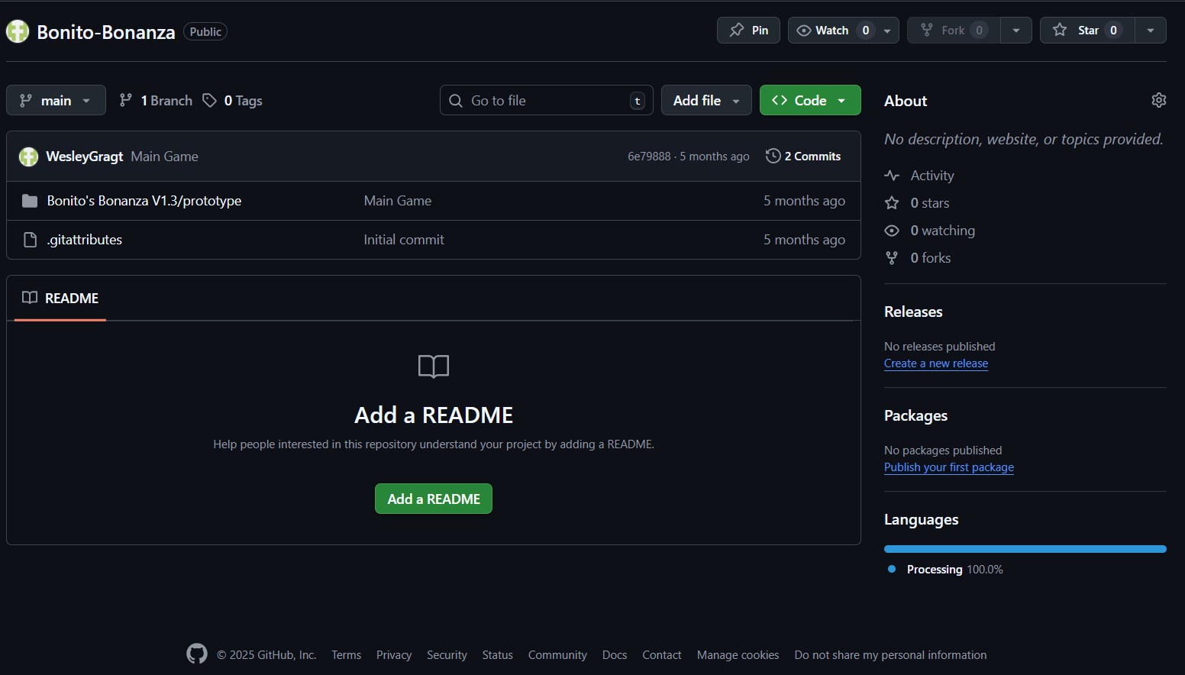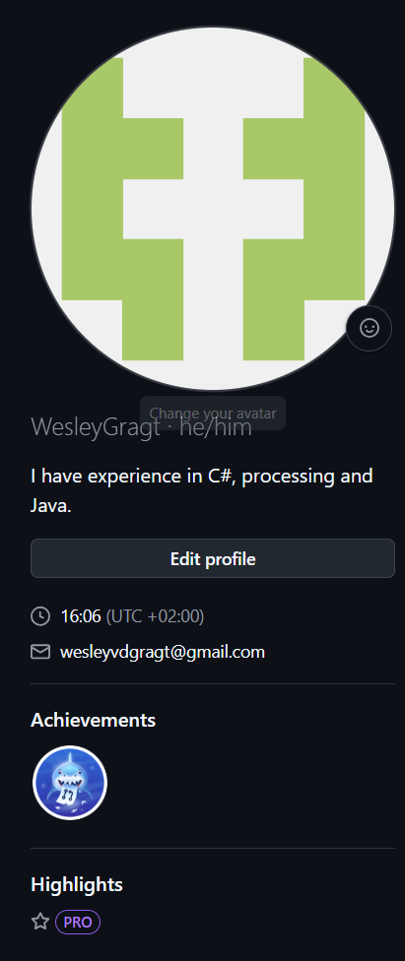

Assignment 7.2
Explain in 300-500 words why you chose this specific platform (e.g., ArtStation, GitHub, Itch.io, Behance, Squarespace, canva, portfol.io, carbonmande, adobe portfolio, wordpress, your own custom-built website, etc.) to showcase your portfolio. In your explanation, address the following points:
- Audience: Who is the portfolio for? (studios, recruiters, collaborators, indie dev community, etc.)
- Suitability: Why is this platform well-suited to your type of work (art, design, code, audio, writing, etc.)?
- Features: What features of the platform make it easy to present your projects effectively? (e.g., visual galleries, code repositories, ease of customization, visibility in the industry)
- Professionalism: How does this platform help you present yourself in a professional way?
- Future use: How do you see this platform supporting you as you continue developing your skills and applying for jobs or internships?
Audience:
My GitHub portfolio is primarily intended for recruiters, fellow programmers, tech communities, and potential collaborators. Recruiters often use GitHub to assess a candidate’s technical skills, coding style, and activity level. By maintaining an active and organized portfolio, I aim to demonstrate my coding abilities, problem-solving skills, and growth over time. In addition, I want to engage with the broader programming community—people who are passionate about software development, open-source projects, and collaboration. By putting my work out there, I increase the chances of finding like-minded developers who may be interested in working with me on future projects.
Suitability:
GitHub is especially suitable for hosting and showcasing programming projects because it supports version control, collaborative workflows, and code review systems. This makes it easy for me to upload, update, and share my code with others. I can get valuable feedback from users who review my work, which helps me improve not just the code itself, but also my overall coding practices. GitHub’s pull request system also makes it easy for others to contribute to my repositories, helping me collaborate with developers from around the world who are interested in what I’ve built or want to work on something similar.
Features:
GitHub provides several useful features that support both individual and team development. It allows me to create and manage repositories where I can store source code, documentation, and other related files. These repositories are easy to share through direct links or GitHub Pages. GitHub also supports branching and merging, which are essential for working in teams without overwriting each other's code. In addition, issue tracking, project boards, and built-in CI/CD tools help me manage my projects professionally.
Professionalism:
I demonstrate professionalism in my repositories by writing clean, well-structured code and including meaningful comments that explain what each part of the code does. I also use README files to describe the purpose, features, and usage of each project.
Future Use:
Over time, my GitHub portfolio will reflect my learning journey, showcasing how my skills have evolved. Each repository adds to the story of my progress, helping others—and myself—see how far I’ve come and what I’m capable of achieving next.

Week 11: Visiting internship midterm presentations
A good way to learn about what the creative industry has to offer you is by learning from students who are already out in the field. Third-year students currently on their internships will be giving midterm presentations about their experiences. This is your chance to see what kinds of companies you might end up at, what their daily work looks like, and what challenges and opportunities interns actually face.
Attend at least two internship midterm presentations. Afterwards, write two 300–500 word summaries that covers
- What stood out to you about the company and the type of work done there
- What an average day looks like for these interns
- The main takeaways or lessons that could be useful for you as a first-year student
Think of this assignment as collecting a little “preview” of your own future internship.
Summary 1
Rick Tannemaat is a 3rd year engineer who is doing his internship at Nedap in Groenloo.
There he is working in the healthcare department for the Luna Team.
Luna is a kind of calendar that was made for people with dementia with upcoming appointments. It shows the time and date for when those appointments are.

The work there typically starts with a startup where they talk with others for what to work on.
And each week the engineers have a sprint planning where they talk about the next 4 weeks what they are going to work on.

His learning goals for this internship are to help develop the Luna Admin Panel. Where he has to write good code and work in a professional manner.
Learning new coding languages, Luna uses Kotlin as their language and besides that learn Vue3 and MySQL, CSS, Spring boot, HTML, Datadog and CLI.
And how to work with a MacBook.

The reason why he chose these goals are to learn and understand new languages, learn how to review code and get reviewed.
He has trouble with writing tests and Learned PR reviews thru code reviews.

The way he chose to learn from the reflects is by self reviews and reviews, Learning from his mistakes and the way he is coding in the Luna team is like coding a game but not coding a game.
And before sending the code he made to the rest of the team he reviewed the code himself.
The communication in their team was done with standups.
He joined all the standups they did and made himself clear and simple on the work he did.
Talking surface level of the work is good to do but also by going more into depth is a good practice.
And by having a good git usage helps a lot as well.

With his enterprising attitude he had to take initiative by picking something else up when he was done with all his tasks and finding multiple solutions for a single problem and finally meeting with support people to get to know their questions where the support had to write everything down what they found confusing.

Concerning the tasks he did while working in the Luna team at Nedap were
Adding fuzzy search to the app, change the id to a client number, Adding a reboot button, keywords to allowlists and the schedule state of the app.
These are the things he added and changed in the admin panel.

In the end he found it a lot like trial and error working there.
While working on the tasks there it could be difficult to understand of things worked so you should ask on the things you don’t understand.
And in the end you study your way thru an internship.

In conclusion he hopes to doing a lot of work while in the internship and working at the Nedap.
Since making the interview we attended he had to add 3 more features which ended up in a single feature per week.

Summary 2
Niels is a 3rd year engineer who is doing his internship at XR-LAB
Where he worked on a VR training application for military training, serious gaming and mostly VR.

At the start of his internship was a presentation about learning the tools they are using for the first week.

The main project he worked on is LUMC.
Its made for training for anaesthesiologist and show what to do when things go wrong.
He had to make the infusion valve turning for injecting medications into patients and moderating it.
And improving interactions since it was super funky at the start.

The other tasks he did were Catheter placement improvements, showing veins by tapping on a spot on the body and fixing the problems with the heart monitor.

Minor projects he did are STOMA where he had to make a VR application for patients when the get STOMA treatment. Which is basically about how to use the poop bag.

For his reflection while working at the XR-LAB he found out that most code was made using blueprints.
And while working there at the start he had a hard time to ask questions.
He also wasn’t burned out at the end of the internship, unlike previous ones where he was burned out within a couple months.
Those internships were a lot different. If you couldn’t concentrate for 5min it would be a bigger deal for the first internship he did.
He also gained more confidence for a 9-5 job.

Moving forwards he wants to work on bigger tasks in the internship, have more efficiency while working and to keep doing what he is doing at the moment.

We also had a few questions for him at the end of his presentation which were the following.
He mentioned on a bigger project he wanted to work on and that’s writing code for the new eye cover project they are doing.

How did he get the internship? They have internships every semester. You can just send a email of your cover letter, CV and portfolio to the XR-LAB where he got a email a month later saying to come for a interview and he got accepted afterwards.

We also asked what the typical workflow was like in the main projects. Where its 2 weeks a sprint where a supervisor puts tasks onto the sprint and the rest has to work on those. Sometimes you may also be appointed one of the tasks directly by the supervisor. There were no client meetings he had to do and Niels also didn’t find it necessary to do those.

Week 12: Learning from those ahead of you
You’re just starting your studies, and who better to give you a peek into the future than students who are already in year 3 or 4? For this assignment, you’ll interview a senior student to find out what the road ahead might look like.
During your interview, make sure to talk about:
- Have they changed their career path along the way?
- What kind of struggles did they face?
- Do they have any tips for you as a first-year?
- What would they have done differently if they could start over?
Tips for a good interview:
- Avoid yes/no questions. Instead of asking “Did you enjoy your internship?”, try “How did you experience your internship?”
- Prepare your questions in advance. Do you want to ask them in a certain order? Do you have follow-up questions in mind?
- Go deeper than “Was it fun?” Push for insights and reflections.
- Document your interview. Record it (with permission), so you can focus on the conversation and not just on remembering everything.
Conduct one interview and write a 300–500 word summary of what you learned. Highlight the main takeaways and insights that could help you on your own study journey. The summary should contain the name of the person you have interviewed and the reasoning to why that person. Furthermore, it should contain the questions and the reasoning to why you’ve asked these questions.
For my interview I decided to ask questions to Rick Tannemaat since he is a 3rd year engineer and I think he has good skills and insight on what the work is going to be like.

My first question to him was why he chose CMGT in the first place and not something else on which he answered that it was by chance and he was going to the open day for HBO ICT first and saw that CMGT also had one and then decided to do a student day for the both of them and found out that CMGT felt better for him to learn what he wanted to learn.

To which I asked what he found more interesting in CMGT then in HBO ICT on which he said that it’s the way we are taught. With HBO ICT its told how to do a task. And in CMGT you choose how your going to do the task. To which the solution could be better or worse.

He mentioned databases and programming during his answer so I asked him if he is in the engineer tract which he said yes to. And then asked him why he chose this specific route.
To which he said that he really likes writing code and everything that comes with it. Doing the logic puzzles you create while coding. Like you know what you want it to do, its just how your going to do it.

After that I asked what he would’ve done if he didn’t choose for the engineer tract and he replied in short that he would’ve been a designer since his art skills aren’t on par to being an artist.

Since he is a engineer I also asked him what the hardest class was for him as an engineer and he said that it was shader programming in C++ and the reason for that was because it was in C++.

With that answer I asked him what other languages he knows and he said that he knew several at this point, like a bit of C++, Kotlin, java, CSS, HTML, Springbooth and C# and that its also a part because he is doing an internship where you have to learn more languages for.

And after that I asked him how his workload during the years had changed for him. To which he said that it was quite doable in the first year since he already had the basics of coding like reading and understanding it. The 2nd year was slightly harder since there were some courses which he didn’t understand part of yet. At the end he found that the workload was good and high enough for him.

Since the amount of work was good and high enough for him I asked what subject became more important for him and he said that they were all equally important but in the 2nd year if there was a course he would drop each time it was PBP since you could scale your work down slightly if needed because there wasn’t a set goal for it like other subjects have a minimal requirement.

With the amount of workload and subjects he has had, I asked him what tools he had used for all of it. To which he said that he mostly used JRA, GitHub for code and some planning tools for projects. He also sometimes tried AI to help him with problems which he got stuck on for a long time and found it not helpful and still had to ask teachers on how to do it or fix it himself.

Knowing these tools now I then asked him if he has any tips for a first year and what he would’ve wished to know before going to this school. To which he said is to have fun is more important than having a good grade. To which he told a small story where in his first project he didn’t have fun, he only put a lot of effort into and didn’t end up with a good grade. To which he said to himself that he is going to have fun with his team in the next projects and not care about the grade that will follow. If he gets a 6 he gets a 6, if he gets a 9 he gets a 9. A good grade will follow if your having fun.

He mentioned earlier in the interview that he is in a internship so I asked how he had gotten one, to which he told that you should go from the inside. Find an employee at the company in a senior position and contact them for an internship and not the company because the company almost never replies back.
And my final question was if he had any tips for first year engineers to which he said to play around a lot. Create a ton, either in a big project or a small one. It doesn’t matter. The more you use the code the better you learn it and to create dumb silly games. Create anything you want and learn from it. It doesn’t have to be a project or a game you want to finish.

Prepared questions:
- Why did you choose this study?
- Did u stay with your original route?
- If you would’ve done something different. What would that have been?
- What classes did u find the hardest?
- How did your workload change throughout the years?
- What subjects became more important to you?
- Did you use any tools to help you with your education?
- What is one thing you wish you knew when you were in my grade?
- Any tips on how to get a internship?
- Do you got any tips for a first year?

Feedback:
Week 5: Company name + Location missing by some. Overall very nice job applications and provided with clear information.
The other assignments for week 5 are clearly filled with the information that was asked for.
Missing 3 portfolio’s 5.3

Week 6: everything clear and provided what asked for.

Week 7: Provided the needed screenshot for the assignment and told a very clear and organized explanation why he used github for his portfolio.

Week 11: not provided yet

Week 12: Broad range of questions.

Overall very clear and organized information. Provided what asked for. Maybe add a little bit more to the questions in week 6.

