This is intended to be a place where we can explain and discuss what we are working on

My initial idea as seen in the initial commit is to have a few different tabs.
- The main intro screen
- The downloads tab
- and the actual video editing tab

This is my (I hearby claim green as Matts colour) initial idea for what the editor might look like. Not sure what you'r thinking but this is deffinitaly not final and is open to discussion
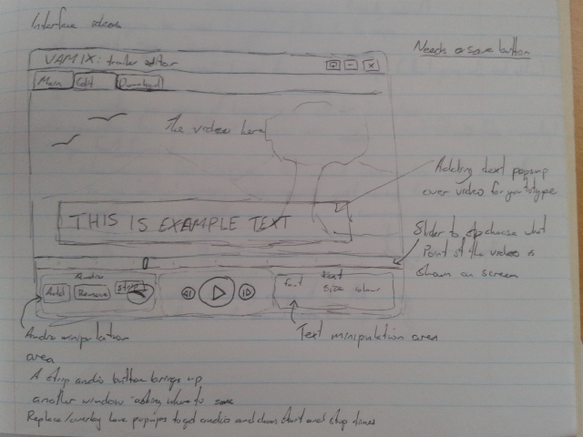
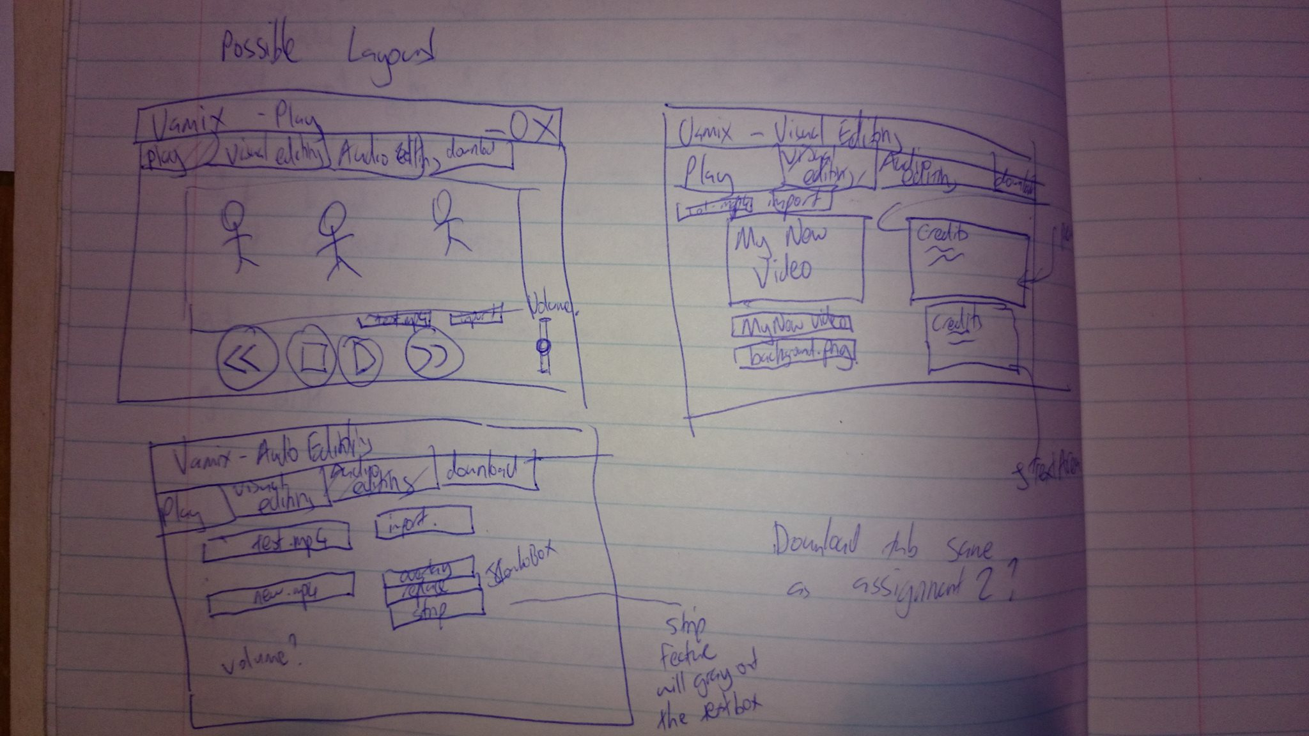
Wesleys ideas for the layout (you have been given blue so we can tell everything apart)

In my latest/this commit I have added the video player to the editor tab with a simple button that when first clicked lets the user choose a file to play, it then works as a pause play button.
The layout is currently just a simple box layout as that was quick and easy but we will have to work on it at some point.
My next task will be to have a seperate button to choose the file. Also I will add a stop button that stops the video rather then pausing it (in preperation for another video to be played I guess)

Testing pushing to github---

List of tasks:
- stop video – matt
- choose file - matt
- overwrite if download exists - wesley
- strip audio
- replace audio track
- overlay audio on existing track
- various volumes
- fast forward/ fast back
- create title and credits

For layouts, I would suggest using MigLayout, which is what I used for assignment 2, and was also used last semester for the Flickr browser. It's really easy to use and to see how everything is laid out.

I started using MigLayout for the downloads panel, Im a little confused as to how it works so I will have to do some research on it.
I have also added a stop button which gets rid of the current video so a new one can be loaded, im not sure if stop is the correct name for it. There will be a load button added at some point so that the user isn't expected to click stop then play in order to start a new video.

