Khepera Simulator

Background

Evolutionary Robotics (ER) is an extension of the basic Evolutionary Algorithm (EA) to the domain of robotics. Typically the ER process is used to automate the development of optimized and accurate robotic controllers, since ER removes the need for manual coding of robotic controllers by a human.

The controller used by a robot allows the robot to perform a certain action. A robotic controller typically produces appropriate motor movements which will allow a robot to perform its task accurately.

A simple version of the ER process would look as follows:

initialize a random population of candidate controllers
while stopping condition(s) not true do
evaluate the fitness of each controller in the population
perform crossover and mutation to create offspring controllers
select the new population
end while
output the best evolved controller in the final population

Algorithm 1: The ER Process

As can be seen from Algorithm 1, the ER process is identical to the basic EA. However, certain considerations have to be made when implementing an ER process:

- Encoding used to represent candidate controllers in the population
  - for simple robotic tasks (such as the one to be evolved in this assignment), array type structures can be used to encode controllers
- The fitness evaluation process of each controller
  - as in the basic EA, a fitness function is typically employed in order to measure the performance of each controller in the population. This fitness function often depends on physical quantities that can be measured in the robot’s environment, e.g. the position of the robot at a given point in time

Use is often made of robotic simulators during the ER process. This is because measuring the physical quantities needed to calculate the fitness value for each controller in the real world can be very time consuming. If we can thus simulate these quantities, the ER process can be performed completely in software and is much faster.

Simulator

The robot on which the simulator is based, is a Khepera III mobile wheeled robot. This robot makes use of differential steering to move, similar to a wheel chair. The robot has two wheels which are controlled by two independent motors. Examples of motion for this robot are:

- If both motors turn forward at the same speed, the robot will move forward in a straight line.
- If both motors turn backward at the same speed, the robot will move backward in a straight line.
- If the motors turn in opposite directions at the same speed, the robot will turn on the spot.

The simulator is written in Java. You only have to know about a few classes to use it.

//class describing the physical state of the robot at a given point in time.
//x and y are the robot’s position and a is its orientation angle
//units: x and y in cm and a in degrees
public class State
{
double x, y, a;

public State (double xin, double yin, double ain)
{
x = xin;
y = yin;
a = ain;
}
}

//class describing a certain motor command given to the robot
//left and right are the motor speeds given to either of the robots wheels. A positive value for either of //these speeds represents forward motion of the wheel, 0 represents a stationary wheel and a negative //value represents backward motion.
//time is an integer > 0 which represents the time in milliseconds that a command will be maintained
//NB: Note the max and min values for motor speeds. Values falling below the min value should be //rounded down to zero
public class Command
{
public int left;
public int right;
public int time;
public long timestamp;

//Please note:
//max_motor_speed=17500.0 (positive or negative)
//min_motor_speed=8000.0 (positive or negative)
//max_motor_time=3100
//min_motor_time=300
//preferred_motor_time=800

public Command(int l, int r, int t)
{
this.left = l;
this.right = r;
this.time = t;
}
}

//class returned be the simulator in response to a command. Contains the new position and the readings //from the nine IR sensors. A Boolean is set to true if a collision was detected during the command
class KheperaState
{
State position; //x, y location and angle
double[] sensorReadings;
//9 sensor readings in order: left_90, left_45, front_left, //front_right, right_45, right_90, back_right, back, back_left
boolean collision; //true if robot is currently in a collision state
}

//class describing the robotic simulator as a whole. An ArrayList of obstacles are passed to the simulator
//in the constructor if needed. At the moment, the only obstacles that are simulated are soda cans
public class KheperaSimulator
{
//default constructor for the simulator
public KheperaSimulator (State start) {}

//constructor for the simulator if obstacles are present
public KheperaSimulator (ArrayList<Point> obstacles, State start) {}

//this method is where the actual simulation occurs
//INPUTS:
//It is assumed that the robot will begin from rest before receiving the commands. commands
//is an ArrayList containing one or more Command objects which are given to the robot in the
//order that they appear in this ArrayList
//OUTPUT: An ArrayList containing the predicted path that the robot will follow when given the //commands in commands. This ArrayList includes the initial state of the robot and all //subsequent states following the commands
public ArrayList<KheperaState> getKheperaState(ArrayList<Command> commands)
}

//class that can be used to visualize a path followed by the robot
public class VisualFrame
{
//constructor for VisualFrame class
//INPUT: The location and dimensions of the frame, radius of obstacles, a target point, start point, radius of target
public VisualFrame(int left, int right, int width, int height, ArrayList<Point> obstacles,
double obstacleSize, Point target, Point start, double targetSize)

//Setting the path to be animated. This method takes as input nn ArrayList of States describing a
//path taken by the robot. A string to be displayed in the frame is also taken as input
public void setPath(ArrayList<State> path, String message)
}
Animation is started by the run method of the VisualFrame. Since the class implements Runnable, the animation can either be started by spinning off a separate thread, or simply by calling run.

Note that in the above description, it is assumed that a global set of axes, namely the x-axis and y-axis are defined. The robot therefore moves in the xy-plane. The position and orientation of the robot are then defined as shown in Figure 1:

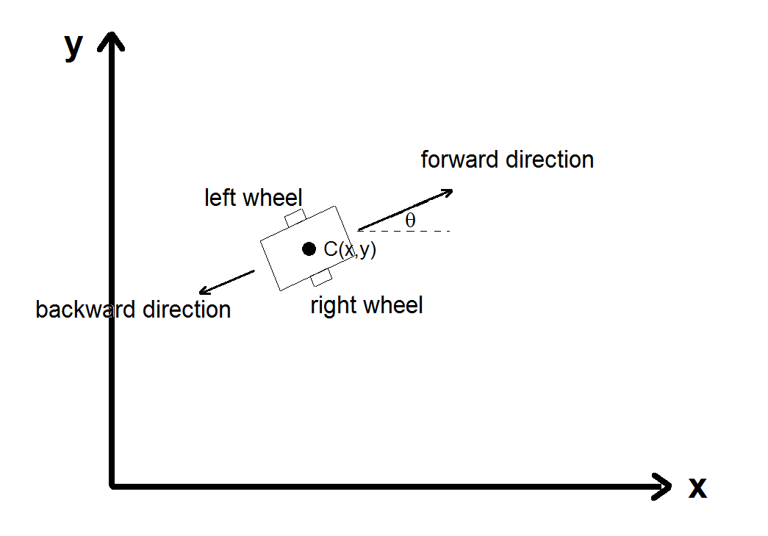
Figure 1: Simulator definitions

The x and y coordinate of the robot are actually the x and y coordinate of the centre point of the robot in the defined coordinate frame, C(x,y). The orientation angle θ of the robot is the angle that a forward-pointing vector makes with the y-axis. For example a robot moving in a straight line in the direction of the positive x-axis will have a constant orientation angle of 270 degrees (or -90), one moving in the direction of the negative y-axis will have orientation angle of 0 degrees etc.

The file Example.java contains the examples of using the simulator and the visual frame.

