

|  |
| --- |
| **PROPOSTA DA ATIVIDADE:** |

A partir do diagrama apresentado abaixo desenvolva um script no Oracle Live SQL que crie as tabelas aluno, matrícula e classe com seus respectivos atributos respeitando o relacionamento das chaves primaria e estrangeira. Após o desenvolvimento copie o cole o script abaixo.

Oracle Live SQL disponível em: [https://livesql.oracle.com](https://livesql.oracle.com/)/

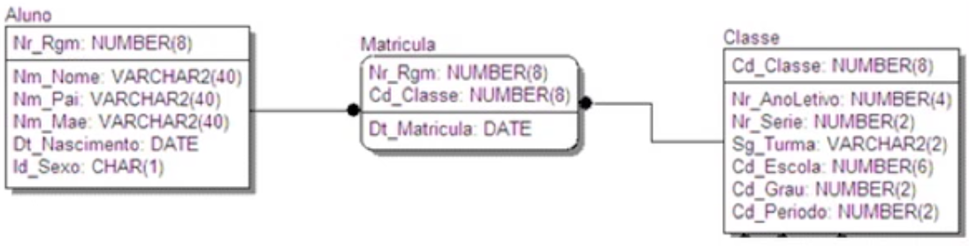

|  |
| --- |
| **SCRIPT –** *cole o script desenvolvido abaixo* |

**create table aluno**

(Nr_Rgm int(8) UNSIGNED not null AUTO_INCREMENT,

Nm_Nome varchar(40) not null,

Nm_Pai varchar(40) not null,

Nm_Mae varchar(40) not null,

Dt_Nascimento date not null,

Id_Sexo char(1) not null,

constraint primary key(Nr_Rgm));

**create table classe**

(Cd_Classe int(8) UNSIGNED not null AUTO_INCREMENT,

Nr_AnoLetivo int(4) not null,

Nr_Serie int(2) not null,

Sg_Turma varchar(2) not null,

Cd_Escola int(6) not null,

Cd_Grau int(2) not null,

Cd_Periodo int(2) not null,

constraint primary key(Cd_Classe));

create table matricula

(Nr_Rgm int(8) UNSIGNED not null,

Cd_Classe int(8) UNSIGNED not null,

constraint matricula_nr_rgm_foreign foreign key (Nr_Rgm)

REFERENCES aluno (Nr_Rgm) ON DELETE CASCADE,

constraint matricula_cd_classe_foreign foreign key (Cd_Classe)

REFERENCES classe (Cd_Classe) ON DELETE CASCADE);

(Nr_Rgm int(8) UNSIGNED not null AUTO_INCREMENT,

Nm_Nome varchar(40) not null,

Nm_Pai varchar(40) not null,

Nm_Mae varchar(40) not null,

Dt_Nascimento date not null,

Id_Sexo char(1) not null,

constraint primary key(Nr_Rgm));

**create table classe**

(Cd_Classe int(8) UNSIGNED not null AUTO_INCREMENT,

Nr_AnoLetivo int(4) not null,

Nr_Serie int(2) not null,

Sg_Turma varchar(2) not null,

Cd_Escola int(6) not null,

Cd_Grau int(2) not null,

Cd_Periodo int(2) not null,

constraint primary key(Cd_Classe));

**create table matricula**

(Nr_Rgm int(8) UNSIGNED not null,

Cd_Classe int(8) UNSIGNED not null,

constraint matricula_nr_rgm_foreign foreign key (Nr_Rgm)

REFERENCES aluno (Nr_Rgm) ON DELETE CASCADE,

constraint matricula_cd_classe_foreign foreign key (Cd_Classe)

REFERENCES classe (Cd_Classe) ON DELETE CASCADE);