Weslyn Wagner EE 5343 UTSA: Project Proposal 11/08/2016

**Proposal:**

Create a program that will read a file of string items as available ingredients and prompt the user to select a meal from a list of pre-set list of meal options. The program should compare the available ingredients with those required to make the selected meal; if all of the ingredients are not available, then the user should add them to the file of available ingredients and try again. If the appropriate ingredients are available, then the recipe should be displayed in a user-friendly presentation via graphical user interface and the user should have the option to “make” that meal. If the meal is made, then the ingredients used should be deducted from the inventory.

**Design:**

There should be several types of java classes for the program to be constructed properly—a main class which reads the file, prompts the user for input, and calls other necessary classes; a class for every known meal choice which contains its ingredients and its recipe; a class to compare the available ingredients to those required for the chosen meal; and a class which displays the information in a GUI. Though each of these classes will have member variables and methods, none of them should require getters/setters for this program.

**Example GUI:**

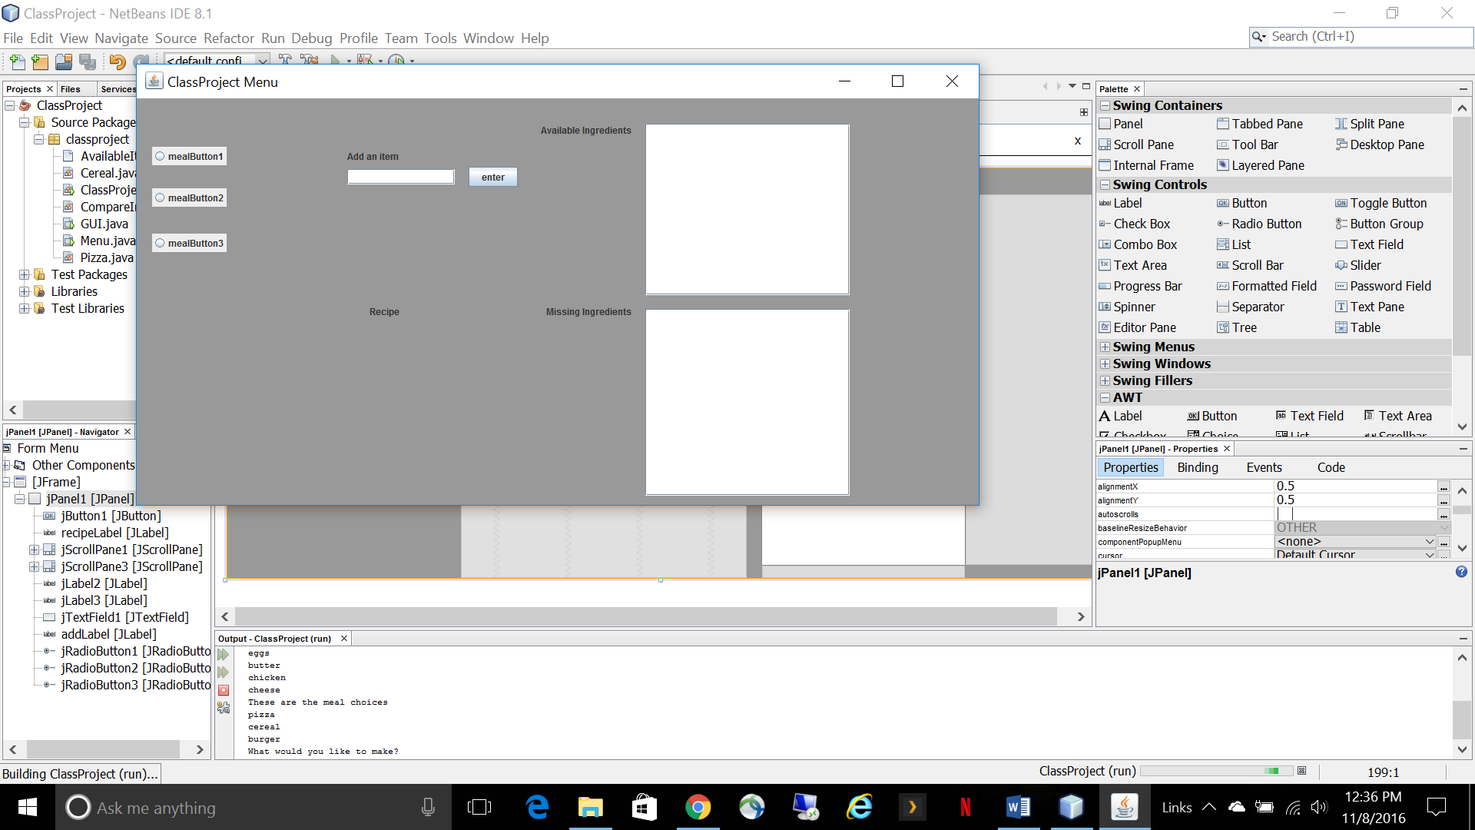

Input file of available ingredients

Read the next line in the input file and store the data in a list

Ask the user to select a meal option from a menu

Are all of the ingredients available?

Display the recipe in the GUI

Yes

No

Tell the user to add the missing ingredients to the input file