**Lab 2.1 Setting up Ubuntu Linux with VMWare Player**

**Overview**

Linux is a great environment for programming because the tools are readily available. And, there some utilities you can only access using Linux. You have a few options for running Linux on a Windows PC:

* Use Putty (or other terminal emulation software) to log into a remote Linux server via SSH.
* Run Linux on your local Windows PC. Using :
  + Dual boot computer
    - This can be time consuming to setup
    - This is good if you are doing lots of computational work or graphics
  + Use cygwin
    - People rarely do this anymore
  + Use a Linux from a bootup disk
    - This is great for certain uses
  + You can set up Linux to run in virtually using VMware player -  So EASY!
    - There are other utilities you can use such as [VirtualBox](https://www.virtualbox.org/).
    - In our lab, we will use VMWare Player

The lab uses Ubuntu Linux.The cool thing about using VMWare Player is that you can have different flavors of Linux running (at the same time) in different players. This gives you a chance to evaluate which one you like best. Here is lab objective:

1. Setting up Ubuntu Linux with VMWare Player
2. Learn to edit a file in **vi** Text Editor.

Steps:

1. Download VMWare Player in this website (<https://www.vmware.com/products/workstation-player/workstation-player-evaluation.html>)

Install VMWare Player.

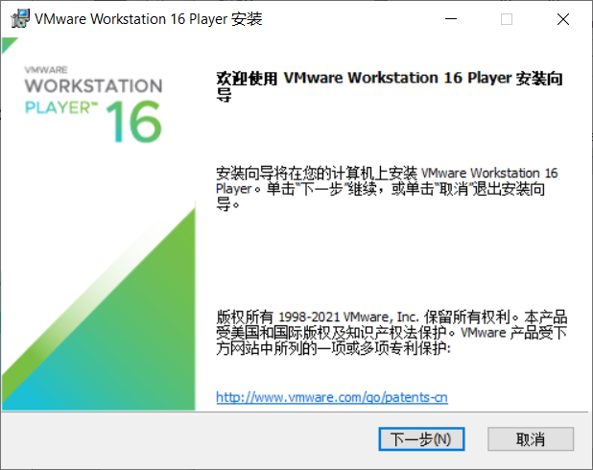

VMWare Workstation Player install complete.

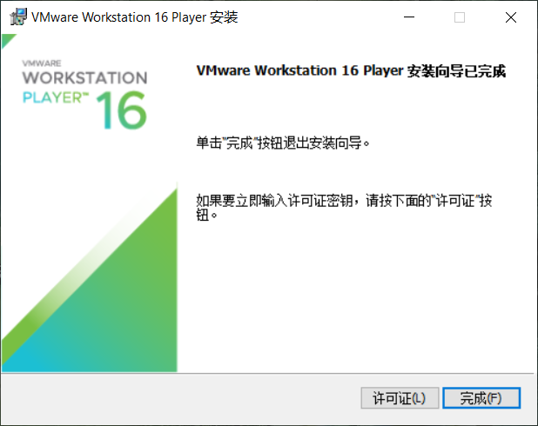

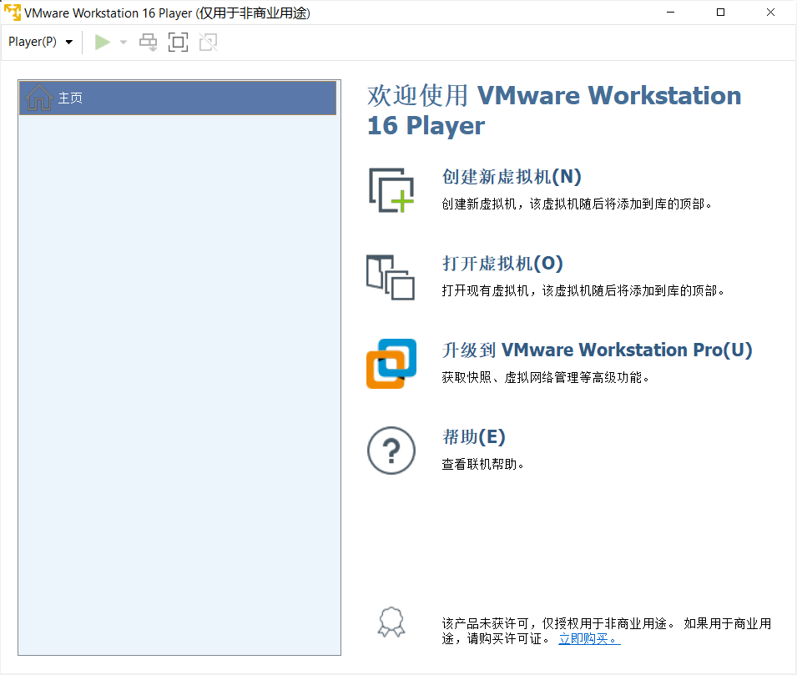

1. Download Ubuntu version 12.04 64 bit.



1. Setup Ubuntu Linux with VMWare Player

Create New Virtual Machine

 Next

Install the operating system later.

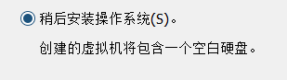 Next

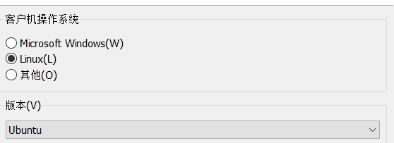 Next…Next

After finish creating, we can see that a new virtual machine created complete.

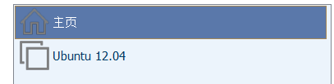

Then click Ubuntu 12.04, setting up the machine.

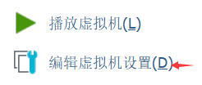

Goes to CD/DVD setting, then browse the Ubuntu version 12.04.iso file.

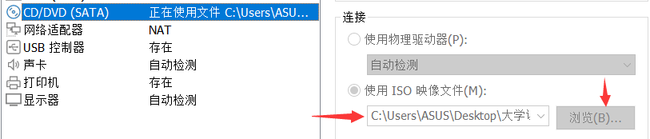

Browse this file and the setting is completed.



Then, double click Ubuntu 12.04 and start to install Ubuntu.

After clicking, we can see this page.

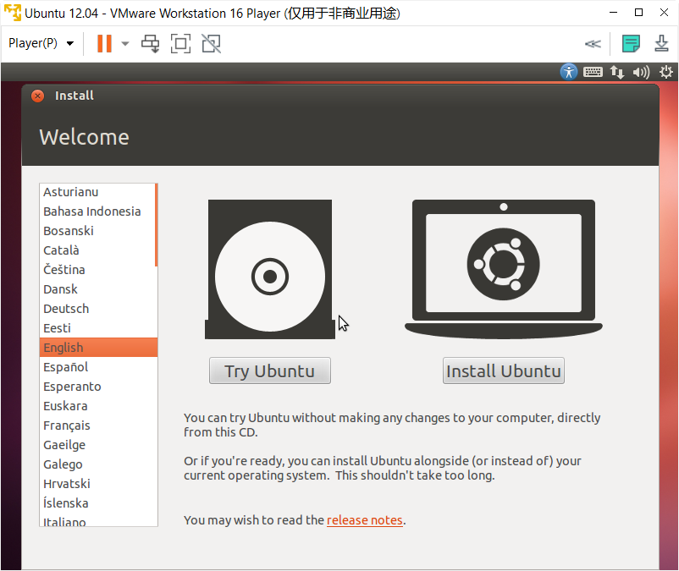

Click Install Ubuntu.

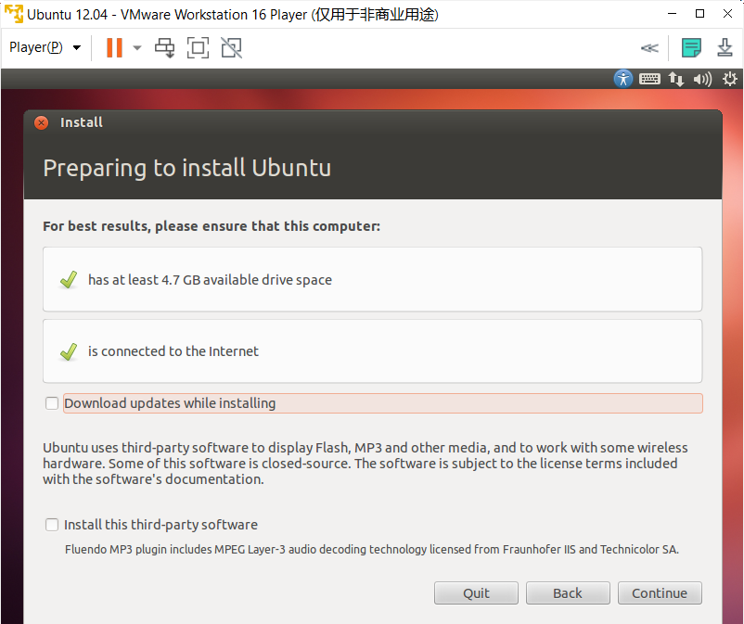

1. Install Complete

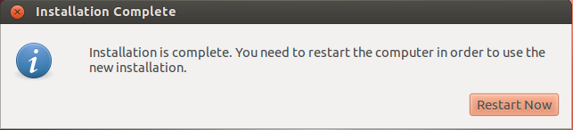

1. Login into Ubuntu

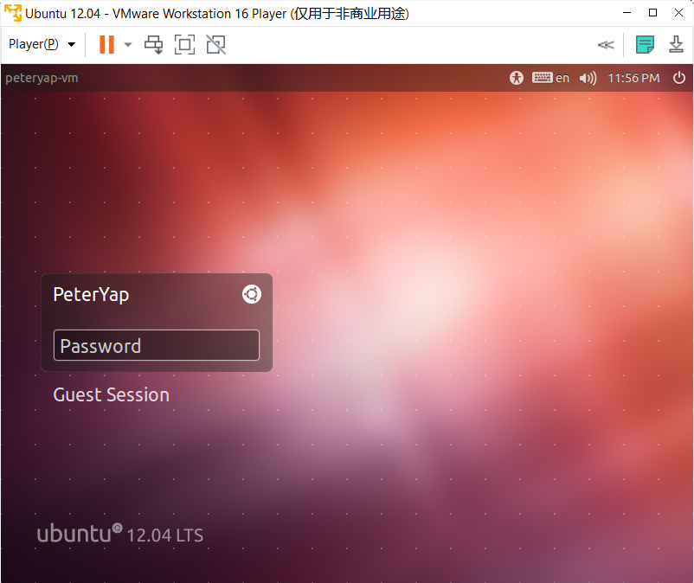

1. Login Successful

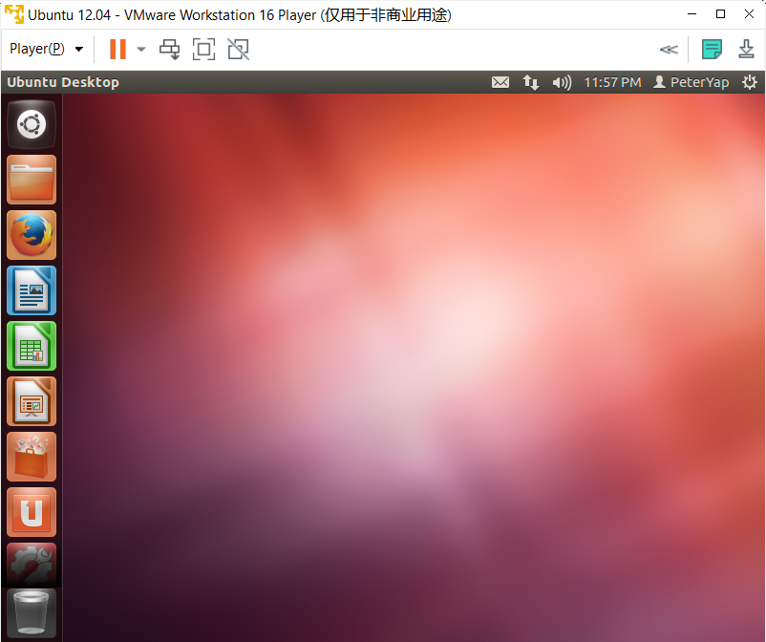

1. Open terminal, insert command with vi hello.txt in the terminal to create hello.txt file.

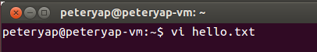

1. Press key ‘i’ to switch to Insert mode, type “Hello World!” in the text editor. Then, press Esc key and type :wq , the hello.txt file is saved and exit.



1. We can type “cat hello.txt” in the terminal to see the text in the hello.txt file

