**Lab 2.2 Running a Hello World Program in C using GCC**

**Overview**

The lab helps familiarize you with writing a simple Hello World program using C, the GCC compiler [link](http://gcc.gnu.org/), and Pico(a text editor, [link](http://en.wikipedia.org/wiki/Pico_(text_editor))). It uses Ubuntu VM created in Lab 2.1.Here is lab objective:

1. Learn to run a program in gcc.
2. Learn to debug a program in gdb.

**Steps :**

1. Writing a simple Hello World program using C language. Create a .c file using text “vi hello.c”. 

Write a Hello World c program.

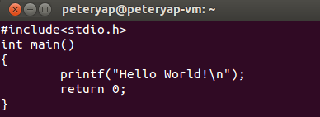

1. Save and exit the text editor. Insert the command with gcc -o hello hello.c to compile the C program, then insert ./hello to execute the c program. “Hello World!” is printed out.

This command will invoke the GNU C compiler to compile the file hello.c and output (-o) the result to an executable called hello.



1. Create debug_me.c file. “vi debug_me.c”.



1. Copy the code of lab2.2 website and add two more include header file which is #include<stdio.h> and #include<stdlib.h>

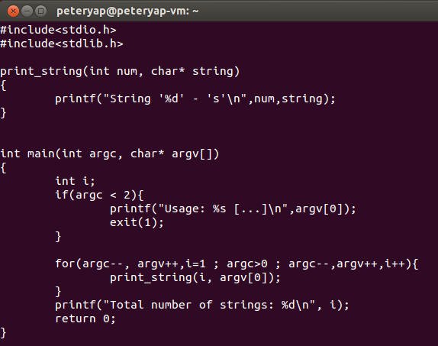

1. Insert two command “gcc -g debug_me.c -o debug_me” and “gdb debug_me”

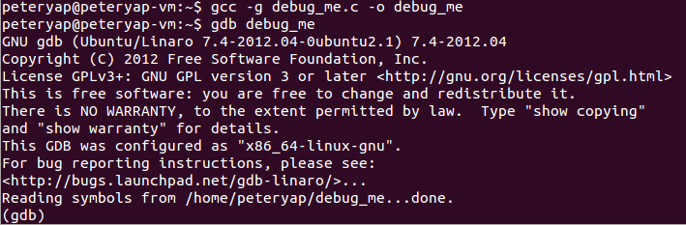

1. In the gdb command insert run “hello,world” “goodbye,world”.

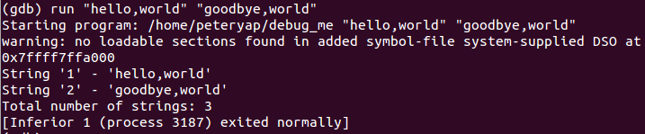

1. Setting breakpoint by using “break main” or “break debug_me.c:19” at a specific line.

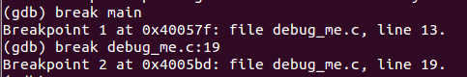

1. After setting breakpoints, run the program step by step with two methods.(next or step).

The difference between "next" and "step" is that "step" stops inside a called function, while "next" executes called functions at (nearly) full speed, stopping only at the next line in the current function.

1. Use the two methods as below :

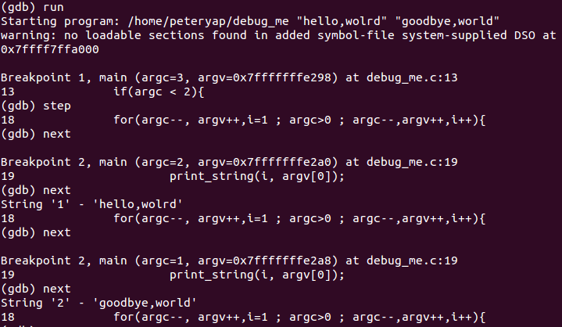

When running in the second loop, we can use the print method to check the value of variable i, insert command “print i”.

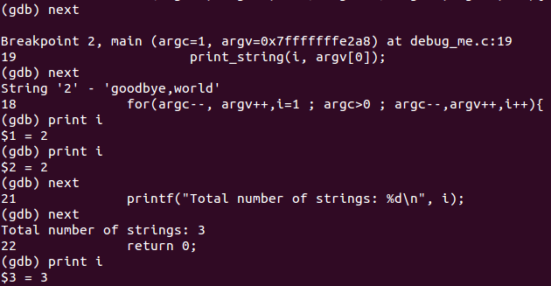

When use the next method and goes out of the for loop, the integer i++, and print i again, we can see that the variable become 3.

1. We can also use the command “where” to check the function call stack.

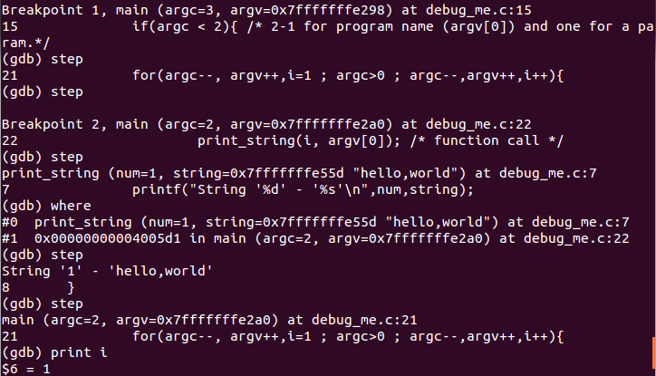

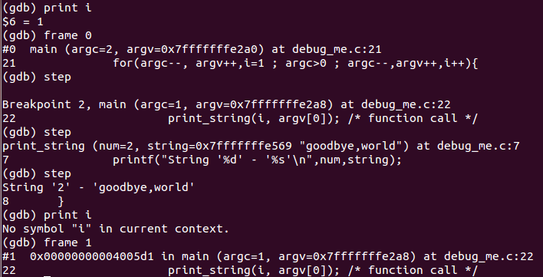

Using the “frame” command to switch, different frame print out different variable i, because of the variable i is not defined in the function, however the variable i in main function is i = 1.

1. The Lab is completed.