配置：1.windows8-64bit环境下载，qt-opensource-windows-x86-msvc2013_64-5.6.3.exe、opencv2.4.13、VS2013

2.qt所有都勾选上，构建套件

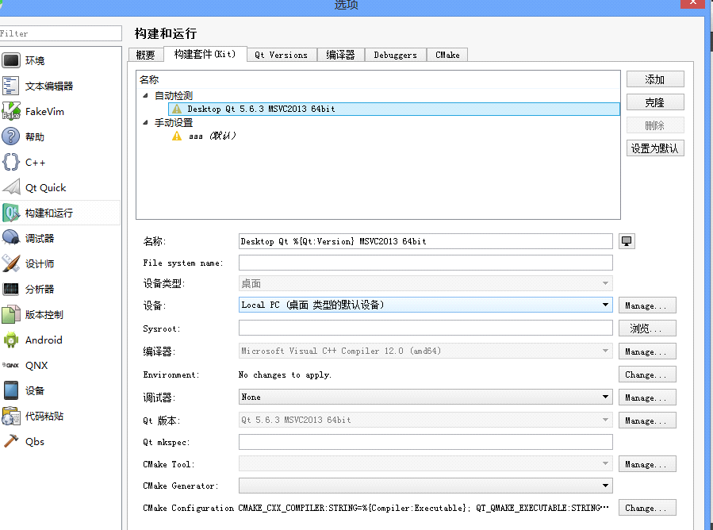

编译器选择c++ comipile12.0(amd64)这个是vs2013带的,Qtshi5.6.3MSVC2013 64bit

vs2015不能运行

3.opencv配置,要加环境变量path。

4.运行发来的代码,在Qt里新建opencv项目，要在项目.pro文件加入opencv路径，然后点击qmake，界面文件.ui也要复制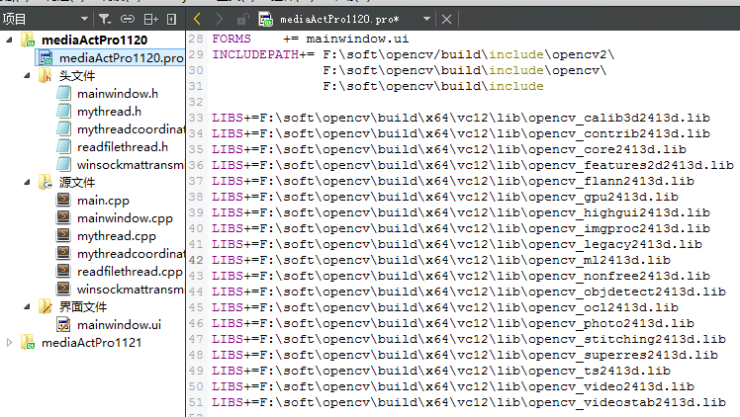

宁波电脑的路径复制下面的就行：

INCLUDEPATH+= D:\opencv2413\opencv\build\include\opencv2\

D:\opencv2413\opencv\build\include\opencv\

D:\opencv2413\opencv\build\include

LIBS+=D:\opencv2413\opencv\build\x64\vc12\lib\opencv_calib3d2413d.lib

LIBS+=D:\opencv2413\opencv\build\x64\vc12\lib\opencv_contrib2413d.lib

LIBS+=D:\opencv2413\opencv\build\x64\vc12\lib\opencv_core2413d.lib

LIBS+=D:\opencv2413\opencv\build\x64\vc12\lib\opencv_features2d2413d.lib

LIBS+=D:\opencv2413\opencv\build\x64\vc12\lib\opencv_flann2413d.lib

LIBS+=D:\opencv2413\opencv\build\x64\vc12\lib\opencv_gpu2413d.lib

LIBS+=D:\opencv2413\opencv\build\x64\vc12\lib\opencv_highgui2413d.lib

LIBS+=D:\opencv2413\opencv\build\x64\vc12\lib\opencv_imgproc2413d.lib

LIBS+=D:\opencv2413\opencv\build\x64\vc12\lib\opencv_legacy2413d.lib

LIBS+=D:\opencv2413\opencv\build\x64\vc12\lib\opencv_ml2413d.lib

LIBS+=D:\opencv2413\opencv\build\x64\vc12\lib\opencv_nonfree2413d.lib

LIBS+=D:\opencv2413\opencv\build\x64\vc12\lib\opencv_objdetect2413d.lib

LIBS+=D:\opencv2413\opencv\build\x64\vc12\lib\opencv_ocl2413d.lib

LIBS+=D:\opencv2413\opencv\build\x64\vc12\lib\opencv_photo2413d.lib

LIBS+=D:\opencv2413\opencv\build\x64\vc12\lib\opencv_stitching2413d.lib

LIBS+=D:\opencv2413\opencv\build\x64\vc12\lib\opencv_superres2413d.lib

LIBS+=D:\opencv2413\opencv\build\x64\vc12\lib\opencv_ts2413d.lib

LIBS+=D:\opencv2413\opencv\build\x64\vc12\lib\opencv_video2413d.lib

LIBS+=D:\opencv2413\opencv\build\x64\vc12\lib\opencv_videostab2413d.lib

界面文件右键以普通文本编辑器格式打开就可以复制粘贴了。

修改完清除一下

5.启动方式：

先启动服务器用户gpu，进入目录

cd openpose

启动服务端程序

./build/examples/user_code/openpose_match1120.bin

如果提示Address already in use，结束程序，等待占用释放，再次启动即可。

然后启动客户端

直接打开QT，选择D:\Projects\opencv\mediaActPro里的.pro加载代码，直接运行就行，改代码后记得清除一下。

录制的时候在服务端按S。结束录制也按S