
Introduction to Electronics II

Overview

Electronics is the foundation of modern devices, from lights and appliances to robots, sensors, and smart systems. In a makerspace, basic electronics skills enable members to build interactive projects that respond to the environment using microcontrollers (like the Arduino Uno R3) and components such as LEDs, resistors, sensors, and servos.

In this introduction to electronics, participants will learn safe and correct breadboarding practices, how to control outputs (LED + servo), how to read sensor data (ultrasonic distance sensor), and how to combine sensor input with actuator output to create an interactive system.

This training focuses on breadboard prototyping and microcontroller-based sensing and control.

Outcomes
After completing this training, you should be able to:
- Explain basic electronics concepts (voltage, ground, current limiting, inputs vs outputs)
- Use a breadboard correctly, including power rails and row/column connectivity
- Build circuits involving an LED, a resistor, a sensor, and a servo controlled by the Arduino Uno R3 (including dimming using PWM)
- Apply safe wiring practices to prevent component damage (especially LEDs and servos)

Prerequisites
- Successful completion of IdeaStudio’s Introduction Electronics I Training
- Arduino IDE installed and accessible
- Access to the course GitHub repository:
https://github.com/WestHoustonInstitute/Intro-to-Electronics-with-Arduino

Assessment
To successfully complete this training, you will need to demonstrate competency and earn at least 40 points on the assessment. The following are the individualized criteria on which you will be assessed.
CRITERIA | Needs Work  (0 points) | Competent  (5 points) | Exceptional  (10 Points)
Explain the basic electrical concepts of Voltage, Current, and Resistance.
Identify the main components of an Arduino-based electronics system.
Identify and correctly use a breadboard for circuit construction.
Upload and run a basic Arduino program.
Integrate sensor input and actuator outputs into a complete automated system.
Identify common circuit or program failures and troubleshoot.
TOTAL SCORE:

Electronics Using Arduino Microcontroller Systems
Electronics prototyping is a subset of engineering known as Embedded Systems Development. Embedded systems involve the use of programmable microcontrollers to monitor real-world conditions through sensors and respond by controlling output devices such as lights, motors, or alarms.
There are several ways to build interactive electronic systems. In this training, you will learn the specific points necessary to create a physical automated response system using one of the most common beginner-friendly microcontroller platforms, known as the Arduino.
An Arduino microcontroller uses electrical signals from connected input devices (such as sensors) and processes that information using programmed logic. The Arduino can then control output devices such as LEDs or servo motors in response to the input data.
In this training, participants will construct a proximity-based automated system using an Ultrasonic Distance Sensor, LED, and Servo Motor.

Step by Step Overview
The first step in building an embedded electronics system is identifying and gathering the required hardware components.
Typical components used in this training include:
- Arduino Uno Microcontroller
- Breadboard
- LED
- 220Ω Resistor
- Ultrasonic Distance Sensor (HC-SR04)
- Servo Motor
The next step is constructing the physical circuit using the breadboard. The breadboard allows components to be connected without soldering by providing internal conductive pathways.
Participants will first construct a basic LED circuit using a resistor to limit electrical current and prevent damage to the LED.
After assembling the circuit, the Arduino Integrated Development Environment (IDE) is used to upload code to the microcontroller.
The ultrasonic distance sensor sends out sound waves and measures the time it takes for the waves to return after hitting an object. This time measurement is used to calculate the distance between the sensor and the object.
The Arduino reads this distance data through its digital input pins and processes the information based on programmed conditional logic.
Once the system receives distance input data, the Arduino can:
- Turn an LED ON when an object is detected within a specific range
- Rotate a servo motor when the distance threshold is met
- Return the servo motor to its original position when the object moves away

This allows the system to simulate real-world automation applications such as:
- Smart gates
- Parking assistance systems
- Object detection alarms
- Robotic obstacle avoidance

Troubleshooting Circuit Failures
Electronics system failures can occur for many different reasons. First, understand that system failures are a normal part of the design process.
Some of the most common causes of electronics system failures include:
Incorrect LED polarity can prevent the LED from lighting properly. Ensure that the longer leg of the LED is connected to the correct digital output pin through the resistor.
Loose jumper wire connections may prevent signals from properly reaching components. Check that all wires are fully inserted into the breadboard and Arduino pins.
Improper wiring of the ultrasonic sensor (VCC, GND, Trig, Echo) may prevent accurate distance readings.
Servo motors require a Pulse Width Modulation (PWM) signal from the Arduino. Connecting the servo to a non-PWM pin may prevent proper rotation.
Incorrect pin assignments in the program may also cause the system to behave improperly. Ensure that the pins used in the code match the physical wiring of the circuit.
Keep in mind that a system experiencing issues may still be functional but incorrectly wired or programmed.

Instructions for the first circuit: LED + Resistor

Hardware Setup
Before uploading any program to the Arduino, the LED circuit must be constructed correctly on the breadboard.
Follow the steps below to assemble the circuit.

Step 1 — Place the LED
Insert the LED into the breadboard so that:
- The long leg (positive leg) of the LED is placed in E15
- The short leg (negative leg) of the LED is placed in E16
The LED legs must be in different rows so the circuit can be completed properly.

Step 2 — Connect the Arduino Output Pin
Insert a jumper wire:
- From Arduino Digital Pin 3
- To C15 on the breadboard
This allows the Arduino to control the LED.

Step 3 — Add the Resistor
Insert the resistor so that:
- One leg of the resistor goes into D16
- The other leg goes into D23
The resistor limits the electrical current and protects the LED from damage.

Step 4 — Connect Ground
Insert a jumper wire:
- From C23
- To the negative (–) rail of the breadboard

Step 5 — Connect the Breadboard Rails
Use two jumper wires to connect the breadboard to the Arduino power pins.
- Connect the positive (+) rail of the breadboard to Arduino 5V
- Connect the negative (–) rail of the breadboard to Arduino GND
This provides electrical power to the circuit.

Step 6 — Verify the Circuit
Before running the program, confirm the following:
- The LED long leg is connected to Digital Pin 3
- The LED short leg connects to the resistor
- The resistor connects to ground
- The breadboard rails are connected to Arduino 5V and GND
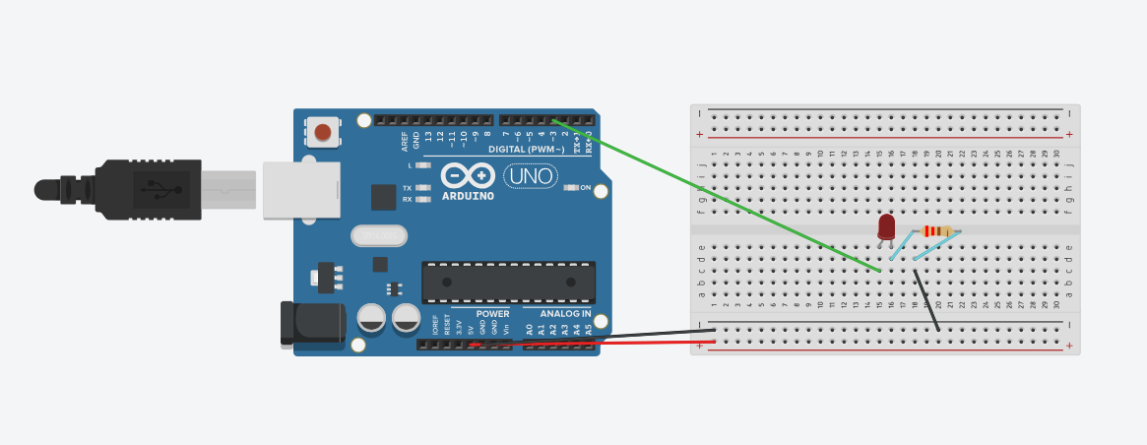Arduino Program – LED Blink for the LED + Resistor
The following Arduino code will cause the LED connected to Digital Pin 3 to blink on and off every 1 second continuously: Click on the Link and download the file to run the program on Arduino IDE.
Connect one end of the USB cable to the Arduino and the other to your computer. Open the Arduino IDE and copy-paste the code above. Next, click “Upload” in the top-left corner and observe the LED.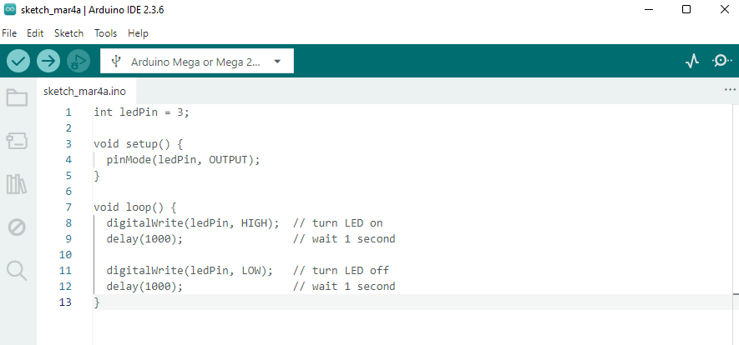

Instructions for the second circuit: Ultrasonic Distance Sensor
In this step, the circuit will be expanded by adding an Ultrasonic Distance Sensor (HC-SR04). The sensor will measure the distance of objects in front of it. When an object comes closer than 20 cm, the Arduino will turn the LED ON continuously.

Hardware Setup – Ultrasonic Distance Sensor
Follow the steps below to add the ultrasonic sensor to the existing LED circuit.

Step 1 — Identify the Sensor Pins
The HC-SR04 Ultrasonic Sensor has four pins:
- VCC – Power
- Trig – Trigger signal
- Echo – Return signal
- GND – Ground

Step 2 — Connect Sensor Power
Insert jumper wires so that:
- VCC connects to the positive (+) rail of the breadboard
- GND connects to the negative (–) rail of the breadboard
The breadboard rails should already be connected to Arduino 5V and GND.

Step 3 — Connect the Trigger Pin
Insert a jumper wire:
- From Trig on the sensor
- To Arduino Digital Pin 9
The trigger pin sends an ultrasonic pulse.

Step 4 — Connect the Echo Pin
Insert a jumper wire:
- From Echo on the sensor
- To Arduino Digital Pin 10
The echo pin receives the returning signal after the sound wave reflects from an object.

Step 5 — Verify the Circuit
Before running the program, confirm that:
- LED circuit is still connected to Digital Pin 3
- Trig → Pin 9
- Echo → Pin 10
- VCC → 5V rail
- GND → Ground rail
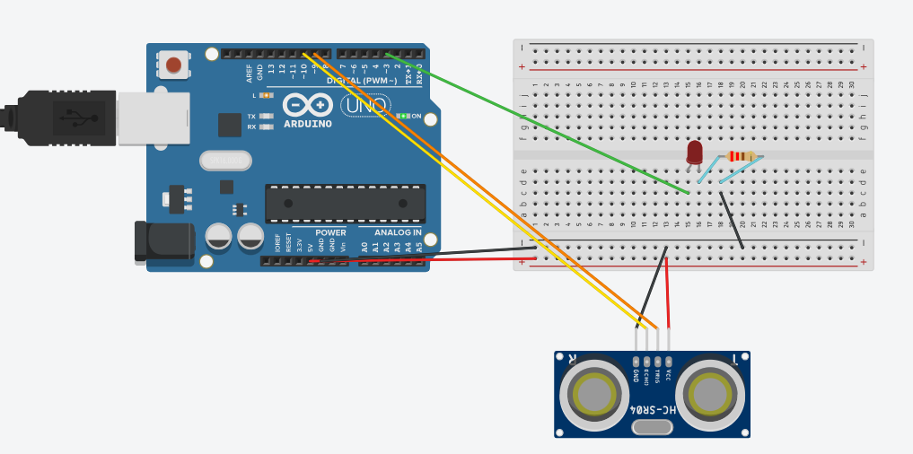Arduino Program – Distance Detection
This program measures the distance using the ultrasonic sensor. If an object is closer than 20 cm, the LED turns ON. If the object is farther away, the LED turns OFF: Click on the Link and download the file to run the program on Arduino IDE.

Instructions for the Third Circuit: Controlling a Servo Motor
In this step, you will connect a servo motor directly to the Arduino and program it to rotate 180 degrees, wait 1 second, then rotate back to 0 degrees, and repeat this motion continuously.
Servo motors are commonly used in robotics and automation systems because they can rotate to precise angles using PWM (Pulse Width Modulation) signals from the Arduino.

Hardware Setup – Servo Motor
A typical micro servo motor (such as SG90) has three wires:
- Red → Power (5V)
- Brown or Black → Ground (GND)
- Orange or Yellow → Signal (control pin)

Step 1 — Connect the Power Wire
Connect the red wire of the servo to:
Arduino 5V
This supplies power to the motor.

Step 2 — Connect the Ground Wire
Connect the brown or black wire of the servo to:
Arduino GND
This completes the electrical circuit.
Step 3 — Connect the Signal Wire
Connect the orange or yellow wire of the servo to:
Arduino Digital Pin 6
This pin will send control signals to rotate the servo.

Step 4 — Verify the Connections
Confirm the following wiring before uploading the program:
- Red → 5V
- Brown/Black → GND
- Orange/Yellow → Digital Pin 6
Once the wiring is complete, the Arduino can control the servo motor.
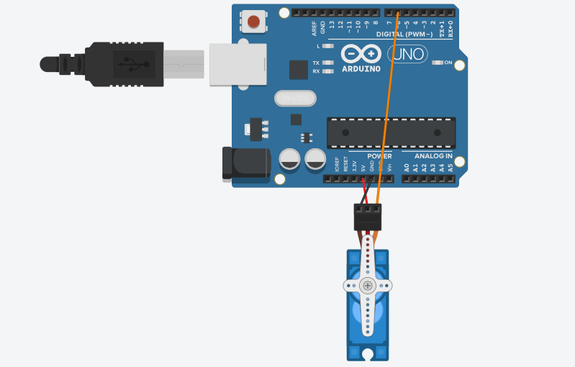Arduino Program – Servo Rotation
The following program rotates the servo between 0° and 180°, pausing 1 second between movements: Click on the Link and download the file to run the program on Arduino IDE.

Instructions for the Final Circuit: Putting Everything Together
Follow the steps below to assemble the full system.

Part 1 — LED Circuit

Step 1 — Place the LED
Insert the LED into the breadboard:
- Long leg (positive) → E15
- Short leg (negative) → E16

Step 2 — Connect Arduino Output
Insert a jumper wire:
- Arduino Digital Pin 3 → C15
This allows the Arduino to control the LED.

Step 3 — Add the Resistor
Insert the resistor:
- One leg → D16
- Other leg → D23

Step 4 — Connect Ground
Insert a jumper wire:
- C23 → Negative (–) rail
Part 2 — Breadboard Power
Use jumper wires to connect the breadboard rails.
- Breadboard + rail → Arduino 5V
- Breadboard – rail → Arduino GND

Part 3 — Ultrasonic Distance Sensor
The HC-SR04 sensor has four pins: VCC, TRIG, ECHO, and GROUND
Step 1 — Connect Sensor Power
- VCC → Positive rail
- GND → Negative rail

Step 2 — Connect Trigger Pin
Insert a jumper wire:
- Trig → Arduino Digital Pin 9

Step 3 — Connect Echo Pin
Insert a jumper wire:
- Echo → Arduino Digital Pin 10

Part 4 — Servo Motor
A servo motor has three wires.
- Red → Power
- Brown/Black → Ground
- Orange/Yellow → Signal

Step 1 — Connect Servo Power
- Red wire → Positive rail

Step 2 — Connect Servo Ground
- Brown/Black wire → Negative rail

Step 3 — Connect Servo Signal
- Orange/Yellow wire → Arduino Digital Pin 6

Part 5 — Verify the Full Circuit
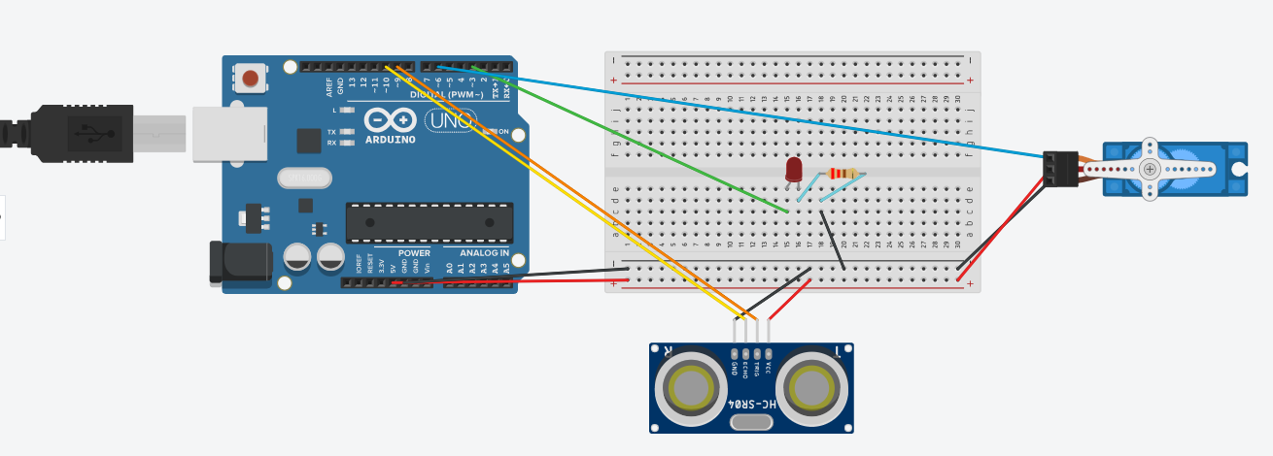
Once the wiring is correct, upload the Arduino program: Click on the Link and download the file to run the program on Arduino IDE.

Electronics Resources
There are a number of online resources that can further your understanding and increase your skills in electronics and embedded systems. Almost all of the resources listed below are available to use for free.

Arduino Documentation and Learning
Arduino IDE
https://www.arduino.cc/en/software
Arduino Web Editor
https://create.arduino.cc
Arduino Tutorials
https://www.arduino.cc/en/Tutorial/HomePage
Hands-on Learning with West Houston Institute
https://github.com/WestHoustonInstitute

Circuit Simulation Tools
TinkerCAD Circuits
https://www.tinkercad.com
Wokwi Arduino Simulator
https://wokwi.com
Falstad Circuit Simulator
https://falstad.com/circuit

Electronics Component Information
SparkFun Electronics Tutorials
https://learn.sparkfun.com
Adafruit Learning System
https://learn.adafruit.com
Electronics Tutorials
https://www.electronics-tutorials.ws

